Advantage of Spring boot
- Faster Development
- Easy to Configure
- Convention(Boot) over configuration(SF)
- Actuators Health check metrics
- Initilizer
@RequestBody
@Controller RestController (@Controller + @ResponseBody)
How Do you design REST API ?
Task : develop e-com order api
Request :
Endpoint : /order/place
Method : POST
Content Type : JSON
Request Data:
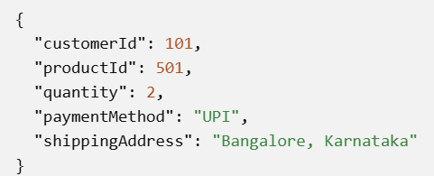
Response :
