C Create Records (save)
R Read the records from database
U Update the records
D Delete the Records.
- Soft delete maintain the status / flag (A, D, Active etc)

Instagram sign up mobile, email, user name, password, geo etc..

- Above info will be saved in DB users tables
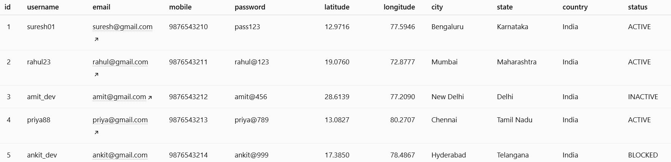

Audit column created date, updated date, deleted date etc…

Hard Delete removing the record from table.

Design a REST Api to search the order-by-Order Id.

Request
End Point : /orders/findOrder
Method : GET
Data : customer_id

Reponse

Order details(customer_id, order_id, payment_method, product_id, quantity, shipping_address)

Derived Method

Controller Service Repository Entity

