ASSIGNMENT 1
INTRODUCTION TO WEB DEVELOPMENT
Name: Sumit Kumar Sharma
Course: B.Tech CSE
University: GLA University, Mathura

Question 1: Explain the difference between frontend, backend, and full-stack development with suitable real-world examples.
Frontend Development
Frontend is the visible part of a website that users interact with. It is created using HTML, CSS, and JavaScript. Buttons, forms, menus, images, and animations are part of the frontend.
Backend Development
Backend is the server-side part of a website. It manages databases, authentication, APIs, and business logic. Common backend technologies include Java, Python, PHP, and Node.js.
Full-Stack Development
A full-stack developer can develop both frontend and backend components of a website.
Real-Life Example:
In an online shopping website like Amazon, product pages and buttons belong to the frontend, while payment processing, user login, and order management belong to the backend.

Question 2: Client–Server Model
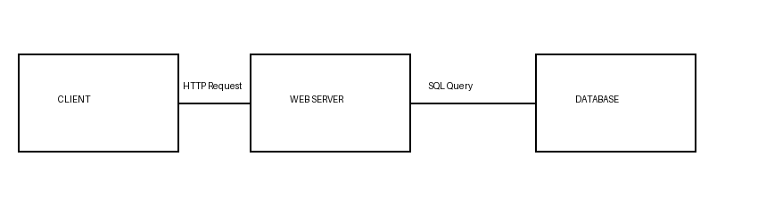
Working:
1. The client sends an HTTP request.
2. The web server processes the request.
3. The server retrieves data from the database.
4. The response is sent back to the client browser.

Question 3: Browser Request Process
1. User enters a URL.
2. Browser sends an HTTP request.
3. DNS resolves the domain.
4. Server processes the request.
5. Server returns HTML, CSS, JavaScript files.
6. Browser renders the webpage and displays it to the user.

Question 4: Tools Required for Web Development
• Visual Studio Code – Code editor.
• Google Chrome – Testing browser.
• Chrome DevTools – Debugging.
• Git – Version control.
• GitHub – Code hosting.
• Node.js – Runtime and package manager.
• Live Server – Live preview during development.

Question 5: What is a Web Server?
A web server stores website files and delivers them to users through HTTP/HTTPS protocols.
Examples:
• Apache
• Nginx
• Microsoft IIS
• Node.js Server
Advantages:
• Fast content delivery
• Secure communication
• Handles multiple client requests

Question 6: Roles in a Web Development Project
Frontend Developer:
Creates responsive user interfaces.
Backend Developer:
Develops APIs, authentication, databases, and server logic.
Database Administrator:
Designs databases, manages backups, security, and optimization.

Question 7: VS Code Setup
Install Visual Studio Code and add:
• Live Server
• Prettier
• HTML CSS Support
• Auto Rename Tag
• Auto Close Tag
(Insert your VS Code screenshot before submission.)

Question 8: Static vs Dynamic Websites
Static Website:
• Fixed content
• Faster
• No database
Example: Portfolio Website
Dynamic Website:
• Database-driven
• Interactive
• Content changes automatically
Example: Facebook, Amazon, Instagram

Question 9: Web Browsers
Google Chrome – Blink
Microsoft Edge – Blink
Mozilla Firefox – Gecko
Safari – WebKit
Opera – Blink
Rendering engines convert HTML, CSS, and JavaScript into webpages. Different rendering engines can display websites slightly differently.

Question 10: Basic Web Architecture Flow
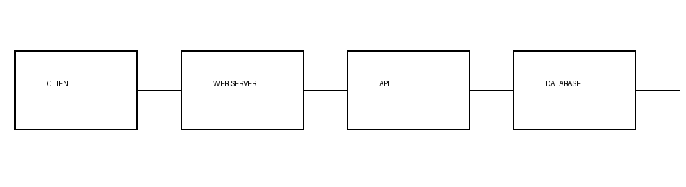
Flow Summary:
Client → Web Server → API/Application → Database.
The database returns results to the API, the API sends them to the web server, and finally the web server returns the webpage to the client.

