Telling the Story of Global Cyber Threats
A data storytelling report on 3,000 cyber incidents, 2015 to 2024
Sumit Mhalaskar
Week 2 Task: Advanced Data Visualization and Storytelling with Python
9 October 2026

Contents
1. Introduction
2. Methods
3. Visual Analyses
3.1 The big picture: losses over time
3.2 Which attack does the most damage?
3.3 Who is hit hardest?
3.4 Where in the world?
3.5 Do defense tools speed up recovery?
3.6 Does a bigger breach cost more?
4. Business and Scientific Implications
5. Conclusion
6. Limitations and Future Work
Appendix

1. Introduction
Cyber attacks are often discussed in technical language that hides the human and financial picture behind them. This report turns a large table of numbers into a short story that a non-technical reader can follow. It uses the Global Cybersecurity Threats dataset, a public dataset of 3,000 incidents recorded in 10 countries between 2015 and 2024. Each incident lists the country, year, attack type, target industry, financial loss in million dollars, number of users affected, attack source, security vulnerability, defense mechanism used and the hours taken to resolve it.
Story question: Which cyber attacks cost the most, who gets hit hardest, and does the choice of defense tool actually help organizations recover faster?
Target audience: Business managers and decision makers without a technical background. Every chart therefore has a headline that states its main finding, and every figure is followed by a plain-language explanation.
Story outline: The story has a beginning, a middle and an end. It opens with the scale of the problem (Figure 1), moves to who and where it hits hardest (Figures 2 to 4) and ends with what organizations can and cannot control (Figures 5 and 6).

1.1 The dataset at a glance
Item | Value
Incidents recorded | 3,000 (no missing values)
Period covered | 2015 to 2024
Countries / industries / attack types / defenses | 10 / 7 / 6 / 5
Total financial loss | 151,479 million dollars (about 151.5 billion)
Average loss per incident | 50.5 million dollars
Average resolution time | 36.5 hours (range 1 to 72)
Average users affected per incident | about 505,000

2. Methods

2.1 Tools
The analysis was done in Python inside a Jupyter notebook. pandas was used to prepare and summarize the data. Matplotlib and Seaborn produced the static charts (Figures 1, 2, 3 and 5), and Plotly produced the interactive charts (Figures 4 and 6). All charts were saved as 300 dpi images for this document.

2.2 Data preparation
- The CSV file was loaded with pandas and its columns were renamed to short names (for example, loss_musd and user_affected) to keep the code readable.
- All 3,000 rows were complete: no column contained missing values, and duplicate rows were checked.
- Data types were confirmed (year and counts as integers, loss as a decimal, categories as text).
- Summary statistics showed that losses range from 0.5 to 99.99 million dollars and resolution times from 1 to 72 hours, with no extreme outliers to remove.
- Group summaries (by year, attack type, industry, country and defense) were calculated to find where the story is before any final chart was drawn.

2.3 Design choices
- Headline titles. Each chart title states the finding instead of only describing the data.
- Consistent color. Red marks money lost and danger, blue is used for neutral comparisons, and grey is used for background bars so that one highlighted bar draws the eye.
- Right chart for the question. A line chart for time, ranked bars for comparison, a heatmap for two categories at once, a map for geography, a box plot for spread and a scatter plot for relationships.
- Clear labels. Exact values are written on the charts where possible, and any vertical axis that does not start at zero is flagged in the caption.

2.4 Chart experiments
Several charts were tried before the final versions were chosen:
- Figure 2. A chart of average loss per attack type was almost flat (49.4 to 52.0 million dollars), so total loss was used instead, which gives a clearer ranking and combines how often an attack happens with how much it costs.
- Figure 5. Average resolution time per defense differed by only about one hour, so a box plot was used to show the full spread and make the overlap between defenses visible.
- Figure 1. In the first version the peak label overlapped the chart title. The axis limit was raised and the label moved, and the lowest year was also labeled.
- Figures 4 and 6. These were built with Plotly so that readers can hover over a country or an incident for exact values. The images in this document are static versions of those interactive charts.

2.5 Overview of the figures
Figure | Chart type | Library | Role in the story
1 | Two line charts | Matplotlib | The big picture: is the problem getting worse?
2 | Ranked horizontal bars | Matplotlib | Which attack types cause the most damage
3 | Heatmap | Seaborn | Which industries suffer from which attacks
4 | Map (choropleth) | Plotly | Where in the world losses are highest
5 | Box plot | Seaborn | Whether defense tools change recovery time
6 | Scatter plot | Plotly | Whether bigger breaches cost more

3. Visual Analyses

3.1 The big picture: losses over time
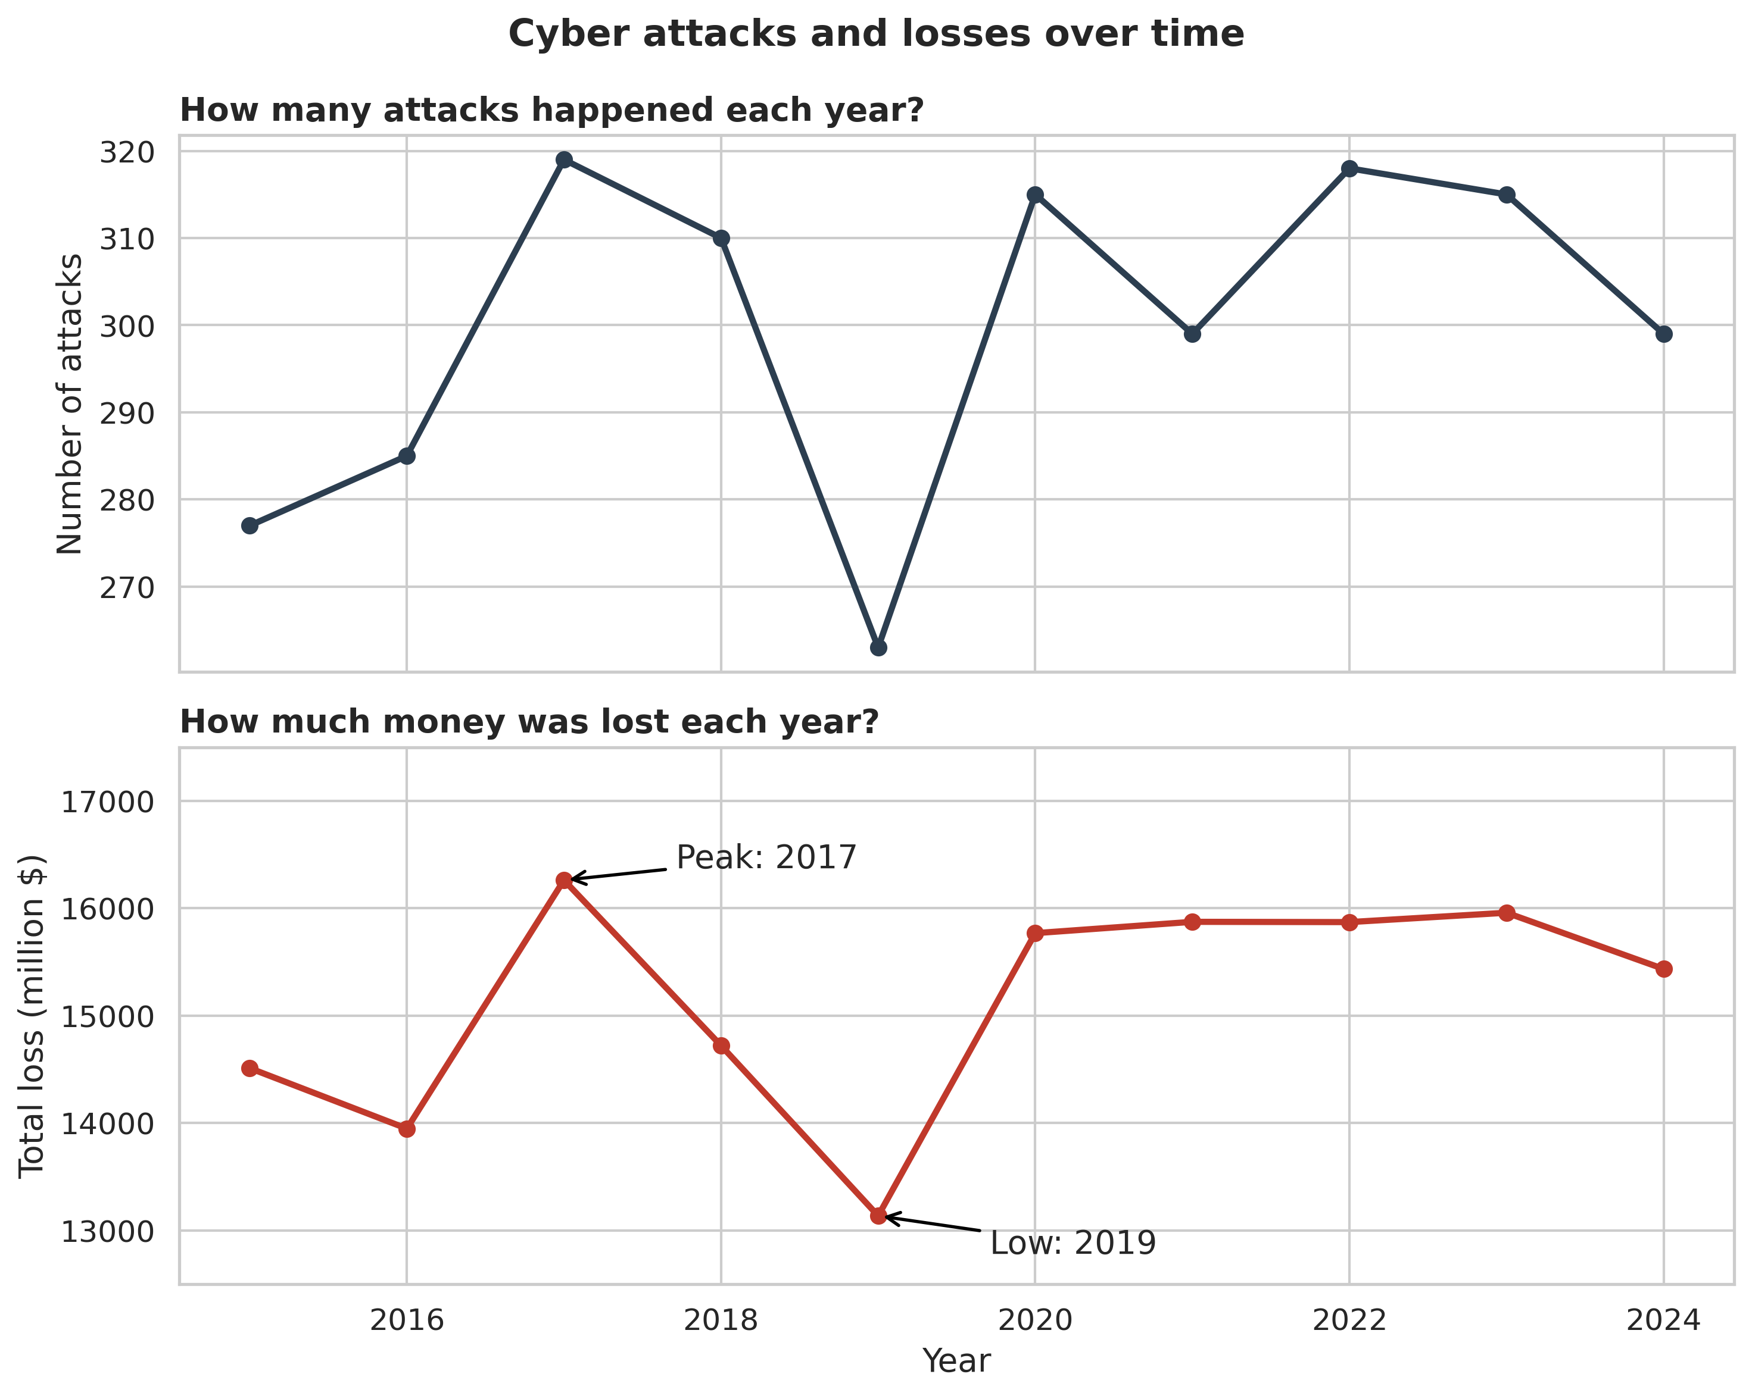
Figure 1. Number of cyber attacks (top) and total financial loss (bottom), 2015 to 2024. Losses peaked in 2017, fell to a low in 2019 and have stayed at a higher level since 2020. The vertical axes do not start at zero.
What to notice: Losses peaked in 2017 at about 16,262 million dollars, fell to a low of about 13,135 million in 2019 and then settled at roughly 15,400 to 16,000 million dollars a year from 2020 onwards. Between 2019 and 2020 total losses rose by about 20%. The two lines move together, so the swings come mainly from how many attacks happen, not from each attack becoming more expensive: the average loss per attack stayed between about 47.5 and 53.1 million dollars in every year.
Why this chart type: A line chart is the natural choice for change over time because the eye follows the slope and spots peaks and dips at once. Placing the attack count above the money lost lets the reader compare both over the same years.
Link to the story: The problem is large and persistent. The next question is which kinds of attack do the most damage.

3.2 Which attack does the most damage?
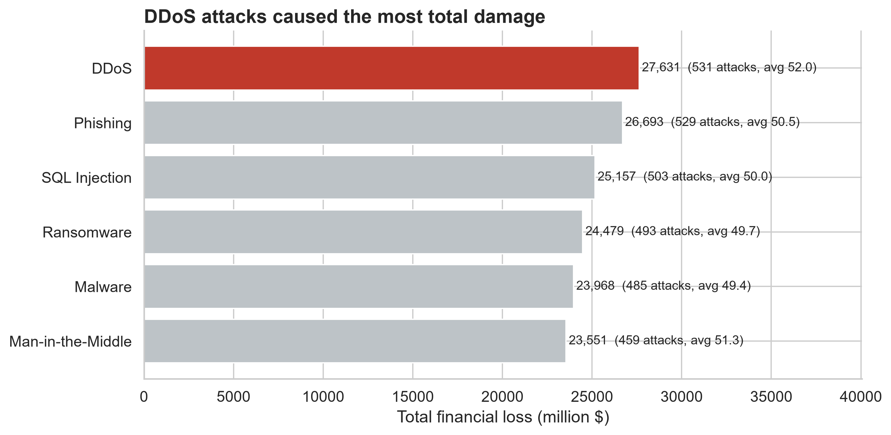
Figure 2. Total financial loss by attack type, 2015 to 2024. DDoS caused the most total damage, followed by Phishing and SQL Injection. Differences between attack types are modest.
What to notice: DDoS caused the most total loss (27,631 million dollars from 531 attacks), followed by Phishing (26,693) and SQL Injection (25,157). Man-in-the-Middle caused the least (23,551). DDoS is about 17% above the lowest type, so the gap is real but modest, and no attack type is harmless.
Why this chart type: A ranked horizontal bar chart makes comparison between categories easy. Lengths are simple to judge, sorting shows the ranking at a glance and the single red bar points a non-technical reader to the main finding. Horizontal bars also leave room for long names such as Man-in-the-Middle.
Link to the story: Attack type is only half of the picture. Who is attacked matters just as much.

3.3 Who is hit hardest?
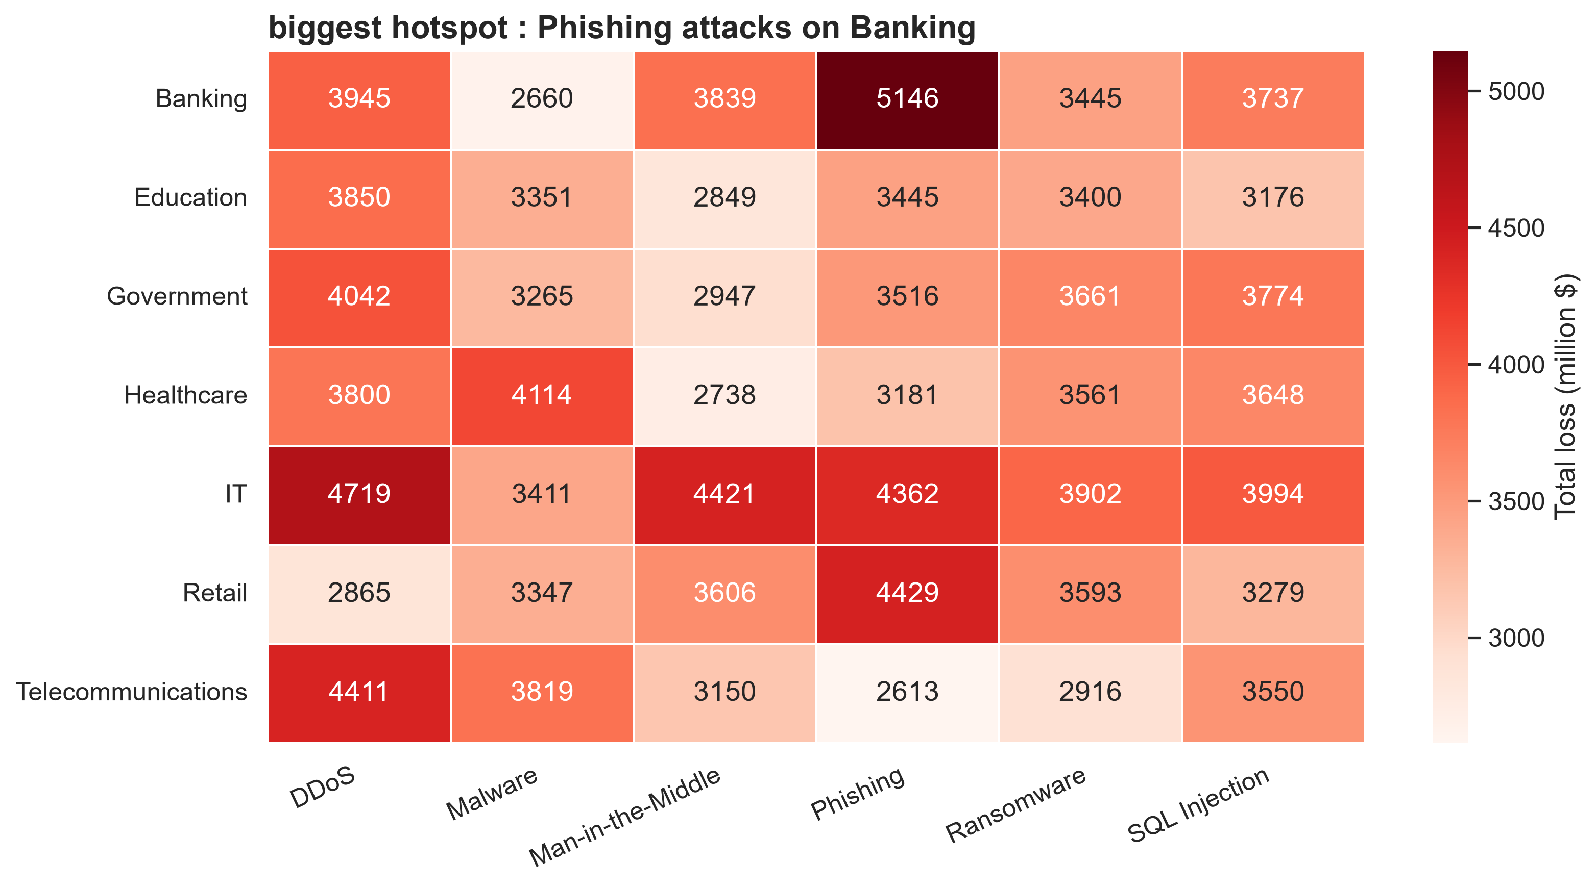
Figure 3. Total financial loss by industry and attack type, 2015 to 2024. Darker cells mean larger losses. Phishing on Banking is the biggest hotspot, while IT suffers high losses across several attack types.
What to notice: Phishing on Banking is the darkest cell at 5,146 million dollars, almost double the lightest cell, Phishing on Telecommunications (2,613). IT is hit hard by several attacks at once (DDoS 4,719, Man-in-the-Middle 4,421 and Phishing 4,362) and has the highest total loss of any industry (24,810 million dollars, about 24% above Education at 20,071).
Why this chart type: A heatmap fits because the question involves two categories at once. Color intensity lets the reader find hotspots at a glance, which would take several separate bar charts to show. The printed numbers let careful readers check the exact values.
Link to the story: We now know what hurts and who it hurts. The next question is where in the world.

3.4 Where in the world?
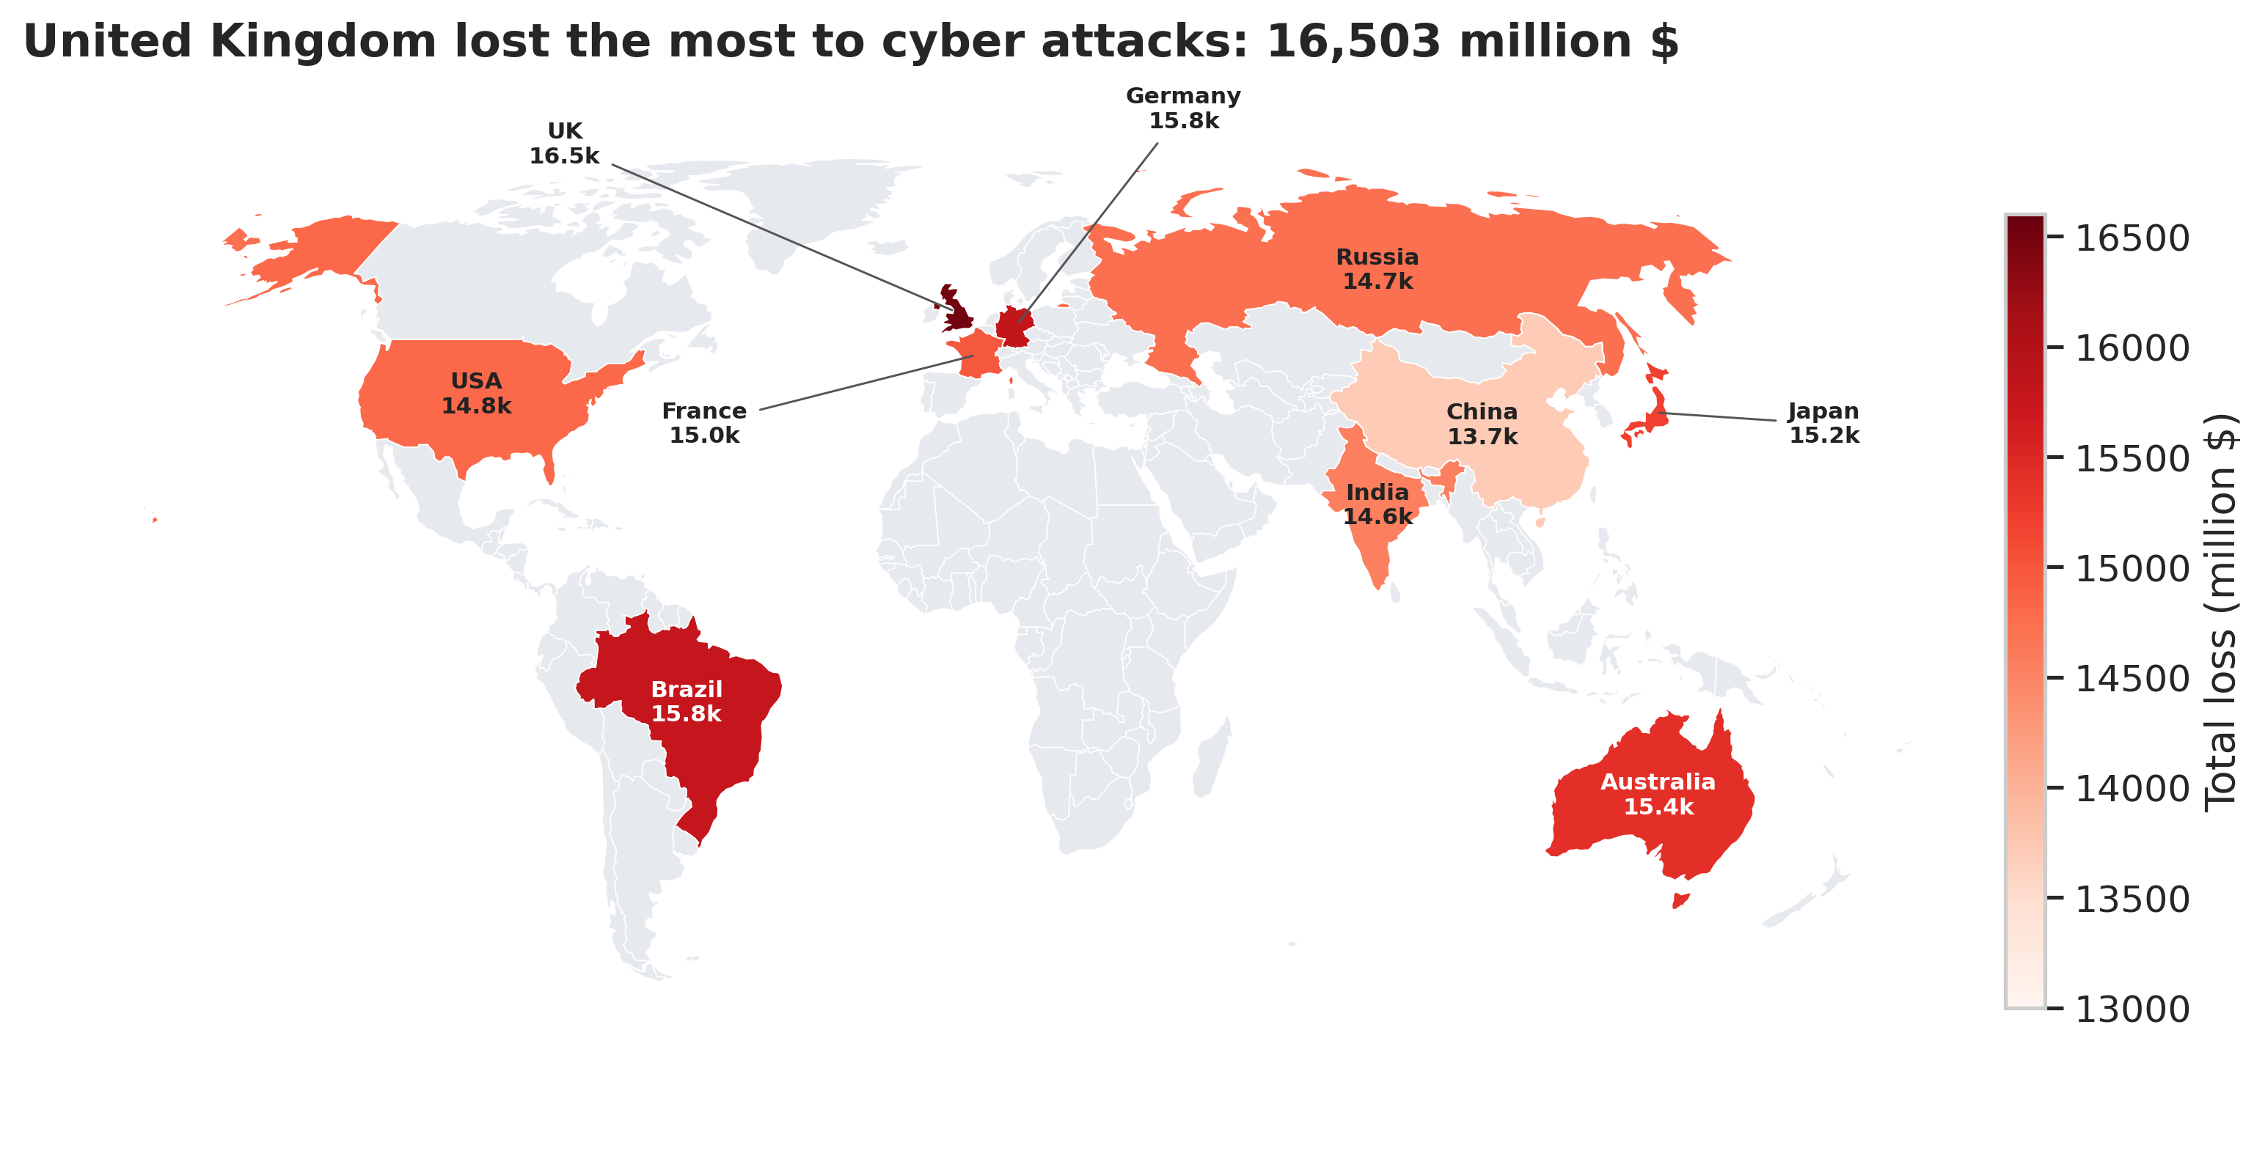
Figure 4. Total financial loss by country, 2015 to 2024. The United Kingdom recorded the highest total loss. Differences between countries are modest, and grey countries are not in the dataset. An interactive version (fig4_map.html) accompanies this report.
What to notice: The United Kingdom lost the most (16,503 million dollars), followed by Germany (15,793) and Brazil (15,783). China is lowest at 13,714, so the UK lost about 20% more than China. No country is spared, and the spread between countries is smaller than the spread between industries.
Why this chart type: A choropleth map suits a geographic question. Coloring each country by its total loss shows where damage is concentrated without a table, and in the interactive version hovering reveals the number of incidents and the average loss for each country.
Link to the story: Location and industry are mostly outside an organization's control. The next question is whether the defenses it chooses make a difference.

3.5 Do defense tools speed up recovery?
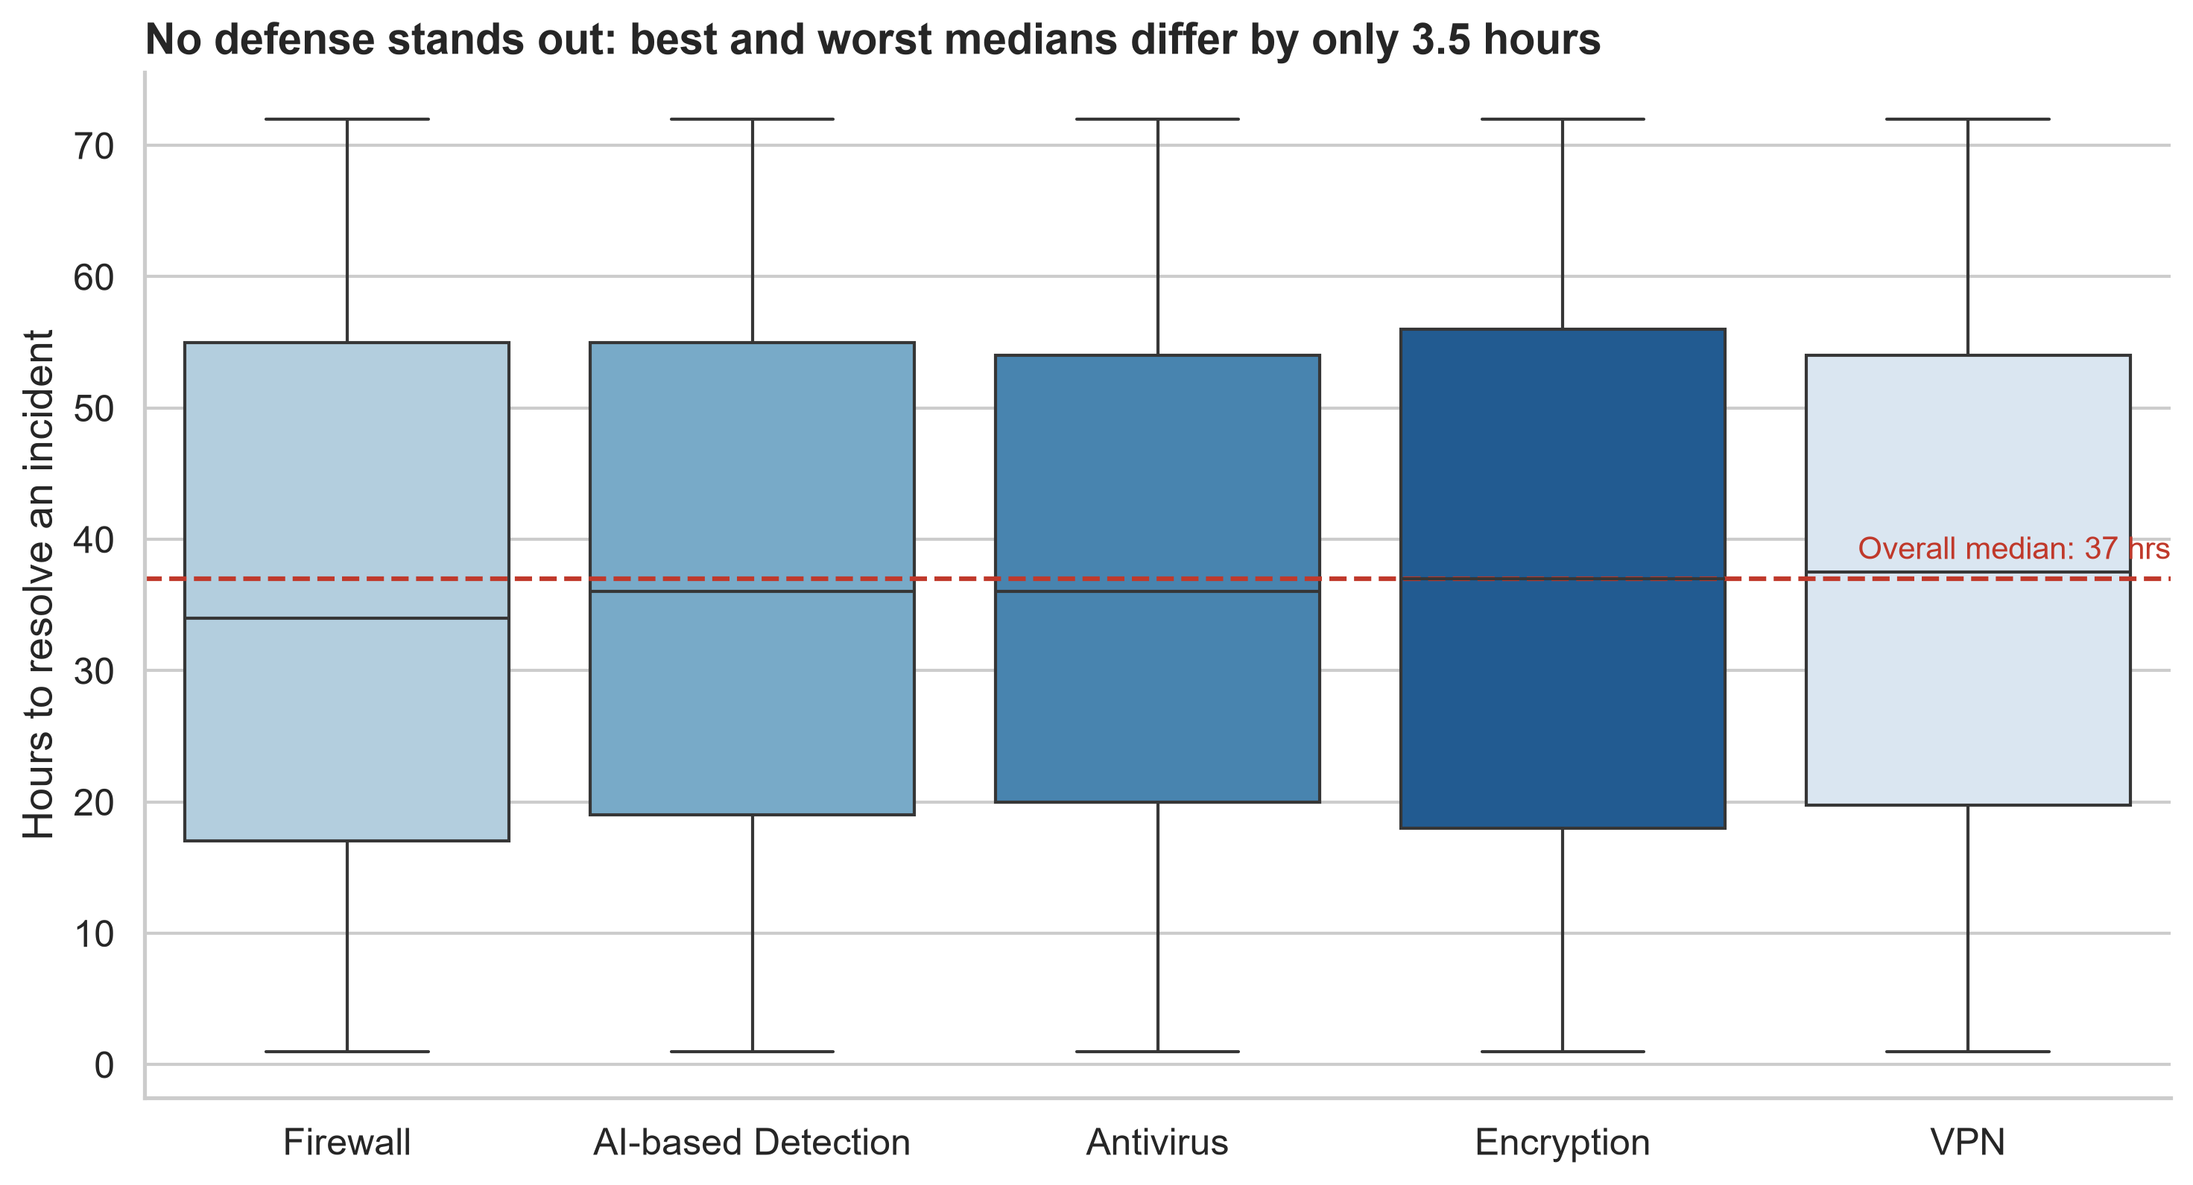
Figure 5. Distribution of incident resolution time by defense mechanism. The dashed line marks the overall median (37 hours). The boxes overlap almost completely, so no single defense tool clearly speeds up recovery.
What to notice: Firewall has the lowest median resolution time (34 hours) and VPN the highest (37.5 hours), a gap of only 3.5 hours. For every defense, the middle half of incidents takes roughly 18 to 55 hours and the full range is 1 to 72 hours. The choice of tool does not predict how quickly an incident is resolved.
Why this chart type: A box plot shows the whole distribution instead of a single average: the median, the typical range and the extremes for each defense side by side. This lets the reader judge whether the differences are meaningful. Here they are not, and the dashed overall-median line makes that easy to see.
Link to the story: If the tool does not decide recovery time, what does? The last chart checks one more common assumption: that bigger breaches cost more.

3.6 Does a bigger breach cost more?
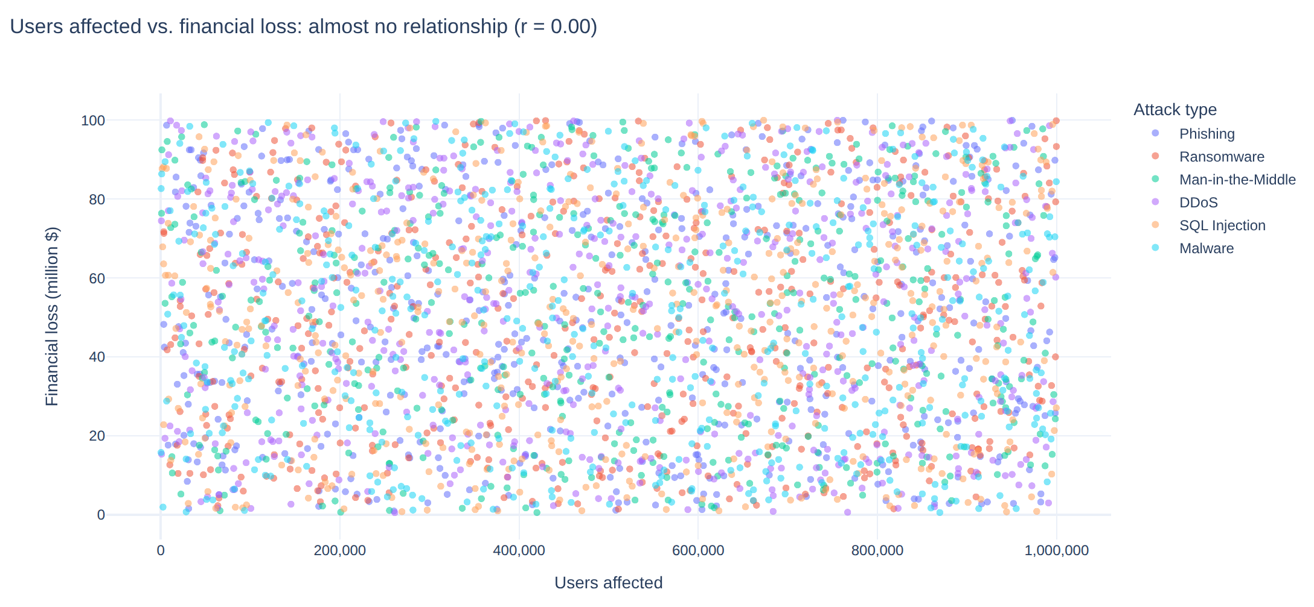
Figure 6. Users affected versus financial loss for each of the 3,000 incidents, colored by attack type. The points form an even cloud (correlation 0.002), so breach size does not predict cost. An interactive version (fig6_scatter.html) accompanies this report.
What to notice: The points are spread evenly across the whole chart and the correlation is 0.002, which is effectively zero. An incident affecting 50,000 users can cost as much as one affecting 900,000. Attack types are mixed throughout, with no cluster in any corner.
Why this chart type: A scatter plot is the standard way to test whether two numbers are related. Showing every incident as a dot reveals the overall pattern and any outliers, and in the interactive version hovering over a dot shows the country, industry, year and resolution time.
Link to the story: Neither breach size nor defense tool explains cost or recovery. This leads to the implications in the next section.

4. Business and Scientific Implications

4.1 Business implications
- Plan for a lasting problem. Losses settled at about 15 to 16 billion dollars a year after 2019. Cyber risk should be budgeted as a permanent running cost, not a one-time spike.
- Match protection to the industry. Banking suffers most from Phishing (5,146 million dollars), and IT is hit hard by DDoS, Man-in-the-Middle and Phishing. Banks should prioritize email security and staff training against phishing, while IT firms need broad, layered protection.
- Do not rely on a single tool. Recovery time is almost the same whichever defense is used. Organizations should invest in response processes (incident playbooks, drills and clear ownership) on top of a layered set of tools, instead of relying on one product.
- Do not use breach size as a proxy for cost. The number of users affected has no link to financial loss (correlation 0.002). Severity should be judged by financial exposure and business impact, not by headline user counts.
- Think globally. Every country in the data lost between 13.7 and 16.5 billion dollars. Security programs should be designed for all regions, not only for the highest-loss ones.
- Improve attribution. About 26% of incidents (768 of 3,000) have an unknown source. Better logging and forensic capability would help organizations understand who is attacking them and why.

4.2 Scientific implications
- The very even spread of losses, users affected and resolution times across categories is itself a finding. It suggests that one-factor explanations (attack type, defense tool or country alone) do not account for outcomes, and that studies should look at combinations of factors.
- Future research could test whether factors missing from this dataset, such as organization size, time to detect and incident severity, explain the variation in cost and recovery.

5. Conclusion
Across 3,000 recorded incidents, cyber attacks cost about 151.5 billion dollars between 2015 and 2024. After a dip in 2019, the yearly cost has stayed at a higher level of roughly 15 to 16 billion dollars. DDoS and Phishing cause the most damage, IT and Banking are the hardest-hit industries, and the United Kingdom, Germany and Brazil lose the most, although the gaps between categories are modest.
The most important finding is what does not matter. The defense tool in use barely changes how fast an incident is resolved, and the number of users affected tells us nothing about the cost. For decision makers the message is to invest in preparation, response and layered defense, and to look beyond any single number or product.

6. Limitations and Future Work
- The dataset contains 3,000 incidents with values spread very evenly, which suggests it may be simulated or heavily aggregated. The conclusions describe this dataset and should not be generalized to the real world without further evidence.
- The analysis shows associations only. It does not prove cause and effect.
- Several differences, for example between attack types and between countries, are modest, and each heatmap cell is based on a small number of incidents. No statistical significance tests were run.
- The vertical axes in Figure 1 do not start at zero, which makes changes look larger than they are. This is stated in the caption.
- Resolution time does not account for how severe an incident was, and the dataset has no information on organization size or time to detect.
- Future work could add statistical tests, a forecast of future losses and richer data on incident severity and organization size.

Appendix
Author profile: https://github.com/Sumitmhalaskar
Files provided with this report: the Jupyter notebook (week2.ipynb), the six figure images and the two interactive charts (fig4_map.html and fig6_scatter.html).
Example code used for Figure 5:
medians = df.groupby("defense")["resolution_hrs"].median()
order = medians.sort_values().index
sns.boxplot(data=df, x="defense", y="resolution_hrs", order=order,
hue="defense", palette="Blues", legend=False)
ax.axhline(df["resolution_hrs"].median(), color="#c0392b", linestyle="--")

