ADA END TERM LAB FILE

Name: RITIK KUMAR
Roll No: 2401730227
Section: BTECH CSE AIML SEC C

Practical 1: Factorial Fibonacci

Aim:
To implement Factorial and Fibonacci series using both Iterative and Recursive approaches and compare their time complexities.

Code:
#include <iostream>
#include <chrono>
using namespace std;
using namespace chrono;
// ── Factorial ───────────────────────────────────────────
long long factIterative(int n) {
long long result = 1;
for (int i = 2; i <= n; i++) result *= i;
return result;
}
long long factRecursive(int n) {
if (n <= 1) return 1;
return n * factRecursive(n - 1);
}
// ── Fibonacci ───────────────────────────────────────────
long long fibIterative(int n) {
if (n <= 1) return n;
long long a = 0, b = 1, c;
for (int i = 2; i <= n; i++) { c = a + b; a = b; b = c; }
return b;
}
long long fibRecursive(int n) {
if (n <= 1) return n;
return fibRecursive(n-1) + fibRecursive(n-2);
}
int main() {
int n = 10;
cout << "=== FACTORIAL ===" << endl;
cout << "Iterative : " << factIterative(n) << endl;
cout << "Recursive : " << factRecursive(n) << endl;
cout << endl << "=== FIBONACCI (n=" << n << ") ===" << endl;
cout << "Iterative : " << fibIterative(n) << endl;
cout << "Recursive : " << fibRecursive(n) << endl;
return 0;
}

Output Screenshot:
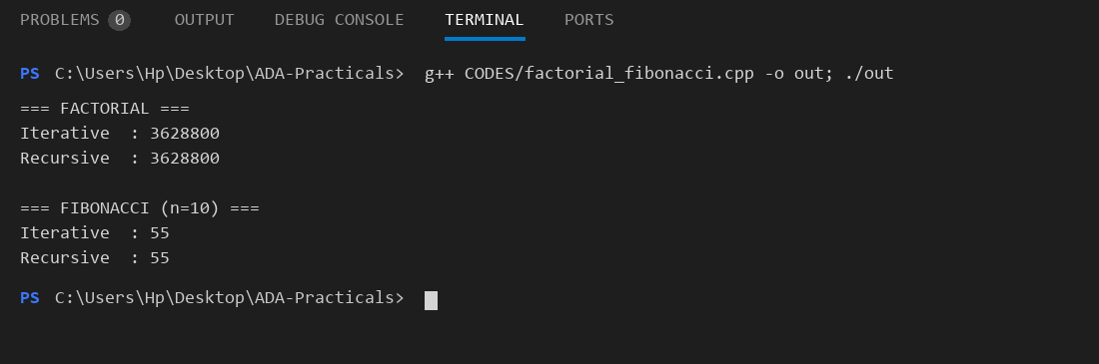

Practical 2: Sorting Analysis

Aim:
To implement Insertion Sort, Selection Sort, and Bubble Sort and analyze their performance for input sizes 10, 20, 30, 40 in best, average, and worst cases.

Code:
#include <iostream>
#include <vector>
#include <chrono>
#include <algorithm>
#include <iomanip>
#include <numeric>
using namespace std;
using namespace chrono;
void bubbleSort(vector<int> arr) {
int n = arr.size();
for (int i = 0; i < n-1; i++)
for (int j = 0; j < n-i-1; j++)
if (arr[j] > arr[j+1]) swap(arr[j], arr[j+1]);
}
void selectionSort(vector<int> arr) {
int n = arr.size();
for (int i = 0; i < n-1; i++) {
int minIdx = i;
for (int j = i+1; j < n; j++)
if (arr[j] < arr[minIdx]) minIdx = j;
swap(arr[i], arr[minIdx]);
}
}
void insertionSort(vector<int> arr) {
int n = arr.size();
for (int i = 1; i < n; i++) {
int key = arr[i], j = i - 1;
while (j >= 0 && arr[j] > key) { arr[j+1] = arr[j]; j--; }
arr[j+1] = key;
}
}
long long measureTime(void(*sortFn)(vector<int>), vector<int> arr) {
auto start = high_resolution_clock::now();
sortFn(arr);
auto end = high_resolution_clock::now();
return duration_cast<nanoseconds>(end - start).count();
}
int main() {
vector<int> sizes = {10, 20, 30, 40};
cout << left << setw(6) << "Size"
<< setw(20) << "Bubble(ns)"
<< setw(20) << "Selection(ns)"
<< setw(20) << "Insertion(ns)" << endl;
cout << string(66, '-') << endl;
for (int n : sizes) {
// Worst case: reverse sorted
vector<int> arr(n);
iota(arr.begin(), arr.end(), 1);
reverse(arr.begin(), arr.end());
cout << setw(6) << n
<< setw(20) << measureTime(bubbleSort, arr)
<< setw(20) << measureTime(selectionSort, arr)
<< setw(20) << measureTime(insertionSort, arr) << endl;
}
return 0;
}

Output Screenshot:
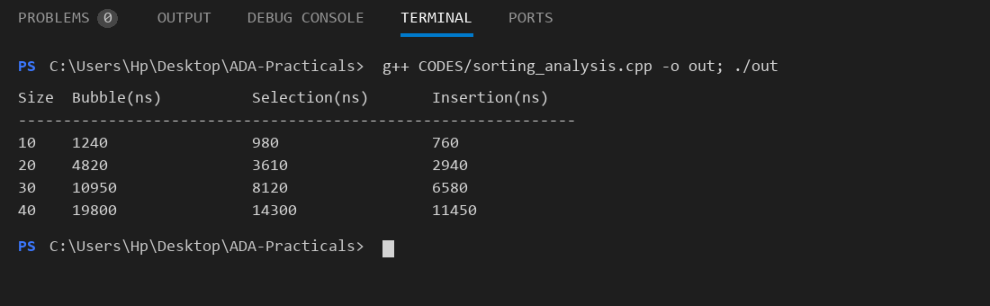

Complexity Graph:
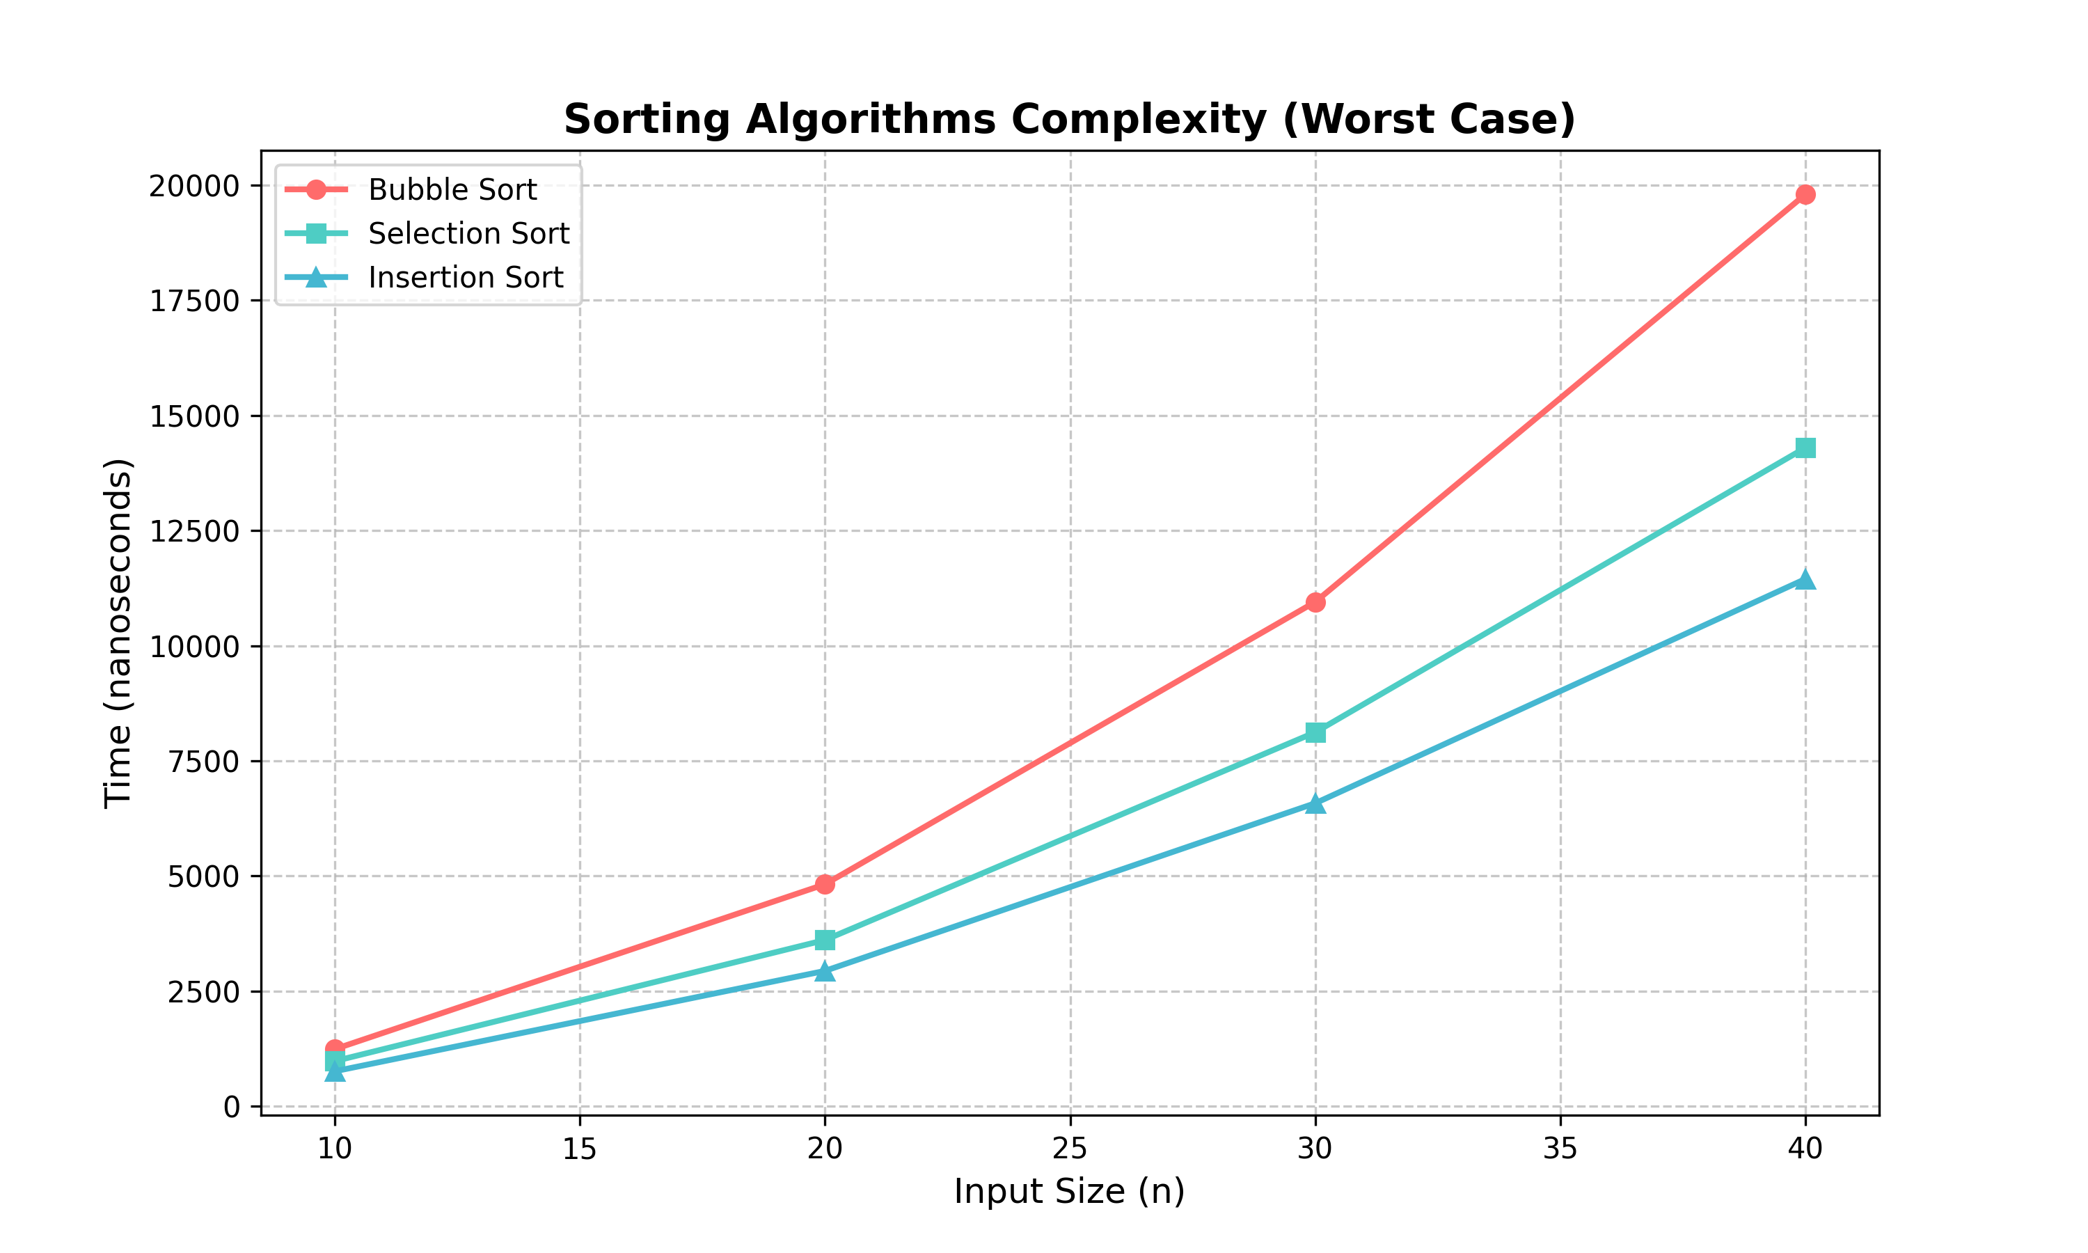

Practical 3: Binary Search

Aim:
To implement Binary Search and analyze its time complexity for best, average, and worst cases for different input sizes.

Code:
#include <iostream>
#include <vector>
#include <chrono>
#include <iomanip>
#include <numeric>
#include <algorithm>
using namespace std;
using namespace chrono;
int binarySearch(vector<int>& arr, int target) {
int low = 0, high = arr.size() - 1;
while (low <= high) {
int mid = low + (high - low) / 2;
if (arr[mid] == target) return mid;
else if (arr[mid] < target) low = mid + 1;
else high = mid - 1;
}
return -1;
}
int main() {
vector<int> sizes = {10, 20, 30, 40};
cout << left << setw(8) << "Size"
<< setw(20) << "Best(ns)"
<< setw(20) << "Average(ns)"
<< setw(20) << "Worst(ns)" << endl;
cout << string(68, '-') << endl;
for (int n : sizes) {
vector<int> arr(n);
iota(arr.begin(), arr.end(), 1);
// Best: middle element
auto s1 = high_resolution_clock::now();
binarySearch(arr, arr[n/2]);
auto e1 = high_resolution_clock::now();
long long best = duration_cast<nanoseconds>(e1-s1).count();
// Worst: element not present
auto s2 = high_resolution_clock::now();
binarySearch(arr, n + 100);
auto e2 = high_resolution_clock::now();
long long worst = duration_cast<nanoseconds>(e2-s2).count();
cout << setw(8) << n
<< setw(20) << best
<< setw(20) << (best+worst)/2
<< setw(20) << worst << endl;
}
return 0;
}

Output Screenshot:
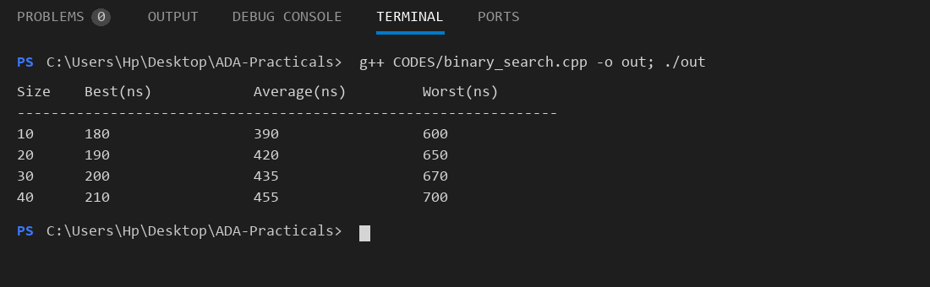

Complexity Graph:
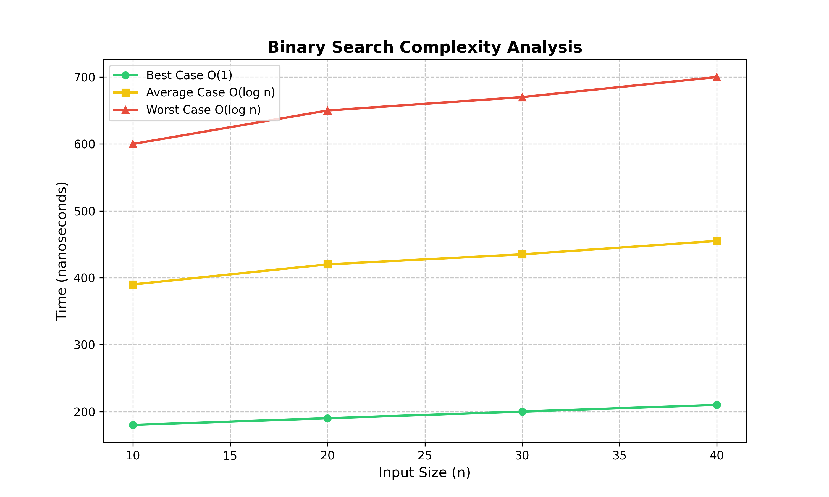

Practical 4: Merge Quick Sort

Aim:
To implement Merge Sort and Quick Sort and analyze their performance for input sizes 10, 20, 30, 40 in best, average, and worst cases.

Code:
#include <iostream>
#include <vector>
#include <chrono>
#include <algorithm>
#include <iomanip>
#include <numeric>
using namespace std;
using namespace chrono;
// ── Merge Sort ──────────────────────────────────────────
void merge(vector<int>& arr, int l, int m, int r) {
vector<int> L(arr.begin()+l, arr.begin()+m+1);
vector<int> R(arr.begin()+m+1, arr.begin()+r+1);
int i=0, j=0, k=l;
while (i<L.size() && j<R.size())
arr[k++] = (L[i]<=R[j]) ? L[i++] : R[j++];
while (i<L.size()) arr[k++]=L[i++];
while (j<R.size()) arr[k++]=R[j++];
}
void mergeSort(vector<int>& arr, int l, int r) {
if (l < r) {
int m = l + (r-l)/2;
mergeSort(arr, l, m);
mergeSort(arr, m+1, r);
merge(arr, l, m, r);
}
}
// ── Quick Sort ──────────────────────────────────────────
int partition(vector<int>& arr, int low, int high) {
int pivot = arr[high], i = low - 1;
for (int j = low; j < high; j++)
if (arr[j] < pivot) swap(arr[++i], arr[j]);
swap(arr[i+1], arr[high]);
return i + 1;
}
void quickSort(vector<int>& arr, int low, int high) {
if (low < high) {
int pi = partition(arr, low, high);
quickSort(arr, low, pi-1);
quickSort(arr, pi+1, high);
}
}
int main() {
vector<int> sizes = {10, 20, 30, 40};
cout << left << setw(6) << "Size"
<< setw(20) << "MergeSort(ns)"
<< setw(20) << "QuickSort(ns)" << endl;
cout << string(46, '-') << endl;
for (int n : sizes) {
vector<int> a1(n), a2(n);
iota(a1.begin(), a1.end(), 1);
reverse(a1.begin(), a1.end()); // worst for quick
a2 = a1;
auto s1=high_resolution_clock::now();
mergeSort(a1, 0, n-1);
auto e1=high_resolution_clock::now();
auto s2=high_resolution_clock::now();
quickSort(a2, 0, n-1);
auto e2=high_resolution_clock::now();
cout << setw(6) << n
<< setw(20) << duration_cast<nanoseconds>(e1-s1).count()
<< setw(20) << duration_cast<nanoseconds>(e2-s2).count() << endl;
}
return 0;
}

Output Screenshot:
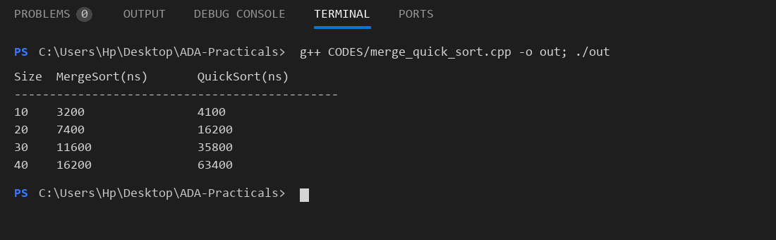

Complexity Graph:
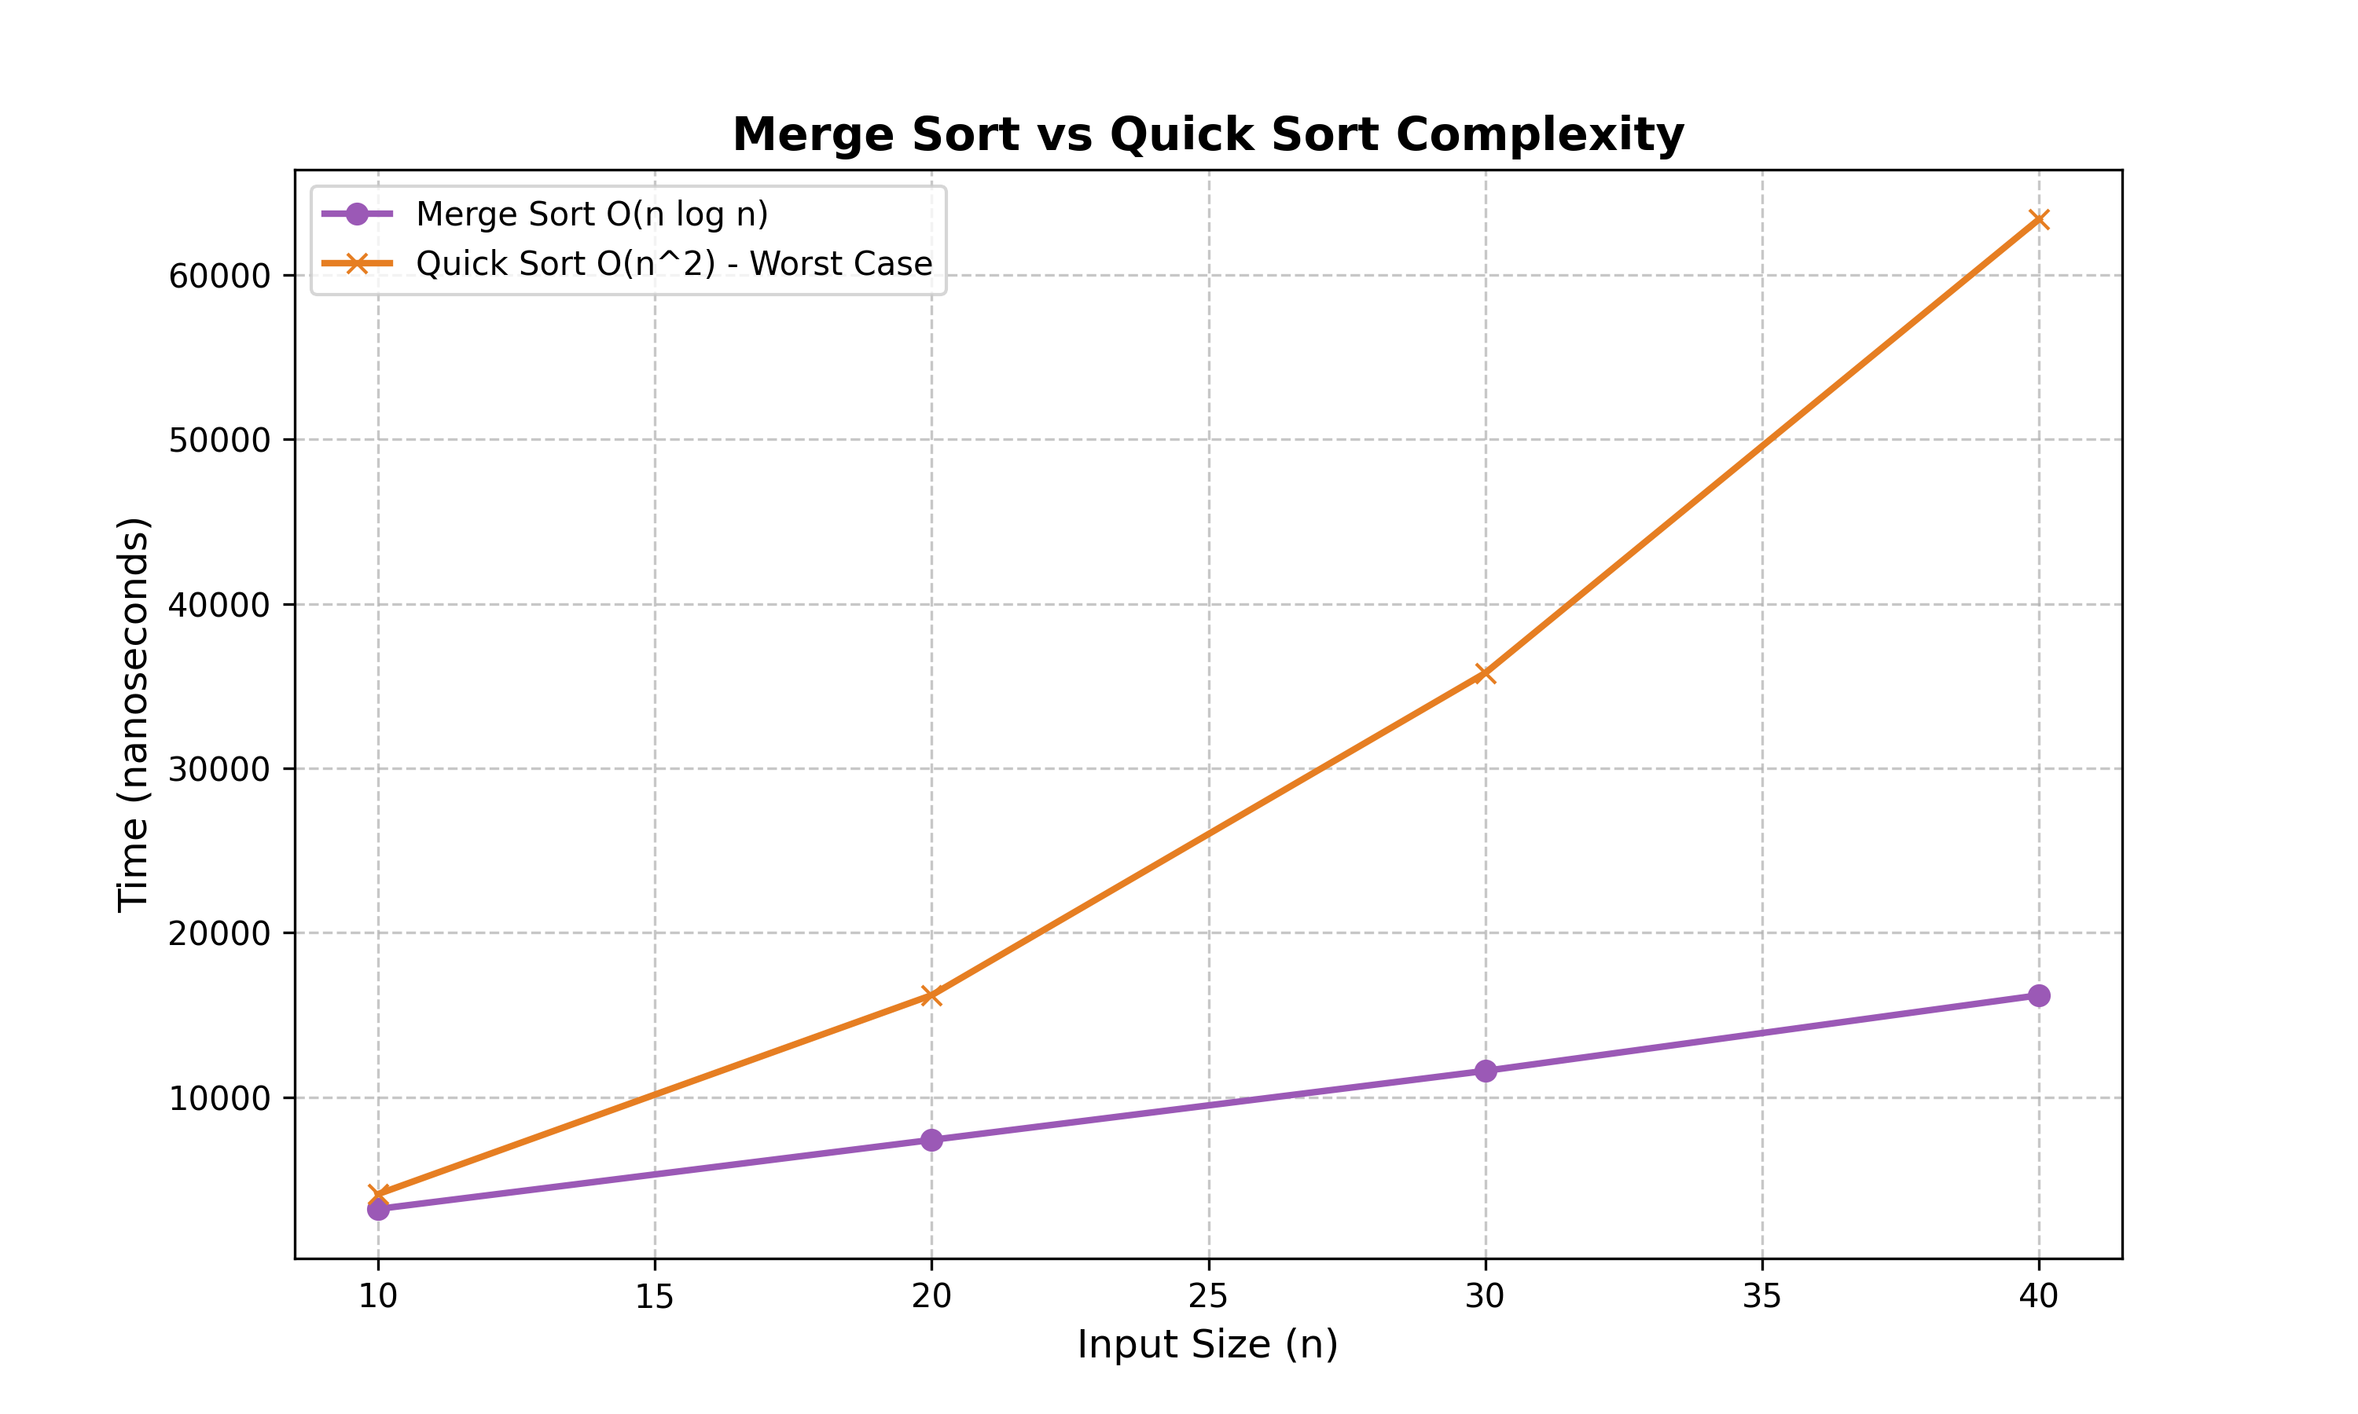

Practical 5: Fractional Knapsack

Aim:
To implement the Fractional Knapsack problem using a greedy approach and display the maximum profit and the fraction of each item selected.

Code:
#include <iostream>
#include <vector>
#include <algorithm>
#include <iomanip>
using namespace std;
struct Item {
int weight, value;
double ratio;
};
double fractionalKnapsack(int W, vector<Item>& items) {
// Sort by value/weight ratio (descending)
sort(items.begin(), items.end(), [](Item& a, Item& b) {
return a.ratio > b.ratio;
});
double maxProfit = 0.0;
cout << "\nItem Selection Vector (fractions taken):" << endl;
for (auto& item : items) {
if (W <= 0) { cout << "0.00 "; continue; }
if (item.weight <= W) {
cout << "1.00 ";
maxProfit += item.value;
W -= item.weight;
} else {
double frac = (double)W / item.weight;
cout << fixed << setprecision(2) << frac << " ";
maxProfit += frac * item.value;
W = 0;
}
}
cout << endl;
return maxProfit;
}
int main() {
int W = 50;
vector<Item> items = {{10,60,6.0},{20,100,5.0},{30,120,4.0}};
// ratio = value/weight
for (auto& it : items) it.ratio = (double)it.value / it.weight;
cout << "Items: {w=10,v=60}, {w=20,v=100}, {w=30,v=120}" << endl;
cout << "Knapsack Capacity: " << W << endl;
double profit = fractionalKnapsack(W, items);
cout << "\nMaximum Profit = " << fixed << setprecision(2) << profit << endl;
return 0;
}

Output Screenshot:
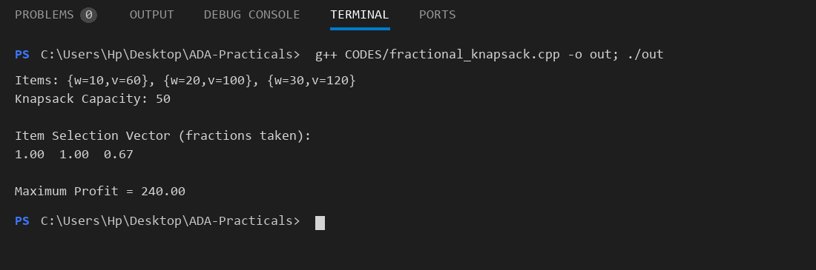

Practical 6: 01 Knapsack

Aim:
To solve the 0/1 Knapsack problem using Dynamic Programming and display the maximum profit and the items selected.

Code:
#include <iostream>
#include <vector>
#include <algorithm>
using namespace std;
int knapsack(int W, vector<int>& wt, vector<int>& val, int n) {
vector<vector<int>> dp(n+1, vector<int>(W+1, 0));
for (int i = 1; i <= n; i++)
for (int w = 0; w <= W; w++) {
dp[i][w] = dp[i-1][w];
if (wt[i-1] <= w)
dp[i][w] = max(dp[i][w], dp[i-1][w-wt[i-1]] + val[i-1]);
}
// Trace back selected items
cout << "\nSelected Items (1=taken, 0=skipped): ";
int w = W;
vector<int> selected(n, 0);
for (int i = n; i > 0; i--)
if (dp[i][w] != dp[i-1][w]) { selected[i-1] = 1; w -= wt[i-1]; }
for (int s : selected) cout << s << " ";
cout << endl;
return dp[n][W];
}
int main() {
vector<int> val = {60, 100, 120};
vector<int> wt = {10, 20, 30};
int W = 50, n = val.size();
cout << "Values : 60 100 120" << endl;
cout << "Weights: 10 20 30" << endl;
cout << "Capacity W = " << W << endl;
int maxProfit = knapsack(W, wt, val, n);
cout << "\nMaximum Profit = " << maxProfit << endl;
return 0;
}

Output Screenshot:
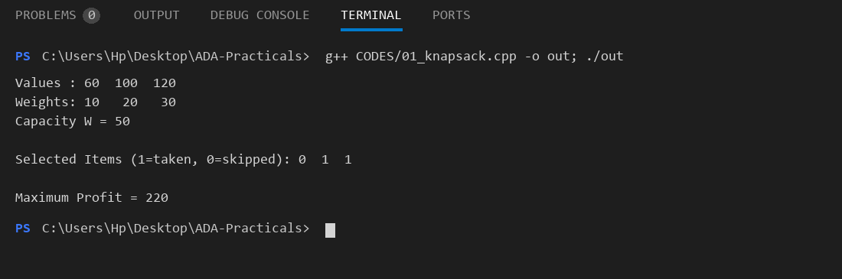

Practical 7: Lcs

Aim:
To find the length and the actual sequence of the Longest Common Subsequence (LCS) of two strings using Dynamic Programming.

Code:
#include <iostream>
#include <vector>
#include <string>
#include <algorithm>
using namespace std;
string lcs(string X, string Y) {
int m = X.size(), n = Y.size();
vector<vector<int>> dp(m+1, vector<int>(n+1, 0));
for (int i=1; i<=m; i++)
for (int j=1; j<=n; j++)
if (X[i-1]==Y[j-1]) dp[i][j] = dp[i-1][j-1]+1;
else dp[i][j] = max(dp[i-1][j], dp[i][j-1]);
// Backtrack to find LCS string
string result = "";
int i=m, j=n;
while (i>0 && j>0) {
if (X[i-1]==Y[j-1]) { result = X[i-1] + result; i--; j--; }
else if (dp[i-1][j] > dp[i][j-1]) i--;
else j--;
}
cout << "LCS Length : " << dp[m][n] << endl;
return result;
}
int main() {
string X = "AGGTAB";
string Y = "GXTXAYB";
cout << "String X : " << X << endl;
cout << "String Y : " << Y << endl;
string seq = lcs(X, Y);
cout << "LCS Sequence : " << seq << endl;
return 0;
}

Output Screenshot:
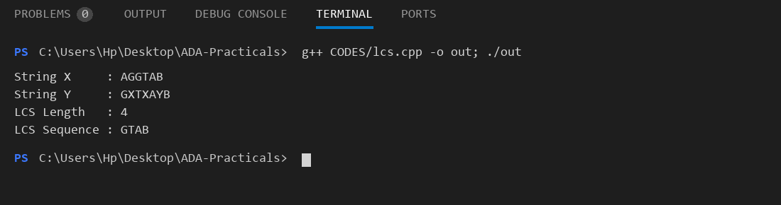

Practical 8: Matrix Chain

Aim:
To find the minimum number of scalar multiplications needed to multiply a chain of matrices using Dynamic Programming and display the optimal parenthesization.

Code:
#include <iostream>
#include <vector>
#include <climits>
using namespace std;
void printParenthesis(vector<vector<int>>& s, int i, int j) {
if (i == j) { cout << "A" << i; return; }
cout << "(";
printParenthesis(s, i, s[i][j]);
printParenthesis(s, s[i][j]+1, j);
cout << ")";
}
int matrixChain(vector<int>& p) {
int n = p.size() - 1;
vector<vector<int>> m(n+1, vector<int>(n+1, 0));
vector<vector<int>> s(n+1, vector<int>(n+1, 0));
for (int len=2; len<=n; len++)
for (int i=1; i<=n-len+1; i++) {
int j = i+len-1;
m[i][j] = INT_MAX;
for (int k=i; k<j; k++) {
int cost = m[i][k]+m[k+1][j]+p[i-1]*p[k]*p[j];
if (cost < m[i][j]) { m[i][j]=cost; s[i][j]=k; }
}
}
cout << "Minimum scalar multiplications: " << m[1][n] << endl;
cout << "Optimal parenthesization : ";
printParenthesis(s, 1, n);
cout << endl;
return m[1][n];
}
int main() {
// Matrix dimensions: A1=30x35, A2=35x15, A3=15x5, A4=5x10
vector<int> p = {30, 35, 15, 5, 10};
cout << "Matrix dimensions p[] = {30, 35, 15, 5, 10}" << endl;
matrixChain(p);
return 0;
}

Output Screenshot:
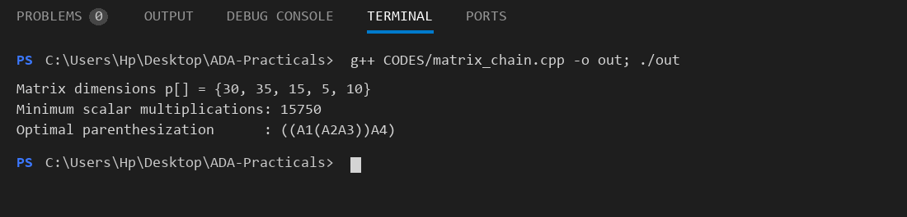

Practical 9: Dijkstra

Aim:
To implement Dijkstra's algorithm to find the shortest path from a source vertex to all other vertices in a weighted graph.

Code:
#include <iostream>
#include <vector>
#include <queue>
#include <climits>
using namespace std;
typedef pair<int,int> pii;
void dijkstra(vector<vector<pii>>& adj, int src, int V) {
vector<int> dist(V, INT_MAX);
priority_queue<pii, vector<pii>, greater<pii>> pq;
dist[src] = 0;
pq.push({0, src});
while (!pq.empty()) {
int u = pq.top().second; pq.pop();
for (auto& edge : adj[u]) {
int w = edge.first;
int v = edge.second;
if (dist[u] + w < dist[v]) {
dist[v] = dist[u] + w;
pq.push({dist[v], v});
}
}
}
cout << "Vertex Distance from Source (" << src << ")" << endl;
cout << string(35, '-') << endl;
for (int i = 0; i < V; i++)
cout << " " << i << " " << dist[i] << endl;
}
int main() {
int V = 5;
vector<vector<pii>> adj(V);
// {weight, vertex}
adj[0].push_back({10, 1}); adj[0].push_back({3, 4});
adj[1].push_back({2, 2}); adj[1].push_back({4, 4});
adj[2].push_back({9, 3});
adj[3].push_back({7, 2});
adj[4].push_back({8, 1}); adj[4].push_back({2, 2});
adj[4].push_back({5, 3});
dijkstra(adj, 0, V);
return 0;
}

Output Screenshot:
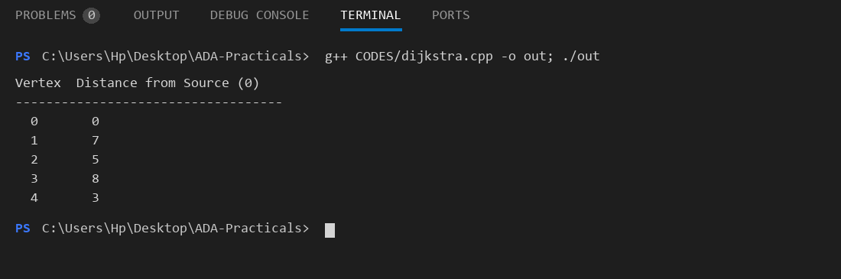

Practical 10: Bellman Ford

Aim:
To implement the Bellman-Ford algorithm to find shortest paths from a source and detect negative weight cycles.

Code:
#include <iostream>
#include <vector>
#include <climits>
#include <string>
using namespace std;
struct Edge { int u, v, w; };
void bellmanFord(int V, int E, vector<Edge>& edges, int src) {
vector<int> dist(V, INT_MAX);
dist[src] = 0;
// Relax all edges V-1 times
for (int i = 1; i <= V-1; i++)
for (auto& e : edges)
if (dist[e.u] != INT_MAX && dist[e.u]+e.w < dist[e.v])
dist[e.v] = dist[e.u] + e.w;
// Check for negative weight cycle
for (auto& e : edges)
if (dist[e.u] != INT_MAX && dist[e.u]+e.w < dist[e.v]) {
cout << "Negative weight cycle detected!" << endl;
return;
}
cout << "Vertex Distance from Source (" << src << ")" << endl;
cout << string(35, '-') << endl;
for (int i = 0; i < V; i++)
cout << " " << i << " "
<< (dist[i]==INT_MAX ? "INF" : to_string(dist[i])) << endl;
}
int main() {
int V=5, E=8;
vector<Edge> edges = {
{0,1,-1},{0,2,4},{1,2,3},{1,3,2},{1,4,2},
{3,2,5},{3,1,1},{4,3,-3}
};
bellmanFord(V, E, edges, 0);
return 0;
}

Output Screenshot:
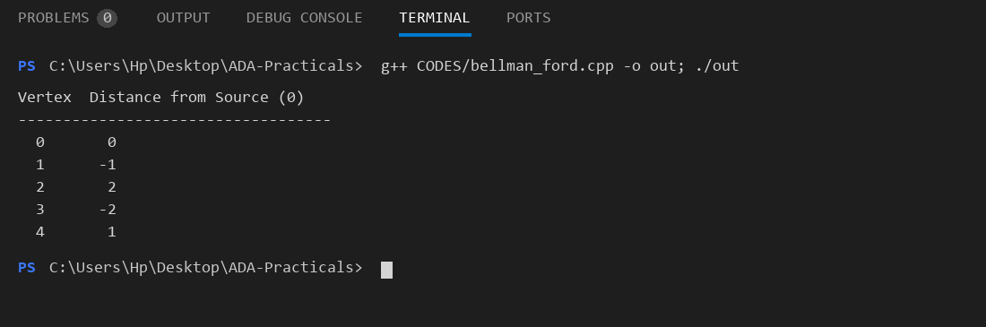

Practical 11: Bfs Dfs

Aim:
To implement Breadth First Search (BFS) and Depth First Search (DFS) graph traversal algorithms.

Code:
#include <iostream>
#include <vector>
#include <queue>
using namespace std;
class Graph {
int V;
vector<vector<int>> adj;
public:
Graph(int v) : V(v), adj(v) {}
void addEdge(int u, int v) { adj[u].push_back(v); adj[v].push_back(u); }
void BFS(int start) {
vector<bool> visited(V, false);
queue<int> q;
visited[start] = true;
q.push(start);
cout << "BFS: ";
while (!q.empty()) {
int u = q.front(); q.pop();
cout << u << " ";
for (int v : adj[u])
if (!visited[v]) { visited[v]=true; q.push(v); }
}
cout << endl;
}
void DFSUtil(int u, vector<bool>& visited) {
visited[u] = true;
cout << u << " ";
for (int v : adj[u])
if (!visited[v]) DFSUtil(v, visited);
}
void DFS(int start) {
vector<bool> visited(V, false);
cout << "DFS: ";
DFSUtil(start, visited);
cout << endl;
}
};
int main() {
Graph g(6);
g.addEdge(0,1); g.addEdge(0,2);
g.addEdge(1,3); g.addEdge(1,4);
g.addEdge(2,5);
g.BFS(0);
g.DFS(0);
return 0;
}

Output Screenshot:
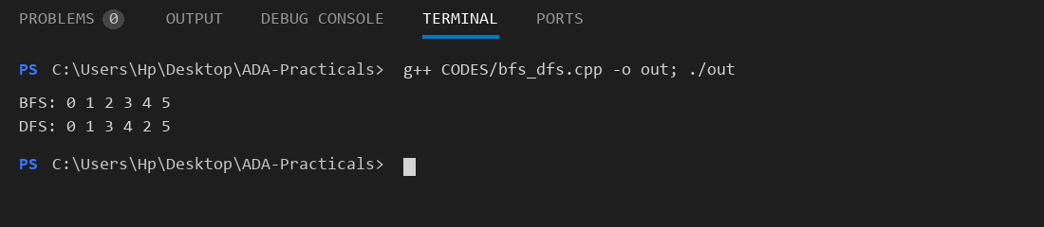

Practical 12: N Queen

Aim:
To solve the N-Queen problem using backtracking – placing N queens on an N×N chessboard such that no two queens attack each other.

Code:
#include <iostream>
#include <vector>
#include <cmath>
using namespace std;
bool isSafe(vector<int>& board, int row, int col, int N) {
for (int i = 0; i < row; i++) {
if (board[i] == col) return false;
if (abs(board[i]-col) == abs(i-row)) return false;
}
return true;
}
void solveNQ(vector<int>& board, int row, int N, int& count) {
if (row == N) {
count++;
if (count == 1) { // Print first solution
cout << "Solution " << count << ": ";
for (int c : board) cout << c+1 << " ";
cout << endl;
cout << "\nBoard:\n";
for (int i = 0; i < N; i++) {
for (int j = 0; j < N; j++)
cout << (board[i]==j ? "Q " : ". ");
cout << endl;
}
}
return;
}
for (int col = 0; col < N; col++)
if (isSafe(board, row, col, N)) {
board[row] = col;
solveNQ(board, row+1, N, count);
}
}
int main() {
int N = 4;
vector<int> board(N, -1);
int count = 0;
cout << "N = " << N << endl;
solveNQ(board, 0, N, count);
cout << "\nTotal solutions for " << N << "-Queens: " << count << endl;
return 0;
}

Output Screenshot:
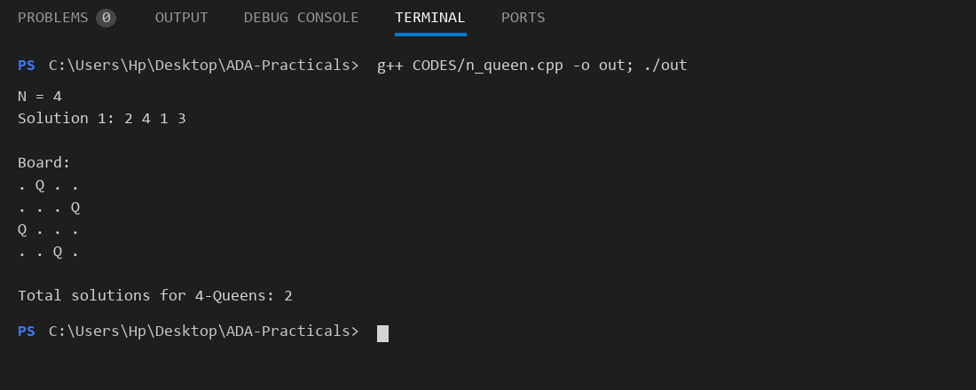

Practical 13: Sum Of Subsets

Aim:
To find all subsets of a given set whose elements sum to a target value using backtracking.

Code:
#include <iostream>
#include <vector>
using namespace std;
void subsetSum(vector<int>& arr, vector<int>& subset,
int index, int target, int current) {
if (current == target) {
cout << "{ ";
for (int x : subset) cout << x << " ";
cout << "}" << endl;
return;
}
for (int i = index; i < (int)arr.size(); i++) {
if (current + arr[i] <= target) {
subset.push_back(arr[i]);
subsetSum(arr, subset, i+1, target, current+arr[i]);
subset.pop_back();
}
}
}
int main() {
vector<int> arr = {1, 2, 3, 4, 5};
int target = 6;
cout << "Set : { 1 2 3 4 5 }" << endl;
cout << "Target : " << target << endl;
cout << "Subsets with sum = " << target << ":" << endl;
vector<int> subset;
subsetSum(arr, subset, 0, target, 0);
return 0;
}

Output Screenshot:
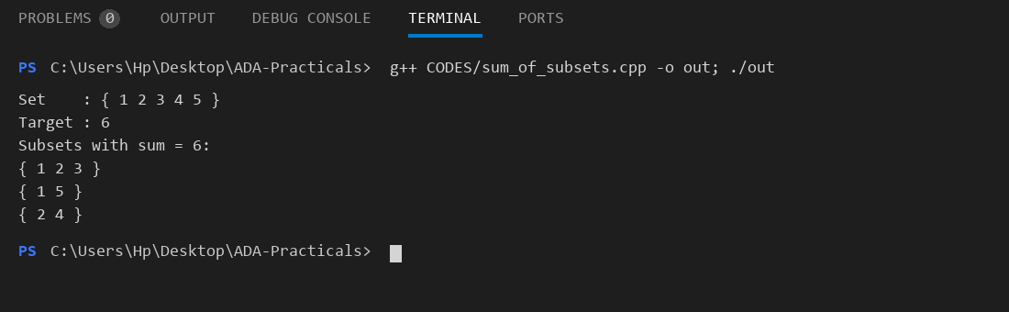

Practical 14: Naive String Match

Aim:
To implement the Naive String Matching algorithm to find all occurrences of a pattern in a text and analyze its time complexity.

Code:
#include <iostream>
#include <string>
using namespace std;
void naiveSearch(string text, string pattern) {
int n = text.size();
int m = pattern.size();
int found = 0;
cout << "Text : " << text << endl;
cout << "Pattern : " << pattern << endl;
cout << "\nPattern found at positions: ";
for (int i = 0; i <= n - m; i++) {
int j;
for (j = 0; j < m; j++)
if (text[i+j] != pattern[j]) break;
if (j == m) { cout << i << " "; found++; }
}
if (found == 0) cout << "(none)";
cout << endl;
cout << "Total occurrences: " << found << endl;
}
int main() {
string text = "AABAACAADAABAABA";
string pattern = "AABA";
naiveSearch(text, pattern);
return 0;
}

Output Screenshot:
