**Objective Questions:**

1. **What is the total no. of tables present in the data?**

The data consists of two tables: raw data and country description. Additionally, multiple pivot tables have been created to address objective, subjective, and dashboard-specific requirements.

1. **What is the total no. of attributes present in the data?**

The dataset comprises 20 attributes (columns), with 8 additional columns created as per the requirement, including country names, year, month, price in INR, and others.

1. **How many categorical columns are there in the data? [Search about categorical and continuous data, and try to answer this question]**

There are 13 categorical columns in the data:

Country

Country Code

RestaurantName

Locality

City

Currency

Currency Symbol

Has table delivery

Has online delivery

Is delivering now

Switch to order menu

Date key opening

There are 3 Continuous data

Price range

Votes

Rating

1. **The data consists of some inconsistent and missing values so ensure that the data used for further analysis is cleaned**.

* Trimmed whitespace.
* Filled missing longitude and latitude values for cities where they were “0” by matching them with corresponding city entries, as these values remain consistent or close for a given city.
* Corrected the date format using the FIND(), RIGHT(), MID() and extracted the year, month, and quarter using the CHOOSE() functions.
* Created a customized price column in INR using currency conversion.

1. **Using the LookUp functions, fill up the countries in the original data using the country code.**

Used V lookup function to fill country names from country description

=**VLOOKUP(C2, 'country description'!$A$2:$B$16, 2, FALSE)**

1. **Create a table to represent the number of restaurants opened in each country.**

**TOTAL NUMBER OF RESTAURANTS IN EACH COUNTRY**

| *CountryName* | COUNT of RestaurantID |
| --- | --- |
| Australia | 24 |
| Brazil | 60 |
| Canada | 4 |
| India | 8652 |
| Indonesia | 21 |
| New Zealand | 40 |
| Philippines | 22 |
| Qatar | 20 |
| Singapore | 20 |
| South Africa | 60 |
| Sri Lanka | 20 |
| Turkey | 34 |
| United Arab Emirates | 60 |
| United Kingdom | 80 |
| United States of America | 434 |
| **Grand Total** | **9551** |

1. **Also, the management wants to look at the number of restaurants opened each year, so provide them with something here.**

**TOTAL NUMBER OF RESTAURANTS IN EACH YEAR**

| *Year* | COUNT of RestaurantID |
| --- | --- |
| 2010 | 1080 |
| 2011 | 1098 |
| 2012 | 1022 |
| 2013 | 1061 |
| 2014 | 1051 |
| 2015 | 1024 |
| 2016 | 1027 |
| 2017 | 1086 |
| 2018 | 1102 |
| **Grand Total** | **9551** |

1. **What is the total number of restaurants in India in the price range of 4?**

The number of restaurants in India that have price range 4 is 388, as per

COUNTIFS()

**=COUNTIFS('Raw Data'!D:D, "India", 'Raw Data'!Q:Q, 4)**

1. **What is the average number of voters for the restaurants in each country according to the data?**

**Average number of voters for the restaurants in each country.**

| *CountryName* | AVERAGE of Votes |
| --- | --- |
| Australia | 111.4166667 |
| Brazil | 19.61666667 |
| Canada | 103 |
| India | 137.212552 |
| Indonesia | 772.0952381 |
| New Zealand | 243.025 |
| Philippines | 407.4090909 |
| Qatar | 163.8 |
| Singapore | 31.9 |
| South Africa | 315.1666667 |
| Sri Lanka | 146.45 |
| Turkey | 431.4705882 |
| United Arab Emirates | 493.5166667 |
| United Kingdom | 205.4875 |
| United States of America | 428.2211982 |
| **Grand Total** | **156.9097477** |

1. **Calculate the average rating for all the restaurants that have price_range < 4 and provide online delivery. Use only the “IF” function, Logical Operators, and Aggregation functions to solve this problem. [Note: Don’t use Conditional aggregation in this question.]**

The average rating for required conditions is 3.2738, calculated using:

**=AVERAGEIFS('Raw Data'!$T$2:$T$10000, 'Raw Data'!$Q$2:$Q$10000, "<4", 'Raw Data'!$N$2:$N$10000, "Yes")**

1. **Using Conditional formatting highlights the rows of restaurants that are located in the countries or cities that you’ve suggested to the management for opening new restaurants.**

I have used conditional formatting for cells in the country name that is suggested to management.

Custom formula used

**=OR($D2 = "Canada",$D2 = "Philippines",$D2 = "Qatar",$D2 = "Sri Lanka",$D2 = "Singapore")**

1. **Create a new customised price column that consists of the abbreviation/symbol of the currency along with the Average_cost_for_two value. [Use string operations to do this task]**

Using the CONCATENATE() function, we created a customized price column by appending "Rs" to the amount in INR (Indian Rupees) and named it "Customized Price."

**=CONCATENATE("Rs.", $S$2)**

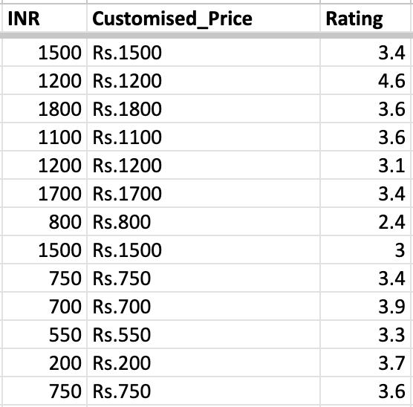

1. **How can you create an array formula in Excel or Google Sheets to count the number of restaurants listed that do not offer online delivery, are in the lowest price range, and have an average cost for two people less than or equal to 250 Indian Rupees?**

The array formula for required conditions is

**=ARRAYFORMULA(SUM(('RawData'!N2:N="No")*('Raw Data'!Q2:Q=1)*('Raw Data'!V2:V<=250)))**

and the **count is 1676**.

**Subjective Questions**

1. **Suggest a few countries where the team can open newer restaurants with lesser competition. Which visualisation/technique will you use here to justify the suggestions?**

**APPROACH :**

From a dataset comprising 15 countries and over 9.5K restaurants, it is crucial to identify the right choices. Since the objective is to open new restaurants, the focus was primarily on locations with low competition, affordability, moderate customer engagement, and reasonable pricing to cater to a broader audience.

To identify countries with lower competition, a pivot table was created from the data, leading to the selection of the most suitable options:

**CANADA**

**QATAR**

**SINGAPORE**

**SRI LANKA**

**PHILIPPINES**

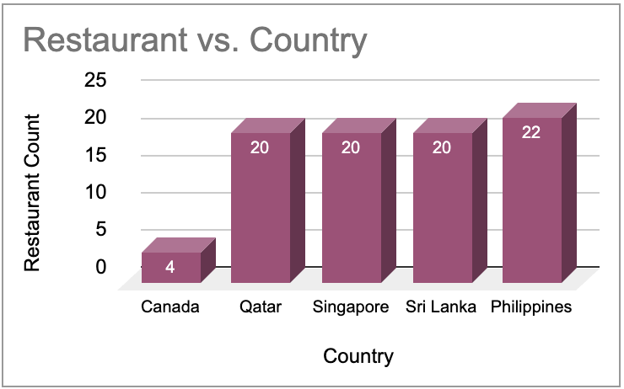

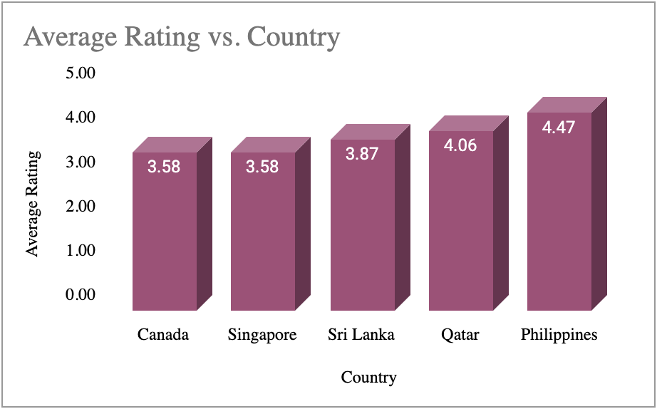

**INSIGHTS :**

Based on low competition, customer engagement, affordability, and balanced pricing, the best countries to open new restaurants are:

**Canada** *(Low competition, affordable, moderate customer engagement, reasonable pricing)***Australia** *(Affordable, balanced pricing, moderate customer engagement, low competition)***Qatar** *(Low competition, high engagement, slightly higher pricing but good market potential)***Sri Lanka** *(Low competition, decent engagement, but slightly higher costs)*

**Philippines** (Moderate competition, high engagement, reasonable cost).

1. **Come up with the names of States and cities in the suggested countries suitable for opening restaurants.**

**APPROACH:**

A pivot table was created for different cities from the selected countries and used as a reference data source.

| *CountryName* | *City* | COUNT of Restaurant | AVERAGE of Rating | SUM of Votes | AVERAGE of Price_range |
| --- | --- | --- | --- | --- | --- |
| Canada | Chatham-Kent | 1 | 3.7 | 176 | 2 |
|  | Consort | 1 | 3.0 | 6 | 2 |
|  | Vineland Station | 1 | 4.3 | 204 | 4 |
|  | Yorkton | 1 | 3.3 | 26 | 2 |
| Philippines | Makati City | 2 | 4.7 | 905 | 3 |
|  | Mandaluyong City | 4 | 4.6 | 1200 | 3.75 |
|  | Pasay City | 3 | 4.4 | 1818 | 4 |
|  | Pasig City | 3 | 4.6 | 2090 | 3 |
|  | Quezon City | 1 | 4.8 | 294 | 3 |
|  | San Juan City | 2 | 4.3 | 681 | 3 |
|  | Santa Rosa | 2 | 3.8 | 101 | 3 |
|  | Tagaytay City | 1 | 4.5 | 211 | 3 |
|  | Taguig City | 4 | 4.5 | 1663 | 3.5 |
| Qatar | Doha | 20 | 4.1 | 3276 | 3.65 |
| Singapore | Singapore | 20 | 3.6 | 638 | 3.65 |
| Sri Lanka | Colombo | 20 | 3.9 | 2929 | 2.85 |

**INSIGHTS :**

* **Canada:** Consort has poor ratings (3.0) and very few votes (6), indicating high dissatisfaction and an opportunity for better dining options along with Yorkton.
* **Philippines:** Cities like Makati, Mandaluyong, and Pasig have high ratings (4.5+) and engagement, while Santa Rosa (3.8) shows potential for improvement.
* **Qatar:** Doha has strong engagement (3276 votes) but a moderate rating (4.1), suggesting room for quality enhancements in premium dining.
* **Singapore:** Despite a decent vote count (638), ratings are low (3.6), indicating a demand for better services in this high-cost market.
* **Sri Lanka:** Colombo has high engagement (2929 votes) but a 3.9 rating, signaling the need for improved offerings within the current price range.

**RECOMMENDATIONS:**

Based upon the insights and pivot data we can highlight following cities to cater

our interests.

| *CountryName* | *City* | AVERAGE of Rating |
| --- | --- | --- |
| Canada | Chatham-Kent | 3.7 |
|  | Consort | 3.0 |
|  | Vineland Station | 4.3 |
|  | Yorkton | 3.3 |
| Philippines | Makati City | 4.7 |
|  | Mandaluyong City | 4.6 |
|  | Pasay City | 4.4 |
|  | Pasig City | 4.6 |
|  | Quezon City | 4.8 |
|  | San Juan City | 4.3 |
|  | Santa Rosa | 3.8 |
|  | Tagaytay City | 4.5 |
|  | Taguig City | 4.5 |
| Qatar | Doha | 4.1 |
| Singapore | Singapore | 3.6 |
| Sri Lanka | Colombo | 3.9 |

The cities highlighted are the appropriate choices for opening new restaurants.

1. **According to the countries you suggested, what is the current quality regarding ratings for restaurants that are open there?**

**APPROACH:**

We made a pivot table for understanding the average of ratings of the recommended countries that will help us for market expansion.

We will further supplement the pivot with a column chart to see the visual look.

| *CountryName* | AVERAGE of Rating |
| --- | --- |
| Canada | 3.58 |
| Singapore | 3.58 |
| Sri Lanka | 3.87 |
| Qatar | 4.06 |
| Philippines | 4.47 |

**INSIGHTS:**

**RECOMMENDATIONS:**

It is clear most countries have average ratings below 4, which justifies the need of options that can better satisfy the customers.

1. **Also, what is the current expenditure on food in the suggested countries, so we can keep our financial expenditure in control?**

**APPROACH :**

As the prices were in different currencies, a new column named **INR (Indian Rupees)** was created to convert all prices into a common denomination for comparison. A pivot table was then generated to analyze averages, followed by a chart for visualization.

### **INSIGHTS:**

* **Singapore** has the highest average spending capacity, while **India and Sri Lanka** have the lowest.
* This helps in setting appropriate cuisine prices based on the purchasing power of each country.

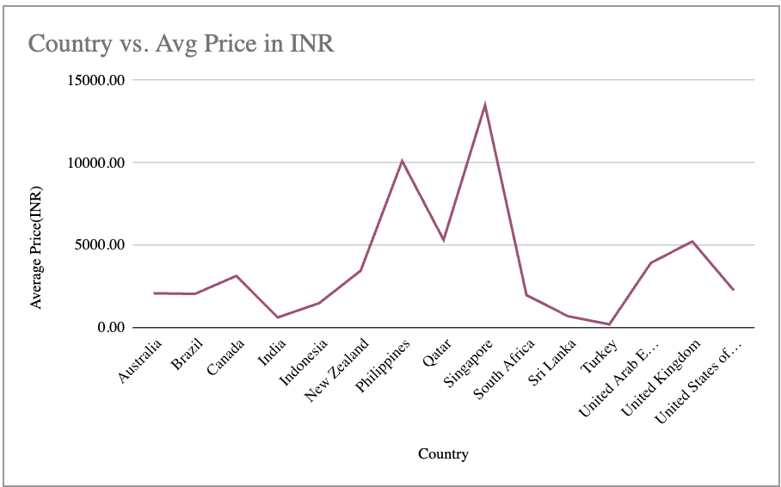

| *Country* | Average Cost(INR) |
| --- | --- |
| Australia | 2086.82 |
| Brazil | 2047.75 |
| Canada | 3141.06 |
| India | 623.37 |
| Indonesia | 1490.31 |
| New Zealand | 3460.30 |
| Philippines | 10106.89 |
| Qatar | 5325.25 |
| Singapore | 13495.74 |
| South Africa | 1976.94 |
| Sri Lanka | 697.06 |
| Turkey | 201.95 |
| United Arab Emirates | 3924.11 |
| United Kingdom | 5232.12 |
| United States of America | 2266.08 |

**RECOMMENDATIONS:**

To enable better comparison, respective currencies were converted to **Indian Rupees (INR)**, and a **stacked column chart** was created to visualize variations across recommended countries in a common currency.

### **INSIGHT:**

This approach aids in optimizing resource allocation and pricing strategies based on market variations.

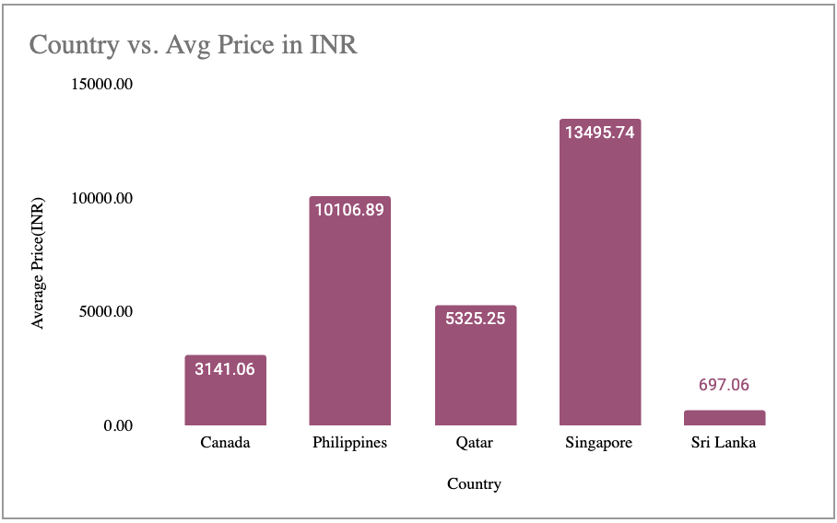

While opening the restaurant, we will ensure that, keeping other factors constant, our pricing aligns with the ranges outlined in the table for the recommended countries.

| *Country* | Average Cost(INR) |
| --- | --- |
| Canada | 3141.06 |
| Philippines | 10106.89 |
| Qatar | 5325.25 |
| Singapore | 13495.74 |
| Sri Lanka | 697.06 |

1. **Come up with the names of restaurants from the recommended states that are our biggest competitors and also those that are rated in the lower brackets, i.e. 1-2 or 2-3.**

### **APPROACH:**

To identify competitors and those in lower brackets, a **pivot table** was created for recommended countries, listing corresponding restaurants and their **average ratings**. The data was then **sorted from high to low** based on ratings.

* **Restaurants highlighted in GREEN** are top-rated and major competitors.
* **Restaurants highlighted in RED** have poor ratings or fall in the lower bracket.

**INSIGHTS:**

We have whole range of Restaurants across Philippines, Canada, Sri Lanka,

Qatar, Singapore having ratings from 1 to 5.

Particularly in Singapore and Sri Lanka we can see highest poorly rated

Restaurant and top rated to, that can help us to identify challenges.

| *Country* | *RestaurantName* | AVERAGE of Rating |
| --- | --- | --- |
| Canada | Consort Restaurant | 3 |
|  | Arigato Sushi | 3.3 |
|  | Tokyo Sushi | 3.7 |
|  | Lake House Restaurant | 4.3 |
| Philippines | Cafe Arabelle | 3.6 |
|  | Buffet 101 | 4 |
|  | Nonna's Pasta & Pizzeria | 4 |
|  | Guevarra's | 4.2 |
|  | Mad Mark's Creamery & Good Eats | 4.2 |
|  | Vikings | 4.2 |
|  | Sodam Korean Restaurant | 4.3 |
|  | Din Tai Fung | 4.4 |
|  | Heat - Edsa Shangri-La | 4.4 |
|  | Wildflour Cafe + Bakery | 4.4 |
|  | Balay Dako | 4.5 |
|  | Hobing Korean Dessert Cafe | 4.5 |
|  | Izakaya Kikufuji | 4.5 |
|  | The Food Hall by Todd English | 4.5 |
|  | NIU by Vikings | 4.7 |
|  | Le Petit Souffle | 4.8 |
|  | Locavore | 4.8 |
|  | Sambo Kojin | 4.8 |
|  | Silantro Fil-Mex | 4.85 |
|  | Ooma | 4.9 |
|  | Spiral - Sofitel Philippine Plaza Manila | 4.9 |
| Qatar | 7st by Mumbai Spices | 3.4 |
|  | Indian Coffee House | 3.4 |
|  | Ponderosa | 3.6 |
|  | Coral - InterContinental Doha | 3.7 |
|  | Aalishan | 3.8 |
|  | Applebee's | 3.8 |
|  | Punjab Restaurant | 3.8 |
|  | Eatopia | 3.9 |
|  | Roti & Boti | 3.9 |
|  | MRA Bakery Sweets & Restaurant | 4 |
|  | Texas Roadhouse | 4 |
|  | The Manhattan FISH MARKET | 4 |
|  | Zaoq | 4.2 |
|  | Gokul Gujarati Restaurant | 4.3 |
|  | Sabai Thai - The Westin Doha Hotel & Spa | 4.3 |
|  | Vine - The St. Regis | 4.4 |
|  | Paper Moon | 4.5 |
|  | Zaffran Dining Experience | 4.6 |
|  | Gymkhana | 4.7 |
|  | Mainland China Restaurant | 4.9 |
| Singapore | Makansutra Gluttons Bay | 3 |
|  | Potato Head Folk | 3.1 |
|  | The Lokal | 3.1 |
|  | Artichoke Cafe | 3.2 |
|  | Boufe Boutique Cafe | 3.2 |
|  | I Am | 3.2 |
|  | Super Loco | 3.2 |
|  | The Refinery Singapore | 3.2 |
|  | Sky On 57 | 3.4 |
|  | Chye Seng Huat Hardware | 3.7 |
|  | Artistry | 3.8 |
|  | Colony | 3.8 |
|  | Jaan | 3.8 |
|  | Restaurant Andre | 3.8 |
|  | Bitters & Love | 3.9 |
|  | Rhubarb Le Restaurant | 3.9 |
|  | Summer Pavilion | 3.9 |
|  | Cut By Wolfgang Puck | 4 |
|  | Fratini La Trattoria | 4.1 |
|  | Al'frank Cookies | 4.2 |
| Sri Lanka | Elite Indian Restaurant | 2.4 |
|  | Queen's Cafe | 2.5 |
|  | Chinese Dragon Cafe | 3.4 |
|  | Malay Restaurant | 3.5 |
|  | The Paddington | 3.6 |
|  | CIOCONAT Lounge | 3.7 |
|  | Cafe Shaze | 3.8 |
|  | T.G.I. Friday's | 4 |
|  | The Commons | 4 |
|  | The Manhattan FISH MARKET | 4 |
|  | Upali's | 4 |
|  | Burger's King | 4.1 |
|  | Cafe Beverly | 4.1 |
|  | Carnival Ice Cream | 4.1 |
|  | Arabian Knights | 4.2 |
|  | Butter Boutique | 4.2 |
|  | Cricket Club Cafe | 4.2 |
|  | The Sizzle | 4.2 |
|  | Simply Strawberries By Jagro | 4.5 |
|  | Ministry of Crab | 4.9 |

1. **Which cuisines should we focus on in the newer restaurants to get better feedback? Does the choice of cuisines affect the restaurant ratings?**

**APPROACH:**

The data clearly shows that cuisine popularity varies across countries, making it essential to identify the right choices for the recommended locations.

To analyze this, a **pivot table** was created between **available cuisines and their average ratings**, providing insights into the most preferred cuisines.

| *Cuisines* | AVERAGE of Rating |
| --- | --- |
| Seafood | 4.9 |
| European, Asian, Indian | 4.9 |
| Filipino, Mexican | 4.9 |
| Japanese, Korean | 4.8 |
| French, Japanese, Desserts | 4.8 |
| Seafood, American, Mediterranean, Japanese | 4.7 |
| Juices, Desserts | 4.5 |
| Japanese | 4.5 |
| Filipino | 4.5 |
| Cafe, Korean, Desserts | 4.5 |
| American, Asian, Italian, Seafood | 4.5 |
| Seafood, Asian, Filipino, Indian | 4.4 |
| Cafe, Bakery, American, Italian | 4.4 |
| Thai | 4.3 |
| Korean | 4.3 |
| Japanese, Sushi | 4.3 |
| Italian, Mediterranean, Pizza | 4.3 |
| Italian | 4.3 |
| Chinese | 4.2 |
| Seafood, Filipino, Asian, European | 4.2 |
| Middle Eastern, Arabian | 4.2 |
| Desserts, Bakery | 4.2 |
| Continental, American, Seafood | 4.2 |
| Bakery | 4.2 |
| American, Ice Cream, Desserts | 4.2 |
| American, Fast Food, Steak, Beverages | 4.2 |
| Indian | 4.2 |
| Fast Food | 4.1 |
| Desserts, Ice Cream | 4.1 |
| Continental, American | 4.1 |
| International | 4.1 |
| Steak, American | 4.0 |
| Sri Lankan | 4.0 |
| Seafood, Italian | 4.0 |
| Seafood, American | 4.0 |
| Pakistani | 4.0 |
| Kerala, Indian, Chinese, Bakery | 4.0 |
| Italian, Pizza | 4.0 |
| Cafe, Sri Lankan, Continental, American | 4.0 |
| Asian, European | 4.0 |
| American, Steak | 4.0 |
| Finger Food | 3.9 |
| European, Arabian, Japanese, Bakery, Desserts | 3.9 |
| Chinese, Seafood, Cantonese, Dim Sum | 3.9 |
| French | 3.9 |
| North Indian, Chinese, Turkish | 3.8 |
| French, Mediterranean, European | 3.8 |
| Cafe, Fast Food, Beverages | 3.8 |
| Asian, Continental, Seafood | 3.8 |
| American, Tex-Mex | 3.8 |
| American, Bakery, European, Burger, Fusion | 3.8 |
| Italian, Cafe, Desserts | 3.7 |
| Cafe | 3.7 |
| Steak | 3.6 |
| Cafe, Italian | 3.6 |
| Cafe, American, Italian, Filipino | 3.6 |
| Malaysian, North Indian, Sri Lankan | 3.5 |
| Indian, Street Food | 3.4 |
| Chinese, Continental, Singaporean | 3.4 |
| Asian | 3.3 |
| Western, Fusion, Fast Food | 3.2 |
| Italian, French, Bakery, Cafe | 3.2 |
| Cafe, Spanish, Turkish, Greek | 3.2 |
| American, Mexican | 3.2 |
| American, Japanese, Singaporean | 3.2 |
| Singaporean, Australian, German | 3.1 |
| American | 3.1 |
| Singaporean, Chinese, Seafood, Malay, Indian | 3.0 |
| Chinese, Canadian | 3.0 |
| American, Chinese, North Indian | 2.5 |
| North Indian, Chinese, Sri Lankan | 2.4 |

**INSIGHTS:**

To streamline analysis, the extensive pivot table was **filtered and shortlisted** to identify **popular cuisines specific to each country**, ensuring a more targeted approach.

**RECOMMENDATIONS:**

Following are the cuisines on bases of average ratings nearly or above 4, that means they are popular and are segregated according to Recommended countries.

| **Country** | **Cuisines suggested** |
| --- | --- |
| **Philippines** | Japanese, Sushi |
|  | European,Asian,Indian |
|  | Filipino,Mexican |
|  | Japanese, Korean |
|  | Desserts,French |
| **Canada** | Italian, Mediterranean, Pizza |
|  | Japanese, Sushi |
| **Qatar** | Chinese |
|  | Italian |
|  | Thai |
|  | Indian |
| **Singapore** | Bakery |
|  | Italian |
|  | American, Steak |
| **Sri Lanka** | Seafood |
|  | Juices, Desserts |
|  | Middle Eastern, Arabian |

**IMPACT**

Selecting **top-rated cuisines** based on analysis is likely to enhance customer feedback and improve overall ratings.

1. **According to our current data, should we go for online delivery and table booking? Does that affect the customer’s ratings?**

**APPROACH:**

A pivot table was created to analyze the availability of online delivery and table booking across countries. To assess customer preference, another pivot table was generated to examine the relationship between online availability, table booking, and average ratings.

| *Online_delivery* | *CountryName* | AVERAGE of Rating | Count of Has_Online_delivery |
| --- | --- | --- | --- |
| No | Australia | 3.658333333 | 24 |
|  | Brazil | 3.846666667 | 60 |
|  | Canada | 3.575 | 4 |
|  | India | 2.572981217 | 6229 |
|  | Indonesia | 4.295238095 | 21 |
|  | New Zealand | 4.2625 | 40 |
|  | Philippines | 4.468181818 | 22 |
|  | Qatar | 4.06 | 20 |
|  | Singapore | 3.575 | 20 |
|  | South Africa | 4.21 | 60 |
|  | Sri Lanka | 3.87 | 20 |
|  | Turkey | 4.3 | 34 |
|  | United Arab Emirates | 4.3375 | 32 |
|  | United Kingdom | 4.1 | 80 |
|  | United States of America | 4.011290323 | 434 |
| No Total |  | 2.754309859 | 7100 |
| Yes | India | 3.278456459 | 2423 |
|  | United Arab Emirates | 4.114285714 | 28 |
| Yes Total |  | 3.288004896 | 2451 |

### **INSIGHT:**

Out of the available restaurants:

* **7,100** do not offer **online delivery**, with an **average rating of 2.75**.
* **2,451** offer **online delivery**, with a **higher average rating of 3.28**.

This suggests that **offering online delivery positively impacts customer satisfaction and ratings**

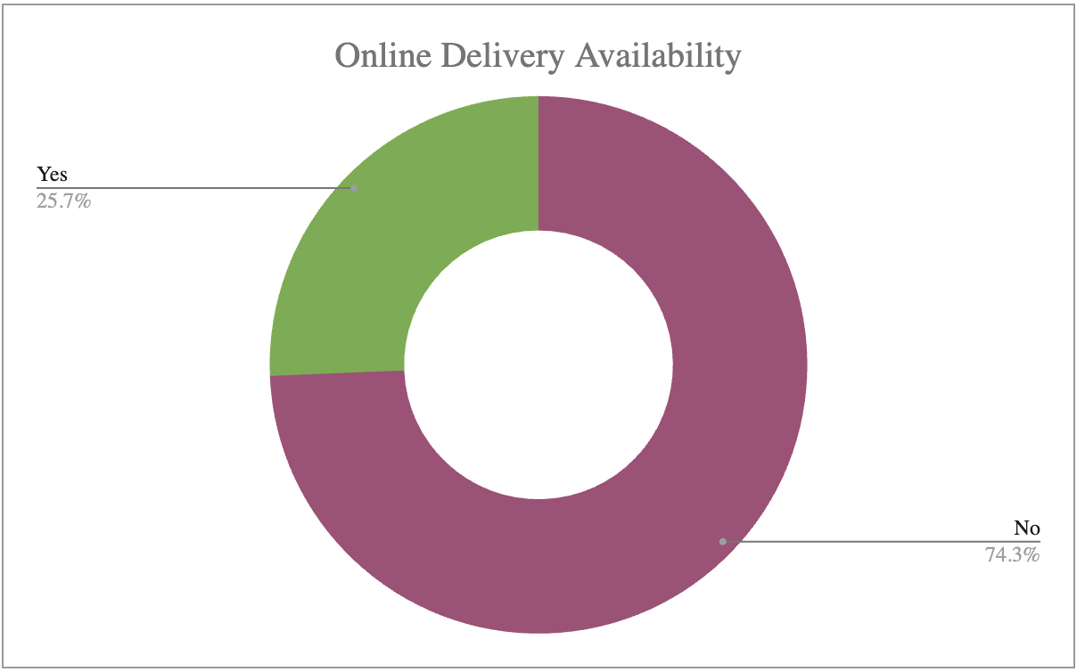

| *Has_Table_booking* | *CountryName* | AVERAGE of Rating | COUNT of Has_Online_delivery |
| --- | --- | --- | --- |
| No | Australia | 3.658333333 | 24 |
|  | Brazil | 3.846666667 | 60 |
|  | Canada | 3.575 | 4 |
|  | India | 2.671582018 | 7541 |
|  | Indonesia | 4.295238095 | 21 |
|  | New Zealand | 4.2625 | 40 |
|  | Philippines | 4.425 | 8 |
|  | Qatar | 4.026315789 | 19 |
|  | Singapore | 3.575 | 20 |
|  | South Africa | 4.213793103 | 58 |
|  | Sri Lanka | 3.87 | 20 |
|  | Turkey | 4.3 | 34 |
|  | United Arab Emirates | 4.128571429 | 42 |
|  | United Kingdom | 4.058823529 | 68 |
|  | United States of America | 4.011290323 | 434 |
| No Total |  | 2.809686644 | 8393 |
| Yes | India | 3.44230423 | 1111 |
|  | Philippines | 4.492857143 | 14 |
|  | Qatar | 4.7 | 1 |
|  | South Africa | 4.1 | 2 |
|  | United Arab Emirates | 4.477777778 | 18 |
|  | United Kingdom | 4.333333333 | 12 |
| Yes Total |  | 3.482556131 | 1158 |

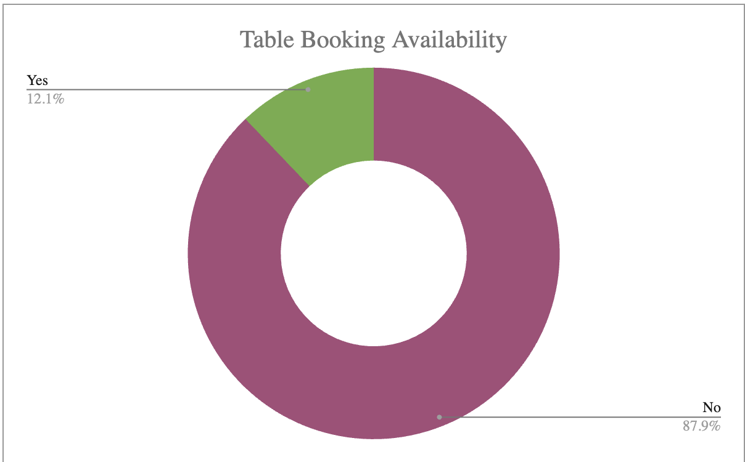

### **INSIGHT:**

* **8,393** restaurants **do not offer table booking**, with an **average rating of 2.81**.
* **1,158** restaurants **offer table booking**, with a **higher average rating of 3.48**.

This indicates that **providing table booking enhances customer satisfaction and leads to better ratings**.

### **RECOMMENDATIONS:**

* There is a **75%+ potential market** for **online delivery and table booking**, indicating a **high growth opportunity** in this sector.
* Restaurants offering **online delivery and table booking** have **higher average ratings**, making it a **strategic and profitable choice** to invest in these services.

| *Has_Online_delivery* | *Has_Table_booking* | COUNT of RestaurantID | AVERAGE of Rating |
| --- | --- | --- | --- |
| No | No | 6377 | 2.68 |
|  | Yes | 723 | 3.41 |
| Yes | No | 2016 | 3.22 |
|  | Yes | 435 | 3.60 |

1. **Should the team keep the rate of cuisines higher? Will that affect the feedback? According to our data are the rates of cuisines and ratings, correlated?**

### **Approach:**

To determine the **appropriate price bracket** for each cuisine without affecting customer feedback, a **table was created** linking **average ratings (sorted in descending order) with their respective price range**.

This analysis helps in **identifying the price range of top-rated cuisines** in the **recommended countries**.

| *Cuisines* | AVERAGE of Rating | AVERAGE of Price_range |
| --- | --- | --- |
| Seafood | 4.9 | 4 |
| European, Asian, Indian | 4.9 | 4 |
| Filipino, Mexican | 4.9 | 3 |
| Japanese, Korean | 4.8 | 4 |
| French, Japanese, Desserts | 4.8 | 3 |
| Seafood, American, Mediterranean, Japanese | 4.7 | 4 |
| Juices, Desserts | 4.5 | 2 |
| Japanese | 4.5 | 3 |
| Filipino | 4.5 | 3 |
| Cafe, Korean, Desserts | 4.5 | 2 |
| American, Asian, Italian, Seafood | 4.5 | 4 |
| Seafood, Asian, Filipino, Indian | 4.4 | 4 |
| Cafe, Bakery, American, Italian | 4.4 | 4 |
| Thai | 4.3 | 4 |
| Korean | 4.3 | 3 |
| Japanese, Sushi | 4.3 | 3 |
| Italian, Mediterranean, Pizza | 4.3 | 4 |
| Italian | 4.3 | 4 |
| Chinese | 4.2 | 3.333333333 |
| Seafood, Filipino, Asian, European | 4.2 | 4 |
| Middle Eastern, Arabian | 4.2 | 3 |
| Desserts, Bakery | 4.2 | 2 |
| Continental, American, Seafood | 4.2 | 3 |
| Bakery | 4.2 | 2 |
| American, Ice Cream, Desserts | 4.2 | 3 |
| American, Fast Food, Steak, Beverages | 4.2 | 3 |
| Indian | 4.2 | 3.4 |
| Fast Food | 4.1 | 2 |
| Desserts, Ice Cream | 4.1 | 2 |
| Continental, American | 4.1 | 3 |
| International | 4.1 | 4 |
| Steak, American | 4.0 | 4 |
| Sri Lankan | 4.0 | 3 |
| Seafood, Italian | 4.0 | 4 |
| Seafood, American | 4.0 | 4 |
| Pakistani | 4.0 | 3.5 |
| Kerala, Indian, Chinese, Bakery | 4.0 | 3 |
| Italian, Pizza | 4.0 | 3 |
| Cafe, Sri Lankan, Continental, American | 4.0 | 3 |
| Asian, European | 4.0 | 4 |
| American, Steak | 4.0 | 4 |
| Finger Food | 3.9 | 3 |
| European, Arabian, Japanese, Bakery, Desserts | 3.9 | 4 |
| Chinese, Seafood, Cantonese, Dim Sum | 3.9 | 4 |
| French | 3.9 | 4 |
| North Indian, Chinese, Turkish | 3.8 | 3 |
| French, Mediterranean, European | 3.8 | 4 |
| Cafe, Fast Food, Beverages | 3.8 | 3 |
| Asian, Continental, Seafood | 3.8 | 4 |
| American, Tex-Mex | 3.8 | 4 |
| American, Bakery, European, Burger, Fusion | 3.8 | 3 |
| Italian, Cafe, Desserts | 3.7 | 3 |
| Cafe | 3.7 | 3 |
| Steak | 3.6 | 3 |
| Cafe, Italian | 3.6 | 3 |
| Cafe, American, Italian, Filipino | 3.6 | 3 |
| Malaysian, North Indian, Sri Lankan | 3.5 | 2 |
| Indian, Street Food | 3.4 | 4 |
| Chinese, Continental, Singaporean | 3.4 | 4 |
| Asian | 3.3 | 2 |
| Western, Fusion, Fast Food | 3.2 | 4 |
| Italian, French, Bakery, Cafe | 3.2 | 3 |
| Cafe, Spanish, Turkish, Greek | 3.2 | 4 |
| American, Mexican | 3.2 | 4 |
| American, Japanese, Singaporean | 3.2 | 4 |
| Singaporean, Australian, German | 3.1 | 4 |
| American | 3.1 | 4 |
| Singaporean, Chinese, Seafood, Malay, Indian | 3.0 | 3 |
| Chinese, Canadian | 3.0 | 2 |
| American, Chinese, North Indian | 2.5 | 3 |
| North Indian, Chinese, Sri Lankan | 2.4 | 2 |

**INSIGHT:**

* Among the **top 10 cuisines by rating**, only **one** falls under **price range 2**, while the rest belong to **higher price brackets**.
* **Price range 4** has the **highest average rating**, indicating that **higher-priced cuisines tend to receive better customer feedback**.

| *Price_range* | AVERAGE of Rating | COUNTA of Cuisines |
| --- | --- | --- |
| 1 | 2.4 | 4444 |
| 2 | 3.1 | 3113 |
| 3 | 3.7 | 1408 |
| 4 | 3.8 | 586 |

### **RECOMMENDATIONS:**

* Price range 3-4 is the most suitable choice, as it has higher average ratings and fewer competing cuisines.
* Focusing on a select number of cuisines in this segment can lead to higher customer satisfaction and better market positioning.

**=CORREL('Raw Data'!S:S, 'Raw Data'!T:T)**

0.05895703261

The correlation coefficient (0.0589) is very close to 0, which suggests that there is no strong relationship between cuisine prices and ratings.

1. **What is the distribution of the number of restaurants of different price ranges in all the countries?**

### **APPROACH:**

A **pivot table** was created to analyze key aspects and extract relevant insights, ensuring a **data-driven approach** to decision-making.

| *COUNTA of RestaurantName* | *Price_range* |  |  |  |
| --- | --- | --- | --- | --- |
| *CountryName* | 1 | 2 | 3 | 4 |
| Canada |  | 3 |  | 1 |
| Qatar |  | 1 | 5 | 14 |
| Singapore |  | 1 | 5 | 14 |
| Sri Lanka |  | 6 | 11 | 3 |
| Indonesia |  | 1 | 20 |  |
| Philippines |  | 1 | 12 | 9 |
| Australia | 4 | 14 | 5 | 1 |
| Turkey |  | 11 | 18 | 5 |
| New Zealand | 3 | 4 | 17 | 16 |
| Brazil | 2 | 7 | 16 | 35 |
| South Africa |  | 4 | 17 | 39 |
| United Arab Emirates |  | 9 | 29 | 22 |
| United Kingdom | 4 | 28 | 32 | 16 |
| United States of America | 136 | 165 | 110 | 23 |
| India | 4295 | 2858 | 1111 | 388 |

**INSIGHTS :**

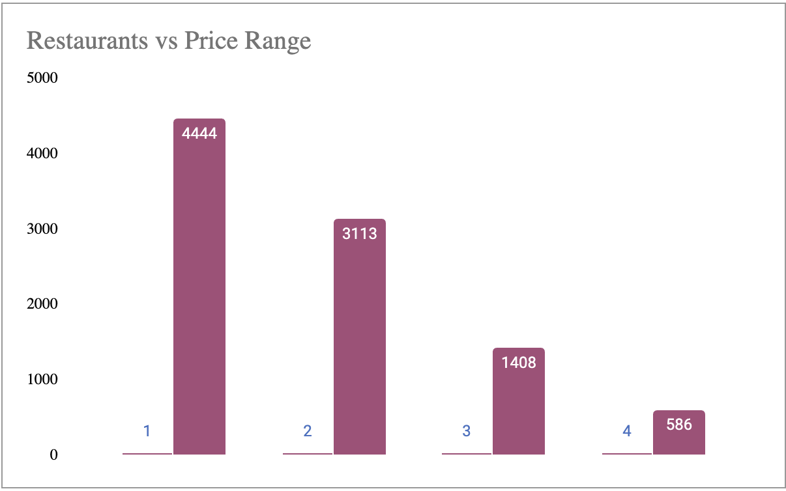

### **PRICE RANGE DISTRIBUTION:**

* Price Range 1 (Lowest) – 4,444 restaurants: Low-cost dining
* Price Range 2 – 3,113 restaurants: Mid-low priced restaurants
* Price Range 3 – 1,408 restaurants: Mid-to-high priced dining
* Price Range 4 (Highest) – 586 restaurants: Premium restaurants

**RECOMMENDATIONS:**

The majority of restaurants fall in the lower price range, which is ideal for conventional and quick service dining. Meanwhile, premium restaurants in higher price ranges focus on providing enhanced experiences beyond just dining.

1. **Explain your approach in brief for suggesting countries/cities in order to open new restaurants, if the objective and subjective questions would have not been given to assist you. [you have to give bullet pointers in order to answer this question]**

**METHODOLOGICAL APPROACH:**

* Understanding the Data: Familiarize with the dataset and key insights.
* Data Cleaning: Identify and handle duplicates, inconsistencies, and missing values using Excel functions and visualization techniques.
* Data Analysis: Determine relevant columns and set aside non-essential ones for future use.
* Pivot Tables & Statistics: Create pivot tables to consolidate data and analyze metrics such as sum of votes, average ratings, and cuisine ratings.
* Identifying Opportunities: Focus on countries with underperforming restaurants that have lower competition and higher growth potential.
* Cuisine Popularity: Analyze the most preferred cuisines by city, locality, and votes to determine regional demand.
* Pricing & Ratings: Examine the relationship between price range and customer ratings to assess what customers are willing to pay for top-rated cuisines.
* Dining Preferences: Evaluate table booking and online ordering preferences to understand customer behavior.
* Strategic Replication: Implement findings in high-demand areas with strong customer engagement and preferred dining choices.
* Visualization & Dashboards: Create necessary charts, interconnected tables with slicers for easy comparisons, and develop a comprehensive dashboard summarizing all insights.