**PROJECT-NAME:MEN’S CLOTHING**

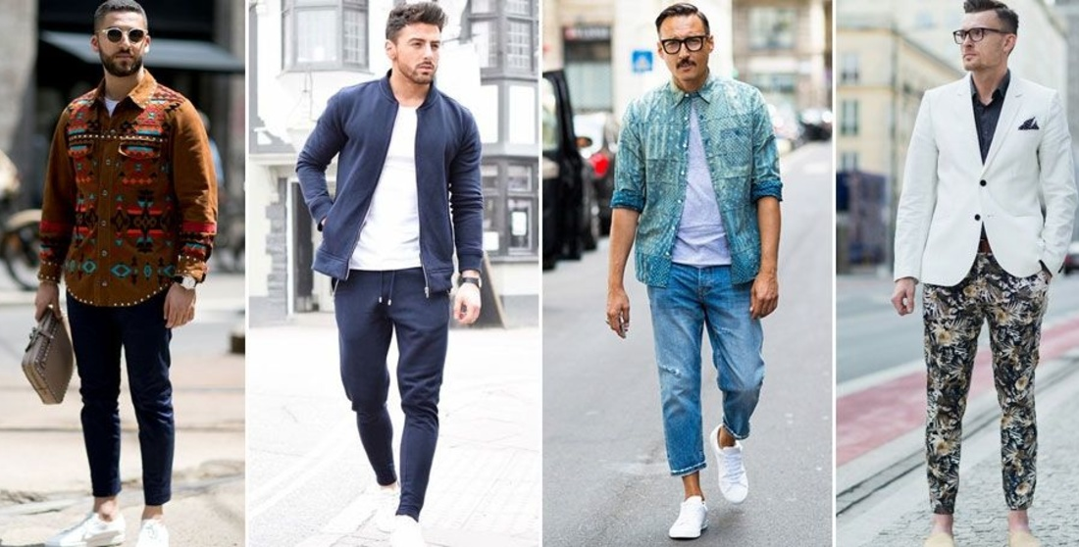

**\*OVERVIEW:** It’s an e-commerce website for men’s Clothing,

from only Men’s related clothes

everything is available under all

brands.

1. **HOME PAGE:**

# LOGO

# ICONS - (WISHLIST, ADD TO CART)

# SEARCH BAR

# SLIDERS WITH ARROWS - (IMAGES)

# FOOTER – ( CONTACT US , HELPLINES , BRIEF DESCRIPTION

ABOUT THE COMPONY,SOCIAL-MEDIA HANDLE ICONS)

1. **REGISTRATION FORM:**

# E-MAIL ADDRESS

# D.O.B

# SHOPPING PREFERENCE

**3. MAIN PAGE:**

# FILTERS - ( BRANDS , COLOR , DISCOUNT RANGE , PRICE

COUNTRY OF ORIGIN , MATERIAL , FEATURES ,

FIT , OCCASION , PATTERN , RATING , SIZE ,

TYPE , SORT BY: )

# IMAGES OF THE CHOSEN PRODUCT WITH DETAILS LIKE -

( BRAND , PRODUCT NAME , PRICE , DISCOUNT% ( IF

ANY ) )

# ON CLICKING THE IMAGE - (MULTIPLE IMAGES OF THE

PRODUCT WILL APPEAR FROM DIFFERENT ANGLES ,

ZOOM IN , ZOOM OUT

# PRODUCT DESCRIPTION - BRAND , PRODUCT NAME ,PRICE , DISCOUNT% (IF ANY) , SIZE CHART , DELIVERY OPTIONS, PRODUCT DETAILS , SIZE & FIT , MATERIAL & CARE , SPECIFICATIONS , RATINGS , CUSTOMER REVIEWS WITH IMAGES(IF ANY)

# LOWER HALF OF THE PAGE - RELATED PRODUCTS

1. **PAYMENT PAGE:**

# ADDRESS SELECTION

# PAYMENT METHOD - (PHONEPE , GOOGLE PAY ,

BHIM UPI , COD , CREDIT/DEBIT CARD ,

NET - BANKING , EMI , PAYTM).

**4.TECHNOLOGIES USES:**

**1.Html**

**2.Css**

**3.Bootstrap**

**4.JavaScript**

**5.Node.js**

**6.React**

**7.Express Js**

**8.MongoDb**