IBM SKILLSBUILD
Data Analytics & AI Internship 2026

AI-Powered E-Commerce Customer
Churn Analytics & Retention
Decision Support System
Predicting 90-Day Customer Inactivity Risk Using Transactional Analytics and Machine Learning
DATASET  UCI Online Retail | ELIGIBLE CUSTOMERS  1,765 | PRIMARY MODEL  Logistic Regression | SNAPSHOT  31 Aug 2011

Prepared by Tanmay Chawhan
24 September 2026
Project framing
This report documents the implemented analytics, machine-learning methodology, validation results, and Streamlit decision-support dashboard. The project uses a fixed 31-Aug-2011 snapshot and a 90-day future-inactivity target window.

1. Executive Summary
This project develops an end-to-end e-commerce customer churn analytics and retention decision-support system using the UCI Online Retail dataset. The workflow combines data-quality auditing, transaction cleaning, customer eligibility rules, RFM analysis, customer-level behavioral feature engineering, a project-defined 90-day future-inactivity target, Logistic Regression, risk segmentation, and a Streamlit dashboard.
The source workbook contains 541,909 transaction rows spanning 1 December 2010 through 9 December 2011. After validation, exact duplicate removal, cancellation identification, missing-customer handling, and the qualifying-purchase filter, 392,692 transactions were retained for customer analytics. Applying the snapshot-period eligibility rule produced 1,765 eligible customers.
For those customers, the project defines Churn_90D from future behavior after the 31-Aug-2011 snapshot. During 1 September 2011 through 29 November 2011, 490 eligible customers made no qualifying purchase and were assigned Churn_90D = 1, while 1,275 made at least one qualifying purchase and were assigned Churn_90D = 0. The observed future-inactivity rate is therefore 27.76%.
The primary predictive model is a leakage-safe Logistic Regression pipeline with StandardScaler and balanced class weights. On the held-out 20% test set (353 customers), the model achieved Accuracy 0.5864, Precision 0.3723, Recall 0.7143, F1 0.4895, ROC-AUC 0.7063, and PR-AUC 0.4686. Operational risk scoring is then applied across all 1,765 eligible customers using continuous predicted inactivity probabilities, producing 706 Low Risk, 706 Medium Risk, and 353 High Risk customers.
Key methodological distinction
Model-performance metrics are calculated only on the held-out 353-customer test set. The dashboard's probabilities and risk tiers are operational scores applied to the full 1,765-customer eligible population; they are not presented as held-out predictions.

1.1 Project at a Glance
Measure | Verified result
Raw transaction rows | 541,909
Rows after exact deduplication | 536,641
Qualifying transaction rows | 392,692
Eligible customers | 1,765
Observed future-inactive customers | 490 (27.76%)
Observed future-active customers | 1,275 (72.24%)
Held-out test size | 353
ROC-AUC | 0.7063
PR-AUC | 0.4686
Operational High Risk customers | 353 (20.0%)

2. Introduction and Problem Statement

2.1 Business Context
Customer retention is a recurring analytical problem in online retail because customer behavior changes over time and transaction histories contain signals about purchase recency, frequency, and value. This project turns historical transactions into customer-level evidence that can support structured retention prioritization.

2.2 Problem Statement
The core analytical problem is to identify eligible customers whose historical behavior is associated with a higher likelihood of future inactivity, quantify that risk with an interpretable machine-learning model, and present the results in a form that can support customer-level and segment-level review.

2.3 Objectives
- Validate and clean the UCI Online Retail transaction data without altering the raw source file.
- Construct a snapshot-based customer analytical dataset using only information available on or before 31 August 2011.
- Perform RFM analysis and supporting behavioral analysis.
- Create a project-defined 90-day future-inactivity target.
- Train and evaluate a leakage-safe Logistic Regression classifier.
- Generate continuous customer inactivity probabilities and operational risk tiers.
- Provide retention decision support through a Streamlit dashboard.
- Package the work into reproducible notebooks, tests, README documentation, and project artifacts.

3. Dataset and Source
The project uses the official UCI Machine Learning Repository Online Retail dataset (dataset 352), supplied locally as Online Retail.xlsx. The UCI record describes 541,909 instances covering transactions from 01/12/2010 through 09/12/2011 for a UK-based registered non-store online retailer. The dataset includes transaction identifiers, product identifiers, descriptions, quantities, invoice timestamps, unit prices, customer identifiers, and country information.
Source note
The locally verified workbook used in this project contains eight columns: InvoiceNo, StockCode, Description, Quantity, InvoiceDate, UnitPrice, CustomerID, and Country. The UCI catalog page describes the dataset and provides the official citation/DOI.

3.1 Verified Source Schema
Column | Project use
InvoiceNo | Transaction/invoice identifier; cancellation detection
StockCode | Product identifier; unique-product feature
Description | Product description; missing values normalized for analysis
Quantity | Item quantity; qualifying rule requires > 0
InvoiceDate | Transaction date/time; temporal filtering and features
UnitPrice | Price per unit in GBP; qualifying rule requires > 0
CustomerID | Customer identifier; required for customer-level analysis
Country | Customer country; descriptive and dashboard analysis

4. Data Quality Audit
The raw workbook was validated before any customer-level analysis. The audit reproduced the independently verified source characteristics exactly. This provided a controlled baseline for the cleaning pipeline and prevented later calculations from depending on silently transformed source data.
Audit check | Verified result
Raw transaction rows | 541,909
Raw columns | 8
Missing CustomerID | 135,080
Missing Description | 1,454
Exact duplicate rows | 5,268
Cancellation rows (InvoiceNo starts with C) | 9,288
Negative Quantity rows | 10,624
Zero Quantity rows | 0
Negative UnitPrice rows | 2
Zero UnitPrice rows | 2,515
Unique invoices | 25,900
Unique products | 4,070
Unique customers | 4,372
Countries | 38
Date range | 2010-12-01 to 2011-12-09

4.1 Cleaning Pipeline
- Schema validation and InvoiceDate parsing were performed first.
- Missing Description values (1,454 rows) were normalized to "Unknown" for analysis without making otherwise valid purchases ineligible.
- Exact duplicate rows (5,268) were removed from the analytical transaction dataset.
- Cancellation status was identified explicitly using InvoiceNo values beginning with "C".
- Missing CustomerID, cancellations, non-positive Quantity, and non-positive UnitPrice were excluded from the qualifying purchase dataset.
- Revenue was calculated as Quantity × UnitPrice after numeric validation.

4.2 Row-count Reconciliation
Processing stage | Rows
Raw loaded | 541,909
After deduplication | 536,641
After qualifying-purchase filter | 392,692

The resulting qualified_transactions.csv contains 392,692 rows. Every retained row satisfies the four qualifying conditions and has positive calculated Revenue.

5. Customer Eligibility and Temporal Design

5.1 Observation and Future Windows
Component | Definition
Observation period | 01-Dec-2010 through 31-Aug-2011 inclusive
Snapshot date | 31-Aug-2011
Future label window | 01-Sep-2011 through 29-Nov-2011 inclusive
Churn target | Future inactivity within the 90-day window

All predictor features are constructed from transactions available on or before the snapshot date. The future window is used only to assign the Churn_90D target. The implementation explicitly handles full calendar-day boundaries so all transactions occurring on 31 August and 29 November are included in their intended windows.

5.2 Customer Eligibility Rule
A customer is eligible for churn modeling only if both of the following conditions hold during the observation period: (1) at least two distinct qualifying invoices, and (2) at least 30 days between the first and last qualifying purchase. This reduces the model population to customers with sufficient observable purchase history to support behavioral features.
Applying this rule produced 1,765 eligible customers from the qualifying transaction history available at the 31-Aug-2011 snapshot.

5.3 Churn_90D Target
The UCI dataset does not supply a native churn label. This project therefore defines Churn_90D as a future-inactivity proxy: an eligible customer receives Churn_90D = 1 when there is no qualifying purchase from 1 September through 29 November 2011, and Churn_90D = 0 when at least one qualifying purchase occurs in that window.
Churn_90D | Customers | Share
0 — Future active / retained | 1,275 | 72.24%
1 — Future inactive | 490 | 27.76%

6. Customer Feature Engineering
Customer-level features were calculated from observation-period transactions only. The resulting customer table contains one row per eligible customer. CustomerID was retained as an identifier but was excluded from the predictive feature matrix.
Feature | Definition
Recency | Days from 31-Aug-2011 to the latest qualifying purchase
Frequency | Number of distinct qualifying invoices
Monetary | Sum of qualifying Revenue
AvgOrderValue | Monetary ÷ Frequency
UniqueProducts | Distinct StockCode count
TotalItems | Sum of qualifying Quantity
ActiveMonths | Distinct calendar months with qualifying purchases
TenureDays | Snapshot date − first qualifying purchase date
PurchaseSpanDays | Last qualifying purchase date − first qualifying purchase date
Country | Most frequent observation-period country; tie broken by most recent qualifying purchase

Leakage safeguard
No predictor uses information after 31-Aug-2011. Future transactions are isolated for target generation only. This rule is enforced in the feature-building and churn-label modules and covered by automated leakage tests.

7. RFM Analysis and Customer Segmentation
RFM analysis summarizes customer behavior across Recency, Frequency, and Monetary dimensions. The project uses quintile-based scoring with the direction of Recency reversed so that more recent customers receive higher scores. Frequency and Monetary assign higher scores to larger values.
Component | Scoring direction
R — Recency | Lower days since last purchase = higher score; best quintile = 5
F — Frequency | More distinct invoices = higher score; highest quintile = 5
M — Monetary | Higher spend = higher score; highest quintile = 5
RFM_Score | R + F + M; range 3–15

RFM Score | Segment | Customers
13–15 | Very High Value | 358
10–12 | High Value | 419
7–9 | Medium Value | 486
3–6 | Lower Value | 502

The project keeps descriptive RFM scoring separate from model preprocessing. RFM_Score and RFM_Segment are used for analytics and decision support rather than being treated as arbitrary predictive inputs.

7.1 Frequency Quartile Correction
The frequency distribution is discrete and heavily tied at lower order counts. A direct four-way pd.qcut implementation collapsed two quantile edges and initially produced only three groups. The dashboard implementation was corrected using deterministic ranking followed by four equal-population rank bins, yielding Q1–Q4 with 1,765 customers assigned exactly once.
Frequency quartile | Customers | Observed future inactivity
Q1 | 442 | 43.89%
Q2 | 441 | 37.87%
Q3 | 441 | 22.45%
Q4 | 441 | 6.80%

The quartile analysis is descriptive: Q1 and Q4 are population groups created from ranked frequency values. Because ties are common, raw frequency values can overlap across adjacent quartiles.

8. Exploratory Analysis
The exploratory analysis examined distributions and relationships among customer behavior metrics, including Recency, Frequency, Monetary, RFM scores, and customer-value groupings. The patterns shown in the dashboard are descriptive associations derived from the historical dataset and the project-defined future-inactivity target.
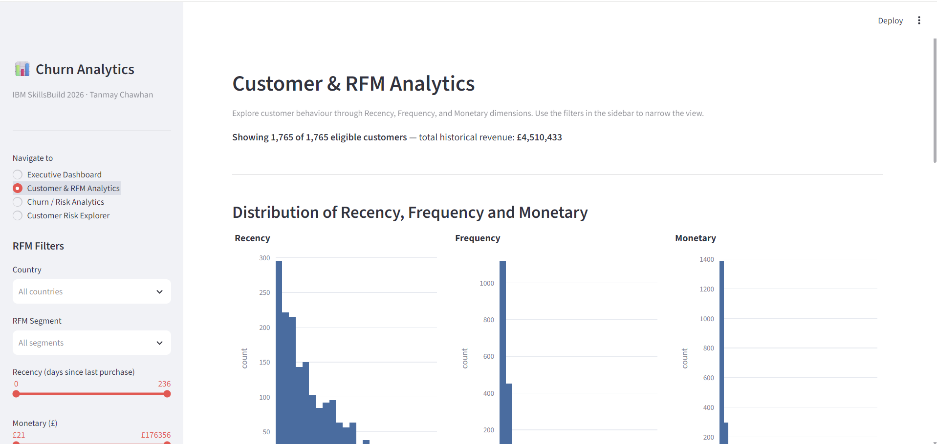
Figure 1. Customer & RFM Analytics dashboard — distributions, RFM scoring, and behavioral relationships.

8.1 Observed Inactivity by Customer Group
Group | Observed inactivity rate
Recency ≤30 days | 18.4%
31–60 days | 24.9%
61–90 days | 32.7%
91–120 days | 39.8%
121–180 days | 46.6%
>180 days | 59.6%

Customer-value quartile | Observed inactivity rate
Bottom 25% | 47.1%
25–50% | 33.1%
50–75% | 21.5%
Top 25% | 9.3%

These group comparisons support the analytical observation that customer inactivity varies systematically across historical recency and value bands. They do not, by themselves, establish causal effects.

9. Machine Learning Methodology

9.1 Predictive Feature Set
- Recency
- Frequency
- Monetary
- AvgOrderValue
- UniqueProducts
- TotalItems
- ActiveMonths
- TenureDays
- PurchaseSpanDays
CustomerID, Churn_90D, R/F/M labels, RFM_Score, and RFM_Segment were excluded from the predictive feature matrix. The primary model used the nine approved numeric behavioral features. No future-derived predictor was included.

9.2 Train/Test Design
The final customer feature table was split at the customer level into 80% training and 20% testing with stratification on Churn_90D and random_state = 42. The split produced 1,412 training customers and 353 test customers while preserving the 27.76% target prevalence in both partitions.

9.3 Logistic Regression Pipeline
The primary model uses a scikit-learn Pipeline containing StandardScaler followed by LogisticRegression(class_weight="balanced", max_iter=1000, random_state=42). The preprocessing is fitted only on the training data and serialized together with the model using Joblib.
Why Logistic Regression
The project prioritizes interpretability, reproducibility, probability output, and a transparent coefficient-based explanation of model associations. The model is used for risk estimation rather than causal inference.

10. Model Evaluation
Evaluation is based exclusively on the held-out 20% test set containing 353 eligible customers. The test set was not used to fit preprocessing or the model.
Metric | Held-out test result
Accuracy | 0.5864
Precision | 0.3723
Recall | 0.7143
F1 | 0.4895
ROC-AUC | 0.7063
PR-AUC | 0.4686

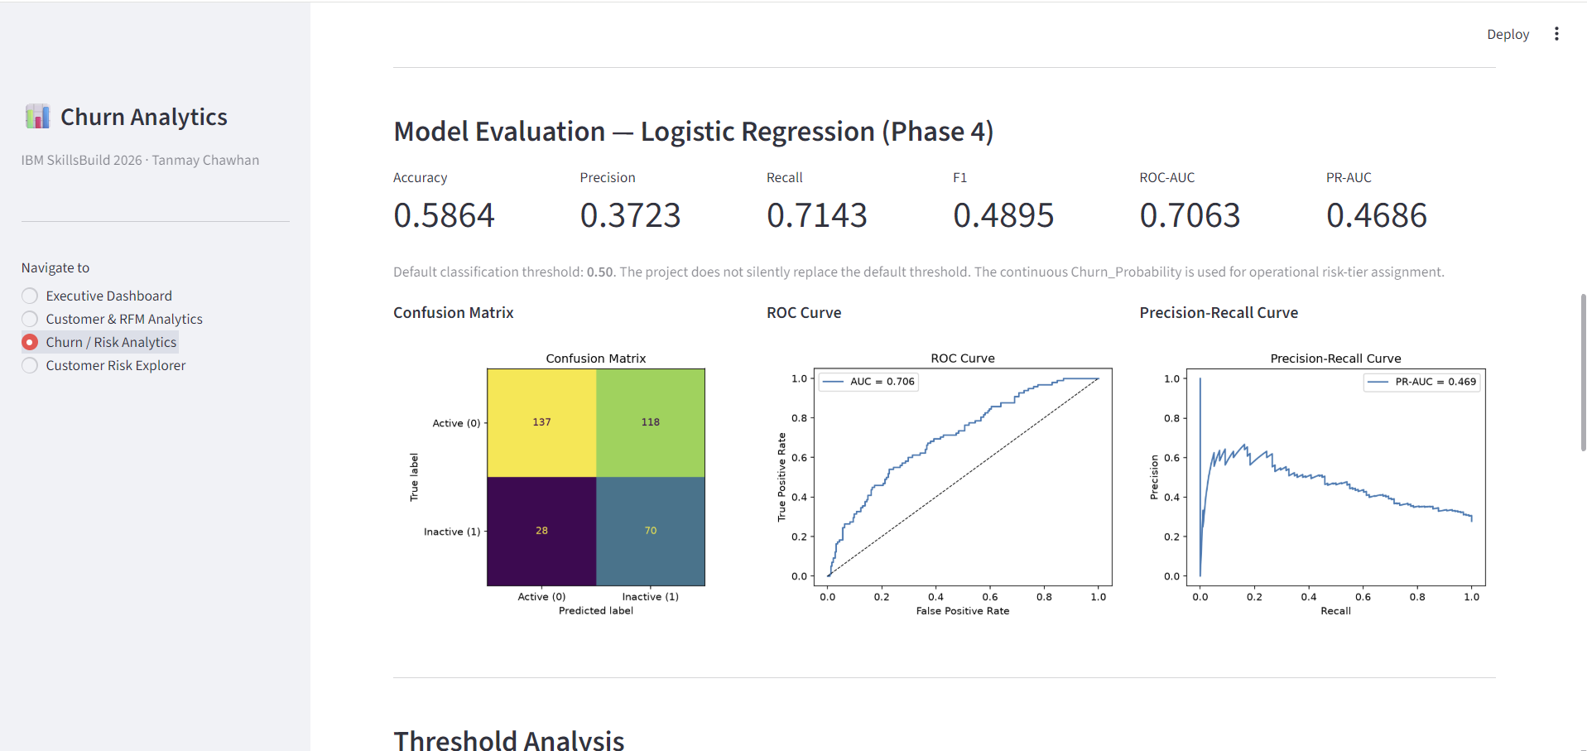
Figure 2. Churn / Risk Analytics dashboard — model metrics, confusion matrix, ROC curve, and precision-recall curve.

10.1 Confusion Matrix
 | Predicted Active (0) | Predicted Inactive (1)
True Active (0) | 137 | 118
True Inactive (1) | 28 | 70

At the default 0.50 threshold, the model identifies 70 of the 98 future-inactive test customers and misses 28. It also classifies 118 future-active customers as inactive. This reflects the trade-off created by balanced class weighting and the chosen threshold.

10.2 Threshold Analysis
Threshold | Precision | Recall | F1
0.20 | 0.3297 | 0.9286 | 0.4866
0.25 | 0.3308 | 0.8878 | 0.4820
0.30 | 0.3386 | 0.8776 | 0.4886
0.35 | 0.3529 | 0.8571 | 0.5000
0.40 | 0.3511 | 0.8061 | 0.4892
0.45 | 0.3623 | 0.7653 | 0.4918
0.50 | 0.3723 | 0.7143 | 0.4895
0.55 | 0.4061 | 0.6837 | 0.5095
0.60 | 0.4385 | 0.5816 | 0.5000

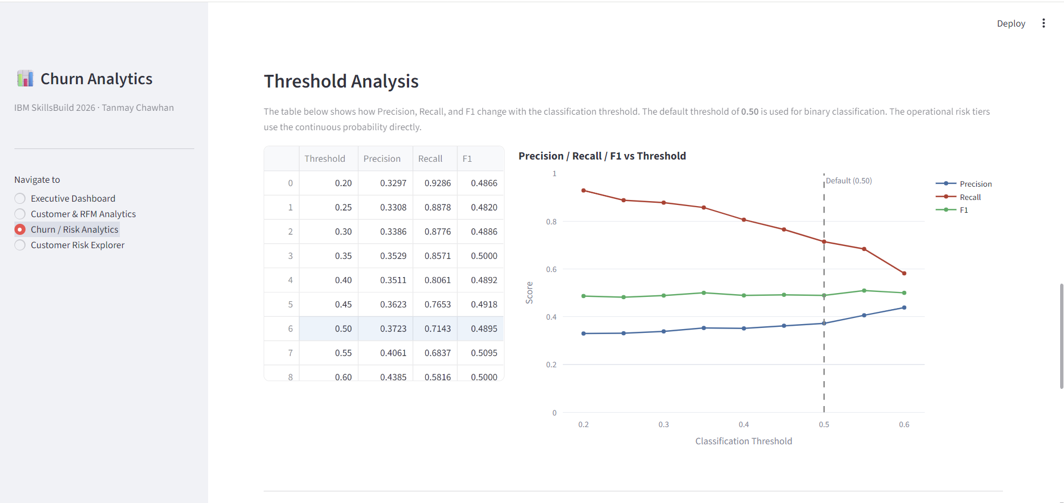
Figure 3. Threshold analysis showing Precision, Recall, and F1 trade-offs across classification thresholds.
The default classification threshold remains 0.50. The dashboard uses the continuous Churn_Probability for operational risk tiers rather than silently replacing the binary threshold with a different cutoff.

11. Model Coefficient Associations
Because the model is standardized Logistic Regression, the coefficient signs and magnitudes can be inspected as associations with predicted inactivity risk. They should not be interpreted as independent causal effects, particularly because customer behavior measures such as Monetary, Frequency, and AvgOrderValue can be correlated.
Feature | Coefficient | Direction in fitted model
Monetary | +0.374 | Associated with higher predicted inactivity risk
Recency | +0.132 | Associated with higher predicted inactivity risk
TenureDays | +0.123 | Associated with higher predicted inactivity risk
ActiveMonths | −0.790 | Associated with lower predicted inactivity risk
Frequency | −0.774 | Associated with lower predicted inactivity risk
TotalItems | −0.769 | Associated with lower predicted inactivity risk
UniqueProducts | −0.410 | Associated with lower predicted inactivity risk

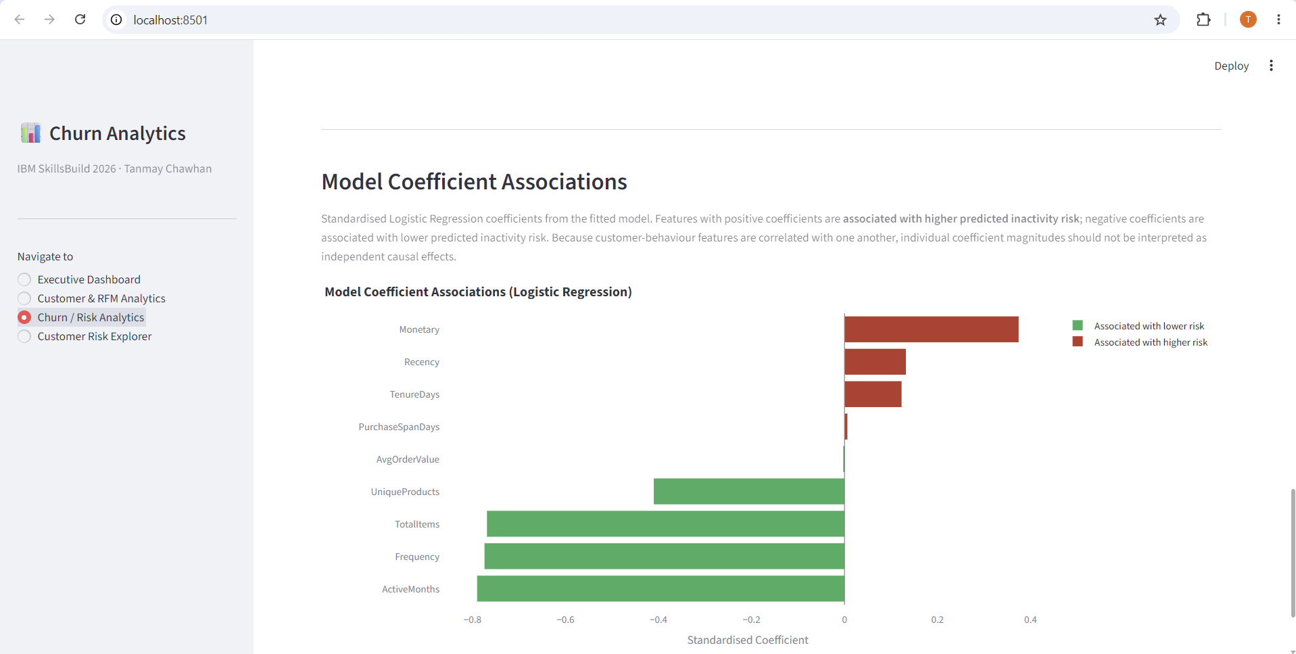
Figure 4. Model coefficient associations shown in the Churn / Risk Analytics dashboard.
The final interpretation emphasizes directional association rather than causality. In particular, the positive Monetary coefficient should be interpreted alongside correlated Frequency, TotalItems, and AvgOrderValue measures rather than as evidence that spending causes inactivity.

12. Customer Risk Segmentation and Retention Decision Support
The dashboard applies the saved model to the full set of 1,765 eligible customers to obtain continuous Churn_Probability values. Risk tiers are then assigned using the approved operational distribution rule: the bottom 40% are Low Risk, the middle 40% are Medium Risk, and the top 20% are High Risk.
Operational tier | Population rule | Customers
Low Risk | Bottom 40% of predicted probability | 706
Medium Risk | 40th–80th percentile | 706
High Risk | Top 20% of predicted probability | 353

Retention Priority combines predicted risk with historical customer-value segments. The matrix is a decision-support mechanism designed to help users interpret which combinations of risk and value warrant different levels of attention; it is not an experimentally validated intervention policy.
Risk × value context | Decision-support label
High Risk + Very High / High Value | Priority retention attention
High Risk + Medium Value | Targeted attention
High Risk + Lower Value | Lower-cost intervention
Medium Risk + High Value | Monitor / targeted engagement
Low Risk + High Value | Relationship / loyalty attention
Low Risk + Lower Value | Standard engagement

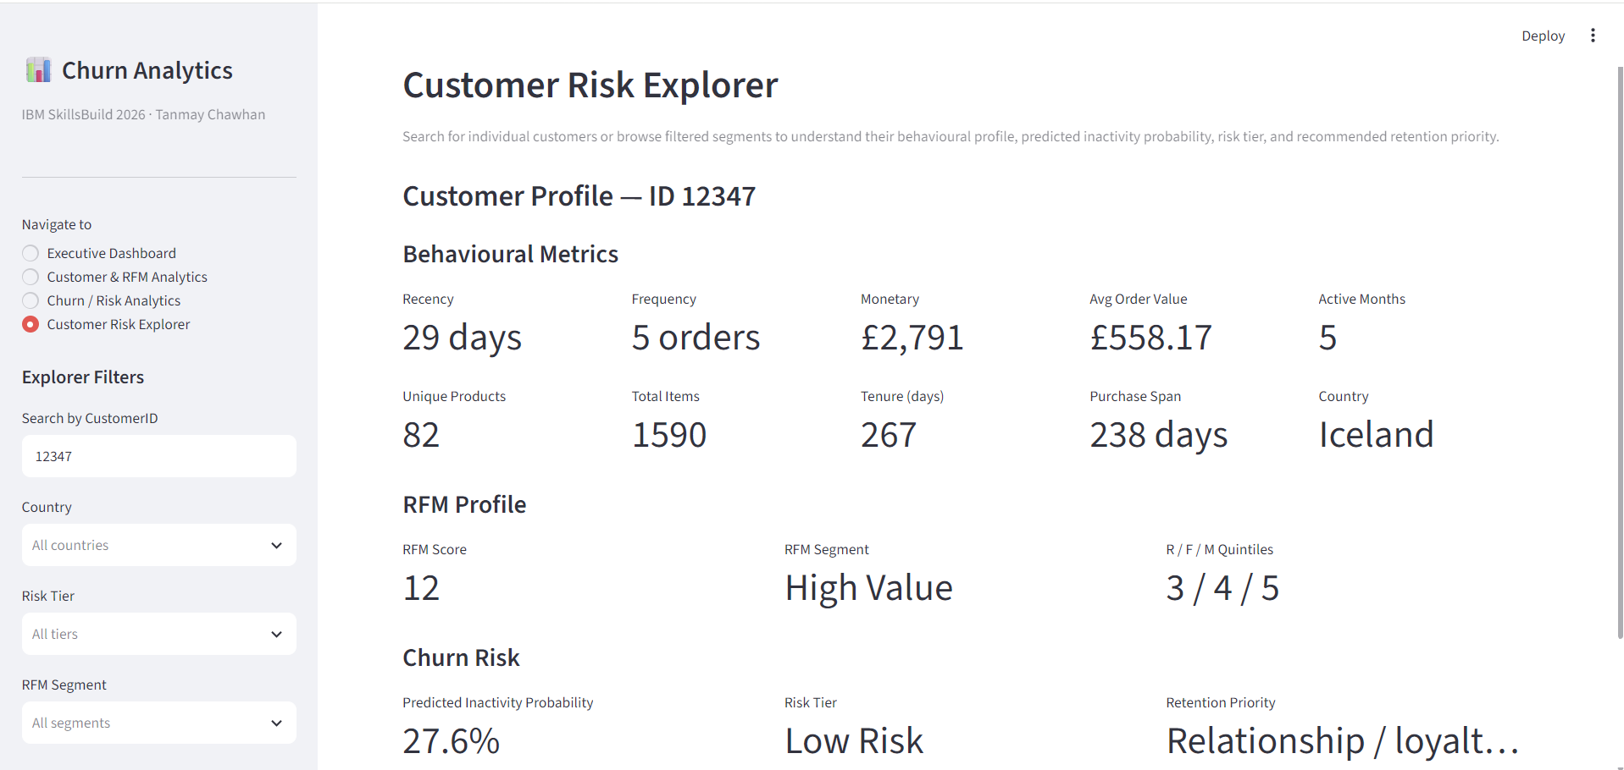
Figure 5. Customer Risk Explorer — individual customer behavioral profile, RFM profile, predicted inactivity probability, and retention priority.
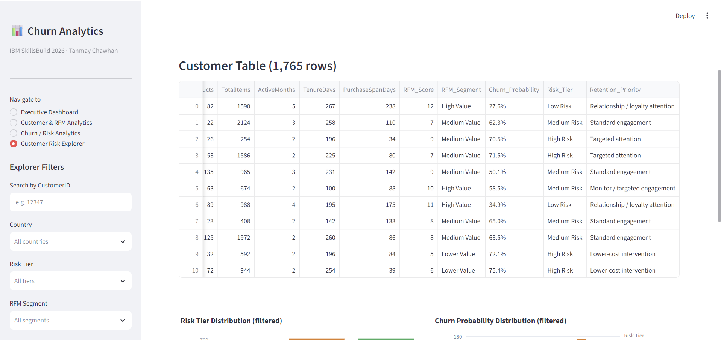
Figure 6. Customer Risk Explorer — customer-level table with RFM score/segment, churn probability, risk tier, and retention priority.

13. Streamlit Dashboard
The final application is implemented as a Streamlit dashboard with four sections: Executive Dashboard, Customer & RFM Analytics, Churn / Risk Analytics, and Customer Risk Explorer. The application loads the processed customer table, saved model pipeline, and saved evaluation outputs without retraining the model during normal use.
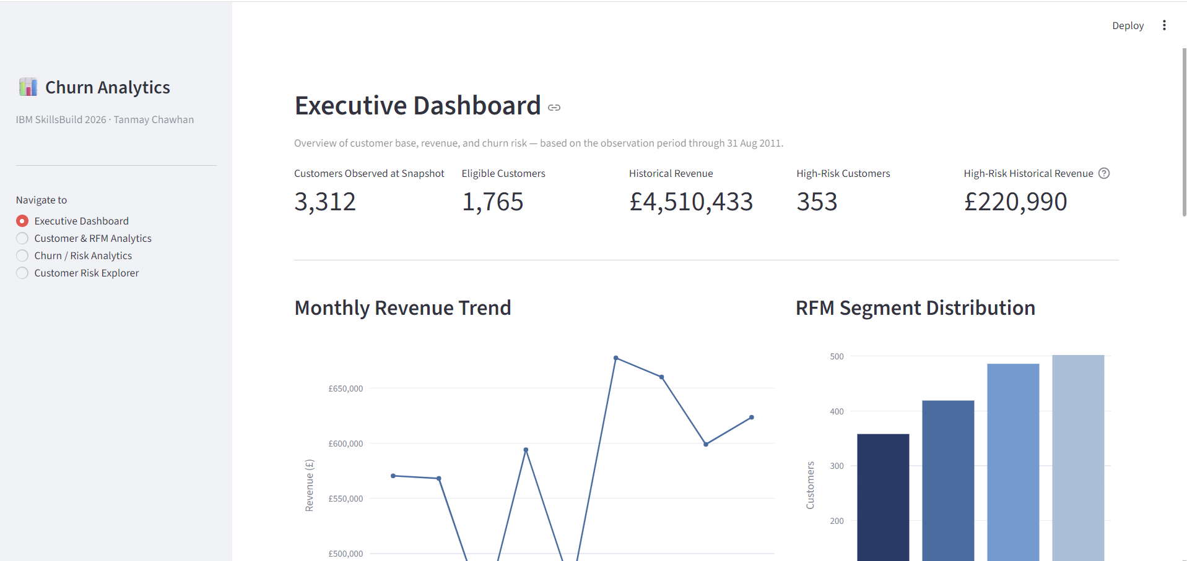
Figure 7. Executive Dashboard — snapshot KPIs, revenue trend, RFM segments, risk tiers, country revenue, and key insights.

13.1 Executive Dashboard
- Customers Observed at Snapshot: 3,312
- Eligible Customers: 1,765
- Historical Revenue: £4,510,433
- High-Risk Customers: 353
- High-Risk Historical Revenue: £220,990
Figure 8. Customer & RFM Analytics — filters, customer-behavior distributions, RFM segmentation, and behavioral scatter plots.

13.2 Dashboard Interaction and Validation
The dashboard was tested using valid and invalid customer lookups. CustomerID 12347 returned one customer profile. A non-existent numeric ID (99999999) and a non-numeric input (abc) returned no match without an application error. Dashboard filtering, risk-tier assignment, model loading, and evaluation-output loading were also exercised during the project validation cycle.
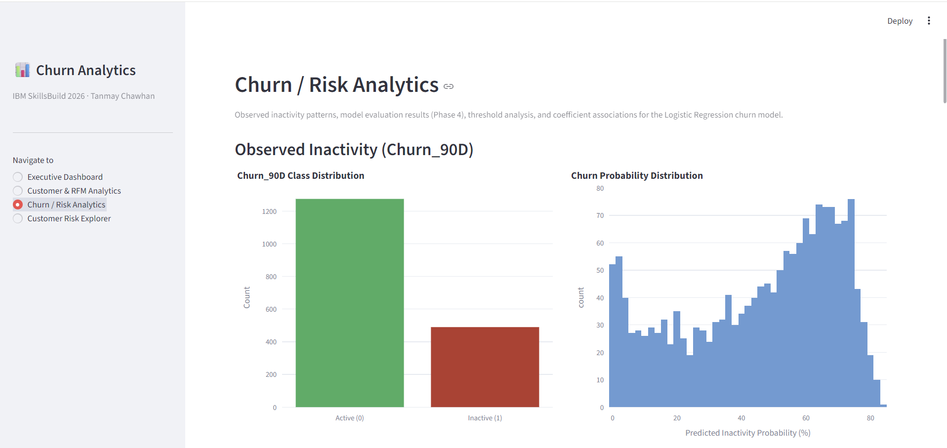
Figure 9. Churn / Risk Analytics — observed inactivity, predicted probability distribution, and group-level inactivity analysis.
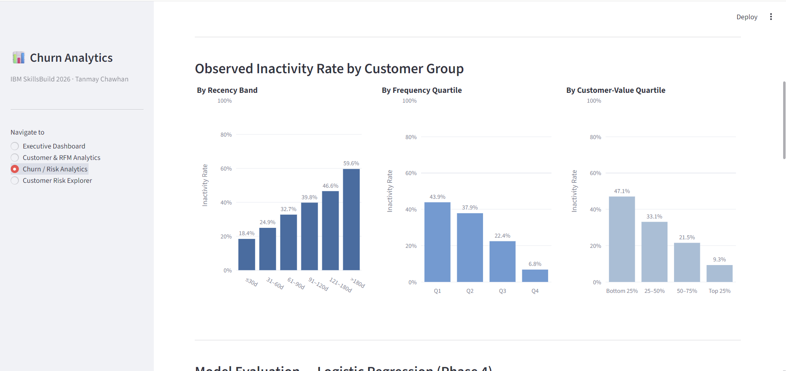
Figure 10. Updated frequency-quartile analysis — four deterministic quartiles with observed inactivity rates.

14. Testing, Reproducibility, and Engineering Validation
The project includes automated tests covering data loading and schema validation, cleaning and eligibility logic, RFM features, Churn_90D generation, leakage guards, model training/evaluation, risk-tier assignment, dashboard helper functions, and customer lookup behavior.
Validation stage | Result
Phase 1 baseline tests | 42 passed
After Phase 2 | 55 passed
After Phase 3 | 73 passed
After Phase 4 | 100 passed
After Phase 5 | 135 passed
After frequency-quartile fix | 140 passed
Final Phase 6 engineering validation | 141 passed

The final project environment was verified with Python 3.13.4, pip 25.1.1, scikit-learn 1.9.1, and the pinned project requirements. The saved Joblib model loads without warnings in the project virtual environment. The raw workbook remained intact throughout the workflow.

14.1 Reproducibility Controls
- Project-relative paths using pathlib and a repository-root configuration.
- Pinned direct dependencies in requirements.txt.
- random_state = 42 for deterministic train/test splitting and deterministic modeling behavior.
- Raw data preserved under data/raw/ and not overwritten by the pipeline.
- Saved model pipeline under models/churn_model.joblib.
- Executed notebooks and automated tests retained as project evidence.
- Git repository published on GitHub on the main branch with verified commits and a clean working tree.

15. Key Findings
- The raw dataset contains substantial missing CustomerID values and duplicate/cancellation/invalid-value records, making explicit cleaning rules necessary before customer analytics.
- Customer eligibility reduces the broad qualifying population to 1,765 customers with at least two distinct invoices and at least 30 days of purchase history by the snapshot date.
- 27.76% of eligible customers had no qualifying purchase in the 90-day future window used to construct Churn_90D.
- Observed future inactivity increases across recency bands, from 18.4% for customers with recency ≤30 days to 59.6% for customers with recency >180 days.
- Observed future inactivity is lower in higher historical customer-value quartiles: 47.1% in the bottom quartile versus 9.3% in the top quartile.
- Observed future inactivity is also lower across higher frequency quartiles, from 43.89% in Q1 to 6.80% in Q4.
- The Logistic Regression model shows non-random discrimination on the held-out test set, with ROC-AUC 0.7063 and PR-AUC 0.4686; these metrics should be interpreted alongside the precision/recall trade-off and target imbalance.
- The most prominent negative model associations are ActiveMonths, Frequency, and TotalItems, while Monetary, Recency, and TenureDays have positive coefficients in the fitted standardized model.

16. Limitations
- Churn_90D is a project-defined future-inactivity proxy rather than a native churn label supplied by the UCI dataset.
- The temporal design uses a fixed 31-Aug-2011 snapshot and 90-day future window; different business horizons could produce different target behavior.
- The data represents one retailer and a specific historical period, so the results should not be assumed to generalize directly to other retailers or time periods.
- The model is observational and predictive; coefficient associations do not establish causal effects.
- Risk tiers are operational distribution-based segments rather than universally calibrated probability categories.
- Retention priority labels provide structured decision support but are not validated by an intervention experiment.
- Accuracy is relatively low at the selected 0.50 threshold, so interpretation should focus on the full metric set and the intended recall-oriented operating context rather than accuracy alone.

17. Future Scope
- Validate the proxy churn target against a real CRM-defined retention outcome when labeled intervention data becomes available.
- Compare additional interpretable models or calibrated classifiers after establishing a stable baseline and monitoring data drift.
- Add model calibration and probability monitoring to improve the operational meaning of predicted risk values.
- Extend the temporal design to rolling snapshots so model stability can be measured over time.
- Connect the retention decision-support layer to intervention outcomes to evaluate uplift rather than relying only on observational risk ranking.
- Add controlled scenario analysis for retention-budget allocation once intervention costs and outcomes are available.

18. Conclusion
The completed project provides a reproducible workflow for transforming e-commerce transaction data into customer-level churn-risk evidence. Starting from 541,909 raw transactions, the pipeline applies explicit quality controls and eligibility rules, constructs snapshot-based behavioral and RFM features, defines future inactivity over a fixed 90-day window, and trains an interpretable Logistic Regression model.
The final system combines analytical segmentation with probability-based risk scoring and a Streamlit interface that supports executive review, RFM exploration, model evaluation, and customer-level inspection. The work is supported by automated tests, validated notebooks, saved model and analytical artifacts, repository documentation, and a clean Git commit.
The project should be interpreted as a decision-support prototype: it identifies observable historical patterns and provides a structured way to prioritize customer review. It does not establish why customers become inactive or guarantee that any particular retention action will change future behavior.

19. References
- UCI Machine Learning Repository. Online Retail. Dataset 352. DOI: 10.24432/C5BW33. Official repository record: https://archive.ics.uci.edu/dataset/352/online+retail
- Chen, D., Sain, S. L., & Guo, K. (2012). Data mining for the online retail industry: A case study of RFM model-based customer segmentation using data mining. Journal of Database Marketing & Customer Strategy Management, 19(3), 197–208. DOI: 10.1057/dbm.2012.17.
- scikit-learn documentation. LogisticRegression, Pipeline, StandardScaler, model evaluation metrics, and model-selection utilities.
- Streamlit documentation. Multipage applications and sidebar navigation configuration.

Appendix A. Final Project Deliverables
Artifact | Location / purpose
Raw dataset | data/raw/Online Retail.xlsx
Qualified transactions | data/processed/qualified_transactions.csv
Customer feature table | data/processed/customer_features.csv
Audit summary | data/processed/data_quality_audit.json
RFM/churn summary | data/processed/rfm_churn_summary.json
Test predictions | data/processed/test_predictions.csv
Saved ML pipeline | models/churn_model.joblib
Model evaluation | reports/model_evaluation.json
Evaluation figures | reports/confusion_matrix.png, roc_curve.png, precision_recall_curve.png
Analysis notebooks | notebooks/01_data_audit.ipynb through 04_churn_model.ipynb
Streamlit app | app/app.py and app/pages/
Automated tests | tests/
README | README.md
Screenshots | assets/screenshots/
Git repository | Initial commit 42b9259; latest verified commit 07fabd1 on main branch

Appendix B. Final Model and Risk Summary
Item | Value
Snapshot | 31-Aug-2011
Future window | 01-Sep-2011 to 29-Nov-2011
Eligible customers | 1,765
Future inactive | 490
Future active | 1,275
Inactivity rate | 27.76%
Train/Test | 1,412 / 353
Accuracy | 0.5864
Precision | 0.3723
Recall | 0.7143
F1 | 0.4895
ROC-AUC | 0.7063
PR-AUC | 0.4686
Risk tiers | 706 Low / 706 Medium / 353 High

