
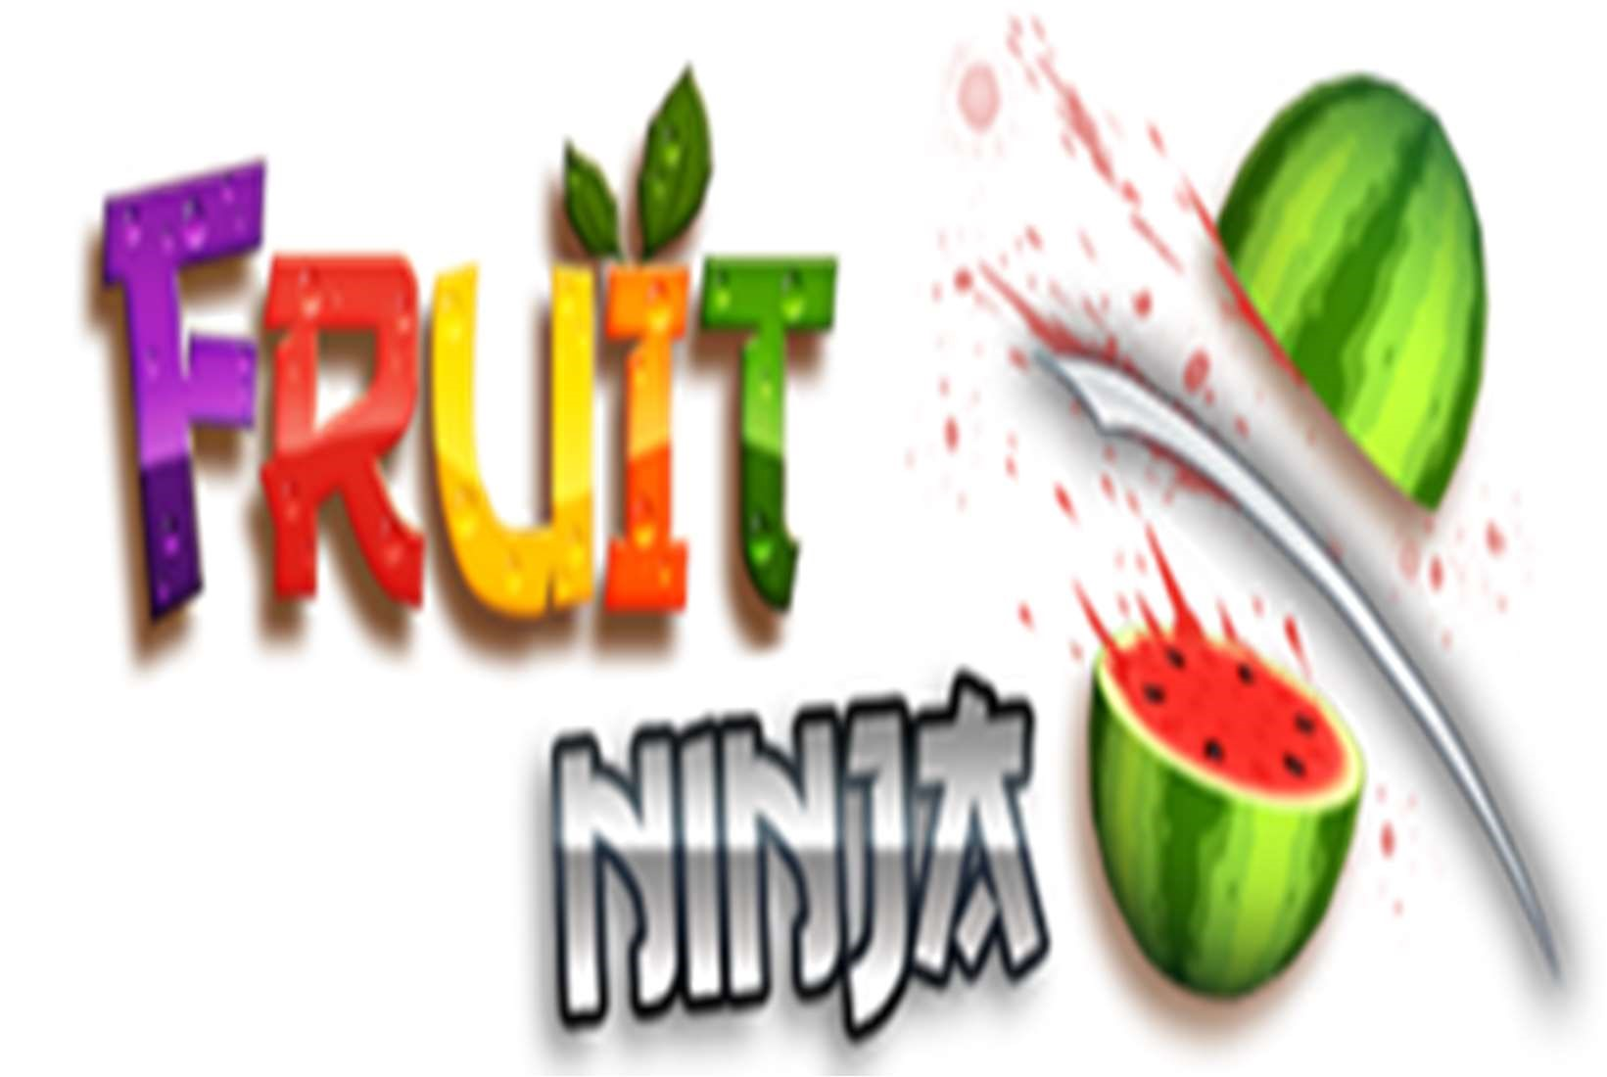

UNIVERSITY OF MUMBAI

PROJECT ENTITLED
“Fruit Ninja”

SUBMITTED BY
Mr. Sumit Rathod
ROLL NO
8953
UNDER GUIDANCE OF
Prof. Agnas Vidya Michael

SUBMITTED FOR THE FULFILLMENT OF THE CURRICULUM OF
DEGREE
OF BACHELOR OF SCIENCE
IN COMPUTER SCIENCE

PILLAI COLLEGE OF ARTS, COMMERCE &
SCIENCE, NEW PANVEL
2023-2024



Certificate

This is to certify that Mr. Sumit Rathod of T.Y B.Sc. C.S.
Semester V has completed the project work in the Subject of Game Programming during the academic year 2022-23 under the guidance of Prof. Agnas Vidya Michael being the partial requirement for the fulfilment of the curriculum of Degree of Bachelor of Science in Computer Science, University of Mumbai.

Place: Date:

Name & Signature of faculty Name & Signature of external

Name & Signature of Co-Ordinator

The Fruit Ninja project is created by Sumit Rathod student of Pillai College of Arts, Commerce & Science would like to express our sincere gratitude towards computer science department.
I would like to thank lecturer Prof. Agnas Vidya Michael and for their constant support during the project. Last but not least we thank all my colleagues for being with me throughout the project, which leads to a successful completion of my project. The project would not have been completed without creativity and energy, which our friends provided.

INDEX

SR.NO TOPIC SIGN

1. | Introduction
2. | FEATURES
3. | CODE OF PROJECT
4.  5. | SPRITES/OUTPUT SCREENSHOT
4.  5. | VIDEO LINK

The game was first released on April 21, 2010, for iPod
Touch and iPhone devices. It was later released as Fruit Ninja HD on July 12, 2010 for the iPad. On September 17, 2010, Fruit Ninja was ported to Android OS devices.
Fruit Ninja is a simple game of slicing fruit. Holding the device sideways, players use their fingers to slice the pieces of fruit that jump into the screen. As the game progresses, more and more fruit come onto the screen, and players can slice multiple fruit at once to score combos. If a piece of fruit falls off the screen without being sliced however, the player earns an “X,” and if this happens three times the game is over. Also, bombs eventually appear on the screen, and if players slice those by accident, they will also earn a game over screen. The goal is to rack up as many points as possible, while more and more fruit and bombs clutter the screen. Due to the lack of inappropriate content and simplistic nature of the game, Fruit Ninja is recommended to players ages 4 and up.

- Scoring System
- Restart

❖ Slicing of Fruits with other Obstacles
❖ Endless Game

CODE OF PROJECT GameManager.cs:
using System.Collections; using System.Collections.Generic; using UnityEngine; using TMPro; using UnityEngine.UI; using UnityEngine.SceneManagement;
public class GameManager : MonoBehaviour
{
int score; int lives; public TextMeshProUGUI scoreText; public TextMeshProUGUI livesText; public TextMeshProUGUI gameOverText; public Button restartButton;
void Start()
{ score = 0; lives = 3;
} public void UpdateTheScore(int scorePointsToAdd)
{
score += scorePointsToAdd;
scoreText.text = score.ToString();
} public void UpdateLives()
{ if(gameIsOver == false)
{ lives--;
livesText.text = "Lives: " + lives;

if (lives == 0) {
GameOver();
}
}

} public void GameOver()
{ gameIsOver = true; gameOverText.gameObject.SetActive(true); restartButton.gameObject.SetActive(true);
} public void RestartTheGame()
{
SceneManager.LoadScene(SceneManager.GetActiveScene().name);
}
}

Blade.cs:
using System.Collections; using System.Collections.Generic; using UnityEngine;
public class Blade : MonoBehaviour
{ private Rigidbody rb; private SphereCollider sc; private TrailRenderer tr; private GameManager gm;

// Variablen zuweisen void Start()
{ rb = GetComponent<Rigidbody>(); sc = GetComponent<SphereCollider>(); tr = GetComponent<TrailRenderer>(); gm = FindObjectOfType<GameManager>();
} void Update()
{ if(gm.gameIsOver == false)
{ if (Input.GetMouseButtonDown(0))
{ tr.enabled = true; sc.enabled = true;
} if (Input.GetMouseButtonUp(0))
{
tr.enabled = false; sc.enabled = false;
}
BladeFollowMouse();
} } private void BladeFollowMouse()
{
Vector3 mousePos = Input.mousePosition; mousePos.z = 8; rb.position = Camera.main.ScreenToWorldPoint(mousePos);
}
}

BombScript.cs:
using System.Collections; using System.Collections.Generic; using UnityEngine;
public class BombScript : MonoBehaviour
{ private float rotationForce = 200; public ParticleSystem explosionParticle;
void Update()
{ transform.Rotate(Vector2.right * Time.deltaTime * rotationForce);
} private void OnTriggerEnter(Collider other)
{ if(other.tag == "Blade") {
Destroy(gameObject);
Instantiate(explosionParticle, transform.position, explosionParticle.transform.rotation);
FindObjectOfType<GameManager>().GameOver();
}
}
}

Fruit.cs:
using System.Collections; using System.Collections.Generic; using UnityEngine;
public class Fruits : MonoBehaviour
{ private GameManager gm; public GameObject slicedFruit; public GameObject fruitJuice; private float rotationForce = 200; private Rigidbody rb; public int scorePoints;
void Start()
{
rb = GetComponent<Rigidbody>(); gm = FindObjectOfType<GameManager>();
} void Update()
{ transform.Rotate(Vector2.right * Time.deltaTime * rotationForce);
} private void InstantiateSlicedFruit()
{

GameObject instantiatedFruit = Instantiate(slicedFruit, transform.position, transform.rotation);
GameObject instantiatedJuice = Instantiate(fruitJuice, new Vector3(transform.position.x, transform.position.y, 0), fruitJuice.transform.rotation);

Rigidbody[] slicedRb = instantiatedFruit.transform.GetComponentsInChildren<Rigidbody>();
foreach(Rigidbody srb in slicedRb)
{
srb.AddExplosionForce(130f, transform.position, 10); srb.velocity = rb.velocity * 1.2f;
}

Destroy(instantiatedFruit, 5);
Destroy(instantiatedJuice, 5);
}

private void OnTriggerEnter(Collider other)
{ if(other.tag == "Blade")
{
gm.UpdateTheScore(scorePoints);
Destroy(gameObject);
InstantiateSlicedFruit();
}
if(other.tag == "BottomTrigger")
{ gm.UpdateLives();
}
}
}

SpawnObjects.cs:
using System.Collections; using System.Collections.Generic; using UnityEngine;
public class SpawnObjects : MonoBehaviour
{ public GameObject[] objects; public float left; public float right;
void Start()
{
StartCoroutine(SpawnRandomObject());
} private IEnumerator SpawnRandomObject()
{ yield return new WaitForSeconds(1);
while (FindObjectOfType<GameManager>().gameIsOver == false) {
InstantiateRandomObject(); yield return new WaitForSeconds(RandomRepeatrate()); }
} private void InstantiateRandomObject()
{ int objectIndex = Random.Range(0, objects.Length);
GameObject obj = Instantiate(objects[objectIndex], transform.position, objects[objectIndex].transform.rotation);

obj.GetComponent<Rigidbody>().AddForce(RandomVector() * RandomForce(), ForceMode.Impulse);
obj.transform.rotation = Random.rotation;
}
private float RandomForce()
{
float force = Random.Range(14f, 16f); return force;
}
private float RandomRepeatrate()

{ float repeatrate = Random.Range(0.5f, 3f); return repeatrate;
}
private Vector2 RandomVector()
{
Vector2 moveDirection = new Vector2(Random.Range(left, right),
1).normalized; return moveDirection;
}
}

Sprites:
Bomb
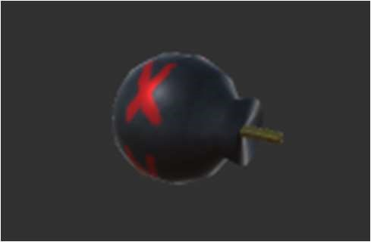
Fruits:
Apple
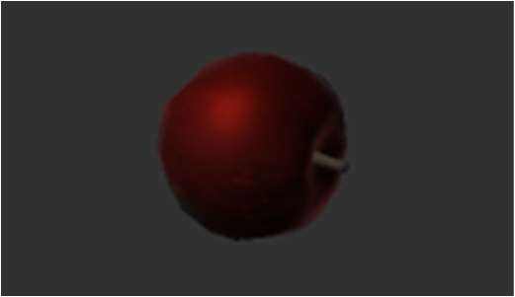
Coconut
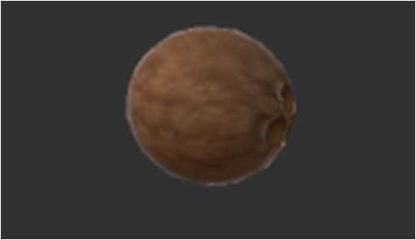
Orange
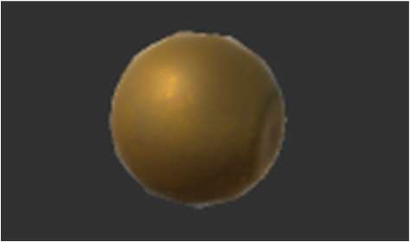
Pear
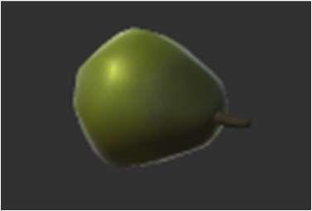
Watermelon
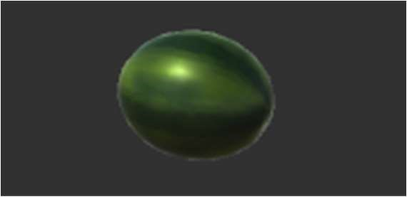

Output/Screenshots:
Start of Game

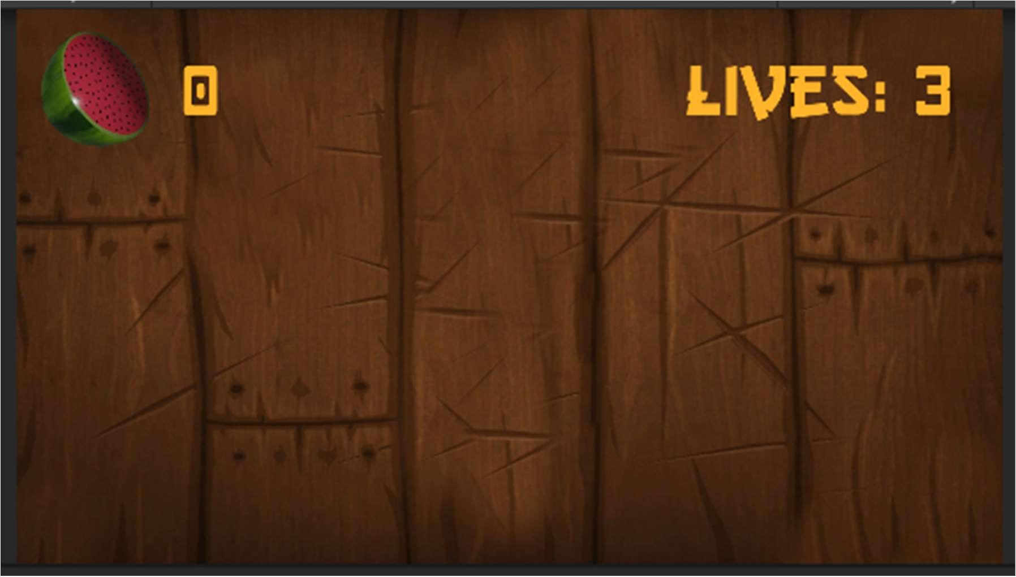

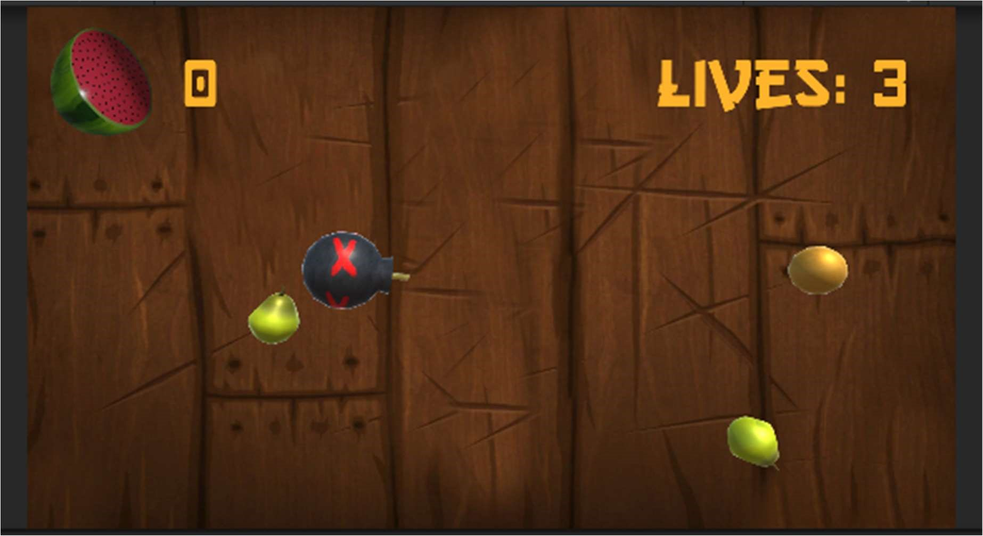

Slicing the fruit:
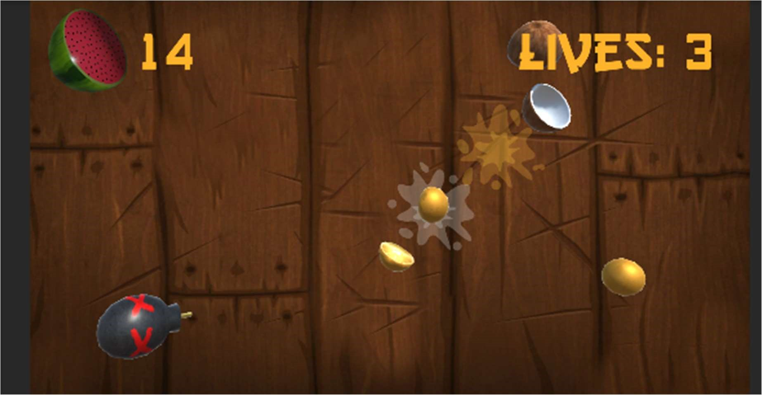

Live 3:
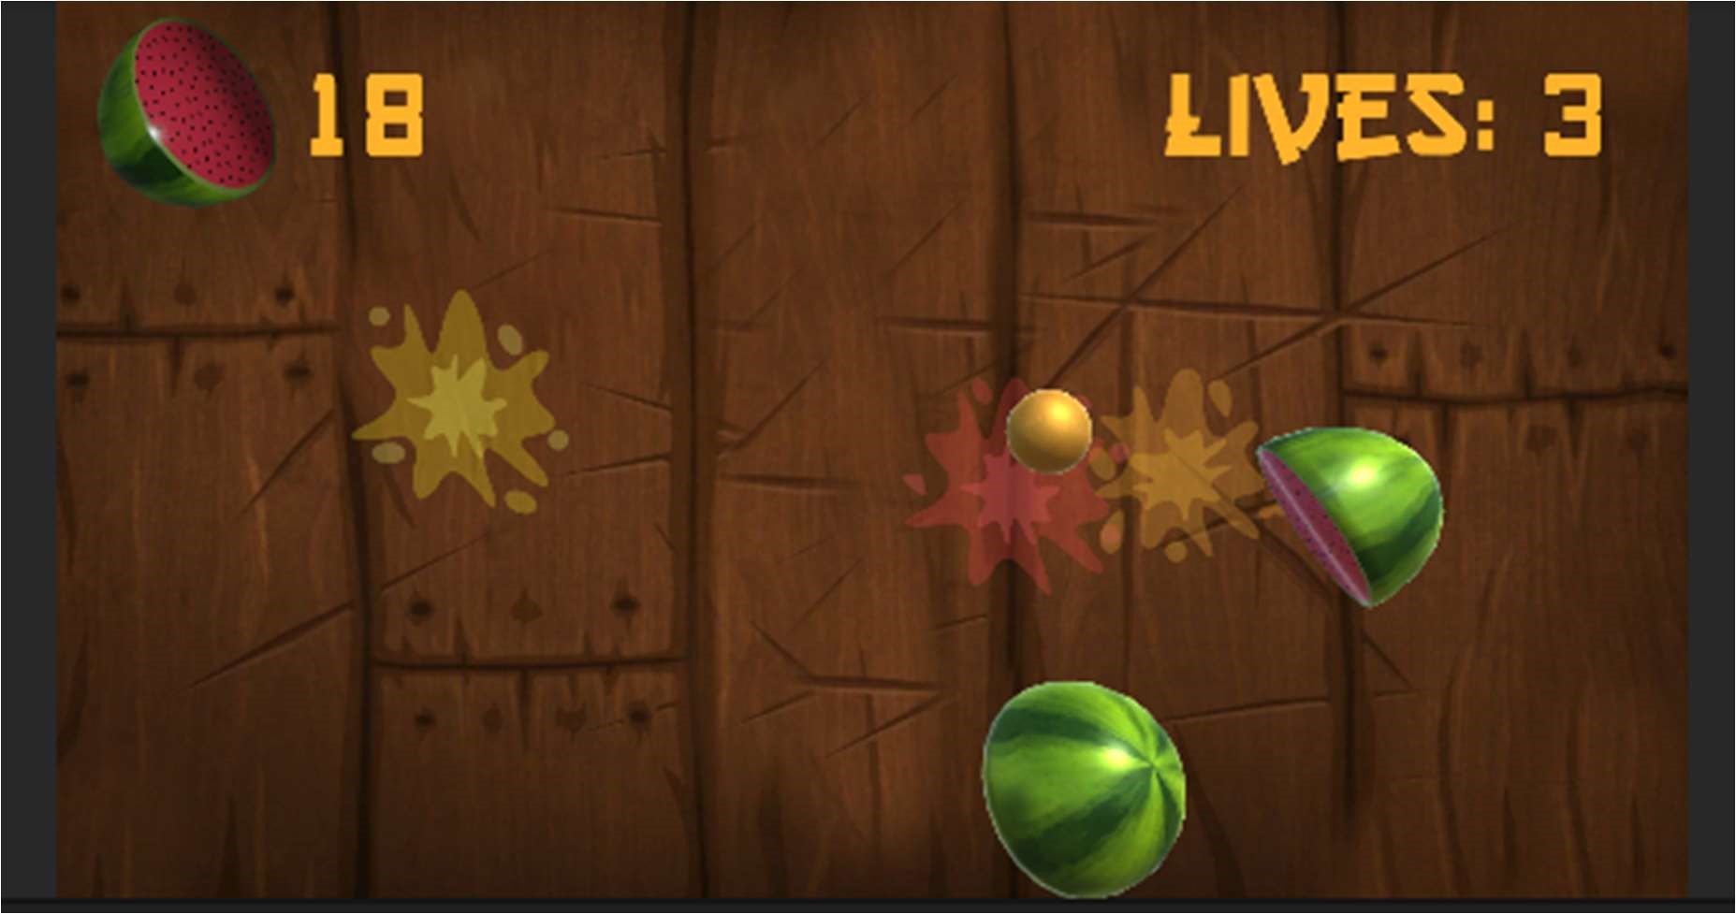

Live 2:
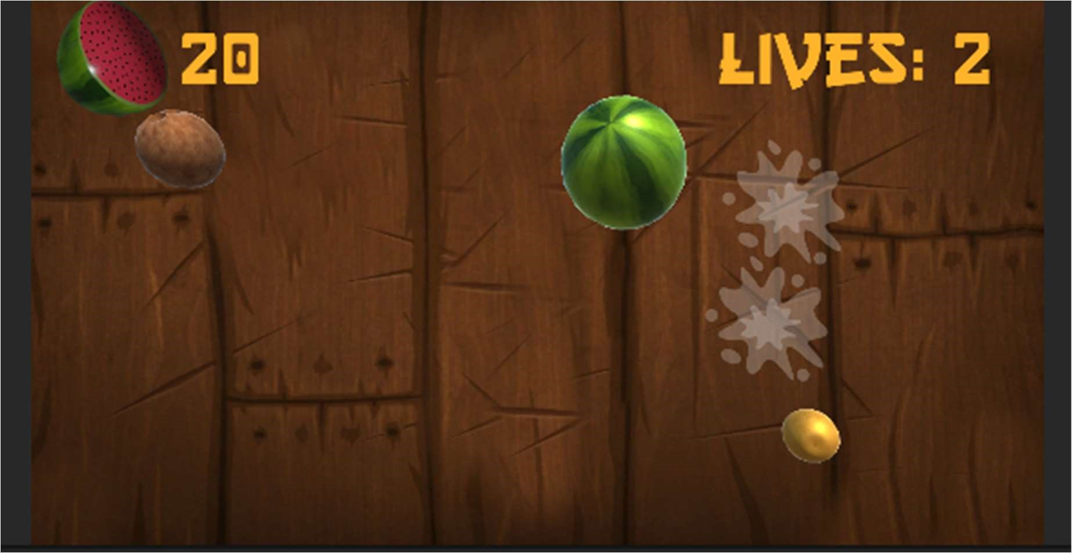

Live 1:
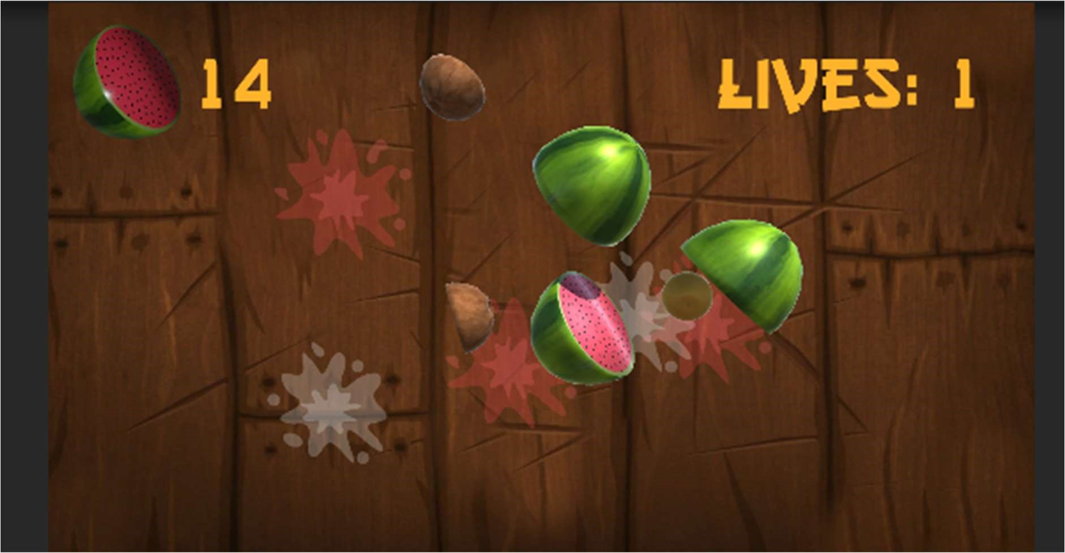

Game Over:
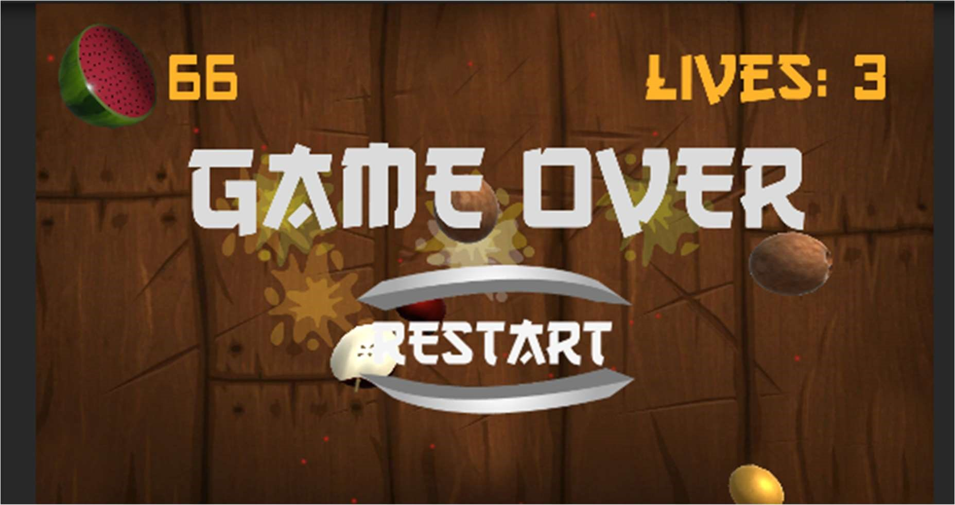

VIDEO LINK

https://drive.google.com/file/d/1_uXGxpHYPQ4_Sw5wapHuYOvRad1uUYx/view?usp=sharing


THANK YOU

