Domain Knowledge: Global Banking Standards

Purpose of Global Banking Standards:

The main purpose or theme of this document is to broadly layout the information regarding the "Global Banking Standards" which drives home the complex nature of the global banking regulatory measures like:

- BASEL Compliance,
- Advanced Internal Rating Based (AIRB) systems and
- Anti-Monetary Laundering (AML) policies

It is indeed delightful to know that these concepts and regulatory measures are being used by most of the Tier 1, Tier 2 as well as Tier 3 banks and financial institutions in US, Europe as well as Asia.

Audience:

The intended audience can be anyone from Business Analyst, Functional, Technical or Testing Team – as it gives a quick heads up to most of the necessary Banking Standard information's in a single and comprehensive document. A Sales Personnel or Project Manager(s) might find it useful for pitching new customers by demonstrating their brief knowledge about the ever evolving global banking standards.

BASEL Compliance:

Background:

- The Basel Committee on Banking Supervision (BCBS) was established in 1974 by the central-bank Governors of the Group of Ten (G10) countries* in the aftermath of serious disturbances in international currency and banking markets and deterioration in capital ratios.

- The Committee does not possess any formal supranational supervisory authority. Rather, it formulates broad supervisory standards and guidelines and recommends statements of best practice.

- The BCBS has been devoted in recent years is capital adequacy by implementing a weighted approach to the measurement of risk, both on and off the balance sheet

* The Committee's members come from Belgium, Canada, France, Germany, Italy, Japan, Luxembourg, the Netherlands, Spain, Sweden, Switzerland, United Kingdom and United States. Countries are represented by their central bank (e.g., US Federal Reserve Bank of New York, Bank of England, etc.) and generally meet quarterly.

Why BASEL Compliance needed
1. Banks are in the business of taking risks | 3. Banks manage their own capital levels
2. Banks hold capital:  - as a buffer against potential losses  - to provide them with financial flexibility  - as a sign of strength to their customer | 4. There is a need for regulatory capital:  - Capital ratios determine legal lending limits  - Banks operate very close to this level and are closely monitored by regulators  - For some very successful banks, this is almost irrelevant  - Others are committed to excellent compliance for their reputation

BASEL 2: Three Pillars
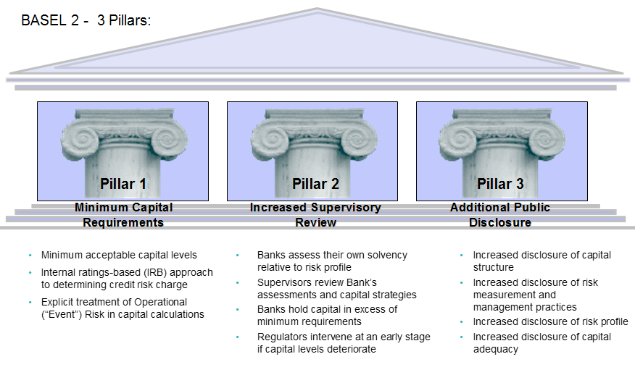

BASEL 2: Who must comply, benefits and risks

BASEL 2 – Who must comply:
Financial Institutions, Banks (Tier 1, 2, 3), Insurance companies, etc

BASEL 2 – Benefits for comply:
- Improved Financial Status by non-redundant investments & freed capital (due to lower capital reserves) which can be used into new business

- Adopt global best practices since the BASEL Committee works closely with banks of member countries in identifying business issues and providing solutions based on global best practices. By adopting BASEL 2, banks will enjoy closer cooperation with foreign financial institutions

- Strengthen core competencies by adopting advanced methods to identify and measure risks in quantifiable manner, banks will manage better risks and reduce losses due to current risk exposures. At the same time, improved risks management capability will provide banks with opportunity to expand their product and markets since they will have the ability to access the risks of default by their customers

BASEL 2 – Risk for not comply:

- Lower ratings of banks by external rating firms

- Without adopting BASEL 2, banks will not be able to reduce their capital reserves

- Large international and active banks will incur large and redundant investment since such banks having operations in global markets need to abide by the host country governance systems (i.e. BASEL 2) as well as operate in their local geography. This will make the financial institutions to build and operate two sets of business processes and IT systems resulting in large and redundant investments

Advanced Internal Rating Based (AIRB)

- What is A-IRB
- Advanced IRB and its relationship with BASEL 2
- A-IRB Measurements

What is Advanced IRB

The term Advanced IRB or A-IRB is an abbreviation of advanced internal rating-based approach and it refers to a set of credit risk measurement techniques proposed under BASEL 2 capital adequacy rules for banking institutions.

Under this approach the banks are allowed to develop their own (hence INTERNAL) empirical model to quantify required capital for credit risk. Banks can use this approach only subject to approval from their local regulators

Advanced IRB and its relationship with BASEL 2

AIRB is an off-shoot of one of the requirements of BASEL 2 Pillar1.

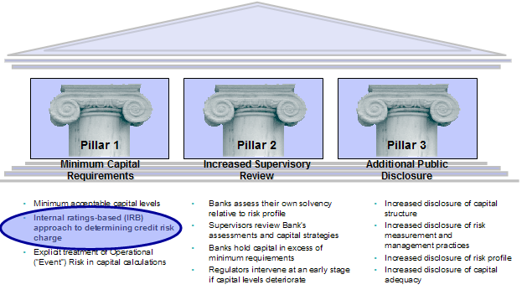
- IRB Measurements

The A-IRB measurement can be achieved via various means depending upon the risks being measured, which can be, Credit Risk and Operational Risk.

The various strategies that might be adopted are illustrated below:

Credit Risk

STANDARDIZED APPROACH
INTERNAL RATING APPROACH
FOUNDATION
ADVANCED

CREDIT RISK

Under the standardized approach the risk weights will be determined by the category of the borrower based on external information (e.g., credit rating agencies).

Under the Internal Ratings Based (IRB) approach, risk weights will be calculated by the bank based on its internal assessment of its counter parties and exposures.

There are 2 IRB sub-options, namely, Foundation & Advanced. Selection will be dependent on the bank’s ability to generate agreed loss factors and overall sophistication of credit risk management environment

Under Advanced -IRB banks are supposed to use their own quantitative models to estimate. These are:
PD (Probability of Default)
EAD (Exposure at Default)
LGD (Loss Given Default)
And other parameters required for calculating the RWA (Risk Weighted Asset).

Then total REQUIRED CAPITAL is calculated as a fixed percentage of the estimated RWA (usually around 8% approx)

Banks would normally adopt the “Internal - Advanced” approach of credit risk measurement although they may choose other options.

Operational Risk
BASIC
STANDARD
ADVANCED

OPERATIONAL RISK

Under the Basic approach banks will hold capital equal to a fixed percentage of annual gross income.

The standardized approach is similar to the basic however institutions are divided into key business areas (e.g., Retail Banking, Commercial Banking, etc.) and capital requirements will be a fixed percentage of average Gross Income for these business units.

For the Advanced Measurement Approach (AMA), regulatory capital will equal the risk measure generated by the bank’s internal assessment method (subject to supervisory approval).

Banks would normally adopt the “Advanced” approach of operational risk measurement although they may choose other options.

Anti Money Laundering (AML)

- AML Definition & Who must comply
- AML Adherence - Benefits for comply & Risk for not comply
- AML Adherence - AML – Process and Procedures
- AML Trends

AML Definition & who must comply
AML Definition:
- A term mainly used in the financial and legal industries to describe the legal controls that require financial institutions and other regulated entities to prevent or report money laundering activities

- Government and Central Financial institutional bodies in US and Europe are formatting regulations emphasizing the importance of AML as cornerstone of compliance

- Financial Service Institutions (FSI’s) have no commercial reasons to undertake AML surveillance. It’s a regulatory compliance requirement to avoid significant fines and damage to reputation. Peer pressure (from other banks action) is also a significant reason for AML adherence

Who must comply:

- Financial Institutions, Banks (Tier 1, 2,, 3), Insurance companies, etc will need to comply

- In the past 2 years, regulators in US, Canada and the European Union (UK being the an “early adopter”) are all emphasizing the importance of effective AML technology for compliance with anti-money laundering activities

AML Adherence - Benefits for comply & Risk for not comply

Benefits:
- Complying with AML regulations is a costly burden. Regulators do not explicitly mandate uptake but the risks are very high hence adhering to AML becomes order of the day
- Derived Benefits include avoid penalties or fines, good reputation, prevent crime or corruption via Politically Exposed Person (PEP), accelerate economic growth and put proceeds of money laundering to good use

Risks:
- Financial Institutions face local and International penalties for failing to properly file CTR (Cash Transaction Report) and SAR (Suspicious Activity Report ) including heavy fines and regulatory restrictions, even to the point of charter revocation.

- International Sanctions. E.g. Financial Action Task Force (FATF) list of non-cooperative countries, US Patriot Act concluding that a foreign country, institution or an account is of primary money laundering concern, UK Proceeds of Crime Act, etc

- Damage to reputation, Encouragement to domestic and trans-national crime

AML Adherence - AML – Process and Procedures

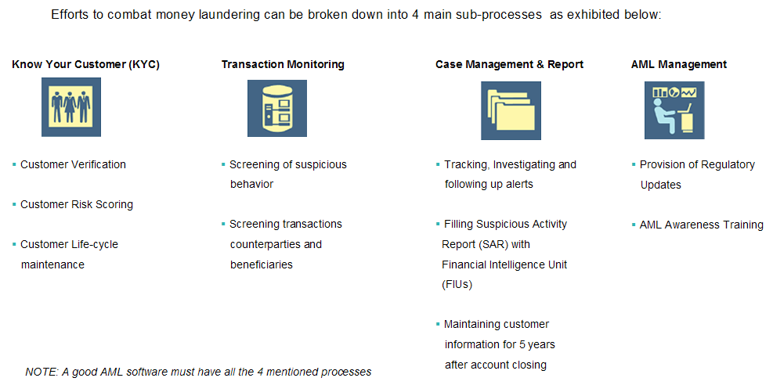

- AML Trends

- 9/11 Terrorist Attack triggered the intensification of AML regulations

- Today all Financial Institutions (FIs) globally are required to monitor, investigate and report transactions of a suspicious nature to the Financial Intelligence Units (FIU) of the central bank in their respective country

- Small FIs, Mid-Tier FIs and Large FIs have already woken up to the AML IT requirements

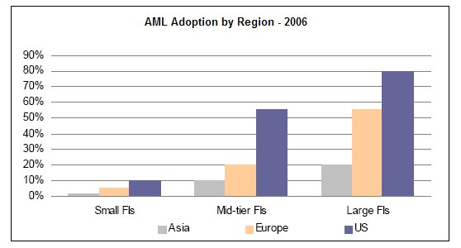
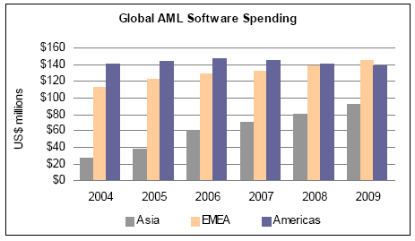
By Manoj Shaw

