CURRICULUM VIATE

YOGESH RAJ DHAMI

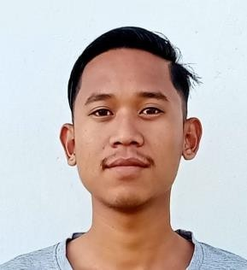



CONTACT
Yogeshrajdhamj09@gmail.com 9829533227
Barahachhetra 3, sunsari

PROFILE SUMMARY
Highly motivated and enthusiastic person seeking a challenging job as receptionist, assistant consultant, customer service representative or office assistant in consultancy and school.
- DOB:1st march 2003

SKILLS
- Attention to detail
- Communication skill
- Fluency in English speaking
- 6 months computer course at NEW HELI COMPUTER INSTITUTE.
- Expert at tally(from
PATHEBHARA COMPUTER )

LANGUAGES
- English: Fluent
- Nepali: Native
- Hindi: Fluent

EXPERIENCE

Driving
Have the personal driving license and proper skill of driving.

  - 2 years of working in itahari as a post of waiter in HOTEL PATHIBHARA INTERNATIONAL.

EDUCATION

+2 IN MANAGEMENT

Jagannath Dedraj Janta Secondary School

Barahachhetra-5, Sunsari CGPA 2.91

SEE
Morning Star School

Barahachhetra-3, Sunsari CGPA 3.25

