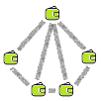

**SummaTRON-SHOP**

Digital marketplace based on TRX and SummaTRON-API

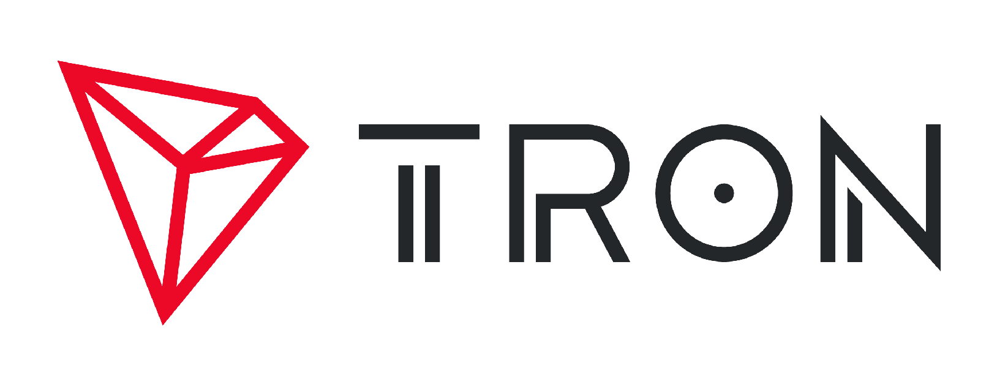

Index

Introduction 3

Operation of SummaTRON-SHOP 4

Inserting a Product 5

Purchase of a product 6

Modify a Product 9

Delete a Product 11

Roadmap 13

# Introduction

The TRON project has achieved in about 18 months surpassing the million active accounts, this implies an exponential growth, adding to this growth having already exceeded the 3 million of operations in a single day.

All this growth assumes that the number of users of the TRON system grows every day and the possibility of being able to make TRX-based managements are getting higher.

SummaTRON has created a totally distributed online store, based on the Tron.Network and without the need of previous registration. We have called SummaTRON-SHOP.

The goal is that users who have a digital product they want to sell do not need intermediaries like Amazon, Apple, Google, Facebook, Microsoft, etc., but directly they can insert them in SummaTRON-SHOP, put a price on TRX and you directly get the ingResos your sales to your TRON account.

The elimination of intermediary will increase the benefits of the users that so far they shared most of the income with the intermediary companies.

The existence of the intermediary companies makes sense when the product is a physical element, since they are generally the ones in charge of carrying out the distribution of the product and all the logistics that it entails.

When it comes to digital products the whole process can be done directly between the creator and the client. There is only the problem of payment, which is currently resolved by payment gateways with banks, credit cards, or Paypal. In general all these companies take a percentage of the sale, along with the percentage that takes the platform of sale.

SummaTRON-SHOP proposes a system where the platform It only manages the list of products, but all the support is in Tron. Network, the purchase is made directly by the customer paying by TRX the product and automatically download it to your computer.

Logically the type of digital products have to be of the type: Ebook, music, videos, drawings, etc. As long as they can be digitally uploaded and downloaded.

The operation of SummaTRON-SHOP isá Based on 3 processes:

1. The insert of a product
2. The sale of products
3. The modification of products

# Operation of SummaTRON-SHOP

The operation of SummaTRON-SHOP is based on three very simple processes: Insert, sale and modification.

Everything is based on Tron.Network, except for a table in a database so that you can search the description. Everything else is based on Tron's protocol.

We hope that a future the data field could contain a JSON and that later the applications could access their fields as indexes, this way the whole system would be decentralized.

The main idea of the project is that users who have a digital product like Ebooks, Music, videos, etc. They can register their product in a very simple form, and even the products do not have to move to the platform of SummaTRON, but the insert register performs a reference to the object using a URL.

The key part of the process is to link the digital product to the TRON account, so it is not necessary to make a previous record. In addition The TRON account is used to make the payment of the product.

With this simple process the owner of a digital product has the control of the price, and the number of downloads, there are no intermediaries or commissions for managing the sale since the payment platform is TRON.

Only in the case of having to modify the information of the product, for example the price, the user would have to login into SummaTRON-SHOP, to make it you must use IdTron or TronWallet.me, and to identify with the same account associated with the product. This function has been implementing using SummaTRON-API so that the user just has to press the central icon of IdTron to access the modification form.

Again thanks to Tron's protocol, only the user who owns the Tron account knows the private key with which he signs the token transfers. From the server side, when it detect a transfer that matches the QR data shown on your modification page, you leave access to the modification form

The process is very simple and safe, given that SummaTRON-API is as safe as any 2FA procedure or existing CAPTCHA, and the user can at any time modify or delete this product from the platform.

In all actual marketplace the user get only a little quantity of money, and you never control del number of sales.

We think that SummaTRON-SHOP is the first marketplace where the user can trace his sales over an open and distributed platform: Tron.Network.

# Inserting a Product

The user must own a digital product and of course a TRON account.

The inserting process does not require a pre-registration process, the control over the property of the product is enhanced only if you want to modify and delete.

The fields to be completed are:

-Type of product

-Price.

-The TRX account where you will receive the charges.

-The title to show

-A description of 1,024 characters maximum

-URL of the image to show or file to upload

-Product URL to download it or file to upload

Very important, the TRX account will be used by the payment system of SummaTRON-SHOP as access control for the download of the product and the place where the user will receive the payment, so the user has to keep that account in a safe way.

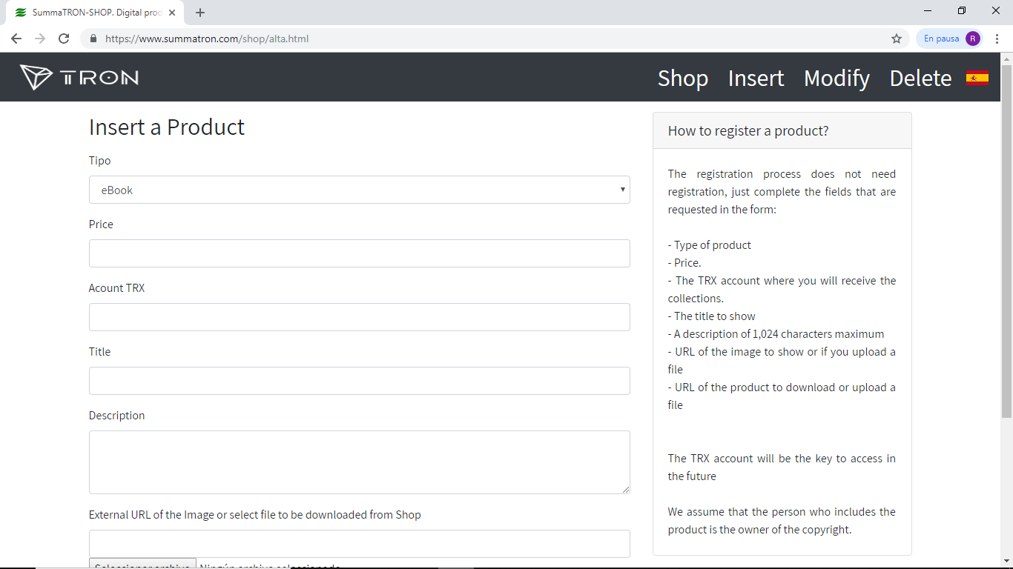

# Purchase of a product

The sales process has been designed to be the simplest thing for a customer, in summary There are 4 steps:

1. The list of available products is shown.
2. A QR is displayed with the payment information.
3. The client scans the QR and sends the payment.
4. Shop detects payment and gives access to the product, which being in digital format can be downloaded at that time.

The following images show the successive screens displayed during the purchase process:

Product selection

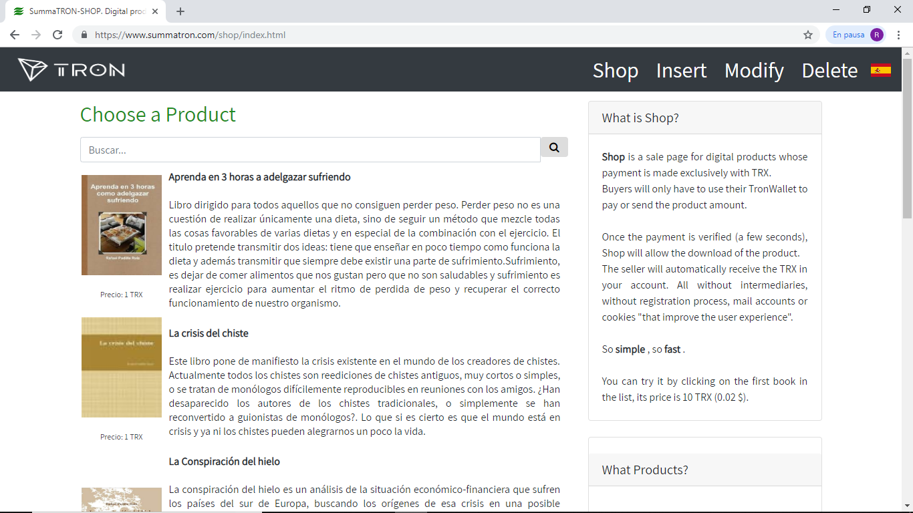

Product Payment Screen

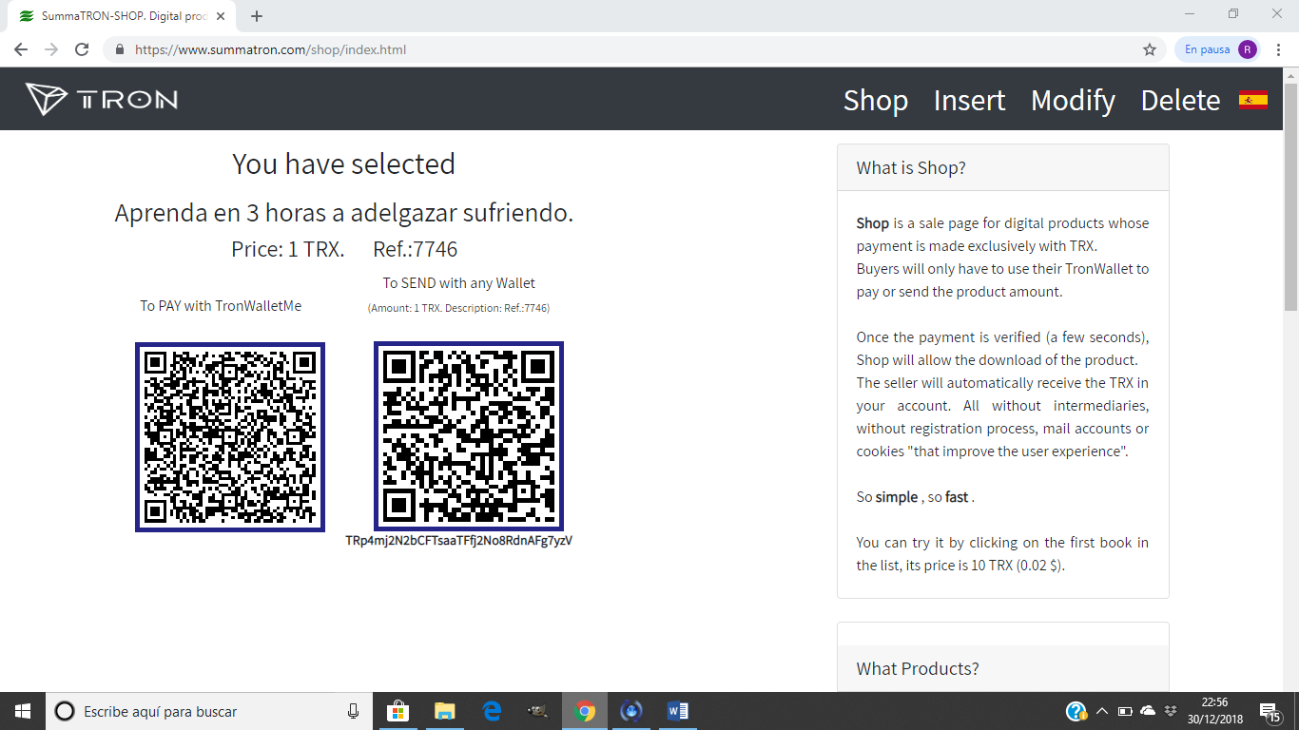

SummaTRON-SHOP does not receive any payment or charge for the platform, only detects in movements of payment between the Tron account of the client and the Tron account of the vendor that is shown in the QR code.

Product Download screen.

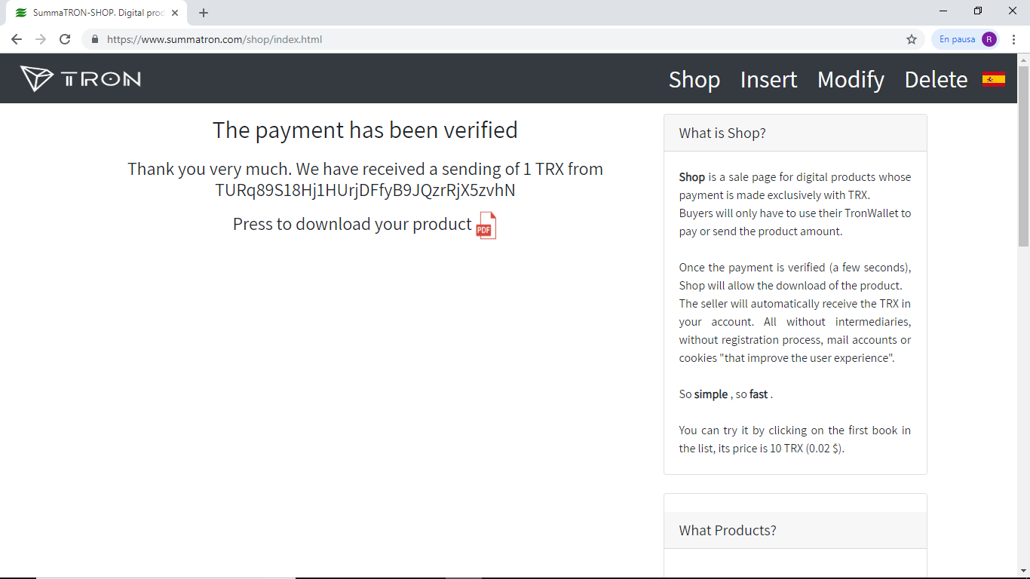

The download result screen, in this case an ebook.

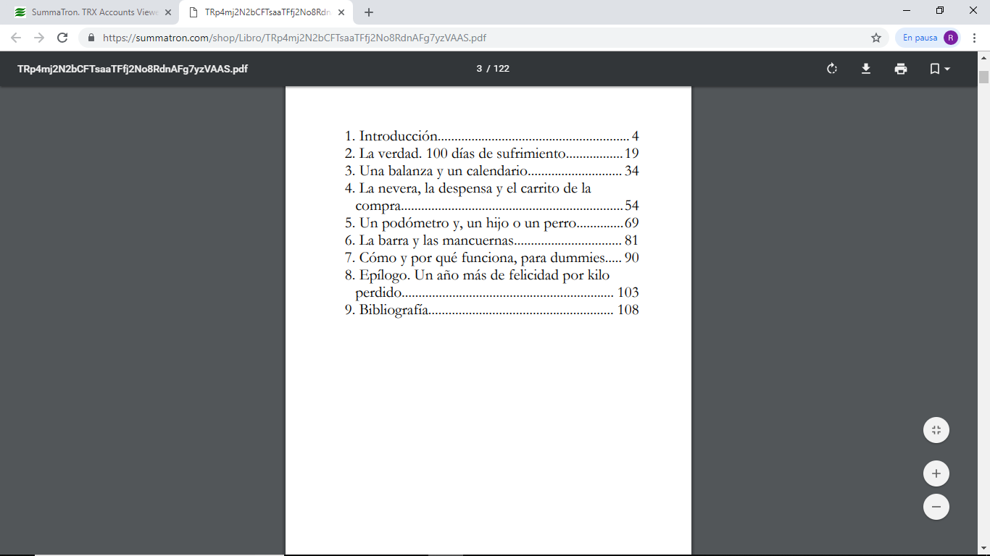

# Modify a Product

In the process of modifying a product has been developed using SummaTRON-API, from form that in this case besides TronWallet.me you can use IdTron.

As has already been commented the insert process of a product does not require any type of registration, but as required field is the TRON account of the product owner. This account is used to charge for the product, but it is also used as an identification mechanism.

SummaTRON-SHOP displays a QR code that the user should scan, when the server detect the sending of 1 IdTronix, access to a form is allowed for the user to modify the product information.

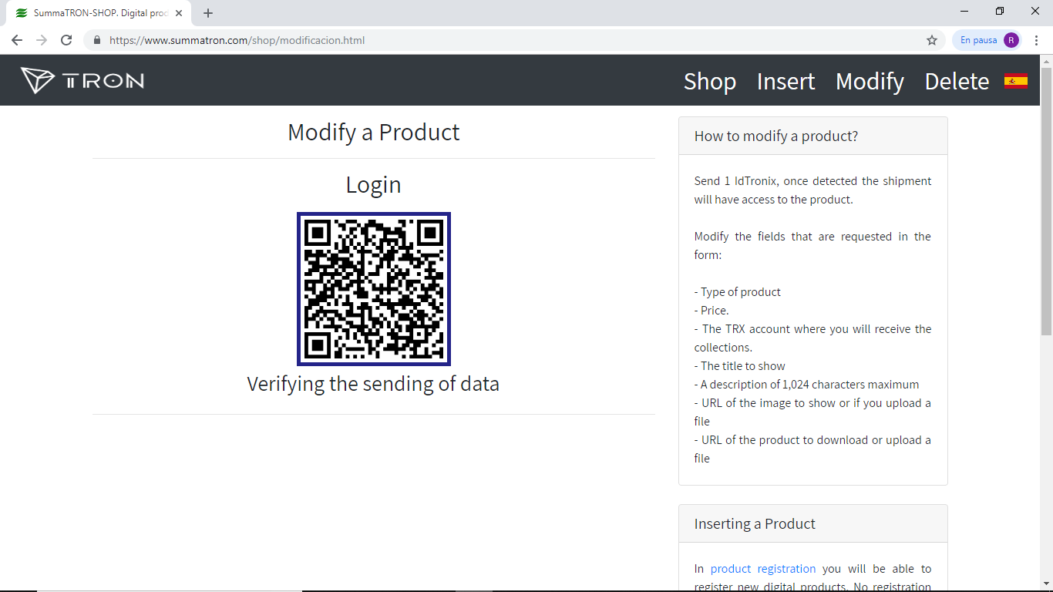

As a user can include in SummaTRON-SHOP various products, the first thing that is shown is a list with all the products in which your TRON account appears.

From that list you can select one and perform the change of the fields.

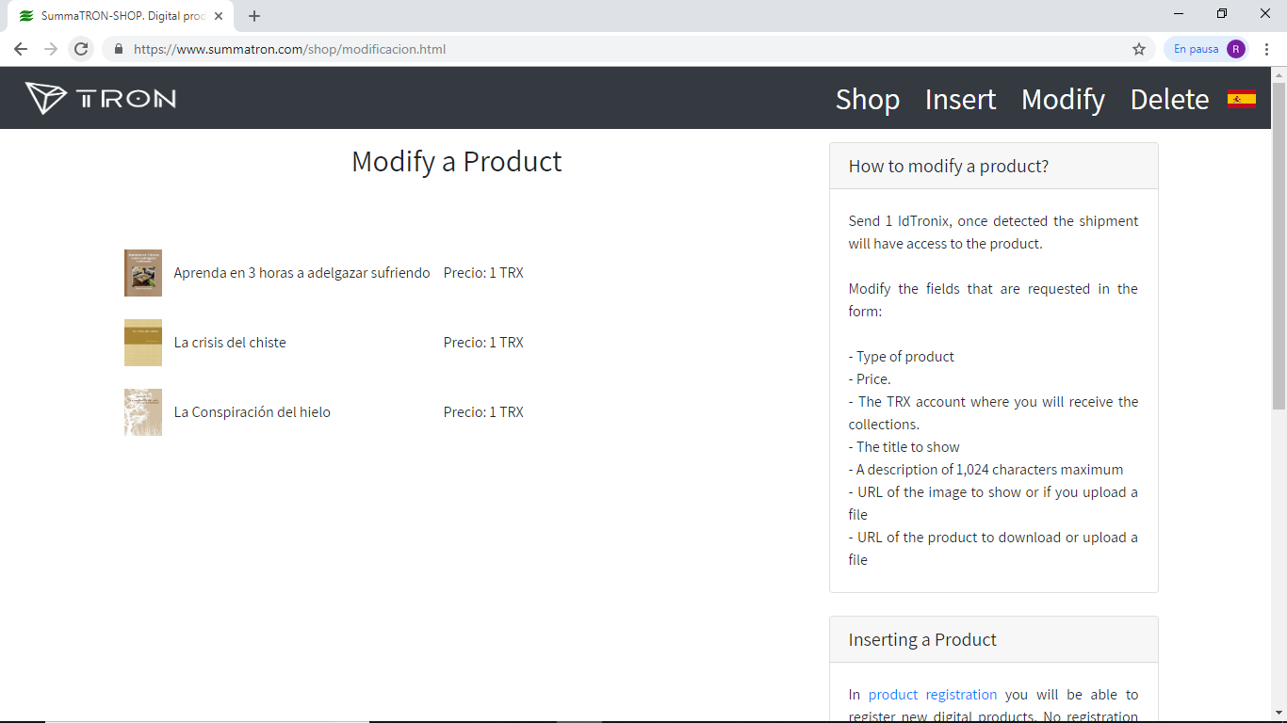

The fields you can modify are all that you introduced at the time of signup, even the TRON account, so you must make sure it is the right one and your property, but never again could access the product.

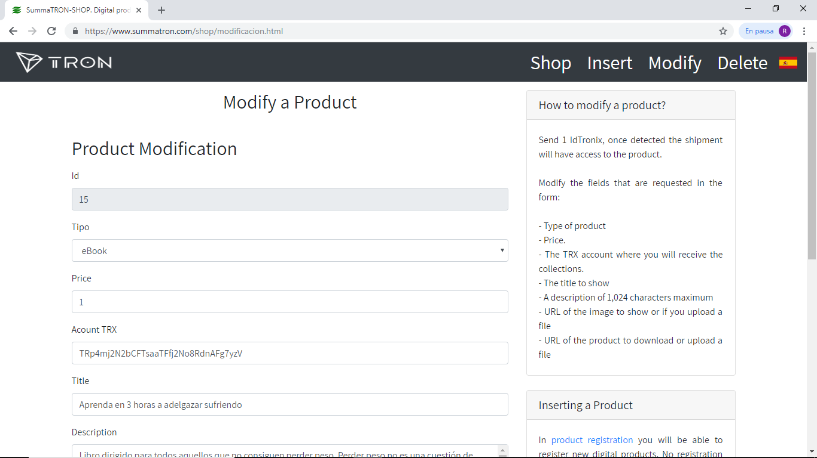

# Delete a Product

The deletion process is very similar to that of modification except in the final result of the operation in this case, when it is identified also leaves the relation of products, but no fields can be modified only the Delete button is active.

If everything goes correctly, an alert is displayed indicating that the product has been deleted, otherwise an error will be displayed.

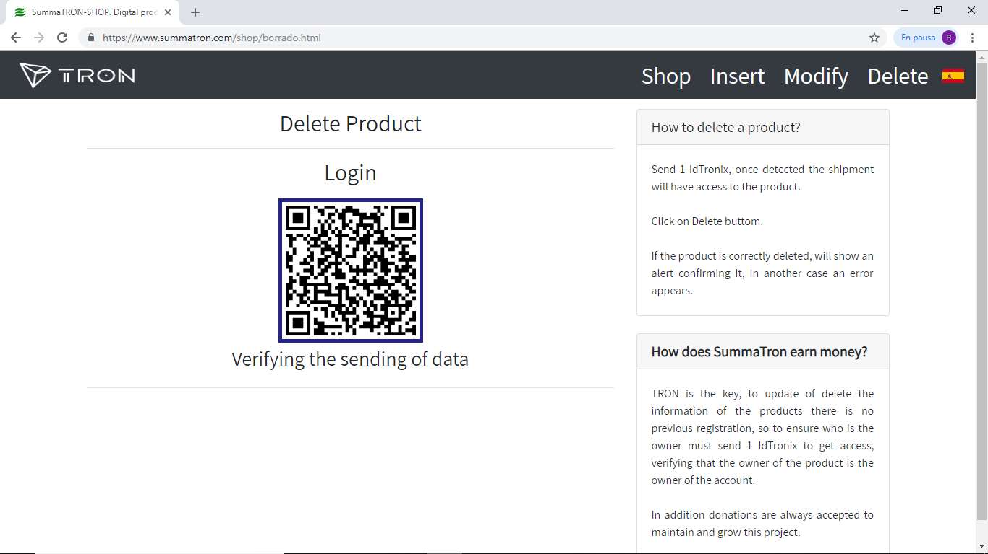

Products list.

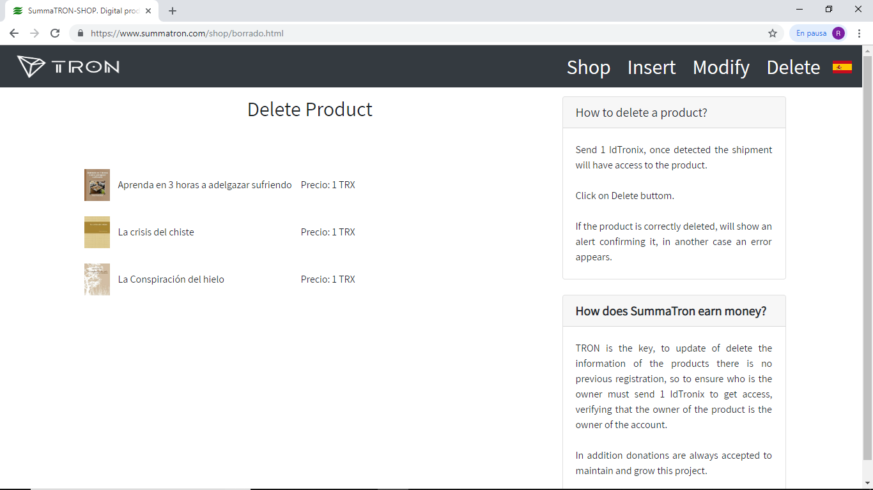

Screen to run the product deletion.

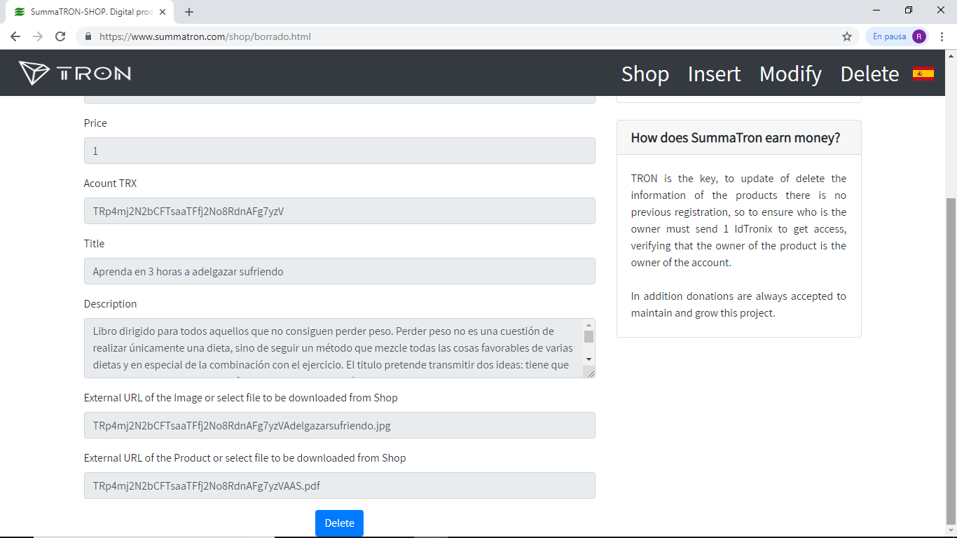

# Roadmap

In October 2018, the IdTronix (ITX) was created to provide 10 billion tokens for The process of Identification.

In November 2018, The first version of Shop is available to be able to be user by users publishers and customers buyers.

In march 2019, Access, download and user benefit statistics are incorporated based on the history stored in Tron. Network.

In June 2019, improvement of user interface.