1. **Introduction**
   1. **Domain Introduction**

**Deep learning**

Deep learning is a branch of machine learning which is based on artificial neural networks. It is capable of learning complex patterns and relationships within data. In deep learning, we don’t need to explicitly program everything. It has become increasingly popular in recent years due to the advances in processing power and the availability of large datasets. Because it is based on artificial neural networks (ANNs) also known as deep neural networks (DNNs). These neural networks are inspired by the structure and function of the human brain’s biological neurons, and they are designed to learn from large amounts of data.

1. Deep Learning is a subfield of Machine Learning that involves the use of neural networks to model and solve complex problems. Neural networks are modeled after the structure and function of the human brain and consist of layers of interconnected nodes

that process and transform data.

1. The key characteristic of Deep Learning is the use of deep neural networks, which have multiple layers of interconnected nodes. These networks can learn complex representations of data by discovering hierarchical patterns and features in the data. Deep Learning algorithms can automatically learn and improve from data without the need for manual feature engineering.
2. Deep Learning has achieved significant success in various fields, including image recognition, natural language processing, speech recognition, and recommendation systems. Some of the popular Deep Learning architectures include Convolutional Neural Networks (CNNs), Recurrent Neural Networks (RNNs), and Deep Belief Networks (DBNs).
3. Training deep neural networks typically requires a large amount of data and computational resources. However, the availability of cloud computing and the development of specialized hardware, such as Graphics Processing Units (GPUs), has made it easier to train deep neural networks.

In summary, Deep Learning is a subfield of Machine Learning that involves the use of deep neural networks to model and solve complex problems. Deep Learning has achieved significant success in various fields, and its use is expected to continue to grow as more data becomes available, and more powerful computing resources become available.

**What is Deep Learning?**

Deep learning is the branch of [machine learning](https://www.geeksforgeeks.org/machine-learning/) which is based on artificial neural network architecture. An artificial neural network or ANN uses layers of interconnected nodes called neurons that work together to process and learn from the input data.

In a fully connected Deep neural network, there is an input layer and one or more hidden layers connected one after the other. Each neuron receives input from the previous layer neurons or the input layer. The output of one neuron becomes the input to other neurons in the next layer of the network, and this process continues until the final layer produces the output of the network. The layers of the neural network transform the input data through a series of nonlinear transformations, allowing the network to learn complex representations of the input data.

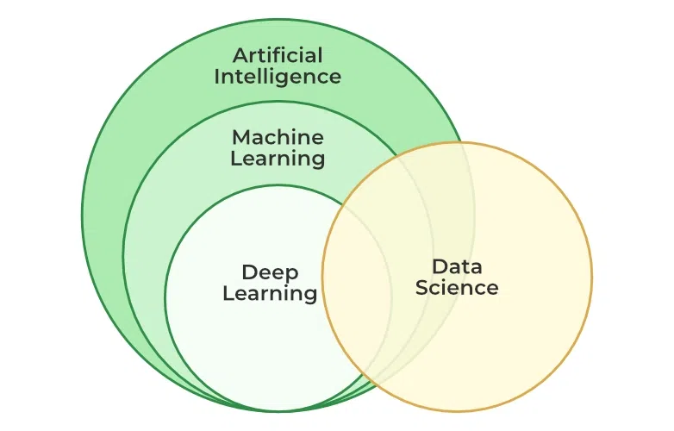

* 1. **Project Introduction**

Early detection of skin cancer is crucial as it is a dangerous form of cancer spreading vigorously among humans[1]. With the progress of Machine learning, Machine learning-enabled skin cancer detection systems are demanding. Still, very few real-time skin cancer detection systems are available for the general public and primarily available are the paid. Recently, Convolutional Neural Network (CNN) based methods advanced cancer detection. The proposed method is developed using computer vision and image processing techniques combined with a convolutional neural network algorithm. Each year in the USA alone, approximately 5.4 million new cases of skin cancer are recorded[2][3]. The mortality rate of this condition is expected to increase in the next decade. The survival rate is less than 14% [4], [5], [6]. if diagnosed in later stages. However, if skin cancer is detected at early stages, the survival rate is nearly 97% [7]. This demands the early detection of skin cancer. This research addresses the issue of early diagnosis with improved accuracy. To diagnose skin cancer speedily at the earliest stage and solve some of the problems mentioned above, there have been extensive research solutions by developing computer image analysis algorithms. The dataset used for this research is taken from the International Skin Image Collaboration (ISIC) archive. It consists of a total of three thousand five hundred pictures. These pictures include 1800 pictures of benign moles and 1497 pictures of malignant classified moles. The high definition pictures are modified to low-resolution pictures to improve the performance, and pictures have all been resized to low resolution (224x224x3) RGB. The dataset is pretty balanced, and the model will be tested with accuracy. In this paper, we address developing deep learning-based image classification models to identify skin cancer without prior programming knowledge. The main objective of this paper is: 1. To classify the cell images into two types of Cancer and identify Cancer with improved accuracy using Convolution Neural Network. The two types of skin cancers focussed here are: 1. Benign 2. Malignant.

1. **Literature Survey**

Fulgencio Navarro, Marcos Escudero -Vinolo and Jesus Bescos. et al. [1] authored a paper in 2019 which studies image processing as an image registration approach that outperforms top image registration techniques. Combined with the proposed lesion segmentation algorithm, this allows for the accurate extraction of features to assess the evolution of the lesion in a skin cancer scenario. Thus, it presents a case study with the lesion-size feature, paving the way for the development of automatic systems to easily evaluate skin lesion evolution. The main drawback of this paper is that this paper gives more dependance on feature extraction, Segmentation and not on prediction using machine learning.

[3]Bangladesh: Skin disease, 2018, [Online]. Available: https://www. worldlifeexpectancy.com/bangladesh-skin-disease. (Accessed 9 July 2021). According to the latest WHO data published in 2020 Skin Disease Deaths in Bangladesh reached 1,131 or 0.16% of total deaths. The age adjusted Death Rate is 1.01 per 100,000 of population ranks Bangladesh #110 in the world. Review other causes of death by clicking the links below or choose the full health profile.

[5] Md. Al Mamun, Mohammad Shorif Uddin, 2 IJCRT2307676 International Journal of Creative Research Thoughts (IJCRT) www.ijcrt.org f777 survey on a skin disease detection system, Int. J. Healthc. Inform. Syst. Inform. 16 (4) (2021)

This article focuses on the review of the tools and techniques used in the diagnosis of 28 common skin diseases. Furthermore, it has discussed the available image databases and the evaluation metrics for the performance analysis of various diagnosis systems. This is vital for figuring out the implementation framework as well as the efficacy of the diagnosis methods for the neophyte. Based on the performance accuracy, the state-of-the-art method for the diagnosis of a particular disease is figured out. It also highlights challenges and shows future research directions.

[6] C.N. Vasconcelos, B.N. Vasconcelos, Experiments using deep learning for dermoscopy image analysis, Pattern Recognit. Lett. 139 (2020) 95–103.

Skin cancer is a major public health problem, as is the most common type of cancer and represents more than half of cancer diagnosed worldwide. Early detection influences the outcome of the disease and motivates the research presented in this paper. Recent results show that deep learning based approaches learn from data, and can outperform human specialists in a set of tasks when large databases are available for training. This research investigates the scenario where the amount of data available for training is small. It obtains relevant results for the ISBI 2016 melanoma classification challenge (named Skin Lesion Analysis for Melanoma Detection) facing the peculiarities of dealing with such a small and unbalanced biological database. To do this, it explores committees of Deep Convolutional Neural Networks (DCNN), the augmentation of the training data set by image processing classical transforms and by deformations guided by expert knowledge about the lesion axis, and it introduces a third class aiming to improve the classifiers' distinction of the region of interest of the lesion. The experiments show that the proposed approach improves the final classifier invariance for common melanoma variations, common skin patterns and markers, and dermatoscope capturing conditions.

[7] U.-O. Dorj, K.K. Lee, J.Y. Choi and. M. Lee, The skin cancer classification using deep convolutional neural network, Multimedia Tools Appl. 77 (2018) 9909–9924.

This paper addresses the demand for an intelligent and rapid classification system of skin cancer using contemporary highly-efficient deep convolutional neural network. In this paper, we mainly focus on the task of classifying the skin cancer using ECOC SVM, and deep convolutional neural network. RGB images of the skin cancers are collected from the Internet. Some collected images have noises such as other organs, and tools. These images are cropped to reduce the noise for better results. In this paper, an existing, and pre-trained AlexNet convolutional neural network model is used in extracting features. A ECOC SVM clasifier is utilized in classification the skin cancer. The results are obtained by executing a proposed algorithm with a total of 3753 images, which include four kinds of skin cancers images. The implementation result shows that maximum values of the average accuracy, sensitivity, and specificity are 95.1 (squamous cell carcinoma), 98.9 (actinic keratosis), 94.17 (squamous cell carcinoma), respectively. Minimum values of the average in these measures are 91.8 (basal cell carcinoma), 96.9 (Squamous cell carcinoma), and 90.74 (melanoma), respectively.

[8] M. Taufiq, N. Hameed, A. Anjum, F. Hameed, mSkin Doctor: A Mobile Enabled System for Early Melanoma Skin Cancer Detection Using Support Vector Machine, in: eHealth 360◦. International Summit on eHealth, 2017, pp. 468–475.

Early detection of skin cancer is very important as it is one of the dangerous form of cancer spreading vigorously among humans. With the advancement of mobile technology; mobile enabled skin cancer detection systems are really demanding but currently very few real time skin cancer detection systems are available for general public and mostly available are the paid. In this paper authors proposed a real time mobile enabled health care system for the detection of skin melanoma for general users. Proposed system is developed using computer vision and image processing techniques. Noise is removed by applying the Gaussian filter. For segmentation Grab Cut algorithm is used. Support Vector Machine (SVM) is applied as a classification technique on the texture features like area, perimeter, eccentricity etc. The sensitivity and specificity rate achieved by the m-Skin Doctor is 80% and 75% respectively. The average time consumed by the application for classifying one image is14938 ms

1. Jagdis etal., J.A.D.L. Cruz-Vargas, M.E.R. Camacho, Advance study of skin diseases detection using image processing methods, Nat. Volatiles Essent. OilsJ. 9 (1) (2022) 997–1007. In this research advanced study of skin disease detection using image processing methods is considered. As we know skin diseases vary accordingly from symptom and severity. They can represent permanent or temporary or painful or painless based on affected disease. Some diseases have a genetic cause or some situational. Some diseases can be found life threatens or some minor based condition. But as per the survey report, many skin diseases become serious issues. So it is very important to continuously monitor and detect skin disease to provide proper treatment and faster recovery protocols. In this investigation, advance study of skin disease detection using fuzzy clustering with machine learning methods KNN and SVM classification algorithm with wavelet analysis is tested with 50 sample images. The results represent the K-Nearest Neighbor classification algorithm works well compared to the Support vector machine (SVM) classification technique with an accuracy of 91.2%. The algorithm also identifies the type [11] S.K. Bandyopadhyay, P. Bose, A. Bhaumik, S. Poddar, Machine learning and deep learning integration for skin diseases prediction, Int. J. Eng. Trends Technol. 70 (2) (2022) 11–18. Living creature skin disease is a fairly prevalent ailment. In the medical world, monitoring dermatological disorders and classifying them is a complex process. Due to the sheer intricacy of individual skin tone and the visible proximity effect of infections, recognizing the precise type can be challenging at times. As a result, it is critical to diagnose and recognize skin disease as soon as possible

[12] A. Kalaivani, S. Karpagavalli, Detection and classification of skin diseases withensembles of deep learning networks in medical imaging, Int. J. Health Sci. 6(S1) (2022) 13624–13637.

Skin disorders are a serious worldwide public health issue that affects a large number of individuals. In recent years, with the fast advancement of technology and the use of different data mining approaches, treatment of skin predictive classification has really become highly predictive as well as accurate. As a result, the type of machine learning approaches capable of efficiently differentiating skin condition categorization is essential. So far, no one machine learning approach has outperformed the others in terms of skin disease prediction. In this research, we introduce a new method that combines two separate data mining approaches into a single unit, as well as an ensemble approach that combines both data mining techniques into a single group. We explore different data mining strategies to categorize the skin condition using an informative Dermatology publicly accessible dataset ISIC2019 images, and then apply an ensemble deep learning method. Furthermore, the presented ensemble technique, which is based on machine and deep learning, was tested on Dermatology datasets and was able to categorize skin disorders into seven categories.

[13] S.A. AlDera, M.T.B. Othman, A model for classification and diagnosis of skin disease using machine learning and image processing techniques, Int. J. Adv. Comput. Sci. Appl. 13 (5) (2022).

Skin diseases are a global health problem that is difficult to diagnose sometimes due to the disease’s complexity, and the time-consuming effort. In addition to the fact that skin diseases affect human health, it also affects the psycho-social life if not diagnosed and controlled early. The enhancement of images processing techniques and machine learning leads to an effective and fast diagnosis that help detect the skin disease early. This paper presents a model that takes an image of the skin affected by a disease and diagnose acne, cherry angioma, melanoma, and psoriasis. The proposed model is composed of five steps, i.e., image acquisition, preprocessing, segmentation, feature extraction, and classification. In addition to using the machine learning algorithms for evaluating the model, i.e., Support Vector Machine (SVM), Random Forest (RF), and K-Nearest Neighbor (K-NN) classifiers, and achieved 90.7%, 84.2%, and 67.1%, respectively. Also, the SVM classifier result of the proposed model was compared with other papers, and mostly the proposed model’s result is better. In contrast, one paper achieved an accuracy of 100%.

[14] P.R. Kshirsagar, H. Manoharan, S. Shitharth, A.M. Alshareef, N. Albishry, P.K. Balachandran, Deep learning approaches for prognosis of automated skin disease, Life 2022 12 (426) (2022).

Skin problems are among the most common ailments on Earth. Despite its popularity, assessing it is not easy because of the complexities in skin tones, hair colors, and hairstyles. Skin disorders provide a significant public health risk across the globe. They become dangerous when they enter the invasive phase. Dermatological illnesses are a significant concern for the medical community. Because of increased pollution and poor diet, the number of individuals with skin disorders is on the rise at an alarming rate. People often overlook the early signs of skin illness. The current approach for diagnosing and treating skin conditions relies on a biopsy process examined and administered by physicians. Human assessment can be avoided with a hybrid technique, thus providing hopeful findings on time. Approaches to a thorough investigation indicate that deep learning methods might be used to construct frameworks capable of identifying diverse skin conditions. Skin and non-skin tissue must be distinguished to detect skin diseases. This research developed a skin disease classification system using MobileNetV2 and LSTM. For this system, accuracy in skin disease forecasting is the primary aim while ensuring excellent efficiency in storing complete state information for exact forecasts.

[15]M.Q. Hatem, Skin lesion classification system using a Knearest neighbor al- gorithm, in: Visual Computing for Industry, Biomedicine, and Art. Vol. 5, (7) 2022.

One of the most critical steps in medical health is the proper diagnosis of the disease. Dermatology is one of the most volatile and challenging fields in terms of diagnosis. Dermatologists often require further testing, review of the patient’s history, and other data to ensure a proper diagnosis. Therefore, finding a method that can guarantee a proper trusted diagnosis quickly is essential. Several approaches have been developed over the years to facilitate the diagnosis based on machine learning. However, the developed systems lack certain properties, such as high accuracy. This study proposes a system developed in MATLAB that can identify skin lesions and classify them as normal or benign. The classification process is effectuated by implementing the K-nearest neighbor (KNN) approach to differentiate between normal skin and malignant skin lesions that imply pathology. KNN is used because it is time efficient and promises highly accurate results. The accuracy of the system reached 98% in classifying skin lesions.

1. **Objectives of Skin Cancer**

Early detection and treatment has a higher probability of recovery. If we failed to detect early it may spread and once melanoma spread.

Dermoscopy is also known as Dermatoscopy. By using non-invading diagnosis technique like light microscopy can be used to detect pigmented skin lesion. It is a new type of imaging technique which can use to examine skin lesion attached with a piece of equipment called dermatoscopy.

Although analysis of dermoscopy images plays an important role to detect malignant melanoma in the early stage, this traditional method is subjective and time-consuming. Due to these limitations, computer aided diagnosis system is an urgent need for the dermatologists for the clinical evaluation to detect early the risk factor of melanoma

**Objectives:**

* To improve productivity and decision making of a Medical Practitioner. • Maintaining an accurate database of various stages of cancer images.

•

* To remove noise from image using Median Filter algorithm. •
* To try and create an accurate skin cancer detection features dataset with three classes benign, malignant and normal. •
* To apply and analyze the various cancer stages defined by the above three classes using CNN algorithm.

1. **Existing System**

Artificial Neural Network(ANN). An artificial neuron network (ANN) is a statistical nonlinear predictive modelling method which is used to learn the complex relationships between input and output. The structure of ANN is inspired by the biological pattern of our brain neuron [2]. An ANN has three types of computation node. ANNs learn computation at each node through back-propagation.

There are two sorts of data set trained and untrained data set which produces the accuracy by employing a supervised and unsupervised learning approach with different sort of neural network architectures like feed forward, back propagation method which uses the info set at a special manner. Using Artificial Neural Network, accuracy obtained in various researches is 80% which isn’t optimum . Also, ANNs require processors with parallel processing power. ANN produces a probing solution it does not give a clue as to why and how it takes place which reduces trust in the networkArtificial intelligence (AI) is quickly expanding in therapeutic areas in a modern context. For diagnostic purposes, much deep learning (DL) and machine learning (ML) methods are applied. These strategies drastically enhance the diagnosing process while also speeding it up. In this study, to improve disease detection, a model combining deep learning (DL) and machine learning (ML) has been developed.

For classification, three sets of machine learning models were utilized, and for feature selection, four sets of pre-trained deep learning models were being used. For classification models, deep neural networks Alexnet, Googlenet, Resnet50, and VGG16 were used, while Support Vector Machine, Decision tree, and Ensemble boosting Adaboost classifier were applied for classification. To identify the best prediction model, a comparative study was carried out. The hybrid method Resnet50 with SVM produced the best results, with 99.11% accuracy.

1. **Proposed System**

The data used for this project is a dermoscopy image obtained from https://www.kaggle.com. The data set consists of 5202 images for training data and 30 images for data testing. The training data consisted of 2808 melanoma images and 2394 non-melanoma images. Test data consisted of 4 images of melanoma and 4 images of non melanoma.The data to be used is primary data, so preprocessing is necessary to get a good image. After preprocessing, the next step is to extract the features from the preprocessing results to get the statistical features of the image. In the next stage, the statistical features will be used as input for the classification process. The system built will have several stages. The first stage will start from assessing the dermoscopy image which will be used as training data and testing system data to be created. The next stage is preprocessing using the image adjustment method to increase the light intensity of the image, then using the thresholding method to create a black and white image on the image to be stopped, then the classification stage using the Convolutional Neural Network method. Skin disease classification method procedure includes: Image preprocessing, segmentation, feature extraction, and classification. A convolution neural network is an essential type of deep neural network, which is effectively being used in computer vision. It is used for classifying images, assembling a group of input images, and performing image recognition. CNN is a fantastic tool for collecting and learning global data as well as local data by gathering more straightforward features such as curves and edges to produce complex features such as shapes and corners . CNN’s hidden layers consist of convolution layers, nonlinear pooling layers, and fully connected layers. CNN can contain multiple convolution layers that are followed by several fully connected layers. Three major types of layers involved in making CNN are convolution layers, pooling layers, and full-connected layers. the method used for the classification process is Convolutional Neural Network.

1. Determination of filter, pool size, stride and padding The filter used is 3 x 3, while the pool size used is 2 x 2. The Stride and Padding settings are set to default, namely 1 and 0.
2. Determination of the activation function The calculation results between input, weight and bias will be calculated again with the equation of the activation function to get the output of each layer. In this study, the authors used the ReLu on activation function convolutional layer and softmax activation function on the output layer for get a result which is categorical data. Systematically, function ReLu activation can be seen in equation below.



Where a is the calculation result in the layer. The softmax function can be seen from equation below



1. Determination of the optimizer: Optimizer is an algorithm for determining the optimal weight In this research, the optimizer used is Adam.
2. Determination of the batch size: The batch size is used to determine the number of 16observations made before making changes in weight, which is determined relative based on computer specifications. In this study, the authors used several Batch size is the batch size with a value of 128 and the batch size with a value of 1024.

In the training process, the input image measuring 224 x 244 x 3 will first be processed by Convolutional Layer First with a 32 kernel sized filter 112 x 122 x 32 with the results of the size 56 x 61 x 64. In the first pooling layer, size Dimensions were reduced from 224 to 56. At each pooling layer, parameters do not change. Then, the result from the First Convolutional Layer measuring 112 x 122 x 32 will be at process by Convolutional Layer Second with 128 kernels filter 28 x 31 x 128 in size with the results of the size 28 x 31 x 128. In the second pooling layer, the dimensions are reduced from 56 to 28. The results from the Second Convolutional Layer with size 28 x 31 x 128 will be processed by Convolutional Layer Third with a filter 256 kernels of 512 batch normalization size with the results of the size 14 x x 192. In the third pooling layer, measure dimensions reduced from 28 to 14. The results from the Second Convolutional Layer with batch size 128 will be processed by Convolutional Layer Third with a filter 192 kernels of 14 x 16 x 192 size with the results of the size 7 x 8 x 256. In the third pooling layer, measure dimensions reduced from 14 to 7. After the Convolutional Layer process, 2 fully connected layers are generated which has 256 neurons in the first layer and 3 neurons in the second layer. The Training Process for Each Layer uses Deep Convolutional Neural Network can be seen.

1. Determination of epoch: Epoch is literally the amount used to repeat the process learning. The larger the number of epochs the higher the yield rate learning. There are several epoch values used in this research. The number of epochs used in this study is 80 and saving the as comma separated value “.csv” extension.e testing model the configuration of the training process that displays a graph of the results with maximum accuracy of 94.85%, 22.96% loss and confusion matrix of the training process
2. **Proposed Methodology**

The disease detection methodology starts with the first phase of data pre-proceeding and labeling. Secondly, pre-processed data is classified using a Convolution neural network.In below Figure: The CNN is tuned on hyper-parameters which are based on the training of proposed network and numbers of hidden layer. Here, the hyper-parameter are chosen based on the network which used to classify the images.

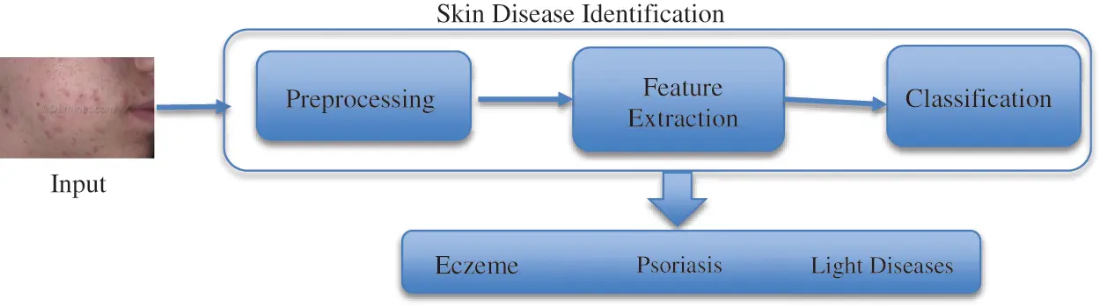

**Figure 2:** Proposed methodology

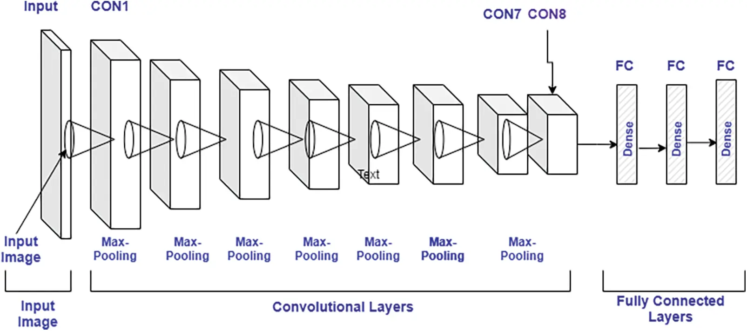

**Figure 3:** CNN model architecture

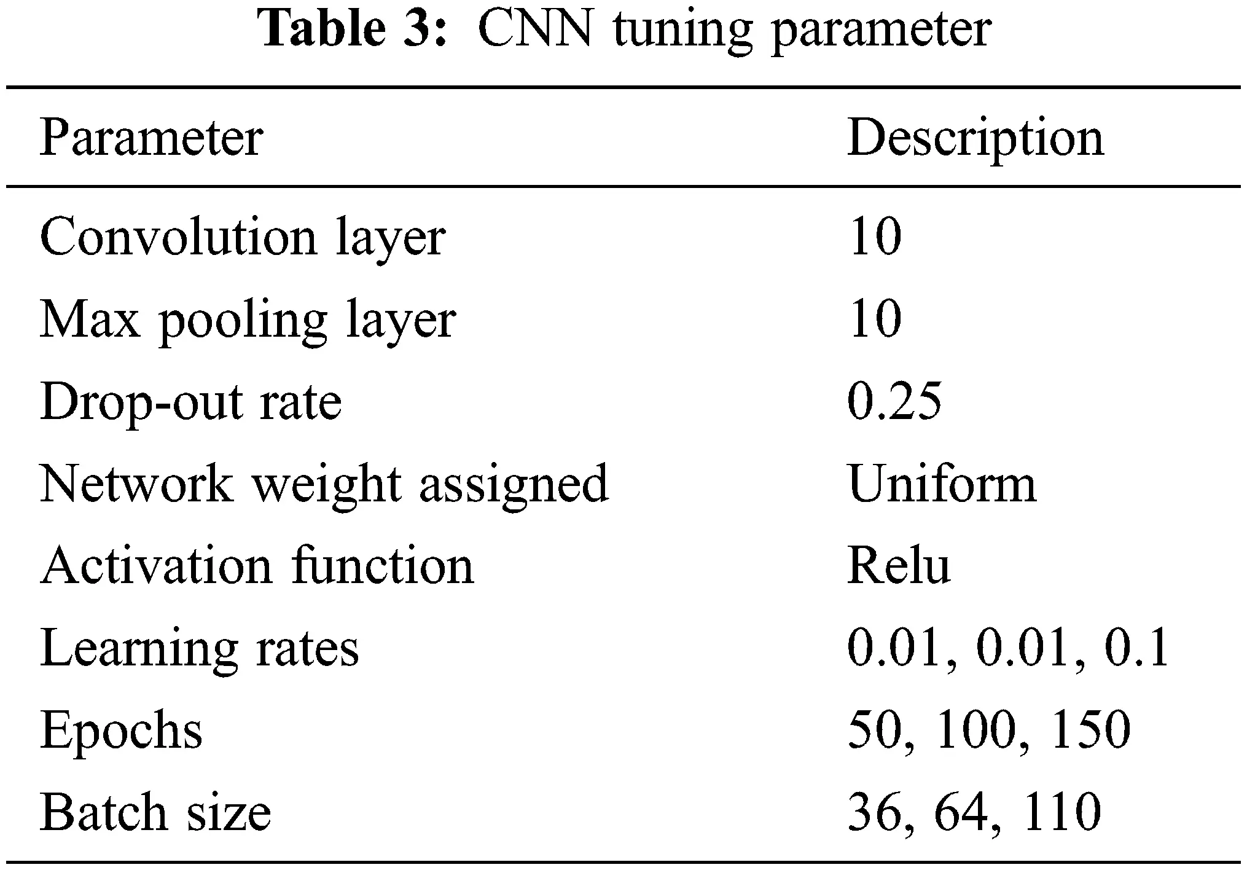

**6.1 Image Pre-Processing and Labelling**

This is an initial phase, where the raw image dataset is pre-processed to remove noise before inputting it to the Convolution neural network classifier. It must for a model to analyze the structure of the network and dataset to generate better outcomes. Therefore, the dataset is preprocessed initially to collect appropriate features of images which can be used by the model to accurately diagnose or predict the actual outcomes. Here in pre-processing, firstly, the size of each image is normalized as per requirement which is 256*256 pixels. The image size is defined during network design and act as input node. The same is used to train the model to achieve consistent results. The python libraries are utilized to perform the same task with maximum accuracy. Secondly, all images are converted into grey images.

The pre-processing stage is considered as a phase that extracts image features to train the model. These training features are the reason for accurate prediction. After pre-processing, the data labeled with the correct acronym. After this data is segregated into different classes which can be used for testing.

**6.2 Mathematical Representation of Classification**

Here, the Convolution neural network (CNN) is utilized for classification, one of the most prominent technologies used at present. Here, the model is accomplished with the feature extracted in the previous phase. In the CNN, the image dataset is processed in different layers and each layer has the following sub-layers:

**a) Convolutional Layer**

The main operation in the convolutional layer is convolution in which the input image is mapped with a filter of m*m and generates outcome feature maps. The outcome of the convolutional layer is expressed by [Eq. (1)](https://www.techscience.com/csse/v44n3/49136/html#eqn-1)

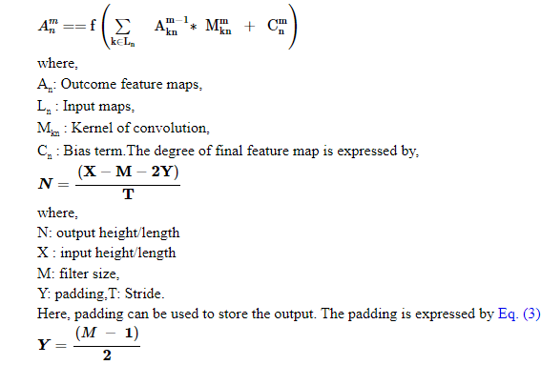

where, M: filter size.

ReLU Layer: This also plays an important in CNN and is also known as the Activation layer. This layer is next to the convolution layer and the output of the same will be input to the ReLU. This layer creates linearity in the convolutional process. So, each convolutional layer is associated with a ReLU layer. The important task of this layer is to update all negative activation to zero and thresholding which is given by f(p) = max(0, p). This layer helps the system to learn quickly and remove gradient problems. ReLU activation function is well designed for multiclass classification.

Max-Pooling Layer: This layer generates the reduce sized output after maximizing the elements of each block. This layer also controls the overfitting problem without the learning process. Dropout Layer: This layer is used to drop out the input elements having a probability less than a certain value and this process is a part of the training phase.

Batch Normalization Layer: This layer plays an important role in between the convolutional and ReLU layer. This layer is used to enhance the training speed and reduce sensitivity. This layer performs different operations (subtractor, division, shifting, and scaling). The activation layer to normalize its value. Firstly, the activation is subtracted with mean, and divided by the standard deviation which is followed by fluctuating by α and then scaled by Θ. The batch normalized outcome, Bk is expressed by the [Eqs. (4)](https://www.techscience.com/csse/v44n3/49136/html" \l "eqn-4)–[(7)](https://www.techscience.com/csse/v44n3/49136/html#eqn-7),

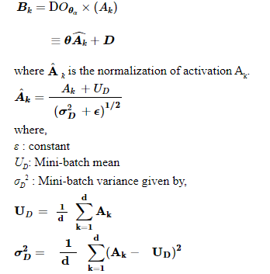

**b) Fully Connected Layer**

Here, the neurons of the next layer are linked with neurons of the previous layer and produced a vector, and the vector dimensions represent the number of classes.

**c) Output Layer**

This layer is a combination of softmax and classification. In this layer, firstly, the softmax is used to distribute the probability and the classification is carried out by the network. The softmax is defined by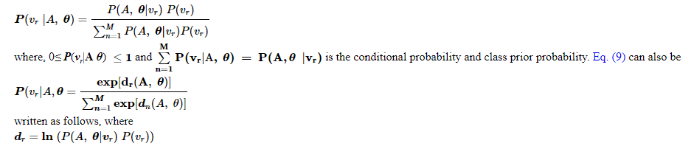 [Eq. (8)](https://www.techscience.com/csse/v44n3/49136/html#eqn-8)

**6.3 Skin Lesion Detection Algorithm**

The algorithm initiates with images ***INRGB***. After that ***INRGB*** is segmented into ***MSmask***. The ***MSmask*** is further partitioned into several regions ***Rsep***. Afterward, it chooses the Region of Interest (RoI) and the same is used to identify skin disease. The proposed algorithm is given in below:

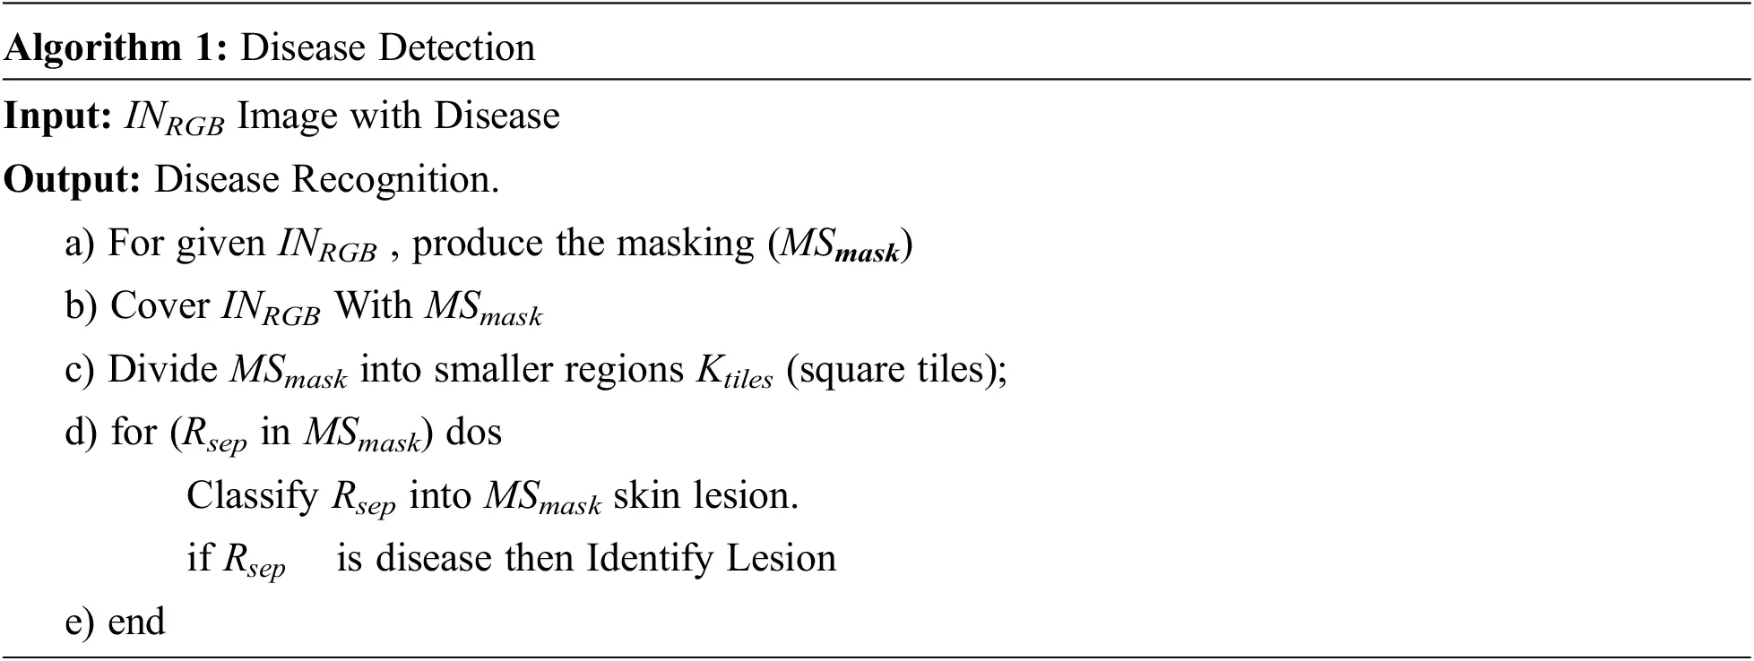

The disease detection methodology starts with the first phase of data pre-proceeding and labeling. Secondly, pre-processed data is classified using a Convolution neural network. “[Fig. 2](https://www.techscience.com/csse/v44n3/49136/html#fig-2): Laid down the complete process of disease classification and detection. The CNN is tuned on hyperparameters which are based on the training of proposed network and numbers of hidden layer. Here in this project, the hyperparameter are chosen based on the network which used to classify the images. The complete Convolution neural network (CNN) layout is shown in [Fig. 3](https://www.techscience.com/csse/v44n3/49136/html#fig-3) and description is given in [Tab. 3](https://www.techscience.com/csse/v44n3/49136/html#table-3)

.



**Figure 2:** Proposed methodology



**Figure 3:** CNN model architecture



**6.4 Image Pre-Processing and Labelling**

This is an initial phase, where the raw image dataset is pre-processed to remove noise before inputting it to the Convolution neural network classifier. It must for a model to analyze the structure of the network and dataset to generate better outcomes. Therefore, the dataset is preprocessed initially to collect appropriate features of images which can be used by the model to accurately diagnose or predict the actual outcomes. Here in pre-processing, firstly, the size of each image is normalized as per requirement which is 256*256 pixels. The image size is defined during network design and act as input node. The same is used to train the model to achieve consistent results. The python libraries are utilized to perform the same task with maximum accuracy. Secondly, all images are converted into grey images.

The pre-processing stage is considered as a phase that extracts image features to train the model. These training features are the reason for accurate prediction. After pre-processing, the data labeled with the correct acronym. After this data is segregated into different classes which can be used for testing.

**6.5 Mathematical Representation of Classification**

Here, the Convolution neural network (CNN) is utilized for classification, one of the most prominent technologies used at present. Here, the model is accomplished with the feature extracted in the previous phase. In the CNN, the image dataset is processed in different layers and each layer has the following sub-layers:

**a) Convolutional Layer**

The main operation in the convolutional layer is convolution in which the input image is mapped with a filter of m*m and generates outcome feature maps.

•   ReLU Layer: This also plays an important in CNN and is also known as the Activation layer. This layer is next to the convolution layer and the output of the same will be input to the ReLU. This layer creates linearity in the convolutional process. So, each convolutional layer is associated with a ReLU layer. The important task of this layer is to update all negative activation to zero and thresholding which is given by f(p) = max(0, p). This layer helps the system to learn quickly and remove gradient problems. ReLU activation function is well designed for multiclass classification.

•   Max-Pooling Layer: This layer generates the reduce sized output after maximizing the elements of each block. This layer also controls the overfitting problem without the learning process.

•   Dropout Layer: This layer is used to drop out the input elements having a probability less than a certain value and this process is a part of the training phase.

  Batch Normalization Layer: This layer plays an important role in between the convolutional and ReLU layer. This layer is used to enhance the training speed and reduce sensitivity. This layer performs different operations (subtractor, division, shifting, and scaling). The activation layer to normalize its value. Firstly, the activation is subtracted with mean, and divided by the standard deviation which is followed by fluctuating by α and then scaled by Θ.

6.6 **Skin Lesion Detection Algorithm**

The algorithm initiates with images ***INRGB***. After that ***INRGB*** is segmented into ***MSmask***The ***MSmask*** is further partitioned into several regions ***Rsep***. Afterward, it chooses the Region of Interest (RoI) and the same is used to identify skin disease. The proposed algorithm is given in below:



1. **System Design** 
   1. **Block Diagram of The Project**

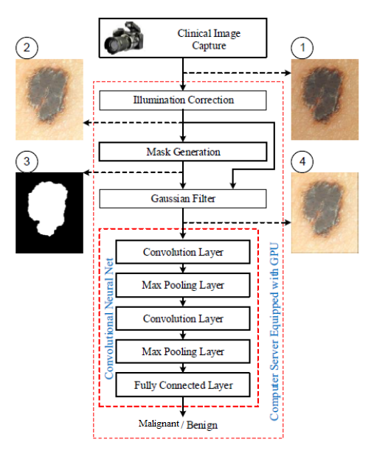

In the above system architecture

1. Clinical Image capture : The system captures the image from camera or user can select the image
2. Illumination correction: Illumination correction (IC) is the method of adjusting the lighting within a collection of images so that the lighting is evenly distributed across the image.
3. Mask generation : Then generates the mask using Gaussian filter algorithm.
4. CNN : Then CNN classification model applies to find whether it is Malignant or benign. This CNN consists of various Layer which is shown in the above figure such as convolutional layer, max layer, fully connected layer.
   1. **Module description**

Dataset: Skin images dataset is used. The data used for this research is a dermoscopy image obtained from https://www.kaggle.com. The data set consists of 5202 images for training data and 30 images for data testing. The training data consisted of 2808 melanoma images and 2394 non-melanoma images. Test data consisted of 4 images of melanoma and 4 images of non melanoma.

Preprocessing: The main goal of this step is to reduce the artifacts that may lead CNN to false classification. Images taken by digital cameras, generally include noises and lighting effects that should be eliminated before processing the image. In this step, a Gaussian filter is applied on the normal regions of the skin. This is done to smooth the area outside the lesion, hence reducing this area effect on the classification.

CNN: In this study, the method used for the classification process is Convolutional Neural Network.The architecture that will be used in this network consists of 3 layers namely the Input Layer, Hidden Layer, and Output Layer. Input data as much as 224 x 224 nodes, Hidden as many as 30 nodes and Output consists of 2 nodes (Non Melanoma and Melanoma). Hidden Node is determined randomly. Thereinafter the scheme will determined through several trials against system requirements. Selection of Hidden 30 Nodes are a good weight in resulting in high accuracy in melanoma identification systems and not takes a lot of time in the image processing. Data to be entered in the Input Layer will be transformed first. Training conducted in order to find the optimal weight and bias or suitable for use on Testing process.

1. **System Implementation**

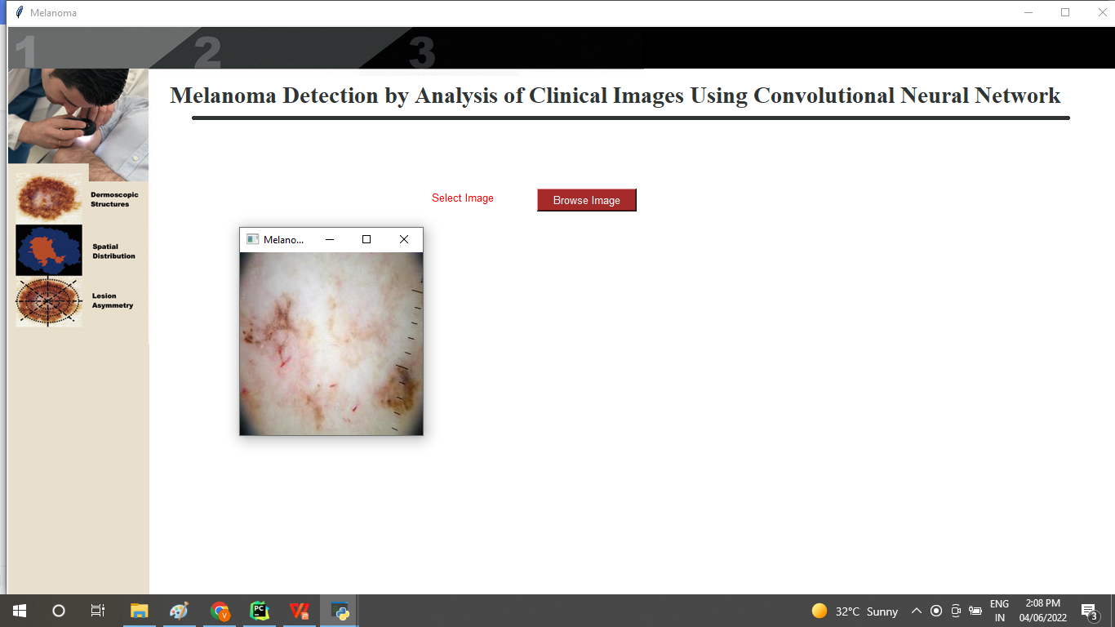

Figure 7.1 : Input Image

In this module selecting the skin image using the following code :

filename = askopenfilename(filetypes=[("images","*.*")])

img = cv2.imread(filename)

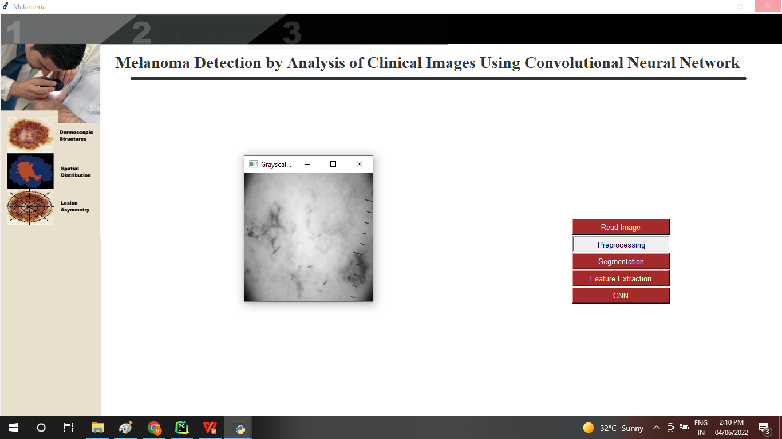

Figure 7.2 : Gray colored Image

In this module, converts the selected image into grayscale and denoises the image using Guassian filter algorithm called preprocessing.



Figure 7.3 :Segmentation

Converts the image into various parts called segmentation.Image segmentation involves converting an image into a collection of regions of pixels that are represented by a mask or a labeled image. By dividing an image into segments, you can process only the important segments of the image instead of processing the entire image.

1. **Conclusion**

This project introduces a method to detect skin cancer using the deep learning method. In our proposed system, the CNN can combine local features and learn characteristics of the image by combining convolutional and pooling layers. The proposed method includes images from International Skin Imaging Collaboration preprocessing to extract the region of interest in the image and then augment some pictures to produce a more extensive dataset containing images. The resulting dataset has been applied to the CNN model to train the model, which comprises different layers, including pooling, convolutional, classification layer, etc. Testing the model produced promising results with an accuracy of 70%. To improve the accuracy, we used another variation of the convolutional neural network, which is resnet50 and VGG19/16. The results are promising. The results were enhanced from 70 to 92%. Unlike other methods, the proposed method based on neural networks shows the best results, and different machine learning techniques can improve the results.

This project presents serveral sections on state of art techniques, analysis and comparisons on benchmark datasets for the brain tumor, breast cancer, lung cancer, skin cancer detection respectively of measure, senstivity, specificity, accuracy, precision point of view it is feasible to Implmented. Different types of cancer detection and classification using machine assistance have opened up a new research area for early detection of cancer, which has shown the ability to reduce manual system impairments.

High Accuracy: Deep learning algorithms can achieve high accuracy rates in identifying skin cancer lesions. These algorithms can be trained on large datasets of skin images, allowing them to learn complex patterns indicative of cancerous or non-cancerous lesions.

Early Detection: Deep learning models can detect skin cancer at early stages, which is crucial for successful treatment and improved patient outcomes. Early detection increases the chances of successful treatment and reduces the risk of metastasis.

Automation: Deep learning models can automate the process of analyzing skin images for signs of cancer. This reduces the workload on healthcare professionals and speeds up the diagnostic process, allowing for faster treatment decisions.

Scalability: Deep learning algorithms can be easily scaled to analyze large volumes of skin images, making them suitable for use in clinics and hospitals with high patient loads. They can also be deployed in remote areas where access to dermatologists may be limited.

Personalized Medicine: Deep learning models can be trained to recognize subtle differences in skin lesions based on individual characteristics such as skin type, age, and gender. This allows for personalized diagnosis and treatment plans tailored to each patient's specific needs.

Cost-Effectiveness: Automating skin cancer detection with deep learning can potentially reduce healthcare costs by streamlining the diagnostic process and minimizing the need for unnecessary biopsies or consultations with specialists.

Continuous Improvement: Deep learning models can continuously learn from new data, allowing them to improve over time and adapt to changes in skin cancer patterns or treatment protocols. This ensures that the system remains effective and up-to-date with the latest medical knowledge.

Automated Diagnosis: Deep learning models can be trained to analyze images of skin lesions and classify them as either benign or malignant with high accuracy. These models can assist dermatologists in making faster and more accurate diagnoses, especially in cases where expertise is limited or unavailable.

Early Detection: Deep learning algorithms can help in the early detection of skin cancer by identifying subtle changes in moles or lesions that may indicate the presence of malignancy. Early detection is crucial for timely intervention and improved patient outcomes.

Risk Assessment: Deep learning models can predict the risk of developing skin cancer based on various factors such as age, skin type, sun exposure history, and family history of cancer. These risk assessment tools can help individuals and healthcare providers identify high-risk patients who may benefit from more frequent screenings or preventive measures.

Personalized Treatment Planning: Deep learning algorithms can analyze molecular and genetic data from skin cancer samples to tailor treatment plans based on individual patient characteristics. This personalized approach to treatment can improve therapeutic outcomes and reduce the risk of adverse effects.

Differential Diagnosis: Deep learning models can assist clinicians in distinguishing between different subtypes of skin cancer, such as melanoma, basal cell carcinoma, and squamous cell carcinoma. Accurate differential diagnosis is essential for selecting the most appropriate treatment strategy for each patient.

Telemedicine: Deep learning algorithms can be integrated into telemedicine platforms to facilitate remote consultations and triage of skin lesions. Patients can upload images of their skin lesions for automated analysis, allowing dermatologists to provide timely feedback and recommendations without the need for an in-person visit.

Education and Training: Deep learning models can serve as educational tools for medical students and healthcare professionals, helping them learn to recognize the characteristic features of skin cancer lesions. Virtual simulation platforms powered by deep learning algorithms can provide interactive training experiences for dermatology residents and practicing clinicians.

Clinical Research: Deep learning techniques can be applied to large-scale datasets of skin cancer images and patient records to identify novel biomarkers, prognostic factors, and therapeutic targets. These insights can inform the development of new diagnostic tests and treatment modalities for skin cancer.

**References**

1. Fulgencio Navarro, Marcos Escudero-Vinolo and Jesus Bescos., et al. "Accurate segmentation and registration of skin lesion images to evaluate lesion change” 2168-2194 (c) 2018 IEEE. Personal.
2. M.W. Greaves, Skin disease, Britannica, 29, 2020, [Online]. Available: https://www.britannica.com/science/human-skindisease. (Accessed 11 June 2021).
3. Bangladesh: Skin disease, 2018, [Online]. Available: https://www. worldlifeexpectancy.com/bangladesh-skin-disease. (Accessed 9 July 2021).
4. Cancer, world health organization, 21, 2021, [Online]. Available: https://www.who.int/newsroom/fact-sheets/detail/cancer. (Accessed 20 March 2020).
5. Md. Al Mamun, Mohammad Shorif Uddin, 2 IJCRT2307676 International Journal of Creative Research Thoughts (IJCRT) www.ijcrt.org f777 survey on a skin disease detection system, Int. J. Healthc. Inform. Syst. Inform. 16 (4) (2021) 1–
6. C.N. Vasconcelos, B.N. Vasconcelos, Experiments using deep learning for dermoscopy image analysis, Pattern Recognit. Lett. 139 (2020) 95–103.
7. U.-O. Dorj, K.K. Lee, J.Y. Choi and. M. Lee, The skin cancer classification using deep convolutional neural network, Multimedia Tools Appl. 77 (2018) 9909–9924.
8. M. Taufiq, N. Hameed, A. Anjum, F. Hameed, mSkin Doctor: A Mobile Enabled System for Early Melanoma Skin Cancer Detection Using Support Vector Machine, in: eHealth 360◦. International Summit on eHealth, 2017, pp. 468–475.
9. Jagdis etal., J.A.D.L. Cruz-Vargas, M.E.R. Camacho, Advance study of skin diseases detection using image processing methods, Nat. Volatiles Essent. OilsJ. 9 (1) (2022) 997–1007.
10. Z. Naeem, G. Zia, Z. Bukhari, A healthcare model to predict skin cancer using deep extreme machine, J. NCBAE 1 (2) (2022) 23–30.
11. S.K. Bandyopadhyay, P. Bose, A. Bhaumik, S. Poddar, Machine learning and deep learning integration for skin diseases prediction, Int. J. Eng. Trends Technol. 70 (2) (2022) 11–18.
12. A. Kalaivani, S. Karpagavalli, Detection and classification of skin diseases withensembles of deep learning networks in medical imaging, Int. J. Health Sci. 6(S1) (2022) 13624–13637.
13. S.A. AlDera, M.T.B. Othman, A model for classification and diagnosis of skin disease using machine learning and image processing techniques, Int. J. Adv. Comput. Sci. Appl. 13 (5) (2022).
14. P.R. Kshirsagar, H. Manoharan, S. Shitharth, A.M. Alshareef, N. Albishry, P.K. Balachandran, Deep learning approaches for prognosis of automated skin disease, Life 2022 12 (426) (2022).