REAL ESTATE INVESTMENT ADVISOR – PROJECT REPORT

Project Title
Real Estate Investment Advisor: Predicting Property Profitability & Future Value

Objective
The objective of this project is to develop a data-driven system that helps real estate investors make informed decisions by:
- Analysing property data
- Identifying investment opportunities
- Understanding factors affecting property prices
- Providing insights through an interactive dashboard

Problem Statement
Real estate investment decisions are often complex and depend on multiple factors such as:
- Location
- Property size
- Amenities
- Infrastructure
- Market trends
This project aims to simplify decision-making by analyzing these factors and providing meaningful insights.

Domain
Real Estate / Investment / Financial Analytics

Tools & Technologies Used
Tool | Purpose
Python | Data processing and analysis
Pandas | Data manipulation
Matplotlib | Data visualization
Streamlit | Dashboard development
Scikit-learn | (Optional ML extension)
Excel/CSV | Data storage

Dataset Description
Dataset: india_housing_prices.csv
Key Features:
- Location: State, City, Locality
- Property Details: BHK, Size, Type
- Financial Data: Price, Price per SqFt
- Infrastructure: Schools, Hospitals, Transport
- Additional Features: Amenities, Parking, Security

Data Preprocessing
The dataset was cleaned and prepared using the following steps:
- Handled missing values using:
  - Mean/median (numerical)
  - Mode (categorical)
- Removed duplicate records
- Converted data types (e.g., numeric columns)
- Created new features:
  - Price per SqFt
  - Age of Property
- Standardized categorical values

Exploratory Data Analysis (EDA)
🔹 1–5: Price & Size Analysis
1. Price Distribution
- Most properties fall within a moderate price range
- Few high-value outliers exist
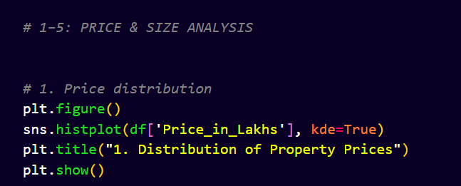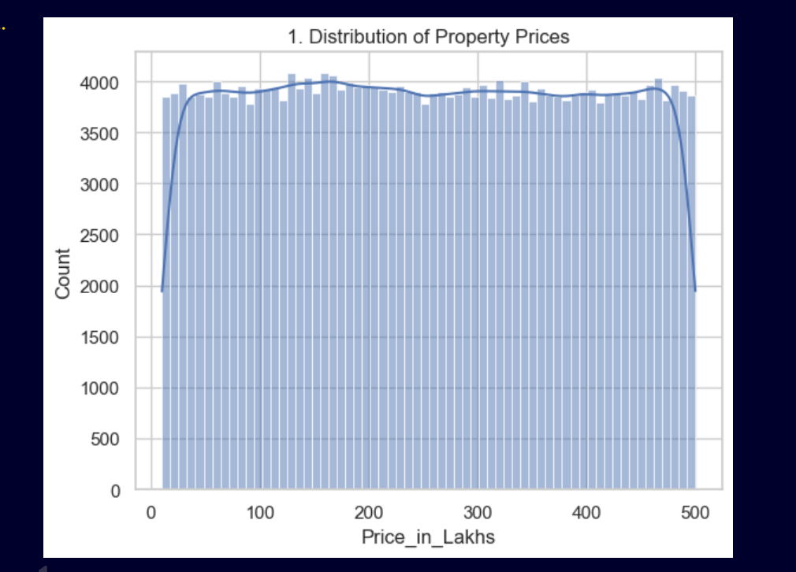

2. Size Distribution
- Majority of properties are mid-sized
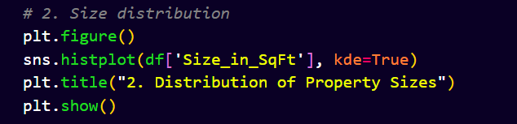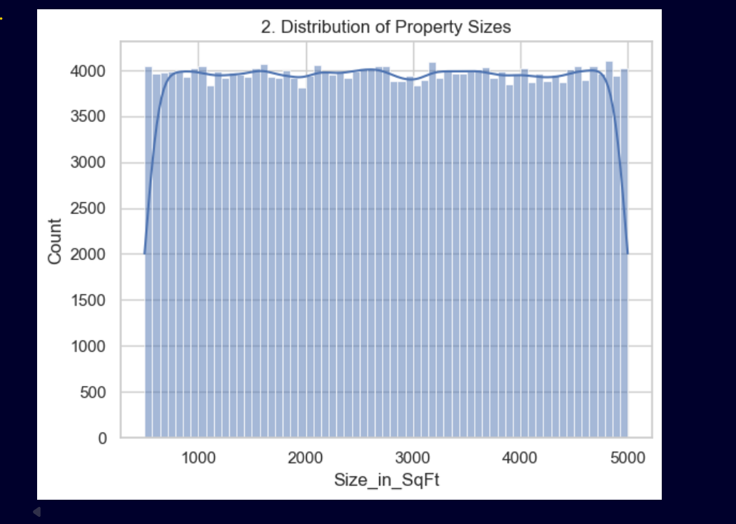

3. Price per SqFt by Property Type
- Villas and premium properties have higher rates
4. Size vs Price Relationship
- Strong positive correlation between size and price

5. Outliers
- Some properties have extremely high price per sqft

🔹 6–10: Location Analysis
6. Price per SqFt by State
- Urban states show higher prices

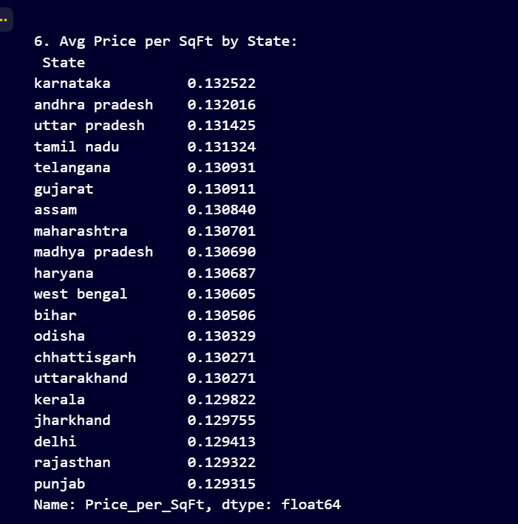
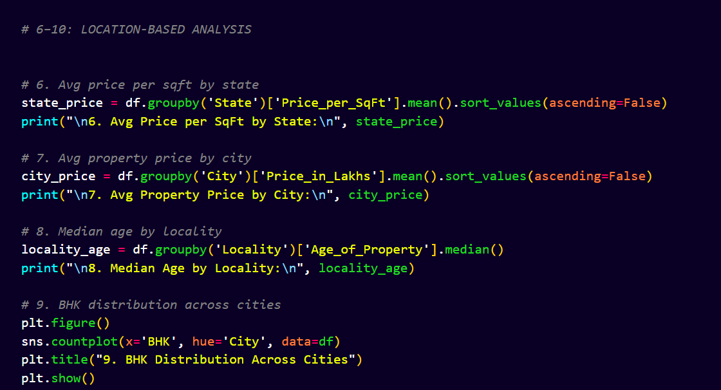

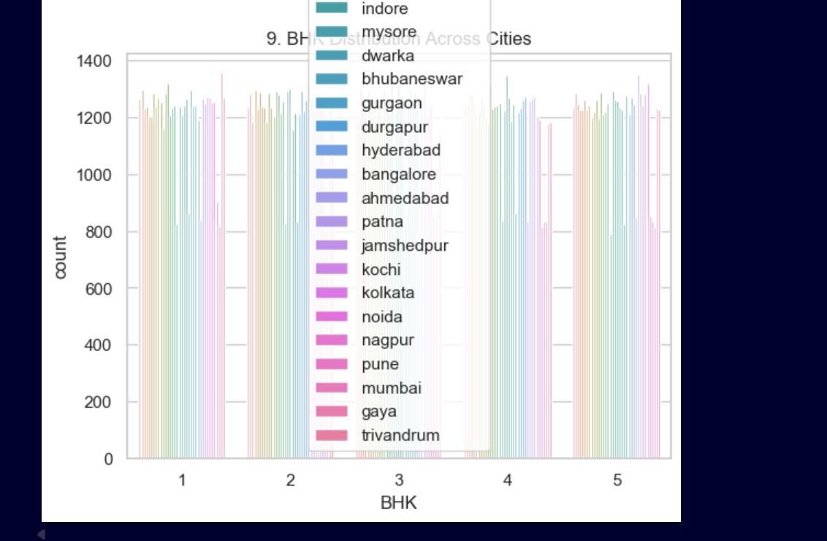
7. Average Price by City
- Metro cities dominate pricing
8. Age of Property by Locality
- Newer areas have lower property age
9. BHK Distribution
- 2BHK and 3BHK dominate
10. Top Expensive Localities
- Premium areas significantly higher than average

🔹 11–15: Feature Relationships
11. Correlation Heatmap
- Size strongly correlates with price
12. Schools vs Price
- Better education access increases value
13. Hospitals vs Price
- Healthcare availability positively impacts pricing
14. Furnished Status vs Price
- Fully furnished properties cost more
15. Facing Direction
- Certain directions (e.g., East/North) preferred
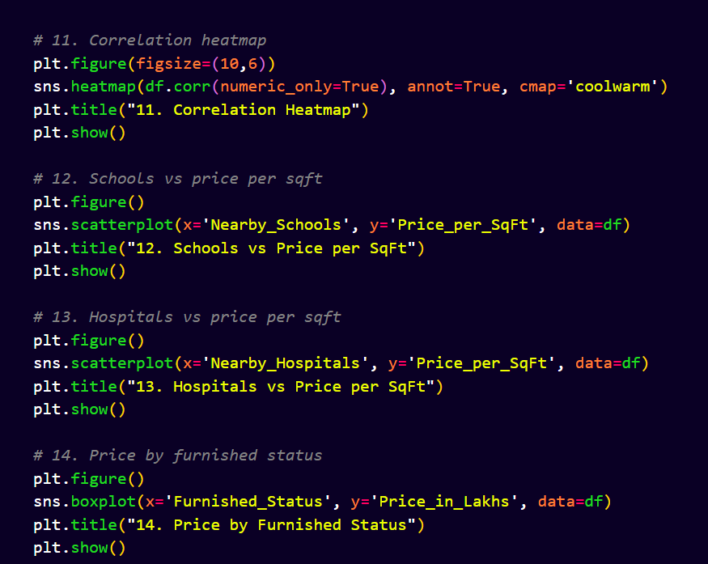

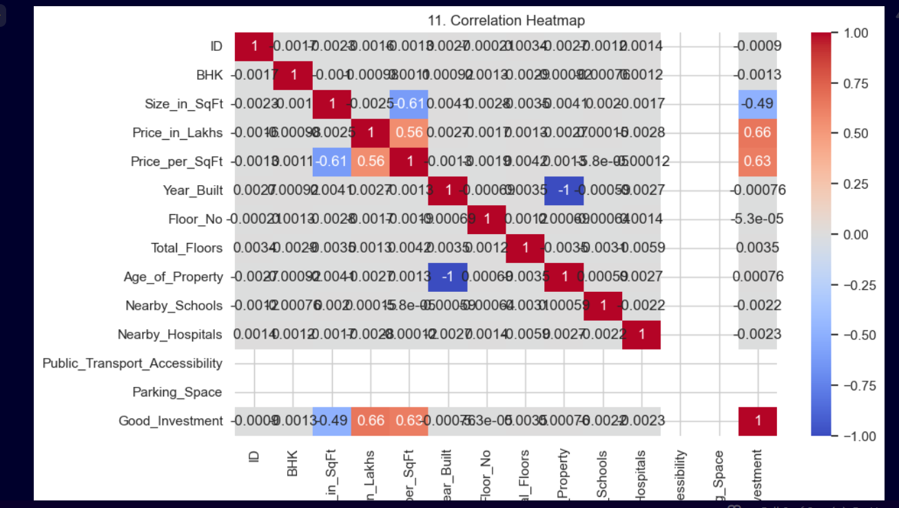
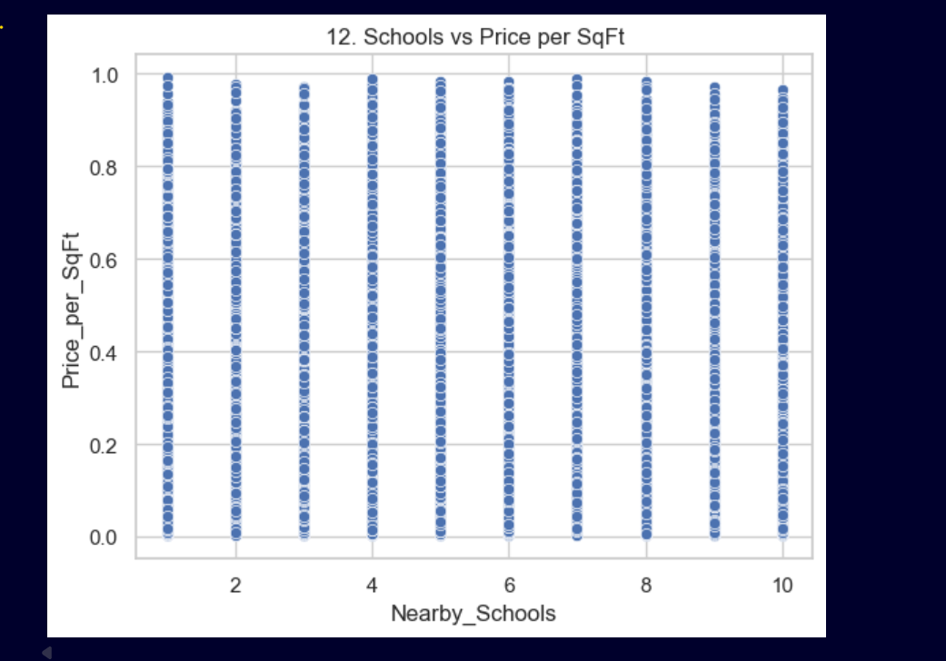

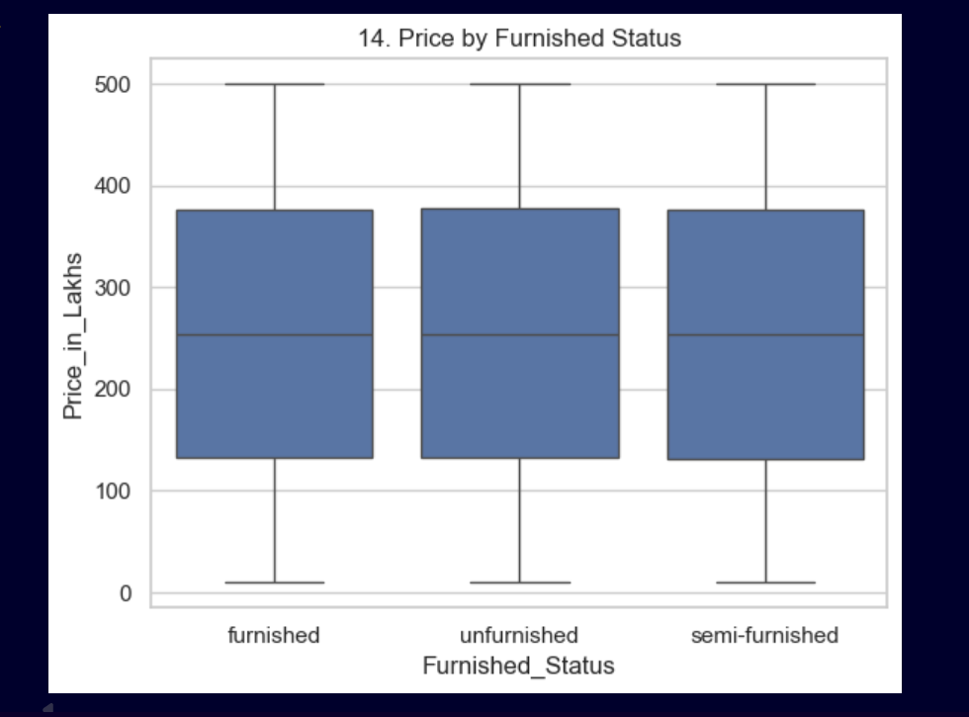

🔹 16–20: Investment Insights
16. Owner Type
- Majority are individual owners
17. Availability Status
- Most properties are available
18. Parking Impact
- More parking = higher price
19. Amenities Impact
- More amenities → higher value
20. Transport Accessibility
- Strong influence on property valuation
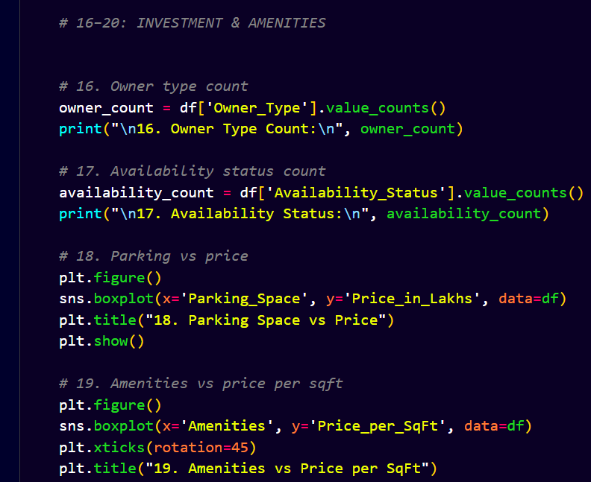

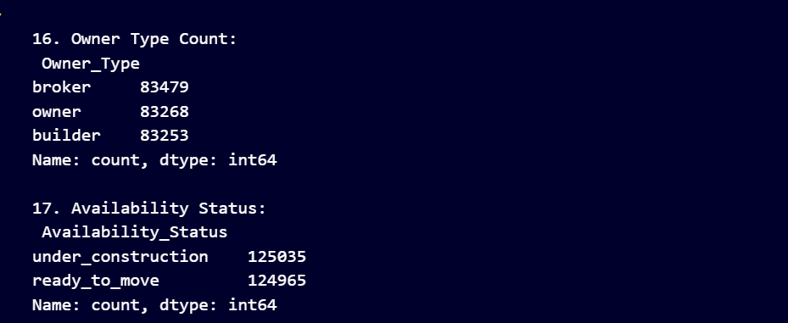

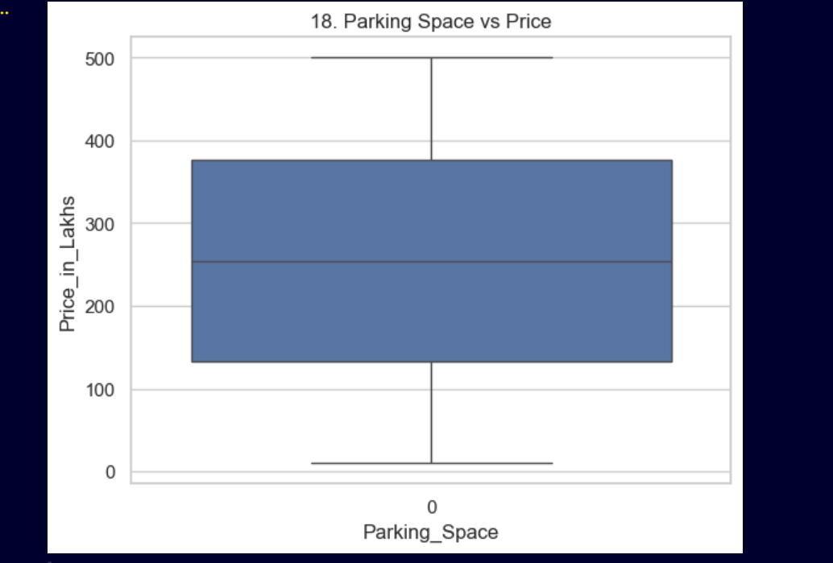

Dashboard (Streamlit Application)
The dashboard includes:
🔹 Overview Page
- Filters (City, Property Type, BHK)
- KPI Metrics:
  - Total Properties
  - Avg Price
  - Avg Size
  - Price per SqFt
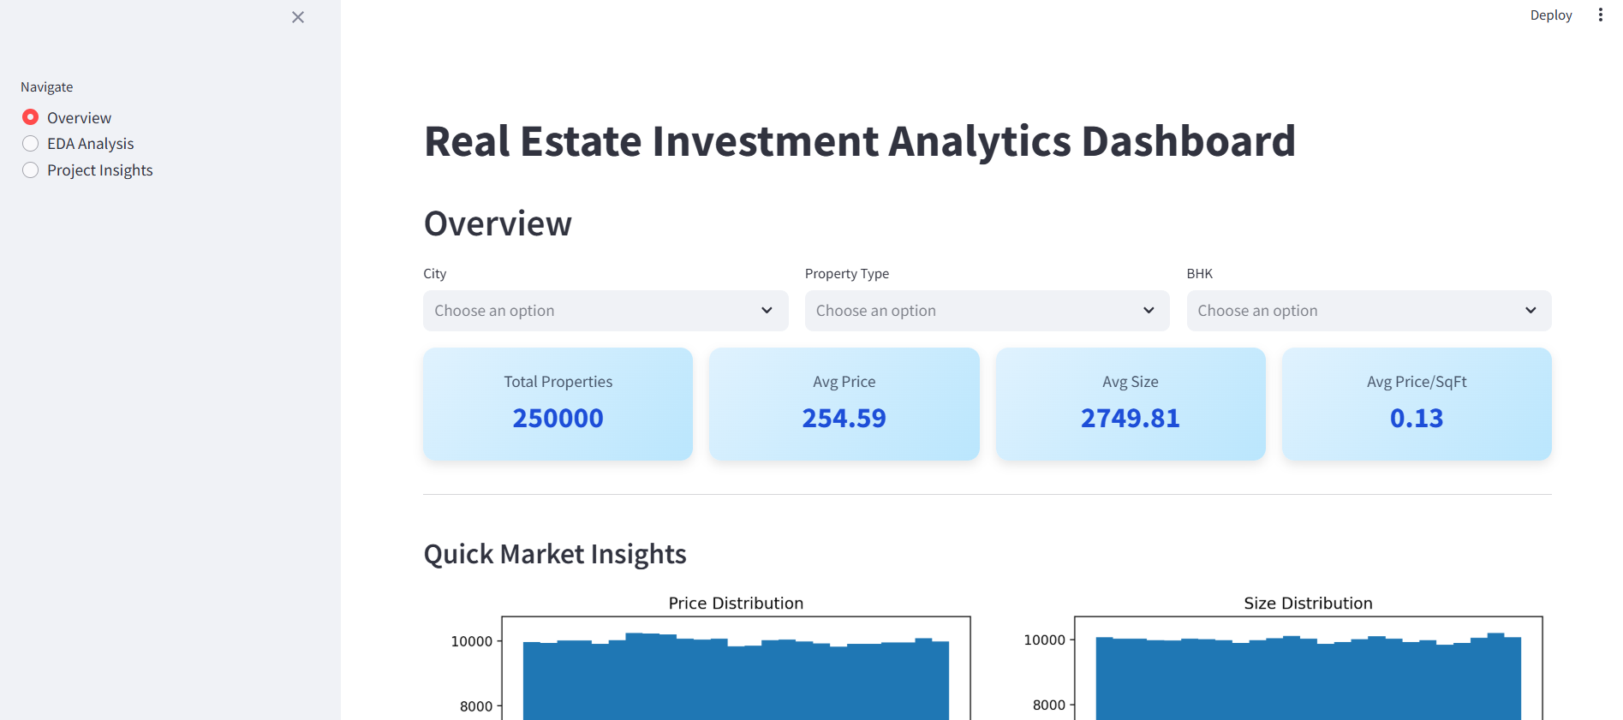

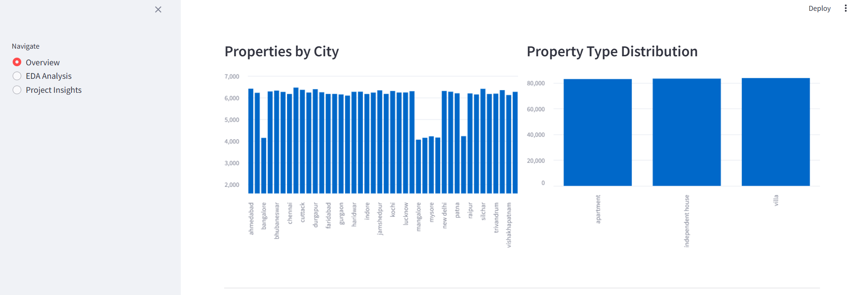
🔹 EDA Page
- Dropdown-based navigation:
  - Price & Size Analysis
  - Location Analysis
  - Feature Relationships
  - Investment Insights
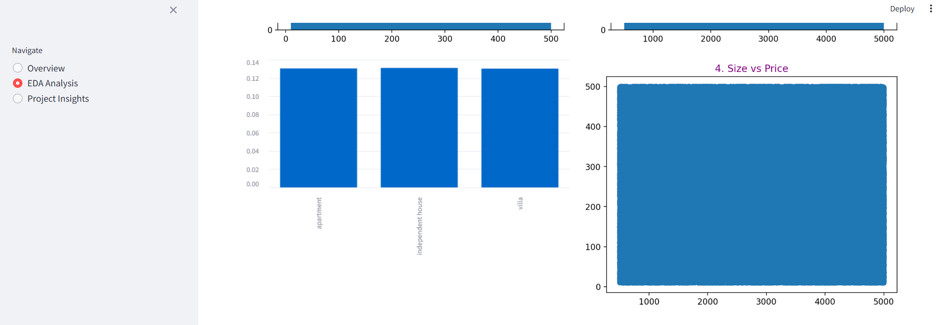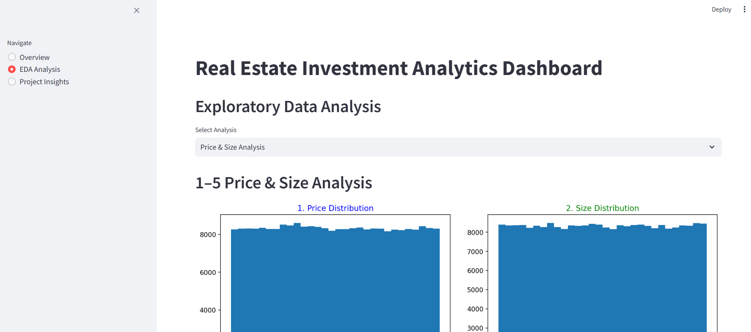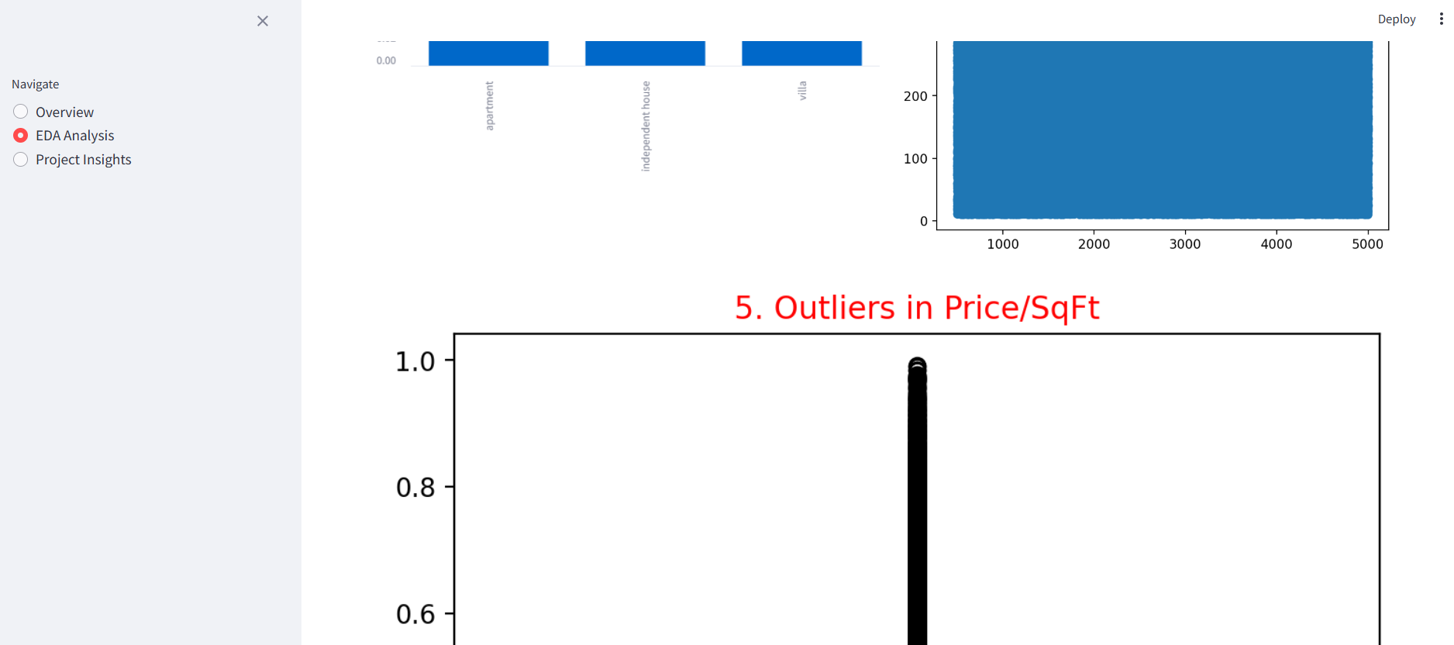

🔹 Insights Page
- Key findings with supporting charts
- Business conclusions

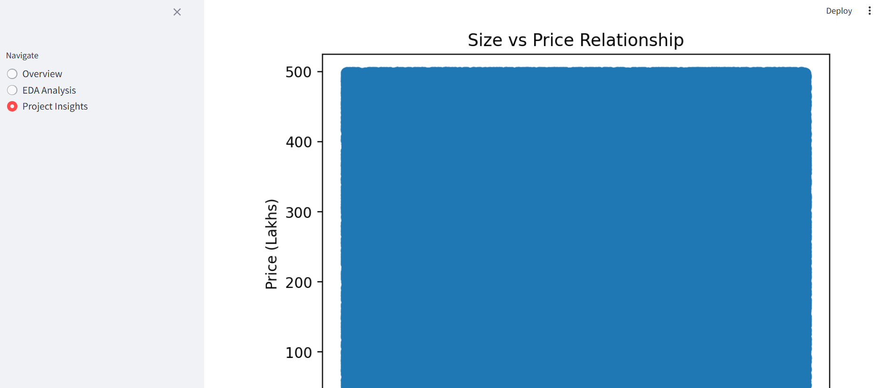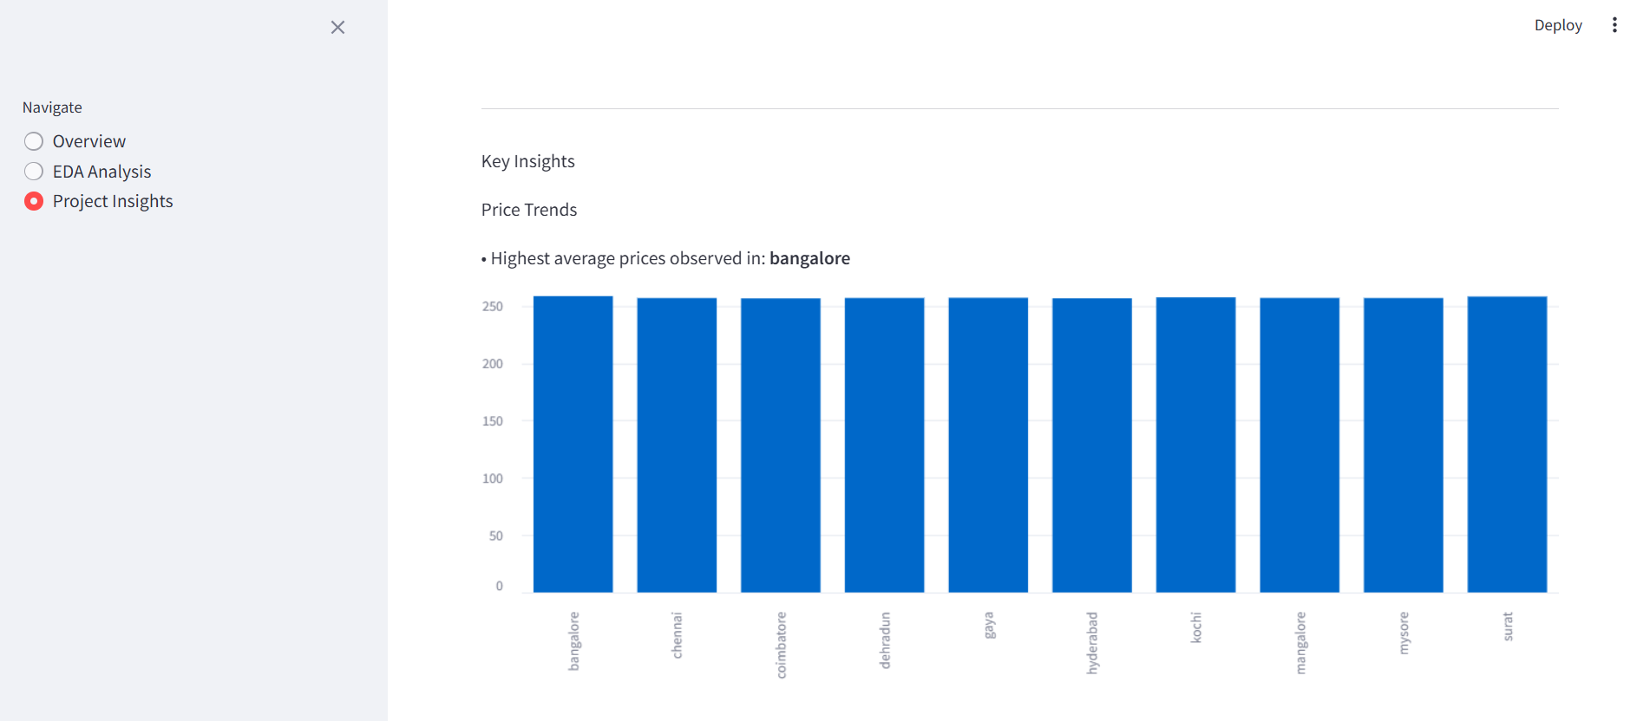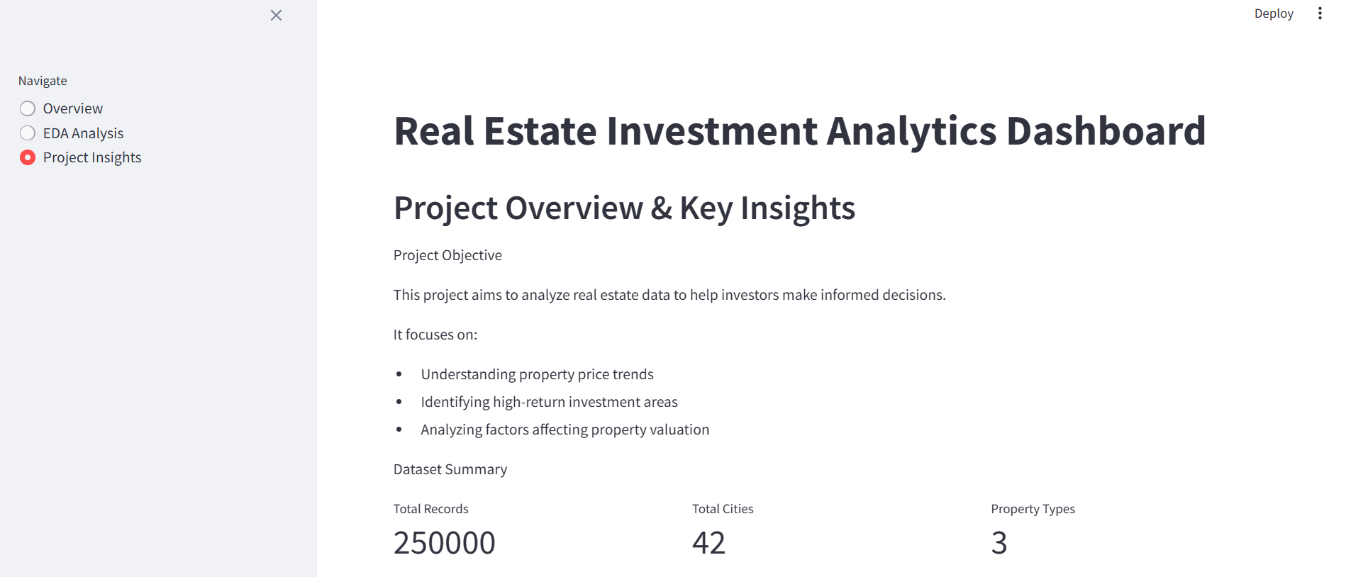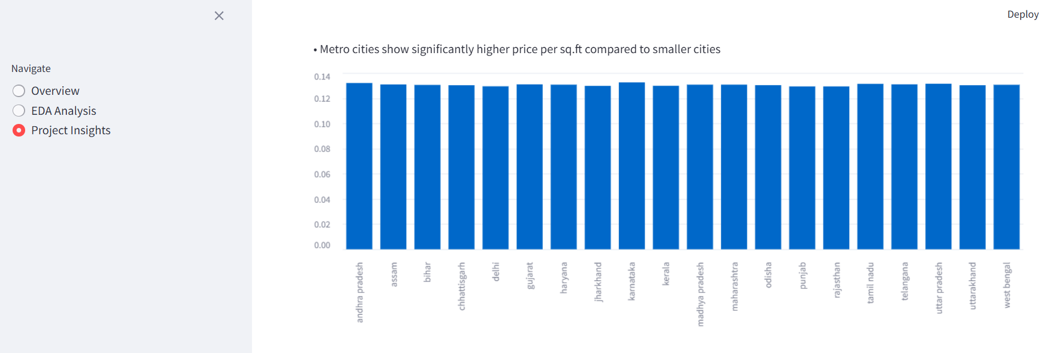

Key Insights
- Property size has a strong positive impact on price
- Metro cities have significantly higher property rates
- Amenities and infrastructure increase property value
- Transport accessibility plays a crucial role
- Villas and independent houses are premium investments

Business Impact
- Helps investors identify profitable properties
- Assists real estate companies in pricing strategies
- Improves customer trust through data-driven insights
- Enables smarter investment decisions

Limitations
- Dataset may not reflect real-time market changes
- Some features may be estimated or generalized
- No live API integration

Future Enhancements
- Add Machine Learning models:
  - Price prediction (Regression)
  - Investment classification
- Integrate real-time data APIs
- Add interactive maps
- Use advanced visualization (Plotly)

Conclusion
This project demonstrates how data analytics can significantly improve real estate investment decisions.
By analysing multiple factors such as:
- Location
- Amenities
- Infrastructure
Investors can make smarter, data-driven, and profitable decisions.

