User manual for EMB8618I

# Basic setup (J-Link)

Step 1: To configure the debugger setting, click the **“Flash”** tag and **“Configure Flash Tools…”** to open the configuration menu.

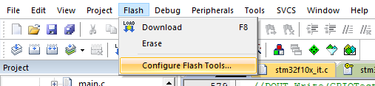

Step 2: Once the configuration menu appears, switch to the **“Debug”** tag and change the debugger to **“J-LINK/J-TRACE Cortex”.** After that, click the **“Settings”** button for configuring debugger settings.

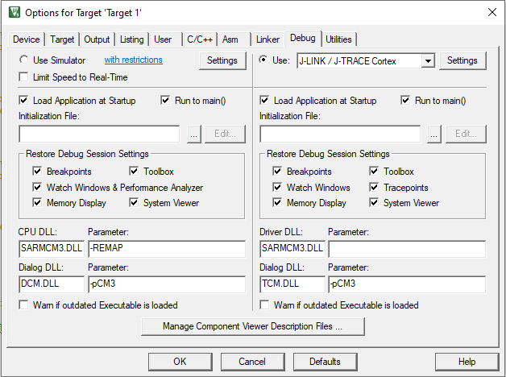

Step 3: For the Cortex JLink/JTrace Target Driver Setup, switch to the **“Flash Download”** tag.

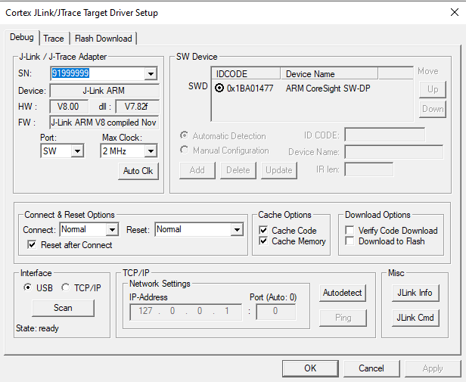

Step 4: Clicking the **“Add”** button for adding the programming Algorithm.

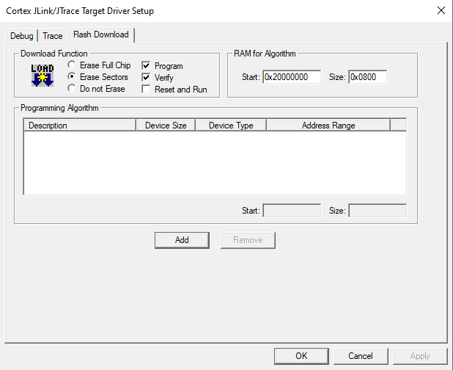

Step 5: Once opened the Flash Programming Algorithm menu, you should add the “STM32F10x Connectivity Line Flash”.

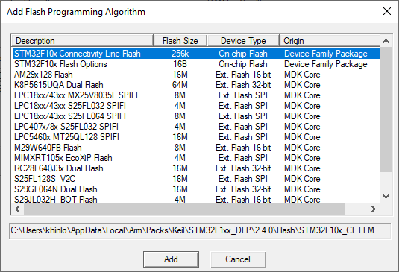

Step 6: Remember to check the **“Reset and Run”** and click OK for confirming the changes.

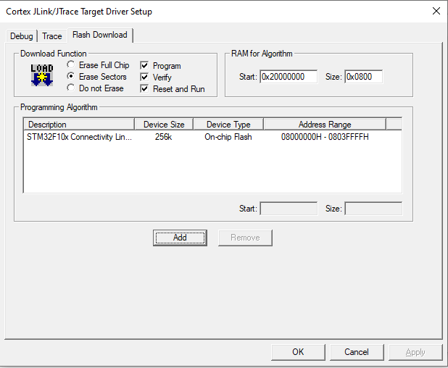

# Pin configuration:

LED, ALARM, ADC, DAC, UART:

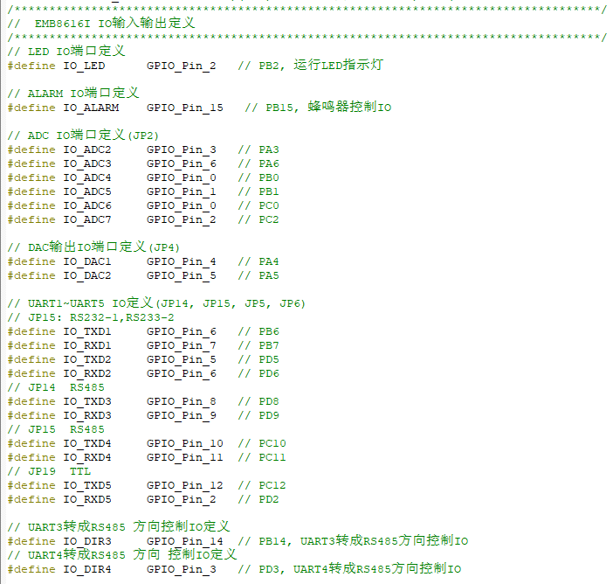

CAN, EEPROM, Pulse FCLK input

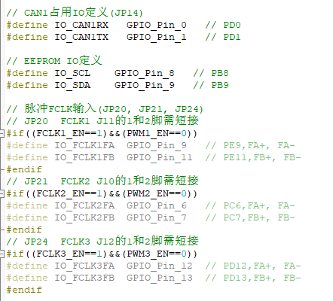

PWM output

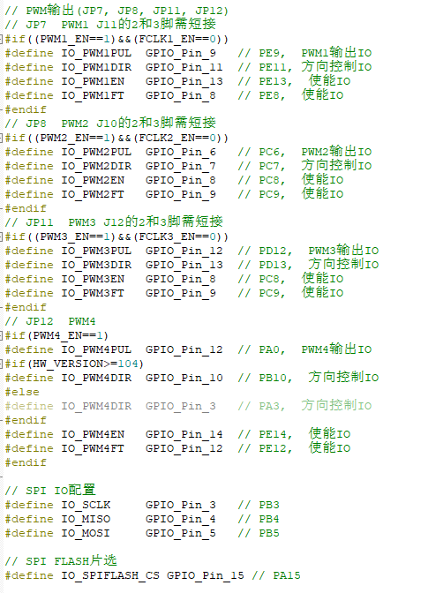

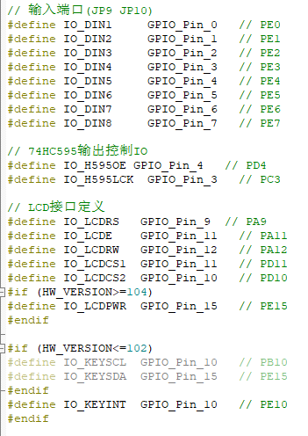

// EMB8616I IOÊäÈëÊä³ö¶¨Òå

/************************************************************************************/

// LED IO¶Ë¿Ú¶¨Òå

#define IO_LED GPIO_Pin_2 // PB2, ÔËÐÐLEDÖ¸Ê¾µÆ

// ALARM IO¶Ë¿Ú¶¨Òå

#define IO_ALARM GPIO_Pin_15 // PB15, ·äÃùÆ÷¿ØÖÆIO

// ADC IO¶Ë¿Ú¶¨Òå(JP2)

#define IO_ADC2 GPIO_Pin_3 // PA3

#define IO_ADC3 GPIO_Pin_6 // PA6

#define IO_ADC4 GPIO_Pin_0 // PB0

#define IO_ADC5 GPIO_Pin_1 // PB1

#define IO_ADC6 GPIO_Pin_0 // PC0

#define IO_ADC7 GPIO_Pin_2 // PC2

// DACÊä³öIO¶Ë¿Ú¶¨Òå(JP4)

#define IO_DAC1 GPIO_Pin_4 // PA4

#define IO_DAC2 GPIO_Pin_5 // PA5

// UART1~UART5 IO¶¨Òå(JP14, JP15, JP5, JP6)

// JP15: RS232-1,RS233-2

#define IO_TXD1 GPIO_Pin_6 // PB6

#define IO_RXD1 GPIO_Pin_7 // PB7

#define IO_TXD2 GPIO_Pin_5 // PD5

#define IO_RXD2 GPIO_Pin_6 // PD6

// JP14 RS485

#define IO_TXD3 GPIO_Pin_8 // PD8

#define IO_RXD3 GPIO_Pin_9 // PD9

// JP15 RS485

#define IO_TXD4 GPIO_Pin_10 // PC10

#define IO_RXD4 GPIO_Pin_11 // PC11

// JP19 TTL

#define IO_TXD5 GPIO_Pin_12 // PC12

#define IO_RXD5 GPIO_Pin_2 // PD2

// UART3×ª³ÉRS485 ·½Ïò¿ØÖÆIO¶¨Òå

#define IO_DIR3 GPIO_Pin_14 // PB14, UART3×ª³ÉRS485·½Ïò¿ØÖÆIO

// UART4×ª³ÉRS485 ·½Ïò ¿ØÖÆIO¶¨Òå

#define IO_DIR4 GPIO_Pin_3 // PD3, UART4×ª³ÉRS485·½Ïò¿ØÖÆIO

// CAN1Õ¼ÓÃIO¶¨Òå(JP14)

#define IO_CAN1RX GPIO_Pin_0 // PD0

#define IO_CAN1TX GPIO_Pin_1 // PD1

// EEPROM IO¶¨Òå

#define IO_SCL GPIO_Pin_8 // PB8

#define IO_SDA GPIO_Pin_9 // PB9

// Âö³åFCLKÊäÈë(JP20, JP21, JP24)

// JP20 FCLK1 J11µÄ1ºÍ2½ÅÐè¶Ì½Ó

#if((FCLK1_EN==1)&&(PWM1_EN==0))

#define IO_FCLK1FA GPIO_Pin_9 // PE9,FA+, FA-

#define IO_FCLK1FB GPIO_Pin_11 // PE11,FB+, FB-

#endif

// JP21 FCLK2 J10µÄ1ºÍ2½ÅÐè¶Ì½Ó

#if((FCLK2_EN==1)&&(PWM2_EN==0))

#define IO_FCLK2FA GPIO_Pin_6 // PC6,FA+, FA-

#define IO_FCLK2FB GPIO_Pin_7 // PC7,FB+, FB-

#endif

// JP24 FCLK3 J12µÄ1ºÍ2½ÅÐè¶Ì½Ó

#if((FCLK3_EN==1)&&(PWM3_EN==0))

#define IO_FCLK3FA GPIO_Pin_12 // PD12,FA+, FA-

#define IO_FCLK3FB GPIO_Pin_13 // PD13,FB+, FB-

#endif

// PWMÊä³ö(JP7, JP8, JP11, JP12)

// JP7 PWM1 J11µÄ2ºÍ3½ÅÐè¶Ì½Ó

#if((PWM1_EN==1)&&(FCLK1_EN==0))

#define IO_PWM1PUL GPIO_Pin_9 // PE9, PWM1Êä³öIO

#define IO_PWM1DIR GPIO_Pin_11 // PE11, ·½Ïò¿ØÖÆIO

#define IO_PWM1EN GPIO_Pin_13 // PE13, Ê¹ÄÜIO

#define IO_PWM1FT GPIO_Pin_8 // PE8, Ê¹ÄÜIO

#endif

// JP8 PWM2 J10µÄ2ºÍ3½ÅÐè¶Ì½Ó

#if((PWM2_EN==1)&&(FCLK2_EN==0))

#define IO_PWM2PUL GPIO_Pin_6 // PC6, PWM2Êä³öIO

#define IO_PWM2DIR GPIO_Pin_7 // PC7, ·½Ïò¿ØÖÆIO

#define IO_PWM2EN GPIO_Pin_8 // PC8, Ê¹ÄÜIO

#define IO_PWM2FT GPIO_Pin_9 // PC9, Ê¹ÄÜIO

#endif

// JP11 PWM3 J12µÄ2ºÍ3½ÅÐè¶Ì½Ó

#if((PWM3_EN==1)&&(FCLK3_EN==0))

#define IO_PWM3PUL GPIO_Pin_12 // PD12, PWM3Êä³öIO

#define IO_PWM3DIR GPIO_Pin_13 // PD13, ·½Ïò¿ØÖÆIO

#define IO_PWM3EN GPIO_Pin_8 // PC8, Ê¹ÄÜIO

#define IO_PWM3FT GPIO_Pin_9 // PC9, Ê¹ÄÜIO

#endif

// JP12 PWM4

#if(PWM4_EN==1)

#define IO_PWM4PUL GPIO_Pin_12 // PA0, PWM4Êä³öIO

#if(HW_VERSION>=104)

#define IO_PWM4DIR GPIO_Pin_10 // PB10, ·½Ïò¿ØÖÆIO

#else

#define IO_PWM4DIR GPIO_Pin_3 // PA3, ·½Ïò¿ØÖÆIO

#endif

#define IO_PWM4EN GPIO_Pin_14 // PE14, Ê¹ÄÜIO

#define IO_PWM4FT GPIO_Pin_12 // PE12, Ê¹ÄÜIO

#endif

// SPI IOÅäÖÃ

#define IO_SCLK GPIO_Pin_3 // PB3

#define IO_MISO GPIO_Pin_4 // PB4

#define IO_MOSI GPIO_Pin_5 // PB5

// SPI FLASHÆ¬Ñ¡

#define IO_SPIFLASH_CS GPIO_Pin_15 // PA15

// ÊäÈë¶Ë¿Ú(JP9 JP10)

#define IO_DIN1 GPIO_Pin_0 // PE0

#define IO_DIN2 GPIO_Pin_1 // PE1

#define IO_DIN3 GPIO_Pin_2 // PE2

#define IO_DIN4 GPIO_Pin_3 // PE3

#define IO_DIN5 GPIO_Pin_4 // PE4

#define IO_DIN6 GPIO_Pin_5 // PE5

#define IO_DIN7 GPIO_Pin_6 // PE6

#define IO_DIN8 GPIO_Pin_7 // PE7

// 74HC595Êä³ö¿ØÖÆIO

#define IO_H595OE GPIO_Pin_4 // PD4

#define IO_H595LCK GPIO_Pin_3 // PC3

// LCD½Ó¿Ú¶¨Òå

#define IO_LCDRS GPIO_Pin_9 // PA9

#define IO_LCDE GPIO_Pin_11 // PA11

#define IO_LCDRW GPIO_Pin_12 // PA12

#define IO_LCDCS1 GPIO_Pin_11 // PD11

#define IO_LCDCS2 GPIO_Pin_10 // PD10

#if (HW_VERSION>=104)

#define IO_LCDPWR GPIO_Pin_15 // PE15

#endif

#if (HW_VERSION<=102)

#define IO_KEYSCL GPIO_Pin_10 // PB10

#define IO_KEYSDA GPIO_Pin_15 // PE15

#endif

#define IO_KEYINT GPIO_Pin_10 // PE10

#endif

# Development Kit requirement

|  |  |  |  |  |
| --- | --- | --- | --- | --- |
| Component | Pin | Number of Pin | Min. requirement | EMB8618I |
| Stepper Motor * 3 | 5V | 3 | 3 | 3 |
|  | Pulse + | 3 | 3 | 3 |
|  | Pulse - | 3 | 3 |  |
|  | ENA + | 3 | 3 | 3 |
|  | ENA - | 3 | 3 |  |
|  | DIR + | 3 | 3 | 3 |
|  | DIR - | 3 | 3 |  |
|  | GND | 3 | 3 | 3 |
|  |  |  |  |  |
| Encoder | 5V | 3 | 3 | 1 |
|  | A+ | 3 | 3 | 1 |
|  | A- | 3 | 3 | 1 |
|  | B+ | 3 | 3 | 1 |
|  | B- | 3 | 3 | 1 |
|  | GND | 3 | 3 | 1 |
|  |  |  |  |  |
| Sensor * 3 * 3 | DI | 9 | 9 | 6 (Front and Back) |
|  |  |  |  |  |
| Switch * 2 | DI | 2 | 2 | 8 - 2 |
|  | GND | 2 | 2 | 8 - 2 |

# GPIO

# DC Motor Setup

# Stepper Motor Setup