User manual for EMB8618I

# Basic setup (J-Link)

Step 1: To configure the debugger setting, click the **“Flash”** tag and **“Configure Flash Tools…”** to open the configuration menu.

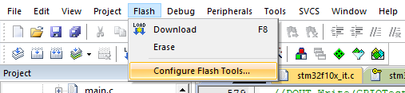

Step 2: Once the configuration menu appears, switch to the **“Debug”** tag and change the debugger to **“J-LINK/J-TRACE Cortex”.** After that, click the **“Settings”** button for configuring debugger settings.

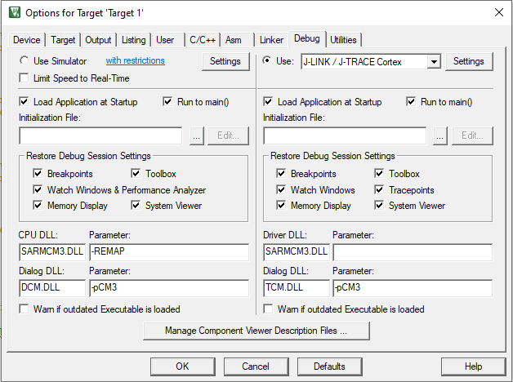

Step 3: For the Cortex JLink/JTrace Target Driver Setup, switch to the **“Flash Download”** tag.

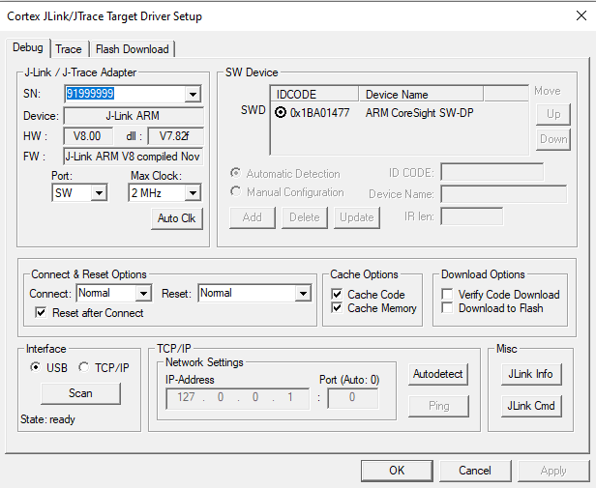

Step 4: Clicking the **“Add”** button for adding the programming Algorithm.

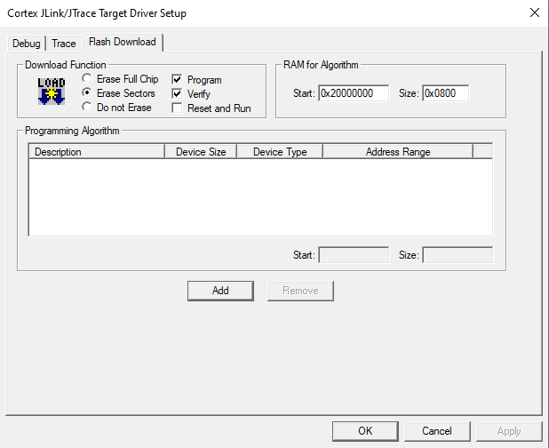

Step 5: Once opened the Flash Programming Algorithm menu, you should add the “STM32F10x Connectivity Line Flash”.

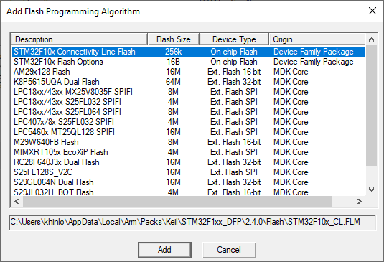

Step 6: Remember to check the **“Reset and Run”** and click OK for confirming the changes.

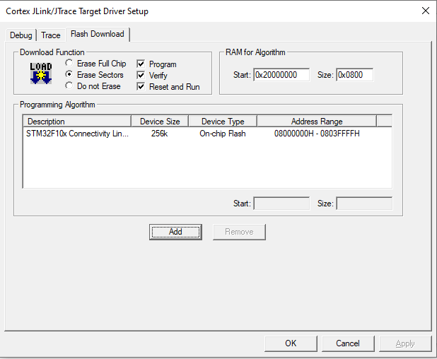

# Pin configuration:

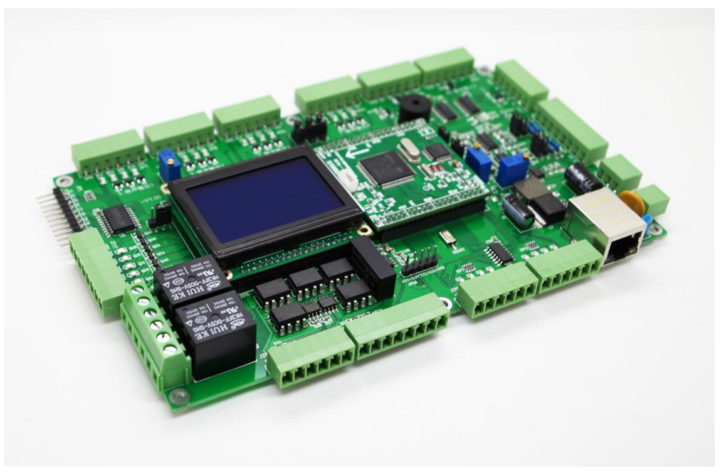

Figure 1: Full image of EMB8618I

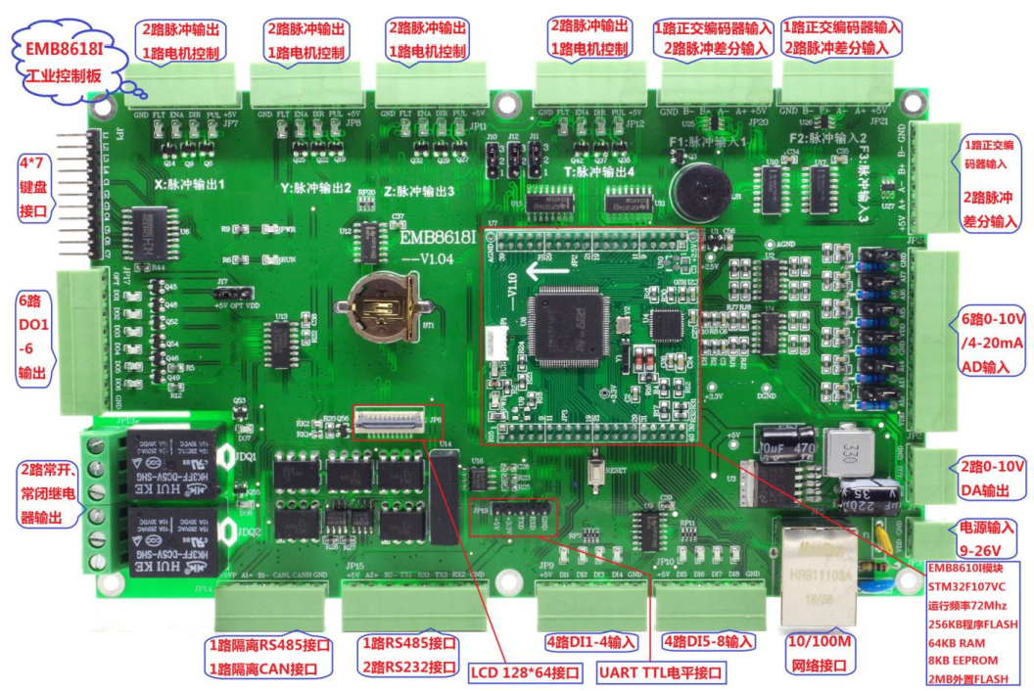

Figure 2: Pin description of EMB8618I

|  |
| --- |
| EMB8618I IO Configuration |
| Core LED: |
|  |
| ALARM IO: |
|  |
| ADC IO (JP2): |
|  |
| DAC output IO (JP4): |
|  |
| UART1 ~ UART5 IO (JP14, JP15, JP5, JP6): |
|  |

|  |
| --- |
| CAN1 IO (JP14): |
|  |
| EEPROM IO: |
|  |
| FCLK Pulse input (JP20, JP21, JP24): |
|  |

|  |
| --- |
| PWM output (JP7, JP8, JP11, JP12): |
|  |
| SPI IO: |
|  |

|  |
| --- |
| Digital input (JP9, JP10): |
|  |
| Digital output: |
|  |
| LAC: |
|  |

# GPIO

A binary address is used to control the Digital input pin.

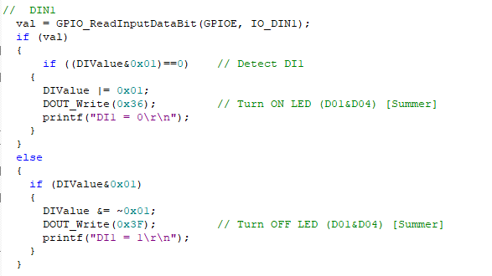

GPIO is using the binary address for controlling and configuring. The logic of DO1-DO6 and DO7-DO8 is reversed.

|  |  |  |
| --- | --- | --- |
| Operation | Address | Address (binary) |
| Turn on DO1 and DO4 | 0x36 | 0011 0110 |
| Turn on DO2 and DO5 | 0x2D | 0010 1101 |
| Turn on DO3 and DO6 | 0x1B | 0001 1011 |
| Turn Off DO1-DO6 | 0x3F | 0011 1111 |

For DO1-DO6, “1” represents OFF, and “0” represents ON

For DO7-DO8, “0” represents ON, and “1” represents OFF

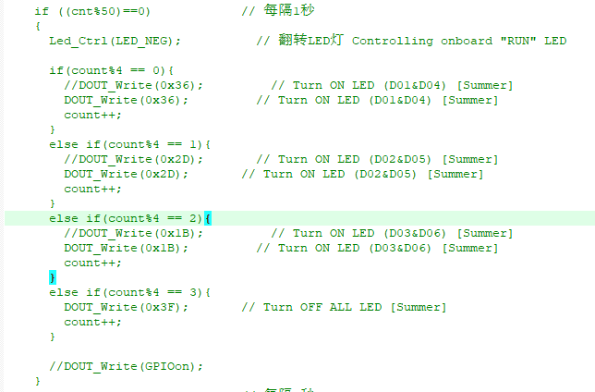

# DC Motor Setup

For EMB8618I, the pulse input and pulse output are sharing the same channel. To adjust the pulse mode, the jumper (JP10, JP12, JP11) has to modify.

|  |  |  |  |
| --- | --- | --- | --- |
| Pulse channel | Jumper Position | Pulse Input mode | Pulse output mode |
| PWM/FCLK1 | J11 | Connecting Pin 1 and 2 | Connecting Pin 2 and 3 |
| PWM/FCLK2 | J10 |
| PWM/FCLK3 | J12 |
| PWM4 |  |  | Default |

To control PWM, the HAL library can be applied.

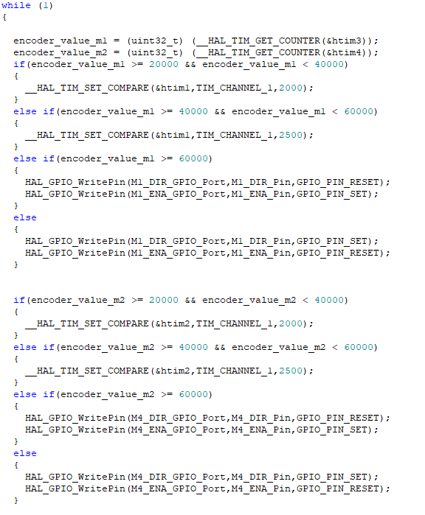

# Stepper Motor Setup

To control the stepper motor, the PUL pin can be configurated as digital output for generating the pulse. To change the velocity of the stepper motor, you need to reconfigure the pulse/revolution of the motor driver and delay for generating the pulse.

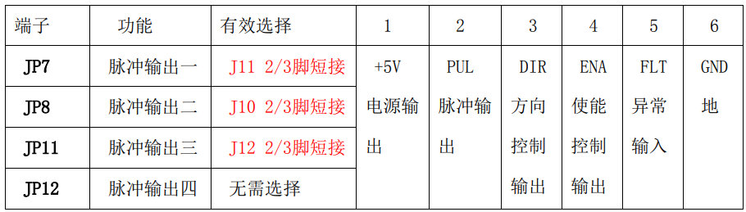

Figure 3: Pulse output pin description

|  |  |  |  |  |
| --- | --- | --- | --- | --- |
| Microstep Driver | | | | |
| Microstep | Pulse/rev | S1 | S2 | S3 |
| NC | NC | ON | ON | ON |
| 1 | 200 | ON | ON | OFF |
| 2/A | 400 | ON | OFF | ON |
| 2/B | 400 | OFF | ON | ON |
| 1 | 800 | ON | OFF | OFF |
| 8 | 1600 | OFF | ON | OFF |
| 16 | 3200 | OFF | OFF | ON |
| 32 | 6400 | OFF | OFF | OFF |

