IC2122 Control and Automation
Robotics Laboratory - Worksheet
Student Name: | Student ID:
 | Date:

Task 3a
Pick the RED block and place it on the table (machine) using Inverse Kinematics for processing and write down the procedure.
Step 1:

Step 2:

Step 3:

Step 4:

Step 5:

Step 6:

Step 7:

Step 8:

Step 9:

Step 10:

Task 3b
Pick the RED block from the table (machine) and place it on the original position using Inverse Kinematics and write down the procedure.
Step 1:

Step 2:

Step 3:

Step 4:

Step 5:

Step 6:

Step 7:

Step 8:

Step 9:

Step 10:

Task 3c
Create a python program to automate the process of raw material by clicking the "Clicking this button for completing whole task automatically" button. Write down the procedure and explain your program
Task 4a
- Find the translation value and rotation angle of UR3B, and Homogeneous Transformation matrix (PowerPoint slide 8) using Homogeneous Transformation
- Draw the UR3B’s position and coordinate at the graph. (you can copy and adjust the UR3A’s arrows and markers for drawing)
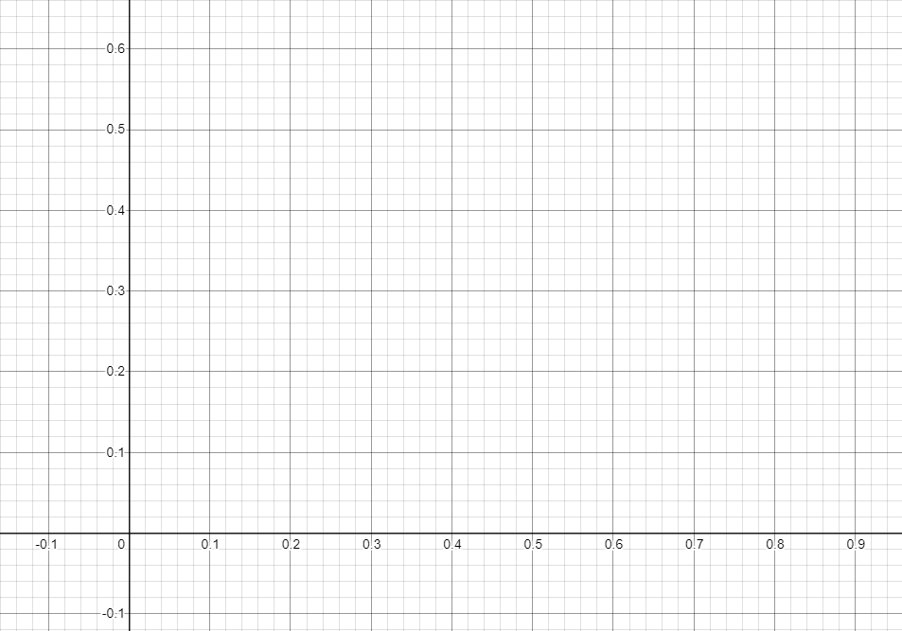
X
Y
UR3A

Task 4b
Calculate the following results using Homogeneous Transformation
- Translation value and rotation angle

- Homogeneous Transformation matrix

- Draw the UR3B’s position and coordinate at the graph. (you can copy and adjust the UR3A’s arrows and markers for drawing)
X
Y
UR3A
WHITE block

- WHITE Block position (x, y, z) based on translation value and rotation angle for UR3B

Task 4c
Calculate the following results using Homogeneous Transformation
- Translation value and rotation angle

- Homogeneous Transformation matrix

- Draw the UR3B’s position and coordinate at the graph. (you can copy and adjust the UR3A’s arrows and markers for drawing)
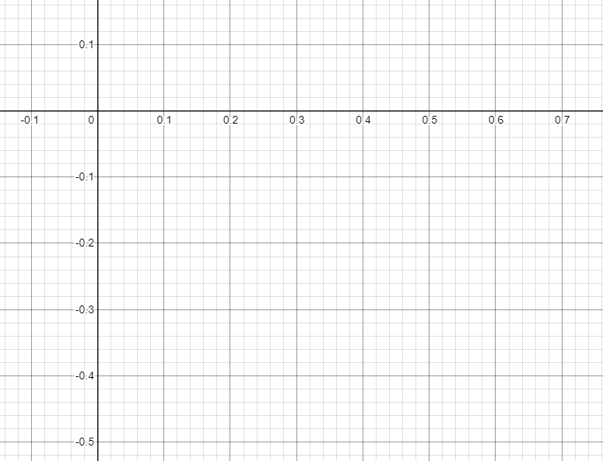
X
Y
UR3A
YELLOW block

- YELLOW Block position (x, y, z) based on translation value and rotation angle for UR3B

