**SYNAPSEMBLE DEMO**

Dartmouth Mind Summer Course 07/2019

Course by Sam McKenzie [sam.a.mckenzie@gmail.com](mailto:sam.a.mckenzie@gmail.com)

Code and concept with Roman Huszar [rh2618@nyu.edu](mailto:rh2618@nyu.edu)

**Motivation:** Memory is thought to depend on changes at the synapse, but currently we don’t have a good way to monitor synaptic coupling while also measuring presynaptic activity, postsynaptic activity, and behavior. The goal of this demo is to extract time-varying synaptic coupling strengths between a group of excitatory and inhibitory neurons recorded extracellularly in freely moving subjects. The challenge is that many hidden forces can non-synaptically synchronize the pair, too many to factor out. Therefore we will take the concept that synapse should inject a higher frequency synchrony than that from 'network' hidden forces (English, McKenzie 2017 Neuron). We regress out the lower frequency co-modulation and then look to see how the pairwise, high-frequency synchrony, that is presumably synaptic, fluctuates on the timescale of minutes. We employ a GLM to predict postsynaptic rate given pre spikes + coarsened postsynaptic rate. The strength of the GLM approach is that other regressors (e.g. short-term plasticity, ripples, running speed, physical location, whatever), can be included, but in general this is a very conservative model as we regress out postsynaptic rate fluctuations on the order of 15ms. Note that this inherently underestimates the synaptic contribution, since the presynaptic cell contributes to the postsynaptic rate. This caveat is somewhat mitigated at synapses made by hippocampal pyramidal cells (PYR) to local interneurons (INT), since the presynaptic rate is 10x less than the postsynaptic rate and the spike transmission probabilities are generally less than 10%, meaning that at best 1% of the firing rate is contributed by the presynaptic target cell.

**Approach:** The method has three conceptual steps

1) Find connected pairs

2) Measure the temporal fluctuations in synaptic coupling for each pair.

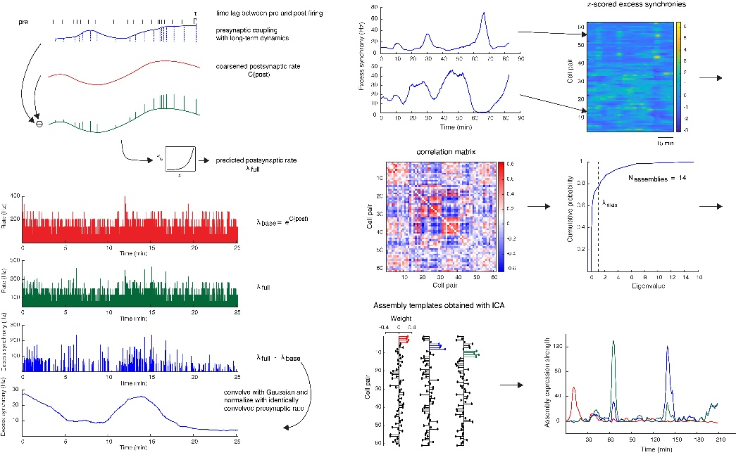 3) Identify synapses that covary together.

1. To find connected pairs, we lean on an old observation (Perkel et al., 1967 Biophys. J.) that pairs of neural spike trains can sometimes have very reliable cross correlations. In vitro (Galaretta et al., 2001) and in vivo (Jouhanneau et al., 2018 Nature Comm.) work shows that this spike transmission probability (the likelihood of observing a postsynaptic spike after a pre) correlates strongly with EPSP magnitude, especially in the fast-spiking cells, probably because there is a single release site (Gulyás et al., 1993 Nature) and the postsynaptic cell sits very close to threshold. We showed that stimulation of the presynaptic cell, with optogenetics or juxtacellular stimulation reliably evoked a postsynaptic response (English, McKenzie et al., 2017, Neuron). We built a simple classifier to detect how much excess spiking synchrony we observe in the causal (py🡪int) direction above a slow baseline and beyond what we see in the anti-causal direction, using the evoked synaptic drive as our ground truth label. This detection algorithm can likely be improved (e.g. Platkiewicz et al., 2017, Neural computation), and then benchmarked against the labeled dataset provided by our Neuron paper, but it is very fast 20ms per pair (in a typical 3-4 hour recording), thus affording a screen of large databases for interactions of interest.

2.) To measure temporal fluctuations in synaptic coupling we need to account for fluctuations in postsynaptic rate. Inspired by Ghanbari et al., 2018 biorxiv, we used a GLM to predict the interneuron firing rate given the presynaptic spikes and a slowly evolving postsynaptic rate. This dodges the issue of trying to fully capture all parameters modulating the estimated postsynaptic firing rate $λ_{post}\left(t\right)$, and instead rests on the assumption of a separation of timescales in which the presynaptic input $Pre(t)$ gives a small, transient boost above a slowly evolving coarse timescale baseline $C\left(Post(t)\right)$. The model takes the following form:

1 $λ_{post}\left(t\right)={\underset{a}{\underbrace{argmax}}e}^{log⁡(C\left(Post\left(t\right)\right))+Pre(t+τ)*K(t)}$

Where $τ$ is the mode time lag between the pre- and postsynaptic firing binned at *dt =* 0.8 ms. The coarsened postsynaptic baseline at coarsened time, $T_{Δ}$ is given by,

2 $C(Post\left(t\right))=$*lerp*($T_{Δ},$ D(Post(t)),α), sampled at *dt*

3 $D(Post\left(t\right))=$ $\frac{\int_{t}^{t+Δ}{P(t)}dt}{Δ}$

Where $Δ=15 ms$ sets the coarsened timescale and *lerp* is linear interpolation of the coarsened postsynaptic rate at *dt*. The coupling kernel $K\left(t\right)$ between the pre- and postsynaptic cell allows the coupling strength to vary over time,

4 $K\left(t\right)=a*B$

here $a$ is a *Nx1* vector fit by the generalized linear model and *B* is a set of *N* cubic splines that are spaced evenly at 400-1000s intervals, chosen through cross validation of the model fit, thus allowing the estimated neural coupling $a$ (Excess Synchrony between pre and postsynaptic cells) to evolve on a time scale of ~5-15 minutes. The model predicts postsynaptic spikes, $Post\left(t\right)$, in the window just after the presynaptic spike, at the mode of the inter-spike interval between the pair, binned at *dt.*

The instantaneous excess synchrony can be estimated by taking the difference between the coarsened postsynaptic rate and that predicted by the full model (coarsened rate + synaptic drive). To estimate the synaptic drive at every moment, even when presynaptic cells are not firing, this instantaneous excess synchrony can be smoothed, here a convolution with a Gaussian (δ = 120 s), and then normalized by the presynaptic spike count, binned and smoothed in the same manner. The procedure gives a time series of excess synchrony (in Hz) for each simultaneously recorded pair.

3) To find the assemblies, these time series are z-scored, and projected onto their first N principal components where *N* = # observed eigenvalues >theoretical max random eigenvalue, as defined by Marčenko-Pastur analysis of independent identically distributed random variables (iids). The data are then projected onto this *N* dimensional space and ICA is performed to determine those components that fluctuate independently of one another (see Lopes-dos-santos 2013 J. Neuro Method, and Van de Ven et al., 2016 Neuron for further details).

**Potential Projects:** We think that memory is stored by changing synaptic coupling. This approach gives us hints as to those dynamics. What next:

Potential physiology questions:

1. Is receptive field plasticity associated with changes in synaptic coupling?
2. What precedes large increases in coupling, can we backwards engineer learning rules?
3. What determines whether pairs co-fluctuate? Can learning reorganize synapsemble membership? Do the presynaptic members of co-fluctuation synapsembles share anything else (anatomy, coding, firing rate)?
4. Do neuromodulators drive the sharp transitions?
5. Does the number of independent components scale with the complexity of the task to be solved? Does it change in disease models?
6. How do brain regions differ in their synapsemble dynamics?
7. Do classic synaptic plasticity protocols (pre/post pairings) alter our measure of synaptic coupling?

Potential statistics problems

1. Can we find confidence bounds around our point estimates for excess synchrony?
2. Can we use presynaptic spike density to adaptively lay down the bases describing coupling dynamics?
3. Can we regress out short term plasticity dynamics?
4. Can we avoid underestimating the presynaptic drive by estimating the proportion of the slow baseline rate contributed by the presynaptic cell of interest?
5. Can we add postsynaptic spiking history to account for apparent spike transmission failures that occur during the refractory period?

Potential modelling questions

1. This work shows that a powerful synapse can be effectively turned off, thus challenging the integrate and fire framework. Instead, it looks like the dendrite acts more like a set of transistors, which gate inputs on/off. How should such a system learn the appropriate gates to solve some computation?
2. How can computation be stable with large fluctuations in synaptic coupling? Can robustness be achieved through the correlated nature of these dynamics?