**Reference Type:**  Journal Article

**Record Number:** 29

**Title:** <2018_06_21_nlp.pdf>

**Short Title:** <2018_06_21_nlp.pdf>

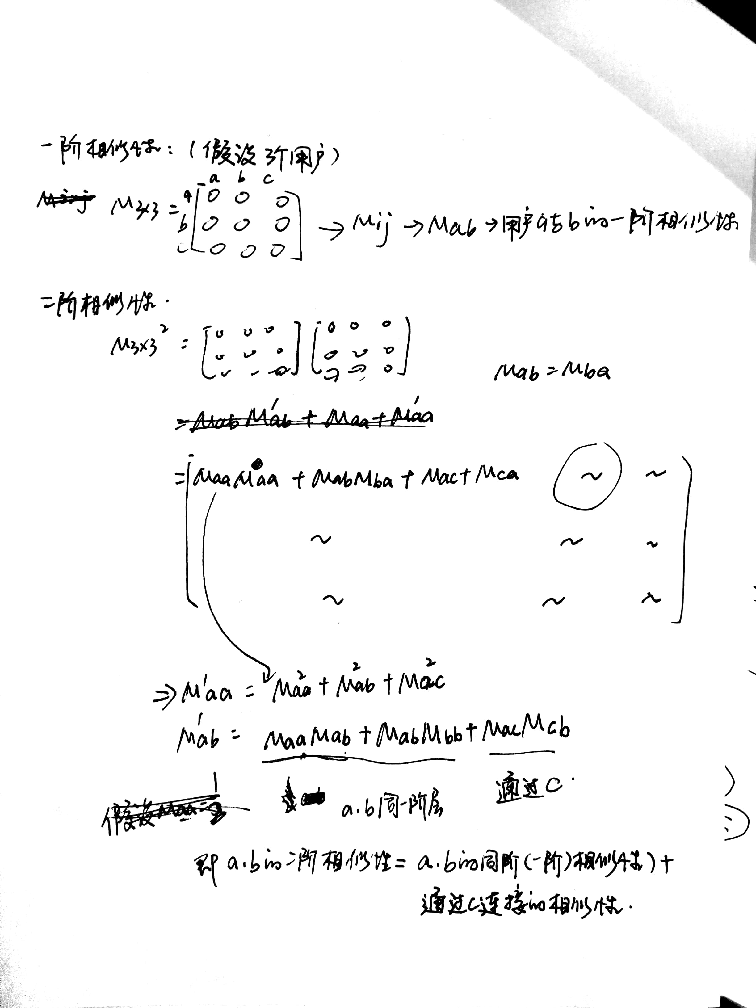**'File' Attachments:** internal-pdf://0691521879/2018_06_21_nlp.pdf

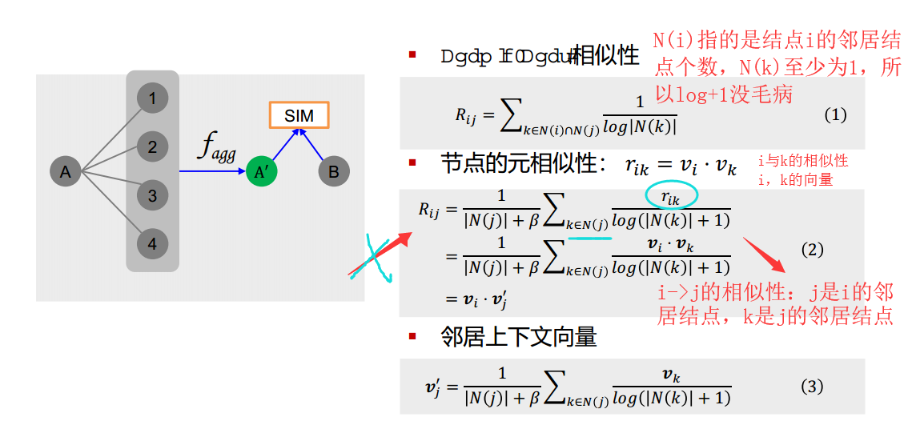

1. 结点i与结点j的相似性=i，j的邻居结点的交集{k}的邻居结点的log的倒数之和

