

Requirement & Design Specification
Canteen Stall Management System with Integrated AI Food Optimization (StallBox)
Version: 1.0

– Da Nang, May 2026 –

Record of Changes
Version | Date | A*  M, D | In charge | Change Description
V1.0 | 20/5 | A | Khoa | Add Introduction, Scope, Use Cases, Screen Flows.
V1.0.1 | 29/5 | M | Khoa | Update Use Case Diagrams.
V1.1 | 31/5 | A | Dương | Add Use Case Descriptions and Functional Descriptions for Authentication, Profile Management, Order Management, Payment Management and Menu Management.  Add Database Design.
V1.2 | 2/6 | A | Hoàng | Add UI Design of each feature.
V1.3 | 7/6 | A | Dương | Add Use Case Descriptions for the remaining features.
V1.4 | 21/6 | A | Hoàng | Add Design Specifications for Order Management.
V1.5 | 21/6 | A | Khoa | Add Design Specifications for auth and user management features.
V1.5.1 | 21/6 | M | Khoa | Update Screen Flow.
V1.6 | 21/6 | M | Dương | Update Design Specifications for Daily Menu Management.
V1.7 | 21/6 | A | Kiều | Add Design Specifications for Scheduled Menu Management, including UI Design, Database Access, and SQL Commands.
V1.8 | 21/6 | A | Châu | Add Design Specifications for Categories and Food Items managerment features.
V1.9 | 27/6 | A | Châu | Add Design Specifications for Payment Tracking and Admin, Manager Dashboard features.
V1.10 | 27/6 | M | Hoàng | Update Design Specifications for Order Management.
V1.11 | 28/6 | M | Kiều | Update Design Specifications for Scheduled Menu Operations.
V1.12 | 28/6 | A | Khoa | Add Design Specifications Payment àn Billing features.
V1.13 | 28/6 | M | Dương | Update Design Specifications for AI Prediction & Recommendation.
*A - Added M - Modified D - Deleted

Contents
Record of Changes 2
I. Overview 6
1. Introduction 6
1.1 Purpose 6
1.2 In Scope 6
2. User Requirements 7
2.1 Actors 7
2.2 Use Cases 8
3. Overall Functionalities 12
3.1 Screens Flow 12
3.2 Screen Descriptions 16
3.3 Screen Authorization 19
3.4 Non-UI Functions 21
4. System High Level Design 23
4.1 Database Design 23
4.2 Code Packages 25
II. Requirement Specifications 27
1. Authentication 27
1.1 UC-01_ Login 27
1.2 UC-02_ Forgot Password 28
1.3 UC-03_ Logout 29
2. Profile Management 29
2.1 UC-04_ View Personal Profile 29
2.2 UC-05_ Update Personal Profile 30
2.3 UC-06_ Change Password 32
3. Order Management 33
3.1 UC-07_ Create Order 33
3.2 UC-08_ Cancel Order 34
3.3 UC-09_ View Own Order History 36
3.4 UC-10_ View Order List 37
4. Payment Management 38
4.1 UC-11_ Process Payment 38
4.2 UC-12_ Print Receipt 39
4.3 UC-13_ View Payment List 40
5. Menu Management 41
5.1 UC-14_ Create Food Item 41
5.2 UC-15_ Update Food Item 42
5.3 UC-16_ Remove Food Item 43
5.4 UC-17_ Configure Food Category 44
5.5 UC-18_ Configure Scheduled Menu 45
5.6 UC-19_ View Scheduled Menu 47
5.7 UC-20_ Update Daily Menu Item 48
6. AI Prediction & Recommendation 50
6.1 UC-21_ Apply Recommended Price Adjustment 50
6.2 UC-22_ Apply Recommended Daily Quantity 51
6.3 UC-23_ View Food Demand Forecast 53
6.3 UC-24_ View Food Preparation Recommendation 54
6.4 UC-25_ View Dynamic Pricing Recommendation 55
7. Analytics & Reporting 56
7.1 UC-26_ View Daily Revenue 56
7.2 UC-27_ View Revenue & Sales Statistics 57
8. User Management 59
8.1 UC-28_ Create User Account 59
8.2 UC-29_ Update User Account 60
8.3 UC-30_ Disable User Account 61
8.4 UC-31_ Reset Password 62
III. Design Specifications 64
1. Authentication 64
1.1 User Login 64
1.2. Forgot Password 65
2. Order Management 66
2.1 Point of Sale (POS) 66
2.2 Order Records 68
3. Payment Management 73
3.1 Checkout & Receipt 73
3.2 Payment Tracking 78
4. Menu Management 82
4.1 Category Management 82
4.2 Food Item Management 87
4.2 Scheduled Menu Operations 93
4.3 Daily Menu Operations 96
5. Analytics & Reporting 98
5.1 Dashboard & Statistics 98
6. AI Prediction & Recommendation 103
6.1 Demand Forecasting 103
7. User Management 109
7.1 Account Administration 109
IV. Appendix 116
1. Assumptions & Dependencies 116
2. Limitations & Exclusions 116
3. Business Rules 116

I. Overview

1. Introduction
The following subsections of the Software Requirements Specifications (SRS) document provide an overview of the entire SRS.

Purpose
The purpose of this Software Requirements Specification (SRS) document is to define the functional and non-functional requirements of the Canteen Stall Management System with Integrated AI Food Optimization, also known as StallBox.
This document describes the system scope, main actors, functional modules, use cases, screen flow, data structure, and quality requirements. It serves as a reference for stakeholders, developers, testers, and project members during the analysis, design, implementation, and testing phases.
CSMS is designed to support daily canteen stall operations, including order processing, payment handling, menu management, revenue monitoring, and AI-based food demand forecasting. The system aims to help the stall reduce food waste, improve preparation planning, and support better operational decision-making.

In Scope
The scope of this system focuses on managing the daily operation of a single canteen stall. The system supports three main user roles: Staff, Manager, and Admin.
The system includes the following major functions:
- User authentication and profile management, including login, logout, forgot password, change password, and update personal profile.
- Sales and order management, including creating orders, processing payments, printing receipts, cancelling orders, and viewing order history.
- Payment processing through an external Payment Gateway.
- Food item and category management for maintaining the master menu.
- Scheduled menu management for assigning menus by date or weekday.
- Daily menu management for updating available food items, prepared quantity, remaining quantity, and item availability.
- Revenue and sales statistics functions for monitoring daily revenue, sales performance, order list, payment list, and key operational indicators.
- AI Food Optimization functions, including food demand forecasting, food preparation recommendation, and dynamic pricing recommendation.
- User account management for Admin, including creating, updating, disabling user accounts, and resetting passwords.
The system does not include customer self-ordering, delivery service, multi-branch management, supplier management, or advanced accounting features in the current version. These features may be considered as future enhancements.

2. User Requirements

2.1 Actors
# | Actor | Description
1 | Staff | A staff member responsible for handling daily sales operations at the canteen stall. Staff can create orders, process payments, print receipts, cancel orders, and view their own order history.
2 | Manager | A management user responsible for supervising stall operations and monitoring business performance. Managers can manage daily menus, monitor sales dashboards, review revenue reports, and apply AI-generated recommendations for food preparation and pricing adjustments.
3 | Admin | The system administrator responsible for managing the entire platform. Admin can manage user accounts, configure food items and scheduled menus, monitor operational reports, and maintain overall system settings and access control.
4 | Payment Gateway | An external payment processing service integrated into the system to securely handle transaction requests, verify payment status, and return payment success or failure results.
5 | AI Prediction Service | An external AI-based prediction service that analyzes historical sales and operational data to forecast food demand, recommend food preparation quantities, and suggest dynamic pricing adjustments to optimize sales performance and reduce food waste.

2.2 Use Cases

a. Diagram(s)
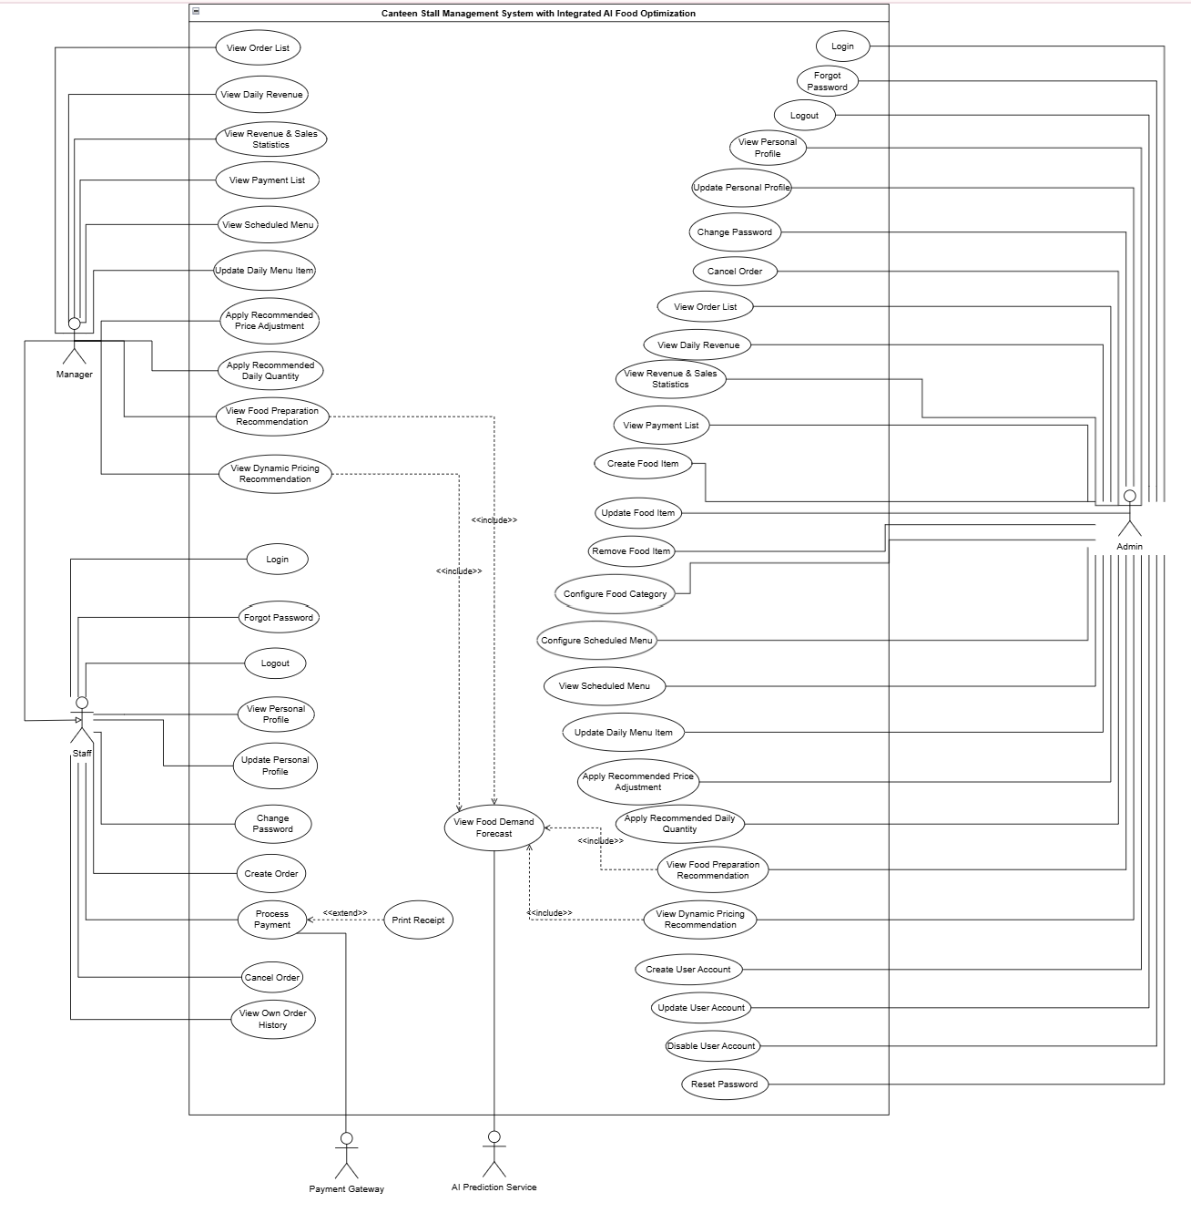
Figure 1. Use Case Diagram Overview
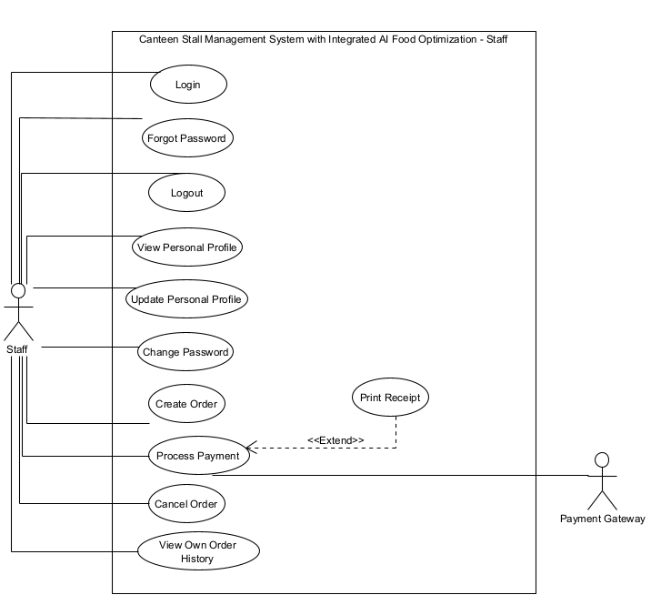
Figure 2. Use Case Diagram for Staff
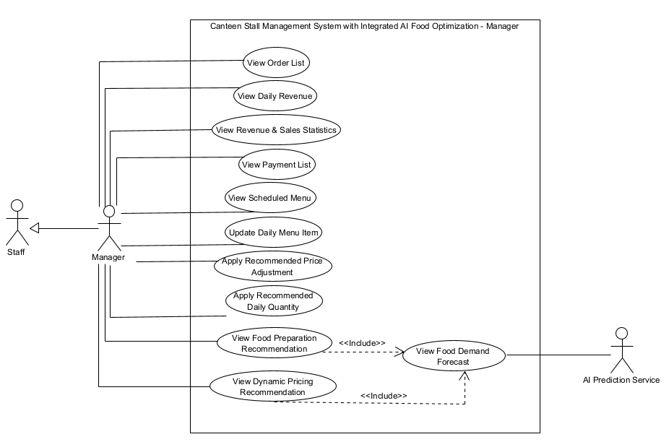
Figure 3. Use Case Diagram for Manager
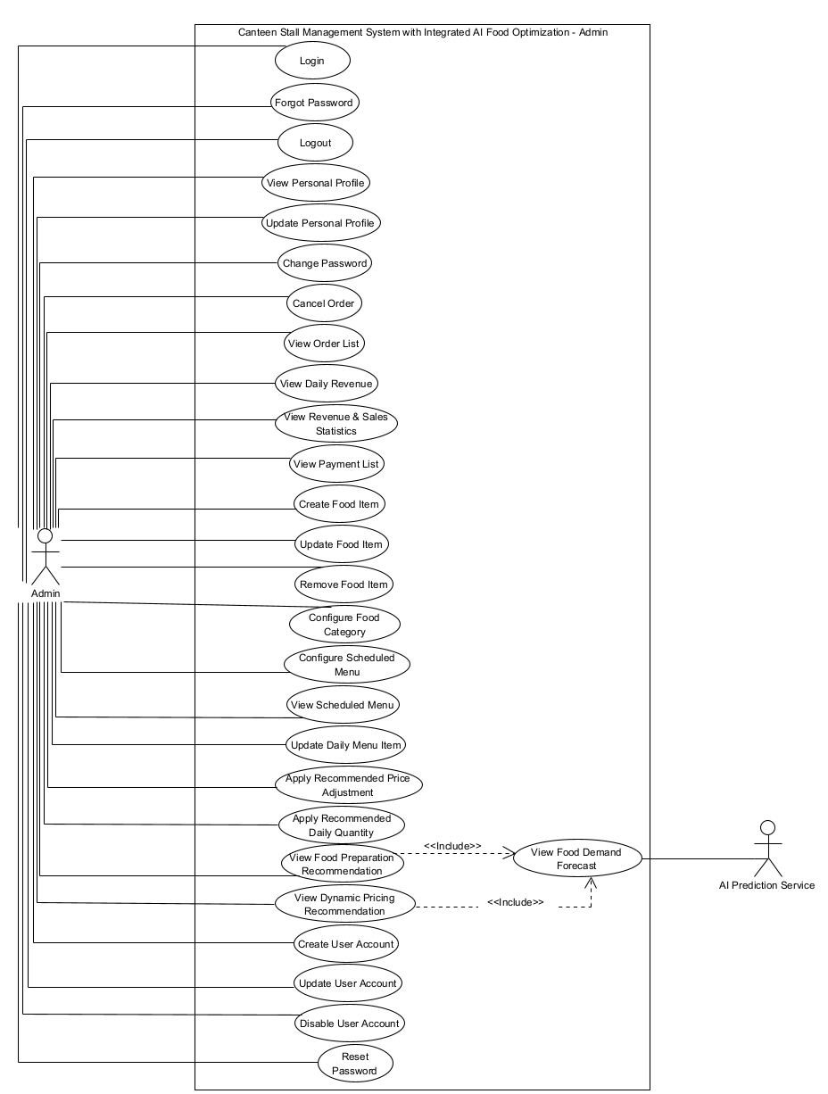
Figure 4. Use Case Diagram for Admin

b. Descriptions
ID | Feature | Use Case | Use Case Description
01 | Authentication | Login | User logs into the system using valid credentials.
02 | Authentication | Forgot Password | User requests a password reset when unable to access their account.
03 | Authentication | Logout | User logs out and ends the current session.
04 | Profile Management | View Personal Profile | User views their personal profile information.
05 | Profile Management | Update Personal Profile | User updates personal information such as name, email, or contact details.
06 | Profile Management | Change Password | User changes their account password.
07 | Order Management | Create Order | Staff or Manager creates a customer order by selecting food items.
08 | Order Management | Cancel Order | Authorized user cancels an existing order when required.
09 | Order Management | View Own Order History | Staff or Manager views the history of orders they have handled.
10 | Order Management | View Order List | Manager or Admin views all orders recorded in the system.
11 | Payment Management | Process Payment | Staff or Manager processes payment for an order through a supported payment method.
12 | Payment Management | Print Receipt | System generates and prints a receipt after successful payment.
13 | Payment Management | View Payment List | Manager or Admin views all payment transactions recorded in the system.
14 | Menu Management | Create Food Item | Admin creates a new food item in the menu catalog.
15 | Menu Management | Update Food Item | Admin updates information related to a food item.
16 | Menu Management | Remove Food Item | Admin removes or archives a food item from the menu catalog.
17 | Menu Management | Configure Food Category | Admin manages food categories used to organize menu items.
18 | Menu Management | Configure Scheduled Menu | Admin configures menu schedules for specific days or periods.
19 | Menu Management | View Scheduled Menu | Manager or Admin views the configured menu schedule.
20 | Menu Management | Update Daily Menu Item | Manager or Admin updates availability, quantity, or status of daily menu items.
21 | AI Prediction & Recommendation | Apply Recommended Price Adjustment | Manager or Admin applies AI-recommended pricing adjustments to menu items.
22 | AI Prediction & Recommendation | Apply Recommended Daily Quantity | Manager or Admin applies AI-recommended preparation quantities for daily operations.
23 | AI Prediction & Recommendation | View Food Demand Forecast | Manager or Admin views AI-generated forecasts of future food demand.
24 | AI Prediction & Recommendation | View Food Preparation Recommendation | Manager or Admin views AI recommendations on food preparation quantities.
25 | AI Prediction & Recommendation | View Dynamic Pricing Recommendation | Manager or Admin views AI recommendations for dynamic pricing adjustments.
26 | Analytics & Reporting | View Daily Revenue | Manager or Admin views the total revenue generated for the current day.
27 | Analytics & Reporting | View Revenue & Sales Statistics | Manager or Admin analyzes revenue and sales performance through statistical reports.
28 | User Management | Create User Account | Admin creates a new user account for system access.
29 | User Management | Update User Account | Admin updates user account information and permissions.
30 | User Management | Disable User Account | Admin disables a user account to prevent system access.
31 | User Management | Reset Password | Admin resets a user's password when necessary.

3. Overall Functionalities

3.1 Screens Flow

3.1.1 Unauthenticated User / Authentication Flow
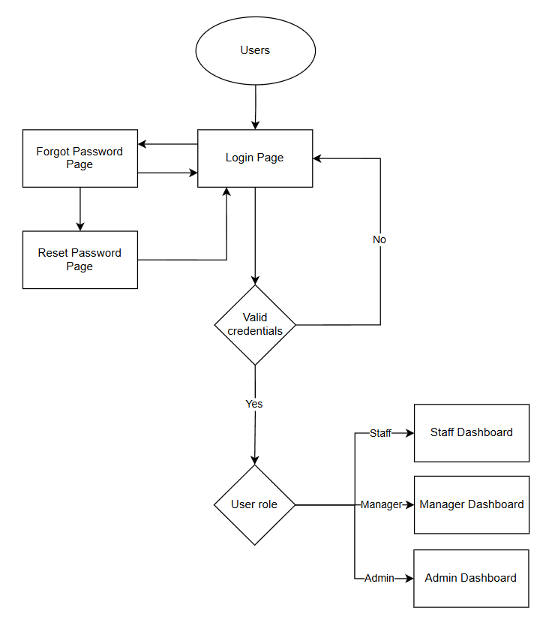

3.1.2 Screen Flow for Authenticated User
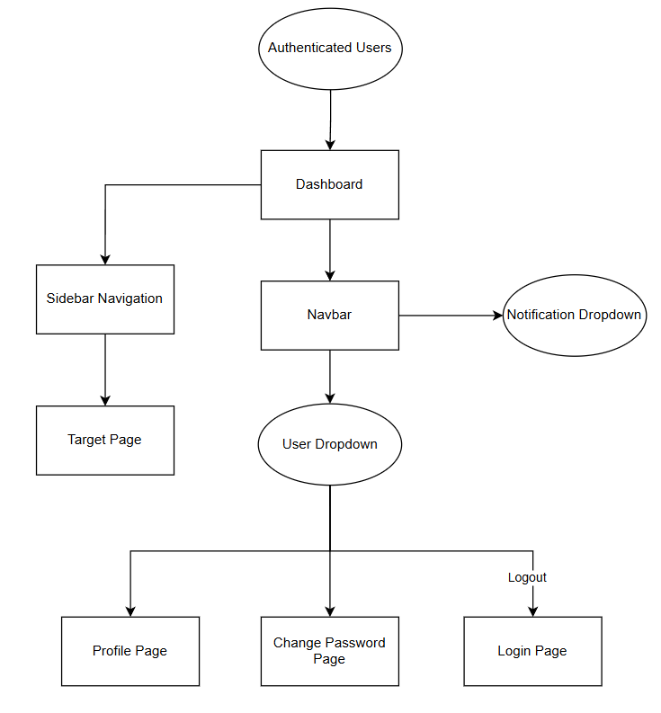

3.1.3 Screen Flow for Admin
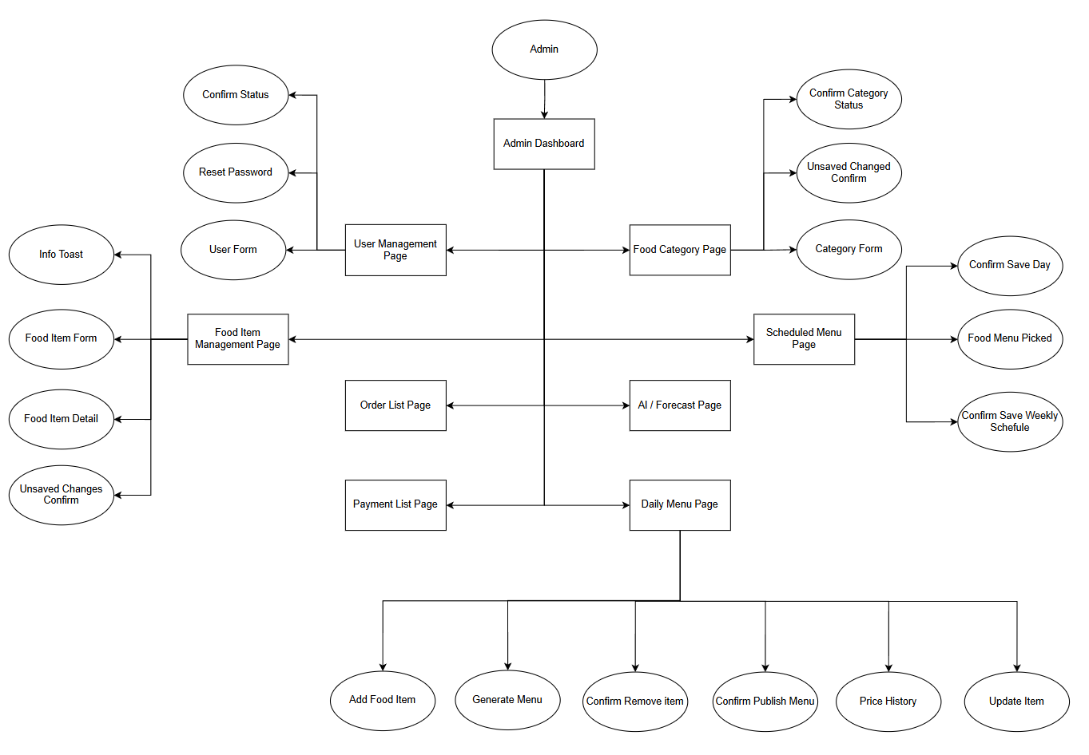

3.1.4 Screen Flow for Manager
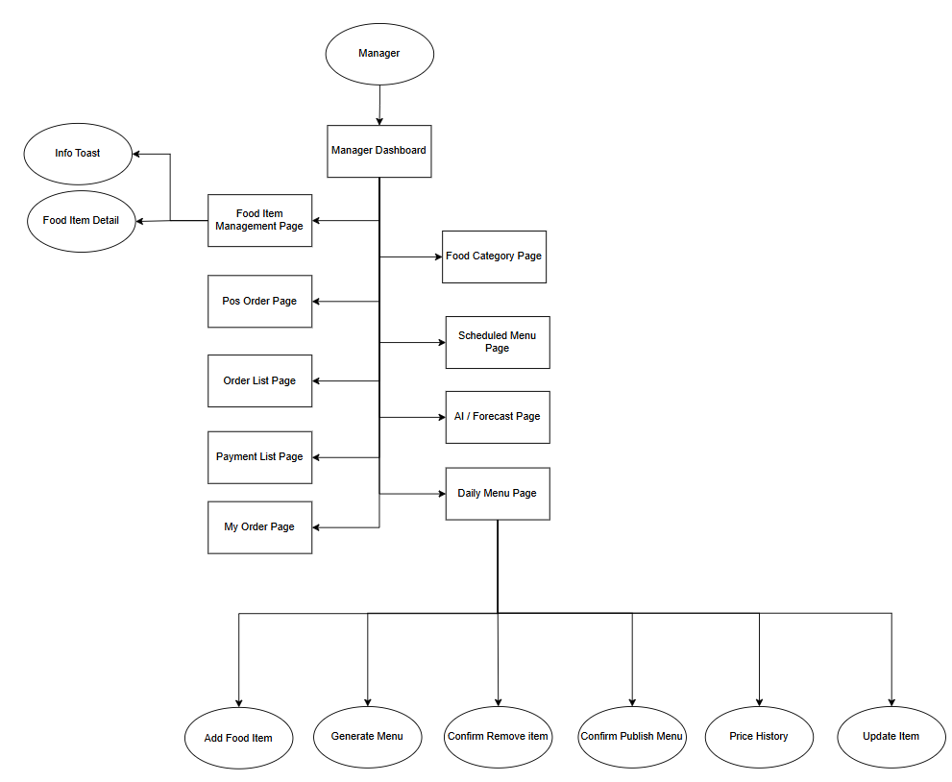

3.1.5 Screen Flow for Staff
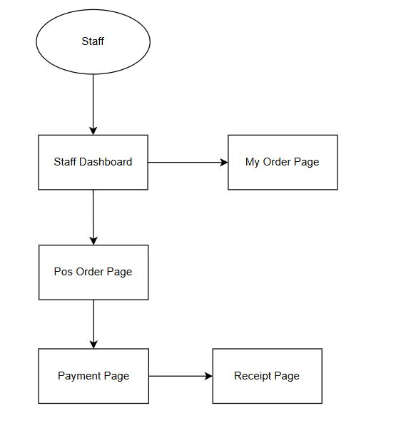

3.2 Screen Descriptions
# | Feature | Screen | Description
1 | Authentication | Login Page | Allows Staff, Manager, and Admin to enter credentials, submit login, navigate to Forgot Password, and be redirected to the correct dashboard after authentication.
2 | Authentication | Forgot Password Page | Allows unauthenticated users to request password recovery by entering their registered email address and receiving a reset instruction or OTP through email.
3 | Authentication | Reset Password Page | Allows users who received a valid reset token or OTP to set a new password and return to the Login Page after successful reset.
4 | Dashboard | Admin Dashboard | Landing page for Admin after login, providing navigation to user management, menu configuration, order/payment monitoring, reporting, and AI optimization areas.
5 | Dashboard | Manager Dashboard | Landing page for Manager after login, summarizing daily operations and providing access to POS, menu operations, orders, payments, analytics, and AI recommendations.
6 | Dashboard | Staff Dashboard | Landing page for Staff after login, providing quick access to POS order creation, own order history, profile, and password change functions.
7 | Profile Management | Profile Page | Displays the logged-in user's own profile information such as full name, username, email, phone number, role, and account status, with the option to update editable fields.
8 | Profile Management | Change Password Page | Allows an authenticated user to change their own password by entering current password, new password, and confirmation password.
9 | Order Management | Create Order Page / POS Page | Allows Staff or Manager to view today's available menu, select food items, adjust quantities, review the cart, calculate total amount, and proceed to payment.
10 | Order Management | Cancel Order Confirmation Popup | Confirms cancellation of a pending or confirmed order before the system updates the order status and restores item quantities to the daily menu.
11 | Order Management | Own Order History Page | Allows Staff or Manager to view only the orders they personally handled, including order number, date, total amount, status, and order details.
12 | Order Management | Order List Page | Allows Manager or Admin to view all recorded orders, search or filter order records, and open order details for monitoring and reconciliation.
13 | Order Management | Order Detail Popup / Detail View | Shows detailed information for a selected order, including ordered items, quantities, prices, total amount, order status, payment information, and available actions.
14 | Payment Management | Payment Page | Allows Staff or Manager to process payment for a pending order by choosing cash or supported digital payment methods and validating the final payment amount.
15 | Payment Management | Receipt Page | Displays the finalized receipt after successful payment, including order information, item list, totals, payment method, received amount, change, and print action.
16 | Payment Management | Payment List Page | Allows Manager or Admin to view all payment records, filter transactions by date, method, or status, and inspect payment details for reconciliation.
17 | Analytics & Reporting | Revenue & Sales Statistics Page | Allows Manager or Admin to monitor daily revenue, sales performance, top-selling items, payment breakdown, cancelled orders, and operational indicators.
18 | Menu Management | Food Category Page | Allows Admin to create, update, or deactivate food categories, while Manager can view categories for menu monitoring and filtering.
19 | Menu Management | Category Form Modal | Popup form used to add or edit a food category, including category name, description, icon, and active status validation.
20 | Menu Management | Food Item Management Page | Allows Admin to manage master food items and Manager to view item information, including category, base price, cost, availability, and archive status.
21 | Menu Management | Food Item Form Modal | Popup form used by Admin to create or update food item information such as name, description, category, base price, cost, and status.
22 | Menu Management | Food Item Detail Dialog | Displays detailed information of a selected food item, including category, pricing, cost, status, and related metadata.
23 | Menu Management | Scheduled Menu Page | Allows Admin to configure the weekly scheduled menu and allows Manager to view planned menu items by day of week.
24 | Menu Management | Scheduled Food Item Picker Modal | Popup used when configuring a scheduled menu day, allowing Admin to select active master food items to add to the schedule.
25 | Menu Management | Daily Menu Page | Allows Manager or Admin to view and update today's operational menu, prepared quantity, remaining quantity, current price, status, and publication state.
26 | Menu Management | Generate Daily Menu Modal | Popup used to generate a daily menu from the scheduled menu template for a selected date before publishing it for operation.
27 | Menu Management | Add Food Item to Daily Menu Modal | Popup used by Manager or Admin to add an active food item into the current daily menu with initial quantity and price information.
28 | Menu Management | Update Daily Menu Item Modal | Popup used by Manager or Admin to update prepared quantity, current price, and availability status of a daily menu item.
29 | Menu Management | Price History Modal | Displays price change history for a daily menu item, including manual or AI source, changed price, changed by, and timestamp.
30 | AI Prediction & Recommendation | AI Food Optimization Page | Allows Manager or Admin to view demand forecasts, preparation recommendations, dynamic pricing recommendations, and apply or reject pending AI suggestions.
31 | AI Prediction & Recommendation | AI Recommendation Confirmation Popup | Confirms before applying or rejecting an AI recommendation and shows the expected effect on price, quantity, or recommendation status.
32 | User Management | User Management Page | Allows Admin to view, search, create, update, disable or enable user accounts, and open reset password actions for system users.
33 | User Management | User Form Modal | Popup form used by Admin to create or update a user account, including username, full name, email, phone, role, and active status.
34 | User Management | Reset Password Modal | Popup used by Admin to reset a selected user's password when required.
35 | User Management | Disable User Confirmation Popup | Confirms disabling or enabling a user account before the account status is changed.
36 | Layout / Common UI | Notification Dropdown | Shows system notifications such as order updates, payment updates, AI alerts, and operational messages, with actions to mark one or all notifications as read.
37 | Layout / Common UI | User Dropdown | Shows the logged-in user summary and provides quick actions for Profile, Change Password, Settings, and Logout.

3.3 Screen Authorization

Screen / Activity | Staff | Manager | Admin | Notes
Login Page | X | X | X | Public screen before authentication
Forgot Password Page | X | X | X | Public screen before authentication
Reset Password Page | X | X | X | Public screen opened from password reset flow
Staff Dashboard | X |  |  | Staff landing page only
Manager Dashboard |  | X |  | Manager landing page only
Admin Dashboard |  |  | X | Admin landing page only
Profile Page | X | X | X | Authenticated users only
Query Own Profile | X | X | X | Read own profile data
Update Own Profile | X | X | X | Update editable personal information only
Change Password Page | X | X | X | Authenticated users only
Update Own Password | X | X | X | Requires current password validation
Create Order Page / POS Page | X | X |  | Sales operation screen
Query Today's Daily Menu | X | X |  | Display available items for ordering
Add New Order | X | X |  | Create pending order
Update Cart Before Payment | X | X |  | Adjust local cart quantities before order confirmation
Payment Page | X | X |  | Requires a pending order
Process Cash Payment | X | X |  | Validate received amount and change
Process Digital Payment | X | X |  | Uses external Payment Gateway
Receipt Page | X | X |  | Available after successful payment
Print Receipt | X | X |  | Print completed order receipt
Own Order History Page | X | X |  | Only orders handled by current user
Query Own Orders | X | X |  | Filter by current user ID
View Own Order Detail | X | X |  | Read own order details only
Cancel Order Confirmation Popup | X | X | X | Allowed for cancellable orders only
Cancel Pending / Confirmed Order | X | X | X | Restore reserved quantities after cancellation
Order List Page |  | X | X | Global order monitoring
Query All Orders |  | X | X | Read all orders in the stall
View Any Order Detail |  | X | X | Open order detail for monitoring or audit
Payment List Page |  | X | X | Global payment monitoring
Query All Payments |  | X | X | Read-only financial records
View Payment Detail |  | X | X | Inspect associated order and payment method
Revenue & Sales Statistics Page |  | X | X | Management reporting area
Query Daily Revenue |  | X | X | View revenue for selected date
Query Revenue & Sales Statistics |  | X | X | View charts, KPIs, and sales summaries
Food Category Page |  | X | X | Manager read-only; Admin manages data
Query Categories |  | X | X | View active and inactive categories
Add / Update / Deactivate Category |  |  | X | Admin write access only
Food Item Management Page |  | X | X | Manager read-only; Admin manages data
Query Food Items |  | X | X | View master food item list
Add / Update / Archive Food Item |  |  | X | Admin write access only
Food Item Detail Dialog |  | X | X | Read food item details
Scheduled Menu Page |  | X | X | Manager read-only; Admin configures schedule
Query Scheduled Menu |  | X | X | View planned weekly menu
Configure Scheduled Menu |  |  | X | Admin write access only
Daily Menu Page |  | X | X | Operational menu management
Query Daily Menu |  | X | X | View daily menu by date
Generate / Publish Daily Menu |  | X | X | Create daily menu from schedule and publish it
Add / Remove Daily Menu Item |  | X | X | Adjust operational menu composition
Update Daily Menu Item |  | X | X | Adjust quantity, price, or availability
View Price History |  | X | X | Read manual and AI price changes
AI Food Optimization Page |  | X | X | AI insight and decision support area
View Food Demand Forecast |  | X | X | Read forecast results from AI Prediction Service
View Food Preparation Recommendation |  | X | X | Read recommended preparation quantities
View Dynamic Pricing Recommendation |  | X | X | Read recommended price adjustments
Apply / Reject AI Recommendation |  | X | X | Update daily menu and AI insight status
User Management Page |  |  | X | Admin account administration only
Query All Users |  |  | X | Read system user accounts
Create User Account |  |  | X | Add Staff, Manager, or Admin account
Update User Account |  |  | X | Edit user details and role
Disable / Enable User Account |  |  | X | Control account access status
Reset User Password |  |  | X | Reset password for selected user
Notification Dropdown | X | X | X | Read assigned notifications
Mark Notification as Read | X | X | X | Update own notification read status
User Dropdown | X | X | X | Account shortcut menu
Logout | X | X | X | End current session

3.4 Non-UI Functions
# | Feature | System Function | Description
1 | Authentication | Credential Verification API | Verifies login identifier and password, checks account status, creates access and refresh tokens, and returns the authenticated user session.
2 | Authentication | Refresh Token Service | Validates refresh token, checks token revocation and expiration, rotates refresh token, and issues a new access token for session continuity.
3 | Authentication | Logout / Token Revocation Service | Revokes the current refresh token and clears server-side session state associated with the logout request.
4 | Authentication | Password Reset OTP / Token Generation | Generates a secure password reset OTP or token, stores its hash with expiration time, and marks previous unused reset tokens as used.
5 | Authentication | Password Reset Email Service | Builds and sends password reset instructions or OTP to the registered user email address through the configured email helper.
6 | Security | Authentication Middleware | Validates access token on protected API requests and attaches the authenticated user context to the request.
7 | Security | Role Authorization Middleware | Checks whether the authenticated user has the required role before allowing access to role-restricted API endpoints.
8 | System Validation | Request Validation Middleware | Validates request body, route parameters, and query parameters before controller execution to prevent invalid data from entering business logic.
9 | System Response Handling | Standard Response Formatter | Formats all successful and failed API responses into a consistent response structure for frontend consumption.
10 | System Error Handling | Global Error Handler | Converts application errors and unexpected exceptions into standardized API error responses with status codes and error codes.
11 | Menu Management | Daily Menu Auto-Generation Job | Runs automatically at 00:00 Asia/Ho_Chi_Minh to generate the daily menu from the scheduled menu template when no daily menu exists for the current date.
12 | Menu Management | Expire Past Daily Menus Job | Runs automatically after midnight to mark past daily menus as unavailable or expired so old menus cannot remain active for ordering.
13 | Menu Management | Daily Menu Publication Service | Publishes a generated daily menu after validation so POS users can view and sell only configured daily menu items.
14 | Menu Management | Price History Logging Service | Records every manual or AI-driven price change in the daily menu item price history with source, user, timestamp, and recommendation reference when applicable.
15 | Order Management | Order Number Generation Service | Generates a unique order number for each new order to support lookup, receipt printing, and reconciliation.
16 | Order Management | Inventory Reservation and Restoration Service | Reserves item quantities during order creation and restores quantities when a cancellable order is cancelled.
17 | Payment Management | Payment Gateway Integration Service | Sends digital payment requests to the external Payment Gateway, receives payment status, and maps success or failure results into internal payment records.
18 | Payment Management | Cash Change Calculation Service | Calculates change returned to customer for cash payments and blocks payment completion when received amount is lower than final amount.
19 | Payment Management | Receipt Formatting Service | Formats completed order and payment data into a printable receipt structure before the frontend or browser print function is triggered.
20 | AI Prediction & Recommendation | AI Demand Forecast Request Service | Collects historical order, sales, menu, and operational data and sends it to the AI Prediction Service for demand forecasting.
21 | AI Prediction & Recommendation | AI Insight Persistence Service | Stores generated demand forecasts, preparation recommendations, and pricing recommendations in the ai_insights collection for later review and application.
22 | AI Prediction & Recommendation | Apply AI Recommendation Service | Applies approved AI recommendations by updating daily menu quantity or price and changing the recommendation status to Applied or Rejected.
23 | Analytics & Reporting | Revenue Aggregation Service | Aggregates paid orders and payment records by date, method, item, and status to provide dashboard and reporting data.
24 | Notification Management | Notification Generation Service | Creates operational notifications for users, including payment events, order events, AI alerts, and system messages.
25 | Data Access | Pagination, Search, and Filter Helpers | Normalizes page, limit, search, filter, and sort parameters for list APIs such as users, categories, food items, orders, and payments.
26 | Data Integrity | Soft Delete / Archive Tracking Service | Keeps historical data intact by archiving or disabling records instead of permanently deleting data that is referenced by orders, menus, or reports.

4. System High Level Design

4.1 Database Design

a. Database Schema
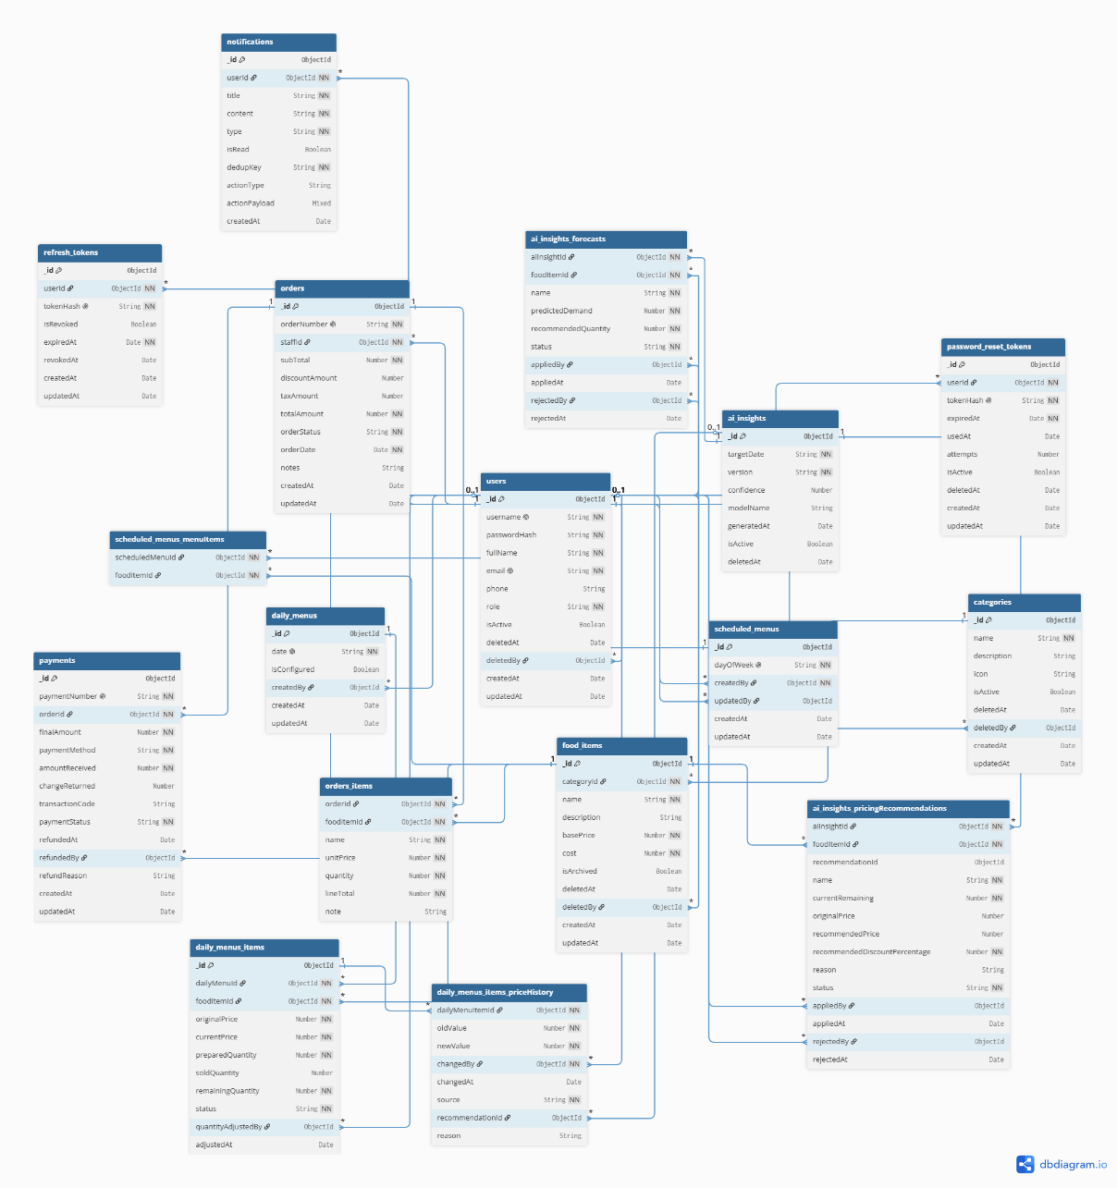

b. Table Descriptions
No | Table | Description
01 | users | Stores user account information, authentication data, and role-based access control for Staff, Manager, and Admin users.  - Primary keys: _id  - Foreign keys: deletedBy → users._id
02 | categories | Stores food categories used to classify food items in the system  - Primary keys: _id  - Foreign keys: deletedBy → users._id
03 | food_items | Stores master information of food items, including pricing, cost, and category assignment.  - Primary keys: _id  - Foreign keys: categoryId → categories._id, deletedBy → users._id
04 | scheduled_menus | Stores predefined weekly menus that assign food items to specific days of the week.  - Primary keys: _id  - Foreign keys: createdBy → users._id, updatedBy → users._id, menuItems.foodItemId → food_items._id
05 | daily_menus | Stores the actual daily menu configuration, including available food items, quantities, prices, and inventory status.  - Primary keys: _id  - Foreign keys: createdBy → users._id, items.foodItemId → food_items._id, items.quantityAdjustedBy → users._id, items.priceHistory.changedBy → users._id, items.priceHistory.recommendationId → ai_insights._id
06 | orders | Stores customer orders, purchased food items, order status, and transaction details.  - Primary keys: _id  - Foreign keys: staffId → users._id, items.foodItemId → food_items._id
07 | ai_insights | Stores AI-generated food demand forecasts, preparation recommendations, and dynamic pricing recommendations.  - Primary keys: _id  - Foreign keys: forecasts.foodItemId → food_items._id, forecasts.appliedBy → users._id, forecasts.rejectedBy → users._id, pricingRecommendations.foodItemId → food_items._id, pricingRecommendations.appliedBy → users._id, pricingRecommendations.rejectedBy → users._id
08 | payments | Stores payment transactions, payment methods, refund information, and payment status for orders.  - Primary keys: _id  - Foreign keys: orderId → orders._id, refundedBy → users._id
09 | password_reset_tokens | Stores password reset tokens used for account recovery and password reset verification.  - Primary keys: _id  - Foreign keys: userId → users._id
10 | notifications | Stores system-generated notifications delivered to users, including AI alerts and operational updates.  - Primary keys: _id  - Foreign keys: userId → users._id
11 | refresh_tokens | Stores refresh tokens used to maintain authenticated user sessions securely.  - Primary keys: _id  - Foreign keys: userId → users._id

4.2 Code Packages

a. Frontend
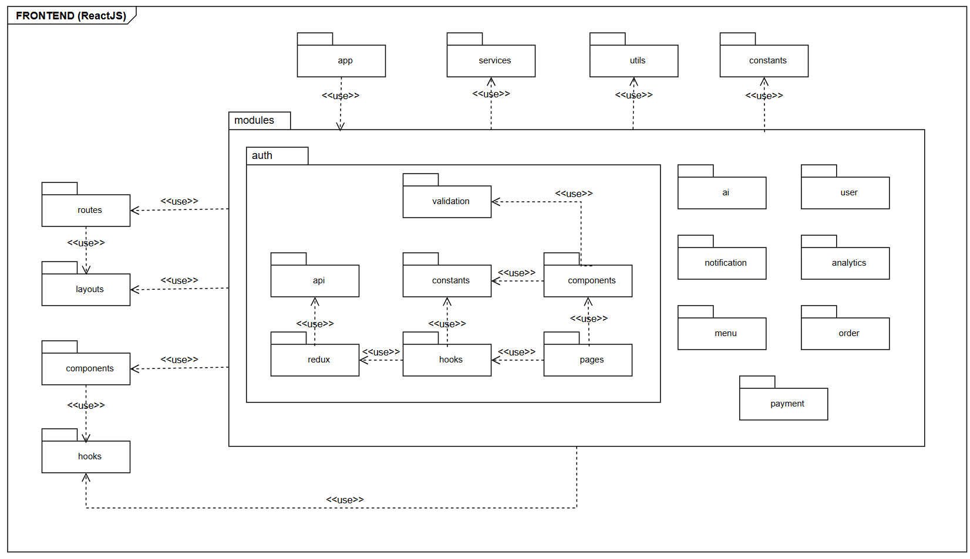
Package descriptions
No | Package | Description
01 | routes | Maps URL paths to feature module pages, handles protected routes by role.
02 | modules | Houses all business feature modules (auth, order, menu, dashboard, user, payment, notification, ai). Each module owns its own pages/, components/, hooks/, redux/, api/, validation/, and constants/.
03 | layouts | Defines page shell structures that wrap module pages.
04 | components | Contains shared reusable UI components that are not tied to any specific business module, organized by category.
05 | hooks | Contains shared custom hooks reusable across multiple modules.
06 | constants | Stores application-wide static values such as user role definitions, route path strings, and status labels shared across modules.
07 | utils | Contains pure helper functions with no side effects.
08 | app | Configures and exports the global Redux store. Registers all slice reducers from feature modules and shared slices.
09 | services | Provides the centralized Axios instance used by all module API files. Configures base URL, default headers, and request/response interceptors.

b. Backend
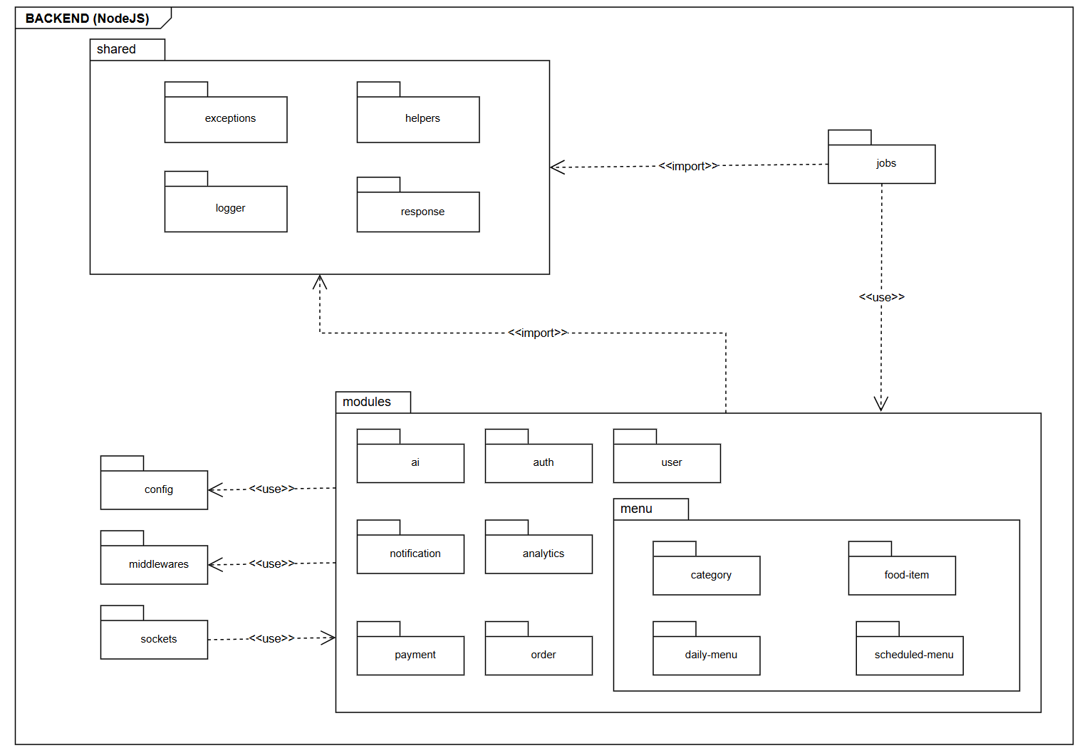
Package descriptions
No | Package | Description
01 | config | Centralizes all environment-based configuration including database connection setup (MongoDB Atlas), JWT secret loading, and environment variable validation.
02 | middlewares | Contains globally applied Express middlewares including authenticate for JWT verification, authorizeRoles for role-based access control, and the global error handler that formats all errors using the standard API response format.
03 | sockets | Manages all real-time communication using Socket.IO. Handles events such as live order status updates and real-time notifications pushed to connected clients
04 | jobs | Contains scheduled background tasks configured with node-cron such as daily menu reset, AI forecast triggering, or periodic data cleanup.
05 | modules | Houses all business feature modules (auth, user, order, menu, payment, notification, ai). Each module owns its own route, controller, service, repository, model, validation, and dto files.
06 | shared | Houses cross-cutting utilities and helpers reused across all modules such as AppError, response formatter, pagination helper, and other common logic that does not belong to any specific business module

II. Requirement Specifications

1. Authentication

1.1 UC-01_ Login

a. Functionalities
UC ID and Name: | UC-01 Login
Created By: | Dương | Date Created: | 31/05/2026
Primary Actor: | Staff, Manager, Admin. | Secondary Actors: | None.
Trigger: | The user opens the StallBox system.
Description: | Allows authorized users to access the StallBox system using valid login credentials.
Preconditions: | PRE-1: The user has a registered account in the system.  PRE-2: The user is not currently logged in.  PRE-3: The StallBox system is available.
Postconditions: | POST-1: The user is authenticated successfully.  POST-2: The system starts a valid user session.  POST-3: The user is redirected to the correct system area based on their role.
Normal Flow: | 01.0 Basic Flow:  1. The user opens the login page.  2. The system displays the login form.  3. The user enters valid login credentials.  4. The user submits the login form.  5. The system verifies the credentials.  6. The system grants access and displays the appropriate page for the user role.
Alternative Flows: | 01.1: User chooses Forgot Password.  1. The user selects the forgot password option.  2. The system redirects the user to the password recovery function.
Exceptions: | 01.0.E1: Invalid login credentials.  1. The system displays an error message and asks the user to try again.  01.0.E2: User account is disabled or unavailable.  1. The system denies access and displays an appropriate message.
Priority: | High, Must Have
Frequency of Use: | High (Continuously every day as work shifts begin).
Business Rules: | BR-AUTH-01, BR-AUTH-02, BR-AUTH-03
Other Information: | This use case is shared by Staff, Manager, and Admin.
Assumptions: | - The user has already been provided with a valid account before logging in.  - Each user account has an assigned role in the StallBox system.

b. Business Rules
ID | Business Rule | Business Rule Description
BR-AUTH-01 | Valid Credentials Required | Users must use valid login credentials to access the StallBox system.
BR-AUTH-02 | Password Encoding | User’s password must be encoded with MD5 hashing.
BR-AUTH-03 | Expired Session Invalidated | The system must automatically manage login sessions and invalidate expired authentication tokens.

1.2 UC-02_ Forgot Password

a. Functionalities
UC ID and Name: | UC-02 Forgot Password
Created By: | Dương | Date Created: | 31/05/2026
Primary Actor: | Staff, Manager, Admin. | Secondary Actors: | Email Service.
Trigger: | The user clicks on the "Quên mật khẩu" link on the Login screen.
Description: | This function allows users (Staff, Manager, Admin) to request a new password reset when they forget their login password, utilizing token-based authentication.
Preconditions: | PRE-1: The user has a registered account in the system.  PRE-2: The user is not currently logged in.  PRE-3: The StallBox system is available.
Postconditions: | POST-1: The user's new password is encrypted and successfully updated  POST-2: The password reset token is marked as used (the usedAt field is updated) in the password_reset_tokens collection.
Normal Flow: | 02.0 Basic Flow:  1. The user navigates to the Forgot Password page.  2. The system displays a form requesting the registered Email address.  3. The user enters the Email and clicks "Gửi mã OTP".  4. The system verifies the Email.  5. The system generates a one-time password (OTP), stores it with an expiration time, and sends the OTP to the user's email.  6. The user receives the OTP, enters the OTP, a new password, and confirms the new password on the Reset Password page.  7. The user clicks "Cập nhật mật khẩu".  8. The system validates the OTP and checks that it has not expired or been used.  9. The system encrypts the new password, updates the user’s account, and records the time the token was used.  10. The system displays a success message and redirects the user to the Login page.
Alternative Flows: | None.
Exceptions: | 02.0.E1: Email does not exist.  1. The system displays an error message and asks the user to try again.  02.0.E2: Invalid or expired OTP.  1. The system displays an error message indicating that the OTP is invalid or has expired.  2. The user remains on the Reset Password page and is prompted to enter a valid OTP or request a new OTP.  02.0.E3: OTP has already been used.  1. The system displays an error message indicating that the OTP is no longer valid.  2. The user is prompted to request a new OTP.
Priority: | High, Must Have
Frequency of Use: | Low (Only occurs when a user forgets their password).
Business Rules: | BR-AUTH-02
Other Information: | None.
Assumptions: | The user still has access to the email inbox they used to register their account.

b. Business Rules
ID | Business Rule | Business Rule Description
BR-AUTH- 02 | Password Encoding | User’s password must be encoded with MD5 hashing.

1.3 UC-03_ Logout

a. Functionalities
UC ID and Name: | UC-03 Logout
Created By: | Dương | Date Created: | 31/05/2026
Primary Actor: | Staff, Manager, Admin. | Secondary Actors: | None.
Trigger: | The user clicks the "Đăng xuất" button on the application's navigation bar or personal profile menu.
Description: | This function allows user roles (Staff, Manager, Admin) to safely end their current session and exit the StallBox system.
Preconditions: | PRE-1: The user has successfully logged into the system and possesses a valid working session (token).
Postconditions: | POST-1: The system revokes the user's token.  POST-2: The system clears all authentication states and session.  POST-3: The user is redirected to the Login page.
Normal Flow: | 03.0 Basic Flow:  1. The user selects the "Đăng xuất" function on the application interface.  2. The system revokes the user's token and clears all authentication states and session data  3. The system redirects the user to the Login screen.
Alternative Flows: | None.
Exceptions: | 03.0.E1: Network disconnection or unresponsive server.  1. The system must still force the execution of step 2: clear the local token and clean up the Redux store to ensure the user is logged out on the client-side.
Priority: | High, Must Have
Frequency of Use: | High (Typically occurs at the end of each employee's shift or when a manager/admin switches accounts).
Business Rules: | None.
Other Information: | None.
Assumptions: | The user's web browser allows the application to execute cache/storage clearing commands (local storage/cookies) normally.

b. Business Rules
None.

2. Profile Management

2.1 UC-04_ View Personal Profile

a. Functionalities
UC ID and Name: | UC-04 View Personal Profile
Created By: | Dương | Date Created: | 01/06/2026
Primary Actor: | Staff, Manager, Admin. | Secondary Actors: | None.
Trigger: | The user clicks on their avatar or selects the "Thông tin cá nhân" option from the application's navigation menu.
Description: | This use case allows a logged-in user to view their own personal account details (such as full name, username, email, phone number, and assigned role) within the StallBox system.
Preconditions: | PRE-1: The user must be successfully logged into the system and have an active, valid session.
Postconditions: | POST-1: The system successfully displays the user's profile information on the screen.
Normal Flow: | 04.0 Basic Flow:  1. The user selects the " Thông tin cá nhân " option from the menu.  2. The system verifies the current session and retrieves the user’s account information.  3. The system displays the Profile page, showing the user’s personal details.
Alternative Flows: | None.
Exceptions: | 04.0.E1: Session Expired or Invalid.  1. At step 2 of flow 4.0, the system detects that the user's session has expired or the authentication token is invalid.  2. The system displays a warning message: "Phiên đăng nhập đã hết hạn. Vui lòng đăng nhập lại."  3. The system automatically redirects the Actor to the Login page.
Priority: | Medium, Should Have.
Frequency of Use: | Low (Users typically only check their profile occasionally).
Business Rules: | BR-Profile-01, BR-Profile-02
Other Information: | Sensitive information, such as the user's password, must never be retrieved or displayed on the profile screen for security reasons.
Assumptions: | The user's account data is intact and properly synchronized between the client and the server.

b. Business Rules
ID | Business Rule | Business Rule Description
BR-Profile-01 | Data Privacy | A user is strictly restricted to viewing only their own profile information through this function. They cannot view the profiles of other staff members (cross-user viewing is reserved for Admin management functions).
BR-Profile-02 | Read-Only State | In this specific use case, the displayed data is purely informational (read-only). Any modifications must go through the "Update Personal Profile" use case.

2.2 UC-05_ Update Personal Profile

a. Functionalities
UC ID and Name: | UC-05 Update Personal Profile
Created By: | Dương | Date Created: | 01/06/2026
Primary Actor: | Staff, Manager, Admin. | Secondary Actors: | None.
Trigger: | The user clicks the "Lưu hồ sơ" button while viewing their personal profile.
Description: | This use case allows a logged-in user to update their personal information such as name, email, or contact details.
Preconditions: | PRE-1: The user must be authenticated and currently viewing the "View Personal Profile" screen.
Postconditions: | POST-1: The user's updated information is successfully saved in the system.  POST-2: The system reflects the new data on the user's profile and across the application interface.
Normal Flow: | 05.0 Basic Flow:  1. The user selects the option to edit their profile.  2. The system displays an editable form pre-filled with the user's current data.  3. The user modifies personal information such as name, email, or contact details.  4. The user clicks the "Lưu hồ sơ" button.  5. The system validates the inputted data against business rules.  6. The system successfully updates the information and displays a success notification.  7. The system returns the user to the View Profile screen, displaying the updated details.
Alternative Flows: | None.
Exceptions: | 05.0.E1 Invalid Input Data:  1. At step 5 of flow 05.0, the system detects missing required fields or invalid data formats (e.g., incorrect email format).  2. The system highlights the fields in error and displays a specific validation message (e.g., "Invalid email format").  3. The user is prompted to correct the information and submit again (returns to step 3).  05.0.E2 Email Already in Use:  1. At step 5 of flow 05.0, the system detects that the newly entered email is already registered to another user.  2. The system displays an error message indicating the email is unavailable.  3. The user is prompted to provide a different email.
Priority: | Medium, Should Have.
Frequency of Use: | Low (Users rarely change their core personal information).
Business Rules: | BR-Profile-03, BR-Profile-04, BR-Profile-04, BR-Profile-06
Other Information: | Upon a successful update, the frontend application must immediately synchronize the new data to update UI elements universally (such as the user's name on the top navigation bar).
Assumptions: | The user has the necessary permissions to edit their own data, and the network connection remains stable during the save operation.

b. Business Rules
ID | Business Rule | Business Rule Description
BR-Profile-03 | Mandatory Fields | The Full Name and Email fields are strictly required and cannot be left blank.
BR-Profile-04 | Email Format | The email address must conform to standard regex validation rules.
BR-Profile-05 | Optional Contact Details | The phone number is an optional field and can be left empty.
BR-Profile-06 | Non-editable Attributes | Users cannot use this function to alter their assigned Role (e.g., change from Staff to Manager) or their Account Status (Active/Inactive); these are managed strictly by Admins.

2.3 UC-06_ Change Password

a. Functionalities
UC ID and Name: | UC-06 Change Password
Created By: | Dương | Date Created: | 01/06/2026
Primary Actor: | Staff, Manager, Admin. | Secondary Actors: | None.
Trigger: | The user selects the "Đổi mật khẩu" option from their profile or account settings menu.
Description: | This use case allows an authenticated user to securely update their account password by verifying their current password and providing a new one.
Preconditions: | PRE-1: The user must be logged into the StallBox system with an active session.
Postconditions: | POST-1: The user's new password is encrypted and successfully updated in the system.
Normal Flow: | 06.0 Basic Flow:  1. The user navigates to the Change Password screen.  2. The system displays a form requesting the "Mật khẩu hiện tại", "Mật khẩu mới", and "Xác nhận mật khẩu mới".  3. The user enters the required information and clicks the "Đổi mật khẩu" button.  4. The system verifies that the entered "Mật khẩu hiện tại" matches the one stored in the database.  5. The system validates that the "Mật khẩu mới" and "Xác nhận mật khẩu mới" match.  6. The system encrypts the new password, saves the updated record, and revokes all active refresh tokens for this user on the server.  7. The system displays a success message indicating the password has been changed.  8. The system automatically clears the local session and redirects the user to the Login page.
Alternative Flows: | None.
Exceptions: | 6.0.E1 Incorrect Current Password:  1. At step 4 of flow 6.0, the system detects that the " Mật khẩu hiện tại" entered is incorrect.  2. The system displays an error message: "Mật khẩu hiện tại không chính xác."  3. The system clears the password fields and prompts the user to try again.  6.0.E2 Passwords Do Not Match:  1. At step 5 of flow 6.0, the system detects that the " Mật khẩu mới" and " Xác nhận mật khẩu mới" do not match.  2. The system displays a validation error: " Xác nhận mật khẩu không khớp."  3. The system prevents form submission until the user corrects the fields.
Priority: | High, Must Have
Frequency of Use: | Low (Users typically change passwords only when required for security or personal preference).
Business Rules: | BR-AUTH-02, BR-AUTH-04
Other Information: | For enhanced security, changing a password revokes all active refresh tokens for this user, ensuring they are logged out of any other active sessions across different devices (implemented in BE).
Assumptions: | The user remembers their current password; if they have forgotten it, they must use the "Forgot Password" (UC-02) flow instead.

b. Business Rules
ID | Business Rule | Business Rule Description
BR-AUTH- 02 | Password Encoding | User’s password must be encoded with MD5 hashing.
BR-Auth-04 | Password Security | The new password must not be identical to the current password.

3. Order Management

3.1 UC-07_ Create Order

a. Functionalities
UC ID and Name: | UC-07 Create Order
Created By: | Dương | Date Created: | 01/06/2026
Primary Actor: | Staff, Manager. | Secondary Actors: | None.
Trigger: | A customer approaches the canteen stall to purchase food, and the Actor initiates a new order on the POS (Point of Sale) interface.
Description: | This use case allows a Staff or Manager to create a customer order by selecting available food items from the daily menu, adjusting quantities, and generating the total bill for payment.
Preconditions: | PRE-1: The user must be authenticated and authorized to access the sales screen.  PRE-2: The daily menu for the current date must be configured and have active items.
Postconditions: | POST-1: A new order record is successfully created in the system with a unique orderNumber.  POST-2: The system temporarily reserves the ordered quantities to prevent double-selling before payment is finalized.
Normal Flow: | 7.0 Basic Flow:  1. User navigates to the POS / Create Order screen.  2. The system displays the current daily menu, including available food items, remaining stock, and their current prices.  3. User selects one or more food items requested by the customer and specifies the quantity for each.  4. The system automatically calculates and displays the subtotal, any applicable discounts/taxes, and the final total amount.  5. User confirms the order details with the customer and clicks " Tạo đơn hàng".  6. The system validates the selected items against current stock and availability status.  7. The system creates the order record with an initial status of 'Pending'.  8. The system transitions the User to the Process Payment screen.
Alternative Flows: | 7.1 Modify Cart Before Creation:  1. At step 3 of flow 7.0, the Actor can increase/decrease item quantities or completely remove items from the cart.  2. The system instantly recalculates the total amount.  3. The Actor proceeds to step 5 of the normal flow.
Exceptions: | 7.0.E1 Insufficient Stock:  1. At step 6 of flow 7.0, the system detects that the requested quantity for a specific item exceeds the remainingQuantity in the daily menu.  2. The system displays an error message.  3. The system highlights the item in the cart, prompting the user to adjust the quantity (returns to step 3).  7.0.E2 Item Became Unavailable:  1. At step 6 of flow 7.0, the system detects that an item's status has just been changed to 'Unavailable' by a Manager.  2. The system displays a warning message.  3. The user must remove the unavailable item from the cart before proceeding.
Priority: | High, Must Have.
Frequency of Use: | Very High (Continuously executed throughout the canteen's operating hours).
Business Rules: | BR-Order-01, BR-Order-02, BR-Order-03, BR-Order-04, BR-Order-05
Other Information: | If network connectivity is lost during step 7, the frontend state (cart data) should be preserved locally so the user does not have to re-enter the entire order once the connection is restored.
Assumptions: | Real-time or near real-time synchronization is functioning properly to ensure the frontend displays accurate remainingQuantity and currentPrice data to the staff.

b. Business Rules
ID | Business Rule | Business Rule Description
BR-Order-01 | Order Minimum Quantity | The quantity for each selected food item inside a single order must be greater than or equal to 1.
BR-Order-02 | Stock Constraint | The ordered quantity cannot exceed the remainingQuantity of the item in the daily menu.
BR-Order-03 | Valid Pricing | The order must capture the currentPrice of the food items at the exact moment of order creation.
BR-Order-04 | Positive Amount | The totalAmount of the order must be greater than or equal to 0.
BR-Order-05 | Initial Status | A newly created, unpaid order is strictly assigned the orderStatus of 'Pending'.

3.2 UC-08_ Cancel Order

a. Functionalities
UC ID and Name: | UC-08 Cancel Order
Created By: | Dương | Date Created: | 01/06/2026
Primary Actor: | Staff, Manager, Admin. | Secondary Actors: | None.
Trigger: | A customer requests to cancel their order before payment is completed, or a staff member identifies an error in a newly created order.
Description: | Authorized user cancels an existing order when required. This ensures the system maintains accurate sales records and restores available food quantities.
Preconditions: | PRE-1: The user must be logged in and authorized to manage orders.  PRE-2: The order must exist in the system and must be in a cancellable state ('Pending').
Postconditions: | POST-1: The system updates the orderStatus of the specific order to 'Cancelled'.  POST-2: The temporarily reserved remainingQuantity for the canceled food items is added back to the daily menu inventory.
Normal Flow: | 8.0 Basic Flow:  1. User navigates to the Order List or current POS cart screen.  2. User selects the specific order they wish to cancel and clicks the "Cancel Order" button (Nút này hiện đang bị ẩn trên UI).  3. The system prompts the user with a confirmation dialog.  4. User confirms the cancellation.  5. The system updates the order record in the database, changing its status to 'Cancelled'.  6. The system recalculates and restores the item quantities back to the daily_menus collection to make them available for other customers.  7. The system displays a success notification and updates the UI accordingly.
Alternative Flows: | 8.1 Cancel during Order Creation:  1. At step 2, if the order has not yet been saved to the database (still in the local cart), the Actor clicks "Clear Cart".  2. The system clears the cart data from the local frontend state.  3. The use case ends without any database interaction.
Exceptions: | 8.0.E1 Order Already Processed:  1. At step 5 of flow 8.0, the system detects that the order's status is already 'Completed' (e.g., payment was just processed by another terminal).  2. The system aborts the cancellation and displays an error message: "Cannot cancel a completed order. Please use the refund/return process."  3. The system refreshes the order details to show the latest status.
Priority: | High, Must Have.
Frequency of Use: | Low to Medium (Occurs occasionally during daily operations when customers change their minds or entry errors happen).
Business Rules: | BR-Order-06, BR-Order-07
Other Information: | If a cancelled order involved a failed or pending digital payment (e.g., Momo, VNPay), the system must also ensure any associated pending payment intent is voided to prevent the customer from being charged later.
Assumptions: | Real-time synchronization is active to immediately reflect the restored inventory quantities to all other staff members' screens.

b. Business Rules
ID | Business Rule | Business Rule Description
BR-Order-06 | Order Status Constraints | An order can only transition to 'Cancelled' if its current orderStatus is 'Pending'. Completed orders cannot be cancelled directly.
BR-Order-07 | Inventory Restoration | Upon cancellation, the exact quantity of each item in the cancelled order must be added back to the corresponding item's remainingQuantity in the daily menu.

3.3 UC-09_ View Own Order History

a. Functionalities
UC ID and Name: | UC-09 View Own Order History
Created By: | Dương | Date Created: | 01/06/2026
Primary Actor: | Staff, Manager. | Secondary Actors: | None.
Trigger: | The user clicks on the "Đơn hang của tôi" section in the application menu.
Description: | This use case allows a Staff member or Manager to view the history of orders they have personally handled or created within the system.
Preconditions: | PRE-1: The user must be successfully authenticated into the StallBox system.  PRE-2: The user's role must be either Staff or Manager.
Postconditions: | POST-1: The system successfully displays a list of past orders that are specifically linked to the logged-in user.
Normal Flow: | 9.0 Basic Flow:  1. User navigates to the Order History screen.  2. The system identifies the user’s unique user ID from their current session.  3. The system queries the orders database collection for records where the staffId matches the user’s ID.  4. The system displays a summary list of the user’s orders, sorted by date (newest first), showing the orderNumber, orderDate, totalAmount, and orderStatus.  5. User may click on a specific order to view its detailed information (items, quantities, payment method).
Alternative Flows: | 9.1 Filter and Search History:  1. At step 4 of flow 9.0, the user applies filters (e.g., date range, specific orderStatus) or searches by a specific orderNumber.  2. The system dynamically updates the query and displays the filtered list of the Actor's orders.
Exceptions: | 9.0.E1 No Order History:  1. At step 3 of flow 9.0, the system detects that the user has not yet created or handled any orders.  2. The system displays a user-friendly message and shows an empty list state.
Priority: | Medium, Should Have.
Frequency of Use: | Medium (Often checked at the end of a shift to verify daily personal performance or reconcile transactions).
Business Rules: | BR-Order-08
Other Information: | The list retrieved from the backend should be paginated to ensure fast loading times and optimized performance on the frontend, especially for staff members who handle a large volume of transactions over time.
Assumptions: | The authentication token properly contains or resolves to the correct user ID required to fetch the isolated data.

b. Business Rules
ID | Business Rule | Business Rule Description
BR-Order-08 | Data Isolation | Under this specific use case, the system must strictly filter the data so the user can only view orders where the staffId matches their own user ID. Viewing all system orders falls under a different use case ("View Order List") reserved for Managers and Admins.

3.4 UC-10_ View Order List

a. Functionalities
UC ID and Name: | UC-10 View Order List
Created By: | Dương | Date Created: | 01/06/2026
Primary Actor: | Manager, Admin. | Secondary Actors: | None.
Trigger: | The user selects the "Đơn hàng" option from the application's navigation menu.
Description: | This use case allows a Manager or Admin to view all orders recorded in the system. It provides a comprehensive overview of sales activities across all staff members.
Preconditions: | PRE-1: The user must be successfully authenticated into the StallBox system.  PRE-2: The user's role must be strictly set to either Manager or Admin.
Postconditions: | POST-1: The system successfully retrieves and displays the global list of past and current orders.
Normal Flow: | 10.0 Basic Flow:  1. User navigates to the global Order List screen.  2. The system queries the orders database collection for all recorded order entries.  3. The system displays a comprehensive list of orders, sorted by date (newest first), showing the orderNumber, orderDate, staffId (creator), totalAmount, and orderStatus.  4. User can click on any specific order row to navigate to the "View Order Details" screen for deeper inspection.
Alternative Flows: | 10.1 Filter and Search Orders:  1. At step 3 of flow 10.0, the user applies filters (e.g., date range, specific staffId, specific orderStatus) or searches by orderNumber.  2. The system dynamically updates the query and displays the filtered list of overall orders.
Exceptions: | 10.0.E1 No Orders Match Criteria:  1. At step 2 of flow 10.0 (or during Alternative Flow 10.1), the system detects no orders matching the applied filters or database state.  2. The system displays a user-friendly message: "No orders found matching the selected criteria." and shows an empty data table.
Priority: | High, Must Have.
Frequency of Use: | High (Regularly used by management for daily monitoring, shift reconciliation, and auditing sales).
Business Rules: | BR-Order-09
Other Information: | The list retrieved from the backend API must implement pagination to ensure fast loading times and optimized performance on the frontend, as the overall order volume will grow significantly over time.
Assumptions: | The system contains valid order data, and the user's role permissions are correctly configured in the authentication token.

b. Business Rules
ID | Business Rule | Business Rule Description
BR-Order-09 | Global Data Access | Unlike standard Staff members who only see their own history, Managers and Admins are granted global read access to view all orders generated across the entire canteen stall.

4. Payment Management

4.1 UC-11_ Process Payment

a. Functionalities
UC ID and Name: | UC-11 Process Payment
Created By: | Dương | Date Created: | 01/06/2026
Primary Actor: | Staff, Manager. | Secondary Actors: | Payment Gateway.
Trigger: | The user selects the option to complete the transaction for a newly created or pending order.
Description: | Staff or Manager processes payment for an order through a supported payment method.
Preconditions: | PRE-1: The order must exist in the database with an orderStatus of 'Pending'.  PRE-2: The user must be authenticated under the role of Staff or Manager.
Postconditions: | POST-1: A record is created in the payments collection with a unique paymentNumber and a paymentStatus of 'Paid'.  POST-2: The associated order's orderStatus is updated to 'Completed'.
Normal Flow: | 11.0 Basic Flow (Digital Payment):  1. User navigates to the payment interface for a pending order.  2. The system displays the finalAmount required to settle the order.  3. User selects a digital paymentMethod ('Momo' or 'VNPay').  4. The system sends a request to the external Payment Gateway to process the transaction.  5. The Payment Gateway confirms the payment status as successful.  6. The system updates the paymentStatus to 'Paid' and the orderStatus to 'Completed'.  7. The system displays a success notification and presents the option to print a receipt.
Alternative Flows: | 11.1 Cash Payment Method:  1. At step 3 of flow 11.0, the user selects 'Cash' as the paymentMethod.  2. User inputs the actual amountReceived collected from the customer.  3. The system calculates and displays the changeReturned.  4. The system updates the paymentStatus to 'Paid' and the orderStatus to 'Completed'.  5. The system displays a success notification and presents the option to print a receipt.
Exceptions: | 11.0.E1 Handle Payment Failure:  1. At step 5 of flow 11.0, the Payment Gateway returns a failed transaction status.  2. The system executes the "Handle Payment Failure" extension.  3. The system updates the paymentStatus to 'Failed' in the database.  4. The system displays an error message and prompts the user to retry the transaction or select an alternative payment method.  11.1.E1 Insufficient Cash Received:  1. At step 2 of flow 11.1, the Actor inputs an amountReceived that is strictly less than the required finalAmount.  2. The system displays a validation error preventing the completion of the payment.  3. The user is required to input a valid amount to proceed.
Priority: | High, Must Have.
Frequency of Use: | Very High (Executed for every successful order placed at the canteen).
Business Rules: | BR-Payment-01, BR-Payment-02, BR-Payment-03
Other Information: | Following a successful payment, the "Print Receipt" use case can be triggered as an extension of this process. The finalAmount represents the actual money collected from the order after any applied discounts or taxes.
Assumptions: | The external Payment Gateway maintains high availability and responds quickly to prevent blocking the sales flow at the physical stall.

b. Business Rules
ID | Business Rule | Business Rule Description
BR-Payment-01 | Supported Methods | The paymentMethod is strictly restricted to 'Cash', 'Momo', or 'VNPay'.
BR-Payment-02 | Valid Amounts | The finalAmount, amountReceived, and changeReturned fields must all be numerical values greater than or equal to 0.
BR-Payment-03 | Status Constraints | The paymentStatus must follow the defined enumeration: 'Pending', 'Paid', 'Failed', or 'Refunded'.

4.2 UC-12_ Print Receipt

a. Functionalities
UC ID and Name: | UC-12 Print Receipt
Created By: | Dương | Date Created: | 01/06/2026
Primary Actor: | Staff, Manager. | Secondary Actors: | None.
Trigger: | The payment is successfully processed, or the Actor explicitly clicks the "Print Receipt" button on a completed order's details screen.
Description: | The system generates and prints a receipt after a successful payment.
Preconditions: | PRE-1: The associated order must exist and be fully paid (the orderStatus is 'Completed' and paymentStatus is 'Paid').  PRE-2: The user must be authenticated as a Staff member or Manager.
Postconditions: | POST-1: The system successfully formats the order data and sends a print directive to the connected receipt printer.
Normal Flow: | 12.0 Basic Flow (Post-Payment Extension):  1. The "Process Payment" use case concludes successfully.  2. The system prompts the user with an option to print the receipt.  3. User selects "Print Receipt".  4. The system retrieves the finalized order details (orderNumber, items, totalAmount) and payment details (paymentMethod, amountReceived, changeReturned).  5. The system formats the retrieved data into a standard receipt layout.  6. The system triggers the browser's print dialog or sends the job directly to the configured POS printer.
Alternative Flows: | 12.1 Manual Print from Order History:  1. Actor navigates to the Order History and views the details of a past completed order.  2. Actor clicks the "Print Receipt" button.  3. The system proceeds to step 4 of the normal flow.
Exceptions: | 8.0.E1 Order Already Processed:  1. At step 5 of flow 8.0, the system detects that the order's status is already 'Completed' (e.g., payment was just processed by another terminal).  2. The system aborts the cancellation and displays an error message: "Cannot cancel a completed order. Please use the refund/return process."  3. The system refreshes the order details to show the latest status.
Priority: | High, Must Have.
Frequency of Use: | Low to Medium (Occurs occasionally during daily operations when customers change their minds or entry errors happen).
Business Rules: | BR-Order-06, BR-Order-07
Other Information: | If a cancelled order involved a failed or pending digital payment (e.g., Momo, VNPay), the system must also ensure any associated pending payment intent is voided to prevent the customer from being charged later.
Assumptions: | Real-time synchronization is active to immediately reflect the restored inventory quantities to all other staff members' screens.

b. Business Rules
ID | Business Rule | Business Rule Description
BR-Order-06 | Order Status Constraints | An order can only transition to 'Cancelled' if its current orderStatus is 'Pending'. Completed orders cannot be cancelled directly.
BR-Order-07 | Inventory Restoration | Upon cancellation, the exact quantity of each item in the cancelled order must be added back to the corresponding item's remainingQuantity in the daily menu.

4.3 UC-13_ View Payment List

a. Functionalities
UC ID and Name: | UC-13 View Payment List
Created By: | Dương | Date Created: | 01/06/2026
Primary Actor: | Manager, Admin. | Secondary Actors: | None.
Trigger: | The user selects the "Payments" or "Transactions" option from the application's navigation menu.
Description: | Manager or Admin views all payment transactions recorded in the system. This provides a comprehensive overview for auditing, end-of-day reconciliation, and financial monitoring.
Preconditions: | PRE-1: The user must be successfully authenticated into the StallBox system.  PRE-2: The user's role must be strictly set to either Manager or Admin.
Postconditions: | POST-1: The system successfully retrieves and displays the global list of payment records.
Normal Flow: | 13.0 Basic Flow:  1. User navigates to the View Payment List screen.  2. The system queries the payments database collection for recorded transactions.  3. The system displays a comprehensive list of payments, sorted by date (newest first), showing the paymentNumber, finalAmount, paymentMethod, and paymentStatus.  4. User can click on any specific payment row to view deeper details, such as the associated orderId, amountReceived, and changeReturned.
Alternative Flows: | 13.1 Filter and Search Payments:  1. At step 3 of flow 13.0, the user applies filters (e.g., date range, specific paymentMethod like 'VNPay' or 'Cash', specific paymentStatus) or searches by paymentNumber.  2. The system dynamically updates the query and displays the filtered list of transactions.
Exceptions: | 13.0.E1 No Payments Match Criteria:  1. At step 2 of flow 13.0 (or during Alternative Flow 13.1), the system detects no payments matching the applied filters or database state.  2. The system displays a user-friendly message: "No payment records found matching the selected criteria." and shows an empty data table.
Priority: | Medium, Should Have.
Frequency of Use: | High (Regularly used by management at the end of shifts or daily for financial reconciliation).
Business Rules: | BR-Payment-04, BR-Payment-05
Other Information: | The list retrieved from the backend API must implement pagination to ensure fast loading times and optimized performance on the frontend, as payment volume will grow daily.
Assumptions: | The system contains valid payment data accurately synced from the Process Payment workflow, and the user's role permissions are correctly configured in their authentication token.

b. Business Rules
ID | Business Rule | Business Rule Description
BR-Payment-04 | Data Access Restriction | Unlike order history, standard Staff members do not have access to view the global payment list; this is reserved for management roles.
BR-Payment-05 | Immutable Records | The payment records displayed in this view are strictly read-only. Manual modification of a paymentStatus directly from this list is not permitted to ensure financial integrity.

5. Menu Management

5.1 UC-14_ Create Food Item

a. Functionalities
UC ID and Name: | UC-14 Create Food Item
Created By: | Dương | Date Created: | 01/06/2026
Primary Actor: | Admin. | Secondary Actors: | None.
Trigger: | The Admin selects the "Thêm món mới" option from the Master Menu management screen.
Description: | Admin creates a new food item in the menu catalog. This establishes the master record for the item before it can be assigned to any scheduled or daily menus.
Preconditions: | PRE-1: The user must be authenticated as an Admin.  PRE-2: At least one active food category must exist in the system.
Postconditions: | POST-1: A new record is successfully created in the food_items database collection.
Normal Flow: | 14.0 Basic Flow:  1. User navigates to the Master Menu screen and clicks "Thêm món mới".  2. The system displays a blank form.  3. User inputs the item details: name, description, category, basePrice, and cost.  4. User clicks "Tạo món ăn".  5. The system validates the inputs against business rules.  6. The system saves the new food item to the food_items collection.  7. The system displays a success message and returns the user to the updated menu list.
Alternative Flows: | 14.1 Cancel Creation:  1. At step 3 of flow 14.0, the user clicks "Hủy bỏ".  2. The system discards the input and returns the user to the menu list.
Exceptions: | 14.0.E1 Invalid Data Entry:  1. At step 5 of flow 14.0, the system detects missing required fields or invalid numeric values (e.g., negative prices).  2. The system highlights the errors and prevents saving.  3. The user is prompted to correct the inputs.
Priority: | High, Must Have.
Frequency of Use: | Low (Occurs only when the canteen introduces new items).
Business Rules: | BR-Menu-01, BR-Menu-02
Other Information: | Newly created items have the isArchived flag set to false by default.
Assumptions: | The Admin possesses the correct pricing and costing information for the new food item.

b. Business Rules
ID | Business Rule | Business Rule Description
BR-Menu-01 | Required Fields | The name, categoryId, basePrice, and cost fields are strictly required.
BR-Menu-02 | Pricing Constraints | The basePrice and cost must be numbers greater than or equal to 0.

5.2 UC-15_ Update Food Item

a. Functionalities
UC ID and Name: | UC-15 Update Food Item
Created By: | Dương | Date Created: | 01/06/2026
Primary Actor: | Admin. | Secondary Actors: | None.
Trigger: | The Admin selects an existing food item from the Master Menu and clicks the edit button.
Description: | Admin updates information related to a food item. This allows modifications to the item's name, category, pricing, or description.
Preconditions: | PRE-1: The user must be authenticated as an Admin.  PRE-2: The target food item must exist in the food_items collection.
Postconditions: | POST-1: The selected food item's record is successfully updated in the database.
Normal Flow: | 15.0 Basic Flow:  1. User navigates to the Master Menu and selects a food item to edit.  2. The system displays a form pre-filled with the item's current details.  3. User modifies the desired fields (e.g., basePrice, cost, name).  4. User clicks "Lưu thay đổi".  5. The system validates the new inputs.  6. The system updates the record in the food_items collection and updates the updatedAt timestamp.  7. The system displays a success notification.
Alternative Flows: | None.
Exceptions: | 15.0.E1 Invalid Data Update:  1. At step 5 of flow 15.0, the system detects invalid inputs (e.g., negative cost).  2. The system displays a validation error and requires the user to fix the values before saving.
Priority: | High, Must Have.
Frequency of Use: | Low to Medium (Occurs when ingredient costs or baseline prices change).
Business Rules: | BR-Menu-02
Other Information: | Updating a basePrice in the master menu does not retroactively change the prices of items already recorded in past orders or currently active in daily_menus.
Assumptions: | Real-time synchronization updates the master catalog for all Admin users.

b. Business Rules
ID | Business Rule | Business Rule Description
BR-Menu-02 | Pricing Constraints | The basePrice and cost must be numbers greater than or equal to 0.

5.3 UC-16_ Remove Food Item

a. Functionalities
UC ID and Name: | UC-16 Remove Food Item
Created By: | Dương | Date Created: | 01/06/2026
Primary Actor: | Admin. | Secondary Actors: | None.
Trigger: | The Admin clicks the "Archive" action for a specific food item in the Master Menu.
Description: | Admin archives a food item from the menu catalog. To maintain data integrity for historical orders, items are soft-deleted or archived rather than permanently erased.
Preconditions: | PRE-1: The user must be authenticated as an Admin.  PRE-2: The target food item must exist in the system.
Postconditions: | POST-1: The item is marked as archived (isArchived: true) in the food_items collection.
Normal Flow: | 16.0 Basic Flow (Soft Delete/Archive):  1. User selects a food item and chooses the removal action.  2. The system displays a confirmation dialog warning the user about the action.  3. User confirms the removal.  4. The system updates the item's record by setting isArchived to true and/or populating the deletedAt and deletedBy fields.  5. The system hides the item from active selection lists (e.g., when configuring scheduled menus).  6. The system displays a success notification.
Alternative Flows: | None.
Exceptions: | 16.0.E1 Item Currently in Daily Menu:  1. At step 4 of flow 16.0, the system detects that the item is actively listed in today's daily_menus.  2. The system warns the user: "Không thể ngừng bán món đang được sử dụng."
Priority: | Medium, Should Have.
Frequency of Use: | Low (Occurs rarely when a dish is permanently discontinued).
Business Rules: | BR-Menu-03
Other Information: | Archived items will still appear in past revenue and sales statistics.
Assumptions: | The Admin understands that archiving an item prevents it from being added to future daily menus.

b. Business Rules
ID | Business Rule | Business Rule Description
BR-Menu-03 | Data Retention | Food items must never be hard-deleted from the database if they have been associated with any historical orders or daily_menus to ensure reporting accuracy.

5.4 UC-17_ Configure Food Category

a. Functionalities
UC ID and Name: | UC-17 Configure Food Category
Created By: | Dương | Date Created: | 01/06/2026
Primary Actor: | Admin. | Secondary Actors: | None.
Trigger: | The Admin navigates to the Category Management section of the Master Menu.
Description: | Admin manages food categories used to organize menu items. This includes creating, updating, or deactivating categories like "Main Dishes", "Drinks", or "Snacks".
Preconditions: | PRE-1: The user must be authenticated as an Admin.
Postconditions: | POST-1: The categories collection is successfully updated with the new, modified, or deactivated category record.
Normal Flow: | 17.0 Basic Flow (Create Category):  1. User clicks "Thêm danh mục".  2. The system prompts for a category name and optional description.  3. User inputs the details and saves.  4. The system validates that the name is unique.  5. The system creates the new record in the categories collection.  6. The system refreshes the category list.
Alternative Flows: | 17.1 Update Category:  1. User selects an existing category and edits its name or description.  2. The system updates the record and the updatedAt timestamp.  17.2 Toggle Category Status:  1. User toggles the status of a category to inactive.  2. The system sets isActive to false, hiding it from standard selection menus.
Exceptions: | 17.0.E1 Duplicate Category Name:  1. At step 4 of flow 17.0 (or 17.1), the system detects the entered name already exists.  2. The system displays an error: "Tên danh mục đã tồn tại.".
Priority: | Medium, Should Have.
Frequency of Use: | Low (Setup phase or occasional restructuring).
Business Rules: | BR-Category-01
Other Information: | Deactivating a category does not automatically delete or archive the food_items linked to it.
Assumptions: | Categories are used globally across the frontend to filter and group items on the POS screen.

b. Business Rules
ID | Business Rule | Business Rule Description
BR-Category-01 | Unique Naming | Category names must be unique and trimmed of whitespace.

5.5 UC-18_ Configure Scheduled Menu

a. Functionalities
UC ID and Name: | UC-18 Configure Scheduled Menu
Created By: | Kiều | Date Created: | 21/06/2026
Primary Actor: | Admin. | Secondary Actors: | None.
Trigger: | The Admin navigates to the Scheduled Menu Management screen and chooses to add, remove, or save food items for one or more weekdays.
Description: | This use case allows the Admin to configure a weekly menu template by assigning active food items to specific weekdays from Monday to Sunday. The configured schedule is used as a reusable weekly template for generating daily menus.
Preconditions: | PRE-1: The user must be authenticated.  PRE-2: The user must have the Admin role.  PRE-3: At least one active food item exists in the master menu.  PRE-4: The Scheduled Menu Management screen is available.
Postconditions: | POST-1: The selected weekday schedule is updated in the scheduled_menus collection.  POST-2: The updated schedule is displayed on the Scheduled Menu Management screen.  POST-3: Unsaved change indicators are cleared after a successful save.
Normal Flow: | - Basic Flow:  1. Admin navigates to the Scheduled Menu Management screen.  2. The system displays the weekly schedule layout with seven weekday columns from Monday to Sunday.  3. Admin clicks the “Add Item” button on a selected weekday column.  4. The system opens the Food Item Picker modal.  5. The system displays active food items with search and category filter options.  6. Admin searches, filters, and selects one or more food items.  7. Admin confirms the selected items.  8. The system adds the selected items to the selected weekday in local state and marks the weekday as modified.  9. Admin may remove an assigned food item from the weekday column before saving.  10. Admin clicks the save action for a single day or the global save action for all modified days.  11. The system displays a confirmation dialog.  12. Admin confirms the save action.  13. The system validates the request data and verifies that all selected food items are valid and active.  14. The system updates the scheduled_menus collection.  15. The system displays a success notification and refreshes the weekly schedule.
Alternative Flows: | 18.1 Cancel Item Selection:  1. At step 6, Admin closes the Food Item Picker modal without confirming.  2. The system closes the modal and does not change the weekday schedule.  - Revert Single Day Changes:  1. After modifying a weekday, Admin clicks the undo action on that weekday column.  2. The system restores the weekday items to the last saved state.  3. The system removes the modified indicator for that weekday.  18.3 Revert All Changes:  1. After modifying one or more weekdays, Admin clicks the global cancel changes button.  2. The system restores all modified weekdays to the last saved state.  3. The system hides the global save and cancel buttons.  18.4 Batch Save Weekly Schedule:  1. Admin modifies multiple weekday columns.  2. Admin clicks the global save action.  3. The system sends all modified weekdays in one batch request.  4. The system updates all submitted weekdays successfully.
Exceptions: | 18.0.E1 Invalid Weekday:  1. The system detects that the submitted dayOfWeek is not one of Monday, Tuesday, Wednesday, Thursday, Friday, Saturday, or Sunday.  2. The system rejects the request and displays a validation error.  18.0.E2 Duplicate Food Item:  1. The system detects duplicate food items in the same weekday schedule.  2. The system rejects the request and displays an error message.  18.0.E3 Food Item Not Found or Archived:  1. The system detects that one or more selected food items no longer exist or have been archived.  2. The system rejects the save request.  3. The system displays an error message and keeps the unsaved changes on the screen.  18.0.E4 Database Save Failure:  1. The system encounters a database error while saving the schedule.  2. The system displays a failure notification.  3. The current local changes remain visible so the Admin can retry.
Priority: | High, Must Have.
Frequency of Use: | Low to Medium (Typically configured once and adjusted occasionally).
Business Rules: | BR-Schedule-01, BR-Schedule-02, BR-Schedule-03, BR-Schedule-04, BR-Schedule-05
Other Information: | The Scheduled Menu is a weekly template, not the actual operational menu for a specific date. The actual menu for daily operation is handled by the Daily Menu module.
Assumptions: | The weekly menu pattern remains relatively stable and is adjusted only when the canteen changes its planned food offerings.

b. Business Rules
ID | Business Rule | Business Rule Description
BR-Schedule-01 | Valid Weekday Required | The dayOfWeek must strictly be one of the standard days: 'Monday', 'Tuesday', 'Wednesday', 'Thursday', 'Friday', 'Saturday', or 'Sunday'.
BR-Schedule-02 | Admin Write Permission | Only Admin users can add, remove, or save scheduled menu items.
BR-Schedule-03 | Active Food Item Only | Only active and non-archived food items can be assigned to a scheduled menu.
BR-Schedule-04 | No Duplicate Items Per Day | The same food item cannot be assigned more than once to the same weekday.
BR-Schedule-05 | Batch Save Consistency | When saving multiple weekdays, the system must validate all submitted days and food items before committing the update.

5.6 UC-19_ View Scheduled Menu

a. Functionalities
UC ID and Name: | UC-19 View Scheduled Menu
Created By: | Kiều | Date Created: | 21/06/2026
Primary Actor: | Manager, Admin. | Secondary Actors: | None.
Trigger: | The Manager or Admin opens the Scheduled Menu Management screen to review the weekly menu template.
Description: | This use case allows Manager and Admin users to view the weekly scheduled menu. The system displays seven weekday columns and the food items assigned to each day. Admin users can edit the schedule, while Manager users can only view it in read-only mode.
Preconditions: | PRE-1: The user must be authenticated.  PRE-2: The user must have the Manager or Admin role.  PRE-3: The Scheduled Menu Management screen is accessible.
Postconditions: | POST-1: The system displays the weekly scheduled menu.  POST-2: Each weekday column shows its assigned food items or an empty state.  POST-3: Admin-only controls are hidden when the user is a Manager.
Normal Flow: | 19.0 Basic Flow:  1. Manager or Admin navigates to the Scheduled Menu Management screen.  2. The system sends a request to retrieve the weekly schedule.  3. The backend retrieves scheduled menu records from the scheduled_menus collection.  4. The backend populates food item and category information.  5. The system formats the response into a complete seven-day weekly schedule.  6. The frontend displays seven weekday columns from Monday to Sunday.  7. Each column displays the assigned food items, including food name, category, and base price.  8. If a weekday has no assigned items, the system displays an empty state message.
Alternative Flows: | 19.1 Manager Read-Only View:  1. Manager accesses the Scheduled Menu Management screen.  2. The system displays the weekly schedule.  3. The system hides add, remove, save, and cancel controls.  4. Manager can only review the configured schedule.  19.2 Empty Weekday:  1. At step 7, a weekday has no assigned food items.  2. The system displays an empty state message such as “No items scheduled for this day.”
Exceptions: | 19.0.E1 Unauthorized User:  1. A Staff user attempts to access the Scheduled Menu Management screen.  2. The system blocks access according to role permission rules.  19.0.E2 Load Failure:  1. The system cannot retrieve scheduled menu data because of a network or server error.  2. The system displays an error notification and does not show outdated data as confirmed data.
Priority: | Medium, Should Have.
Frequency of Use: | Medium (Checked periodically to ensure upcoming days are planned correctly).
Business Rules: | BR-Schedule-06, BR-Schedule-07
Other Information: | The UI should clearly distinguish between the "Scheduled Menu" (the weekly template) and the "Daily Menu" (the actual active menu for today).
Assumptions: | Food items referenced by the scheduled menu are valid items in the master menu or are handled safely by backend formatting rules.

b. Business Rules
ID | Business Rule | Business Rule Description
BR-Schedule-06 | Manager Read-Only Access | Managers can view the scheduled menu but cannot add, remove, or save scheduled menu items.
BR-Schedule-07 | Complete Weekly Display | The system must display all seven weekdays even if some weekdays do not have saved records in the database.

5.7 UC-20_ Update Daily Menu Item

a. Functionalities
UC ID and Name: | UC-20 Update Daily Menu Item
Created By: | Dương | Date Created: | 01/06/2026
Primary Actor: | Manager, Admin. | Secondary Actors: | None.
Trigger: | The Manager or Admin selects an item from today's active Daily Menu and chooses to edit its operational details.
Description: | Manager or Admin updates availability, quantity, or status of daily menu items. This is a critical operational use case for adjusting stock limits, changing item statuses, or manually applying price changes during a shift.
Preconditions: | PRE-1: The user must be authenticated as a Manager or Admin.  PRE-2: A Daily Menu for the current date must be configured and active in the system.
Postconditions: | POST-1: The specific item's record within the daily_menus array is updated (e.g., remainingQuantity, currentPrice, status).
Normal Flow: | 20.0 Basic Flow:  1. User navigates to the Daily Menu management screen.  2. User selects a specific food item to update.  3. User modifies operational values: preparedQuantity, currentPrice, or status.  4. User clicks "Save Updates".  5. The system validates the numeric inputs and status enumerations.  6. The system updates the array element inside the daily_menus collection. If the price was changed, the system logs the change in the priceHistory array with the source as 'MANUAL'.  7. The system pushes the updated state to the POS frontend so Staff see the live changes.
Alternative Flows: | 20.1 Mark Item Unavailable:  1. At step 3, the user simply toggles the item's status to 'Unavailable' (e.g., sold out or ingredients spoiled).  2. The system immediately saves the status and removes the item from the Staff's POS ordering screen.
Exceptions: | 20.0.E1 Invalid Quantity Adjustment:  1. At step 5 of flow 20.0, the user attempts to set preparedQuantity lower than the already soldQuantity.  2. The system blocks the action and displays an error: "Prepared quantity cannot be less than the amount already sold."
Priority: | High, Must Have.
Frequency of Use: | High (Used multiple times a day to manage real-time inventory and pricing at the stall).
Business Rules: | BR-DailyMenu-01, BR-DailyMenu-02, BR-DailyMenu-03
Other Information: | Changes made here instantly impact the "Create Order" (UC-07) flow. The system must handle concurrency if an order is being placed at the exact moment a Manager marks the item 'Unavailable'.
Assumptions: | The frontend uses sockets or polling to quickly reflect these management updates on the POS screens used by Staff.

b. Business Rules
ID | Business Rule | Business Rule Description
BR-DailyMenu-01 | Status Limitation | The daily item status must strictly be 'Available' or 'Unavailable'.
BR-DailyMenu-02 | Quantity Rules | The preparedQuantity and remainingQuantity must be greater than or equal to 0.
BR-DailyMenu-03 | Price Tracking | Any manual modification to the currentPrice must trigger a record creation in the priceHistory sub-document with the source strictly labeled as 'MANUAL'.

6. AI Prediction & Recommendation

6.1 UC-21_ Apply Recommended Price Adjustment

a. Functionalities
UC ID and Name: | UC-21 Apply Recommended Price Adjustment
Created By: | Dương | Date Created: | 05/06/2026
Primary Actor: | Manager, Admin. | Secondary Actors: | AI Prediction Service.
Trigger: | The user clicks the apply button on a dynamic pricing recommendation generated by the AI Prediction Service.
Description: | This use case allows a Manager or Admin to accept and apply an AI-recommended price adjustment (usually a discount) for a specific daily menu item. This feature is designed to stimulate demand for slow-moving items near the end of a shift, thereby optimizing revenue and reducing food waste.
Preconditions: | PRE-1: The user must be authenticated as a Manager or Admin.  PRE-2: There must be an active AI pricing recommendation in the system with a 'Pending' status.  PRE-3: The target food item must currently exist and be 'Available' in today's daily_menus.
Postconditions: | POST-1: The recommendation's status in the ai_insights collection is permanently updated to 'Applied'.  POST-2: The currentPrice of the targeted food item in the Daily Menu is updated to reflect the discount.  POST-3: The system logs the change in the item's priceHistory with the source explicitly marked as 'AI'.
Normal Flow: | 21.0 Basic Flow:  1. User navigates to the AI Dashboard screen.  2. The system displays a pending dynamic pricing recommendation.  3. User reviews the insight and clicks the apply button.  4. The system displays a confirmation dialog showing the original price, the applied discount percentage, and the new final price.  5. User confirms the action.  6. The system calculates the new price and updates the currentPrice in the daily_menus collection.  7. The system appends a new record to the item's priceHistory array, setting the source attribute to 'AI'.  8. The system updates the recommendation record in the ai_insights collection, changing its status to 'Applied'.  9. The system pushes the updated price to the POS frontend so Staff see the live changes, and displays a success notification to the Actor.
Alternative Flows: | 21.1 Reject Recommendation:  1. At step 3 of flow 21.0, the user decides not to follow the AI's suggestion and clicks reject button.  2. The system prompts for a quick confirmation.  3. User confirms the rejection.  4. The system updates the recommendation status to 'Rejected' without modifying the item's current price.  5. The system clears the alert from the user’s active dashboard.
Exceptions: | 21.0.E1 Item Sold Out Concurrently:  1. At step 6 of flow 21.0, the system detects that the item's remainingQuantity has dropped to 0 (sold out) via simultaneous staff orders before the price change could be saved.  2. The system blocks the price update and automatically marks the recommendation status as 'Rejected'.  3. The system displays a warning message to the user: "Cannot apply recommendation; the item is already sold out."
Priority: | Medium, Should Have.
Frequency of Use: | Medium (Typically occurs during off-peak hours or towards the end of operational shifts when the AI detects overstock).
Business Rules: | BR-AI-01, BR-AI-02, BR-DailyMenu-03
Other Information: | Changes made via this use case must instantly impact the POS ordering screens. If a Staff member has the discounted item in a pending cart (UC-07) when the AI price drops, the frontend cart should ideally recalculate or prompt the Staff about the price change before processing the payment.
Assumptions: | The external AI Prediction Service accurately analyzes historical sales velocity and remaining stock to produce mathematically sound recommendations.

b. Business Rules
ID | Business Rule | Business Rule Description
BR-AI-01 | Discount Range | The recommendedDiscountPercentage suggested by the AI must strictly fall within the range of 0 to 100.
BR-AI-02 | Recommendation Immutability | Once a recommendation transitions from 'Pending' to either 'Applied' or 'Rejected', its status becomes final for Managers and cannot be reverted. However, Admins have the explicit permission to override and revert recommendations that were finalized by a Manager.
BR-DailyMenu-03 | Price Tracking | Any price adjustment executed through this specific use case must trigger a record in the priceHistory sub-document with the source strictly labeled as 'AI' (distinguishing it from 'MANUAL' changes made via UC-20).

6.2 UC-22_ Apply Recommended Daily Quantity

a. Functionalities
UC ID and Name: | UC-22 Apply Recommended Daily Quantity
Created By: | Dương | Date Created: | 07/06/2026
Primary Actor: | Manager, Admin. | Secondary Actors: | AI Prediction Service.
Trigger: | The user clicks the "Apply" or "Accept" button on a food preparation recommendation generated by the AI Prediction Service.
Description: | This use case allows a Manager or Admin to accept AI-generated recommendations for the quantity of a specific food item to prepare for a given day. This optimizes inventory, minimizes food waste, and prevents stockouts during operational hours.
Preconditions: | PRE-1: The user must be authenticated as a Manager or Admin.  PRE-2: There must be an active AI preparation recommendation in the system with a 'Pending' status.  PRE-3: The target daily_menus record for the specified date must exist.
Postconditions: | POST-1: The recommendation's status in the ai_insights collection is permanently updated to 'Applied'.  POST-2: The preparedQuantity (and accordingly, the remainingQuantity) of the targeted food item in the Daily Menu is successfully updated.
Normal Flow: | 22.0 Basic Flow:  1. User navigates to the AI Dashboard screen.  2. The system displays pending AI recommendations for preparation quantities.  3. User reviews the insight and clicks the apply button.  4. The system displays a confirmation dialog showing the current planned quantity and the AI's suggested quantity.  5. User confirms the action.  6. The system updates the preparedQuantity in the daily_menus collection. It automatically recalculates the remainingQuantity (preparedQuantity minus any soldQuantity).  7. The system updates the recommendation record in the ai_insights collection, changing its status to 'Applied'.  8. The system displays a success notification and removes the alert from the pending dashboard.
Alternative Flows: | 22.1 Reject Recommendation:  1. At step 3 of flow 22.0, the user decides the suggested quantity is not suitable and clicks reject button.  2. The system prompts for confirmation.  3. User confirms the rejection.  4. The system updates the recommendation status to 'Rejected' without modifying the Daily Menu quantities.  5. The system clears the alert from the dashboard.
Exceptions: | 22.0.E1 Item Removed from Daily Menu:  1. At step 6 of flow 22.0, the system detects that the target food item was recently removed from the daily_menus by another Manager.  2. The system aborts the quantity update and automatically marks the recommendation status as 'Rejected'.  3. The system displays an error message: "Cannot apply recommendation; the target item is no longer on today's menu."
Priority: | Medium, Should Have.
Frequency of Use: | Medium to High (Typically executed once a day during the morning preparation phase or the night before).
Business Rules: | BR-AI-02, BR-DailyMenu-02
Other Information: | If a Manager wishes to use the AI recommendation as a baseline but manually adjust it slightly (e.g., AI suggests 50, Manager wants 55), they will reject the AI insight here and navigate to "Update Daily Menu Item" (UC-20) to manually input the desired number.
Assumptions: | The AI Prediction Service runs daily batch jobs analyzing historical sales data, weather patterns, and schedule context to generate these insights accurately before managers plan the upcoming menu.

b. Business Rules
ID | Business Rule | Business Rule Description
BR-AI-02 | Recommendation Immutability | Once a recommendation transitions from 'Pending' to either 'Applied' or 'Rejected', its status becomes final for Managers and cannot be reverted. However, Admins have the explicit permission to override and revert recommendations that were finalized by a Manager.
BR-DailyMenu-02 | Quantity Rules | The applied preparedQuantity must be a whole number greater than or equal to 0, and strictly greater than or equal to any soldQuantity if the shift has already started.

6.3 UC-23_ View Food Demand Forecast

a. Functionalities
UC ID and Name: | UC-23 View Food Demand Forecast
Created By: | Dương | Date Created: | 07/06/2026
Primary Actor: | Manager, Admin. | Secondary Actors: | AI Prediction Service.
Trigger: | The user navigates to the "AI Insights" section from the application's side navigation menu.
Description: | This use case allows a Manager or Admin to view AI-generated forecasts of future food demand. This strategic insight helps management make informed decisions regarding raw material procurement, staff scheduling, and weekly menu planning.
Preconditions: | PRE-1: The user must be authenticated into the system with the role of Manager or Admin.  PRE-2: The AI Prediction Service must have successfully analyzed historical sales data and generated forecast records for upcoming periods.
Postconditions: | POST-1: The system successfully retrieves and visually displays the forecasted demand data to the user.
Normal Flow: | 23.0 Basic Flow:  1. User navigates to the Demand Forecast screen.  2. The system queries the database for the latest AI-generated demand predictions corresponding to upcoming days/weeks.  3. The system aggregates the data and displays it showing predictedDemand volumes for specific food items.  4. User reviews the projected demand to assist in operational planning.
Alternative Flows: | None.
Exceptions: | 23.0.E1 No Forecast Data Available:  1. At step 3 of flow 23.0, the system detects that no prediction data exists for the selected time range.  2. The system displays a user-friendly message and presents an empty table state.
Priority: | Medium, Should Have.
Frequency of Use: | Medium (Typically checked daily or weekly by management prior to ordering inventory or setting up the scheduled_menus).
Business Rules: | BR-AI-03
Other Information: | None.
Assumptions: | The external AI Prediction Service runs its background batch jobs reliably, ensuring the forecast data available to the Manager/Admin is always up-to-date and based on the latest completed orders.

b. Business Rules
ID | Business Rule | Business Rule Description
BR-AI-03 | Forecast Data Isolation | Access to AI predictive data is strictly limited to management roles (Manager, Admin). Standard Staff members are not authorized to view strategic business forecasts.

6.3 UC-24_ View Food Preparation Recommendation

a. Functionalities
UC ID and Name: | UC-24 View Food Preparation Recommendation
Created By: | Dương | Date Created: | 07/06/2026
Primary Actor: | Manager, Admin. | Secondary Actors: | AI Prediction Service.
Trigger: | The user navigates to the "AI Insights" section from the application's side navigation menu and views the "Đề xuất chuẩn bị món ăn" (Food Preparation Recommendation) screen.
Description: | This use case allows a Manager or Admin to view specific, AI-generated recommendations regarding how much of each food item should be prepared for an upcoming day or shift. The goal is to optimize inventory, minimize food waste (over-preparation), and prevent lost sales (under-preparation).
Preconditions: | PRE-1: The user must be successfully authenticated with the role of Manager or Admin.  PRE-2: The AI Prediction Service must have processed recent sales data and generated preparation insights with a 'Pending' status in the ai_insights collection.
Postconditions: | POST-1: The system successfully retrieves and displays the preparation recommendations to the user without altering any underlying database states.
Normal Flow: | 24.0 Basic Flow:  1. User navigates to the AI Dashboard screen.  2. The system queries the ai_insights database collection for records related to preparation quantities (e.g., filtering by insight type) that are relevant to the upcoming operational days.  3. The system retrieves and displays the recommendations in a user-friendly format (e.g., lists or cards). Each insight displays the target foodItemId, the suggested preparedQuantity, and optionally a brief rationale or confidence score provided by the AI.  4. User reviews the recommendations to inform their daily kitchen operations.
Alternative Flows: | None.
Exceptions: | 24.0.E1 No Recommendations Available:  1. At step 2 of flow 24.0, the system finds no pending preparation insights for the specified period.  2. The system displays an empty state message.
Priority: | Medium, Should Have.
Frequency of Use: | Medium to High (Typically viewed daily, often at the end of a shift to plan for the next day, or early in the morning before kitchen prep begins).
Business Rules: | BR-AI-04
Other Information: | This use case is inherently linked to UC-22 (Apply Recommended Daily Quantity). The UI should ideally present an "Apply" or "Reject" action button directly next to each viewed recommendation to streamline the workflow.
Assumptions: | The external AI Prediction Service successfully completes its data processing batch jobs in a timely manner (e.g., overnight) so that fresh insights are ready when the Manager logs in the next morning.

b. Business Rules
ID | Business Rule | Business Rule Description
BR-AI-04 | Data Access Restriction | Standard Staff members are strictly prohibited from viewing these strategic AI recommendations. Access is reserved exclusively for Managers and Admins to ensure centralized control over inventory decisions.

6.4 UC-25_ View Dynamic Pricing Recommendation

a. Functionalities
UC ID and Name: | UC-25 View Dynamic Pricing Recommendation
Created By: | Dương | Date Created: | 07/06/2026
Primary Actor: | Manager, Admin. | Secondary Actors: | AI Prediction Service.
Trigger: | The user navigates to the "AI Insights" section and selects the "Đề xuất giá động" (Dynamic Pricing) screen.
Description: | This use case allows a Manager or Admin to view dynamic pricing recommendations generated by the AI Prediction Service. These insights typically suggest discounting slow-moving items to stimulate demand and reduce food waste before the end of the day.
Preconditions: | PRE-1: The user must be successfully authenticated with the role of Manager or Admin.  PRE-2: The AI Prediction Service must have analyzed real-time sales data and generated pricing insights with a 'Pending' status in the ai_insights collection.
Postconditions: | POST-1: The system successfully retrieves and displays the pricing recommendations to the user without altering any database records.
Normal Flow: | 25.0 Basic Flow:  1. User navigates to the Pricing Dashboard.  2. The system triggers the dynamic pricing generation logic.  3. The system calculates excess stock ratios (based on remainingQuantity and predictedDemand) and applies rule-based discounts (e.g., 12:30-14:00 or >16:00).  4. The system calculates the recommendedPrice (ensuring it doesn't drop below cost * 1.05) and recommendedDiscountPercentage.  5. The system saves the newly generated recommendations into the pricingRecommendations array of the current ai_insights record.  6. The system displays the recommendations to the user, detailing the rationale (e.g., "Tồn dư cao, xả hàng cuối ngày").
Alternative Flows: | None.
Exceptions: | 25.0.E1 Daily Menu Not Configured:  1. At step 2 of flow 25.0, the system detects the daily menu is missing or isConfigured is false.  2. The system throws a DAILY_MENU_NOT_CONFIGURED error and aborts generation.  25.0.E2 Insight Not Found:  1. At step 2, the system cannot find the base AI forecast insight for the target date.  2. The system displays an empty state message.
Priority: | Medium, Should Have.
Frequency of Use: | Medium to High (Typically viewed during mid-shift or towards the end of operational hours when stock needs to be cleared).
Business Rules: | BR-AI-04
Other Information: | This use case serves as the entry point for UC-21 (Apply Recommended Price Adjustment). The user interface should present action buttons ("Apply" or "Reject") directly alongside each recommendation to facilitate quick operational responses.
Assumptions: | The external AI Prediction Service continuously monitors the remainingQuantity and sales velocity to trigger these insights accurately when food waste risks are detected.

b. Business Rules
ID | Business Rule | Business Rule Description
BR-AI-04 | Data Access Restriction | Standard Staff members are strictly prohibited from viewing these strategic AI recommendations. Access is reserved exclusively for Managers and Admins to ensure centralized control over inventory decisions.

7. Analytics & Reporting

7.1 UC-26_ View Daily Revenue

a. Functionalities
UC ID and Name: | UC-26 View Daily Revenue
Created By: | Dương | Date Created: | 07/06/2026
Primary Actor: | Manager, Admin. | Secondary Actors: | None.
Trigger: | The user navigates to the main Dashboard or the specific "Daily Revenue" tab within the Analytics & Reporting section.
Description: | This use case allows a Manager or Admin to view the total revenue generated for the current operational day. It provides a real-time financial snapshot to help management track daily sales performance.
Preconditions: | PRE-1: The user must be authenticated into the system.  PRE-2: The user's role must be strictly set to either Manager or Admin.
Postconditions: | POST-1: The system successfully retrieves, calculates, and visually displays the aggregated daily revenue metrics.
Normal Flow: | 26.0 Basic Flow:  1. User navigates to the Dashboard or Daily Revenue screen.  2. The system queries the orders (or payments) database collection for all records created on the current date.  3. The system filters these records to include only those with an orderStatus of 'Completed' (and paymentStatus of 'Paid').  4. The system calculates the sum of the totalAmount (or finalAmount) from the filtered records.  5. The system displays the Total Daily Revenue figure on the screen, often alongside a breakdown by paymentMethod (e.g., Cash, Momo, VNPay) and the total number of successful orders.
Alternative Flows: | 26.1 Filter by Shift or Specific Timeframe:  1. At step 5 of flow 26.0, the user applies a filter to view revenue for a specific shift (e.g., Morning Shift vs. Afternoon Shift) within the current day.  2. The system recalculates the totals based on the selected specific hour range and updates the display.
Exceptions: | 26.0.E1 No Sales Recorded Today:  1. At step 3 of flow 26.0, the system finds no completed orders for the current day (e.g., the stall just opened).  2. The system calculates the revenue as 0.  3. The system displays a total of "0" and a user-friendly message such as "No revenue generated yet today."
Priority: | High, Must Have.
Frequency of Use: | High (Checked frequently throughout the day by managers to monitor stall performance).
Business Rules: | BR-Report-01, BR-Report-02
Other Information: | The dashboard should ideally use a near real-time synchronization approach (e.g., polling or WebSockets) so the revenue number ticks up automatically as Staff members process new payments at the POS without requiring the Manager to manually refresh the page.
Assumptions: | The server's timezone is accurately configured to match the physical canteen's location (e.g., Vietnam Time, UTC+7) so that the "current day" query boundaries (00:00:00 to 23:59:59) correctly align with the actual operational working day.

b. Business Rules
ID | Business Rule | Business Rule Description
BR-Report-01 | Revenue Calculation Integrity | The daily revenue calculation must strictly include only completed and fully paid transactions. Orders with statuses like 'Pending', 'Cancelled', or 'Returned', and payments with statuses of 'Failed' or 'Refunded' must be entirely excluded from this sum.
BR-Report-02 | Data Access Restriction | Standard Staff members are strictly prohibited from viewing the aggregated daily revenue of the entire stall.

7.2 UC-27_ View Revenue & Sales Statistics

a. Functionalities
UC ID and Name: | UC-27 View Revenue & Sales Statistics
Created By: | Dương | Date Created: | 07/06/2026
Primary Actor: | Manager, Admin. | Secondary Actors: | None.
Trigger: | The user navigates to the "Statistics," "Reports," or "Analytics" section from the application's navigation menu and selects a specific report type or date range.
Description: | This use case allows a Manager or Admin to analyze revenue and sales performance through statistical reports. It provides aggregated data visualizations (such as charts and graphs) over custom time periods to identify sales trends, determine top-selling items, and assess the overall financial health of the canteen stall.
Preconditions: | PRE-1: The user must be successfully authenticated into the system.  PRE-2: The user's role must be strictly set to either Manager or Admin.
Postconditions: | POST-1: The system successfully retrieves, aggregates, and displays the requested historical sales and revenue data on the screen.
Normal Flow: | 27.0 Basic Flow:  1. User navigates to the Analytics & Reporting screen.  2. User selects the desired report type (e.g., "Revenue Trend over Time," "Top Selling Food Items") and defines a custom date range (e.g., "Last 7 Days," "Current Month").  3. The system queries the orders and payments database collections based on the selected time boundaries.  4. The system filters the records to include only transactions with an orderStatus of 'Completed' and paymentStatus of 'Paid'.  5. The system performs data aggregation (e.g., summing total revenue by day, counting the total quantity of specific foodItemIds sold).  6. The system renders the aggregated data using visual charts (e.g., line charts for revenue trends, bar charts for item performance) alongside a detailed data table.  7. User reviews and analyzes the displayed statistics.
Alternative Flows: | 27.1 Export Statistical Data:  1. At step 6 of flow 27.0, the user clicks the "Export" button (e.g., to CSV or Excel).  2. The system formats the currently queried and aggregated data into the requested file format.  3. The system initiates a file download to the user’s device.
Exceptions: | 27.0.E1 No Data in Selected Range:  1. At step 3 of flow 27.0, the system detects that no valid transactions occurred during the specified date range.  2. The system aborts the chart rendering process.  3. The system displays a user-friendly empty state message: "No sales data found for the selected time period."
Priority: | Medium, Should Have.
Frequency of Use: | Medium (Typically accessed weekly, monthly, or at the end of financial periods for business review).
Business Rules: | BR-Report-01, BR-Report-02
Other Information: | To ensure optimal backend performance, especially as the database grows, the APIs handling this use case must utilize MongoDB Aggregation Pipelines to process the data on the database server rather than fetching raw arrays of documents to the Node.js server.
Assumptions: | Historical data (orders, items) are preserved using soft-deletes/archiving (as defined in UC-16 Remove Food Item), ensuring that past sales reports remain accurate even if a food item is currently discontinued.

b. Business Rules
ID | Business Rule | Business Rule Description
BR-Report-01 | Revenue Calculation Integrity | The daily revenue calculation must strictly include only completed and fully paid transactions. Orders with statuses like 'Pending', 'Cancelled', or 'Returned', and payments with statuses of 'Failed' or 'Refunded' must be entirely excluded from this sum.
BR-Report-02 | Data Access Restriction | Standard Staff members are strictly prohibited from viewing the aggregated daily revenue of the entire stall.

8. User Management

8.1 UC-28_ Create User Account

a. Functionalities
UC ID and Name: | UC-28 Create User Account
Created By: | Dương | Date Created: | 07/06/2026
Primary Actor: | Admin. | Secondary Actors: | None.
Trigger: | The Admin navigates to the User Management module and clicks the "Thêm người dùng mới" button.
Description: | Admin creates a new user account for system access. This function allows the Admin to register new employees (Staff, Manager, or fellow Admins), assign them a specific role, and set up their initial login credentials.
Preconditions: | PRE-1: The user executing this action must be authenticated into the system.  PRE-2: The user's role must be strictly set to Admin.
Postconditions: | POST-1: A new user record is successfully created in the users database collection with an active status.  POST-2: The newly created user is immediately capable of logging into the StallBox system using their assigned credentials.
Normal Flow: | 28.0 Basic Flow:  1. User navigates to the User Management screen.  2. User clicks the "Thêm người dùng mới" button.  3. The system displays a blank user registration form.  4. User inputs the required user information: Full Name, Username, Email, Phone number (optional), Password, and selects a specific Role.  5. User clicks "Tạo người dùng".  6. The system validates the inputs against formatting and uniqueness rules.  7. The system encrypts the initial password.  8. The system saves the new record to the users collection (defaulting isActive to true).  9. The system displays a success notification and refreshes the user list.
Alternative Flows: | 28.1 Cancel Account Creation:  1. At step 4 of flow 28.0, the user clicks the "Hủy" button.  2. The system discards all entered data and returns the user to the User Management list view.
Exceptions: | 28.0.E1 Username or Email Already Exists:  1. At step 6 of flow 28.0, the system queries the database and detects that the entered username or email already belongs to another account.  2. The system blocks the creation and displays a specific error message.  3. The user is prompted to modify the conflicting information.  28.0.E2 Invalid Data Format:  1. At step 6 of flow 28.0, the system detects that the username is too short or the email format is invalid.  2. The system highlights the respective fields with validation warnings.  3. The user must correct the input errors to proceed.
Priority: | High, Must Have.
Frequency of Use: | Low (Occurs only during onboarding of new employees or system setup).
Business Rules: | BR-User-01, BR-User-02, BR-User-03, BR-AUTH-02
Other Information: | Newly created user accounts are granted access immediately because the isActive flag is explicitly set to true by default upon creation.
Assumptions: | The Admin has verified the identity of the new employee and holds the authority to grant system access levels.

b. Business Rules
ID | Business Rule | Business Rule Description
BR-User-01 | Unique Identity | Both username and email fields must be strictly unique across the entire system.
BR-User-02 | Format Constraints | The username must have a minimum length of 4 characters. The email must match standard email regular expressions.
BR-User-03 | Role Assignment Limitation | The role assigned to the new user must strictly be one of the predefined enumerations: 'Staff', 'Manager', or 'Admin'.
BR-AUTH-02 | Password Encoding | User’s password must be encoded with MD5 hashing.

8.2 UC-29_ Update User Account

a. Functionalities
UC ID and Name: | UC-29 Update User Account
Created By: | Dương | Date Created: | 07/06/2026
Primary Actor: | Admin. | Secondary Actors: | None.
Trigger: | The Admin selects an existing user from the User Management list and clicks the edit button.
Description: | Admin creates a new user account for system access. This function allows the Admin to register new employees (Staff, Manager, or fellow Admins), assign them a specific role, and set up their initial login credentials.
Preconditions: | PRE-1: The user executing this action must be authenticated into the system.  PRE-2: The user's role must be strictly set to Admin.  PRE-3: The target user account must exist in the users database collection.
Postconditions: | POST-1: The targeted user's information is successfully updated in the users database collection, and the updatedAt timestamp is modified.
Normal Flow: | 29.0 Basic Flow:  1. User navigates to the User Management screen.  2. User selects a specific user account from the list and clicks "Edit".  3. The system displays an editable form pre-filled with the user's current data (Full Name, Email, Phone, and Role).  4. User modifies the desired fields.  5. User clicks "Lưu thay đổi".  6. The system validates the inputs against formatting and uniqueness business rules.  7. The system updates the record in the users collection.  8. The system displays a success notification and refreshes the user list view.
Alternative Flows: | 29.1 Cancel Update:  1. At step 4 of flow 29.0, the user clicks the "Hủy" button.  2. The system discards all modifications and returns the user to the User Management list view.
Exceptions: | 29.0.E1 Email Already in Use:  1. At step 6 of flow 29.0, the system detects that the newly entered email belongs to a different existing account.  2. The system blocks the update and displays an error message.  3. The user is prompted to provide a different email or cancel the update.  29.0.E2 Invalid Data Format:  1. At step 6 of flow 29.0, the system detects an invalid email format or missing required fields (e.g., a blank Full Name).  2. The system highlights the errors and prevents the save action.  3. The user must correct the fields to proceed.
Priority: | High, Must Have.
Frequency of Use: | Low (Occurs occasionally when employees change phone numbers or receive role promotions/demotions).
Business Rules: | BR-User-01, BR-User-02, BR-User-03, BR-User-04
Other Information: | Updating a user's password is not handled in this use case; it is strictly managed through the "Change Password" (UC-06) or "Reset Password" (UC-31) use cases for security reasons. If an Admin changes a user's role while that user is currently logged in, the system should ideally force the target user to log in again to receive a fresh token with updated permissions.
Assumptions: | The Admin possesses the authority to grant or revoke system access levels for the targeted employee.

b. Business Rules
ID | Business Rule | Business Rule Description
BR-User-01 | Unique Identity | Both username and email fields must be strictly unique across the entire system.
BR-User-02 | Format Constraints | The username must have a minimum length of 4 characters. The email must match standard email regular expressions.
BR-User-03 | Role Assignment Limitation | The role assigned to the new user must strictly be one of the predefined enumerations: 'Staff', 'Manager', or 'Admin'.
BR-User-04 | Immutability of Username | To maintain system consistency and audit trails, the username field cannot be modified once the account is created.

8.3 UC-30_ Disable User Account

a. Functionalities
UC ID and Name: | UC-30 Disable User Account
Created By: | Dương | Date Created: | 07/06/2026
Primary Actor: | Admin. | Secondary Actors: | None.
Trigger: | The Admin selects an active user account from the User Management list and clicks the disable button.
Description: | This use case allows an Admin to disable an existing user account, thereby revoking their access to the StallBox system. This is crucial for offboarding employees (resignation, termination) or temporarily suspending access without deleting historical sales data.
Preconditions: | PRE-1: The user executing this action must be authenticated into the system.  PRE-2: The user's role must be strictly set to Admin.  PRE-3: The target user account must exist in the users collection and currently be active (isActive: true).
Postconditions: | POST-1: The targeted user's isActive flag is updated to false in the database.  POST-2: The disabled user is immediately prevented from logging into the system (triggering exception 1.0.E2 in the Login use case).
Normal Flow: | 30.0 Basic Flow:  1. User navigates to the User Management screen.  2. User locates a specific active user account and clicks the disable action.  3. The system displays a confirmation dialog warning the user about the consequences.  4. User clicks "Tạm khóa" to proceed.  5. The system updates the user's record in the users collection, explicitly setting isActive to false.  6. The system displays a success notification and updates the user's status indicator in the UI to 'Inactive' or 'Disabled'.
Alternative Flows: | 30.1 Re-enable User Account:  1. If the user selects an account that is already disabled, the action button changes to "Enable" or "Activate".  2. User clicks "Enable" and confirms the action.  3. The system updates the isActive flag back to true, restoring the user's system access.
Exceptions: | 30.0.E1 Disable Self Prevention:  1. At step 2 of flow 30.0, the user attempts to disable their own currently logged-in Admin account.  2. The system blocks the action immediately, either by hiding the disable button for the current user's row or by displaying an error message.  3. The action is aborted.
Priority: | High, Must Have.
Frequency of Use: | Low (Typically occurs only when an employee leaves the canteen or requires a temporary suspension).
Business Rules: | BR-User-05, BR-User-06
Other Information: | For maximum security, when an account is disabled, the system backend should ideally execute a background task to find and revoke any currently active refresh_tokens belonging to that user, forcing them out if they are actively using the application at that exact moment.
Assumptions: | The Admin acts with authorization from management to revoke the targeted employee's system access.

b. Business Rules
ID | Business Rule | Business Rule Description
BR-User-05 | Self-Management Restriction | Admins are strictly prohibited from disabling or deleting their own accounts to prevent accidental system lockouts.
BR-User-06 | Historical Data Integrity | Disabling an account only restricts login capabilities. It must absolutely not delete or orphan any historical orders, payments, or ai_insights associated with that user's ObjectId.

8.4 UC-31_ Reset Password

a. Functionalities
UC ID and Name: | UC-31 Reset Password
Created By: | Dương | Date Created: | 07/06/2026
Primary Actor: | Admin. | Secondary Actors: | None.
Trigger: | The Admin selects a specific user from the User Management list and clicks the reset password button.
Description: | This use case allows an Admin to manually reset the password of an existing user account. This administrative function is typically necessary when an employee completely loses access, forgets their password and cannot use the standard self-service recovery (UC-02), or when a security breach is suspected.
Preconditions: | PRE-1: The user executing this action must be authenticated into the system.  PRE-2: The user's role must be strictly set to Admin.  PRE-3: The target user account must exist in the users database collection.
Postconditions: | POST-1: The targeted user's password is successfully overwritten with the newly provided password.  POST-2: The new password is securely encrypted before being stored in the database.
Normal Flow: | 31.0 Basic Flow:  1. User navigates to the User Management screen.  2. User locates the target user account and selects the reset password action.  3. The system displays a secure modal dialog prompting the user to input a "Mật khẩu mới" and "Xác nhận mật khẩu mới".  4. User inputs the new password details and clicks "Lưu mật khẩu mới".  5. The system validates that both password fields match and meet any minimum length requirements.  6. The system encrypts the new password.  7. The system updates the passwordHash field for the target user in the users collection.  8. The system displays a success and closes the modal.
Alternative Flows: | None.
Exceptions: | 31.0.E1 Passwords Do Not Match:  1. At step 5 of flow 31.0, the system detects that the "Mật khẩu mới" and "Xác nhận mật khẩu mới" inputs are not identical.  2. The system blocks the save action and displays an inline validation error.  3. The user must correct the input to proceed.
Priority: | High, Must Have.
Frequency of Use: | Low (Occurs rarely, only when staff members fail to recover their accounts independently).
Business Rules: | BR-AUTH-02
Other Information: | As a best security practice, successfully resetting a user's password through this administrative action should also trigger the backend to revoke all currently active refresh_tokens for that specific user's ObjectId. This forcefully logs the user out of any active sessions on all devices until they log back in with the new credentials.
Assumptions: | The Admin takes responsibility for securely communicating the new temporary password to the respective employee outside of the system (e.g., in person or via direct message).

b. Business Rules
ID | Business Rule | Business Rule Description
BR-AUTH-02 | Password Encoding | User’s password must be encoded with MD5 hashing.

III. Design Specifications

1. Authentication

1.1 User Login
The User Login screen allows Staff, Manager, and Admin to access StallBox by using a username/email and password. The screen supports remember identifier, client-side validation, loading state, friendly error messages, and role-based redirection after successful authentication. Related use cases: UC-01 Login and UC-03 Logout.

UI Design

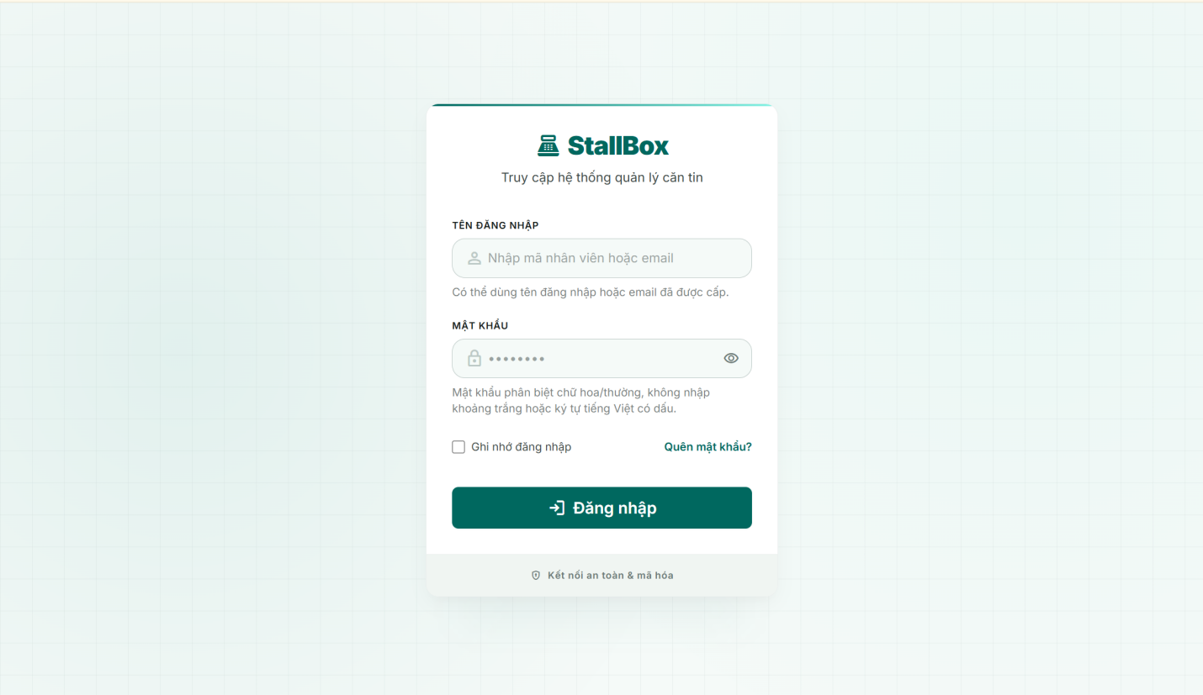

Field Name | Field Type | Description
StallBox Header | Display / Branding | Shows StallBox name, POS icon, and subtitle to identify the system access page.
identifier | Text input | Required. Accepts username or email. Trimmed before submit. Length 3-80. No spaces. If it contains @, it must match email format; otherwise it only accepts letters, numbers, dot, underscore, and hyphen.
password | Password input | Required. Uses reusable PasswordInput. No Vietnamese accented characters, whitespace, or invalid non-ASCII characters. Auto-complete is current-password.
rememberMe | Checkbox | Optional. If checked, the normalized identifier is stored locally and prefilled on the next visit.
Forgot Password link | Navigation link | Redirects unauthenticated user to /forgot-password.
Login button | Submit button | Submits POST /auth/login. Disabled while loading and displays spinner with "Đang đăng nhập...".
Security footer | Display | Shows security message "Kết nối an toàn & mã hóa" at the bottom of the login card.

Database Access
The login function reads user authentication data, verifies password hash and account status, then creates or rotates session tokens. Password hash and refresh token values are never returned to the frontend.
Table | CRUD | Description
users | R | Find user by username or normalized email where deletedAt is null. Read passwordHash internally for password verification and check isActive before granting access.
refresh_tokens | C | Create a refresh token record after successful login. Store only tokenHash, userId, expiredAt, and isRevoked=false.
refresh_tokens | R/U | Validate and revoke refresh tokens during refresh-token rotation and logout.

SQL Commands
1. Find user by username or normalized email where deletedAt is null
users.findOne({ $or: [{ username: identifier }, { email: identifier.toLowerCase() }], deletedAt: null }).

2. Create a refresh token record
refresh_tokens.create({ userId, tokenHash: hashToken(refreshToken), expiredAt }).

1.2. Forgot Password
The Forgot Password screen allows an unauthenticated user to request a password reset OTP by entering the registered email address. The system normalizes the email, validates the format, generates a six-digit OTP for an active account, sends the OTP by email, and then allows the user to continue to the Reset Password screen. Related use case: UC-02 Forgot Password.

UI Design

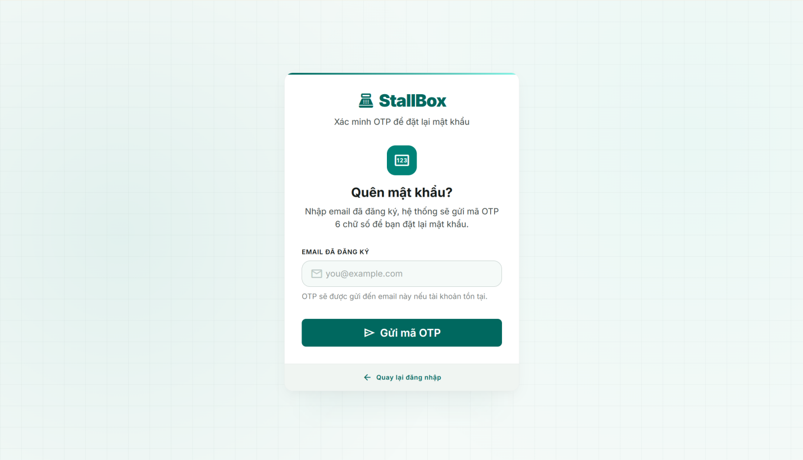
Field Name | Field Type | Description
StallBox Header | Display / Branding | Shows StallBox name and subtitle "Xác minh OTP để đặt lại mật khẩu".
email | Email input | Required. Trimmed and converted to lowercase before submit. No spaces. Must match email format such as user@stallbox.com.
fieldError | Inline validation | Displays email required, whitespace, or invalid format message below the input.
Send OTP button | Submit button | Calls POST /auth/forgot-password. Disabled while sending and shows spinner with "Đang gửi OTP...".
success message | Status alert | After successful request, shows that OTP was sent to the normalized email.
Go to Reset Password button | Navigation button | Visible after successful request. Navigates to /reset-password?email=<normalizedEmail>.
Back to Login link | Navigation link | Returns the user to /login without changing any account data.

Database Access
The forgot password function reads an active user by email, invalidates unused reset tokens, stores a hashed OTP with expiry time, and sends the OTP through the email service. The raw OTP is never stored.
Table | CRUD | Description
users | R | Find account by normalized email and deletedAt=null. Only active accounts can receive a reset OTP.
password_reset_tokens | U | Mark previous unused tokens for the same user as used by setting usedAt to the current time.
password_reset_tokens | C | Create a new reset token record with userId, tokenHash, expiredAt, attempts=0, isActive=true.

SQL Commands
1. Find account by normalized email and deletedAt=null.
users.findOne({ email: normalizedEmail, deletedAt: null }).

2. Mark previous unused tokens for the same user as used by setting usedAt to the current time.
password_reset_tokens.updateMany({ userId, usedAt: null, deletedAt: null }, { usedAt: new Date() }).

3. Create a new reset token record with userId, tokenHash, expiredAt, attempts=0, isActive=true.
password_reset_tokens.create({ userId, tokenHash: hashToken(otp), expiredAt }).

2. Order Management

2.1 Point of Sale (POS)

a. Create Order
Screen for Staff and Manager to view the available daily menu, add food items to the cart, adjust quantities, and process checkout to create a customer order (UC-07: Create Order).

UI Design

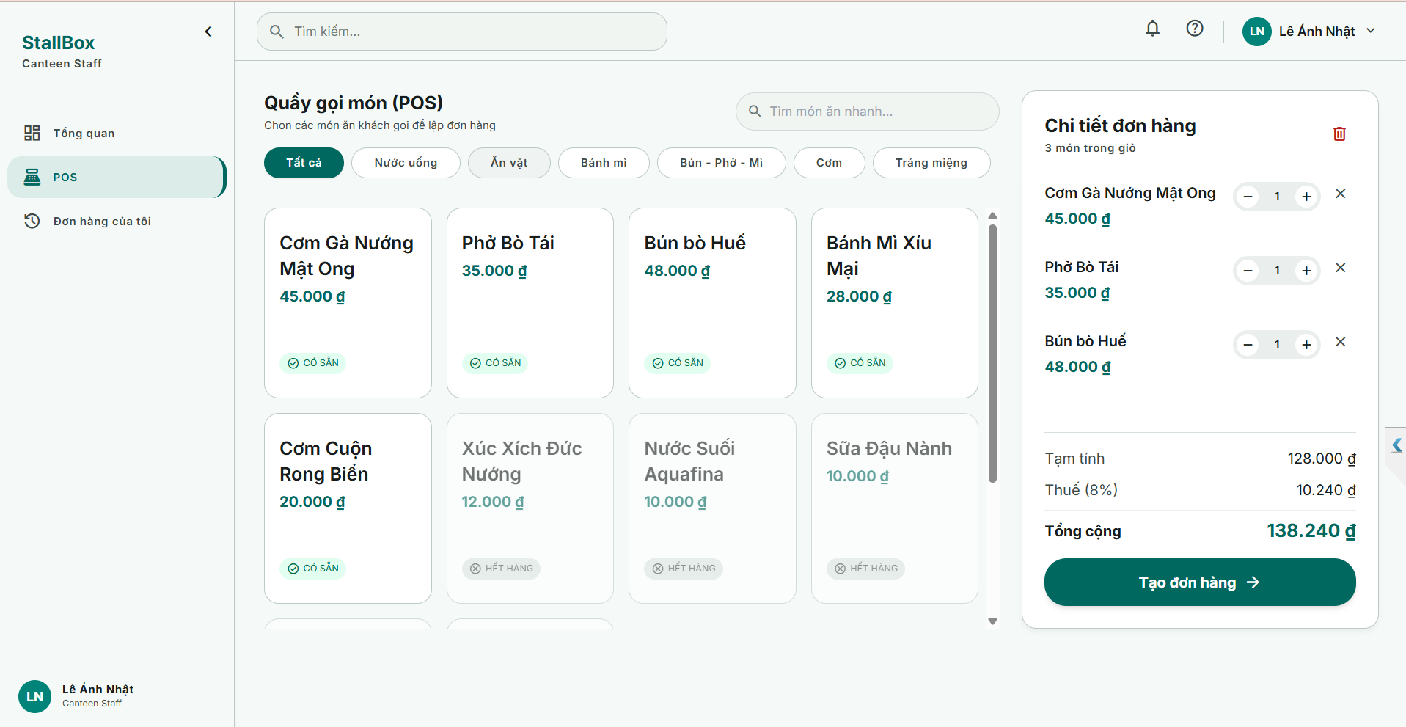

Field Name | Field Type | Description
Daily Menu List
Food Item Name | Text | Display the name of the food item.
Price | Text | Display the current selling price of the item.
Remaining Quantity | Integer | Display the available stock for the item.
Status | Badge | Availability of the item.
Order Cart Panel
Selected Item Name | Text | Name of the food item added to the cart.
Quantity Input | Number Box | Input field or +/- buttons to adjust the quantity. Maximum value is limited by the remaining quantity.
Line Total | Text | Automatically calculated total price for this specific item (Price * Quantity).
Remove Item | Icon | Click to remove the food item from the cart entirely.
Order Summary
Subtotal | Text | Total cost of all items in the cart before tax.
Tax | Text | Automatically calculated tax amount (e.g., 8%).
Total Amount | Text | Final amount the customer needs to pay.
Checkout | Button | Click to process payment and confirm the order creation.

Database Access
Table | CRUD | Description
daily_menus | R, U | Read: Retrieve today's menu to validate food availability and check if remainingQuantity is sufficient.  Update: Automatically decrement remainingQuantity and increment soldQuantity upon successful order creation.
orders | C | Create: Insert the newly created order into the database, including calculated subTotal, taxAmount, and totalAmount.

SQL Commands
1. Retrieve today's menu (Read)
db.daily_menus.findOne({ date: "YYYY-MM-DD" }).populate("items.foodItemId");

2. Deduct item quantity from daily menu (Update) - Using Atomic operations
db.daily_menus.updateOne(
{ _id: menuId },
{ $inc: { "items.$[elem].soldQuantity": quantity, "items.$[elem].remainingQuantity": -quantity } },
{ arrayFilters: [{ "elem.foodItemId": foodItemId, "elem.remainingQuantity": { $gte: quantity } }] }
);

3. Insert new order (Create)
db.orders.insertOne({
orderNumber: "ORD-2026...", staffId: staffId, items: [...], subTotal: 100, taxAmount: 8, totalAmount: 108, orderStatus: "Pending"
});

2.2 Order Records

a. View Own Order History
Screen for Staff to view and track the history of orders they have personally processed (UC-09: View Own Order History).

UI Design

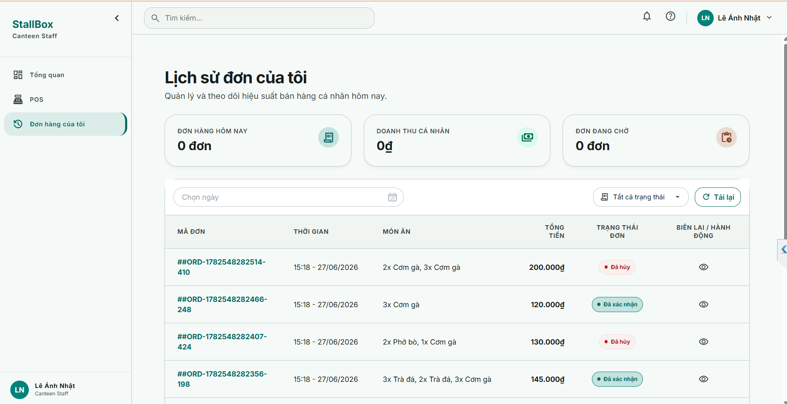

Field Name | Field Type | Description
Search Fields
Order Status | Combo Box  Single-Choice | Values: All Statuses (default), Pending, Confirmed, Completed, Cancelled.  Allow to filter the order list by status.
From Date | Date Picker | Select the start date to filter order history. Default value is blank.
To Date | Date Picker | Select the end date to filter order history. Default value is blank.
Search | Button | Click to refresh the list with the defined filters.
Data Table
Order Number | Text | The unique auto-generated identifier of the order.
Order Date | DateTime | The exact date and time the order was created.
Total Amount | Text | The final total price of the order.
Status | Text | Current status of the order.
Data Actions
View Details | Icon | Click to open the Order Details modal/page to see purchased items and pricing breakdown.

Database Access

Table | CRUD | Description
orders | R | Read: Query the list of orders belonging to the logged-in staff member based on filters (Status, Date range). Count total documents for pagination.

SQL Commands
1. Find and paginate own orders (Read)
db.orders.find({
staffId: currentUserId,
orderStatus: orderStatus,
orderDate: { $gte: fromDate, $lte: toDate }
}).sort({ createdAt: -1 }).skip((page - 1) * limit).limit(limit);

2. Count total documents for pagination (Read)
db.orders.countDocuments({ /* same query parameters as above */ });

b. View Order List
Dashboard screen for Manager and Admin to monitor and manage all customer orders across the entire system. Includes the functionality to update order status (UC-10: View Order List, UC-08: Cancel Order).

UI Design

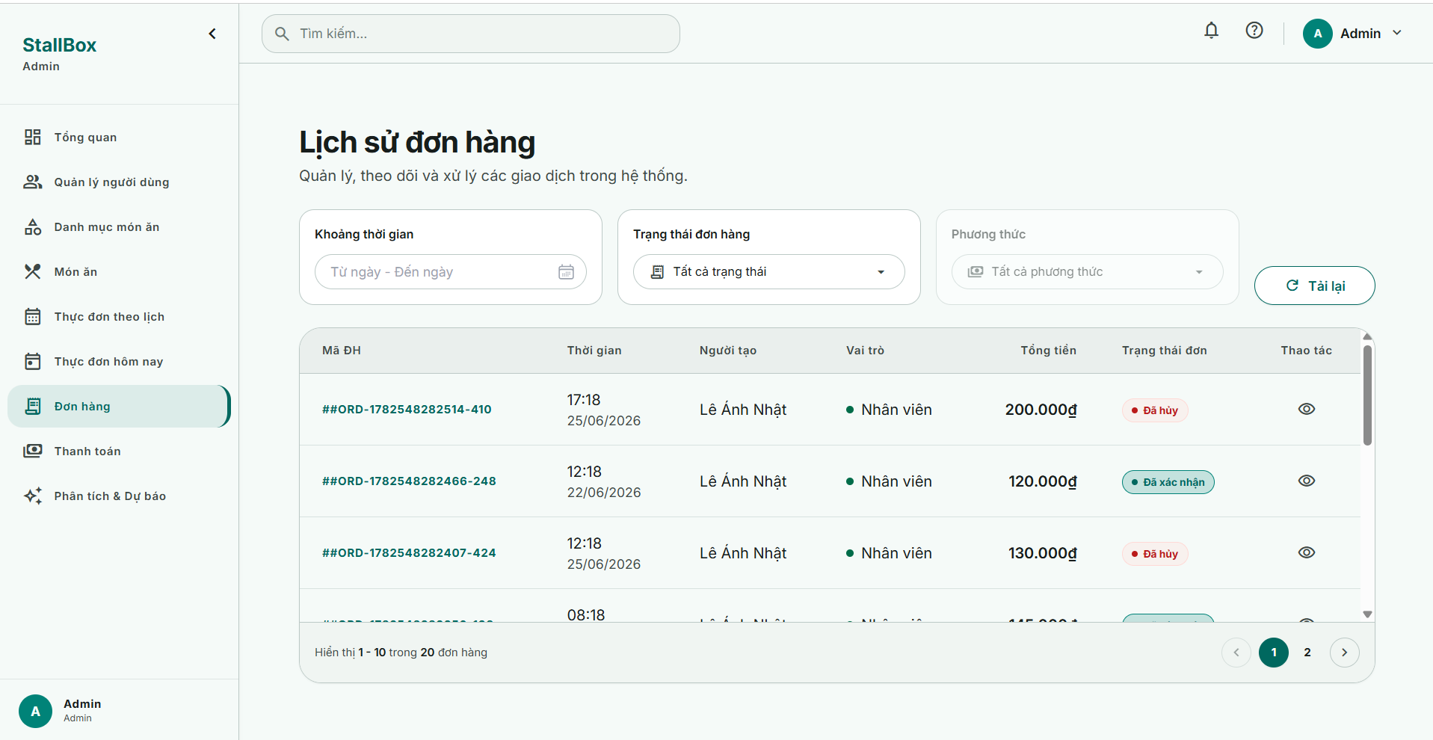

Field Name | Field Type | Description
Search Fields
Order Status | Combo Box  Single-Choice | Values: All Statuses (default), Pending, Confirmed, Completed, Cancelled.  Allow to filter the order list by status.
Staff Name | Combo Box  Single-Choice | Filled with the list of active staff members.  Allow to filter the list by staff. Default is "All Staff".
From Date | Date Picker | Select the start date to filter the order list.
To Date | Date Picker | Select the end date to filter the order list.
Search | Button | Click to refresh the list with the defined filters.
Data Table
Order Number | Text | The unique auto-generated identifier of the order.
Order Date | DateTime | The exact date and time the order was created.
Staff Name | Text | The name of the staff who processed the order.
Total Amount | Text | The final total price of the order.
Status | Text | Current status of the order.
Data Actions
View Details | Icon | Click to open the Order Details modal/page.
Cancel Order | Button | Allows Manager/Admin to open the popup to cancel order.

Database Access
Table | CRUD | Description
orders | R, U | Read: Query the entire list of orders based on various filters (Status, Date range, Specific Staff). Count total documents for pagination.  Update: Modify the orderStatus field of the specified order.

SQL Commands
1. Find and paginate all orders (Read)
db.orders.find({
staffId: staffId, // Optional filter
orderStatus: orderStatus,
orderDate: { $gte: fromDate, $lte: toDate }
}).sort({ createdAt: -1 }).skip((page - 1) * limit).limit(limit);

2. Count total documents for pagination (Read)
db.orders.countDocuments({ /* same query parameters as above */ });

3. Retrieve the existing order to validate state transition (Read)
db.orders.findOne({ _id: orderId });

4. Update the order status to Cancelled/Confirmed (Update)
db.orders.findByIdAndUpdate(orderId, { orderStatus: newStatus }, { new: true });

c. Cancel Order Confirmation Popup
Popup for Staff, Manager, and Admin to confirm the cancellation of a pending order to prevent accidental clicks (Related to UC-08: Cancel Order).

UI Design

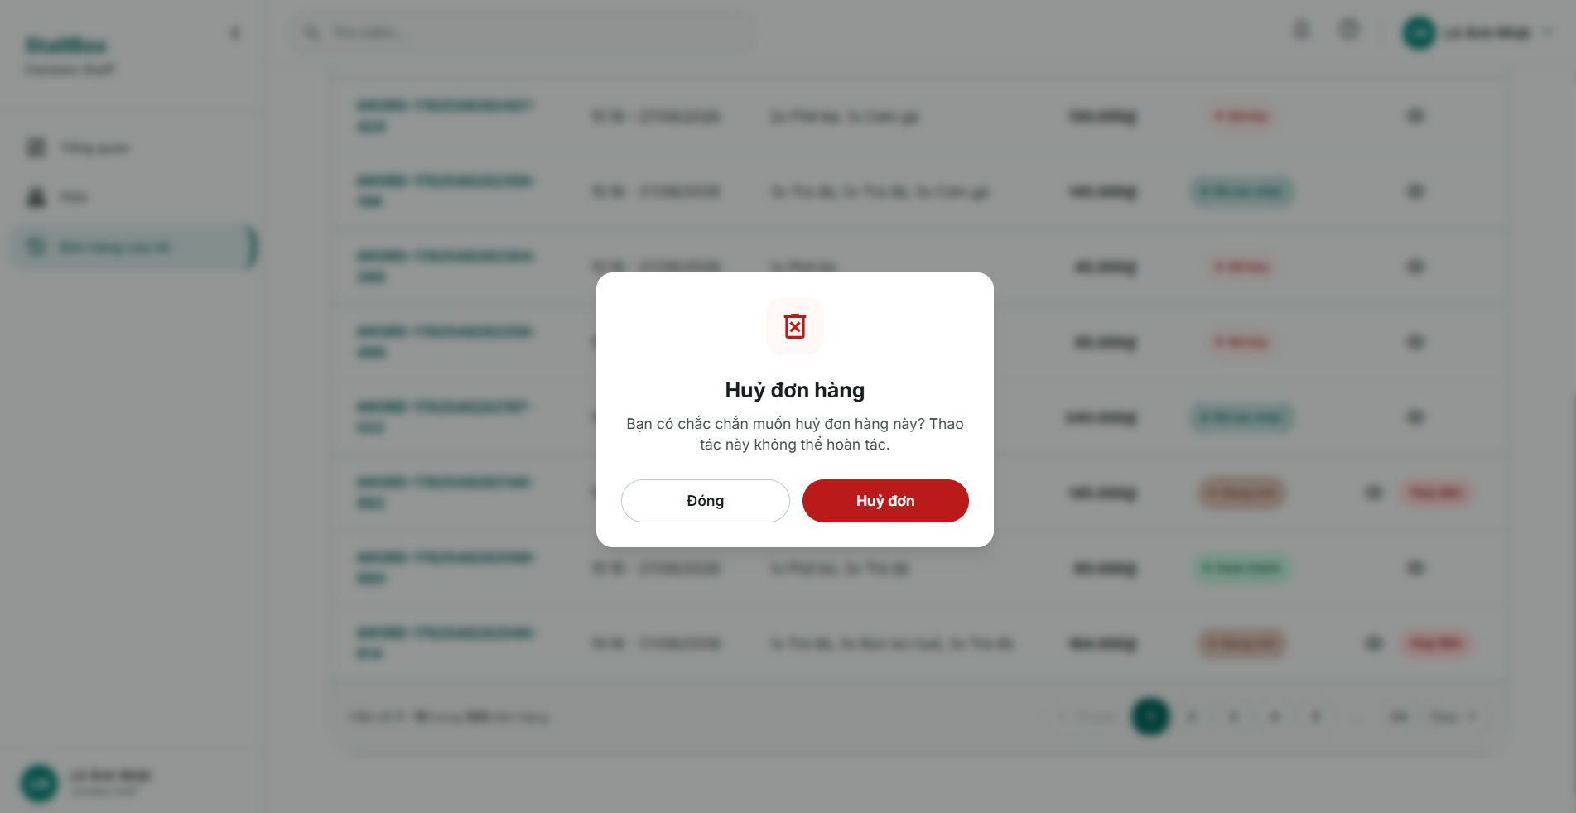

Field Name | Field Type | Description
Confirm Dialog
Title | Text display | Displays the title "Huỷ đơn hàng" (Cancel Order).
Description | Text display | Warning text asking the user to confirm the cancellation ("Are you sure you want to cancel this order? This action cannot be undone.").
Confirm button | Submit Button | Calls the API to cancel the selected order. The button uses a danger (red) variant and shows a loading spinner during the network request to prevent duplicate submissions.
Cancel button | Button | Closes the dialog box immediately without modifying the order status.

Database Access

Table | CRUD | Description
orders | U | Update: Change the orderStatus field of the specified order to "Cancelled".
daily_menus | U | Update: Restore (increment) the remainingQuantity and deduct (decrement) the soldQuantity of the canceled items back to today's daily menu inventory.

SQL Commands
1.Update order status to Cancelled (Update)
db.orders.findOneAndUpdate({ _id: orderId }, { $set: { orderStatus: "Cancelled" } });

2. Restore item quantities to daily menu (Update)
// Executed for each item in the cancelled order using atomic operators
db.daily_menus.updateOne(
{ _id: menuId, "items.foodItemId": foodItemId },
{ $inc: { "items.$.remainingQuantity": quantity, "items.$.soldQuantity": -quantity } }
);

d. Order Detail Popup
Modal popup to view detailed information of a selected order, including purchased items, pricing breakdown, and order status (Related to UC-09: View Own Order History, UC-10: View Order List).

UI Design

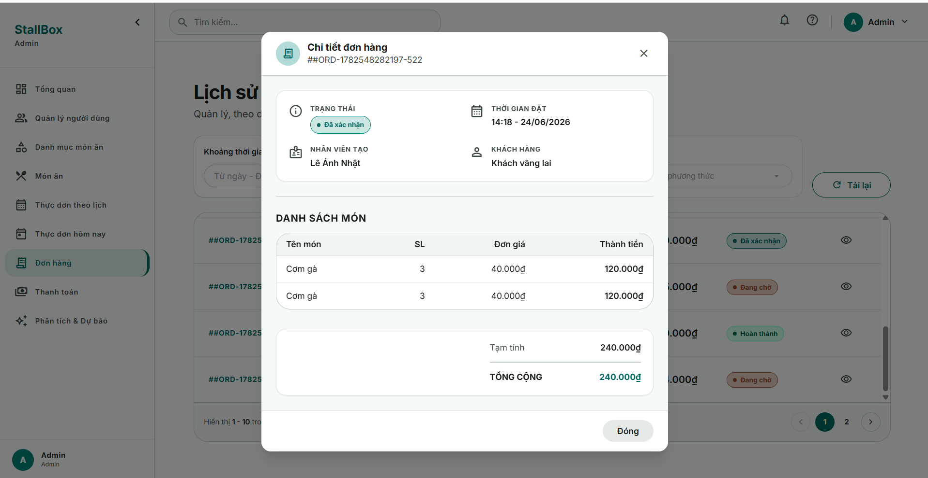

Field Name | Field Type | Description
Order Number & Status | Text / Badge | Displays the unique order ID and its current status badge with specific semantic colors (Pending: Yellow, Completed: Green, Cancelled: Red).
Customer Info | Text | Displays the customer's name and phone number (if provided) or defaults to a guest label.
Item Name | Text | The name of the purchased food item.
Quantity & Price | Text | The ordered quantity and the unit price for each item line.
Total Amount | Text | The final total amount of the order (highlighted).
Cancel Order | Button | An optional action button to cancel the order. Only visible if the order status is "Pending" and the user has sufficient permissions.
Close | Button | Closes the modal and returns the user to the order list view.

Database Access

Table | CRUD | Description
orders | R | Read: Query the specific order by its _id and populate the related foodItemId reference to retrieve the actual food item names.

SQL Commands
1. Retrieve order detail and populate food item names (Read)
db.orders.findOne({ _id: orderId }).populate("items.foodItemId", "name");

3. Payment Management

3.1 Checkout & Receipt

a. Process Payment
This function allows Staff and Manager users to settle a pending order immediately after order creation and is related to UC-11 Process Payment.

UI Design
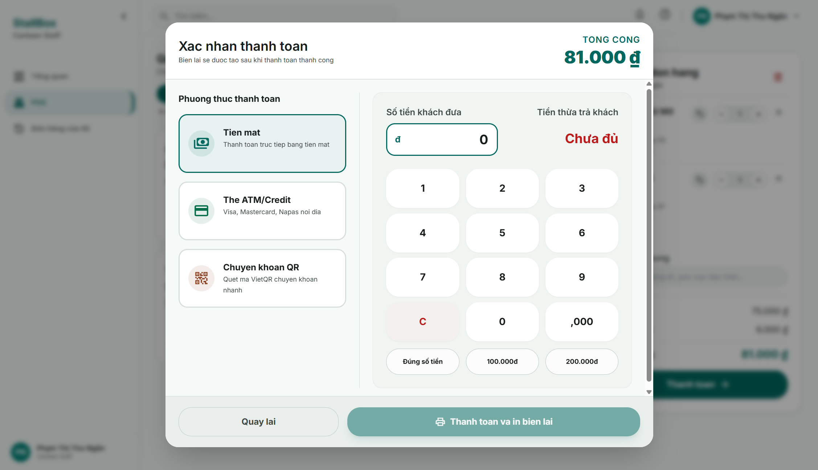

Field Name | Field Type | Description
Payment Method List
Payment Method Card | Card | Available payment methods
Cash Input Panel
Amount Received | Currency Input | Enabled for Cash payment. The actor enters the actual money received from the customer. The value must be greater than or equal to the final amount.
Change Returned | Currency Text | Auto-calculated for Cash payment as amountReceived minus finalAmount. This field is read-only.
Numpad
Footer actions
Cancel / Back Button | Secondary Button | Returns the actor to the order detail or POS screen without completing the payment.
Print Receipt Action | Button | Hidden or disabled until the payment is successfully completed. After success, it navigates to or opens the receipt flow.

Database Access

Table | CRUD | Description
orders | R, U | Read the pending order to validate orderStatus, load order totals and line items, and update the orderStatus to Completed after a successful payment.
payments | C, R, U | Create a payment record with a unique paymentNumber when checkout starts, read existing payment records to prevent duplicate settlement, and update paymentStatus, amountReceived, changeReturned, and transactionCode after the result is known.
users | R | Read the authenticated user context to validate role-based access and identify who processed the payment.

SQL Commands
1. Read the pending order before payment.
db.orders.findOne({
_id: orderId,
orderStatus: "Pending"
}).populate("items.foodItemId", "name sellingPrice");

2. Check whether the order already has an active or completed payment that would make the current checkout invalid.
db.payments.findOne({
orderId: orderId,
paymentStatus: { $in: ["Pending", "Paid"] }
});

3. Create the payment attempt record at the start of the checkout flow.
db.payments.insertOne({
paymentNumber: "PAY-2026-000001",
orderId: orderId,
paymentMethod: paymentMethod,
finalAmount: order.totalAmount,
amountReceived: amountReceived ?? null,
changeReturned: 0,
transactionCode: null,
paymentStatus: "Pending",
createdAt: new Date()
});

4. Confirm a successful cash payment and store changeReturned.
db.payments.findOneAndUpdate(
{ _id: paymentId, paymentStatus: "Pending" },
{
$set: {
paymentStatus: "Paid",
amountReceived: amountReceived,
changeReturned: amountReceived - finalAmount,
paidAt: new Date()
}
},
{ returnDocument: "after" }
);

5. Mark the digital payment as successful and complete the linked order.
db.payments.findOneAndUpdate(
{ _id: paymentId, paymentStatus: "Pending" },
{
$set: {
paymentStatus: "Paid",
transactionCode: gatewayTransactionCode,
paidAt: new Date()
}
},
{ returnDocument: "after" }
);

db.orders.findOneAndUpdate(
{ _id: orderId, orderStatus: "Pending" },
{
$set: {
orderStatus: "Completed",
paymentId: paymentId
}
}
);

6. Mark the payment attempt as failed when the gateway rejects the transaction.
db.payments.findOneAndUpdate(
{ _id: paymentId, paymentStatus: "Pending" },
{
$set: {
paymentStatus: "Failed",
transactionCode: gatewayTransactionCode ?? null,
updatedAt: new Date()
}
}
);

b. Print Receipt
This function supports UC-12 Print Receipt and is triggered after a payment has been completed successfully. The function retrieves the finalized order and payment information, formats them into a receipt layout, and opens the browser print dialog or sends the print directive to the configured POS printer.

UI Design

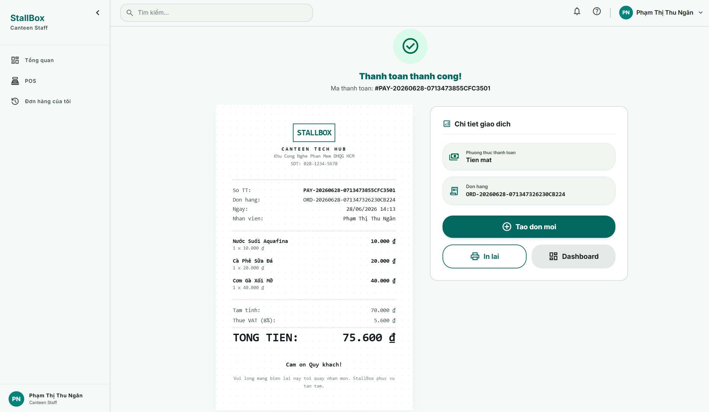

Field Name | Field Type | Description
Receipt
Receipt Header | Static Text | Displays the receipt title and the stall identity so the printed output can be recognized as an official POS receipt of the canteen stall.
Receipt Reference | Text | Displays receipt-related identifiers such as orderNumber and paymentNumber for reconciliation and reprinting purposes.
Payment Date and Time | DateTime | Shows the timestamp when the payment was completed successfully.
Staff Information | Text | Displays the name or username of the staff member who processed the transaction.
Itemized Receipt Lines | Repeating Table | Shows each purchased item with food item name, quantity, unit price, and line total.
Subtotal | Currency Text | Displays the subtotal amount of the order before tax or additional adjustments.
Tax Amount | Currency Text | Displays the tax value used in the finalized order calculation.
Total Amount | Currency Text | Displays the final collected amount of the order.
Payment details
Payment Method | Text | Displays the completed payment method such as Cash, Momo, or VNPay.
Amount Received | Currency Text | For cash payments, shows the actual amount collected from the customer.
Change Returned | Currency Text | For cash payments, shows the amount returned to the customer after payment.
Transaction Code | Text | Displays the payment gateway reference code for digital payments if available.
Print Button | Button | Opens the print dialog or sends the receipt content to the configured POS printer.
Back / Close Button | Button | Returns the actor to the payment success screen, order history, or order detail view.

Database Access

Table | CRUD | Description
orders | R | Read the completed order and its finalized line items, totals, and staff reference before formatting the receipt.
payments | R | Read the associated paid payment record, including paymentMethod, amountReceived, changeReturned, paidAt, and transactionCode.
users | R | Read staff information for receipt display when required by the design.

SQL Commands
1. Read the completed order and populate food item names.
db.orders.findOne({
_id: orderId,
orderStatus: "Completed"
}).populate("items.foodItemId", "name");

2. Read the successful payment associated with the order.
db.payments.findOne({
orderId: orderId,
paymentStatus: "Paid"
}).sort({ paidAt: -1, createdAt: -1 });

3.2 Payment Tracking

a. View Payment List
The implemented screen is shared by Admin and Manager users, while Staff users are not allowed to access the global payment list (related to UC_13).

UI Design

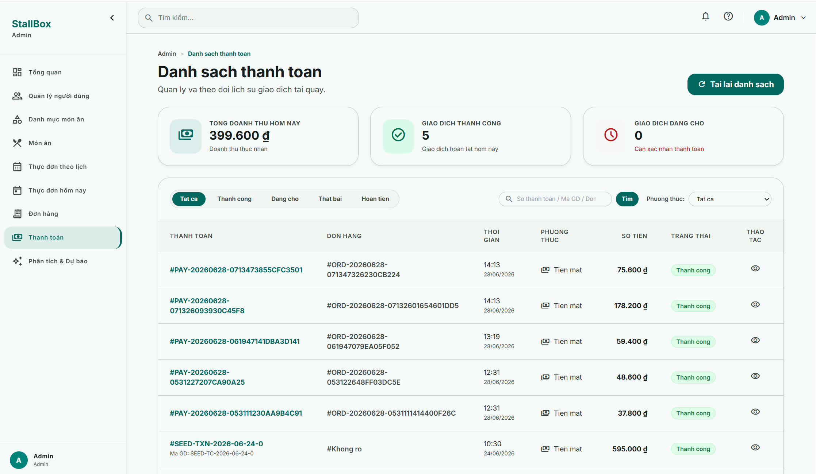

Field Name | Field Type | Description
Page Header
Page Header | Static Text | Displays the title Danh sach thanh toan and a short description that the page is used to manage and monitor transaction history at the stall.
Refresh List Button | Button | Reloads the payment list and KPI cards to fetch the latest transaction data from the system.
Statistics card
Total Revenue Today Card | Summary Card | Displays the total paid revenue of the current day for quick daily reconciliation.
Successful Transactions Card | Summary Card | Displays the number of transactions with paymentStatus Paid for the current day.
Pending Transactions Card | Summary Card | Displays the number of transactions with paymentStatus Pending for the current day so Admin can notice unresolved payments.
Search Fields
Status Filter Tabs | Tab Group | Allows the actor to filter the list by transaction status: All, Paid, Pending, Failed, or Refunded.
Search Input | Text Input | Allows searching by paymentNumber, transactionCode, or linked orderNumber.
Search Button | Button | Applies the current keyword to the payment list query.
Payment Method Filter | Select | Filters the list by payment method. In the current implementation, supported values are Cash, Card, and QR.
Data Table
Payment Reference | Text Block | Shows the paymentNumber as the main identifier and may display the transactionCode underneath when available.
Order Reference | Text | Displays the linked orderNumber for cross-checking with the order flow.
Transaction Time | DateTime | Displays the transaction time and date. For paid transactions, the completed payment time is preferred; otherwise, the created time is shown.
Payment Method Column | Icon + Text | Displays the payment method label and icon for quick visual recognition.
Final Amount | Currency Text | Displays the finalAmount collected for the transaction.
Status Badge | Badge | Displays the current payment status such as Paid, Pending, Failed, or Refunded.
View Receipt Action | Icon Button | Enabled only when the paymentStatus is Paid or Refunded. It opens the receipt detail page for that payment.

Database Access

Table | CRUD | Description
payments | R | Read paginated payment transactions, apply filters by paymentStatus and paymentMethod, search by paymentNumber or transactionCode, and provide data for the daily KPI summary.
orders | R | Resolve orderNumber search matches and populate the linked order reference displayed in the payment list table.

SQL Commands
1. Resolve matching orders when the search keyword may refer to an order number.
orderRepository.findIdsByOrderNumberKeyword(searchKeyword);

2. Build the payment list filter from status, method, and keyword conditions.
const filter = {};

if (paymentStatus) {
filter.paymentStatus = paymentStatus;
}

if (paymentMethod) {
filter.paymentMethod = paymentMethod;
}

if (searchKeyword) {
const regex = new RegExp(searchKeyword, "i");
const searchOr = [
{ paymentNumber: regex },
{ transactionCode: regex },
];

if (matchingOrderIds.length > 0) {
searchOr.push({
orderId: { $in: matchingOrderIds.map(toObjectId) }
});
}

filter.$or = searchOr;
}

3. Read the paginated payment list and populate the linked order reference.
Payment.find(filter)
.populate({
path: "orderId",
select: "orderNumber staffId",
})
.sort({ createdAt: -1 })
.skip(skip)
.limit(limit);

4. Count payment transactions for pagination.
Payment.countDocuments(filter);

5. Calculate the daily KPI summary for the current day based on payment records.
db.payments.aggregate([
{
$addFields: {
referenceDate: {
$cond: [
{ $eq: ["$paymentStatus", "Paid"] },
{ $ifNull: ["$paidAt", "$createdAt"] },
"$createdAt"
]
}
}
},
{
$match: {
referenceDate: {
$gte: startOfDay,
$lt: endOfDay
}
}
},
{
$group: {
_id: null,
totalRevenue: {
$sum: {
$cond: [
{ $eq: ["$paymentStatus", "Paid"] },
"$finalAmount",
0
]
}
},
successCount: {
$sum: {
$cond: [{ $eq: ["$paymentStatus", "Paid"] }, 1, 0]
}
},
pendingCount: {
$sum: {
$cond: [{ $eq: ["$paymentStatus", "Pending"] }, 1, 0]
}
}
}
}
]);

4. Menu Management

4.1 Category Management

a. View Category List
This screen allows Admins to view and browse the list of all food categories configured in the system, including their status and the number of food items associated with each category (related to UC_17).

UI Design
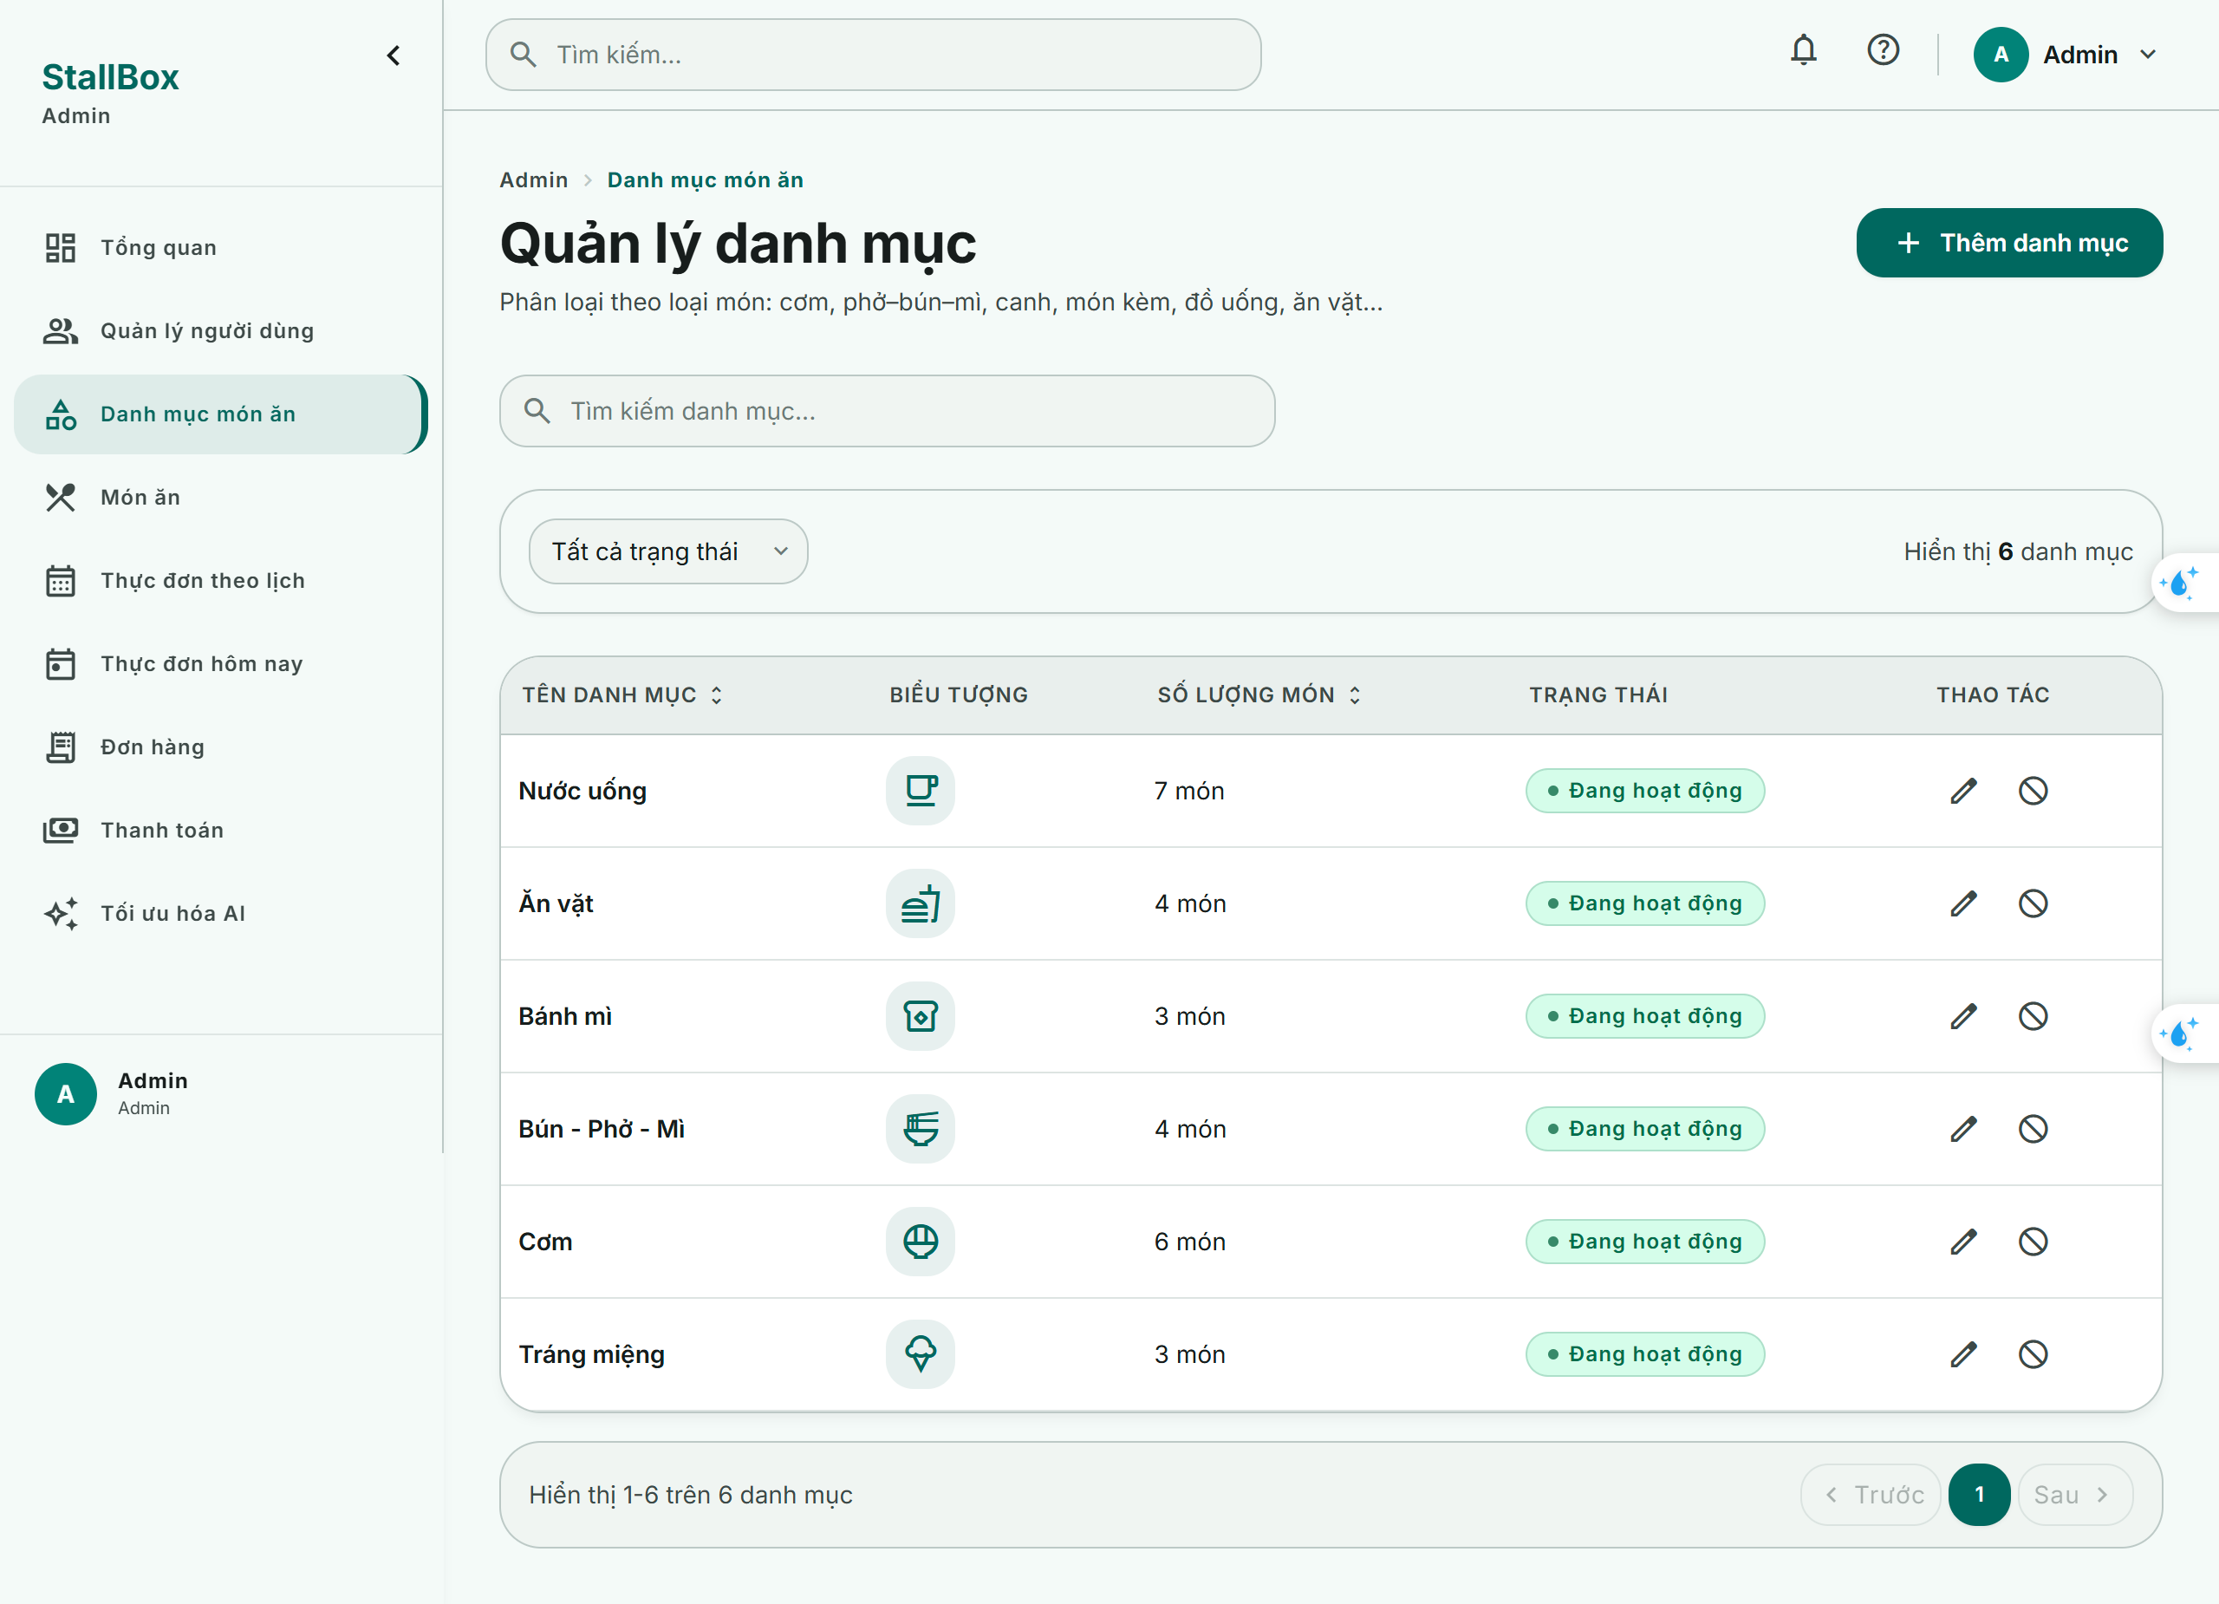

Field Name | Field Type | Description
Page Header
Page Title | Label | Displays “Quản lý danh mục”.
Add Category Button | Button | Opens the Create Category modal.
Search Fields
Search Phrase | Text Box String (100) | Allows Admin to search categories by category name. Default value is blank.
Category Status | Combo Box Single-Choice | Allows Admin to filter categories by status. Values: “Tất cả”, “Đang hoạt động”, “Ngừng hoạt động”.
Reset Filter | Button | Clears search and filter conditions.
Data Table
Category Name | Text | Displays the name of the category.
Category Icon | Icon | Displays the selected icon of the category.
Food Item Count | Number | Displays the number of active food items belonging to the category.
Status | Badge | Displays category status. Values: “Đang hoạt động” and “Ngừng hoạt động”.
Actions | Icon Button Group | Contains action buttons for each category row.

Database Access

Table | CRUD | Description
categories | R | Read category list with search, status filter, sorting, and pagination.
fooditems | R | Count active food items related to each category for displaying the number of food items.
categories | R | Read category list with search, status filter, sorting, and pagination.

SQL Commands

1. Read Category List
db.categories.aggregate([
{
$match: {
name: { $regex: :search, $options: "i" },
isActive: :isActive
}
},
{ $sort: { createdAt: -1 } },
{
$lookup: {
from: "fooditems",
let: { categoryId: "$_id" },
pipeline: [
{
$match: {
$expr: { $eq: ["$categoryId", "$$categoryId"] },
isArchived: false
}
},
{ $count: "count" }
],
as: "foodItemStats"
}
},
{
$addFields: {
foodItemCount: {
$ifNull: [{ $arrayElemAt: ["$foodItemStats.count", 0] }, 0]
}
}
},
{ $project: { foodItemStats: 0 } },
{ $skip: (:page - 1) * :limit },
{ $limit: :limit }
]);

b. Create Category Modal
This screen allows Admins to create a new food category by filling in the required information such as name and description (related to UC_17).

UI Design

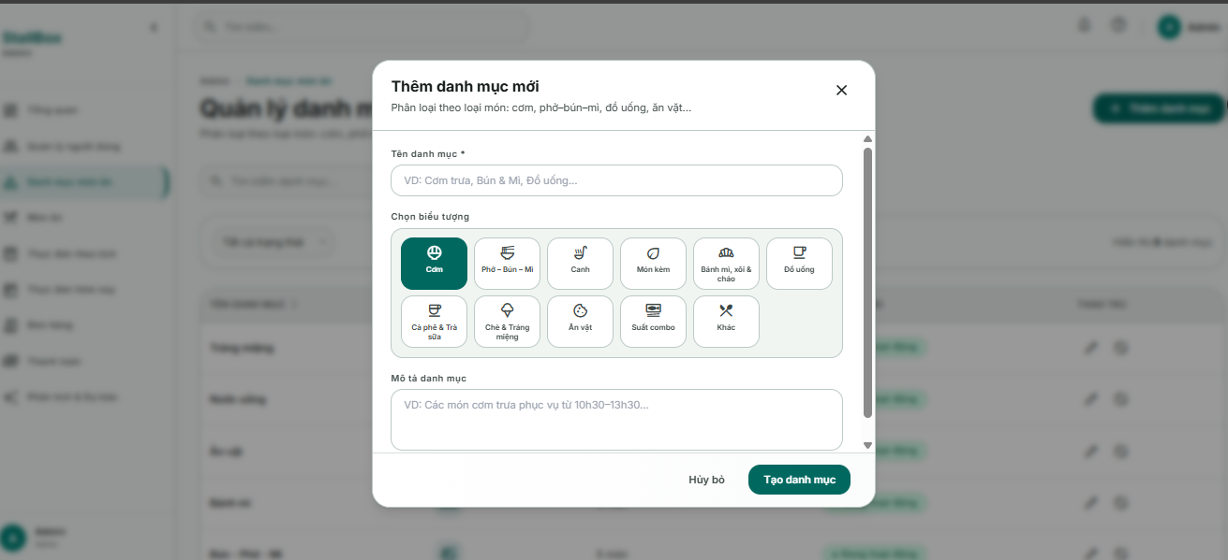

Field Name | Field Type | Description
Modal Header
Modal Title | Label | Displays “Thêm danh mục mới”.
Modal Subtitle | Label | Displays guidance text about classifying food items by category.
Close Button | Icon Button | Closes the modal.
Input Fields
Category Name | Text Box String (100) | Required field. Allows Admin to enter the category name. Default value is blank.
Icon Picker | Icon Picker | Allows Admin to select one icon for the category. Default value is the default selected icon.
Description | Text Area String (500) | Optional field. Allows Admin to enter a short description of the category. Default value is blank.
Modal Footer
Cancel Button | Button | Closes the modal without saving.
Create Button | Button | Submits the form to create a new category. Disabled while submitting.

Database Access

Table | CRUD | Description
fooditems | R | Check whether the food item name already exists.
categories | R | Validate the selected category.
fooditems | C | Create a new food item record.

SQL Commands
1. Create Category
db.categories.insertOne({
name: :trimmedName,
description: :trimmedDescription || null,
icon: :selectedIcon,
isActive: true,
deletedAt: null,
deletedBy: null,
createdAt: new Date(),
updatedAt: new Date()
});

c. Update Category Modal
This screen allows Admins to update the details of an existing food category, such as its name and description (related to UC_17).

UI Design
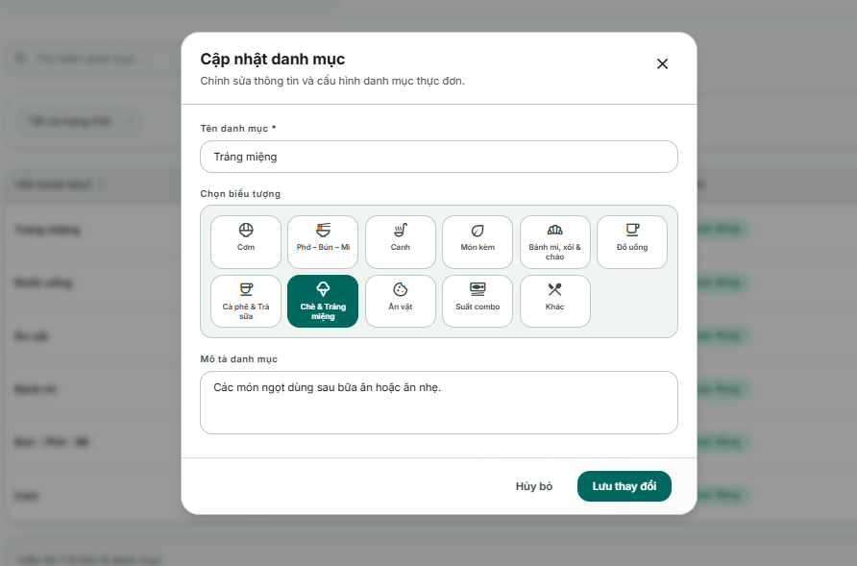

Field Name | Field Type | Description
Modal Header
Modal Title | Label | Displays “Cập nhật danh mục”.
Modal Subtitle | Label | Displays guidance text about classifying food items by category.
Close Button | Icon Button | Closes the modal.
Input Fields
Category Name | Text Box String (100) | Required field. Displays the current category name and allows Admin to update it.
Icon Picker | Icon Picker | Displays the current selected icon and allows Admin to choose another icon.
Description | Text Area String (500) | Optional field. Displays the current category description and allows Admin to update it.
Modal Footer
Cancel Button | Button | Closes the modal without saving.
Save Button | Button | Submits the form to update category information. Disabled while submitting.

Database Access

Table | CRUD | Description
categories | R | Read selected category information and check duplicate category name.
categories | U | Update category name, icon, description, and updated time.
SQL Commands
2. Update Category
db.categories.findOneAndUpdate(
{ _id: ObjectId(:categoryId) },
{
$set: {
name: :trimmedName,
description: :trimmedDescription || null,
icon: :selectedIcon,
updatedAt: new Date()
}
},
{ new: true, runValidators: true }
);

4.2 Food Item Management

a. View Food Item List
This screen allows Admins to view and browse the list of all food items configured in the system, including their name, category, price, and current status.

UI Design

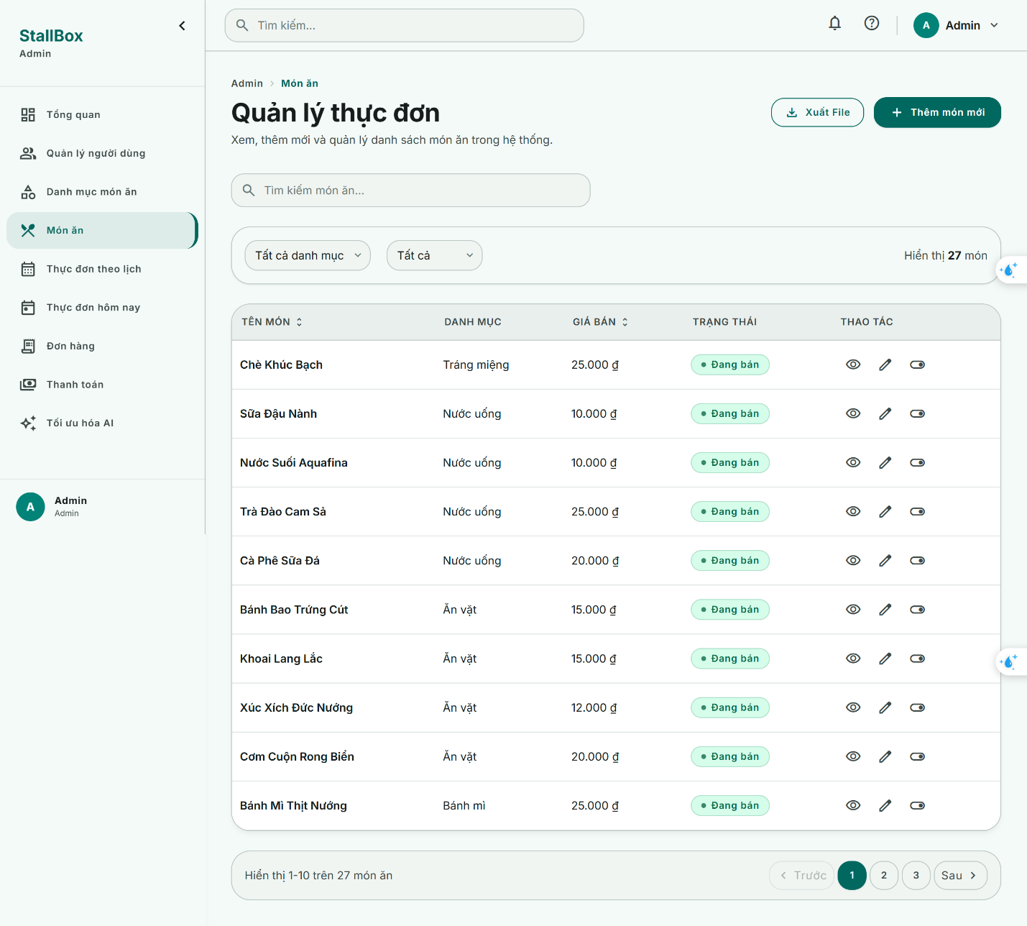

Field Name | Field Type | Description
Page Header
Page Title | Label | Displays “Quản lý danh mục”.
Add Food Item Button | Button | Opens the Create Food Item modal.
Search Fields
Search Phrase | Text Box String (100) | Allows user to search food items by name. Default value is blank.
Category | Combo Box Single-Choice | Allows user to filter food items by category. Default value is “Tất cả danh mục”.
Food Item Status | Combo Box Single-Choice | Allows user to filter food items by sale status. Values: “Tất cả”, “Đang bán”, “Ngừng bán”.
Reset Filter | Button | Clears selected search and filter conditions.
Data Table
Food Item Name | Text | Displays the name of the food item.
Category Name | Text | Displays the category name of the food item.
Base Price | Currency | Displays the selling price of the food item.
Cost | Currency | Displays the cost price of the food item.
Status | Badge | Displays sale status. Values: “Đang bán” and “Ngừng bán”.
Actions | Icon Button Group | Contains action buttons for each food item row.

Database Access

Table | CRUD | Description
fooditems | R | Read food item list with search, category filter, sale status filter, sorting, and pagination.
categories | R | Read category information to display category name in the food item list.
users | R | Read archived user information if the item has been stopped selling.

SQL Commands
1. Read Food Item List
db.fooditems.aggregate([
{
$match: {
name: { $regex: :search, $options: "i" },
categoryId: ObjectId(:categoryId),
isArchived: :isArchived
}
},
{ $sort: { createdAt: -1 } },
{
$lookup: {
from: "categories",
localField: "categoryId",
foreignField: "_id",
as: "category"
}
},
{
$lookup: {
from: "users",
localField: "deletedBy",
foreignField: "_id",
as: "deletedByUser"
}
},
{
$addFields: {
categoryName: {
$ifNull: [{ $arrayElemAt: ["$category.name", 0] }, null]
},
deletedByName: {
$ifNull: [{ $arrayElemAt: ["$deletedByUser.fullName", 0] }, null]
},
deletedByEmail: {
$ifNull: [{ $arrayElemAt: ["$deletedByUser.email", 0] }, null]
}
}
},
{ $project: { category: 0, deletedByUser: 0 } },
{ $skip: (:page - 1) * :limit },
{ $limit: :limit }
]);
]

b. Create Food Item Modal
This screen allows Admins to create a new food item by filling in the required information such as name, category, price, and description (related to UC_14).

UI Design

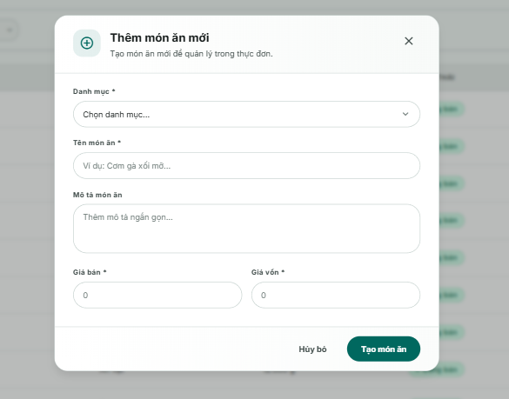

Field Name | Field Type | Description
Modal Header
Modal Title | Label | Displays “Thêm món ăn mới”.
Modal Subtitle | Label | Displays guidance text about creating a food item in the master menu.
Close Button | Icon Button | Closes the modal.
Input Fields
Category | Combo Box Single-Choice | Required field. Allows Admin to select one active category for the food item.
Food Item Name | Text Box String (150) | Required field. Allows Admin to enter the food item name. Default value is blank.
Description | Text Area String (1000) | Optional field. Allows Admin to enter a short description of the food item.
Base Price | Number Box | Required field. Allows Admin to enter the selling price. Minimum value is 0.
Cost | Number Box | Required field. Allows Admin to enter the cost price. Minimum value is 0.
Modal Footer
Cancel Button | Button | Closes the modal without saving.
Create Button | Button | Submits the form to create a new food item. Disabled while submitting.

Database Access

Table | CRUD | Description
fooditems | R | Check whether the food item name already exists.
categories | R | Validate the selected category.
fooditems | C | Create a new food item record.

SQL Commands
1. Create Food Item
db.fooditems.insertOne({
categoryId: ObjectId(:categoryId),
name: :trimmedName,
description: :trimmedDescription || null,
basePrice: Number(:basePrice),
cost: Number(:cost),
isArchived: false,
deletedAt: null,
deletedBy: null,
createdAt: new Date(),
updatedAt: new Date()
});

c. Update Food Item Modal
This screen allows Admins to update the details of an existing food item, such as its name, category, price, and description (related to UC_15).

UI Design
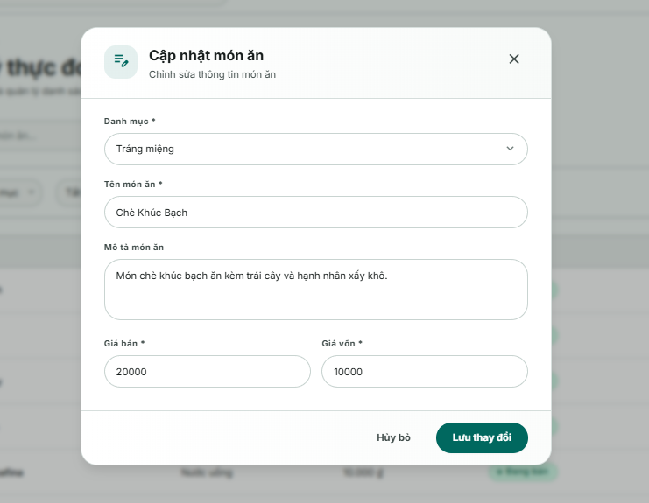

Field Name | Field Type | Description
Modal Header
Modal Title | Label | Displays “Cập nhật món ăn”.
Modal Subtitle | Label | Displays guidance text about creating a food item in the master menu.
Close Button | Icon Button | Closes the modal.
Input Fields
Category | Combo Box Single-Choice | Required field. Displays the current category and allows Admin to change it.
Food Item Name | Text Box String (150) | Required field. Displays the current food item name and allows Admin to update it.
Description | Text Area String (1000) | Optional field. Displays the current description and allows Admin to update it.
Base Price | Number Box | Required field. Displays the current selling price and allows Admin to update it.
Cost | Number Box | Required field. Displays the current cost price and allows Admin to update it.
Modal Footer
Cancel Button | Button | Closes the modal without saving.
Save Button | Button | Submits the form to update food item information. Disabled while submitting.

Database Access

Table | CRUD | Description
fooditems | R | Read selected food item and check duplicate name.
categories | R | Validate the selected category if category is changed.
fooditems | U | Update food item information.

SQL Commands
1. Update Food Item
db.fooditems.findOneAndUpdate(
{ _id: ObjectId(:foodItemId) },
{
$set: {
categoryId: ObjectId(:categoryId),
name: :trimmedName,
description: :trimmedDescription || null,
basePrice: Number(:basePrice),
cost: Number(:cost),
updatedAt: new Date()
}
},
{ new: true, runValidators: true }
);

4.2 Scheduled Menu Operations

a. Configure Scheduled Menu
This screen supports UC-18 Configure Scheduled Menu. It allows Admin users to configure a reusable weekly menu template.

UI Design
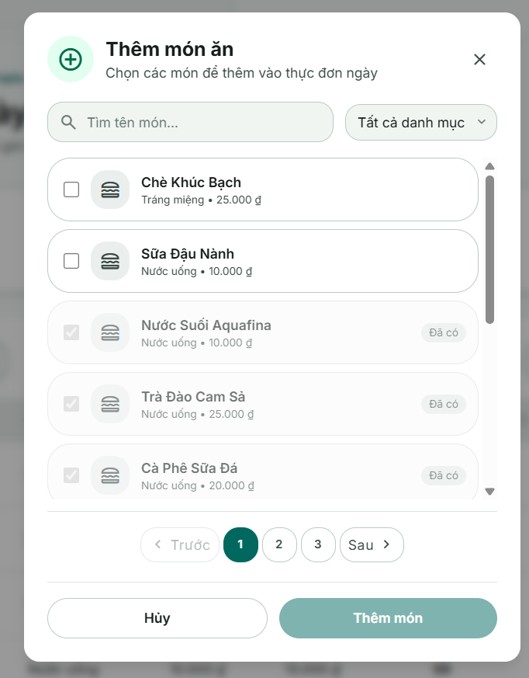

Field Name | Field Type | Description
Search / Filter Fields
Search Input | Text input | Filters food items by name.
Category filter | Pill Filter | Category list fetched from the Category API; select to  filter by category.
Data List
Select checkbox | Checkbox | Tick to select/deselect an item to add to the day.
Item name | Text | Food item name.
Category | Text | Item category name.
Base price | Number (VND) | Item base price.
"Already added" badge ( Da them) | Text (badge) | Shown for items already in the day; checkbox is
Data Actions
Add (N) items (Them (N) mon) | Button | N = number of newly selected items. Click confirms, closes the modal, marks the column dirty. Disabled when N = 0.
Close | Icon Button | Closes the modal, discards the selection.

Database Access

Table | CRUD | Description
scheduled_menus | R | Read weekly schedule records by dayOfWeek and populate assigned food items.
scheduled_menus | C / U | Create or update a weekday schedule when Admin saves changes. If a weekday record does not exist, the system creates it.
food_items | R | Verify that selected food items exist and are active before assigning them to a scheduled menu
categories | R | Read category information through food item population for display and filtering.
users | R | Read authenticated user information for permission checking.
users | U reference only | Store createdBy and updatedBy references when scheduled menu records are created or updated.

SQL Commands
1. Retrieve weekly schedule (Read)
db.scheduled_menus.find()
.populate("menuItems.foodItemId");
Retrieve active food items (Read)
db.food_items.find({
isArchived: false
});

2. Update schedule for a selected weekday (Update / Insert)
db.scheduled_menus.updateOne(
{ dayOfWeek: selectedDay },
{
$set: {
menuItems: foodItemIds.map(id => ({
foodItemId: id
})),
updatedBy: currentUserId
}},{ upsert: true });
Batch update multiple weekdays (Update)
days.forEach(day => {
db.scheduled_menus.updateOne(
{ dayOfWeek: day.dayOfWeek },
{
$set: {
menuItems: day.foodItemIds.map(id => ({
foodItemId: id
})),updatedBy: currentUserId}
},{ upsert: true });
});

4.3 Daily Menu Operations

a. Update Daily Menu Item
This screen allows Managers and Admins to manage and modify the daily menu configuration for a selected date related to UC_20.

UI Design
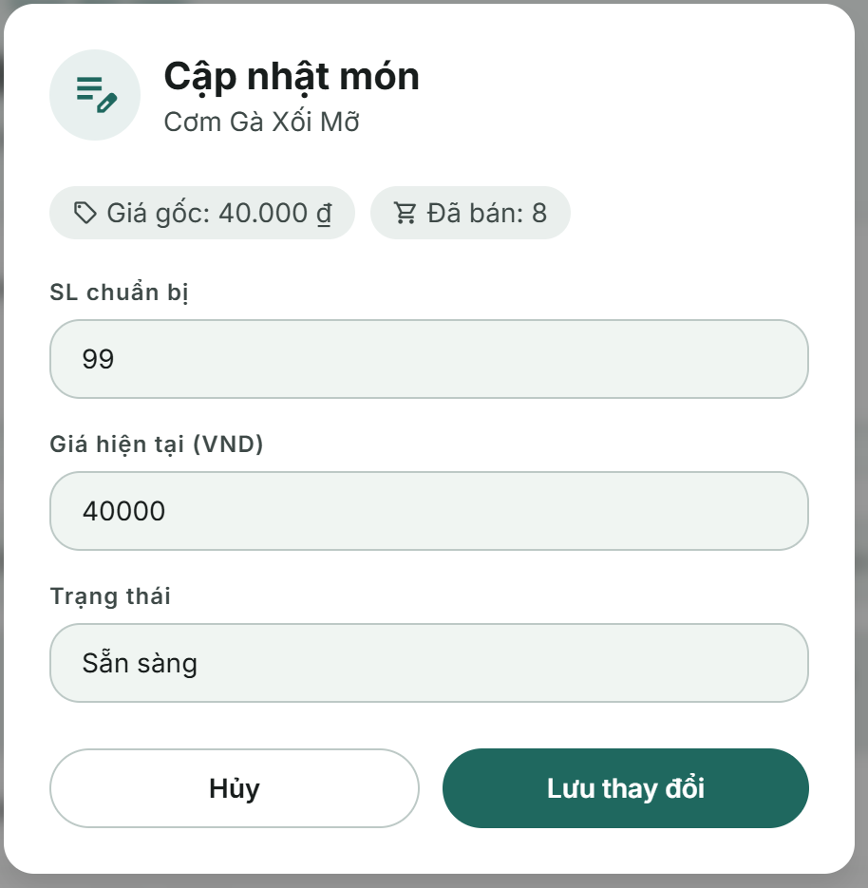

Field Name | Field Type | Description
Information Display
Food Name | Text Label | Displays the name of the selected food item being updated.
Original Price | Text Label | Displays the original/base price of the food item (formatted in VND).
Sold Quantity | Text Label | Displays the number of items sold for the current date.
Input Fields
Prepared Quantity | Text Box | Number type (positive integer). Allows the user to input the number of prepared portions. Default value: The current prepared quantity.
Current Price | Text Box | Number type (positive decimal). Allows the user to set the active selling price of the item. Default value: The current price.
Reason | Text Area | Multi-line text box. Conditional field: Only visible when the entered Current Price is different from the item's original current price. Default value: Blank.
Status | Combo Box | Single-choice dropdown. Values:  • Sẵn sàng (Available)  • Ngừng (Unavailable)  • Default value: The item's current status.
Form Actions
Cancel | Button | Click to close the modal and discard all inputs. Disabled during API execution.
Save Changes | Button | Click to trigger validation and submit the updated payload to the server. Displays a spinner loading indicator while saving. Disabled during API execution.

Database Access

Table | CRUD | Description
dailymenus | R, U | • Retrieve (R): Fetch the daily menu document by menuId to verify item existence, validate preparedQuantity against soldQuantity, and fetch existing priceHistory.  • Update (U): Atomic update ($set) of target item attributes (e.g., preparedQuantity, remainingQuantity, currentPrice, status) and appending new entries to the priceHistory array.
users | R | Populated to resolve auditor information, including the creator of the menu (createdBy) and users modifying prices (changedBy in priceHistory).
categories | R | Query food category information (category name, icon) to display item groupings on the screen.
fooditems | R | Query detailed food item information (name, description, category) populated on each menu item entry.

SQL Commands
Retrieve the daily menu for today or a selected date using the date filter.
DailyMenu.findByIdAndUpdate(
menuId,
{
$set: updateObj,
},
{
arrayFilters: [
{ "item.foodItemId": new mongoose.Types.ObjectId(foodItemId) },
],
new: true,
},
)
.populate("createdBy", "-passwordHash")
.populate({
path: "items.foodItemId",
populate: {
path: "categoryId",
select: "name",
},
})
.populate("items.priceHistory.changedBy", "-passwordHash");

5. Analytics & Reporting

5.1 Dashboard & Statistics

a. Admin Dashboard
The Admin Dashboard provides a high-level overview of current stall performance. Based on the current dashboard UI, it shows today's revenue, today's order count, average order value, a revenue trend chart, and a best-selling food items list. This screen is related to UC-26 View Daily Revenue and UC-27 View Revenue & Sales Statistics.

UI Design
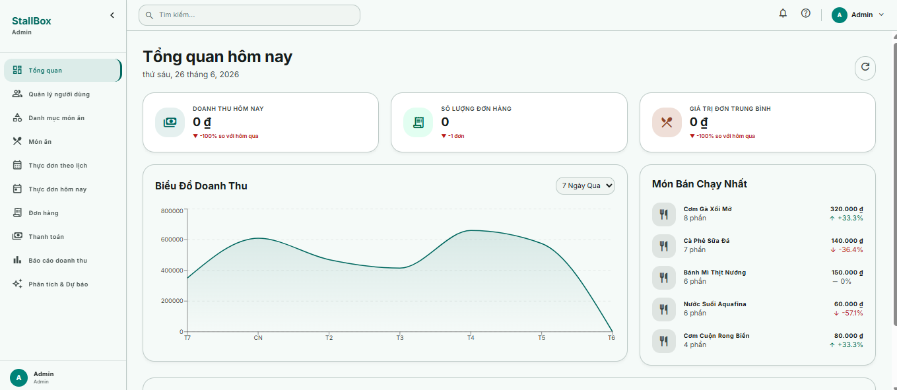

Field Name | Field Type | Description
Page Header
Page Header | Static Text | Displays "Tổng quan hôm nay" with the current date under the title.
Refresh Button | Icon Button | Reloads the dashboard metrics and chart data without changing the current page.
Statistics Card
Today Revenue Card | Statistic Card | Displays today's revenue in VND, for example "Doanh thu hôm nay". The screenshot shows 0 đ when no revenue has been recorded.
Order Count Card | Statistic Card | Displays the number of orders for the current day, for example "Số lượng đơn hàng".
Average Order Value Card | Statistic Card | Displays the average order value for the selected day, for example "Giá trị đơn trung bình".
Revenue Chart
Revenue Chart | Line / Area Chart | Displays revenue trend over the selected period. The current UI shows "Biểu Đồ Doanh Thu" with a period selector such as "7 Ngày Qua".
Chart Period Filter | Dropdown | Allows the user to switch revenue chart period, such as 7 days or month view.
Best-Selling Items Panel

Database Access

Table | CRUD | Description
payments | R | Aggregates paid transactions to calculate today revenue, previous-day comparison, and revenue trend by selected period.
orders | R | Aggregates completed orders to calculate order count, average order value, and sold quantities for best-selling items.
food_items | R | Reads food item names and category references when rendering the best-selling item ranking.
daily_menus | R | Reads current daily menu context when dashboard statistics need to reflect today's active menu items.

SQL Commands
1. Admin reads total revenue & total completed orders of the whole stall for today.
Payment.aggregate([
{ $match: matchPaidPaymentsByCreatedAt(dateStr, dateStr) },
{
$group: {
_id: null,
revenue: { $sum: "$finalAmount" },
orderCount: { $sum: 1 },
},
},
]);
2. Admin reads revenue chart data for the last 7 days.
Payment.aggregate([
{ $match: buildPaymentDateMatch(from, to) },
{
$group: {
_id: {
$dateToString: {
format: "%Y-%m-%d",
date: "$createdAt",
timezone: TIMEZONE,
},
},
revenue: { $sum: "$finalAmount" },
orderCount: { $sum: 1 },
},
},
{ $sort: { _id: 1 } },
]);
3. Admin reads top-selling food items of the whole stall.
Order.aggregate([
{ $match: matchCompletedOrdersByDate(from, to) },
{ $unwind: "$items" },
{
$group: {
_id: "$items.foodItemId",
name: { $first: "$items.name" },
quantity: { $sum: "$items.quantity" },
revenue: {
$sum: { $multiply: ["$items.quantity", "$items.unitPrice"] },
},
},
},
{ $sort: { [sortField]: -1 } },
{ $limit: limit },
{
$project: {
_id: 0,
foodItemId: "$_id",
name: 1,
quantity: 1,
revenue: 1,
imageUrl: { $literal: null },
},
},
]);
4. Admin reads payment method breakdown of the whole stall.
Payment.aggregate([
{ $match: match },
{
$group: {
_id: "$paymentMethod",
count: { $sum: 1 },
amount: { $sum: "$finalAmount" },
},
},
{
$project: {
_id: 0,
method: "$_id",
count: 1,
amount: 1,
},
},
{ $sort: { method: 1 } },
]);

b. Manager Dashboard
The Manager Dashboard uses the same operational statistics layout as the Admin Dashboard but focuses on day-to-day monitoring. It allows the Manager to quickly evaluate revenue, order volume, average order value, sales trend, and top-selling food items before adjusting daily operations.

UI Design

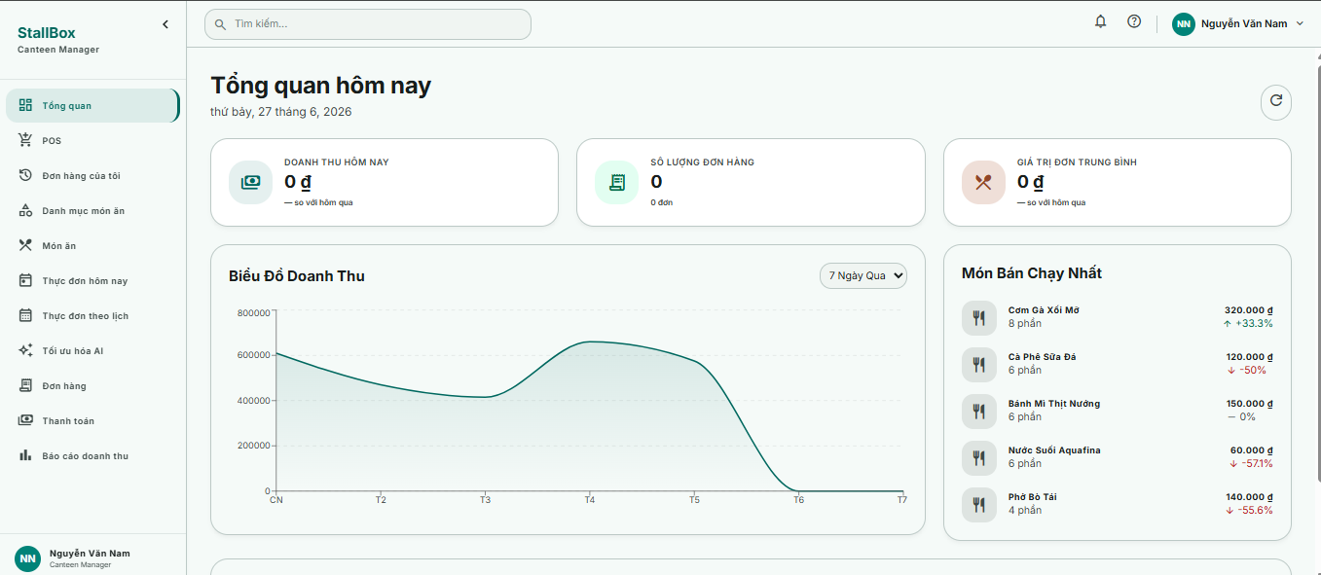

Field Name | Field Type | Description
Page Header
Page Header | Static Text | Displays "Tổng quan hôm nay" with the current date under the title.
Refresh Button | Icon Button | Reloads the dashboard metrics and chart data without changing the current page.
Statistics Card
Today Revenue Card | Statistic Card | Displays today's revenue in VND, for example "Doanh thu hôm nay". The screenshot shows 0 đ when no revenue has been recorded.
Order Count Card | Statistic Card | Displays the number of orders for the current day, for example "Số lượng đơn hàng".
Average Order Value Card | Statistic Card | Displays the average order value for the selected day, for example "Giá trị đơn trung bình".
Revenue Chart
Revenue Chart | Line / Area Chart | Displays revenue trend over the selected period. The current UI shows "Biểu Đồ Doanh Thu" with a period selector such as "7 Ngày Qua".
Chart Period Filter | Dropdown | Allows the user to switch revenue chart period, such as 7 days or month view.
Best-Selling Items Panel

Database Access
Table | CRUD | Description
payments | R | Aggregates paid transactions to calculate today revenue, previous-day comparison, and revenue trend by selected period.
orders | R | Aggregates completed orders to calculate order count, average order value, and sold quantities for best-selling items.
food_items | R | Reads food item names and category references when rendering the best-selling item ranking.
daily_menus | R | Reads current daily menu context when dashboard statistics need to reflect today's active menu items.

SQL Commands
1. Manager reads total revenue & total completed orders of the whole stall for today.
Payment.aggregate([
{ $match: matchPaidPaymentsByCreatedAt(dateStr, dateStr) },
{
$group: {
_id: null,
revenue: { $sum: "$finalAmount" },
orderCount: { $sum: 1 },
},
},
]);
2. Manager reads revenue trend for the selected period.
Payment.aggregate([
{ $match: buildPaymentDateMatch(from, to) },
{
$group: {
_id: {
$dateToString: {
format: "%Y-%m-%d",
date: "$createdAt",
timezone: TIMEZONE,
},
},
revenue: { $sum: "$finalAmount" },
orderCount: { $sum: 1 },
},
},
{ $sort: { _id: 1 } },
]);
3. Manager reads top-selling food items for daily operation review.
Order.aggregate([
{ $match: matchCompletedOrdersByDate(from, to) },
{ $unwind: "$items" },
{
$group: {
_id: "$items.foodItemId",
name: { $first: "$items.name" },
quantity: { $sum: "$items.quantity" },
revenue: {
$sum: { $multiply: ["$items.quantity", "$items.unitPrice"] },
},
},
},
{ $sort: { [sortField]: -1 } },
{ $limit: limit },
{
$project: {
_id: 0,
foodItemId: "$_id",
name: 1,
quantity: 1,
revenue: 1,
imageUrl: { $literal: null },
},
},
]);
4. Manager reads payment method breakdown for reconciliation.
Payment.aggregate([
{ $match: match },
{
$group: {
_id: "$paymentMethod",
count: { $sum: 1 },
amount: { $sum: "$finalAmount" },
},
},
{
$project: {
_id: 0,
method: "$_id",
count: 1,
amount: 1,
},
},
{ $sort: { method: 1 } },
]);

6. AI Prediction & Recommendation

6.1 Demand Forecasting

a. View Food Preparation Recomendation
This screen allows Managers and Admins to view machine learning-generated demand forecasts (XGBoost model recommendations) for a selected date. The system displays predicted portions and recommended preparation quantities for scheduled food items. Users can review ML model performance confidence metrics, check detailed demand curves, and apply these recommendations directly into the daily menu plan to optimize prep quantities and reduce food waste.

UI Design
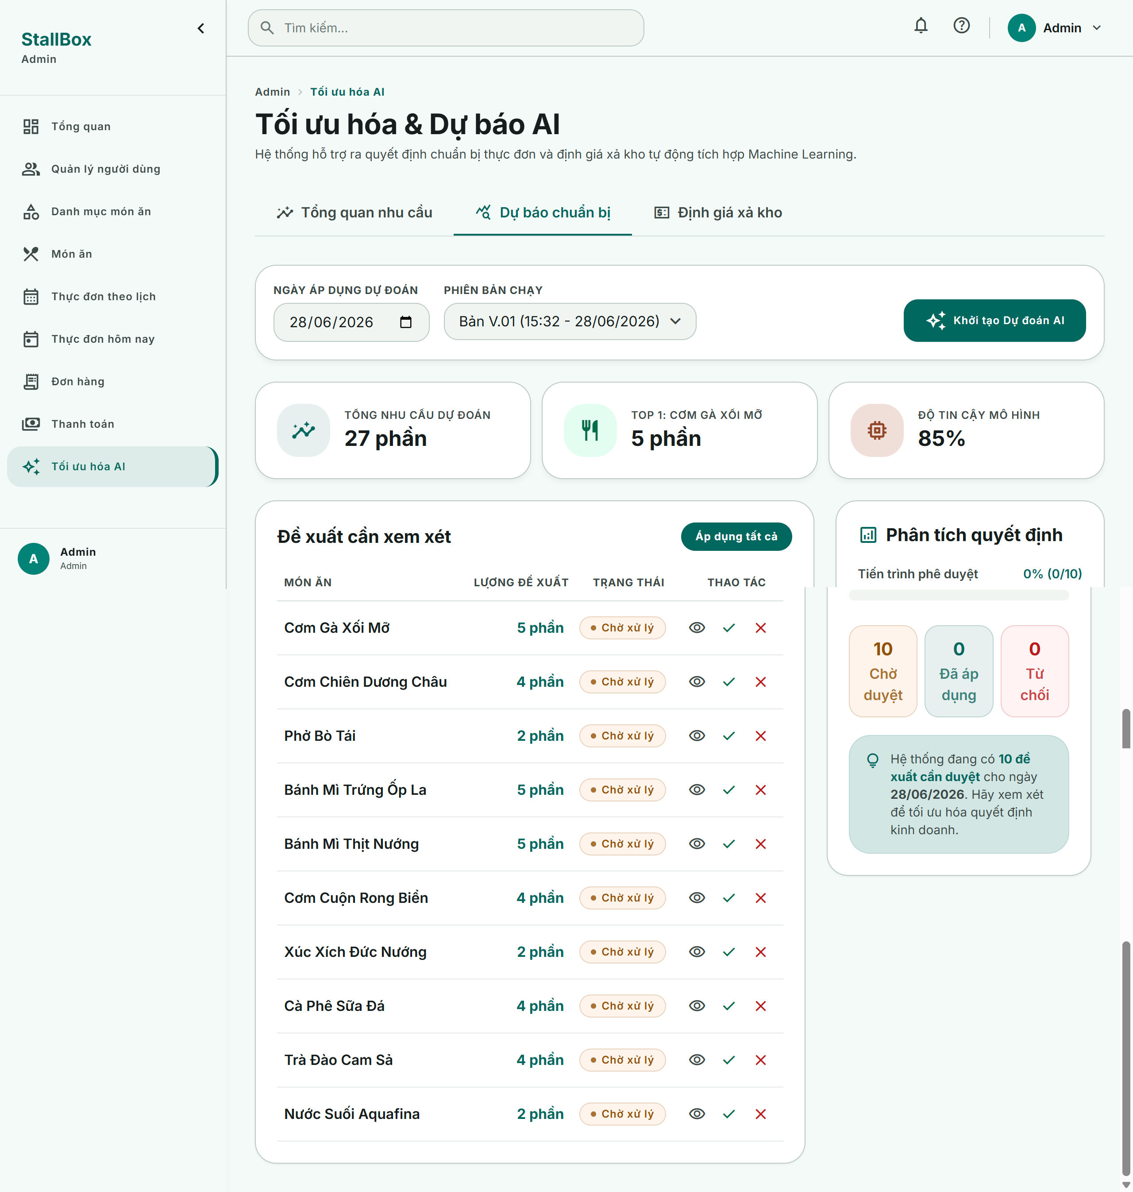

Field Name | Field Type | Description
Control & Version Selector
Target Date | Date Picker | Allows selecting the date to query demand forecasts. Defaults to the current date.
Forecast Run | Combo Box | Single-choice dropdown filled with the versions/timestamps of forecast runs for the selected date. Defaults to the latest run version.
Run Prediction | Button | Triggers the ML pipeline to process historical sales and export new predictions.
Overview Bento Stats
Total Predicted | Text Label | Displays the sum of raw predicted demand for all items.
Total Recommended | Text Label | Displays the sum of recommended prep quantities.
Top Forecasted Dish | Text Label | Displays the name and quantity of the item with the highest forecasted demand.
Confidence & Model | Text Label | Displays the name of the active ML model (e.g. XGBoost Regressor) and its confidence rating (e.g. R² score).
Forecast Data Table
Dish Name | Text Label | The name of the food item.
Recommended Quantity | Text Label | The rounded AI suggested quantity (e.g., "50 phần").
Status Badge | Status Badge | Current state of the recommendation: Pending (yellow), Applied (green), or Rejected (red). Displays operator name if finalized.
Apply | Icon Button | Individual action. Click to apply the recommendation directly to the daily menu.
Reject | Icon Button | Individual action. Click to reject the recommendation.
View Detail | Icon Button | Opens the detailed analytics modal showing historical sales charts and trend analysis.
Apply All Pending | Button | Batch action. Click to apply all recommendations currently in Pending state.
Decision Progress Analytics
Decision Progress | Progress Ring | Displays the percentage of recommendations decided (Applied + Rejected / Total).
Pending / Applied / Rejected | Text Labels | Displays numerical breakdown counts of items in each status.

Database Access

Table | CRUD | Description
aiinsights | R, U | Read (R): Fetch forecasting items, predicted values, and ML metrics for the selected target date and version.  Update (U): Update individual or batch items inside the forecasts array to set status to Applied or Rejected with operator details and timestamps.
dailymenus | R, U | Read (R): Verify daily menu existence for the target date before applying recommendations.  Update (U): Set the preparedQuantity and remainingQuantity for items when recommendations are applied.
fooditems | R | Populated during the query to fetch food metadata (name, category information) for the forecast list.
users | R | Populated to resolve the profile names of operators who applied or rejected predictions.

SQL Commands
1. Fetch Forecast Data by Date & Version
AiInsight.findOne({
targetDate: { $gte: new Date("2026-06-28T00:00:00Z"), $lte: new Date("2026-06-28T23:59:59Z") },
version: 1,
isActive: true,
deletedAt: null
})
.populate("forecasts.appliedBy forecasts.rejectedBy", "username fullName role")
.populate({
path: "forecasts.foodItemId",
populate: { path: "categoryId", select: "name" }
});

2. Fetch Forecast Versions for Dropdown
AiInsight.find({
targetDate: { $gte: new Date("2026-06-28T00:00:00Z"), $lte: new Date("2026-06-28T23:59:59Z") },
isActive: true,
deletedAt: null
})
.select("version generatedAt")
.sort({ version: 1 });

3. Update Recommendation Status in Forecast Record
AiInsight.findOneAndUpdate(
{ _id: "insight_id_123", "forecasts.foodItemId": "food_item_id_456" },
{
$set: {
"forecasts.$.status": "Applied",
"forecasts.$.appliedBy": "user_id_789",
"forecasts.$.appliedAt": new Date()
}
},
{ new: true }
);

4. Apply Recommended Quantity to Daily Menu
DailyMenu.findOneAndUpdate(
{ _id: "menu_id_abc" },
{
$set: {
"items.$[item].preparedQuantity": 50,
"items.$[item].remainingQuantity": 50 - item.soldQuantity,
"items.$[item].quantityAdjustedBy": "user_id_789",
"items.$[item].adjustedAt": new Date()
}
},
{
arrayFilters: [{ "item.foodItemId": "food_item_id_456" }],
new: true
}
);

b. View Dynamic Pricing Recommendation
This screen allows Managers and Admins to view dynamic clearance pricing recommendations generated for food items that are projected to be in surplus as the canteen closing time approaches. The dynamic pricing pipeline computes discounts based on the real-time excess stock ratio (remaining quantity vs remaining forecasted demand), hours left before closing, and food unit cost thresholds (verifying margins to prevent loss). Users can apply these dynamic discounts to adjust active selling prices in the daily menu.

UI Design
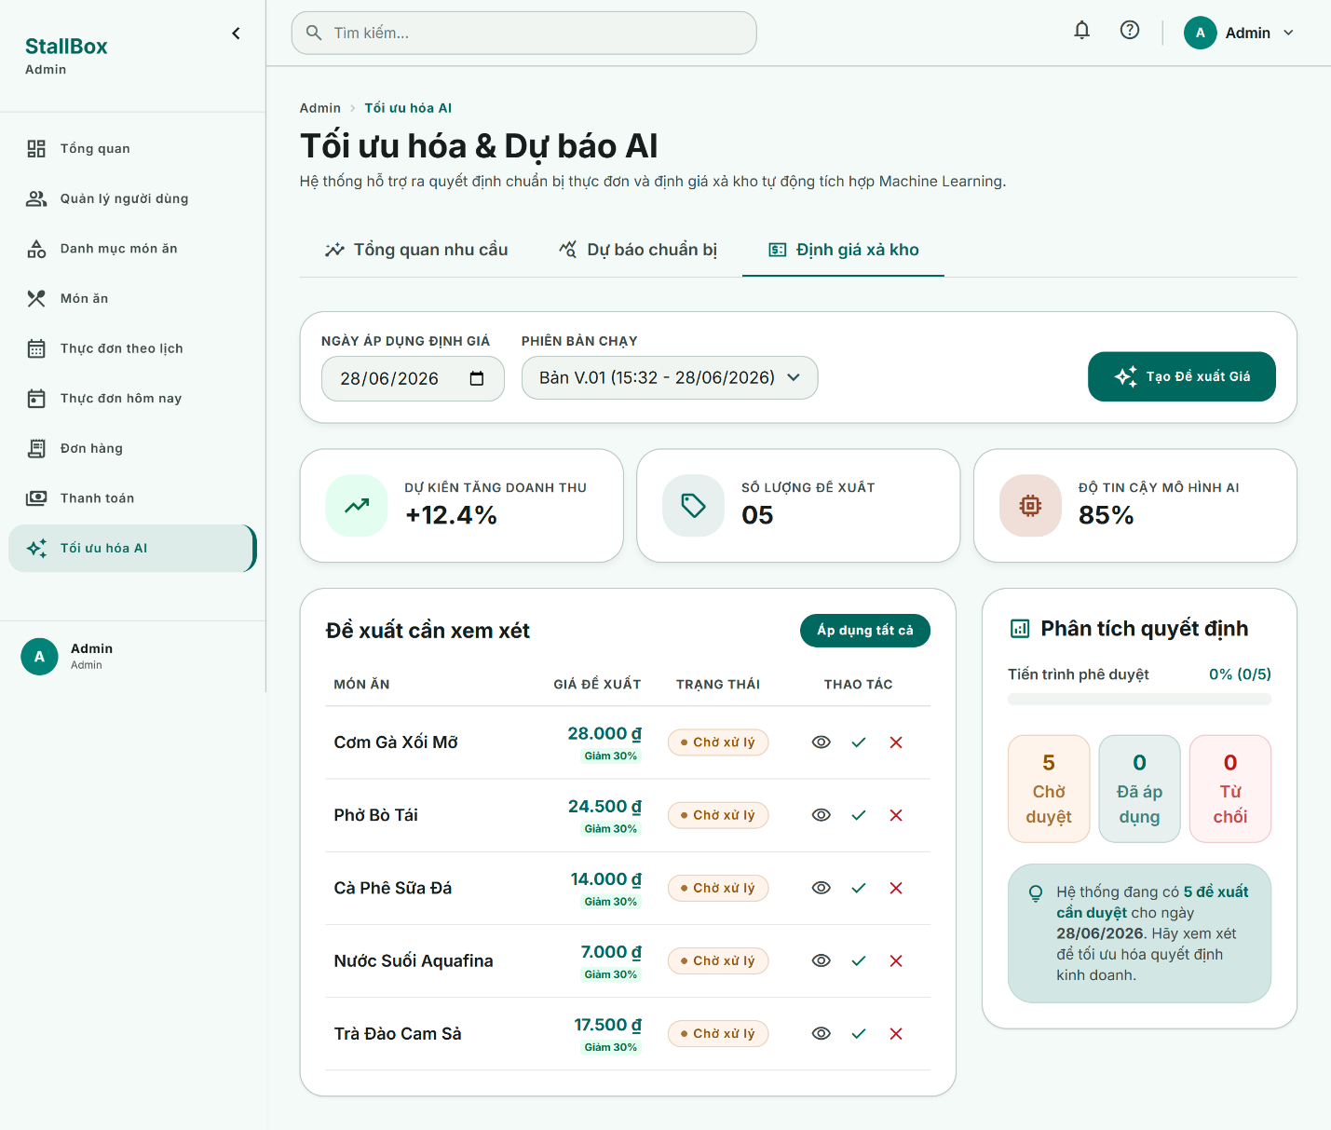

Field Name | Field Type | Description
Control & Version Selector
Target Date | Date Picker | Selects the date to inspect dynamic clearance pricing logs. Defaults to the current date.
Pricing Run | Combo Box | Dropdown displaying dynamic calculation runs. Defaults to the latest configuration version.
Create Pricing Recommendations | Button | Triggers inventory surplus scans and computes dynamic dynamic pricing.
Overview Bento Stats
Revenue Forecast Increase | Text Label | Shows the estimated percentage increase in optimized revenue.
Discount Recommendation Count | Text Label | Total count of food items matching surplus discount rules.
AI Reliability Metric | Text Label | Displays AI model forecast reliability rating.
Pricing Recommendation Table
Dish Name | Text Label | The name of the surplus menu item.
Recommended Price | Text Label | The dynamic clearance price (formatted in VND) accompanied by a discount tag (e.g., "Giảm 20%").
Decision Status | Status Badge | The decision state of the recommendation: Pending (yellow), Applied (green), or Rejected (red), along with the finalizing user name.
Apply | Icon Button | Individual action. Click to update the item price in the daily menu and record it in priceHistory.
Reject | Icon Button | Individual action. Click to reject the discount, preserving the current menu price.
View Detail | Icon Button | Opens the detailed modal displaying inventory metrics (excess ratios, safety price floor, time rule justification).
Apply All Pending | Button | Batch action. Click to apply all pending dynamic pricing adjustments simultaneously.
Decision Progress Analytics
Progress Ring | Progress Ring | Percentage of pricing decisions finalized (Applied + Rejected / Total).
Pending / Applied / Rejected | Text Labels | Quantitative breakdown metrics of pricing decisions.

Database Access

Table | CRUD | Description
aiinsights | R, U | Read (R): Fetch calculated dynamic pricing recommendations, discount percentages, reasons, and status values.  Update (U): Save newly computed pricing recommendations, and update recommendation status values to Applied or Rejected with operator metadata.
dailymenus | R, U | Read (R): Fetch active food items, prices, costs, and remaining stock to evaluate surplus factors.  Update (U): Update the active currentPrice of menu items and append dynamic price entries (PRICE_SOURCE.AI) to the priceHistory log.
fooditems | R | Populated to read item cost variables (cost) to calculate safety price floors.
users | R | Populated to resolve details of users finalising pricing status overrides.

SQL Commands
1. Fetch Daily Menu Stock Metrics for Surplus Scan
DailyMenu.findOne({ date: "2026-06-28" })
.populate("items.foodItemId", "cost name");

2. Save Calculated Dynamic Pricing Recommendations to Database
AiInsight.updateOne(
{ _id: "insight_id_123" },
{ $set: { pricingRecommendations: recommendationsArray } }
);

3. Update Pricing Recommendation Decision Status
AiInsight.findOneAndUpdate(
{ _id: "insight_id_123", "pricingRecommendations.foodItemId": "food_item_id_456" },
{
$set: {
"pricingRecommendations.$.status": "Applied",
"pricingRecommendations.$.appliedBy": "user_id_789",
"pricingRecommendations.$.appliedAt": new Date()
}
},
{ new: true }
);

4. Apply Price Modification & Record Price History
DailyMenu.findOneAndUpdate(
{ _id: "menu_id_abc", "items.foodItemId": "food_item_id_456" },
{
$set: { "items.$.currentPrice": 21000 },
$push: {
"items.$.priceHistory": {
oldValue: 30000,
newValue: 21000,
changedBy: "user_id_789",
changedAt: new Date(),
source: "AI",
recommendationId: "insight_id_123",
reason: "Áp dụng đề xuất định giá AI"
}
}
},
{ new: true }
);

7. User Management

7.1 Account Administration

a. View User List
The User Management page is an Admin-only account administration screen. It displays system users, account statistics, search, role/status filters, pagination, and row-level actions for editing, resetting passwords, and enabling/disabling accounts. Related use cases: UC-28 Create User Account, UC-29 Update User Account, UC-30 Disable User Account, and UC-31 Reset Password.

UI Design

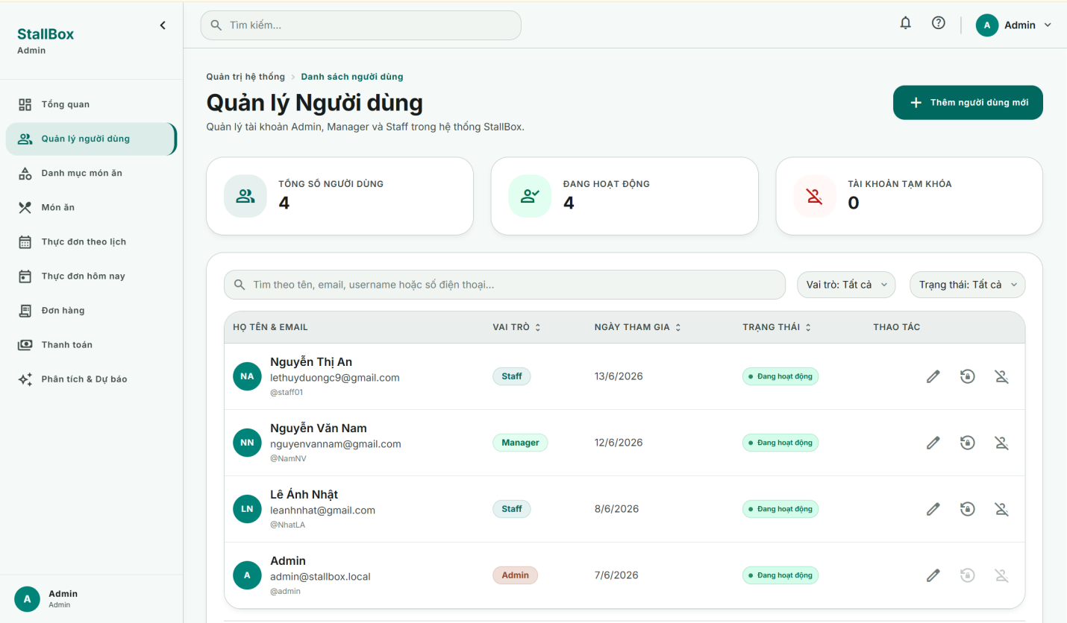

Field Name | Field Type | Description
PageHeader | Header / CTA | Shows breadcrumbs, title "Quản lý Người dùng", description, and "Thêm người dùng mới" button.
Statistic cards | Display cards | Shows total users, active users, and inactive/temporarily locked users.
Search Fields
search | SearchBar | Searches by full name, email, username, or phone. Debounced before API reload.
role filter | Dropdown filter | Filters by Admin, Manager, Staff, or all roles.
status filter | Dropdown filter | Filters by active, inactive, or all statuses.
DataTable
Data Column | Text | Columns: full name and email, role, created date, status, and actions. Supports loading and empty state.
RolePill | Badge | Displays account role with visual style for Admin, Manager, or Staff.
StatusBadge | Badge | Displays "Đang hoạt động" for active users and "Tạm khóa" for disabled users.
Action buttons | Icon buttons | Edit user, reset password, disable active user, or enable inactive user. Self-management sensitive actions are disabled.

Database Access

Table | CRUD | Description
users | R | Read paginated user list. Optional filters: search by username/fullName/email/phone, role, and isActive. Exclude passwordHash from response.
users | R | Count total, active, and inactive users for statistic cards and pagination.

SQL Commands
1. Read paginated user list
users.find(filter).skip((page - 1) * limit).limit(limit)

2. Count total, active, and inactive users for statistic cards and pagination.
users.countDocuments(filter)

b. Create / Update User Account
The Create/Update User Account modal is opened from the User Management page. In create mode, Admin enters username, temporary password, full name, email, phone, and role. In edit mode, the same form is prefilled and excludes the password field. The modal validates input before calling the user management API.

UI Design
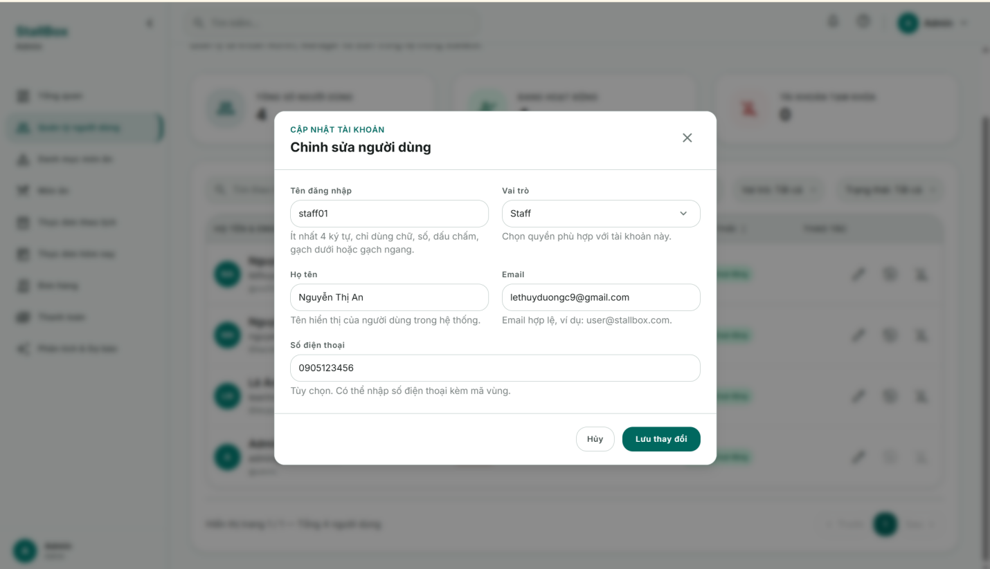

Field Name | Field Type | Description
Modal Header
mode | Modal state | Create mode shows "Tạo người dùng" and password field. Edit mode shows "Cập nhật người dùng" and prefilled data.
Input Fields
username | Text input | Required. Minimum 4 characters. Only letters, numbers, dot, underscore, and hyphen are accepted.
password | Password input | Create mode only. Required. Minimum 6 characters, not only spaces, no whitespace/accented or invalid non-ASCII characters.
fullName | Text input | Required. Display name of the user in the system.
email | Email input | Required. Must match valid email format and be unique.
role | Select input | Required. Allowed values: Admin, Manager, Staff. Default in create mode is Staff.
phone | Text input | Optional. Allows 8-20 characters containing numbers, +, (), spaces, dot, or hyphen.
Modal Footer
Cancel button | Button | Closes modal if no save operation is running.
Save button | Submit button | Calls create or update API, shows spinner while saving, and refreshes list/statistics after success.

Database Access

Table | CRUD | Description
users | R, C, U | Check duplicated username or email before create/update.  Create user with username, passwordHash, fullName, email, phone, role, and isActive=true.  Update username, fullName, email, phone, and role for an existing account. Password is not changed in edit mode

SQL Commands
1. Check duplicated username or email before create/update.
users.findOne({ $or: [{ username }, { email }], _id: { $ne: id } });

2. Create user with username, passwordHash, fullName, email, phone, role, and isActive=true.
users.create({ username, passwordHash: hashPassword(password), fullName, email: email.toLowerCase(), phone, role, isActive: true }).

3. Update username, fullName, email, phone, and role for an existing account. Password is not changed in edit mode.
user.save();

c. Enable / Disable User Account
The Enable/Disable User Account confirmation dialog is opened from the action column on the User Management page. It asks Admin to confirm locking or unlocking an account. Disabling a user prevents login and revokes existing refresh tokens. Admin cannot disable their own account.

UI Design

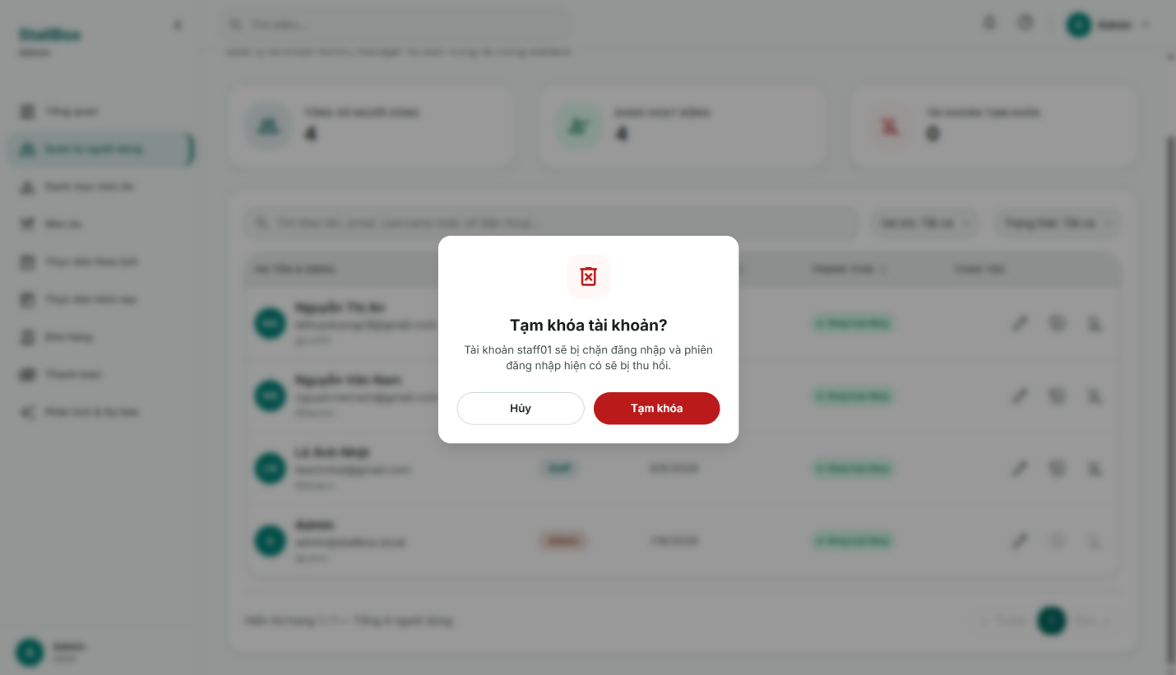

Field Name | Field Type | Description
ConfirmDialog
description | Text display | Explains that disabled users cannot log in and active sessions will be revoked.
Confirm button | Button | Calls disable or enable API. Variant is danger for disable and info for enable.
Cancel button | Button | Closes the dialog without changing user status.

Database Access

Table | CRUD | Description
users | R/U | Read selected account. Disable sets isActive=false, deletedAt=current time, deletedBy=adminUserId. Enable sets isActive=true and clears deletedAt/deletedBy.
refresh_tokens | U | When disabling a user, revoke all active refresh tokens for that user.

SQL Commands
1. Find user by id
User.findOne({
_id: id,
});

2. Update status
user.save();

3. When disabling a user, revoke all active refresh tokens for that user.
refresh_tokens.updateMany({ userId, isRevoked: false }, { isRevoked: true, revokedAt: new Date() })

c. Reset User Password
The Reset User Password modal allows Admin to assign a new password to another user account. The selected user identity is shown for confirmation. The Admin enters and confirms the new password; after success, all active refresh tokens of that user are revoked so the user must log in again.

UI Design

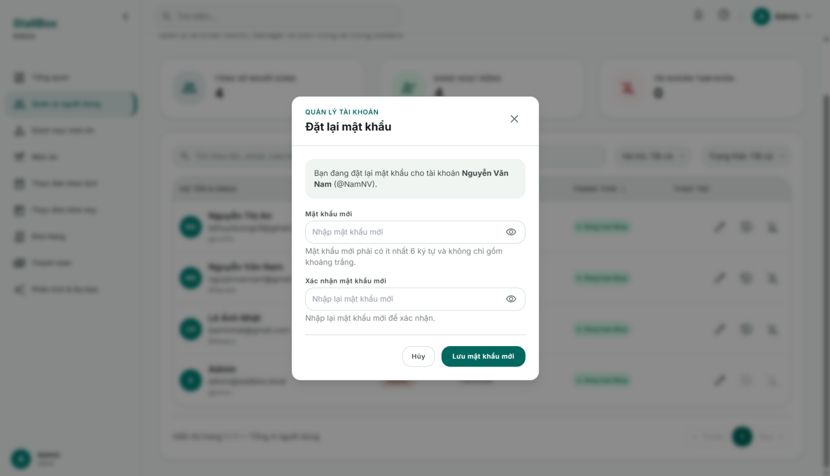

Field Name | Field Type | Description
selected user summary | Display panel | Shows full name or username and @username of the account being reset.
newPassword | Password input | Required. Minimum 6 characters, not only spaces, no whitespace/accented or invalid non-ASCII characters.
confirmPassword | Password input | Required. Must match newPassword.
Save new password button | Submit button | Calls PATCH /users/:id/reset-password. Disabled and shows spinner while saving.
Cancel button | Button | Closes modal without changing the selected account.
error alert | Error message | Displays validation errors, self-reset restriction, or user not found errors.

Database Access

Table | CRUD | Description
users | R/U | Find selected active user by id and update passwordHash with hashPassword(newPassword).
refresh_tokens | U | Revoke all active refresh tokens for the selected user after password reset.

SQL Commands
1. Find selected active user by id.
users.findOne({ _id: id, deletedAt: null }).select(+passwordHash).

2. Update passwordHash with hashPassword(newPassword)
user.passwordHash = hashPassword(newPassword);
user.save().
3. Revoke all active refresh tokens for the selected user after password reset.
refresh_tokens.updateMany({ userId: id, isRevoked: false }, { isRevoked: true, revokedAt: new Date() }).

IV. Appendix

1. Assumptions & Dependencies
AS-1: The canteen stall has stable Internet connectivity during daily operations.
AS-2: Staff, managers, and administrators possess basic computer skills and are able to use the web application.
AS-3: Sales transactions are recorded consistently and accurately, providing reliable historical data for analytics and AI forecasting.
AS-4: The canteen operates as a single-stall business with a centralized menu and inventory management process.
AS-5: Managers regularly review AI recommendations before applying food preparation quantities or price adjustments.
DE-1: StallBox depends on a third-party Payment Gateway to process and verify electronic payment transactions.
DE-2: StallBox depends on the AI Prediction Service to generate food demand forecasts, preparation recommendations, and dynamic pricing recommendations.
DE-3: The system depends on MongoDB for persistent data storage.
DE-4: The system depends on cloud hosting services to ensure application availability and accessibility.
DE-5: Email delivery services are required for password reset and account-related notifications.

2. Limitations & Exclusions

EX-1: The system does not manage raw material inventory or supplier procurement processes.
EX-2: The system does not support multi-branch or multi-store operations in the current version.
EX-3: The system does not provide customer-facing online ordering or food delivery services.
EX-4: The AI module provides recommendations only and does not automatically modify food quantities or prices without manager approval.
EX-5: The system does not integrate with external accounting or enterprise resource planning (ERP) systems.
EX-6: The system does not include employee attendance, payroll, or human resource management functions.
EX-7: Demand forecasts are generated based on historical sales data and cannot guarantee exact future sales outcomes.

3. Business Rules

ID | Category | Rule Definition
BR-01 | Constraints | Only active user accounts are allowed to access the system.
BR-02 | Constraints | A food item's selling price must be greater than zero.
BR-03 | Constraints | Only Admin users may create, update, or archive food items.
BR-04 | Constraints | Only Manager and Admin users may apply AI-generated recommendations.
BR-05 | Facts | Every order must contain at least one food item.
BR-06 | Facts | An order is associated with exactly one payment transaction.
BR-07 | Facts | Daily menu items must be derived from existing food items in the master menu.
BR-08 | Facts | Disabled user accounts cannot perform any business operations.
BR-09 | Computations | Order total amount is calculated as the sum of each food item's selling price multiplied by its ordered quantity.
BR-10 | Computations | Daily revenue is calculated as the sum of all successfully paid orders for the selected date.
BR-11 | Computations | Food demand forecasts are generated based on historical sales data and forecasting models.
BR-12 | Constraints | AI recommendations must be reviewed and approved by a Manager or Admin before being applied.
BR-13 | Constraints | Cancelled orders must not contribute to revenue statistics or AI training datasets.
BR-14 | Facts | Each user account is assigned exactly one role: Staff, Manager, or Admin.
BR-15 | Constraints | A payment must be successfully completed before a receipt can be issued.

