

Requirement & Design Specification
Car Rental Website
Version: 1.0

– Da Nang, June 2024 –

Record of Changes
Version | Date | A*  M, D | In charge | Change Description
V1.0 | 15/2 | A | KienNTHE11
*A - Added M - Modified D - Deleted

Contents
Record of Changes 2
I. Overview.. 4
1. User Requirements 4
1.1 Actors 4
1.2 Use Cases 4
2. Overall Functionalities 5
2.1 Screens Flow.. 5
2.2 Screen Descriptions 5
2.3 Screen Authorization. 5
2.4 Non-UI Functions 6
3. System High Level Design. 6
3.1 Database Design. 6
3.2 Code Packages 7
II. Requirement Specifications 8
1. <<Feature Name>>. 8
1.1 <<UseCaseCode_UC Name>>. 8
2. Common Functions 11
2.1 UC-2_Login System.. 11
3. Patron Feature. 12
3.1 UC-5_Order a Meal 12
3.2 UC-6_Register for Payroll Deduction. 13
III. Design Specifications 14
1. <<Feature Name>>. 14
1.1 <<SubFeature Name>>. 14
1.2 System Access 15
IV. Appendix. 19
1. Assumptions & Dependencies 19
2. Limitations & Exclusions 19
3. Business Rules 19
4. .. 19

I. Overview

1. User Requirements

1.1 Actors
[An actor is a person (or sometimes another software system or a hardware device) that interacts with the system to perform a use case. Following are some questions you might ask to help user representatives identify actors
· Who (or what) is notified when something occurs within the system?
· Who (or what) provides information or services to the system?
· Who (or what) helps the system respond to and complete a task?
This part gives the description of system actors, you can follow the table form as below]
# | Actor | Description
1 | Guest | Customers who haven't registered an account can view cars, see ratings and reviews, register, log in using Google.
2 | Users | Logged-in users can book rides, view bookings, renew bookings, make payments, rate rides, receive notifications about password changes, log out, and apply discount codes.
3 | Staff | Operations staff: confirm payments, update order status, view all bookings.
4 | Admin | Manage the entire system: manage users, vouchers, view statistics, and analyze data.
5 | System | Automatic notifications, token refresh, dynamic pricing.

1.2 Use Cases
[A use case (UC) describes a sequence of interactions between a system and an external actor that results in the actor being able to achieve some outcome of value. The names of use cases are always written in the form of a verb followed by an object. Select strong, descriptive names to make it evident from the name that the use case will deliver something valuable for some user]

a. Diagram(s)
[Provide the UC diagram(s) to show the actor-UCs and UC-UC relationships like the sample below. You can have multiple UC diagrams for the system]
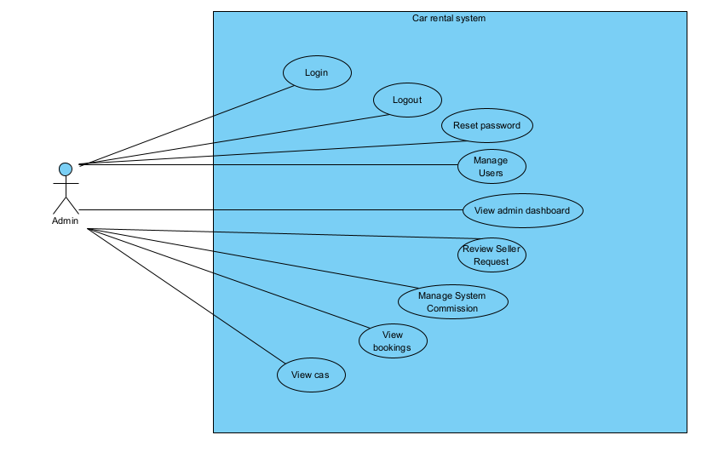

b. Descriptions
This part describes the use cases, you can follow the table form as below]
ID | Feature | Use Case | Use Case Description
01 | Account Management | Login | The Admin logs into the Car Rental system using valid authentication credentials.
02 | Account Management | Logout | The Admin securely logs out of the Car Rental system
03 | Account Management | Reset Password | The Admin requests and completes the password reset process.
04 | System Operations | Manage Users | The Admin manages user accounts, including creating, updating, and deleting user accounts.
05 | System Operations | Review Seller Requests | The Admin reviews and approves or rejects requests from users who want to become sellers on the platform.
06 | System Operations | View | The Admin views the list of completed and existing vehicle bookings.
07 | Reports & Analytics | View Admin Dashboard | The Admin accesses the dashboard to monitor system performance and view overall operational reports.
08 | Financial Management | Manage System Commission | The Admin configures and manages the commission rate collected from vehicle rental transactions.
09 | Data Management | View Cars | The Admin views the list of available vehicles and their detailed information.

2. Overall Functionalities

2.1 Screens Flow
[This part shows the system screens and the relationship among screens. You can draw the Screens Flow for the system in the form of diagram as below. Please note that beside the normal flat screen, we might have the oval notation for pop-up screen (Import Order) or a screen with multiple information tab (Order Details), etc. You may also use text or background format for different visuality purpose]
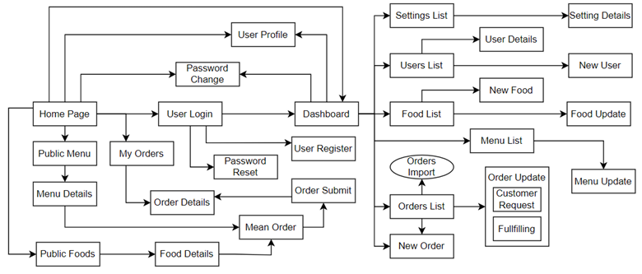

2.2 Screen Descriptions
[Provide the descriptions for the screens in the Screens Flow above]
# | Feature | Screen | Description
1 | Order Meals | Create Order | <<Screen Brief description>>
2 | Order Meals | Change Order
3 | ..

2.3 Screen Authorization
[Provide the system roles authorization to the system features (down to screens, and event to the screen activities if applicable) in the table form as below – replace Role1, Role2,… with your specific system user role names]
Screen | Role-Name1 | Role-Name2 | Role-Name3 | …
<<Screen Name1>> | X |  | X | X
<<Screen Activity>> |  |  | X | X
<<Screen Name2>> | X |  | X
Query All Data | X
Query Own Data |  |  | X
Query Managed Data |  |  | X
Add New Data |  |  | X | X
Update All Data |  |  |  | X
Update Own Data |  |  |  | X
Update Managed Data |  |  |  | X
Delete Data
…

2.4 Non-UI Functions
[Provide the descriptions for the functions which have no UI (or not screens), i.e batch/cron job, service, API, etc.]
# | Feature | System Function | Description
1 | <<Feature Name>> | <<Function Name1>> | <<Function Name1 Description>>
2 | …

3. System High Level Design

3.1 Database Design
[Provide the tables relationship like example below]

a. Database Schema
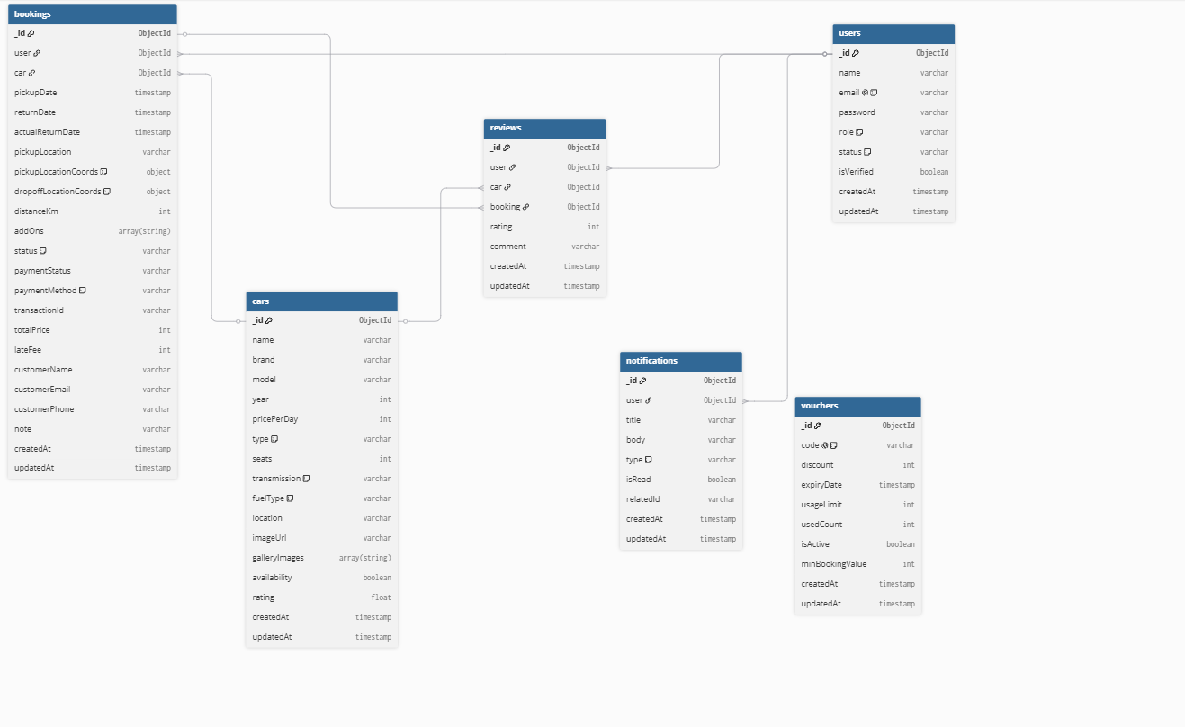

b. Table Descriptions
No | Table | Description
01 | Account | <Description of the table>  - Primary keys: <<list of primary key fields>>  - Foreign keys: <<list of foreign key fields>>
02 | <Table name2> | …

3.2 Code Packages
[Provide the package diagram for each sub-system. The content of this section including the overall package diagram, the explanation, package and class naming conventions in each package. Please see the sample & description table format below]
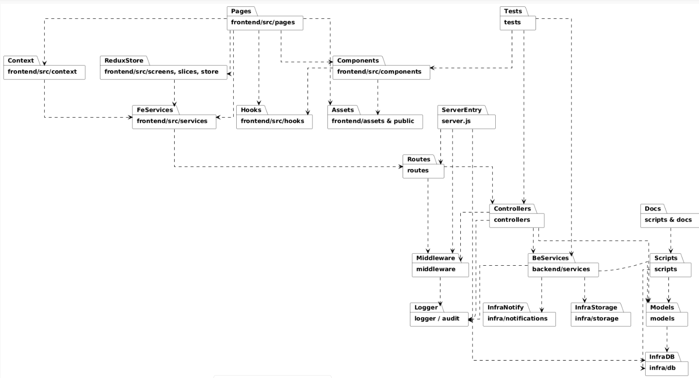
Package descriptions
No | Package | Description
01 | frontend/src/pages/ | React page components (views); contains route-level pages such as Admin, Home, and BookingDetail.
02 | frontend/src/components/ | Reusable UI components such as cards, lists, modals, and controls.
03 | frontend/src/services/ | API client layer (Axios) and helper functions for communicating with backend APIs, separating networking concerns from UI logic
 | frontend/src/context/ | Context providers (e.g., AuthContext, CartContext) for managing global application state.
 | frontend/src/hooks/ | Custom React hooks that encapsulate reusable logic such as data fetching, form handling, and other shared functionality.
 | frontend/assets and public/ | Static assets including images, CSS files, manifest files, and other public resources used by the frontend.
 | routes/ | Defines API endpoints and maps incoming HTTP requests to the appropriate controllers.
 | controllers/ | Handles request processing by validating input, invoking services/models, and returning HTTP responses.
 | middleware/ | Shared middleware for authentication, authorization, error handling, logging, and rate limiting.
 | backend/services/ | (If applicable) Contains business logic, third-party integrations, and reusable services shared across controllers
 | models/ | Mongoose schemas and models (e.g., User, Booking, Car, Notification, SellerRequest, etc.).
 | infra/db/ (or database configuration in server.js) | MongoDB connection layer using Mongoose, including database configuration and retry logic.
 | infra/notifications/ or backend/models/Notification.js | Internal notification system, including the notification model and adapters for sending emails or other notifications.
 | scripts/ | Utility scripts such as database seeding, migrations, test helpers, and cron job starters.
 | infra/storage/ | Storage adapters for file management (e.g., local storage or Amazon S3) if the project supports file uploads or asset handling.
 | logger/ or audit/ | Logging and audit trail system for tracking requests, responses, errors, and administrative actions.
 | frontend/src/screens/, slices/, store/ | (If Redux/Redux Toolkit is used) Contains Redux slices and the application store for managing complex global state.
 | tests/ | Unit and integration test suites for controllers, services, components, and other application modules.
 | scripts/ & docs/ | Development utilities and project documentation, including the README, CHANGELOG, and deployment or operational guides.

II. Requirement Specifications

1. <<Feature Name>>

1.1 <<UseCaseCode_UC Name>>

a. Functionalities
Provide the functional description for the use cases using the template/guides below
Functional Description Template
UC ID and Name:
Created By: |  | Date Created:
Primary Actor: |  | Secondary Actors:
Trigger:
Description:
Preconditions:
Postconditions:
Normal Flow:
Alternative Flows:
Exceptions:
Priority: | High (Medium, Low), Must Have (Should Have, Could Have),..
Frequency of Use:
Business Rules:
Other Information:
Assumptions:

Functional Description Contents
Use Case ID and Name
Give each use case a unique integer sequence number identifier. State a concise name for the use case that indicates the value the use case would provide to some user. Begin with an action verb, followed by an object.
Author and Date Created
Enter the name of the person who initially wrote this use case and the date it was written.
Primary and Secondary Actors
An actor is a person or other entity external to the software system being specified who interacts with the system and performs use cases to accomplish tasks. Different actors often correspond to different user classes, or roles, identified from the customer community that will use the product. Name the primary actor that will be initiating this use case and any other secondary actors who will participate in completing execution of the use case.
Trigger
Identify the business event, system event, or user action that initiates the use case. This trigger alerts the system that it should begin testing the preconditions for the use case so it can judge whether to proceed with execution.
Description
Provide a brief description of the reason for and outcome of this use case, or a high-level description of the sequence of actions and the outcome of executing the use case.
Preconditions
List any activities that must take place, or any conditions that must be true, before the use case can be started. The system must be able to test each precondition. Number each precondition. Example: PRE-1: User’s identity has been authenticated.
Postconditions
Describe the state of the system at the successful conclusion of the use case execution. Label each postcondition in the form POST-X, where X is a sequence number. Example: POST-1: Price of item in the database has been updated with the new value.
Normal Flow
Provide a description of the user actions and corresponding system responses that will take place during execution of the use case under normal, expected conditions. This dialog sequence will ultimately lead to accomplishing the goal stated in the use case name and description. Show a numbered list of actions performed by the actor, alternating with responses provided by the system. The normal flow is numbered “X.0”, where “X” is the Use Case ID.
Alternative Flows
Document other successful usage scenarios that can take place within this use case. State the alternative flow, and describe any differences in the sequence of steps that take place. Number each alternative flow in the form “X.Y”, where “X” is the Use Case ID and Y is a sequence number for the alternative flow. For example, “5.3” would indicate the third alternative flow for use case number 5. Indicate where each alternative flow would branch off from the normal flow, and if pertinent, where it would rejoin the normal flow.
Exceptions
Describe any anticipated error conditions that could occur during execution of the use case and how the system is to respond to those conditions. Number each alternative flow in the form “X.Y.EZ”, where “X” is the Use Case ID, Y indicates the normal (0) or alternative (>0) flow during which this exception could take place, “E” indicates an exception, and “Z” is a sequence number for the exceptions. For example “5.0.E2” would indicate the second exception for the normal flow for use case number 5. Indicate where in the normal (or an alternative) flow each exception could occur.
Priority
Indicate the relative priority of implementing the functionality required to allow this use case to be executed. Use the same priority scheme as that used for the functional requirements.
Frequency of Use
Estimate the number of times this use case will be performed per some appropriate unit of time. This gives an early indicator of throughput, concurrent usage loads, and transaction capacity.
Business Rules
List any business rules that influence this use case. Don’t include the business rule text here, just its identifier so the reader can find it in another repository when needed.
Other Information
Identify any additional requirements, such as quality attributes, for the use case that may need to be addressed during design or implementation. Also list any associated functional requirements that aren’t a direct part of the use case flows but which a developer needs to know about. Describe what should happen if the use case execution fails for some unanticipated or systemic reason (e.g., loss of network connectivity, timeout). If the use case results in a durable state change in a database or the outside world, state whether the change is rolled back, completed correctly, partially completed with a known state, or left in an undetermined state as a result of the exception.
Assumptions
List any assumptions that were made regarding this use case or how it might execute.

b. Business Rules
Provide the business rules those are applied only to the use case
ID | Business Rule | Business Rule Description
FR1 | Password Encoding | User’s password must be encoded with MD5 hashing

2. Common Functions

2.1 UC-1_View Analytics Dashboard

a. Functional Description
UC ID and Name: | UC-01 — View Analytics Dashboard
Created By: | Nguyễn Tiến Dũng | Date Created: | 11/06/2026
Primary Actor: | Admin | Secondary Actors: | None
Trigger: | The Admin opens the Dashboard. .
Description: | Displays overall system metrics, including:  - Total Users  - Total Revenue  - Total Bookings  - Top Rental Cars
Preconditions: | - The Admin is authenticated.  - Analytics endpoints are available.
Postconditions: | - Dashboard metrics are displayed without changing any system data.
Normal Flow | - The Admin opens the Dashboard.  - The system retrieves statistics, top-performing cars, and commission summaries.  - The system renders charts and KPI cards.  - The Admin interacts with filters and chart tooltips.
Alternative Flows: | If one analytics endpoint times out, that section displays a placeholder while the remaining dashboard continues to load.
Exceptions: | - Unauthorized access returns 401.  - Failed endpoints display an error card.
Priority: | High
Frequency of Use: | Daily
Business Rules: | FR2,FR7
Other Information: | Sensitive information is displayed according to user roles.
Assumptions: | The frontend supports chart components with graceful fallback.

2.2 UC-02 — View Booking Statistics

a. Functional Description
UC ID and Name: | UC-01 — View Booking Statistics
Created By: | Nguyễn Tiến Dũng | Date Created: | 11/06/2026
Primary Actor: | Admin | Secondary Actors: | None
Trigger: | The Admin opens the Dashboard and selects "Booking Statistics."
Description: | The Admin views booking statistics, including the number of bookings, booking trends over time, and statistics by location.
Preconditions: | - PRE-1: The Admin has been authenticated (JWT) and has the Admin role.  - PRE-2: The system is connected to the database, and the Analytics Service is available.
Postconditions: | - POST-1: Booking statistics are retrieved and displayed without modifying any system data.
Normal Flow | - The Admin selects Booking Statistics.  - The system verifies the Admin's permissions and calls GET /api/analytics/booking-statistics.  - The system aggregates booking data by day, month, and location.  - The system returns the data in JSON format.  - The frontend renders charts and tables.  - The Admin filters statistics by date range or location.
Alternative Flows: | - If the selected date range is very large, the system returns partial data using pagination or asynchronous loading.
Exceptions: | - E1: Unauthorized or non-admin users receive 401/403 Unauthorized.  - E2: If the database aggregation fails, the system returns 500 Internal Server Error with the message "Failed to load statistics."
Priority: | High
Frequency of Use: | Daily (multiple times per day)
Business Rules: | FR2,
Other Information: | Statistics are read-only.  - Cached or pre-aggregated data should be used to improve performance.  - Heavy reports should be rate-limited.
Assumptions: | Analytics data is either pre-aggregated or generated on demand.

2.3 UC-03 — View Pricing Surge Analytics

a. Functional Description
UC ID and Name: | UC-03 — View Pricing Surge Analytics
Created By: | Nguyễn Tiến Dũng | Date Created: | 11/06/2026
Primary Actor: | Admin | Secondary Actors: | None
Trigger: | Admin selects "Pricing" tab or opens Dynamic Pricing section
Description: | View list/report of dynamic pricing (surges), multiplier rates, and affected cars.
Preconditions: | PRE-1: Admin is authenticated.  PRE-2: Pricing surge service has data available (DB or computed).
Postconditions: | POST-1: Displays current/historical surge list; does not modify data.
Normal Flow | 3.0 Actor: Admin opens Pricing tab.  3.1 System: Calls /api/admin/pricing-surges or analytics endpoint.  3.2 System: Returns data & renders table + badges.  3.3 Actor: Admin filters by car/time or exports data (if applicable).
Alternative Flows: | 3.1.A1: If no surges exist → display "No surges configured".
Exceptions: | 3.0.E1: DB / computation error → returns 500 + message.
Priority: | Medium
Frequency of Use: | Per campaign / as needed
Business Rules: | FR3, FR7
Other Information: | If the system does not utilize dynamic pricing, this section can be hidden.
Assumptions: | Surge model contains multiplier, start/end dates, and isActive flag.

2.4 UC-04 — View All Users

a. Functional Description
UC ID and Name: | UC-04 — View All Users
Created By: | Nguyễn Tiến Dũng | Date Created: | 11/06/2026
Primary Actor: | Admin | Secondary Actors: | None
Trigger: | Admin opens "Users" tab
Description: | Displays user list, roles, and status; supports searching/pagination.
Preconditions: | PRE-1: Admin is authenticated.  PRE-2: Endpoint /api/auth/users is accessible.
Postconditions: | POST-1: Returns a read-only user list; no DB changes.
Normal Flow | 4.0 Actor: Admin opens "Users" tab.  4.1 System: Calls /api/auth/users (with page, filter parameters).  4.2 System: Renders table (name, email, role, status).  4.3 Actor: Admin searches/filters or selects a user to perform actions (toggle/delete).
Alternative Flows: | 4.1.A1: If user count is high → uses server-side pagination.
Exceptions: | 4.0.E1: Unauthenticated → 401; 4.1.E2: DB error → 500.
Priority: | High
Frequency of Use: | Daily / as needed for management
Business Rules: | FR2, FR4
Other Information: | PII data must be processed with care; audit log entry required for every view/status change.
Assumptions: | API supports pagination & filtering.

2.5 UC-05 — Delete User

a. Functional Description
UC ID and Name: | UC-05 — Delete Users
Created By: | Nguyễn Tiến Dũng | Date Created: | 11/06/2026
Primary Actor: | Admin | Secondary Actors: | None
Trigger: | Admin clicks Delete button for a user
Description: | Admin deletes a user account from the system (or marks as deleted).
Preconditions: | PRE-1: Admin is authenticated.  PRE-2: Target user exists (userId).  PRE-3: Admin cannot delete themself (business rule).
Postconditions: | POST-1: User record is marked deleted or removed; related resources handled (bookings remain or cancelled based on policy).  POST-2: Audit entry records the delete action (who, when, target).
Normal Flow | 5.0 Actor: Admin selects Delete on a user.  5.1 System: Displays confirmation popup.  5.2 Actor: Confirms action.  5.3 System: Validates business rules (cannot delete admin, cannot delete self).  5.4 System: Executes deletion (soft delete preferred) and logs audit entry.  5.5 System: Returns success; frontend refreshes the table.
Alternative Flows: | 5.3.A1: If user has active bookings → system requires handling bookings first (reassign/cancel).
Exceptions: | 5.0.E1: Admin attempts to delete themself → returns 409 Conflict.  5.4.E2: DB error → returns 500, rollbacks partial changes.
Priority: | High
Frequency of Use: | Occasionally (upon management request / user violation)
Business Rules: | FR4, FR6, FR7
Other Information: | Prefer soft-delete (flag + timestamp) to preserve integrity of bookings/payments history.
Assumptions: | Audit log & soft-delete capabilities are fully supported.

2.6 UC-06 — View Cars

a. Functional Description
UC ID and Name: | UC-06 — Delete Users
Created By: | Nguyễn Tiến Dũng | Date Created: | 11/06/2026
Primary Actor: | Admin | Secondary Actors: | None
Trigger: | Admin opens "Cars" tab
Description: | Admin views fleet/cars list (view-only for admin per policy).
Preconditions: | PRE-1: Admin is authenticated.
Postconditions: | POST-1: Displays list of cars; does not allow mutation if read-only for admin policy is active.
Normal Flow | 6.0 Actor: Admin opens "Cars" tab.  6.1 System: Calls GET /api/cars and renders cards/table.  6.2 Actor: Admin views details or navigates to specific car page.
Alternative Flows: | 6.1.A1: If admin has advanced permissions (future scope) → display edit/delete buttons (currently disabled).
Exceptions: | 6.0.E1: DB error → returns 500.
Priority: | Medium
Frequency of Use: | Frequently
Business Rules: | FR7
Other Information: | Backend enforces admin read-only constraint for mutations (returns 403).
Assumptions: | Cars API supports filtering features.

2.7 UC-07 — View All Bookings

a. Functional Description
UC ID and Name: | UC-07 — View All Bookings
Created By: | Nguyễn Tiến Dũng | Date Created: | 11/06/2026
Primary Actor: | Admin | Secondary Actors: | None
Trigger: | Admin selects "Bookings" tab
Description: | Admin views all bookings, status, details, can dispatch/coordinate (depending on policy).
Preconditions: | PRE-1: Admin is authenticated.  PRE-2: API /bookings (admin) is protected and returns data.
Postconditions: | POST-1: Displays list of bookings; status is read-only if policy restricts mutation.
Normal Flow | 7.0 Actor: Admin opens "Bookings" tab.  7.1 System: Calls /api/bookings (admin-protected).  7.2 System: Renders list; admin can view details.  7.3 Actor: Admin navigates to booking detail page when necessary.
Alternative Flows: | 7.2.A1: If admin is authorized to mutate booking → display action options (confirm payment, approve, cancel).
Exceptions: | 7.0.E1: Unauthorized → returns 401/403.  7.1.E2: DB error → returns 500.
Priority: | High
Frequency of Use: | Daily
Business Rules: | FR2, FR7
Other Information: | Booking detail page handles the confirm payment workflow.
Assumptions: | Backend enforces read-only admin constraints for booking mutations unless specific protected admin endpoints are explicitly used.

2.8 UC-08 — Receive Money From Bookings

a. Functional Description
UC ID and Name: | UC-08 — Receive Money From Bookings
Created By: | Nguyễn Tiến Dũng | Date Created: | 11/06/2026
Primary Actor: | Admin | Secondary Actors: | None
Trigger: | Admin accesses the Financial Reconciliation dashboard and selects the billing month.
Description: | Admin reviews and confirms the collection of the accumulated monthly commission fees (e.g., 10% platform fee) generated from all completed system bookings during the billing cycle.
Preconditions: | PRE-1: Admin is authenticated and authorized (role = admin).  PRE-2: The targeted billing month has concluded, and booking data for that period is finalized.  PRE-3: The Accounting Service has aggregated the total commission amounts.
Postconditions: | POST-1: The monthly commission invoice/cycle status is updated to "Settled" or "Collected".  POST-2: Platform financial ledger is updated with the final monthly revenue entry.  POST-3: Audit entry records the reconciliation action (who, when, total amount collected).
Normal Flow | 8.0 Actor: Admin opens the Monthly Financial Payout section.  8.1 System: Fetches and displays the aggregated commission report (total bookings, gross revenue, and total calculated admin commission) for the specified month.  8.2 Actor: Admin reviews the breakdown and clicks "Confirm Commission Receipt".  8.3 System: Validates the cycle state, marks the monthly commission record as "Settled", posts the entry to the platform ledger, and logs an audit entry.  8.4 System: Returns success and refreshes the financial dashboard.
Alternative Flows: | 8.2.A1: If manual verification is required (e.g., direct bank transfer reconciliation) → Admin uploads a bank statement proof before clicking confirm.
Exceptions: | 8.1.E1: The requested billing month has not ended yet → System flags an error: "Current billing cycle is still active".  8.3.E2: DB update fails → Rolls back ledger changes, returns 500, and logs an alert for the development ops team.
Priority: | High
Frequency of Use: | Monthly (Once a month per billing cycle)
Business Rules: | FR2, FR5, FR7
Other Information: | This process must be fully transactional and idempotent to prevent double-counting monthly revenue. Access is highly restricted to top-level administrators.
Assumptions: | Backend calculation jobs (computeMonthlyCommission) run automatically at the end of every calendar month.

2.9 UC-09 — Toggle User Status (Lock/Unlock)

a. Functional Description
UC ID and Name: | UC-09 — Toggle User Status (Lock/Unlock)
Created By: | Nguyễn Tiến Dũng | Date Created: | 11/06/2026
Primary Actor: | Admin | Secondary Actors: | None
Trigger: | Admin clicks Lock/Unlock button on user row
Description: | Admin changes user status between Active and Locked.
Preconditions: | PRE-1: Admin is authenticated.  PRE-2: Target user exists and is not an admin (business rule restriction).
Postconditions: | POST-1: user.status is updated; if Locked, user is barred from logging in.  POST-2: Logs audit entry; sends notification to user.
Normal Flow | 9.0 Actor: Admin clicks Toggle.  9.1 System: Validates permissions & business rules.  9.2 System: Updates status in DB, logs audit entry, sends notification.  9.3 System: Returns success; frontend updates status badge.
Alternative Flows: | 9.1.A1: If user has active sessions → invalidates refresh tokens.
Exceptions: | 9.0.E1: Unauthorized access → returns 403.  9.2.E2: DB error → returns 500.
Priority: | High
Frequency of Use: | Occasionally (user management)
Business Rules: | FR4, FR7
Other Information: | Locking action must invalidate active sessions; audit log entry is mandatory.
Assumptions: | Endpoint PUT /auth/users/:id/status is available.

2.10 UC-10 — Approve / Decline Become Seller Request

a. Functional Description
UC ID and Name: | UC-10 — Approve / Decline Become Seller Request
Created By: | Nguyễn Tiến Dũng | Date Created: | 11/06/2026
Primary Actor: | Admin | Secondary Actors: | None
Trigger: | Admin selects a pending seller request → clicks Approve or Decline
Description: | Admin views requests in PENDING status and decides whether to mark as APPROVED (upgrades user.role → seller) or DECLINED (logs justification reason and notifies user).
Preconditions: | PRE-1: Admin is authenticated.  PRE-2: SellerRequest exists with status = PENDING.  PRE-3: User profile is valid (e.g., email verified) — per configuration business rules.
Postconditions: | POST-1 (APPROVED): SellerRequest.status = APPROVED; User.role updated to seller; request.updated_by = adminId; updated_at timestamp is set.  POST-2 (DECLINED): SellerRequest.status = DECLINED; rejected_reason is stored; updated_by and updated_at are set.  POST-3: Notification sent to user; audit entry records the action.
Normal Flow | 10.0 Actor: Admin opens pending seller requests list.  10.1 Actor: Selects request and clicks Approve.  10.2 System: Shows confirmation popup → Admin confirms.  10.3 System: Validates preconditions (request.status must be pending).  10.4 System: If valid, updates request.status = APPROVED, changes user.role → seller, logs audit entry & sends notification.  10.5 System: Returns success; frontend removes request from pending list.
Alternative Flows: | 10.3.A1: If admin wants to postpone decision → sets status = REVIEW (if supported).  10.4.A2: If user has missing verification items → system rejects approval action and displays reason.
Exceptions: | 10.0.E1: Request does not exist → returns 404.  10.3.E2: Request is not PENDING (already reviewed) → returns 409 Conflict.  10.4.E3: DB update fails → returns 500; if role change fails after request is updated → attempts rollback, logs error, marks request status = PENDING, and alerts operations.  10.8.E4: Notification send fails → returns success for DB changes but logs notification failure and queues for retry.
Priority: | High
Frequency of Use: | High
Business Rules: | FR2, FR6, FR8
Other Information: | Flow must be idempotent (double-clicking does not cause duplicate approvals); requires concurrency guards (atomic compare-and-set on status). Audit entry tracks adminId, time, action, and reason (if declined).
Assumptions: | Assumptions: SellerRequest model, sendNotification function, and seller role are supported.

b. Business Rules
ID | Business Rule | Business Rule Description
FR1 | Password Encoding | User’s password must be encoded with MD5 hashing
FR2 | Admin Authorization | Admin-only endpoints require an authenticated token and role=admin. Unauthorized access attempts must return 401/403.
FR3 | Pricing Surge Governance | Dynamic pricing entries must have explicit start/end dates and multiplier values; admin view is read-only for analytics unless special override privileges are granted.
FR4 | User Admin Constraints | An admin cannot delete or lock their own account; administrative actions on fellow admin accounts are restricted based on hierarchy
FR5 | Payment Confirmation Atomicity | Confirming payment must atomically update booking status, ledger records, and commission calculations; partial updates must automatically rollback or trigger compensating transactions.
FR6 | Notification on Reviewer Actions | Any admin action changing user/account state (approve, decline, lock, delete, confirm payment) must automatically trigger a notification to the affected user.
FR7 | Read-Only Admin on Cars/Bookings | The admin role is read-only for Cars and Bookings modules by default; any mutation via admin APIs must be explicitly protected, restricted, and audited.
FR8 | SellerRequest Validation | Only requests in PENDING state can be approved; declining a request requires a non-empty reason string; all status transitions must be validated server-side (strictly PENDING → APPROVED/DECLINED only).

3. Patron Feature

3.1 UC-5_Order a Meal

a. Functional Description
ID and Name: | UC-5 Order a Meal
Created By: | Prithvi Raj | Date Created: | 10/4/13
Primary Actor: | Patron | Secondary Actors: | Cafeteria Inventory System
Description: | A Patron accesses the Cafeteria Ordering System from the corporate intranet or from home, views the menu for a specific date if desired, selects food items, and places an order for a meal to be delivered to a specified location within a specified 15-minute time window.
Trigger: | A Patron indicates that he wants to order a meal
Preconditions: | PRE-1. Patron is logged into COS.  PRE-2. Patron is registered for meal payments by payroll deduction.
Postconditions: | POST-1. Meal order is stored in COS with a status of “Accepted”.  POST-2. Inventory of available food items is updated to reflect items in this order.  POST-3. Remaining delivery capacity for the requested time window is updated.
Normal Flow: | 5.0 Order a Single Meal  1. Patron asks to view menu for a specific date. (see 5.0.E1, 5.0.E2)  2. COS displays menu of available food items and the daily special.  3. Patron selects one or more food items from menu. (see 5.1)  4. Patron indicates that meal order is complete. (see 5.2)  5. COS displays ordered menu items, individual prices, and total price, including taxes and delivery charge.  6. Patron either confirms meal order (continue normal flow) or requests to modify meal order (return to step 2).  7. COS displays available delivery times for the delivery date.  8. Patron selects a delivery time and specifies the delivery location.  9. Patron specifies payment method.  10. COS confirms acceptance of the order.  11. COS sends Patron an email message confirming order details, price, and delivery instructions.  12. COS stores order, sends food item information to Cafeteria Inventory System, and updates available delivery times.
Alternative Flows: | 5.1 Order multiple identical meals  1. Patron requests a specified number of identical meals. (see 5.1.E1)  2. Return to step 4 of normal flow.  5.2 Order multiple meals  1. Patron asks to order another meal.  2. Return to step 1 of normal flow.
Exceptions: | 5.0.E1 Requested date is today and current time is after today’s order cutoff time  1. COS informs Patron that it’s too late to place an order for today.  2a. If Patron cancels the meal ordering process, then COS terminates use case.  2b. Else if Patron requests another date, then COS restarts use case.  5.0.E2 No delivery times left  1. COS informs Patron that no delivery times are available for the meal date.  2a. If Patron cancels the meal ordering process, then COS terminates use case.  2b. Else if Patron requests to pick the order up at the cafeteria, then continue with normal flow, but skip steps 7 and 8.  5.1.E1 Insufficient inventory to fulfill multiple meal order  1. COS informs Patron of the maximum number of identical meals he can order, based on current available inventory.  2a. If Patron modifies number of meals ordered, then Return to step 4 of normal flow.  2b. Else if Patron cancels the meal ordering process, then COS terminates use case.
Priority: | High
Frequency of Use: | Approximately 300 users, average of one usage per day. Peak usage load for this use case is between 9:00 A.M. and 10:00 A.M. local time.
Business Rules: | BR-1, BR-2, BR-3, BR-4, BR-11, BR-12, BR-33
Other Information: | 1. Patron shall be able to cancel the meal ordering process at any time prior to confirming it.  2. Patron shall be able to view all meals he ordered within the previous six months and repeat one of those meals as the new order, provided that all food items are available on the menu for the requested delivery date. (Priority = M)  3. The default date is the current date if the Patron is using the system before today’s order cutoff time. Otherwise, the default date is the next day that the cafeteria is open.
Assumptions: | Assume that 15 percent of Patrons will order the daily special (source: previous 6 months of cafeteria data).

b. Business Rules
None

3.2 UC-6_Register for Payroll Deduction

a. Functional Description
ID and Name: | UC-6 Register for Payroll Deduction
Created By: | Nancy Anderson | Date Created: | 9/15/13
Primary Actor: | Patron | Secondary Actors: | Payroll System
Description: | Cafeteria patrons who use the COS and have meals delivered must be registered for payroll deduction. For noncash purchases made through the COS, the cafeteria will issue a payment request to the Payroll System, which will deduct the meal costs from the next scheduled employee payday direct deposit.
Trigger: | Patron requests to register for payroll deduction, or Patron says yes when COS asks if he wants to register
Preconditions: | PRE-1. Patron is logged into COS.
Postconditions: | POST-2. Patron is registered for payroll deduction.
Normal Flow: | 6.0 Register for Payroll Deduction  1. COS asks Payroll System if Patron is eligible to register for payroll deduction.  2. Payroll System confirms that Patron is eligible to register for payroll deduction.  3. COS asks Patron to confirm his desire to register for payroll deduction.  4. If so, COS asks Payroll System to establish payroll deduction for Patron.  5. Payroll System confirms that payroll deduction is established.  6. COS informs Patron that payroll deduction is established.
Alternative Flows: | None
Exceptions: | 6.0.E1 Patron is not eligible for payroll deduction  6.0.E2 Patron is already enrolled for payroll deduction
Priority: | High
Business Rules: | BR-86 and BR-88 govern an employee’s eligibility to enroll for payroll deduction.
Other Information: | Expect high frequency of executing this use case within first 2 weeks after system is released.

b. Business Rules
None

4. Admin Features

4.1 UC-ADM-01: View Dynamic Pricing
a. Functional Description
Attribute | Description
UC ID and Name | UC-ADM-01: View Dynamic Pricing
Created By | taianh2212
Date Created | 17/Jun/2026
Primary Actor | Admin
Secondary Actors | Database System
Trigger | Admin taps the 'Pricing' tab on the Admin Layout navigation bar.
Description | As an Admin, I want to view dynamic price surges for each vehicle model based on real-time factors so that I can monitor demand multiplier rates.
Preconditions | Admin is logged in and authorized.
Postconditions | Active pricing stats and lists are displayed with corresponding severity color codes.
Normal Flow | 1.0 View Price Surges  1. Admin enters the Pricing tab.  2. System calls backend API getPricingSurgesAPI().  3. System fetches active surges from database.  4. System computes metrics: total active surges, average multiplier rate, and peak rate.  5. System displays metrics dashboard card.  6. System displays listing of all vehicle price surges categorized into colors: Normal (green), Elevated (yellow), High (orange), Critical (red).
Alternative Flows | 1.1 Offline Fallback  1. In step 3, if database is offline, system loads local high-fidelity simulated surge data to ensure the screen functions during offline demo.
Exceptions | 1.0.E1 Loading Failed  1. System cannot retrieve data and offline backup is disabled.  2. System displays error message: 'Failed to load pricing data. Please refresh.'
Priority | Should Have

4.2 UC-ADM-02: Check Car Availability
a. Functional Description
Attribute | Description
UC ID and Name | UC-ADM-02: Check Car Availability
Created By | taianh2212
Date Created | 17/Jun/2026
Primary Actor | Admin
Secondary Actors | Database System
Trigger | Admin taps the 'Availability' tab on the Admin Layout navigation bar.
Description | As an Admin, I want to select a specific car and inspect its rental history timeline to check when the car is booked, available, or undergoing maintenance.
Preconditions | Admin is logged in and authorized.
Postconditions | Selected car's timeline status is displayed.
Normal Flow | 2.0 Check Specific Vehicle Availability  1. Admin enters the Availability tab.  2. System fetches all vehicle list and populates the dropdown selector.  3. Admin selects a specific car model (e.g., Porsche 911).  4. System triggers backend API getAvailabilityByCarAPI(carId).  5. System queries bookings collection for matching car ID.  6. System returns timeline logs (status, date ranges, and notes).  7. System displays availability counts and lists logs sorted chronologically.
Alternative Flows | 2.1 Offline Fallback  1. In step 5, if backend is offline, system loads pre-configured mock timeline logs for the selected vehicle model.
Exceptions | None
Priority | Must Have

4.3 UC-ADM-03: View Availability Calendar
a. Functional Description
Attribute | Description
UC ID and Name | UC-ADM-03: View Availability Calendar
Created By | taianh2212
Date Created | 17/Jun/2026
Primary Actor | Admin
Secondary Actors | Database System
Trigger | Admin taps the 'Calendar' tab on the Admin Layout navigation bar.
Description | As an Admin, I want to view a monthly calendar grid showing daily rental statuses so that I can oversee booking occupancy levels.
Preconditions | Admin is logged in and authorized.
Postconditions | Interactive calendar showing daily counts is displayed.
Normal Flow | 3.0 Browse Monthly Bookings  1. Admin enters the Calendar tab.  2. System renders the monthly calendar grid for the current month.  3. System requests reservation logs via getAvailabilityCalendarAPI().  4. Calendar cells show booking dots indicating status (Available, Booked, Maintenance).  5. Admin presses < or > buttons to change month.  6. Admin taps on a specific calendar day.  7. System expands the Detail Panel showing list of cars rented on that specific date.
Alternative Flows | 3.1 Offline Fallback  1. In step 3, if server is offline, system generates a random mock calendar list based on the chosen month/year to facilitate user demo.
Exceptions | None
Priority | Should Have

4.4 UC-ADM-04: Manage Vouchers
a. Functional Description
Attribute | Description
UC ID and Name | UC-ADM-04: Manage Vouchers
Created By | taianh2212
Date Created | 17/Jun/2026
Primary Actor | Admin
Secondary Actors | Database System
Trigger | Admin taps the 'Vouchers' tab on the Admin Layout navigation bar.
Description | As an Admin, I want to manage vouchers (view usage, create new ones using a custom calendar picker, and delete outdated codes).
Preconditions | Admin is logged in and authorized.
Postconditions | Vouchers collection updates and changes display immediately on the UI.
Normal Flow | 4.0 Create a Voucher  1. Admin clicks the '+' button.  2. Form opens asking for voucher specifications.  3. Admin taps 'Expiry Date' field.  4. Custom inline grid calendar expands under the field.  5. Admin picks a future date (past dates are disabled).  6. Calendar collapses and fills the date field.  7. Admin presses 'Create'.  8. System validates format and inserts the document into the database.  9. Voucher list refreshes.  4.2 Delete a Voucher  1. Admin presses the red trash icon on a voucher card.  2. Alert confirmation dialog is shown.  3. Admin selects 'Delete'.  4. System removes the voucher from database.  5. Voucher list refreshes immediately.
Alternative Flows | 4.1 Offline Fallback (Create/Delete)  1. If API server throws network error during creation/deletion, system handles the error locally.  2. System appends/removes the voucher directly from the React Native UI state.  3. System alerts: 'Offline Mode: Action completed locally.'
Exceptions | 4.0.E1 Code format error  1. Admin types lowercase letters or symbols.  2. Validation error displays: 'Code must be 3–20 uppercase letters/numbers.'
Priority | Must Have

III. Design Specifications

1. <<Feature Name>>

1.1 <<SubFeature Name>>

a. <<Screen/Function Name>>
[Provide brief description of the screen/function + related UC here and other details as in the sub-sections]

UI Design
[This is to describe the UI layout (Mockup prototype) & descriptions for screen fields/components]
<<Mockup prototype>>
Field Name | Field Type | Description
Field Group Name
<<Field-Name>> | <<Field type>> | <<Field description & data initializing design>>

Database Access
[Provide the design description for the screen/function to access the database here: what table the screen/function would access, which transactions does it make (C-Create, R-Read, U-Update, or D-Delete), and how/purpose of the access (by providing Description and SQL commands)]
Table | CRUD | Description
<<Table Name>> | <<transaction(s)>> | <<Table access description: purpose, how,…>>
..

SQL Commands
[Provide the detailed SQL (select, insert, update...) which are used in implementing the screen/function]

1.2 System Access

a. User Login
This screen allows user to be authenticated to the system screens/functionalities.
Related use cases:
· UC02_Login System

UI Design
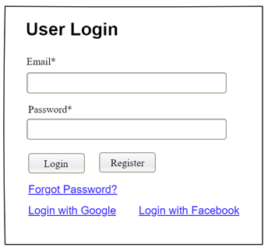

Field Name | Field Type | Description
Email* | Text Box | This is for user to input valid email address for logging in
Password* | Password Box | This is for user to input password for logging in
Login | Button | User clicks to authenticate him/herself into the system with provided email & password
Register | Button | User clicks to redirect to the User Register page for registering new user account to access the system
Forgot Password? | Hyperlink | User clicks to redirect to the Password Reset page for resetting his/her forgot password
Login with Google | Hyperlink | Allow user to login with his/her Google account
Login with Facebook | Hyperlink | Allow user to login with his/her Facebook account

Database Access
Table | CRUD | Description
User | R | Verify UserName & Password information
Setting, User | R | Specify the authorizations of the logged-in user

SQL Commands:
1/ Verify UserName & Password information
SELECT user_id, full_name, email, image_url, status
FROM user WHERE user_name = ? AND password = ?

2/ Specify the authorizations of the logged-in user
SELECT mapped_values FROM setting WHERE setting_id = ?
SELECT setting_name, mapped_values FROM setting WHERE setting_id IN (?)

b. Setting List

UI Design
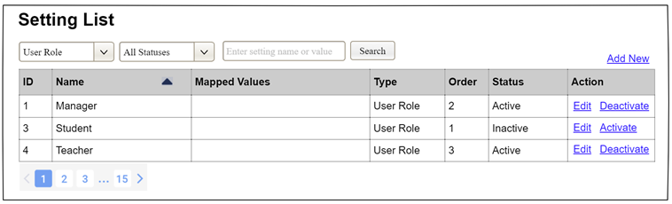

Field Name | Field Type | Description
Search Fields
Setting Type | Combo Box  Single-Choice | Filled with the list of current active setting types  Allow to filter the list by setting type;  Default value is “All Types”
Setting Status | Combo Box  Single-Choice | Values: All Statuses (default), Active, and Inactive  Allow to filter the list by status  Default value: “All Statuses”
Search Phase | Text Box  String (30) | Allow to search using the name or map values  Default value: blank
Search | Button | Click to refresh the list with the defined filter(s) and search phrase.
Add New | Hyperlink | Click to open the Setting Details page for adding new setting (master data)
Data Table
ID | Integer | Auto-increased identifier of the setting
Name | Text | Name of the setting
Mapped Values | Text | Supplementary information for the setting
Type | Text | Type of the setting
Order | Integer | Display order of the setting: the order of the setting type, displayed among the list of settings with the same type
Data Actions
Edit | icon | Click to open the Setting Details page for updating the relevant setting (master data)
Activate | icon | Shown when the data status is inactive. This is to activate the relevant setting (master data)
Deactivate | Ion | Shown when the data status is active. This is to deactivate the relevant setting (master data)

Database Access
Table | CRUD | Description
Setting | RU | Query the list of current settings from the database  Update status of a specific setting

SQL Commands:
1/ Query the list of current settings from the database
SELECT setting_id, setting_name, mapped_values, type_id, display_order, status
FROM setting WHERE (setting_type = ?) AND (status = ?) AND (setting_name LIKE ?)

2/ Update status of a specific setting
UPDATE setting SET status = ? WHERE setting_id = ?

c. Setting Details

UI Design
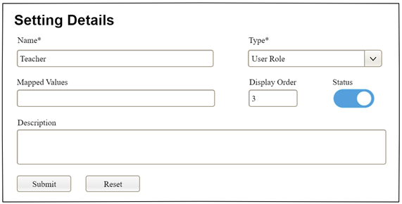

Field Name | Field Type | Description
Name* | Text Box  String (20) | Name of the setting
Type* | Combo Box  (Single Choice) | Type of the setting, filled with the list of setting types  Default value: the first type in the list
Mapped Values | Text Box  String (50) | Supplementary information for the setting (if any)
Order | Text Box  Integer (>=0) | Display order of the setting: the order of the setting type, displayed among the list of settings with the same type
Status | On/Off button | Status of the setting: Active or Inactive  Default value: Active
Description | Text Area  String (200) | Description of the setting
Submit | Button | Click to store new or updated setting details
Reset | Button | Click to reset the changes use has made on the screen fields back to the initial values when the screen is loaded

Database Access
…

2. Admin Screens Design

2.1 Voucher Management Screen
a. UI Design Specifications
Field Name | Field Type | Description
Voucher Code* | TextInput | Admin inputs alphanumeric uppercase code (regex: ^[A-Z0-9_-]{3,20}$), e.g. SUMMER26
Discount Type* | Pressable Pill | Toggles between 'Percentage (%)' and 'Fixed Amount (VNĐ)'
Discount Value* | TextInput | Input number. If type is percentage, value is validated to be <= 100
Min Booking | TextInput | Minimum transaction amount in VNĐ required to apply voucher (optional)
Expiry Date | TouchableOpacity / Custom Calendar | Tapping expands an inline custom monthly grid calendar. Past days are grayed out. Clicking a day sets the value to YYYY-MM-DD.
Max Usage | TextInput | Numeric limit for total voucher redemptions
Description | TextInput | Promotional text display for customers

b. Database Access
Table/Collection | CRUD | Description
vouchers | C, R, D | Read all active vouchers, insert new promo codes, and delete obsolete ones.

c. Query Commands (MongoDB Node.js Driver format)
// Query 1: Get all vouchers sorted by creation date
db.collection('vouchers').find({}).sort({ createdAt: -1 }).toArray();
// Query 2: Insert a new voucher
db.collection('vouchers').insertOne({
code: "NEWVOUCHER20",
discountType: "percentage",
discountValue: 20,
minBookingValue: 1500000,
expiryDate: "2026-12-31",
maxUsage: 100,
usedCount: 0,
isActive: true,
description: "New User discount code",
createdAt: new Date()
});
// Query 3: Delete voucher by ID
db.collection('vouchers').deleteOne({ _id: ObjectId("647a7f47c3fa1b0012345678") });

2.2 Dynamic Pricing Screen
a. UI Design Specifications
Field Name | Field Type | Description
Surge Cards | Non-editable Text | Dashboard summary displaying Surge Active, Peak Rate, Avg Multiplier
Surge List | FlatList / View | Renders individual vehicles. Each row contains car model, surge multiplier rate (e.g. x 1.25), reason, original price, and active surge price.

b. Database Access
Table/Collection | CRUD | Description
pricingsurges | R | Reads active price surge metadata and maps to car objects.
cars | R | Reads standard vehicle information.

c. Query Commands
// Query: Fetch all active pricing surges
db.collection('pricingsurges').find({ isActive: true }).toArray();
// Query: Fetch base pricing from cars
db.collection('cars').find({}, { projection: { brand: 1, model: 1, pricePerDay: 1 } }).toArray();

2.3 Car Availability Screen
a. UI Design Specifications
Field Name | Field Type | Description
Car Dropdown* | Select Picker | Opens list of cars. Triggers timeline search upon selection.
Status Indicators | Non-editable Text | Counter showing aggregate totals for: Booked, Available, Maintenance.
Availability Timeline | ScrollView | Chronological logs rendering booked dates and status colors.

b. Database Access
Table/Collection | CRUD | Description
cars | R | Populates the car selector list.
bookings | R | Reads all bookings matching the selected carId to build the schedule.

c. Query Commands
// Query 1: Get dropdown car list
db.collection('cars').find({}, { projection: { brand: 1, model: 1 } }).toArray();
// Query 2: Get schedule logs for selected car
db.collection('bookings').find({
car: ObjectId("CAR_ID_HERE"),
status: { $in: ["Pending", "Approved", "Completed"] }
}).sort({ startDate: 1 }).toArray();

2.4 Availability Calendar Screen
a. UI Design Specifications
Field Name | Field Type | Description
Calendar Month | View (Interactive Grid) | Displays standard grid layout. Pressing < or > triggers local calculations for days. Cells display status dots.
Detail Panel | ScrollView (Collapsible) | Displays list of rented car details for the tapped date.

b. Database Access
Table/Collection | CRUD | Description
bookings | R | Pulls booking schedule metadata for the selected month window.

c. Query Commands
// Query: Fetch bookings intersecting current month
db.collection('bookings').find({
status: { $in: ["Approved", "Completed"] },
$or: [
{ startDate: { $regex: "^2026-06" } },
{ endDate: { $regex: "^2026-06" } }
]
}).toArray();

IV. Appendix
1.
2.
3.

1. Assumptions & Dependencies
[Record any assumptions that were made when conceiving the project and writing this vision and scope document. Note any major dependencies the project must rely upon for success, such as specific technologies, third-party vendors, development partners, or other business relationships.]
<<Sample:
AS-1: Systems with appropriate user interfaces will be available for cafeteria employees to process the expected volume of meals ordered.
AS-2: Cafeteria staff and vehicles will be available to deliver all meals for specified delivery time slots within 15 minutes of the requested delivery time.
DE-1: If a restaurant has its own on-line ordering system, the Cafeteria Ordering System must be able to communicate with it bi-directionally.
>>

2. Limitations & Exclusions
[Identify any product features or characteristics that a stakeholder might anticipate, but which are not planned to be included in the new product]

3. Business Rules
[Provide common business rules that you must follow. The information can be provided in the table format as the sample below]
<<Sample
ID | Category | Rule Definition
BR-01 | Constraints | Delivery time windows are 15 minutes, beginning on each quarter hour.
BR-02 | Constraints | Deliveries must be completed between 10:00 A.M. and 2:00 P.M. local time, inclusive.
BR-03 | Facts | All meals in a single order must be delivered to the same location.
BR-04 | Facts | All meals in a single order must be paid for by using the same payment method.
BR-11 | Constraints | If an order is to be delivered, the patron must pay by payroll deduction.
BR-12 | Computations | Order price is calculated as the sum of each food item price times the quantity of that food item ordered, plus applicable sales tax, plus a delivery charge if a meal is delivered outside the free delivery zone.
>>

4. ..

