ER 图：
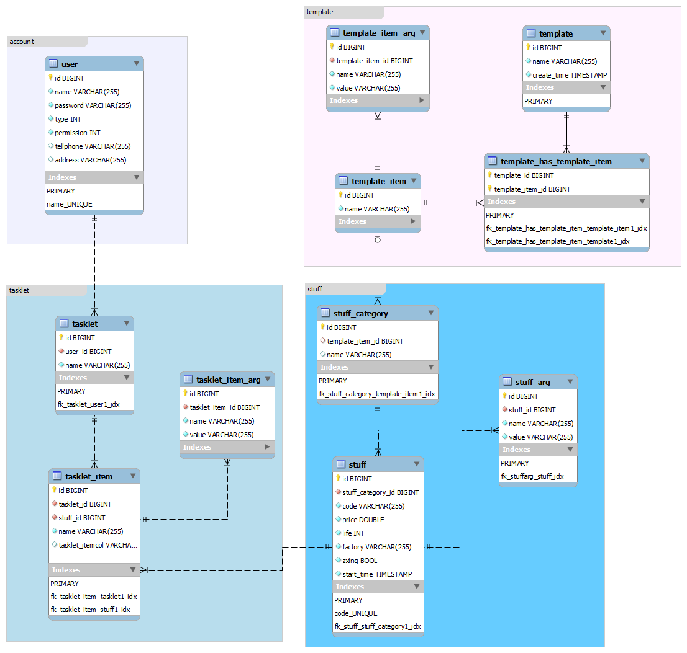

数据字典
User表 |  | This is user table, it contains two type user,one is tour operator,the other is administrator.Every column in this table, except for "tellphone" and "address",is not null!
id | Integer | id of user
name | varchar(255) | name of user
password | varchar(255) | password of user,i think it should encrypted by RSA or other encryption algorithm before stored.
type | Integer | type of user,0 stands for tour operator and 1 stands for administrator
permission | Integer | permission of user,This is the integer that every bit has a meaning.Default 0 represents no permissions.
tellphone | varchar(255) | tellphone of user.
address | varchar(255) | address of user.

tasklet表 |  | tasklet table,every tasklet contains some item (tasklet_item).
id | Integer | id of tasklet
user_id | Integer | id of the user who carry out this tasklet.
name | varchar(255) | name of tasklet

tasklet_item表 |  | item of tasklet,A item is used to check a specific stuff and contains a lot of item arg that every arg is a name-value pair.
id | Integer | id of item
tasklet_id | Integer | id of tasklet which this item belong to.
stuff_id | Integer | id of stuff which this item check for.
name | varchar(255) | name of this tasklet item

task_item_arg表 |  | A arg contain a name-value pair.
id | Integer | id of tasklet_item_arg
tasklet_item_id | Integer | id of tasklet_item which this arg belongs to
name | varchar(255) | name of tasklet_item_arg
value | varchar(255)

stuff表 |  | A concrete things that should be check.
id | Integer | id of stuff
stuff_category_id | Integer | id of stuff category which this stuff belong to.
code | varchar(255) | unique readable code of stuff
price | double | price of stuff
life | Integer | service life of stuff.
factory | varchar(255)
zxing | varchar(255) | path of stuff's two-dimension code,empty string if there isn't two-dimension code exist.
start_time | timestamp | time of stuff start to be used.

stuff_arg表 |  | this arg is close to tasklet_item_arg.
id | Integer | id of stuff_arg
stuff_id | Integer | stuff's id
name | varchar(255)
value | varchar(255)

stuff_category表 |  | category of stuff.
id | Integer | id of this stuff category
template_item_id | Integer | id of template_item which can be used when create a tasklet item for specific.
name | varchar(255) | name of stuff categoy

template表 |  | tasklet's template
id | Integer | id of template
name | varchar(255) | name of template
create_time | timestamp | create time of template

template_has_template_item表 |  | template and template_item is n to m relation.
template_id | Integer
template_item_id | Integer

template_item表 |  | template item,every item contains a lot of arg and each item is template of a specific stuff category.
id | Integer | id of template_item
name | varchar(255) | name of template_item

template_item_arg表 |  | this arg is close to tasklet_item_arg,each arg also contains a name-value pair
id | Integer | id of this arg
template_item_id | Integer | id of template_item which this arg belong to
name | varchar(255)
value | varchar(255)

