一、系统功能（小组讨论最终版）

1.系统管理员：
1.登录
2.管理巡视作业员--添加，删除，修改，浏览
3.管理系统管理员信息--添加，删除，修改，浏览
4.管理巡视的物品--导出物品的二维码，编辑具体巡视物品的信息（添加，删除，浏览，修改信息，），
5.管理巡视任务的模版--编辑 ，每个物品的具体任务模版，
6.管理巡视的任务--编辑任务，下发任务，浏览回传的任务，每个物品具体小任务的管理，任务周期管理
7.缺陷管理
2.巡视人员：
1.登录
2.管理巡视任务--领取任务（在线，离线），回传任务，浏览任务，
3.管理具体一个巡视任务--做任务，填写缺陷
4.获取设备信息
5.管理自己的信息
注：首先制定模板确定任务，利用任务项的顺序表示巡视线路，所以没有单独给出巡视线路图。

二. ER 图

分为4个模块：账户、模板、任务管理、物品信息
其中 账户部分有user表；模板部分有template、template_has_template_items、template_item和template_item_arg表；
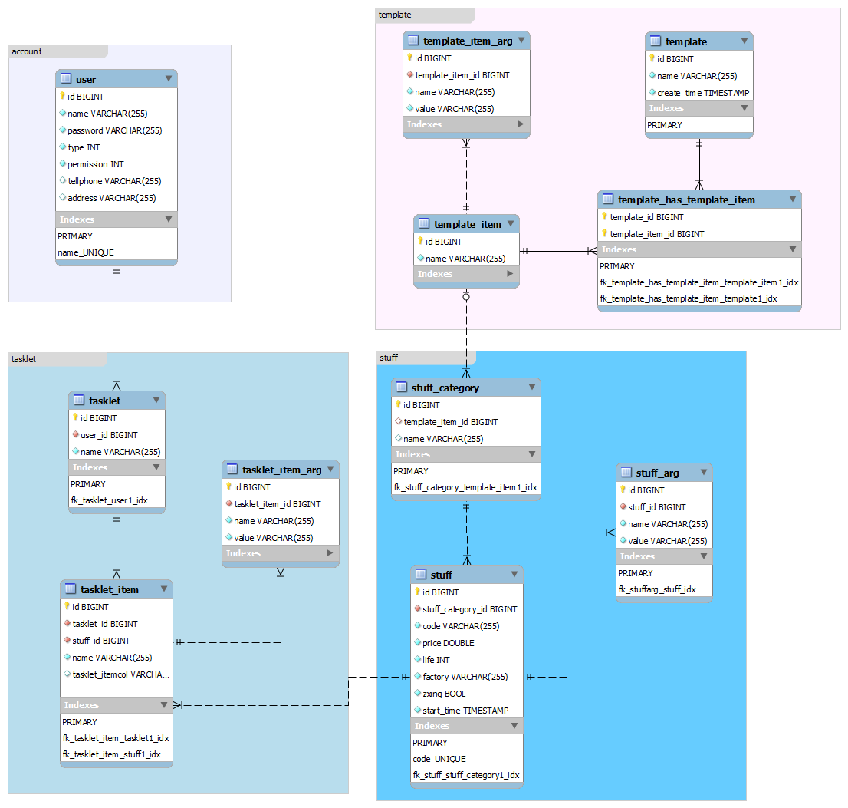

三、数据字典

User table |  | This is a user table. It contains two types of users. One kind is the patrol operator,the other is the administrator. Every column in this table is not null, except for "telephone" and "address".
id | Integer | id of user
name | varchar(255) | name of user
password | varchar(255) | password of user, it should be encrypted by certain encryption algorithm before stored.
type | Integer | type of user, 0 stands for patrol operator and 1 stands for administrator
permission | Integer | permission of user, every bit has a meaning. Default 0 represents no permission.
telephone | varchar(255) | telephone of user.
address | varchar(255) | address of user.

Tasklet table |  | tasklet table,every tasklet contains some item (tasklet_item).
id | Integer | id of tasklet
user_id | Integer | id of the user who carry out this tasklet.
name | varchar(255) | name of tasklet

tasklet_item table |  | item of tasklet, an item is used to check a specific stuff and contains a lot of item args that are name-value pairs.
id | Integer | id of item
tasklet_id | Integer | id of tasklet which this item belongs to.
stuff_id | Integer | id of stuff which this item check.
name | varchar(255) | name of tasklet item

task_item_arg table |  | arg contains a name-value pair.
id | Integer | id of tasklet_item_arg
tasklet_item_id | Integer | id of tasklet_item which this arg belongs to
name | varchar(255) | name of tasklet_item_arg
value | varchar(255)

Stuff table |  | A concrete things that should be checked.
id | Integer | id of stuff
stuff_category_id | Integer | id of category which this stuff belongs to.
code | varchar(255) | unique readable code of stuff
price | double | price of stuff
life | Integer | service life of stuff.
factory | varchar(255)
zxing | varchar(255) | path of stuff's two-dimension code,empty string if there isn't two-dimension code exist.
start_time | timestamp | time of stuff start to be used.

stuff_arg table |  | this arg is close to tasklet_item_arg.
id | Integer | id of stuff_arg
stuff_id | Integer | stuff's id
name | varchar(255)
value | varchar(255)

stuff_category table |  | category of stuff.
id | Integer | id of this stuff category
template_item_id | Integer | id of template_item which can be used when create a tasklet item for specific.
name | varchar(255) | name of stuff categoy

Template table |  | tasklet's template
id | Integer | id of template
name | varchar(255) | name of template
create_time | timestamp | create time of template

template_has_template_item table |  | template and template_item is n to m relation.
template_id | Integer
template_item_id | Integer

template_item表 |  | template item,every item contains a lot of arg and each item is template of a specific stuff category.
id | Integer | id of template_item
name | varchar(255) | name of template_item

template_item_arg表 |  | this arg is close to tasklet_item_arg,each arg also contains a name-value pair
id | Integer | id of this arg
template_item_id | Integer | id of template_item which this arg belong to
name | varchar(255)
value | varchar(255)

