Wallet of Satoshi

Screenshots:

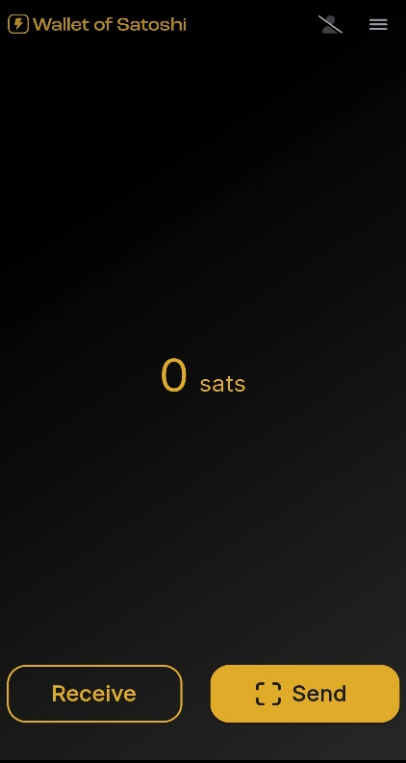 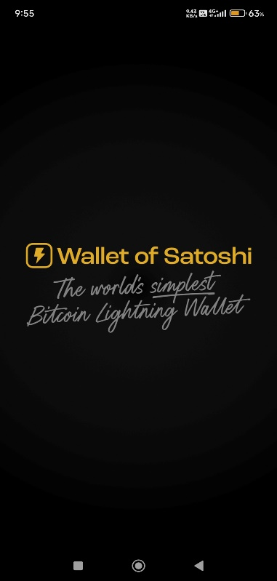 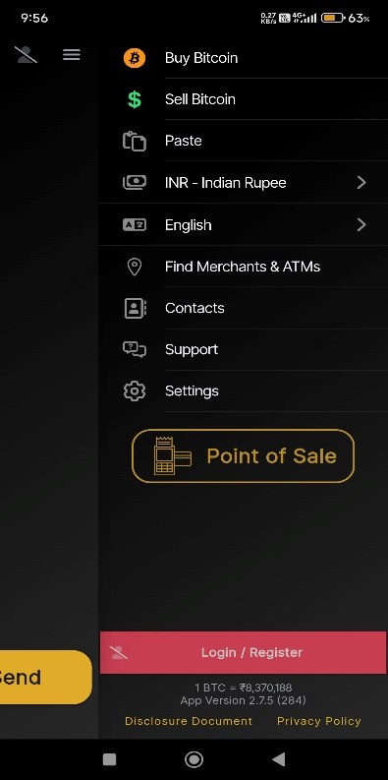

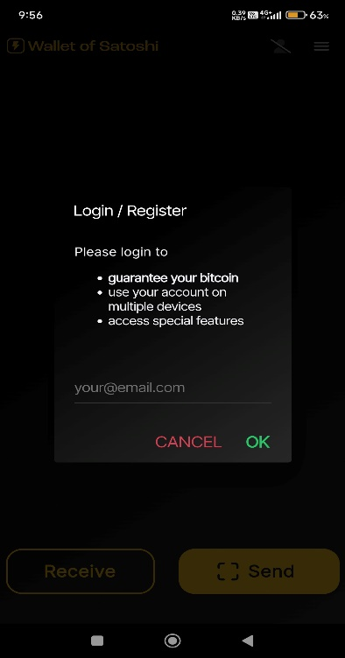 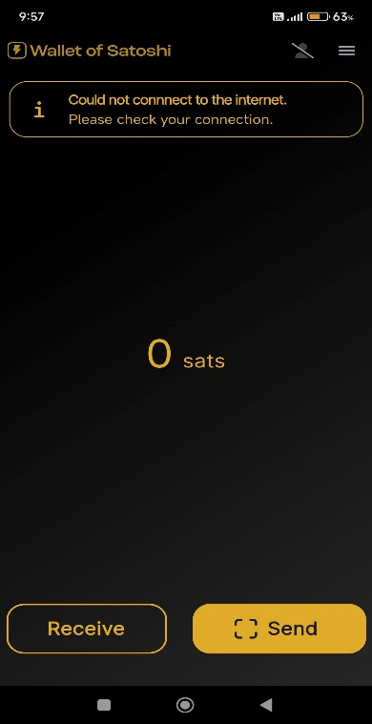 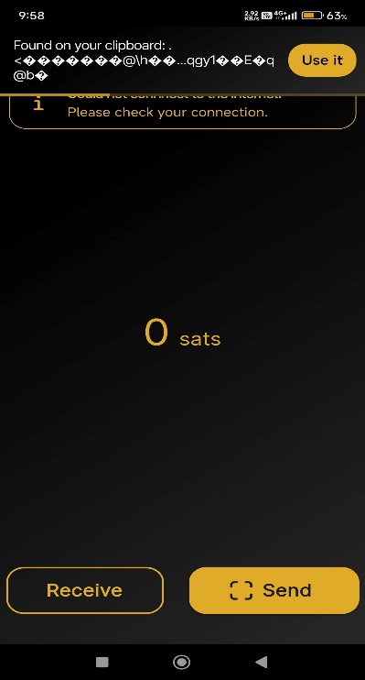

Onboarding & UX Flow

1. What is the first screen a new user sees?

= New users are greeted with a simple interface that includes a disclosure document outlining the wallet's functionality and limitations. This initial screen sets a straightforward tone, allowing users to click "Start" to proceed into the wallet.

1. How does the wallet introduce itself? (Branding, messaging, first impression)

= The onboarding process is designed to be user-friendly, but some users may find the need to register with an email for backup confusing, especially if they are unfamiliar with custodial wallets. However, the app minimizes friction by allowing immediate use without prior setup.

1. Are there any confusing steps or friction points?

= The onboarding process does not assume prior Bitcoin knowledge, making it accessible for beginners. The wallet's simplicity caters to new users who may not be familiar with cryptocurrency concepts.

1. Does the onboarding process assume prior Bitcoin knowledge?

= The UI is very simplistic, does not need any prior bitcoin knowledge, but its good to have knowledge on bitcoin.

Security & Backup

1. How does the wallet handle seed phrases, backups, or security steps?

= “ Wallet of Satoshi” does not require users to manage seed phrases since it is a custodial wallet. Users are encouraged to register with an email for backup purposes, which allows them to recover their account if they lose access to the app.

1. Are security concepts explained clearly, or just enforced?

= Security concepts are primarily enforced through registration and backup prompts rather than being explicitly explained. Users are informed about the importance of registration for fund recovery but may not receive in-depth security education.

1. How does it balance security and ease of use?

= The wallet simplifies security by eliminating the need for seed phrases, making it easy for users to start using it immediately while still providing a mechanism for account recovery through email registration.

Bitcoin Education & Concept Explanation

1. Does the wallet explain self-custody? If so, how?

= The wallet does not emphasize self-custody, as it is a custodial service where users do not hold their private keys. This may lead to a lack of understanding regarding self-custody among new users.

1. How does it introduce fees, transactions, and Bitcoin vs. Lightning?

= The app provides basic information about transactions and fees but does not offer extensive educational content on Bitcoin versus Lightning transactions within the onboarding process.

1. Are there tooltips, help sections, or embedded education materials?

= While there may be some tooltips and basic help sections, comprehensive educational materials on Bitcoin concepts are limited within the app itself, focusing more on usability than education

Key takeaways and recommendation

Takeaways:

1. User-Friendly Design: The Wallet of Satoshi is designed for beginners, featuring a clean and intuitive interface that simplifies the process of sending and receiving Bitcoin.

2. Custodial Model: As a custodial wallet, it does not provide users with private keys or seed phrases, which can limit user control over their funds.

3. Lightning Network Support: The app integrates seamlessly with the Lightning Network, allowing for quick transactions with low fees.

4. Language and Currency Support: It supports 27 languages and displays balances in over 170 fiat currencies, enhancing accessibility for a global audience.

Recommendations for Improvement:

1. Implement Non-Custodial Options: Consider offering a non-custodial wallet option that allows users to manage their own private keys, catering to users who prioritize self-custody.

2. Educational Resources on Security: Provide clear, accessible information about security best practices, including the importance of private keys and seed phrases.

2. Introduce interactive tutorials or walkthroughs during onboarding to help users understand key concepts like Bitcoin transactions and the Lightning Network.

3. Webinars or Video Guides: Offer webinars or video tutorials that explain how to use the wallet effectively and understand Bitcoin fundamentals.

4. Adding a section for FAQs would be great for a better user experience.

Source file: 

BlueWallet

* User flows of the onboarding process



* Annotated screenshots

 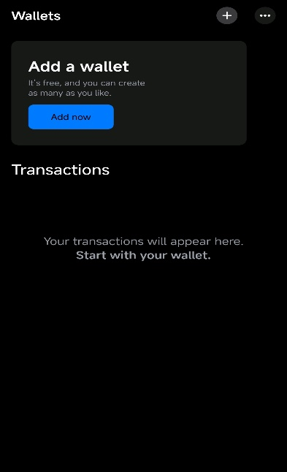

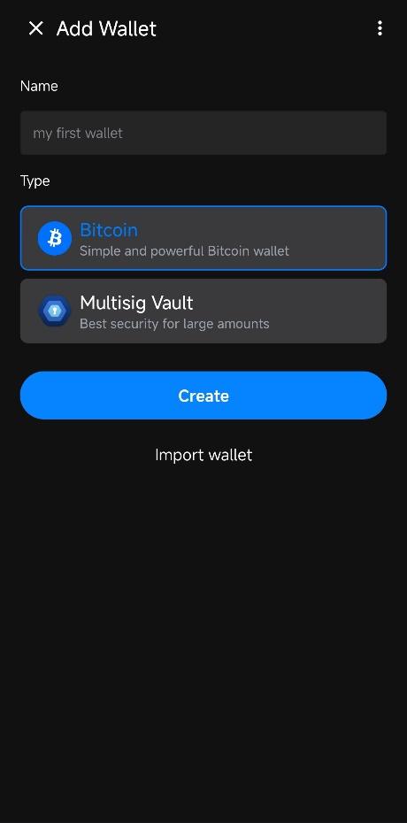 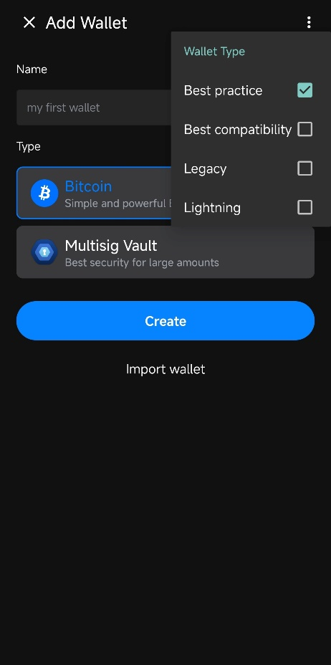

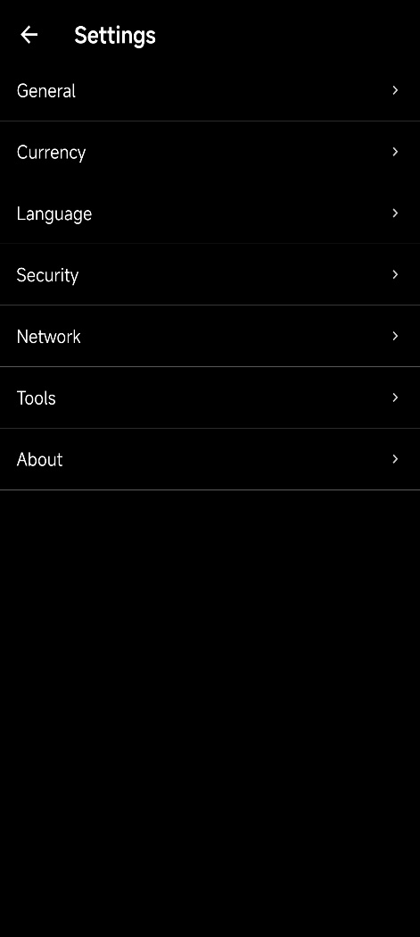 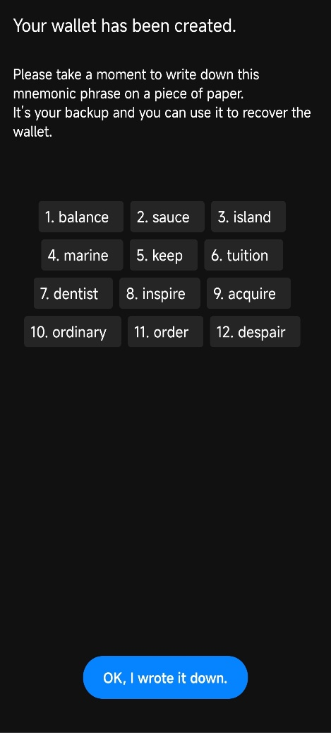

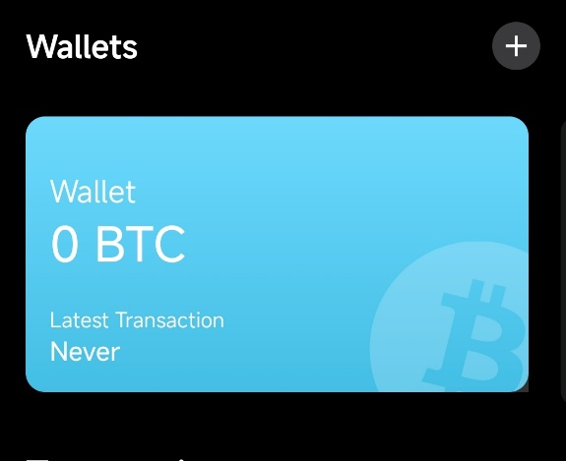 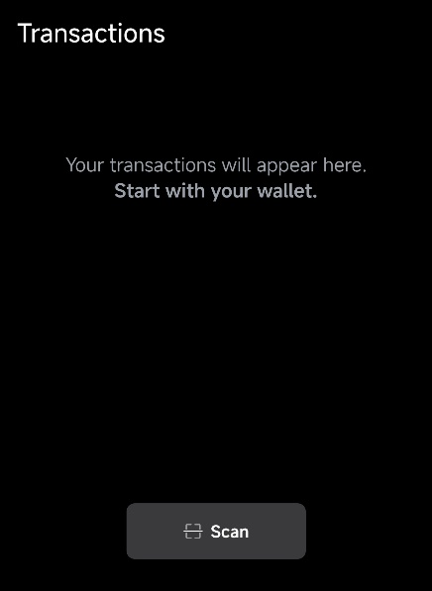

UX analysis:

Onboarding & UX Flow

1. What is the first screen a new user sees?

= New users see a neutral, minimal interface with no introductory tutorial or branding messaging. The UI relies on intuitive design rather than guided instructions, which may leave beginners uncertain about next steps.

1. How does the wallet introduce itself? (Branding, messaging, first impression)

= No seed phrase verification during wallet creation, increasing the risk of backup errors. Advanced features (e.g., address type selection) are hidden in settings and require enabling "Advanced Mode," disrupting the setup flow.

1. Are there any confusing steps or friction points?

= The onboarding process presumes familiarity with concepts like seed phrases and self-custody, offering no explanations for risks like improper backup practices.

1. Does the onboarding process assume prior Bitcoin knowledge?

= As there are no on screen guides or instruction first time user may find it overwhelming, so if someone posses some prior bitcoin knowledge then it will be helpful for them.

Security & Backup

1. How does the wallet handle seed phrases, backups, or security steps?

=Seed phrases are generated without in-app guidance but include warnings against screenshotting and reminders to back up before receiving funds.

- Recovery requires both a seed phrase *and* a user-defined passphrase, enhancing security but complicating recovery if either is lost.

1. Are security concepts explained clearly, or just enforced?

= Security steps (e.g., encryption, biometric locks) are enforced (e.g., blocking screenshots of seeds) but lack clear educational context, leaving users unaware of **why** these measures matter.

1. How does it balance security and ease of use?

= Prioritizes Security: Multi-signature vaults, plausible deniability (decoy wallets), and hardware wallet compatibility.

Usability Trade-offs: Complex recovery requirements (seed + passphrase) and limited guidance may overwhelm novices.

Bitcoin Education & Concept Explanation

1. Does the wallet explain self-custody? If so, how?

= Implied through non-custodial design but not explicitly explained during setup. The app emphasizes self-sovereignty in documentation but assumes users already understand its importance.

1. How does it introduce fees, transactions, and Bitcoin vs. Lightning?

= Lightning Fees: Historically lacked transparency, with hidden fees (0.3–1%) discovered by users through manual calculations.

= Bitcoin vs. Lightning: No in-app distinction between on-chain and Lightning transactions, leaving users unaware of cost/use-case differences.

1. Are there tooltips, help sections, or embedded education materials?

= No embedded tooltips, help sections, or tutorials. Critical concepts (e.g., seed phrase importance) are mentioned only as warnings, not explained.

Key Takeaways

- Robust security features (encryption) and hardware compatibility cater to advanced users

- Minimal onboarding education, hidden fees, and fragmented advanced settings create barriers for beginners.

-Recommendations

- Add guided tutorials, fee transparency, and in-app explanations of core Bitcoin concepts to improve accessibility.

Blink

Diagram :



Screenshots:

 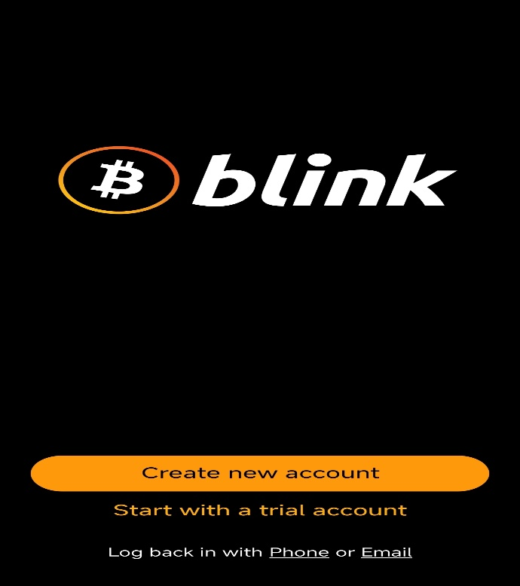

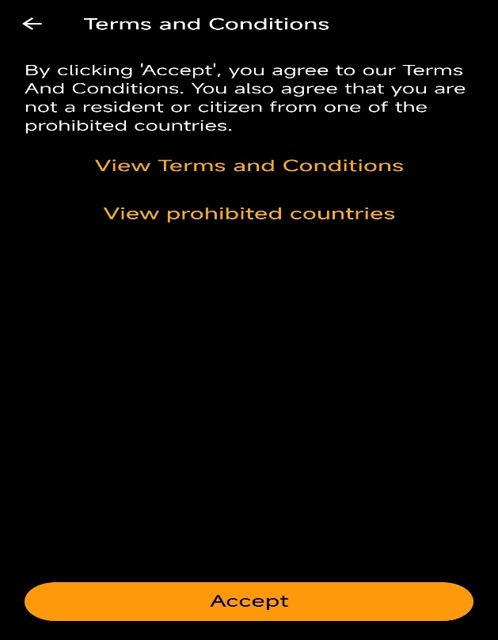 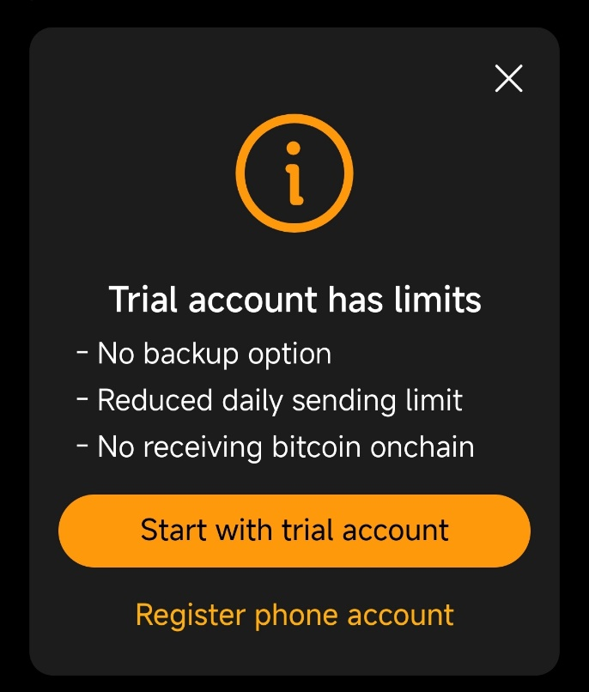

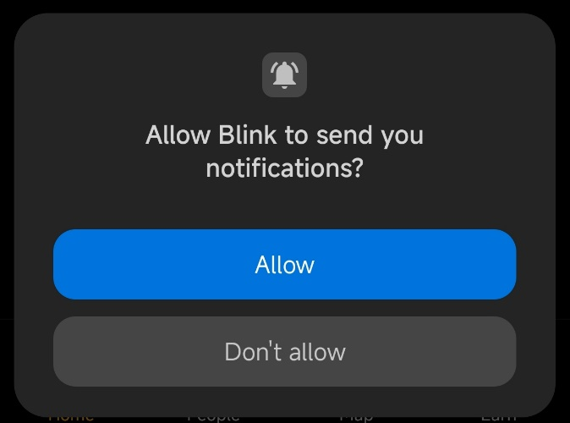 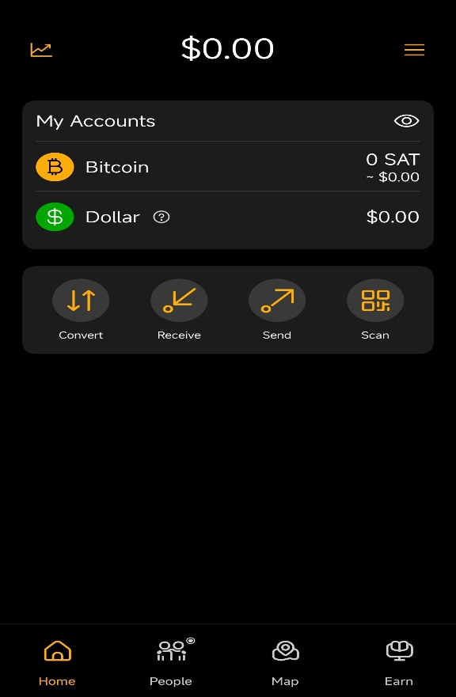

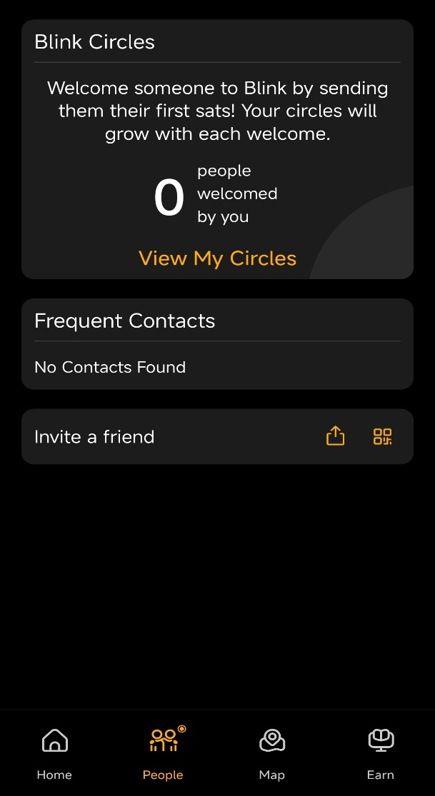 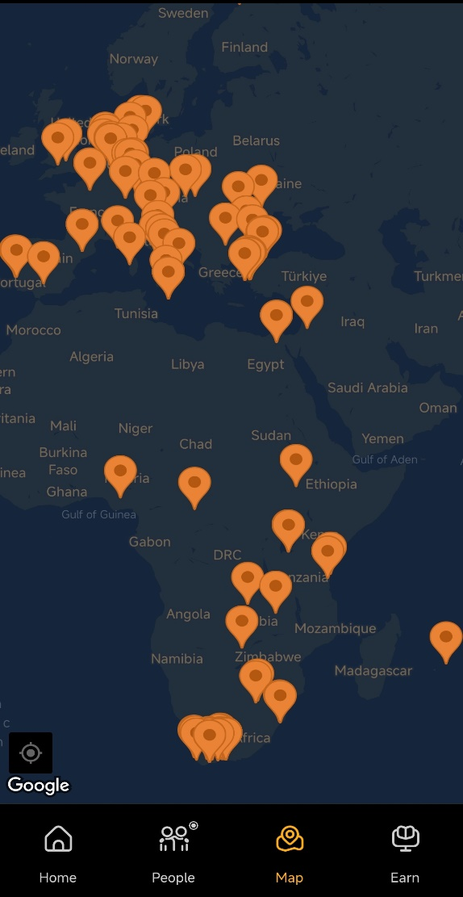

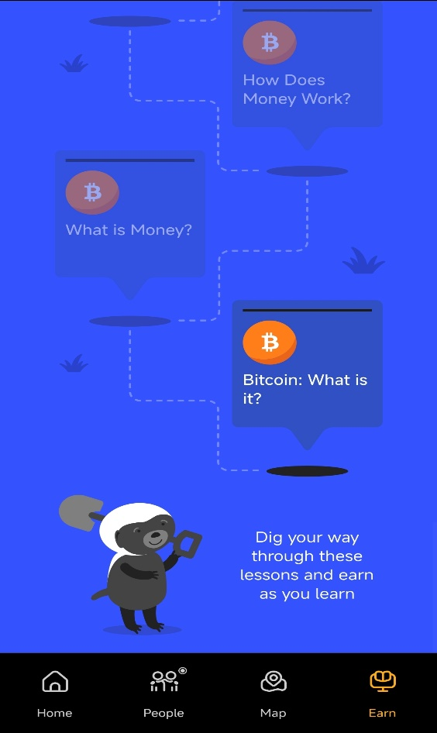 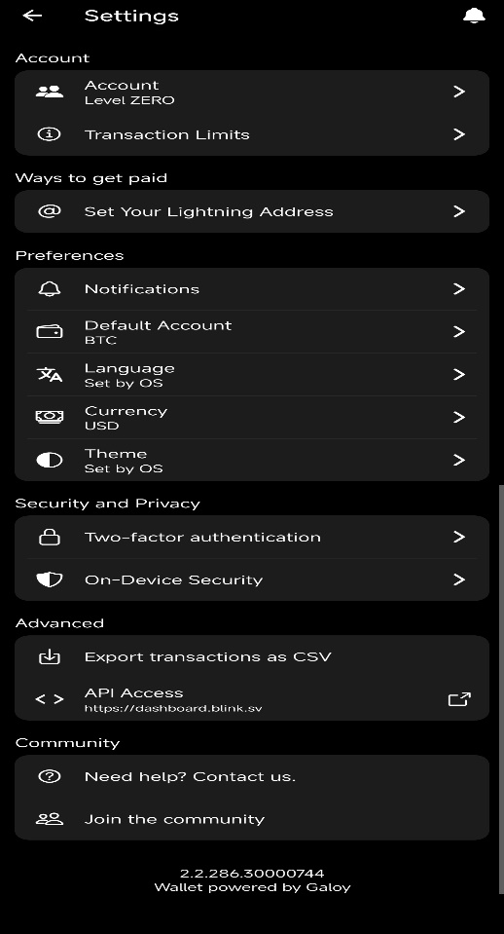

UX analysis:

Onboarding & UX Flow

1. What is the first screen a new user sees?

- The first screen a new user sees is a simple and intuitive setup interface. Users can either create a new account by registering with their phone number or start with a trial account. Blink introduces itself as "The Everyday Bitcoin Wallet," emphasizing ease of use and accessibility for everyday payments.

2. Are there any confusing steps or friction points?

= Some users have reported difficulty downloading the app in countries where it is unavailable, such as the U.S. This can be resolved by changing app store locations or downloading the APK from GitHub. Additionally, while the registration process is straightforward, being a custodial wallet might confuse users accustomed to non-custodial wallets.

3. Does the onboarding process assume prior Bitcoin knowledge?

- The onboarding process does not assume prior Bitcoin knowledge. It is designed to be beginner-friendly, offering features like trial accounts and simple registration via phone numbers, making it accessible even to those new to Bitcoin.

Security & Backup

4. How does the wallet handle seed phrases, backups, or security steps?

- Blink does not use traditional seed phrases for account recovery. Instead, it relies on phone numbers and One-Time Passwords (OTPs) sent via SMS or WhatsApp for account access. Users can also add an email address for additional security layers. This approach simplifies recovery and minimizes user error.

5. Are security concepts explained clearly, or just enforced?

- Security concepts are enforced rather than deeply explained within the app. For example, while users are informed about custodial risks (e.g., "not your keys, not your coins"), there is limited in-app guidance on deeper security practices like self-custody.

6. How does it balance security and ease of use?

- Blink prioritizes ease of use with features like OTP-based logins and email backups while maintaining adequate security measures such as SIM swap protection and two-factor authentication options. However, as a custodial wallet, it sacrifices some security autonomy in favor of user convenience.

Bitcoin Education & Concept Explanation

7. Does the wallet explain self-custody? If so, how?

- Blink openly acknowledges that it is a custodial wallet and does not offer self-custody options. It educates users about the benefits of self-custody through blog posts and external resources but positions itself as a tool for day-to-day spending rather than long-term storage or savings[4][6].

8. How does it introduce fees, transactions, and Bitcoin vs. Lightning?

- Blink introduces users to Bitcoin concepts through its practical features:

- Lightning transactions are highlighted for their speed and low fees (as low as 0.002% routing fees).

- On-chain transactions incur regular miner fees, with Blink offering fee optimization through techniques like Child-Pays-for-Parent (CPFP) to ensure confirmations during high network congestion.

- The "Stablesats" feature allows users to convert Bitcoin into a USD-equivalent balance to mitigate volatility risks.

9. Are there tooltips, help sections, or embedded education materials?

- The app includes educational features such as in-app Bitcoin learning modules and resources for earning satoshis while learning about Bitcoin. Additional materials are available through Blink's website and blog posts.

Key Takeaways and Recommendations

Takeaways

- Beginner-friendly onboarding process that eliminates the complexity of seed phrases.

- Low fees for Lightning transactions and internal transfers between Blink users.

- Educational resources that help users understand Bitcoin basics.

- Unique features like "Stablesats" for USD stability.

Recommendation:

1. Provide more in-app educational content explaining custodial risks and self-custody benefits directly during onboarding.

2. Improve accessibility in restricted regions by offering clearer guidance on alternative download methods.

3. Enhance transparency around custodial security measures with cryptographic proof-of-reserves as planned.

4. Offer optional non-custodial wallet features for advanced users seeking full control over their funds.