



# Table of Contents

# 1.0 Iteration

**1.1 Iteration Goals**

WHAT: Design a travel software that can be designed and completed to meet different needs of different people, so that travelers can remember the purpose of each trip.

WHO: All the people who want to travel.

* First, determine the characteristics of different travel groups. Secondly, it is determined that 18-30 years old young people are the mainstream group. Then, through the analysis of the characteristics of the mainstream group, the software function design is carried out.

WHY: Better travel experience and complete travel memory.

* First of all, there is a certain degree of blindness in the current travel. People are leaving without a careful strategy, which makes travel experience greatly reduced. Second, travel is timeliness, and many of the things in the journey may be forgotten at the end of the trip, but perhaps the forgotten things may be good memories. Then, people's quality of life continues to improve, and the prices of all kinds of transportation are also declining. People are in urgent need of higher quality travel experience. So, our ideas came into being.

WHERE: Everywhere, including places where there is no network or signal.

* People often want to view their own attacks and cached maps anywhere, but so far, many software needs to connect with their orders, information, etc., and do not support the caching function, but our software will avoid the emergence and occurrence of this problem to the maximum extent.

WHEN: Whenever they want to use it, they can get a good experience and service.

HOW:

* Determining the target group.
* Understanding the needs of the target group.
* Collecting and collating the main needs of the user.
* Identifying what we can do to meet the needs of users.
* Designing the functional modules of APP.
* The drawing of module function diagram after determination.
* Software development.
* Constantly analyzing problems and solving problems at design stage.
* Testing after software development is completed.
* Looking for people to experience software experience, ask for feelings and opinions, and improve them.

**1.2 Team Roles**

Table 1.2 Team Roles allocation and description

|  |  |  |
| --- | --- | --- |
| **Role** | **Allocation** | **Description** |
| Manager | Connor Cashman | Chiefly responsible for the project schedule and project plan and how progress compares to the plan. |
| System Architect | Edward Southall | Understands the overall structure of the software system. Must ensure a modular system and keeps an eye on the bigger picture. |
| Requirements Analyst | Hannah Jury | Understanding and communication the system requirements (which define the functional behaviour and qualities). Identifies the stakeholders, eliciting requirements, establishing priorities and documenting progress. |
| Quality Control | Danny | Ensures that quality goals are being met. Produces a good iteration and test plan and ensures it is executed at a high standard. Must establish standard practices and expectations. |
| Technical Documentation | Samuel Eadie | Documentation written for developers and maintainers of a system. Includes formal requirements, design documents, README files and comments in code. Also coordinates work of several people to ensure it is consistent. |
| User Documentation | Cindy | Creates documentation for the users of the software system (end users and administration). Documentation may include user manuals, online help, web based documents and FAQs and information. |
| User Interface | Adrian | Usability expert who takes usability into consideration. Responsible for ensuring that usability decisions are not overlooked. |
| Programmer | Connor Cashman | The programmer is responsible for turning the need for system capabilities into something a computer with actually run. Responsible for realising, as closely as possible, the requirements and designs developed by the team. This helps ensure that what the programmer produces is what the stakeholders actually want. |
| Configuration Control | Edward Southall | As with other roles, part of the build-master's job is to establish practices for others, and part is to administer the version and configuration system. |

**1.3 Task Management**

Documentation

* Iteration 1
* Project Inception/ planning phase
* Software design specification
* Software requirements specification
* SRS review summary
* Team
* User manual

User Interface

* Login/ sign up screen
* Icons
  + Plan
  + info
  + My diary
  + Discover
  + Chat
* My profile screen
* My diary screen
* info screen
* Discover screen
* chat screen
  + Calls
  + Status update
  + Message

Programming

* Basic In
* Links to issues and boards
* Total estimation
* Screen shots

**1.4 Documentation**

* Relevant docs/ diagrams

**1.5 Meeting Summaries**

|  |  |  |
| --- | --- | --- |
| **Date** | **Description** | **Evidence** |
| 26/06/18 | Team member description and ice breaking |  |
| 26/06/18 | Team formulation and name creation (Wolf pack: stay hungry) |  |
| 27/06/18 | Industry Selection (tourism) and breakdown |  |
| 29/06/18 | Idea selection using the 6 thinking hats strategy (The lucky ones, high quality photo app, travel diary). |  |
| 29/06/18 | Travel Diary idea selection and expansion. |  |
| 02/07/18 | Summary and breakdown of the idea of innovation (who, what, when, where, why, how) |  |
| 02/07/18 | Steps for doing, thinking and acting in relation to the travel diary. User stories breakdown (name, title, age, role, skills, education, motivation, environment, scenarios, concerns, pain points, tasks) |  |
| 04/07/18 | Breakdown of team member skills for role allocation |  |

1.6 Retrospective

1.7 Process methods and tools

1.8 Next iteration planning

# 2.0 Project Inception and Planning Phase

**2.1 Process**

* Stand up meetings
* SCRUM
* Trello

**2.2 Initial Feature List**

In order to best demonstrate the features of our product to investors as quickly as possible, we have developed a set of basic features to achieve within a week. This list of features includes but is not necessarily limited to:

* + Login and sign up page
  + Manual text and photo input to create diary
  + Location tracking
  + About me section and profile
  + Basic info
  + Fundamental planning capacity
  + Chat demonstration
  + Demonstration of Discover Feed
  + A server to demonstrate proof of concept for user profile storage

**2.3 Initial Planning**

Table 2.3 SWOT Analysis

|  |  |  |
| --- | --- | --- |
|  | **STRENGTHS**  1. Unique functions  2. Innovativeness  3. Convenient  4. Our team has a clear division of labor and everyone has their own areas of expertise. | **WEAKNESSES**  1. Some complex functions can not be achieved in the short term.  2. Little experience in team management.  3. Without fame, it needs a lot of publicity. |
| **OPPORTUNITIES**  1. The economy is prosperous and the market is wide.  2. At present, some functions are not involved in the travel software industry, and are attractive to potential customers.  3. People's quality of life is improving, and high quality travel service is needed urgently to meet their needs.  4. National support for Tourism. | **OPPORTUNITY-STRENGTH STRATEGIES**  1. Increase publicity.  2. Conducting questionnaires to meet the needs of more people.  3. Pursue higher quality.  4. Make clear the division of labor and improve the efficiency.  5. Pay attention to the national support policy. | **OPPORTUNITY-WEAKNESSES STRATEGIES**  1. When implementing the functions of each module, ask other team members' opinions to improve efficiency and quality.  2. Develop team system to improve team work efficiency and quality.  3. Improve publicity. |
| **THREATS**  1. At present, there are a large number of travel APP on the market, and the market competition is fierce.  2. Some people may have this innovative idea and finish it earlier than we did. | **THREAT-STRENGTH STRATEGIES**  1. We should enhance publicity efforts and focus on publicizing unique functions and advantages.  2. In the early stage, we conducted questionnaires and entered the market in advance. | **THREAT- WEAKNESSES STRATEGIES**  1. Improving the efficiency of software production.  2. Always pay attention to the market situation and maintain the sense of industry. |

**2.4 Risk Management**

**2.4.1 External Risks**

Table 2.4.1 External Risks and Description

|  |  |
| --- | --- |
| **Risk** | **Description** |
| Economic risk | When the economy is depressed, fewer people will go out to travel, and fewer people will use travel software. When the economy is developed, people who travel will increase, and people who use travel software will increase correspondingly. |
| **Competitors** | Although there is no software like us at present, there has been a lot of competitive pressure in the tourism industry. Now many of the functions of the travel software are already very mature, such as the software such as Ctrip, The Same Journey, The Way Cattle and so on. |

**2.4.2 Internal Risks**

Table 2.4.2 Internal Risks and Description

|  |  |
| --- | --- |
| **Risk** | **Description** |
| Technology | There are some difficulties in the implementation of some of the functions. |
| Operational and strategic risks | * Lack of team management experience. * There is no guarantee that customers will like us services enough to use them. * Entrepreneurs frequently borrow money to finance their venture in its earliest stages; there is a chance that they will not make sufficient profits to be able to pay these loans back. * As a business expands, the founders will invariably have to delegate responsibility for certain tasks to employees whom they do not know well. The employees bring uncertainty and risk related to their skills and performance. * We also have to face risks that are external to the day-to-day operations of their companies. These risks include natural disasters (earthquakes, tsunamis, volcanos), freak accidents (plane crashes, car accidents) and long-term environmental changes (global warming, freshwater depletion, etc). |
| Legal Risk: | **Compliance:** Businesses that get on the wrong side of government regulations can face fines and even prosecution. To avoid this problem, companies should ensure that they comply with all the regulations that affect their business, including business licenses, employment laws, corporate governance, and tax compliance. Depending on your chosen industry and jurisdiction, compulsory insurance might be required for certain aspects of your business.  **Errors and Omissions:** Businesses run the risk of loss and legal liabilities resulting from inadequate or failed internal processes, fraud, human error in processing transactions, etc. These risks can be minimized by establishing standardized operating procedures and adding control steps at appropriate points in the process workflow. Furthermore, businesses should obtain a professional liability insurance that protects companies and individuals against claims made by clients for inadequate work or negligent actions.  **Intellectual Property:** To discourage competitors from stealing your innovation, consider investing in copyrights, trademarks and patents. Very small businesses should assess whether the costs of potential litigation (including opportunity costs) justify the expense of IP protection.  **Work Safety:** To protect your employees and avoid falling foul of Health and Safety legislation, entrepreneurs should formulate contingency plans for emergencies such as fires and explosions. |
| Financial Risk | * Customers can refuse to pay your invoices (credit risk). * The cost of your raw materials or suppliers could rise suddenly. * Customers may switch to a competing product and not buy your product or service any more. * A strengthening local currency can reduce the net profits from your foreign customers, or a weak currency can increase the cost of running your foreign operations (exchange rate risk). * A spike in interest rates could raise the cost of your working capital (interest rate risk). * A plunge in the value of stocks or real estate you pledged as collateral could cause your bank to cut your credit lines (asset price risk). * A slowing economy could reduce the demand for your firm’s product or service. |

**2.5 Development**

**2.5.1 Tools**

In order to produce a product of the highest quality, we will be exploiting multiple sets of tools. These can be categorised into organisational tools and technical tools:

*Organisational tools*

* Mind Mapping - we have used and will continue to use a variety of different mind mapping techniques for planning our work
* Trello - we are using the free online organisational software Trello to assign tasks to be completed by each member each day. This way we can ensure that people are not working on the same tasks, and we can hold each other accountable for the quality and quantity of work that we produce.
* Github - in order to facilitate the sharing of both technical and non-technical files between team members, we have created a Github account to store our work in.

*Technical Tools*

* Android Studio - Used to write some android code that we can later combine with react native to program the mobile device.
* Android Phone Emulator - Used to make it easier for the developing team to test their code without needing to flash the mobile device to frequently test the code.
* React native - the primary programming language used to write the app’s code
* Moss - an external server provided by UQ including additional IP addresses used to write and test the server-client code.

**2.5.2 Deployment**

**2.5.3 Version control**

As previously explained, all version control of both technical and non-technical documents will be implemented using the created Github repository.

**2.5.4 Coding Convention**

In order to ensure that our code is modular and can be easily built upon by others, we intend to use the conventional google style guide for our programming. Since we intend to program in React Native, this gives us the ability to combine JavaScript and Android programming languages. The full style guide we intend to follow can be found at <https://google.github.io/styleguide/jsguide.html> , however a summary is provided below:

* Classes: Upper Camel Case
* Everything else: Lower Camel Case
* Indentation: 4 spaces = 1 indent
* Line width: maximum 80 characters per column

**2.5.5 Initial architecture**

For the initial demonstration of implementation the architecture will consist of 5 basic states. These are:

1. Discover Feed
2. Plan
3. My Diary
4. Chat
5. Me

The big picture state architecture is fairly simple, as each state is entered upon button push, and there is no restriction between the entering and exiting of each state. A state diagram is shown below:

**2.5.6 Testing strategy**

We intend to implement a two pronged testing strategy to ensure that our product is of high quality. This includes:

1. Developer testing - developers are required to test the code that they have written to ensure that each function meets the specification given
2. Black box testing - testing of the app by a non-developing team member, to ensure that the app is intuitive and easy to use and functions as expected. This will then be fed back to the developing team for further bug fixes.

# 3.0 Software Design Spec

**3.1 Introduction Document Goals**

This document will clearly outline and detail the software design for the AdvenShare app to facilitate its effective, efficient and timely implementation and execution.

**3.2 Main product Features and Capabilities**

The core functionality to be completed in the first iteration consists of:

* User profiles
* Automatic diary generation and manual entry
* Basic information of current location (accommodation, weather, exchange rate and tours)
* Social networking: chat functionality between users
* Discover feed: travel diaries from other users

**3.3 UML Modelling**

**3.3.1** Deployment Diagrams

The deployment for AdvenShare is outlined below.

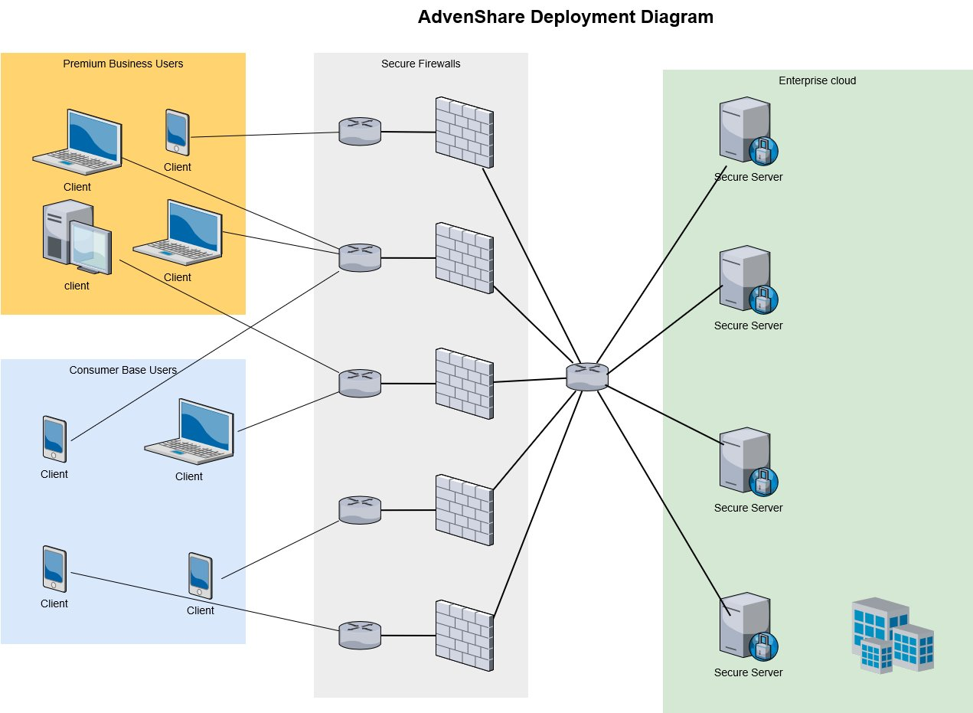

However, as a proof of concept for iteration 1, the deployment is modified accordingly.

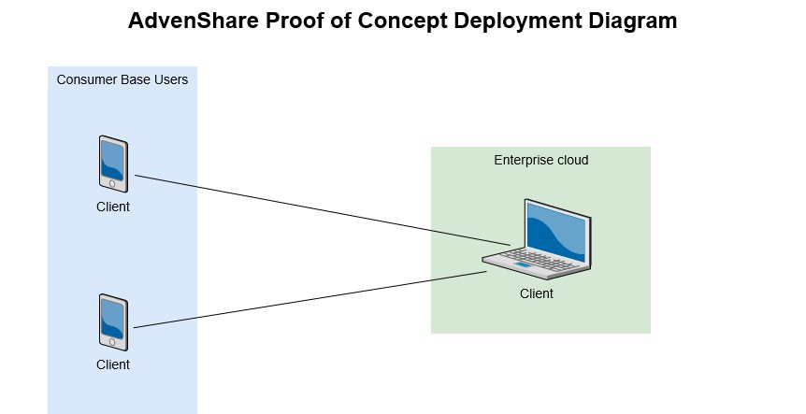

**3.3.2 CRC Cards & Class Diagrams**

**3.3.3 Behaviour: Sequence and/or State Diagrams**

A typical use sequence for AdvenShare is outlined below.

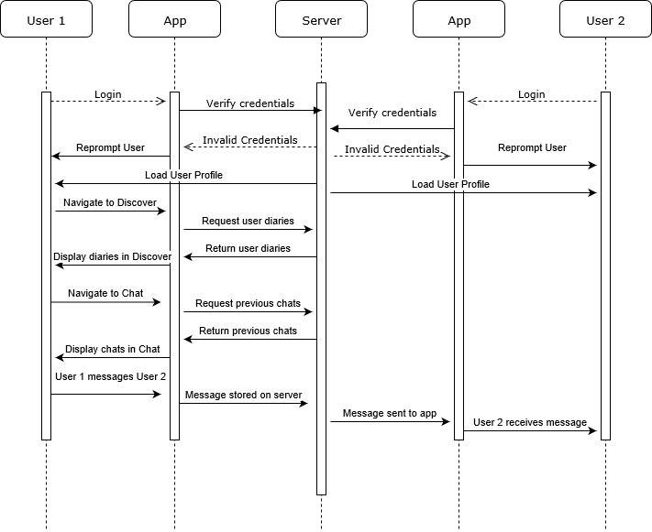

**3.3.4 Persistence**

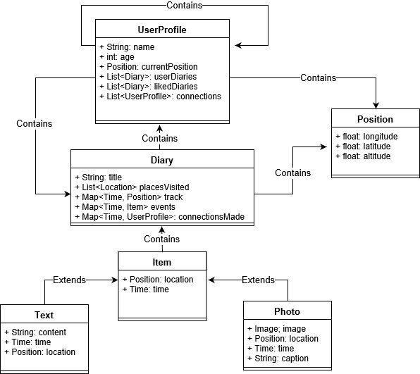

**3.3.6 Security**

**3.3.7 Wireframes**

# 4.0 Software Requirements Spec

**4.1 Introduction**

This part of the document will be used to guide the development of the application. By effectively expressing the goals of what we wish to achieve for the initial prototype of our app, we can ensure that our software development is well guided and that all of work is tapered towards achieving our goals. This will provide us with the best chance of impressing our investors early.

**4.1.1 Goal**

**4.1.2 Scope**

|  |  |
| --- | --- |
| In Scope | Out of Scope |
| * Loading pages * Icon for chat * Icon for plan * Itinerary plan * About me page * Storage of multiple diaries * Basic info: weather, currency, tours, accommodation -> creating a method for uploading data | * Security * Options to sign up or log in * Duplex communication * Chatting with other users |

**4.1.3 Glossary**

|  |  |
| --- | --- |
| Key Term | Description |
| App |  |
| Moss |  |
|  |  |

**4.1.4 Overview**

**4.2 User Cases**

**4.2.1 Actor and stakeholder table**

Actors

* End users
* User roles
* Persons
* Companies
* Organisations
* Networks
* Computer hard for system
* Databases
* Applications

Stakeholders

* End users of system
* Investors
* Suppliers
* Customers
* Vendors
* Companies
* Developers

**4.2.2 Main use-case Diagram**

**4.2.3 UC1**

fserranocs460.blogspot.com/2014/01/use-cases-actors-vs-stakeholders.html

# 4.2.4 UC2

**4.3 User Stories**

Cindy is a 21 year old backpacker who has just graduated from college and wants to see the world before starting full time work at an engineering firm. She also hasn’t travelled much before, and is setting out on a long around the world trip, and is afraid that by the end she may not remember where she went at the start, as she is quite forgetful. As Cindy is travelling for an extended period of time, there are also parts of her trip when she will be travelling alone, and she is feeling rather apprehensive about this aspect of her trip. Since Cindy has just graduated from college, she hasn’t had much time to research much about each of the places she is planning to travel to, and needs an easy way to access this information on the go.

Cindy is an avid user of social media, and loves to update her friends and family on what she is doing all the time. She also likes to meet new people, especially people from other countries, but often finds it difficult to approach strangers in a hostel setting.

We envision somebody like Cindy, a younger traveller aged 18 - 30, to be our primary user from the direct consumer end of our product. We can ease Cindy’s pain points by using our primary features:

* Automated diary creation based on photos and location tracking
* A discover feed dedicated to travel posts, so that friends don’t grow weary of extensive travel posts, but can still access her trips when they desire
* Our basic info feature will allow travellers to quickly find out the most important information for each city they plan to travel to, such as weather, currency exchange rate, local language and recommended items for the trip.
* A chat feature which allows travellers to connect with people they meet along their journey, and also allows people to seek out and meet like minded travellers

Cindy decides that she would like to travel before starting her new job. While finishing her college studies, Cindy daydreams about where she would like to go and what she would like to do by following other travellers on her *Discover Feed*. Using this feed she is able to see what travellers like to do in each location, and she adds her favourites to her *Dream Itinerary* to begin planning her trip.

Being a disorganised and busy college student, Cindy doesn’t leave herself much time to pack, and so she doesn’t have much time to research what she is likely to need for her trip. In the Advenshare app, she taps the *Basic Info* button and adds the cities she plans to travel to. Now she knows what the weather will be like, and what the items are most recommended by other travellers who have been to the same place. She also knows what she can expect the exchange rate to be in relation to her local currency, and what the local language is so that she can study up on the plane.

When Cindy is ready to begin her adventure, she taps the *Let’s Travel!* button in our app to begin her diary creation. From now on, Cindy’s phone tracks which attractions and locations she visits, and the photos she takes and creates an automated diary for her of her travels. If Cindy is inclined to add additional information, she can record short stories about her day to her diary, but if not then she will have a record of where she has visited and the photos she took.

After a few days, Cindy is ready to meet some friends, so she opens the *Chat* section of the Advenshare app. Using this feature, Cindy finds travellers who have similar interests to her and arranges to meet them the next day. When they meet up, they add each other to their diaries for that day, so that they will always remember each other and will be able to contact each other again to arrange another trip.

Chris

Chris was an avid traveller in his youth, and in a desperate bid to cling on to some remnant of his glory days, has become a marketing manager for Contiki Europe. His primary role at Contiki is to increase participation numbers in the tours offered by his company. To do this, he needs to create connections, clearly and honestly communicate the services offered by Contiki and most importantly, stay up to date with what is currently popular with younger travellers so that he can best sell the tours. Chris often struggles to find ways to reach his target market and attract more customers to Contiki. By nature, he and Contiki often struggle to retain their customer base.

We envision that people working in the tourism industry such as Chris to be our backend premium users, to which we can offer services such as:

* Providing honest feedback on tours from travellers using the Advenshare app so that Chris can know what travellers liked best, and what they would like to change
* Allowing Chris to see what young travellers typically do in the locations he provides tours, so that he can keep updating the tours and keep them fresh
* Advertising through the app, Chris can pay to boost the travel diaries of people that have enjoyed Contiki, so that other travellers are more likely to see that story in their *Discover Feed.*
* Check the travel diary of job applicants to see if they are likely to be a good fit for the job.

In an effort to boost participation numbers in his tours, Chris signs Contiki up to Advenshare as a premium user. On the next Contiki tour, Chris recommends that the participants use the Advenshare app to document their travels, and offers a 500 euro bar tab to the person that has the best Advenshare diary at the end of the trip.

After the trip, Chris then pays Advenshare to boost the diary of the winning traveller, so that other travellers can then see what they did, and get them enthused and excited about coming on Contiki. He can also continue to track the winning travellers to see if they would be a good fit for working at Contiki in the future.

Xi Yang Hong

Xi Yang Hong is a retired man who has worked hard his whole life and has not had the opportunity to travel in his youth, but has decided that he would like to see the world in his retirement. Being a Chinese national, he decides to start with a trip to Beijing to see the Great Wall of China.

**4.4 Non-functional Requirements**

**4.4.1 Environmental Requirements**

There is a growing emphasis world-wide, particularly among youth and travellers on reducing the impact that we as individuals have on the environment. This is an avenue that we believe we could utilise to meet our corporate social responsibility goals. We believe that we can have a positive impact on both the global and local environments by:

* Giving interested travellers the information they need to know where to go to have minimal environmental impact if they are trying to decide between multiple travel destinations.
* Informing travellers of the environmental impact of their travels, and suggesting things they can do to offset this impact, such as paying to offset their carbon emissions, or by planting trees.
* Filtering the popularity of sites that are being harmed by excessive visits from tourists, such as Machu Pichu to try to temporarily reduce the number of travellers during periods of peak tourism.

We can also use our talents to have a positive impact on the local communities by working together with the local governments to:

* Inform travellers of things that may have a negative effect that they may not realise, such as giving money to begging children
* Working together with local governments to achieve their tourism goals
* Inform the traveller of things they can do to ensure that all of their consumerism is ethical. For example, making sure they are not buying souvenirs from businesses that exploit child labour.

**4.4.2 Hardware Requirements**

In order to run our application, the user needs to ensure they have an Android phone, running android 6.0 or higher with enough memory to install the application. On our side, we also need to ensure that we have a constant IP address and a fixed server infrastructure for full scale development and roll out.

**4.4.3 Additional Requirements**

**4.4.4 User Interface Prototype**

# 5.0 SRS Review Summary

* Project Name
* Problem that came up with the SRS itself

# 6.0 Team

**6.1 Team Members & Roles**

* Adrian: UI
* Cindy: Documentation
* Connor: Basic Information
* Danny: Routing
* Edward: Diary builder
* Hannah: Documentation
* Samuel: Networking

**6.2 Client**

Teachers: Give us some advice and help us

Other groups: Look at our creativity and provide their ideas and needs.

Users: Consumers, tourism providers, influencers, travel insurance companies

**6.3 Team Values**

* Common goals: Our goal is to enable tourists to have a better sense of travel, to better remember every trip and to have a unique travel experience. The common goal enables our team to better link together.
* Common values: Shared values enable us to be more confident and cooperate better.
* Autonomy: Everyone has their own field of expertise. We do our job in areas where we are good at it, which makes our work more efficient.
* Efficiency: After we have completed their respective work, we will discuss, modify the deficiencies and increase the content.
* Thinking: In the process of project development, we constantly reflect on the shortcomings and improvement methods, so that the project can be carried out better.
* Collaboration: Benefit by mutual discussion.
* Communication: Continuous communication in the project to improve efficiency.
* Encouragement: Group members encourage each other in the project.

**6.4 Team Communication**

**Github:** First, you can share files so that members can download them by themselves. Second, you

can upload the results of the stage. Finally, we can find what we need to accomplish.

Trello: First of all, make all plans that need to be completed, to individuals in detail. Second, work out the content that needs to be done every day, upload what is being done and upload the completed content. Finally, everyone can see everyone's progress and make comments on the outcome of the stage.

- E-mail: Mail can share documents and share large files.

# 7.0 User Manual