题目
You should spend about 20 minutes on this task.
The chats below gave information about travel to and from The UK, and about the mostpopular counrtries for UK residents to visit.
Summarise the information by selecting and reporting the main features,and make comparisons where relevant.
Write at least 150 words.
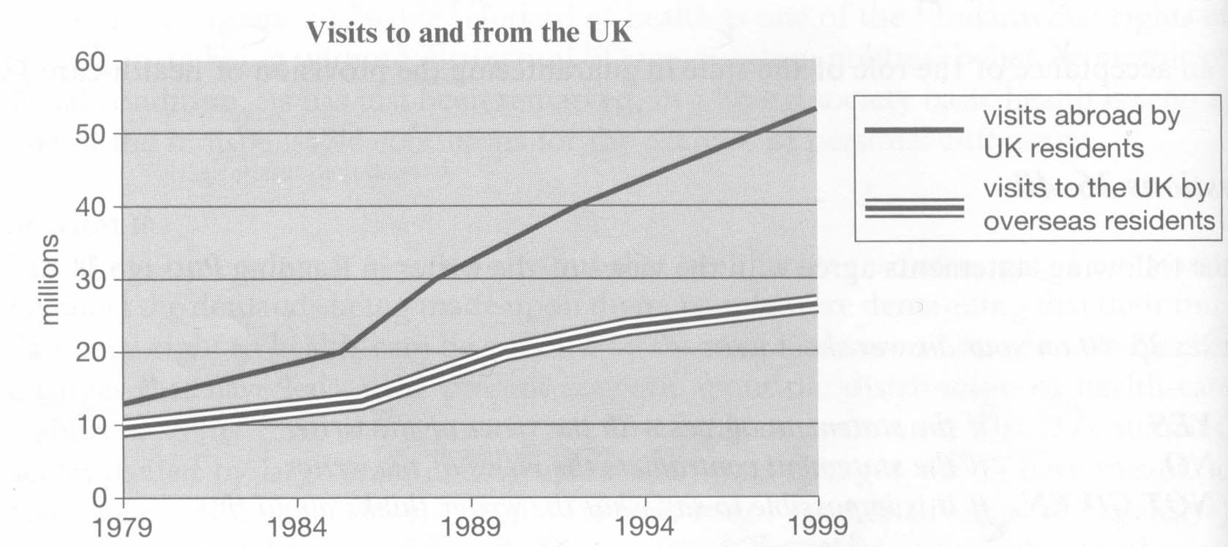
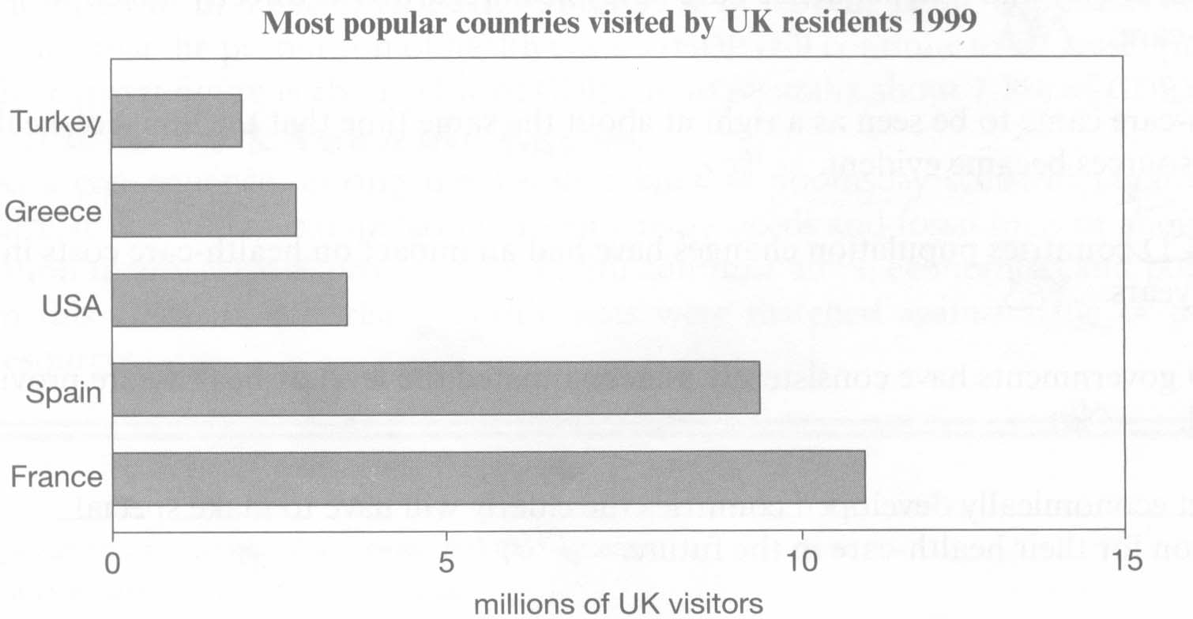

The graphs reveal an information about overseas residents traveling to the UK and the UK residents traveling to other countries and the most popular countries for the UK residents to visit.
According to the line chart,visit abroad by the UK residents increased from about 12 to 57 million from 1979 to 1999. While visit to the UK by overseas residents went up from about 10 to 28 million. It is obviously that the UK tourists were more and increased more sharply than tourist from overseas during the period.
The bar chart demonstrate that most UK tourist went to France and Spain, which were 11 million and 9 million. Also they were attracted by the USA(3.5 million) and Greece(3 million) and Turkey(2.5 million).
If consider this tow charts together, in 1999, over 40 percent of UK residents traveled to Span and France.

