新概念英语第四册课后题答案

李延隆

        答案具体的解释可以参考外研社的《新概念英语练习详解4》,四册课后题比较简单，课上时间有限，除个别题外我就不专门在课上讲解了。

[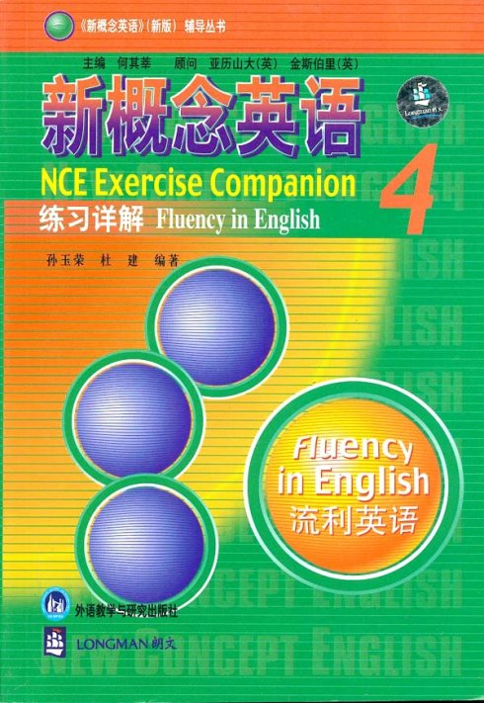](http://photo.blog.sina.com.cn/showpic.html#blogid=4e25a82401000bof&url=http://static1.photo.sina.com.cn/orignal/4e25a82443fe04bc7e5e0)

Lesson 1 CABDD BDAAC AB  
  
Lesson 2 BCBDC ACAAD BC  
  
Lesson 3 CABDA CDABA CD  
  
Lesson 4 ACCAB BCDAA BD  
  
Lesson 5 CABAB DACBB DD  
  
Lesson 6 CACCC AAADB AA  
  
Lesson 7 DCABA BACDA AC  
  
Lesson 8 BDABD BAABC BC  
  
Lesson 9 CDBAA CABAC AD  
  
Lesson 10 CAABD CBBDC AA  
  
Lesson 11 AABDD DADDB DD  
  
Lesson 12 CABAC CDACA AB  
  
Lesson 13 ACDAC BDABC AD  
  
Lesson 14 DBDCC ACCBD BD  
  
Lesson 15 CADCD DBACA CA  
  
Lesson 16 ABCCA DDBAB AC  
  
Lesson 17 BBADA BBDCD CA  
  
Lesson 18 BABCD CDCCC BA  
  
Lesson 19 BBCAD AABDD BC  
  
Lesson 20 BCADC CCBDB CA  
  
Lesson 21 BDBBA ADDAB CA  
  
Lesson 22 CDACB ADBCD AB  
  
Lesson 23 CADCC DCABC AC  
  
Lesson 24 AACCB CADDA CD  
  
Lesson 25 DBADD CACDB CA  
  
Lesson 26 CBCBA CDDAB AC  
  
Lesson 27 BCDCC ACCDD DA  
  
Lesson 28 ADCDA BCADA BD  
  
Lesson 29 CCADD CCADA BC  
  
Lesson 30 CABDD BCCAC DC  
  
Lesson 31 AABAD BADDC BD  
  
Lesson 32 BDCBA DBDCA BC  
  
Lesson 33 BDBAD BCCDC BA  
  
Lesson 34 DCACB DACDB CA  
  
Lesson 35 CBCAC ABBDC CD  
  
Lesson 36 ACBCC ACCDB AC  
  
Lesson 37 CABAC DBCDC BD  
  
Lesson 38 CAABB ACBDD AB  
  
Lesson 39 BCADA BDDBD BC  
  
Lesson 40 DCDAC ADDDA DB  
  
Lesson 41 ACACD CBBBD BC  
  
Lesson 42 BCCBD BDADC AC  
  
Lesson 43 DBABC CDDAC BB  
  
Lesson 44 AAAAB BBBDC BA  
  
Lesson 45 CADAC CACDC DC  
  
Lesson 46 BBDBD ABCDA BD  
  
Lesson 47 CAADB CACDB BC  
  
Lesson 48 CCBCC CCDBA AB