实验四 blobstore原理和源码分析

**一、实验目的**

1. 掌握blobstore原理
2. 完成基于nvme的blobstore读写。

**二、实验内容**

1. 学习Blob基本原理
2. 完成hello_blob 程序运行
3. 修改底层bdev为nvme
4. **实验代码及结果**

Makefile:

SPDK_ROOT_DIR := /home/miracle/work/spdk

include $(SPDK_ROOT_DIR)/mk/spdk.common.mk

include $(SPDK_ROOT_DIR)/mk/spdk.modules.mk

APP = miracle_blob

C_SRCS := miracle_blob.c

SPDK_LIB_LIST = $(ALL_MODULES_LIST) event event_bdev

include $(SPDK_ROOT_DIR)/mk/spdk.app.mk

run: all

@ rm -f miracle_blob.d miracle_blob.o

@ $(SPDK_ROOT_DIR)/scripts/gen_nvme.sh - json-with-subsystems >

./miracle_bdev.json

@ sudo ./miracle_blob ./miracle_bdev.json

miracle_blob.c:

#include "spdk/stdinc.h"

#include "spdk/bdev.h"

#include "spdk/env.h"

#include "spdk/event.h"

#include "spdk/blob_bdev.h"

#include "spdk/blob.h"

#include "spdk/log.h"

#include "spdk/string.h"

struct my_context

{

struct spdk_blob_store *bs;

struct spdk_blob *blob;

spdk_blob_id blobid;

struct spdk_io_channel *channel;

uint8_t *read_buff;

uint8_t *write_buff;

uint64_t io_unit_size;

int rc;

};

static void cleanup(struct my_context *p)

{

spdk_free(p > read_buff);

spdk_free(p > write_buff);

free(p);

}

static void unload_complete(void *cb_arg, int bserrno)

{

struct my_context *p = cb_arg;

SPDK_NOTICELOG("entry\n");

if (bserrno)

{

SPDK_ERRLOG("Error %d unloading the bobstore\n", bserrno);

p > rc = bserrno;

}

spdk_app_stop(p > rc);

}

static void unload_bs(struct my_context *p, char *msg, int bserrno)

{

if (bserrno)

{

SPDK_ERRLOG("%s (err %d)\n", msg, bserrno);

p > rc = bserrno;

}

if (p > bs)

{

if (p > channel)

{

spdk_bs_free_io_channel(p > channel);

}

spdk_bs_unload(p > bs, unload_complete, p);

}

else

{

spdk_app_stop(bserrno);

}

}

static void delete_complete(void *arg1, int bserrno)

{

struct my_context *p = arg1;

SPDK_NOTICELOG("entry\n");

if (bserrno)

{

unload_bs(p, "Error in delete completion", bserrno);

return;

}

unload_bs(p, "", 0);

}

static void delete_blob(void *arg1, int bserrno)

{

struct my_context *p = arg1;

SPDK_NOTICELOG("entry\n");

if (bserrno)

{

unload_bs(p, "Error in close completion", bserrno);

return;

}

spdk_bs_delete_blob(p > bs, p > blobid, delete_complete, p);

}

static void read_complete(void *arg1, int bserrno)

{

struct my_context *p = arg1;

int match_res = -1;

SPDK_NOTICELOG("entry\n");

if (bserrno)

{

unload_bs(p, "Error in read completion", bserrno);

return;

}

match_res = memcmp(p > write_buff, p > read_buff, p > io_unit_size);

if (match_res)

{

unload_bs(p, "Error in data compare", -1);

return;

}

else

{

SPDK_NOTICELOG("read SUCCESS and data matches!\n");

}

spdk_blob_close(p > blob, delete_blob, p);

}

static void read_blob(struct my_context *p)

{

SPDK_NOTICELOG("entry\n");

p > read_buff = spdk_malloc(p > io_unit_size, 0x1000, NULL,

SPDK_ENV_LCORE_ID_ANY, SPDK_MALLOC_DMA);

if (p > read_buff = NULL)

{

unload_bs(p, "Error in memory allocation", -ENOMEM);

return;

}

spdk_blob_io_read(p > blob, p > channel, p > read_buff, 0, 1, read_complete,

p);

}

static void write_complete(void *arg1, int bserrno)

{

struct my_context *p = arg1;

SPDK_NOTICELOG("entry\n");

if (bserrno)

{

unload_bs(p, "Error in write completion", bserrno);

return;

}

read_blob(p);

}

static void blob_write(struct my_context *p)

{

SPDK_NOTICELOG("entry\n");

p > write_buff = spdk_malloc(p > io_unit_size, 0x1000, NULL,

SPDK_ENV_LCORE_ID_ANY, SPDK_MALLOC_DMA);

if (p > write_buff = NULL)

{

unload_bs(p, "Error in allocating memory", -ENOMEM);

return;

}

memset(p > write_buff, 0x5a, p > io_unit_size);

p > channel = spdk_bs_alloc_io_channel(p > bs);

if (p > channel = NULL)

{

unload_bs(p, "Error in allocating channel", -ENOMEM);

return;

}

spdk_blob_io_write(p > blob, p > channel, p > write_buff, 0, 1,

write_complete, p);

}

static void sync_complete(void *arg1, int bserrno)

{

struct my_context *p = arg1;

SPDK_NOTICELOG("entry\n");

if (bserrno)

{

unload_bs(p, "Error in sync callback", bserrno);

return;

}

blob_write(p);

}

static void resize_complete(void *cb_arg, int bserrno)

{

struct my_context *p = cb_arg;

uint64_t total = 0;

if (bserrno)

{

unload_bs(p, "Error in blob resize", bserrno);

return;

}

total = spdk_blob_get_num_clusters(p > blob);

SPDK_NOTICELOG("resized blob now has USED clusters of %" PRIu64 "\n",

total);

spdk_blob_sync_md(p > blob, sync_complete, p);

}

static void open_complete(void *cb_arg, struct spdk_blob *blob, int bserrno)

{

struct my_context *p = cb_arg;

uint64_t free = 0;

SPDK_NOTICELOG("entry\n");

if (bserrno)

{

unload_bs(p, "Error in open completion", bserrno);

return;

}

p > blob = blob;

free = spdk_bs_free_cluster_count(p > bs);

SPDK_NOTICELOG("blobstore has FREE clusters of %" PRIu64 "\n", free);

spdk_blob_resize(p > blob, free, resize_complete, p);

}

static void blob_create_complete(void *arg1, spdk_blob_id blobid, int

bserrno)

{

struct my_context *p = arg1;

SPDK_NOTICELOG("entry\n");

if (bserrno)

{

unload_bs(p, "Error in blob create callback", bserrno);

return;

}

p > blobid = blobid;

SPDK_NOTICELOG("new blob id %" PRIu64 "\n", p > blobid);

spdk_bs_open_blob(p > bs, p > blobid, open_complete, p);

}

static void create_blob(struct my_context *p)

{

SPDK_NOTICELOG("entry\n");

spdk_bs_create_blob(p > bs, blob_create_complete, p);

}

static void bs_init_complete(void *cb_arg, struct spdk_blob_store *bs, int

bserrno)

{

struct my_context *p = cb_arg;

SPDK_NOTICELOG("entry\n");

if (bserrno)

{

unload_bs(p, "Error initing the blobstore", bserrno);

return;

}

p > bs = bs;

SPDK_NOTICELOG("blobstore: %p\n", p > bs);

p > io_unit_size = spdk_bs_get_io_unit_size(p > bs);

create_blob(p);

}

static void base_bdev_event_cb(enum spdk_bdev_event_type type, struct

spdk_bdev *bdev, void *event_ctx)

{

SPDK_WARNLOG("Unsupported bdev event: type %d\n", type);

}

static void hello_start(void *arg1)

{

struct my_context *p = arg1;

struct spdk_bs_dev *bs_dev = NULL;

int rc;

rc = spdk_bdev_create_bs_dev_ext("Nvme0n1", base_bdev_event_cb, NULL,

&bs_dev);

if (rc = 0)

{

SPDK_ERRLOG("Could not create blob bdev, %s ! \n", spdk_strerror(-

rc));

spdk_app_stop(-1);

return;

}

spdk_bs_init(bs_dev, NULL, bs_init_complete, p);

}

int main(int argc, char **argv)

{

struct spdk_app_opts opts = {};

int rc = 0;

struct my_context *p = NULL;

SPDK_NOTICELOG("entry\n");

spdk_app_opts_init(&opts, sizeof(opts));

opts.name = "hello_miracle";

opts.json_config_file = argv[1];

p = calloc(1, sizeof(struct my_context));

if (p)

{

rc = spdk_app_start(&opts, hello_start, p);

if (rc)

{

SPDK_NOTICELOG("ERROR!\n");

}

else

{

SPDK_NOTICELOG("SUCCESS!\n");

}

cleanup(p);

}

else

{

SPDK_ERRLOG("Could not alloc hello_context struct ! \n");

rc = -ENOMEM;

}

spdk_app_fini();

return rc;

}

运⾏hello_blob:

sudo ./build/examples/hello_blob ./examples/blob/hello_world/hello_blob.json

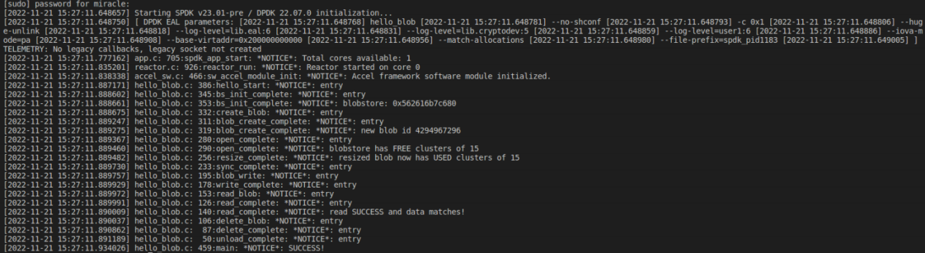

运行：make run:

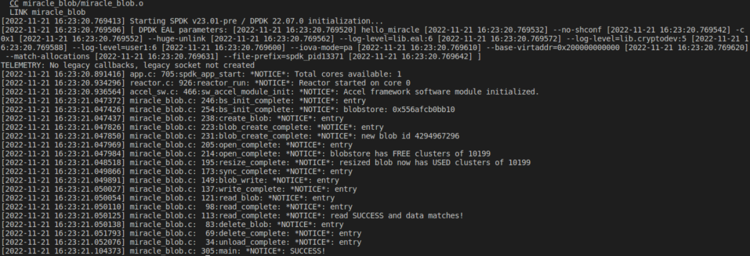

**四、调试和心得体会**

本次实验学习了Blob基本原理，完成了hello_bdev程序运行，并最修改底层bdev为nvme。