1. please give evidence that you have finished Tasks I and II

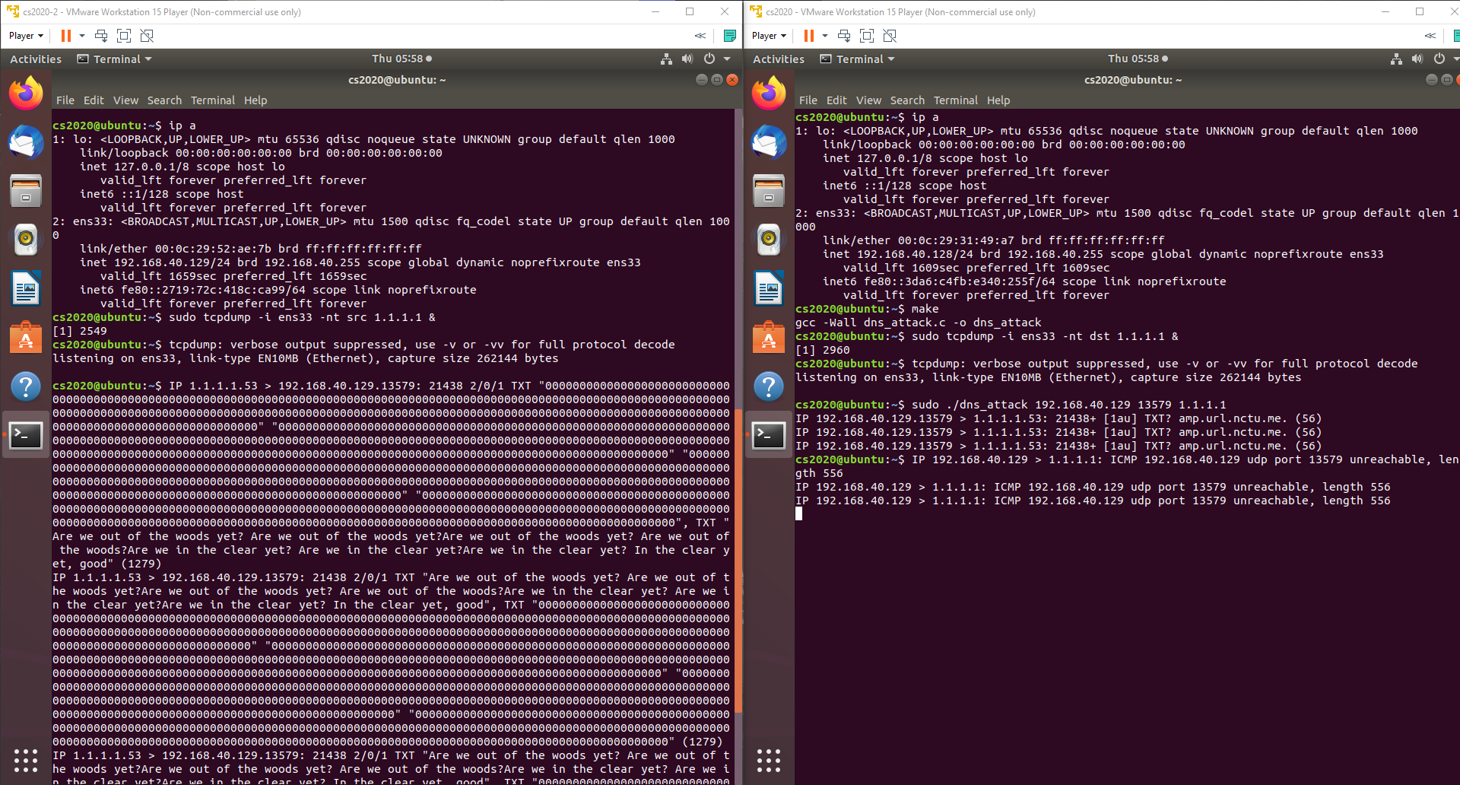

**Response Size**





**DNS Response**

**Query Size**



**DNS Query**

**Launch Attack**

d

**Victim IP**

**Attacker IP**

d

d

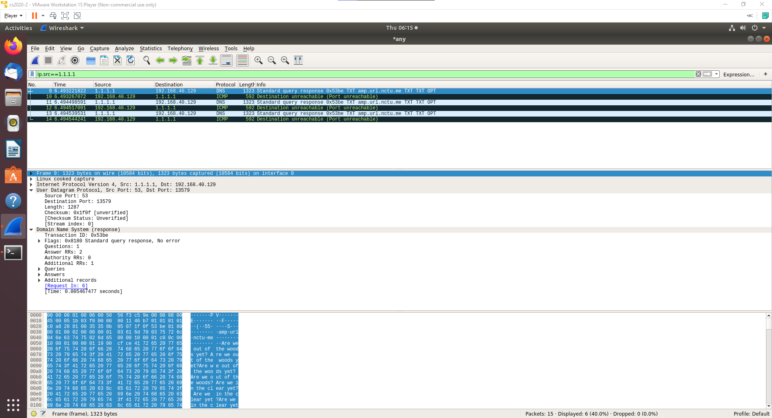

𝑆𝑟 = 1279 + 8(UDP header size) = 1287

𝑆𝑞 = 56 + 8 = 64

R = 1287/64 = 20.1

1. please explain how you amplify the DNS response

First, I create some personal and large TXT entries in a public domain hosting service (in this case the nctu.me domain hosting service). Then, I query these TXT entries. Since the TXT entries are rather large, I am able to amplify the DNS response.

1. please propose a solution that can defend against the DoS attack based on the DNS reflection

To solve the root cause, the internet service providers should stop packets with spoofed IP from leaving the network. Other than that, DNS resolvers can configure their servers so that they won’t respond to deviant query such as the ANY query. Finally, those who run web services can seek protection from large company such as Cloudflare or Akamai since the malicious bandwidth is not likely to overwhelm those companies.