_________________ Andrey Tur _______________
Mira 16/2/99 Minsk Belarus
(C) +375297559177 (E) andrtur@gmail.com
Profile____________________________________________________________________ Position as an Electrical Control Engineer (SCADA HMI PLC)

Areas of Expertise _____________________________________________________________________

- Experience with digital control systems
- Expert in installing electronic equipment
- Definite experience in work with OPC, ModBus, Ethernet data transfer protocols; iFix, Wizcon, Siemens WinCC SCADA systems
- Microsoft Windows XP, 7, 2003 server – Advanced user, system administration skills(10 years experience);Ubuntu Linux 8.04 – 12.04 (Advanced user 5 years experience)
- Microsoft Office, Visio, Autocad
- Programming skills: Microsoft .NET Framework 2.0, 3.5, 4.0, ASP.NET, WinForms, ADO.NET, LinqToSql,C#(development of solutions to meet internal corporate requirements, and not a commercial development),SQL(extensive experience in drafting SQL requests) , Oracle 9i, 10g,SQL server 2000, 2005(5 years administration skills and development ASP.NET solutions)

Professional experience _________________________________________________________________

12/2005 – present Electric Company Belarus, Minsk
Control Engineer

Creating HMI in SCADA environment in Electric Energy Company for control electrical equipment(Siemens WinCC, Wizcon, iFix,own SCADA)

Maintained data storage system based on Oracle 9i, 10g,11g DB for various kinds telemetry parameters and alarms.

Ensured, that all preventative actions were maintained in the facility along with stable production process.

Checked any problem that related to the working of the equipment, assembly automation, work stations and automated equipment.

Documented all changes and updated the reports accordingly.

Took part in developing solutions for calculating power losses (.NET C#).

Implementation and support HMI of Automated-control system that allows real-time information on equipment status, control, calculation of losses in electrical energy networks, power generation and facilities management.

Create a workstation terminals, include the HMI system, which allows you to display the technological scheme with the current values ​​of various parameters and the state of process equipment, system configuration, its configuration, collaboration with users.

Creation of dynamic models of electrical energy networks, allowing to make calculations of losses in the transmission of electricity, to determine the location of damage.
Education ____________________________________________________________________________
2004 IT University Minsk Belarus
Control Systems Engineer
Bachelor of science.

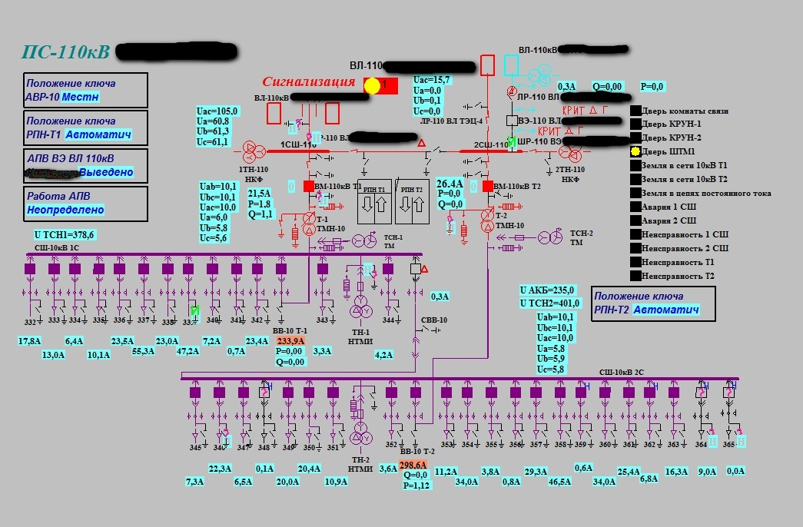

Example HMI Power Energy station for operational personnel, fully created at own SCADA with possibilities of getting alarm information and full remote control of equipment.

