**Artificial Intelligence and Machine Learning**

Project Report

Semester-IV (Batch-2022)

hOUSE PRICE PREDICATOR

**Supervised By: Submitted By:**

Rajiv Bhardwaj SUMAN RANJAN

2210990872

G-31

**Department of Computer Science and Engineering**

**Chitkara University Institute of Engineering & Technology,**

|  |  |  |
| --- | --- | --- |
| **SR NO.** | **TOPICS** | **PAGE NO.** |
| 1. | INTRODUCTION | 3 |
| 2. | PROBLEM DEFINATION | 3 |
| 3. | PROPOSED DESIGN | 4 |
| 4. | FOLDER STRUCTURE | 4 |
| 5. | CODE | 5 |
| 6. | RESULTS | 11 |
| 7. | REFERENCES | 11 |

INTRODUCTION

Project is a web-based application designed to provide users with estimated prices for houses based on certain input parameters. The project utilizes HTML, CSS, and JavaScript to create a user-friendly interface where users can input details such as the number of bedrooms, bathrooms, size of the house, and zip code.

Upon submitting this information, the application sends a request to a backend server using JavaScript's Fetch API. The server, which is assumed to have a predictive model implemented, then processes this data and returns the predicted price. This price is then dynamically displayed on the webpage without requiring a full page refresh.

The project's interface is clean and intuitive, featuring a header for branding, a main section for the input form and predicted price display, and a footer for copyright information. It employs modern design principles, such as responsive layout and simple styling, to ensure a pleasant user experience across different devices.

Overall, project serves as a practical tool for individuals interested in estimating house prices based on specific criteria, potentially aiding in real estate decision-making processes.

PROBLEM DEFINATION

The problem addressed by my project is the prediction of house prices based on various factors. In the real estate industry, accurately determining the value of a property is crucial for both buyers and sellers. However, this task can be complex due to the multitude of variables that influence house prices, including location, size, number of bedrooms and bathrooms, and other amenities.

Project aims to tackle this problem by leveraging machine learning techniques to build a predictive model. By inputting key features of a house, such as the number of bedrooms, bathrooms, size, and zip code, users can obtain an estimated price for the property. This prediction empowers both potential buyers and sellers with valuable insights into the market value of a house, facilitating informed decision-making.

The predictive model utilized in your project is trained on historical data, capturing the relationships between input features and house prices. Through this data-driven approach, the model learns patterns and trends within the housing market, allowing it to make accurate price predictions for new or unseen properties.

Overall, the problem is, the project addresses is the need for reliable and accessible tools to estimate house prices, providing stakeholders in the real estate industry with valuable information to guide their transactions and investments.

PROPOSED DESIGN

* FOLDER STRUCTURE

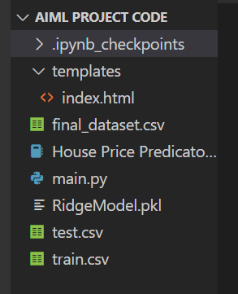

* METHODOLOGY

**pandas (pd):** Pandas is a powerful library for data manipulation and analysis. It provides data structures and functions to efficiently work with structured data, such as tables or spreadsheets. It is commonly used for tasks like data cleaning, transformation, and exploration.

**numpy (np):** Numpy is a fundamental library for numerical computing in Python. It provides support for large, multi-dimensional arrays and matrices, along with a collection of mathematical functions to operate on these arrays efficiently. It is widely used for scientific computing and data analysis tasks.

**seaborn (sns):** Seaborn is a data visualization library built on top of matplotlib. It provides a high-level interface for creating attractive and informative statistical graphics. Seaborn simplifies the process of creating complex visualizations and offers additional functionality compared to matplotlib.

**Scikit-learn:**  sklearn is a popular open-source machine learning library in Python. It provides a wide range of tools and algorithms for various machine learning tasks, including classification, regression, clustering, dimensionality reduction, and more.

**To install the following libraries:**

pip install pandas

pip install numpy

pip install seaborn

pip install scikit-learn

**Regression Algorithms:**

Linear Regression: A simple and commonly used regression algorithm that models the relationship between the independent variables and the dependent variable by fitting a linear equation to the observed data.

Lasso regression: short for Least Absolute Shrinkage and Selection Operator regression, is a type of linear regression technique used for variable selection and regularization.

Ridge regression: is a type of linear regression technique used for modeling and prediction. It is similar to ordinary least squares (OLS) regression but includes a regularization term to prevent over fitting.

* CODE

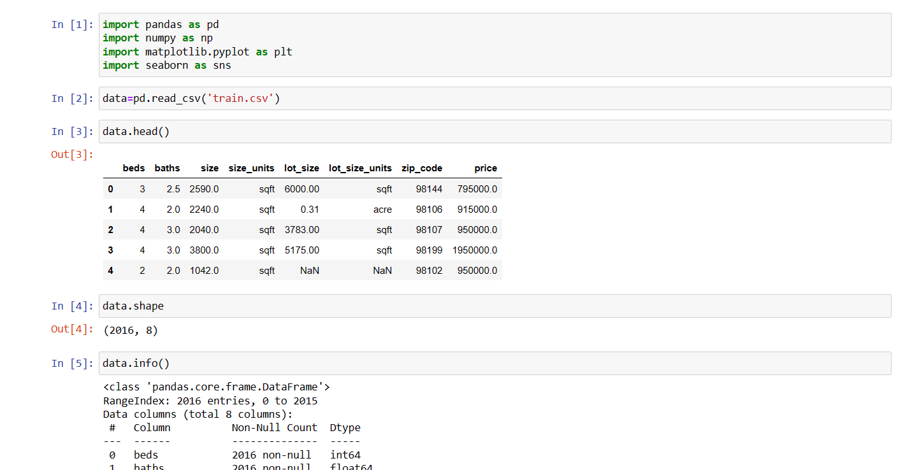

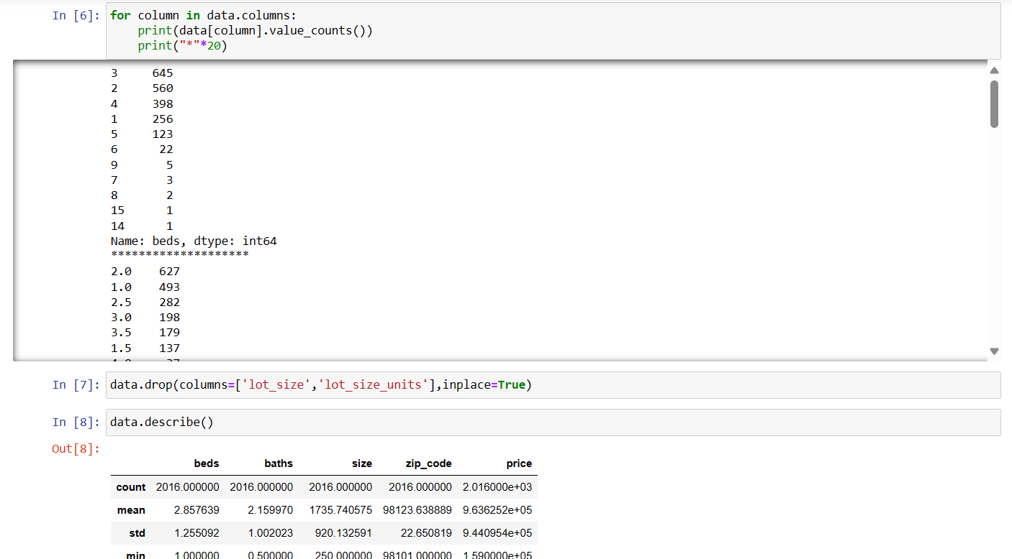

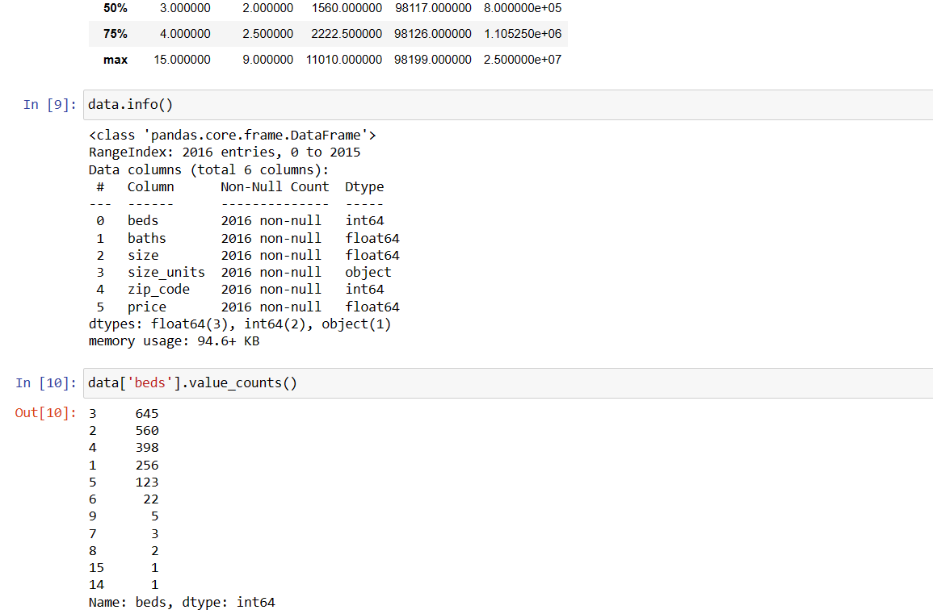

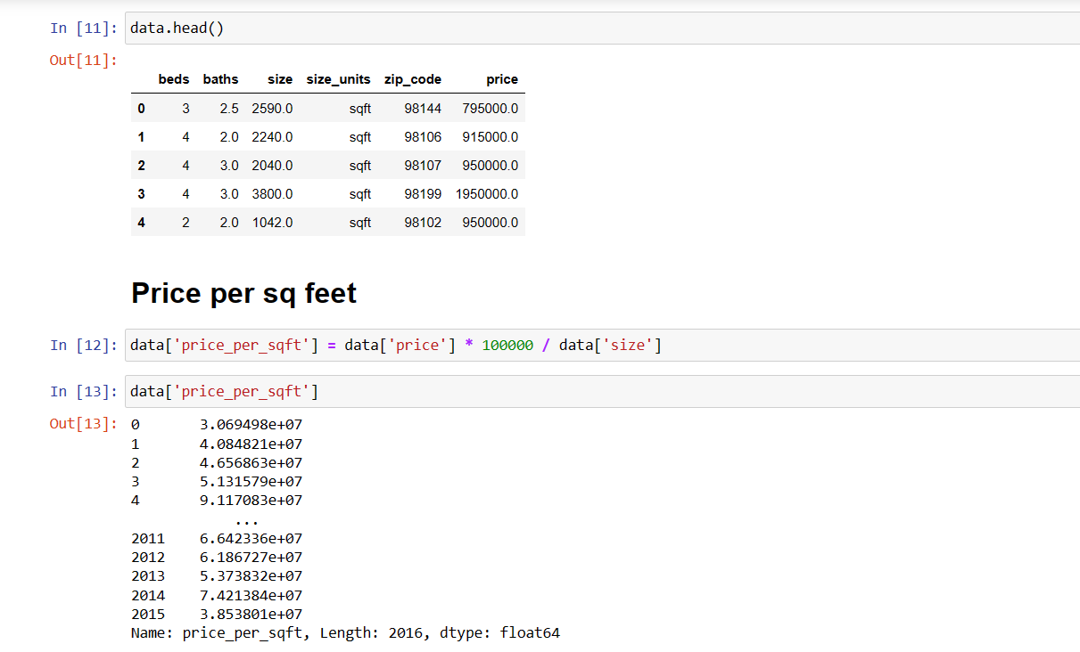

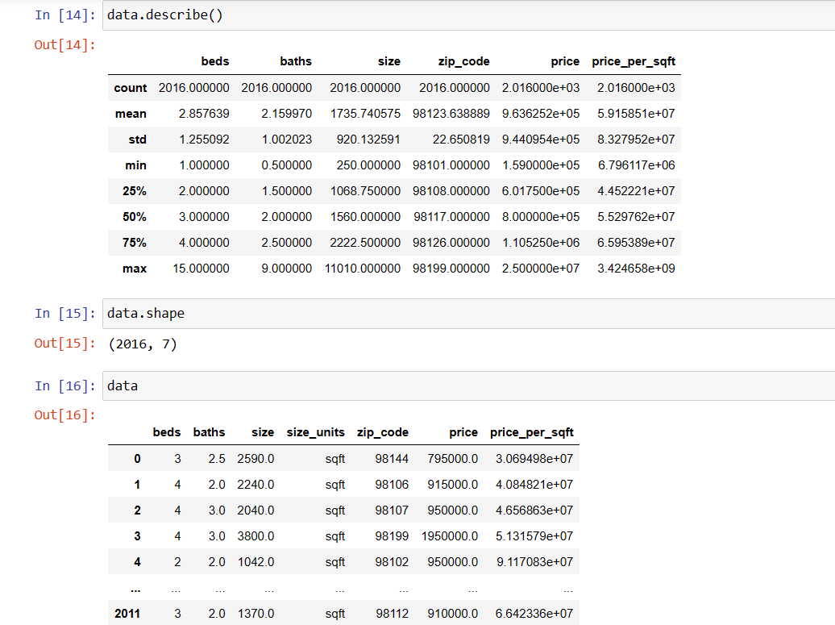

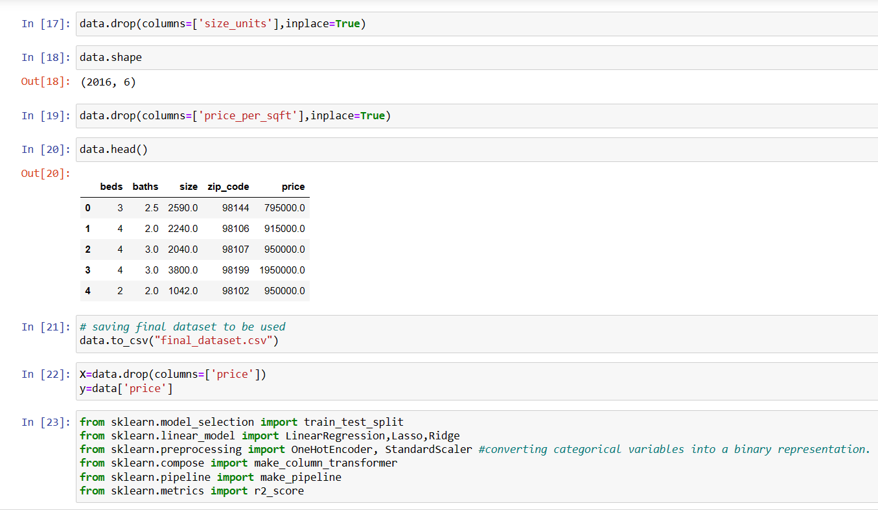

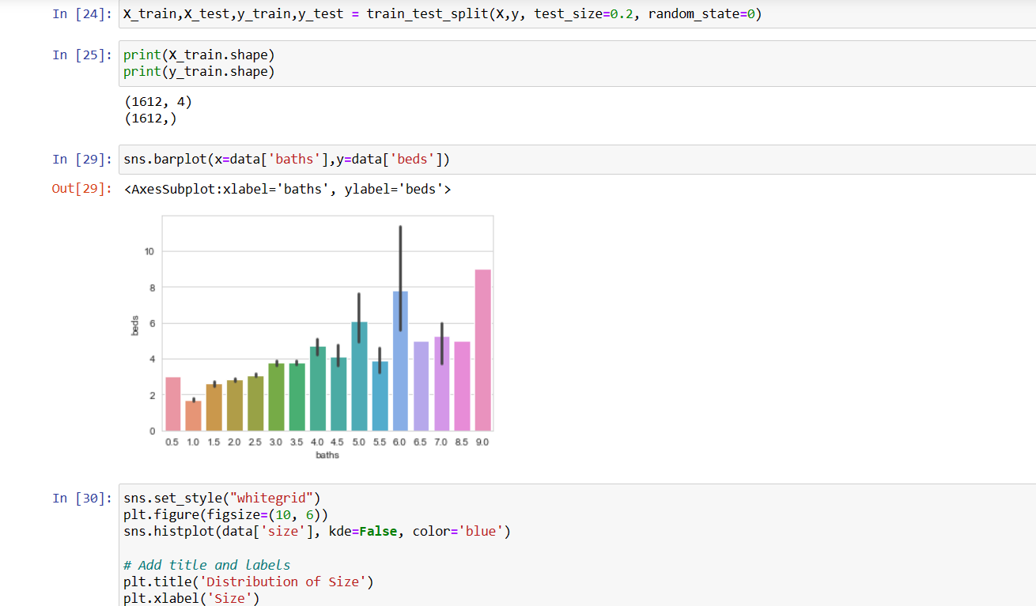

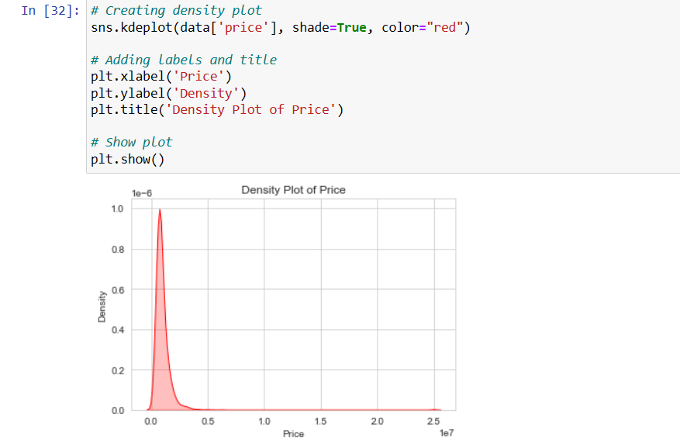

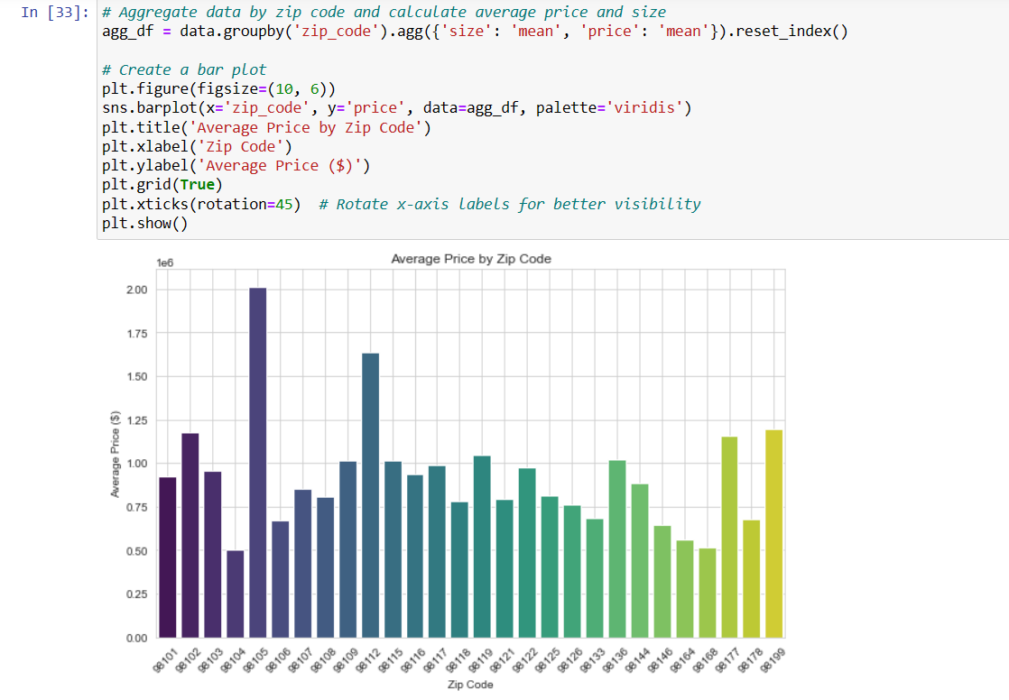

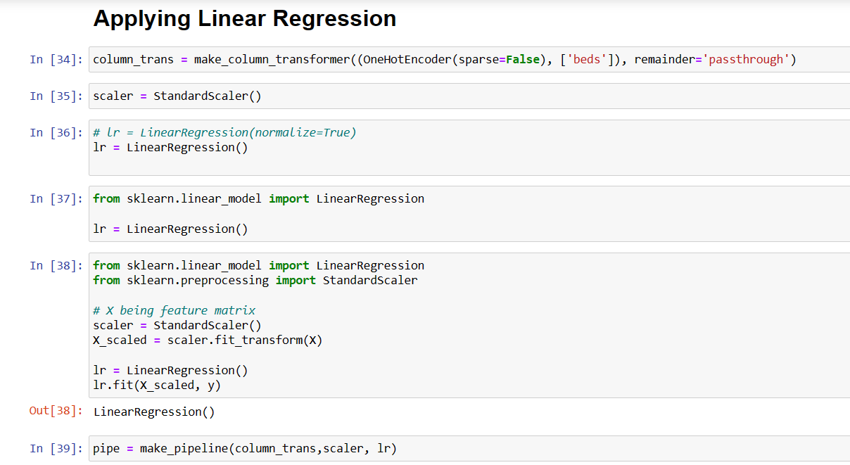

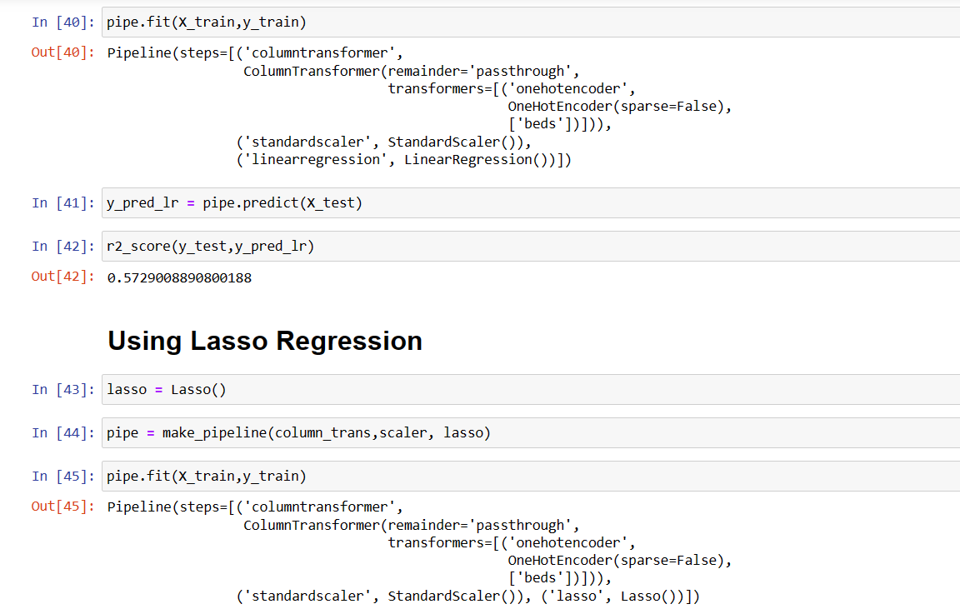

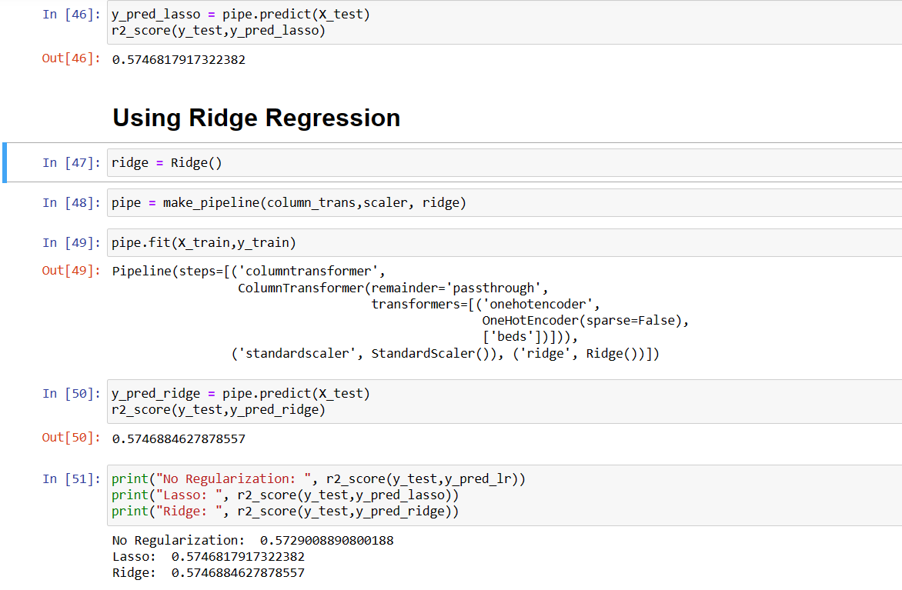



RESULTS

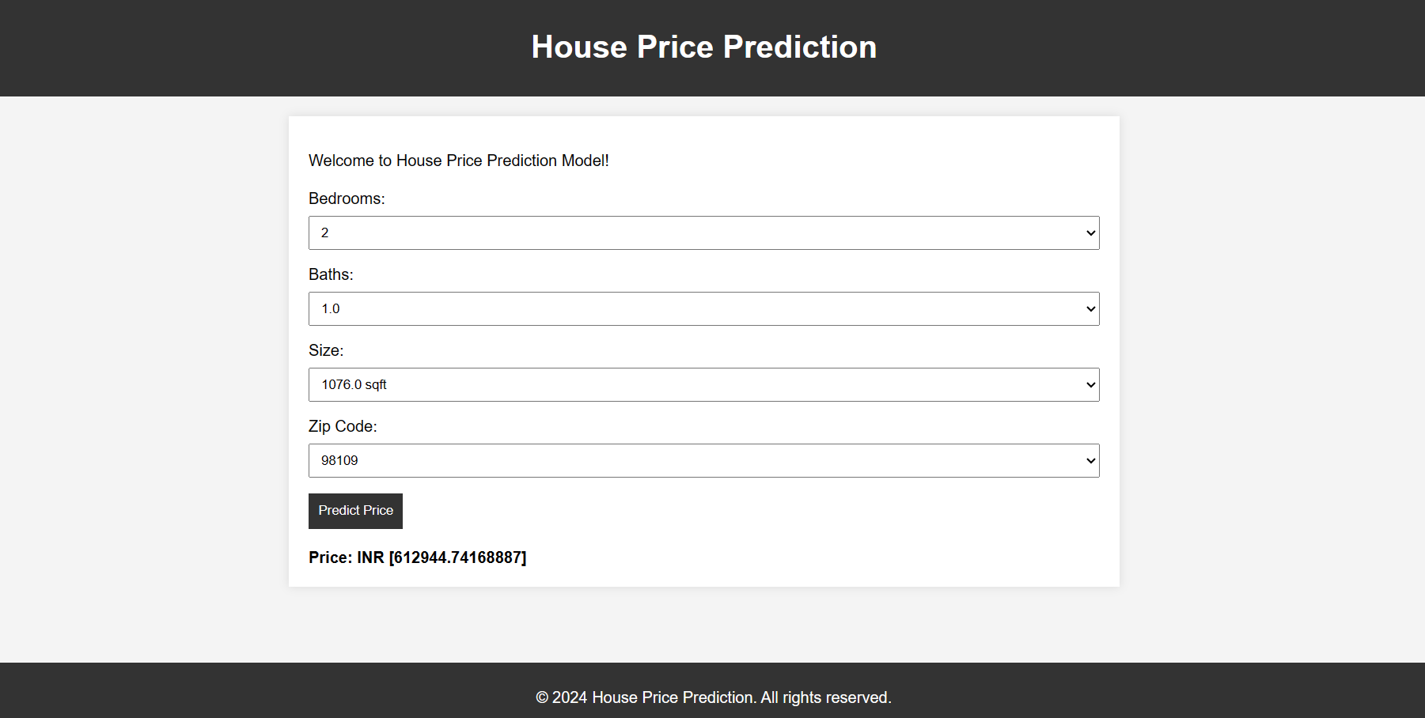

REFERENCES

* <https://www.kaggle.com/datasets/samuelcortinhas/house-price-prediction-seattle?resource=download>
* <https://docs.python.org/3/>