# 📘 Project Report: Automated Network Request Management in ServiceNow

**Project Title:** Automated Network Request Management in ServiceNow  
 **Submitted by :** M.V.S. GEETH SREETHAM  
 **GitHub Repository:** [Servicenow Project Link](https://github.com/geethsreetham/Automated-Network-Request-Management-in-ServiceNow)

**Screenshots Folder:**[View Screenshots](https://github.com/geethsreetham/Automated-Network-Request-Management-in-ServiceNow/tree/main/screenshots)

## 

## 

## Abstract

This project demonstrates the automation of **network request management** within ServiceNow using **Service Catalogs, Variable Sets, Flow Designer, Approvals, and Notifications**.

The system allows users to raise a network-related request through a **catalog item**, capture all necessary inputs via **variables**, and process the request automatically using **flow automation**. The project eliminates manual intervention, reduces approval delays, and ensures real-time communication with stakeholders through email notifications.

## Introduction

ServiceNow is a powerful cloud-based ITSM (IT Service Management) platform. One of its most impactful features is the ability to **automate workflows**, reducing repetitive tasks and ensuring standardization.

In IT organizations, **network requests** (VPN access, firewall changes, port requests, etc.) are frequent. Manual handling of such requests is prone to delays, miscommunication, and lack of tracking.

This project solves that by:

1. Creating a **Catalog Item** for submitting network requests.
2. Designing a **Flow** in Flow Designer to automatically process requests.
3. Implementing **approvals** for supervisor authorization.
4. Sending **automated email notifications** to requesters.

## Objectives

1. **Automation** – Replace manual request processing with fully automated workflows.
2. **Standardization** – Ensure every request follows a structured and auditable path.
3. **Efficiency** – Reduce delays caused by manual approvals and notifications.
4. **User Experience** – Provide a simple and professional request submission form.
5. **Transparency** – Keep all stakeholders informed of request status in real time.

## Literature Review

1. **Service Catalog** – A digital catalog containing services available for request. Each item can have fields (variables) to capture user input.
2. **Variable Set** – A reusable group of variables that can be applied to multiple catalog items.
3. **Flow Designer** – A no-code automation tool in ServiceNow for creating process flows.
4. **Approvals** – Used to enforce authorization before fulfilling requests.
5. **Notifications** – Automated emails or messages sent at key stages of the workflow.

This project combines all of these ServiceNow concepts into a single automated solution.

## Methodology

The project follows a **step-by-step approach**:

### Step 1: Service Catalog Item Creation

A catalog item titled **Network Request** was created to allow users to submit network-related requests.  
 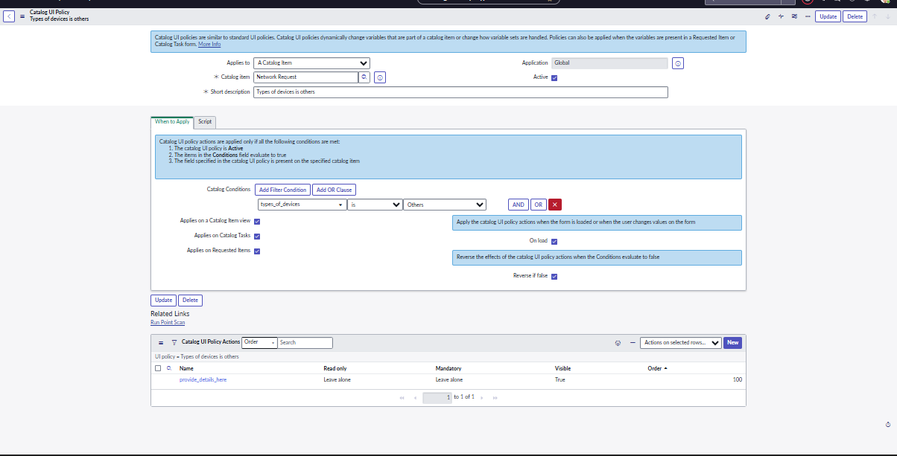

### Step 2: Defining Variables and Variable Sets

A **Variable Set** was configured to capture inputs like:

1. Request Type (VPN, Firewall, Port Access, etc.)
2. Requester Details (Name, Department, Email)
3. Justification

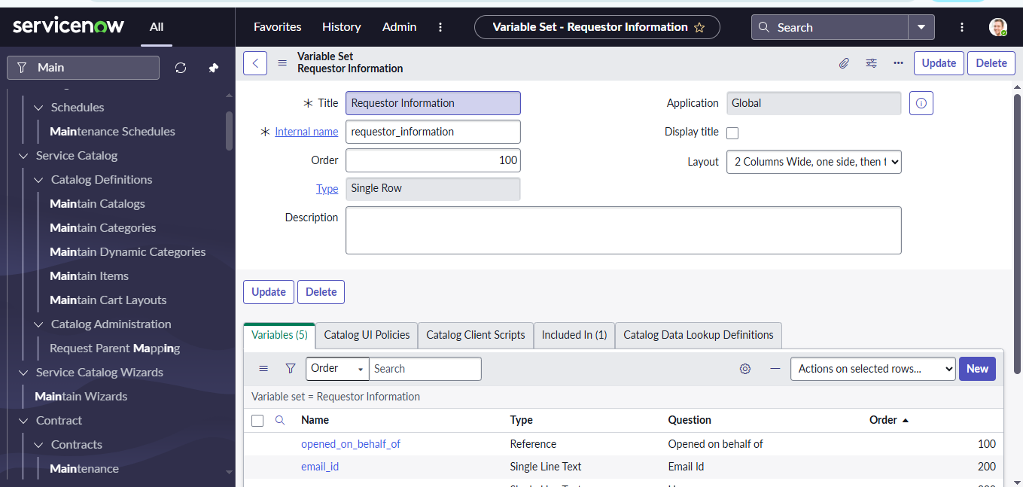

### Step 3: Flow Designer – Initial Setup

A new flow was created in Flow Designer triggered when the catalog item is submitted.  
 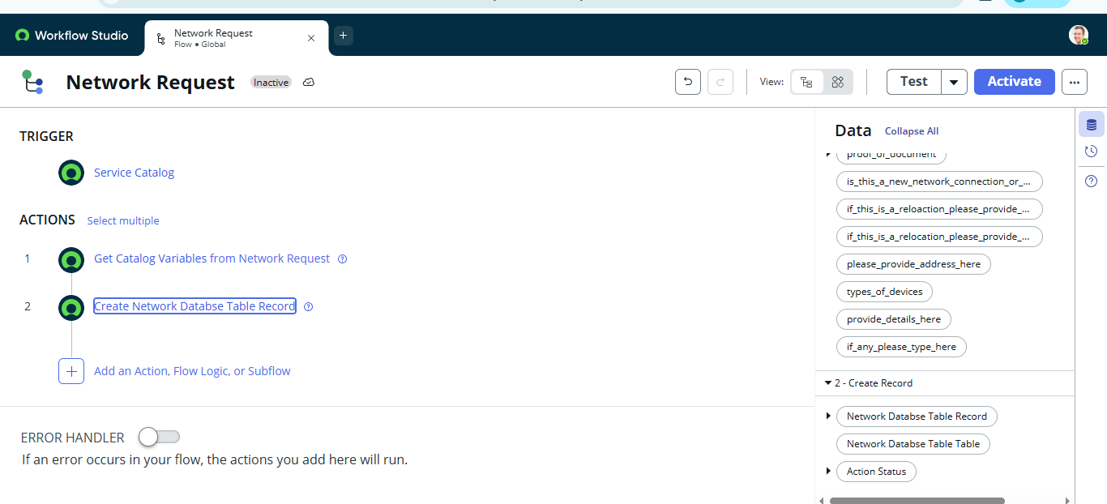

### Step 4: Get Catalog Variables Action

This step fetches the submitted variables for further processing.  
 

### Step 5: Create Record Action

Automatically creates a record in the database for tracking.  
 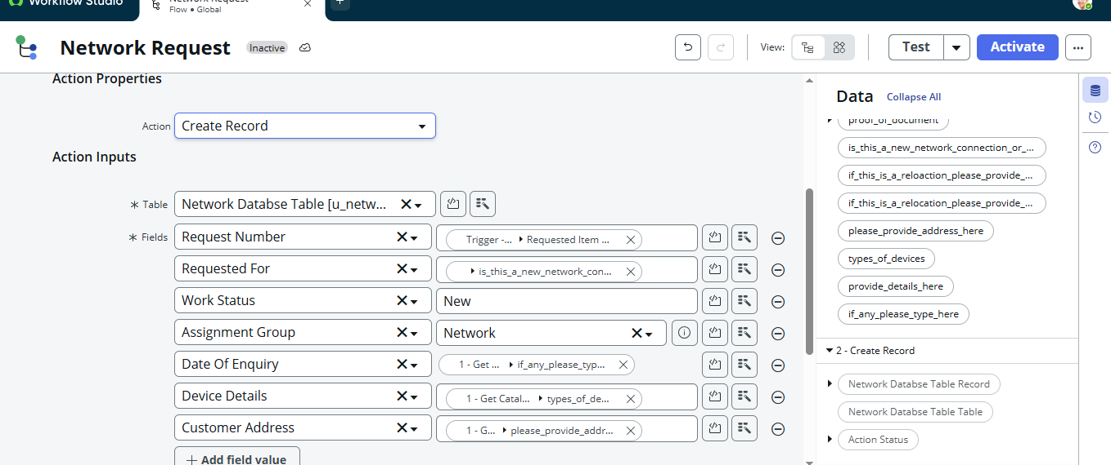

### Step 6: Send Email Action

An automated email notification is sent to the requester with request details.  
 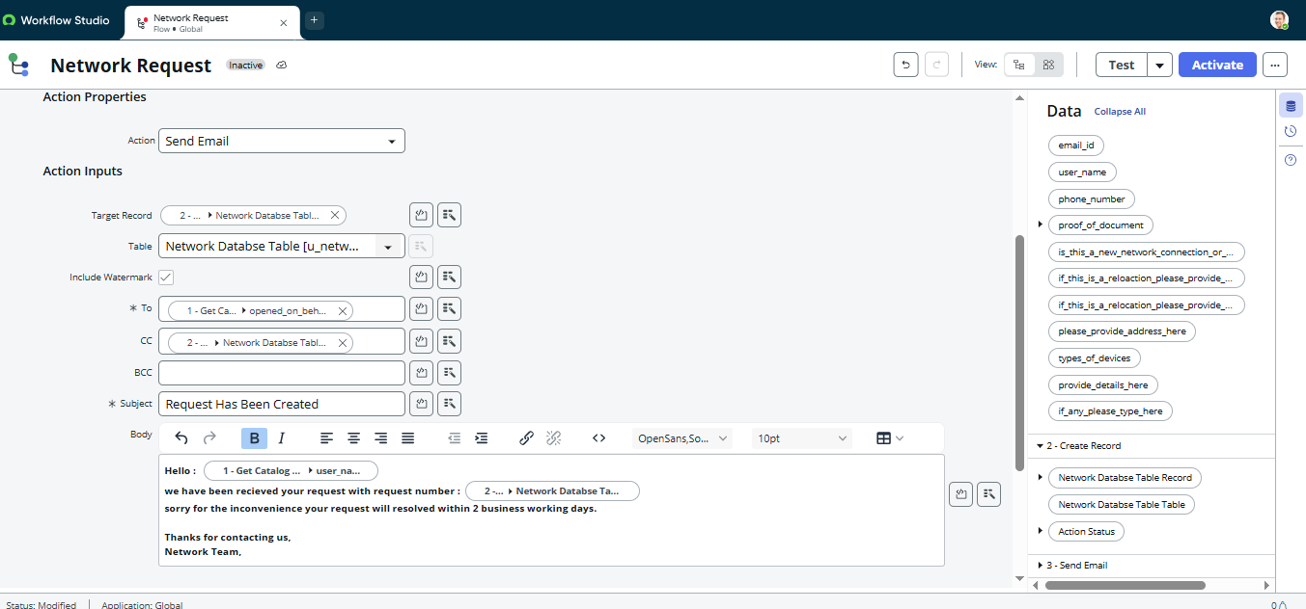

### Step 7: Ask for Approval Action

The request is routed to the **Approver (Manager/Network Admin)** for authorization.  
 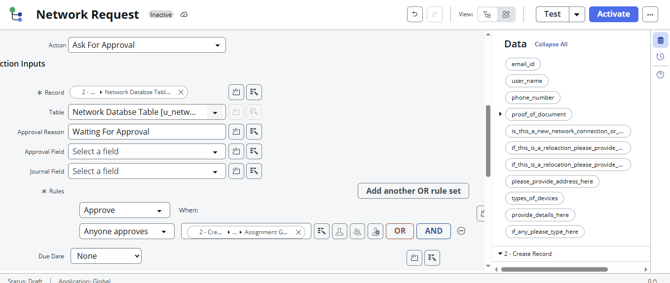

### Step 8: Conditional Flow Logic

Based on approval:

1. **If Approved → Proceed with request fulfillment**.
2. **If Rejected → Notify requester with reason**.  
   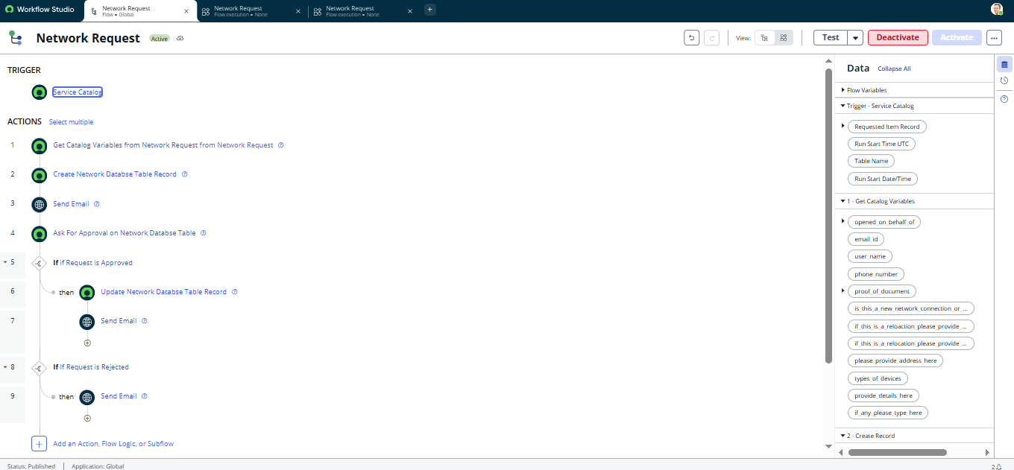

### Step 9: Update Record Action

The record is updated with the latest status (Approved/Rejected).  
 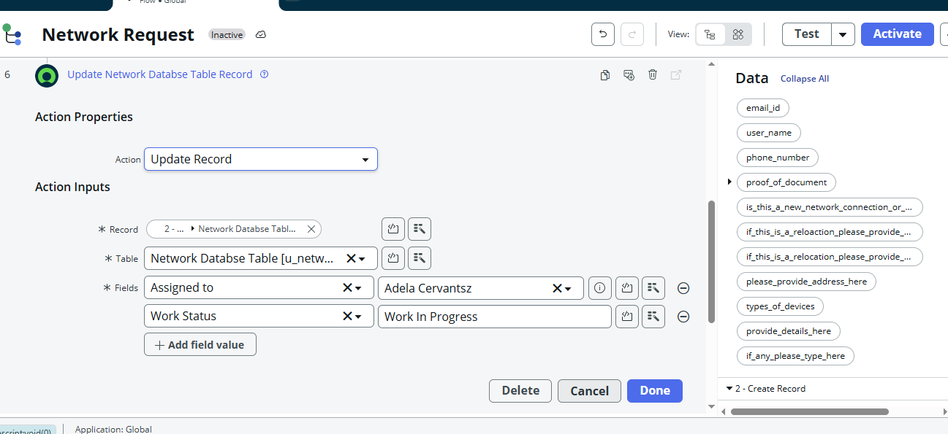

### Step 10: Final Flow Design

The complete workflow is now automated end-to-end.  
 

## Results

1. Users can now raise network requests directly from the catalog.
2. Each request is automatically logged, tracked, and routed.
3. Approvals and notifications are **fully automated**.
4. Manual effort and errors are significantly reduced.  
   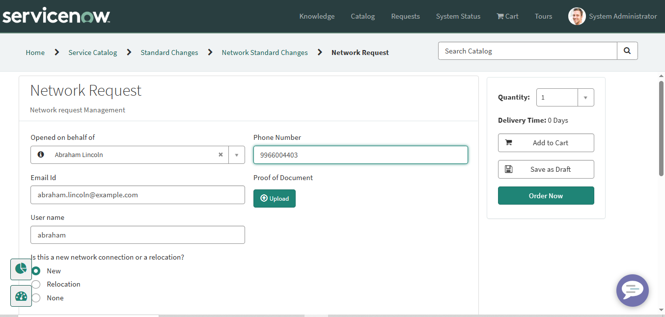

## Conclusion

The project successfully demonstrates the **automation of network requests in ServiceNow**. By leveraging **Catalogs, Variables, Flow Designer, Approvals, and Notifications**, the system ensures faster resolution, transparency, and standardization.

This implementation can be scaled across other IT service requests like hardware provisioning, software installations, and employee onboarding.

## Future Enhancements

1. **Integration with CMDB** – Automatically update configuration items linked to requests.
2. **SLA Tracking** – Attach Service Level Agreements for timely fulfillment.
3. **Chatbot Integration** – Allow employees to raise requests via a virtual agent.
4. **Reporting Dashboard** – Provide real-time analytics on request trends.

## References

1. ServiceNow Documentation – https://docs.servicenow.com/