**Objectives:**

**•** We have to learn how to connect series and parallel element on a breadboard.

**•** We have to validate the voltage and current divider rules.

**•** We have to verify Kirchhoff’s laws.

**Equipments:**

**•** Trainer Board.

**•** Digital Multimeter.

**•** 2×1kΩ resistors.

**•** 1×3.3kΩ resistor.

**•** 1×4.7kΩ resistor.

**Theory:**

**•** Series Circuit:

A circuit is any combination of elements that will result in a continuous flow of charge or current through the configuration. The direction of conventional current in a series circuit is such that it leaves the positive terminal of the power supply and returns to the negative terminal of the power supply. The current is same at any point of the series circuit. The total resistance of a series configuration is the sum of the resistance levels.

*Rt = R1 + R2* + *R3……….Rn.*

The more resistors we add in series, the greater is the resistance, no matter what their value. In a series configuration, maximum power delivered to highest resistor.

• Parallel Circuit:

In general two nodes, elements, branches are in parallel if they have two points in common. For resistors in parallel, the resistance is measured by this equation.

$\frac{1}{Rt}$*= $\frac{1}{R1}$ + $\frac{1}{R2}$ + $\frac{1}{R3}$ +……….+ $\frac{1}{ Rn}$*

The total resistance of parallel resistors is always less than the value of the smallest resistor. if the smallest resistance of a parallel combination is much smaller than that of the other parallel resistors, the total resistance will be very close to the smallest resistance value.

**•** Kirchhoff’s Law:

The law to be described in this section is one of the most important in this field. It has application not only to dc circuits but also to any type of signal whether it be ac, digital, and so on. The law, called Kirchhoff’s voltage law (KVL):

The algebraic sum of the potential rises and drops around a closed path (or closed loop) is zero.

$∑↻ V=0$.

Kirchhoff is also credited with developing the following equally important relationship between the currents of a network, called Kirchhoff’s current law (KCL):

The algebraic sum of the currents entering and leaving a junction (or region) of network is zero. The sum of the currents entering a junction (or region) of a network must equal the sum of the currents leaving the same junction (or region)

The above statement can be written as follows :

**∑***Ii = ∑Io*

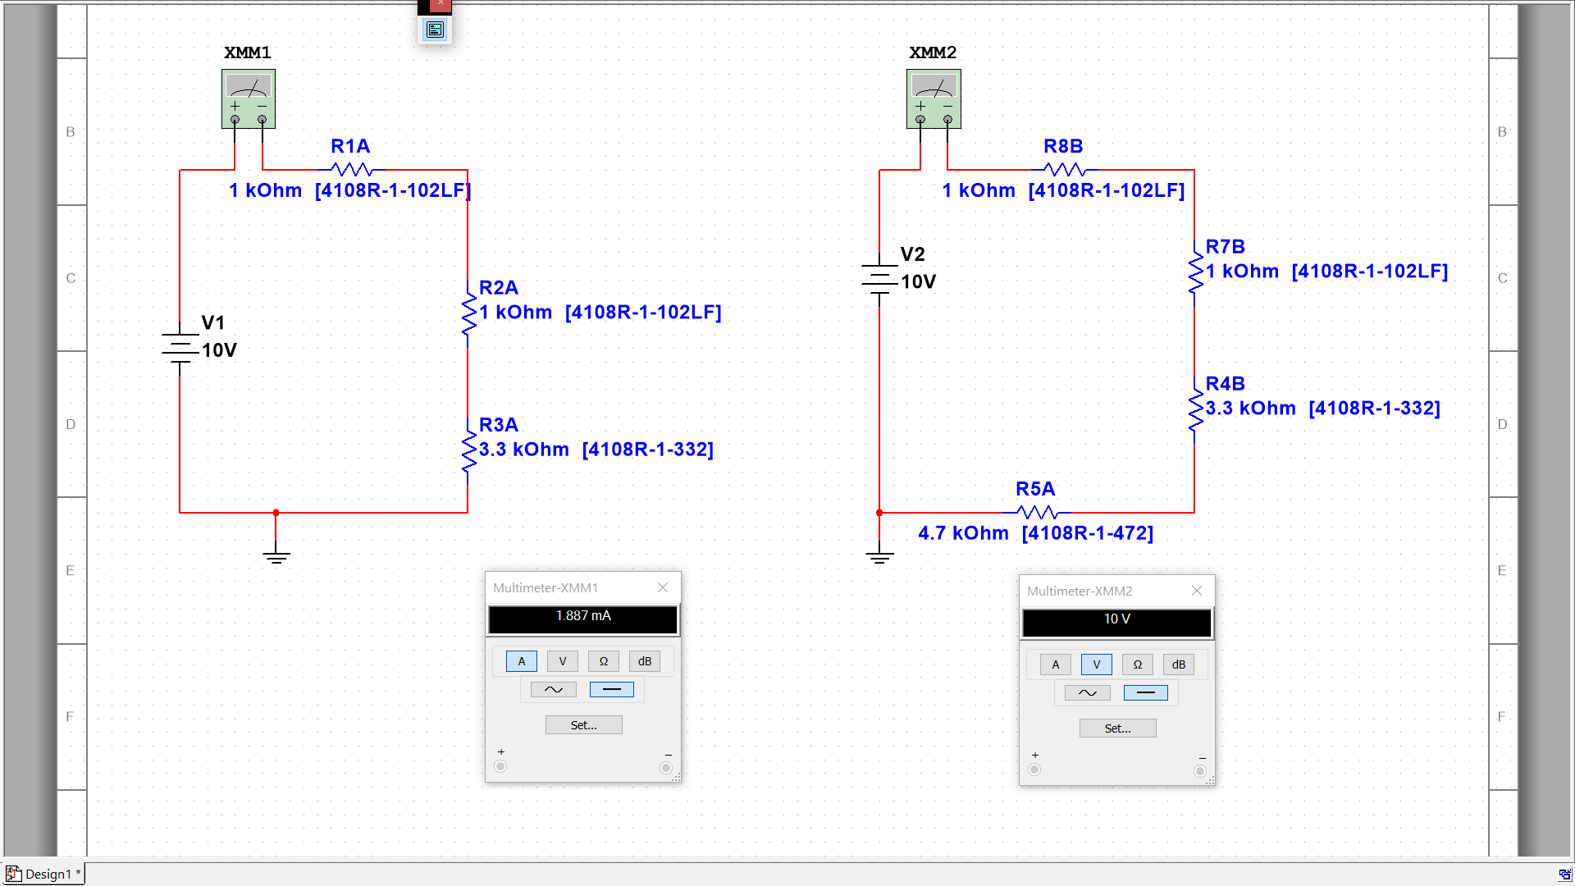

**Results:**

Finding the resistance of the resistor given in the lab using color coding.

|  |  |  |  |
| --- | --- | --- | --- |
|  | Resistance using color code | Resistance using DMM | **%**Error |
| R1 | Brown, Black, Red (Golden) 1KΩ | 1.0KΩ | 0% |
| R2 | Brown, Black, Red (Golden) 1KΩ | 1.0KΩ | 0% |
| R3 | Orange, Orange, Red(Golden) 3.3KΩ | 3.3KΩ | 0% |
| R4 | Yellow, Violet, Red (Golden) 4.7KΩ | 4.6KΩ | 2.12% |

|  |  |  |  |  |
| --- | --- | --- | --- | --- |
|  | Circuit 1 | Circuit 2 | Circuit 3 | Circuit 4 |
| Rt | 1KΩ | 2KΩ | 5.3KΩ | 9.8KΩ |
| I | 10.07mA | 5.05mA | 1.92mA | 1.02mA |
| E | 10.07V | 10.07V | 10.07V | 10.07V |
| Vr1 | 10.07V | 5.05V | 1.92V | 1.02V |
| Vr2 |  | 5.02V | 1.92V | 1.01V |
| Vr3 |  |  | 6.24V | 3.31V |
| Vr4 |  |  |  | 4.72V |
| ∑Vdrops | 10.07V | 10.07V | 10.07V | 10.06V |

**Experiment 2**

**Equipments:**

•Trainer board.

• Digital Multimeter.

• 2×1kΩ resistors.

• 1×3.3kΩ resistor.

•1×4.7kΩ resistor.

**Results:**

|  |  |  |  |  |
| --- | --- | --- | --- | --- |
|  | Circuit 1 | Circuit 2 | Circuit 3 | Circuit4 |
| Rt | 1KΩ | 0.7KΩ | 0.4KΩ | 0.4KΩ |
| E | 10.07V | 10.07V | 10.07V | 10.06V |
| Vdrop | 10.07V | 10.07V | 10.07V | 10.06V |
| Is | 10.07 mA | 19.94 mA | 25.175 mA | 23.8 mA |
| IR1 | 10.07 mA | 10.07 mA | 10.92 mA | 9.8 mA |
| IR2 |  | 10.15 mA | 10.92 mA | 9.46 mA |
| IR3 |  |  | 3.31 mA | 2.87 mA |
| IR4 |  |  |  | 2.02 mA |

**Experiment 3**

**Equipments:**

**•** Trainer Board.

**•** Digital Multimeter.

**•** 2×1kΩ resistors.

**•** 1×3.3kΩ resistor.

**•** 1×4.7kΩ resistor.

• 1×10kΩ resistor.

**Results:**

Identifying the given resistors using color code.

|  |  |  |  |
| --- | --- | --- | --- |
|  | Resistance using color code | Resistance using  DMM | %Error |
| R1 | Brown, Black, Red 1KΩ | 1KΩ | 0% |
| R2 | Brown, Black, Orange 10KΩ | 10KΩ | 0% |
| R3 | Yellow, Violet, Red 4.7KΩ | 4.6KΩ | 2.12% |
| R4 | Orange, Orange, Red 3.3KΩ | 3.3KΩ | 0% |
| R5 | Brown, Black, Red 1KΩ | 1KΩ | 0% |
| R6 | Brown, Black, Red 1KΩ | 1KΩ | 0% |

|  |  |
| --- | --- |
| Component | Voltage |
| E | 11.97V |
| R1 | 2.53V |
| R2 | 9.44V |
| R3 | 7.45V |
| R4 | 1.98V |
| R5 | 1V |
| R6 | 0.99V |

**Discussion:**

By doing this experiments we learned how to build series circuit and parallel circuit. We also learned how to measure current and voltage in both series and parallel circuits. We have experimentally verified some fundamental and basic laws of electrical circuits. We also verified Kirchhoff’s current law and voltage law. We measured the *V*drops And *V*rises , which was equal to the total voltage. As we know from Kirchhoff’s Law *E* = *V*1 + *V*2 . That verifies Kirchhoff’s voltage law (KVL). We also verified the Kirchhoff’s current law (KCL). As we measured current in the 2nd experiment we found the that current was entering from a junction and got divided in many junctions. But the summation of current of the outer junctions were equal to the current of the entering junction. We know that current will remain same in both sides of Kirchhoff’s current law (∑*Ii* = ∑*Io*) . We found the current was same in both sides, which verifies Kirchhoff’s current law (KCL).

Some equipments were faulty in the lab, which made things really hard for us to measure the right voltage and current. Besides we saw the the percentage error for the equipments were minimal and the experimental values were close to theoretical values.

We have learned a lot of things from those experiments. It was a great achievement for all of us. And the most beautiful part was the experiments were successfully done by us.