**Experiment no:** 03

**Experiment name:**

**Objective**: Amplitude modulation is defined as the multiplication of onetime domain signal by another time domain signal. The signals may or may not be complex in nature. It is impossible to have amplitude modulation unless at least two different signals are involved. Modulation is inherently a non-linear process, and always gives rise to frequency components that did not exist in either of the two original signals.

**Discussion:** In this experiment I was learn about modulation technique. There was a horrific day for me. Nothing was right. Finally, with the help of sir, I could finish the lab. Alhamdulillah.

% DSB-sc

% Matlab code:

clear all;

close all;

clc;

%%dsb-sc

t=0:0.001:1;

vd=8*cos(2*pi*5*t);

vc=0.1*cos(2*pi*15*t);

ft=vc.*vd;

am=ft+vc;

figure(1)

plot(t,vd);

figure(2)

plot(t,vc);

figure(3)

plot(t,am);

figure (4)

plot(t,ft);

**Result:**

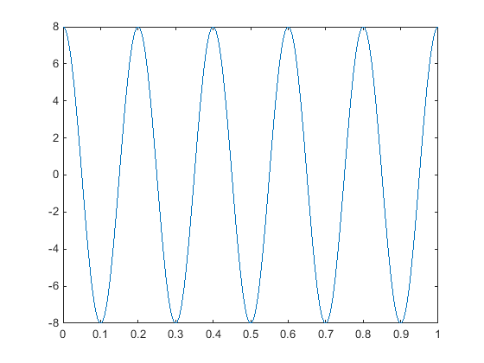

figure 1

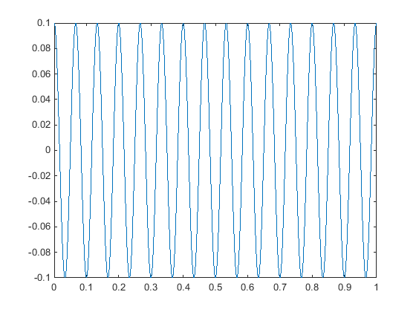

figure 2

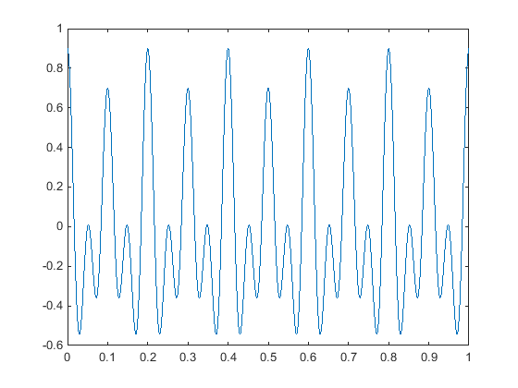

figure 3

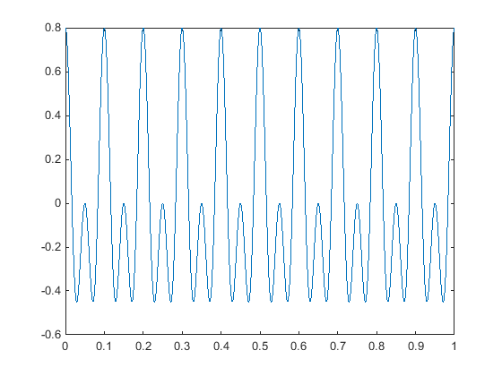

Figure 4

%% DSB-fc

Matelab code:

clear all;

close all;

clc;

%%user define

t=input('enter the value of time period:');

vm=input('enter the value of amplitude:');

vc=input('enter the value of amplitude:');

fm=input('enter the value of amplitude:');

fc=input('input enter the value of frequency:');

vm=10;

vc=5;

t=0:0.0001:0.0999;

f=1:1:999;

wc=2*pi*fc;

wm=2*pi*fm;

V1=vc+vm*sin(wm*t);

V2=-(vc+vm*sin(wm*t));

Vm=vm*sin(wm*t);

Vc=vc*sin(wc*t);

Vam=(1+sin(wm*t)).*(sin(wc*t));

vf=abs(fft(Vam,10000))/10000;

figure;

plot(t,Vam);

hold on;

plot(t,V1,'r')

plot(t,V2,'r');

xlabel('frequency');

ylabel('amplitude');

grid on;

**result**

enter the value of time period:0:0.0001:0.0999

enter the value of amplitude:10

enter the value of amplitude:5

enter the value of amplitude:5

input enter the value of frequency:100

