**Experiment** **No**: 05

**Experiment** **name**: pulse width modulation (PWM)

**Objective**:

1. To understand the basic theory of Pulse Width Modulation (PWM).

2. To understand the waveform Pulse Width Modulation (PWM) using Matlab.

% LAB 5

% pulse width modulation

clc;

clear all;

t = 0:0.001:1;

fc = input ('Enter the frequency of carrier signal ( sawtooth ) = ');

fm = input ('Enter the frequency of message signal ( sine ) = ');

a = input ('Enter the amplitude of carrier signal = ');

b = input ('Enter the amplitude of carrier signal (should be < carrier) = ');

vc = a.*sawtooth(2*pi*fc*t);

vm = b.*sin(2*pi*fm*t);

n = length(vc);

for i= 1:n

if(vm(i)>= vc(i))

pwm(i) = 1;

else

pwm(i) = 0;

end

end

subplot(3,1,1);

plot(t, vm);

xlabel ('Time _____');

ylabel ('Amplitude _____');

title (' Message Signal ');

grid on;

subplot(3,1,2);

plot(t, vc);

xlabel ('Time _____');

ylabel ('Amplitude _____');

title (' Carrier Signal ');

grid on;

subplot(3,1,3);

plot(t, pwm);

xlabel ('Time _____');

ylabel ('Amplitude _____');

title (' PWM Signal ');

axis ([0 1 0 2]);

grid on;

* For information frequency of 10Hz with 5v altitude and carrier frequency of 30Hz with 10v aptitude generate PWM result looks like

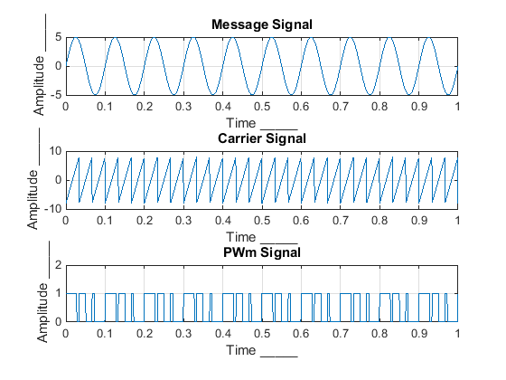

**Discussion:** pulse width modulation (PWM) is a modulation technique used to encode a message into a pulsing signal. In this case I use for information frequency of 10Hz with 5v amplitude and carrier frequency of 30Hz with 10v amplitude. No major problem facing during lab hour.