

**CSE489:** **Mobile Programming**

**Project Report**

**DeliveryJet: Optimal Delivery Service Platform**

**Course Code:** CSE489

**Section:** 1

**Submitted by:**

**Name:** Sumona Yeasmin

**ID:** 2018-2-60-062

**Submitted to:**

Md Mostafa Kamal Rasel

Assistant Professor

East West university

**TABLE OF CONTENTS**

|  |  |
| --- | --- |
| Topic | Page |
| 1. Introduction | **3** |
| 1. Motivation | **3-4** |
| 1. Features | **4-12** |
| 1. Benefits | **12-13** |
| 1. Conclusion and Future Plan | **13-14** |

1. **Introduction**

DeliveryJet is a digital delivery service App that optimizes the delivery of orders and services to customers. The App can optimize the delivery based on the minimum distance of Company location, Customer address, and Delivery person’s address. DeliveryJet has an intelligent algorithm that schedules the delivery of the orders and service dynamically, which is efficient and convenient for both customers, companies, and delivery persons.

There are two types of users in this application. These are companies and delivery persons. With this App, the companies can create orders and update their list of orders and services. They can also give emails to customers about order information while attaching delivery person information into the orders. Once the company creates the order, the App assigns a delivery person to deliver the order to its appropriate address. This delivery person assignment is done by an intelligent algorithm that calculates the distance between each delivery person’s address, customer address, and company address. The delivery person with the minimum distance overall is selected to deliver the service. The App ensures optimal delivery services keeping in mind the factors such as customers satisfaction and high throughput of delivery persons.

1. **Motivation**

DeliveryJet is developed, aiming to achieve customer satisfaction through intelligent delivery services in an optimized way. The motivation to build such a system is listed below.

* If a company wants to place an order to any courier, they must send their person to the courier office to post the order, and then the process will start. It is a hassled and time-consuming process. By using this App, the company can set their order details. After assigning it, it will automatically inform the suitable delivery person to collect the order and deliver it to the customer's address.
* Once a product is ordered, there could be an unexpected delay because of the distant locations among the delivery person, company, and customer addresses. By using this App, the traveling distance will be less. Here, an order is assigned to that particular delivery person whose location is more suitable or close to both company and customer location.
* It has been observed that one of the main reasons customers unsatisfaction is delayed delivery service. This App alleviates this possibility as the company does not need to go to the courier office. The delivery person will also be assigned intelligently based on the distance need to be travelled.
* Last but not least, DeliveryJet aims to deliver orders in a secured manner. The company will assign a code to the order and send the code along with the delivery person’s information to the customer's email address through the App. Once the order is delivered, the delivery person must enter the code given by the customer, ensuring the guaranteed delivery of the order that it would not be lost in the way.

1. **Features**
   1. **User Registration**

The home page of the DeliveryJet App contains the provision of user registration (see Figure 1). There are two types of users in our App. Among them, the following type of users must register to use the application.

1. Company
2. Delivery Persons

**Scenario:** New users must register to the system. Once the user installs or opens the DeliveryJet App, the home page will appear. The home (landing) page provides forms to register different types of users.

Figure 1: Screenshot of User Registration

* 1. **User Authentication**

Users must sign in to the App to use it. Figure 2 shows the interface to sign in.

**Scenario:** On the home page, there is an option to sign in. Since the user's data is sensitive, it must be protected, and therefore, the user needs to enter the username and the password and user type accordingly to log in to the App. There are two types of users in the application, as mentioned in Section 3.1. We discuss the authentication mechanism for each kind of user below.

1. *Company user:*

Input: Email address, Password, User type

Output: Authentication, access to company-specific pages and editing profile page, adding and editing order and logout option.

1. *Delivery Person user:*

Input: Email address, Password, User type

Output: Authentication, access to a delivery person-specific pages and editing profile page, seeing order details, update order state and logout option.

Figure 2: Screenshot of User Authentication

* 1. **Company Feed**

Companies can see the order list after logging in to the App. Figure 3 shows the interface. Companies can see the basic information like Order Id, Due date, and status such as ‘Assigned,’ ‘Unassigned,’ and ‘Delivered’ of a particular order. Companies can also delete the orders by pressing a long click on any order in the list.

Figure 3: Screenshot of Company Feed

* 1. **Editing Company Profile**

Companies can edit their profile information once they sign in to the App (see Figure 4).

**Scenario:** After logging in to the App, company users can edit their details. The company profile includes the following fields.

1. Company Logo
2. Full Name
3. Password
4. Address
5. Website
6. Contact No.

The company user can update the data mentioned above.

Figure 4: Screenshot of Company Profile

* 1. **Editing Delivery Person Profile**

Delivery persons can edit their profile information once they sign in to the application. Figure 5 shows the interface.

**Scenario:** After logging in to the application, delivery person users can edit their details. The delivery person profile data includes the following fields.

1. Image
2. Full Name
3. Official Document Type (Passport/NID/Driving License)
4. Official Document Number
5. Address
6. Contact No
7. Gender

The delivery person user can update the data mentioned above.

Figure 5: Screenshot of Delivery Person Profile

* 1. **Creating Order information by Companies**

Companies can create and edit order information through their account.

**Scenario:** After logging in to the application, a company user can create/edit order information. The company user should choose the option of Create New Order from the navigation menu and then create new orders with the following fields.

1. Order Id
2. Order Details
3. Order Weight
4. Order Due Date
5. Order Code
6. Customer Name
7. Customer Email Address
8. Customer Address
9. Customer Contact No

After creating the order, the relevant order information is displayed in the company user feed. As shown in Figure 6, the order is still unassigned.

Later, the company user can also edit the unassigned order. Companies can see the order information of all assigned, unassigned, and delivered orders.

Figure 6: Screenshot of Order Creation

* 1. **Order Assigning**

After clicking the ‘Assign’ button, the order will be assigned to a registered delivery person whose address is the closest to it by considering the company address and the customer address. Google Maps APIs are used to find the distance between two locations for this purpose. A delivery person can see the orders assigned to him in his feed. Figure 7 shows the corresponding interface of the App.

Also, the company can send an email about order information via this App while assigning the order.

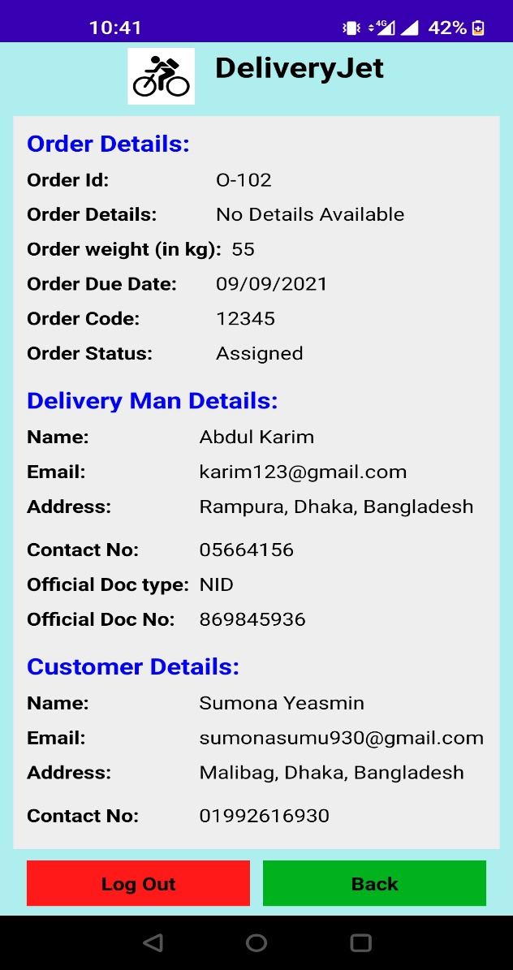

Figure 7: Screenshot of the Order with status ‘Assigned’

* 1. **Delivery Confirmation**

The Delivery person can see order details by clicking on any order. Once an order is delivered, the delivery person will enter the code given to the recipient (see Figure 8). It works as the delivery confirmation, and the corresponding order will be removed from their service lists. Figure 9 shows the delivery confirmation interface.

|  |  |
| --- | --- |
| Figure 8: Screenshot of Entering Delivery Code | Figure 9: Screenshot of Delivery Confirmation |

The App will also change the status of the order when it is successfully delivered. The order status will now change from ‘Assigned’ to ‘Delivered,’ which is accessible from the company user feed. Figure 10 shows the screenshot of the order status changing.

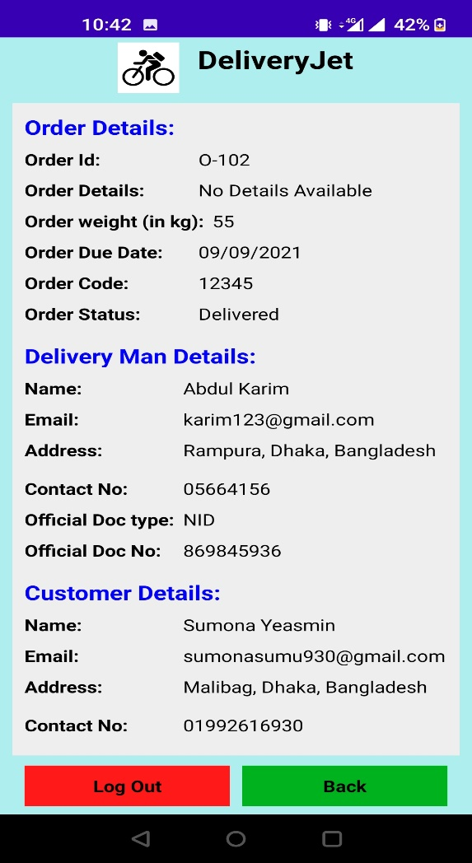

Figure 10: Screenshot of the Order with status ‘Delivered’

1. **Benefits of the App**

DeliveryJet app is a valuable App for courier service systems. Any courier service system or a company can be benefited in many ways through this App.

DeliveryJet provides appropriate user access control for different types of users. It also offers password-protected login for every user. User access control ensures that no user can see or misuse other user’s information without login access.

We have also used a smooth UI that allows users to have a comfortable environment while using this App. The App is intuitive, easy to navigate and understand. Besides, this App does not access any user's personal information, so the user will feel safe using this App.

This App provides a digital courier service system. Thus, the company or delivery person does not need to physically go to the courier office to know about the order information or track. A company can create and edit its order with straightforward steps to fill a user-friendly form and click some buttons. The company also can track the order status, see the history of orders, and delete unnecessary order information if they need. The company can also send order information to the customer (recipient) by clicking a button; they do not need to write a mail using a separate email service. Instead, the App will generate an email for them to be sent.

Delivery persons can access orders assigned to them. They can see order details, company details as well as customer details in their feed. They can confirm order delivery through a unique code given to the customer beforehand through this App. The company can also see and monitor the status of different orders.

The primary benefit of this App is the optimal order assignment. In a manual system, we need human resources to analyze which order we should assign to which delivery person. This App solves this issue in an automated process. Orders will be automatically assigned to the most suitable delivery person through this App by considering the delivery person's location, company location, and customer location. Thus, the need for human resources will be less, and the delay and hassle of delivery will be minor.

1. **Conclusion and Future Plan**

DeliveryJet App is mainly created targeting the courier service organization to make their life easier. It is a digital courier system service by which the courier company does not need a physical office cost and extra workforce cost. Moreover, the company that will post orders to deliver to the customer does not need to send the package physically and fill in order information. The delivery person can access the assigned order information without being present in the main office. Customers will have the order within less time as the order assignment is an optimal automated process. By using the DeliveryJet App, all the users will have benefits, and the security of users is highly preserved.

In the era of Smartphones, an Android phone is available in every hand. Downloading an app is the easiest way. DeliveryJet app is easy to have by searching in any app store and downloading it but solves so many issues in an optimal way in less time. As it works based on algorithms, it is more trustable than newly appointed people.

In the future, I will try to increase the features, which will be more helpful. I have a plan to create an admin-type user who will observe the rest users, and if any mishaps happen or any fake user misuse, the app admin will delete the user account and restrict that user from using the App. I am also planning to make the algorithm more advanced and intelligent by considering different delivery addresses of customers on different weekdays and times, which will be matched with the delivery person’s availability and preferred area. Moreover, storing the user information in private secured cloud storage could be another way to extend the App. In that case, the newly created or modified data could be broadcast to the relevant group of users. Therefore, the App would be more synced with all the users and provide maximum friendliness and satisfaction.