

Subject: Software Engineering Lab
Group No.: 10
Topic: Shop Inventory Management System
Members:
Sreemoyee Ghosh (Roll – 28)
Suvajit Debnath (Roll – 29)
Koushiki Kundu (Roll – 43)
Sumona Bhattacherjee (Roll – 44)

Shop Inventory Management System – Use Case Diagram Documentation

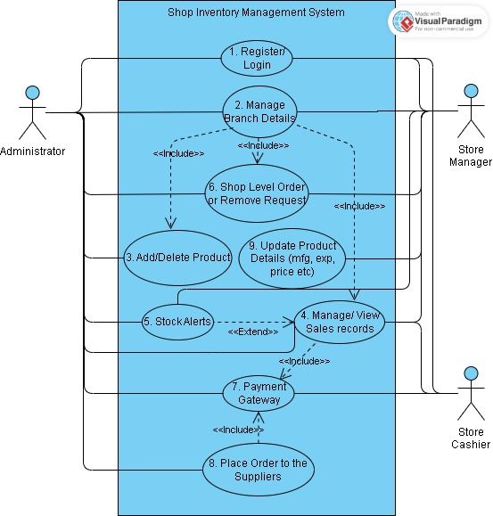
Figure 1: Use Case Diagram

Actors
An actor represents an external entity (person, group, or system) that interacts with the system.
As shown in Figure 1, the actors involved are:
- Administrator/ Admin:
Checks stock records of all the stores, analyzes sales trends across different locations, stores and products. Adds new items, replenish low stocks upon notified or removes dead stocks upon store manager's request or by will. Places order to suppliers and monitors the inventory.

- Store Manager:
Checks day-to-day branch-level stock records, places product order or removal requests to the admin based on the current stocks. Monitors and verifies the sales record of the respective branches.

- Store Cashier:
Generates bills and records payment methods, manages sales and return transactions, updates customer details, and provides transaction reports to the store manager. Ensures accurate inventory updates and supports day-to-day financial operations within the system.

Use Cases
A use case is a description of how actors interact with the system to achieve a particular goal or perform a specific task.
The use cases depicted in Figure 1 are as follows:
- Register/ Login:
- Actors: Administrator Store Manager, Store Cashier
- Functionality:
This use case allows system users (Administrator, Store Managers, and Store Cashiers) to securely access the Shop Inventory Management System. Users register themselves in the system by creating login credentials for first-time access. Existing users log in with their credentials to securely enter the system. The system provides role-based access where Admin, Store Manager, and Store Cashier can only access the functionalities assigned to their respective roles.
The role hierarchy is Administrator → Store Manager → Store Cashier.
This means the Administrator has the highest authority, registers all Store Managers, and can remove or disqualify them if necessary. Similarly, Store Managers manage Store Cashiers and have the authority to register or remove them as well.

- Manage Branch Details:
- Actor: Administrator
- Functionality:
The Administrator can view and manage overall stock information across all the branches including the inventory stored in central hub and can also view the Store Manager and location details.
The Administrator can monitor branch wise stock details, analyse sales records of different stores and products, place stock orders to the suppliers depending on overall inventory requirements and distributes the incoming stocks to the respective branches after storing a fraction of it in the central hub.

- Add/Delete Product:
- Actor: Admin
- Functionality:
The Administrator adds new products to the existing inventory centrally to all branches or to specific branches for new launches and removes certain products (for example dead stocks) from either at the request of the store manager or based on his own decision after analysing the sales trends.

- Manage/View Sales Record:
- Actors: Administrator, Store Manager, Store Cashier
- Functionality:
Store cashier records each sale or returns in the system, which automatically updates the stock details. The system generates a graphical view of sales for better analysis. The store manager reviews and verifies the sales records of the respective branch, while the admin can view overall sales records across all branches. Updated stock information based on sales can also trigger low-stock alerts to the store manager and admin.

- Stock Alerts:
- Actors: Administrator, Store Manager
- Functionality:
The system monitors product quantities against predefined minimum stock levels (lower bounds). If the available quantity of any product falls below or equals its lower bound, the system automatically generates a stock alert and notifies the Administrator and the Store Manager. Store Manager can review the alerts and may request Administrator for stock replenishment or the Administrator can also review the alerts and take necessary steps to replenish the stocks.

- Shop Level Order or Remove Request:
- Actors: Store Manager, Administrator
- Functionality:
This use case allows the Store Manager of respective stores to raise requests to Administrator for ordering additional stock or removing unwanted (discontinued)/expired products at the branch level. It ensures that the store inventory is always updated with the correct and sufficient stock levels. Administrator then fulfil order requests after analysing and verifying the sales report.

- Payment Gateway:
- Actor: Administrator, Store Manager, Store Cashier
- Functionality:
Store cashier generates bills, records customer details, their payment methods and updates sold or returned product stocks. Store manager reviews the updated stock details and cash flow details entered by the cashier. The admin also uses this integrated payment gateway to pay suppliers.

- Place Order to the Suppliers:
- Actor: Administrator
- Functionality:
This use case enables the Administrator to place purchase orders directly to the suppliers whenever stock needs replenishment. It includes coordination and is integrated with the Payment Gateway to process payments securely and ensures smooth resourcing of stocks.

- Update product details (mfg, exp, price, etc.):
- Actor: Store Manager
- Functionality:
This use case allows the Store Manager to update essential product details such as manufacturing date, expiry date, and pricing information. It helps maintain accurate product/stock database in the inventory system, which is crucial for both sales and stock management in order to avoid any confusion about the current stock details.

