Group Assignment 3
(DFD, Structure Chart & Data Dictionary)

Subject: Software Engineering Lab
Group No.: 10
Topic: Shop Inventory Management System
Submitted by:
Sreemoyee Ghosh (Roll - 28)
Suvajit Debnath (Roll - 29)
Koushiki Kundu (Roll - 43)
Sumona Bhattacherjee (Roll - 44)

Data Flow Diagrams

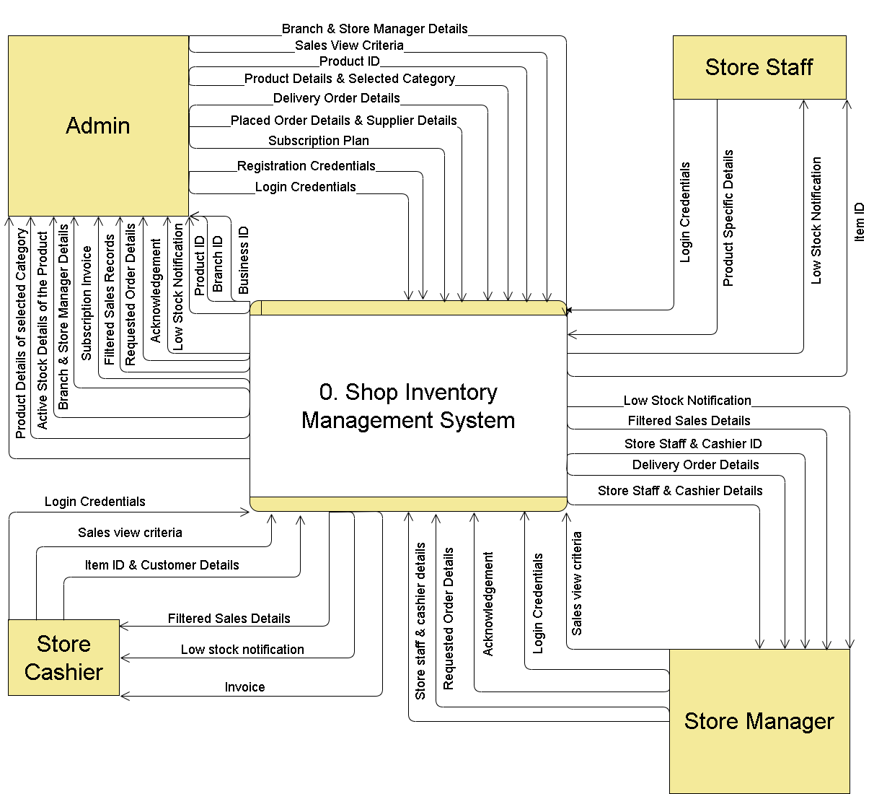
DFD - Level 0

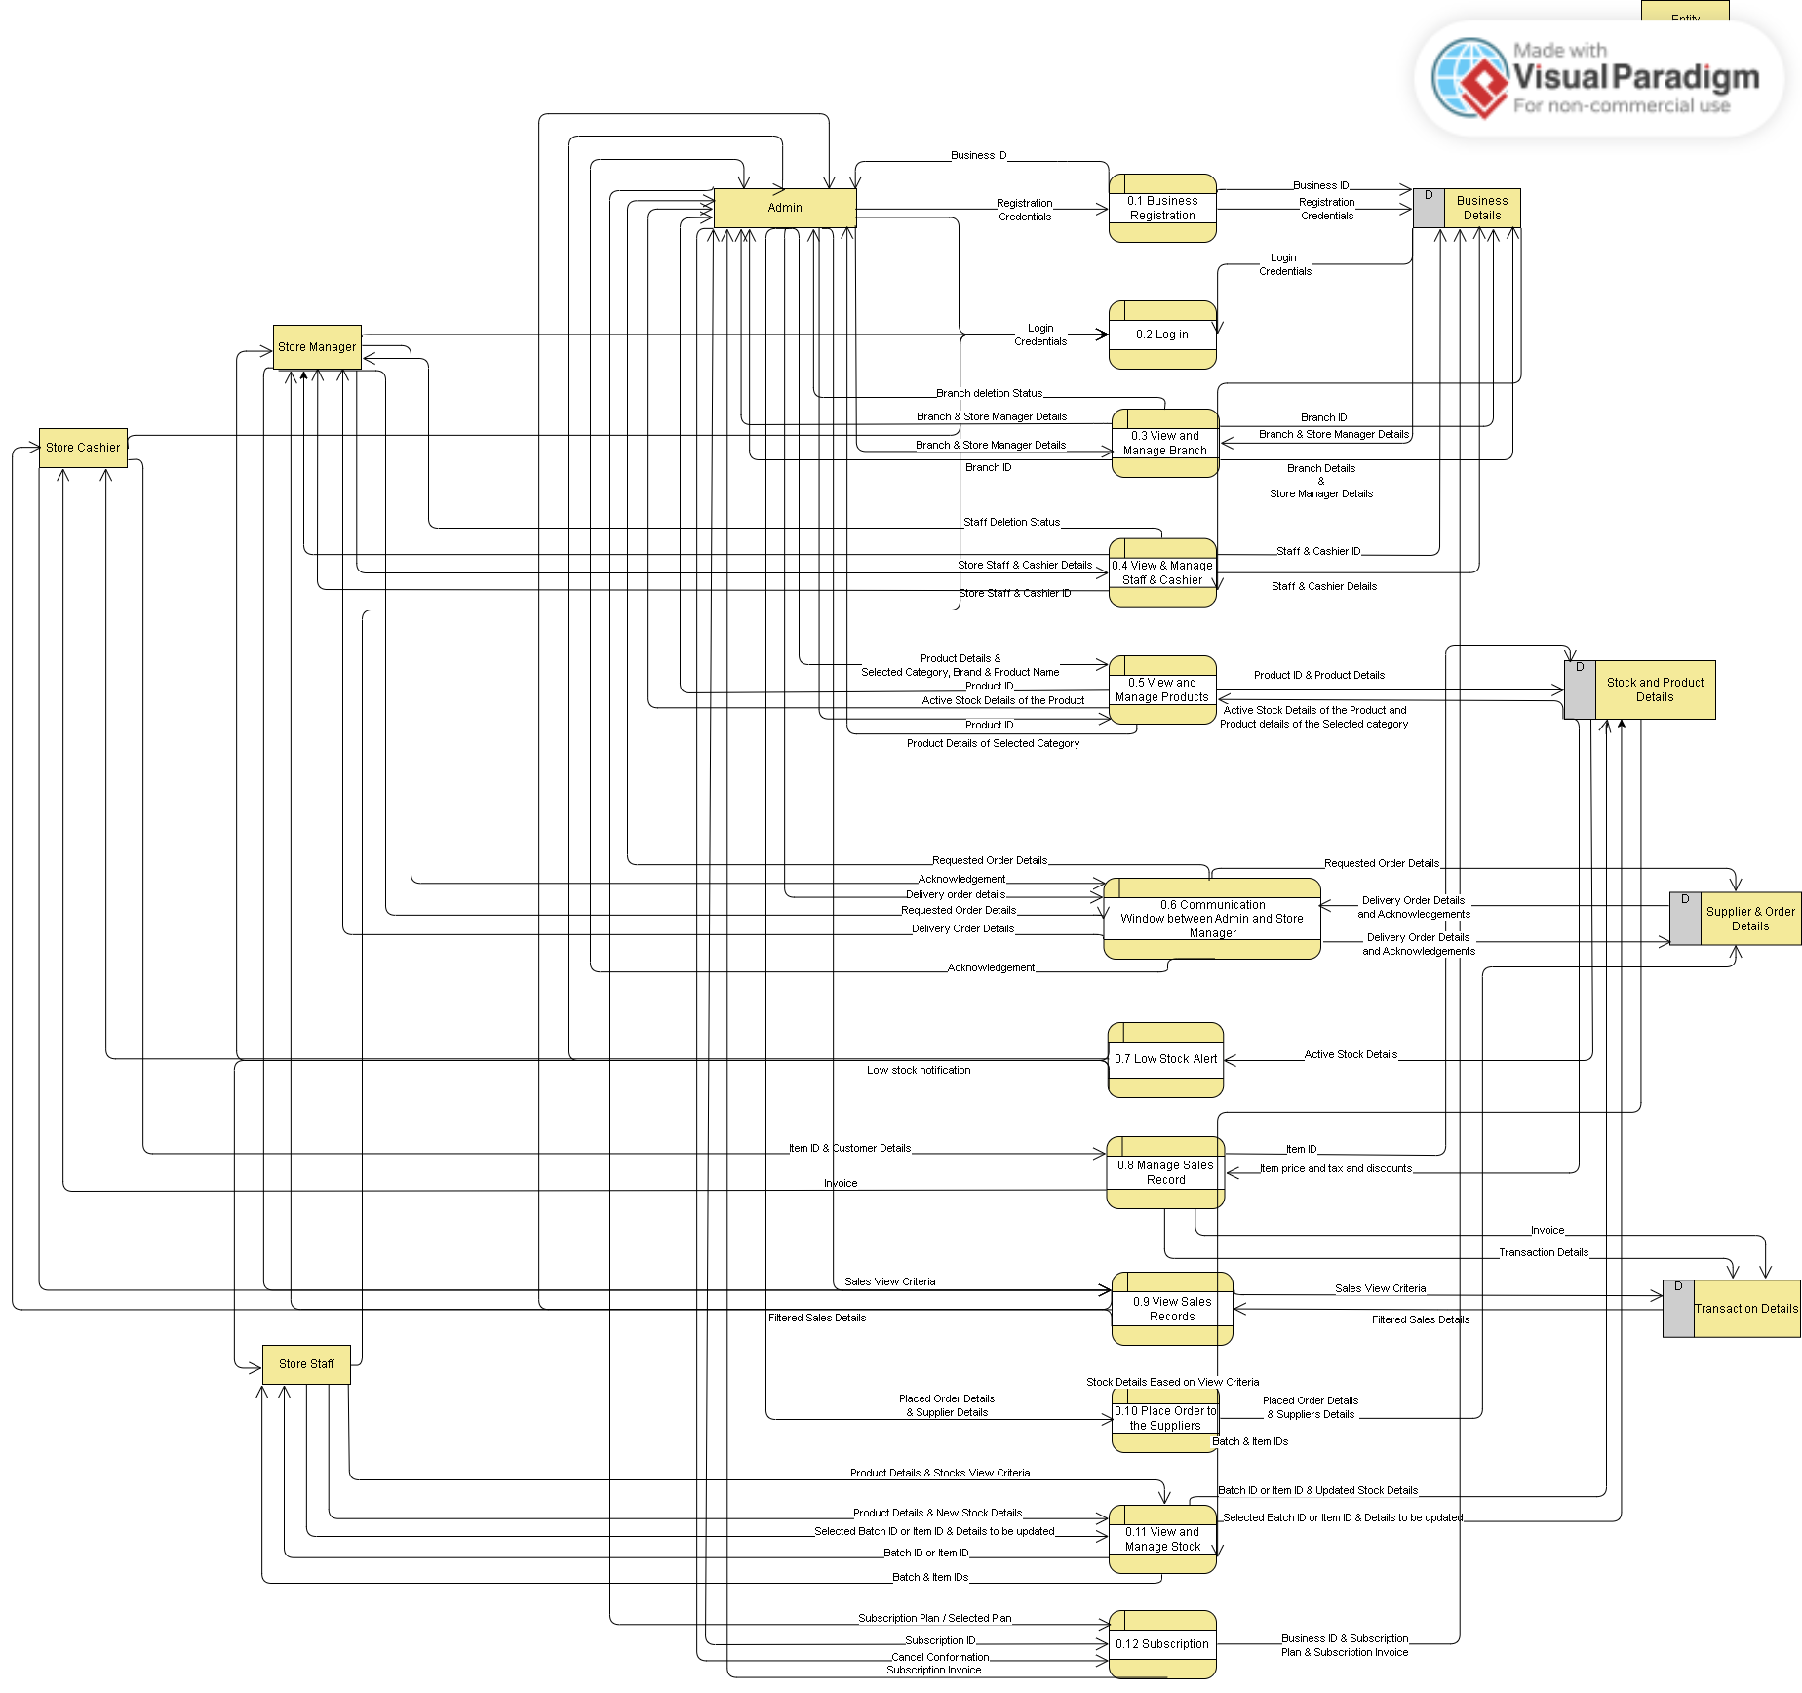
DFD - Level 1

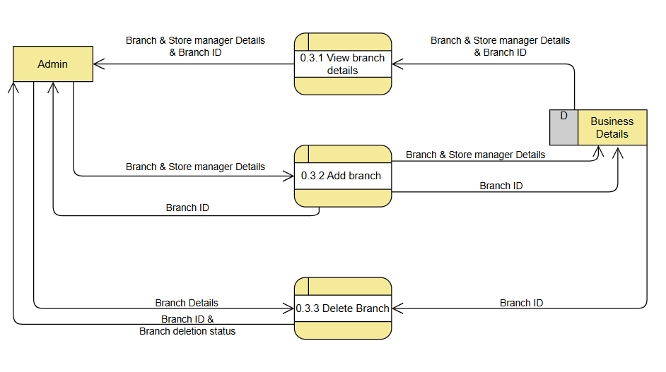DFD - Level 2 (Process 0.3)
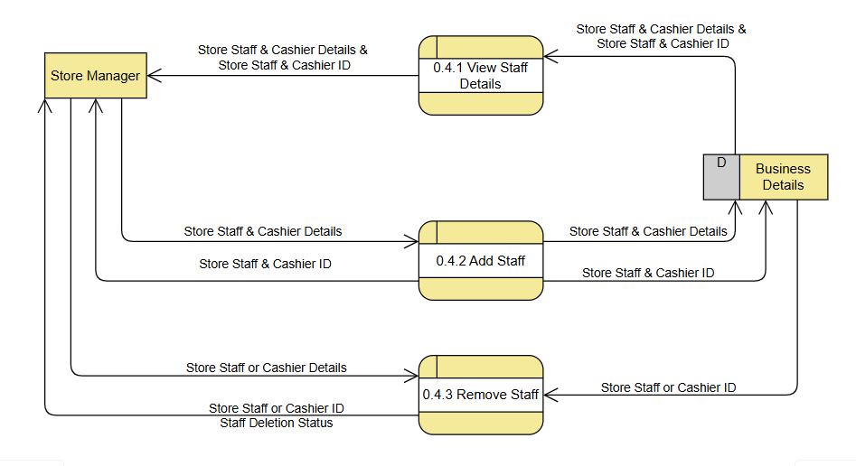
DFD - Level 2 (Process 0.4)

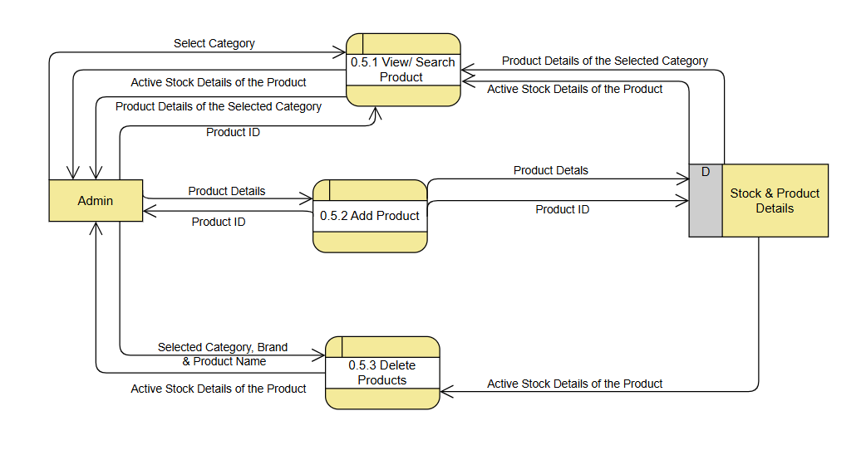

DFD - Level 2 (Process 0.5)
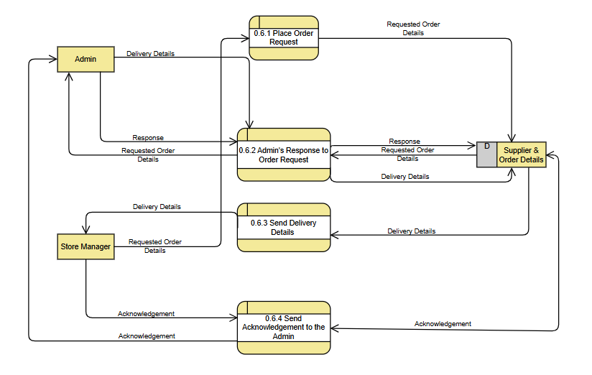
DFD - Level 2 (Process 0.6)

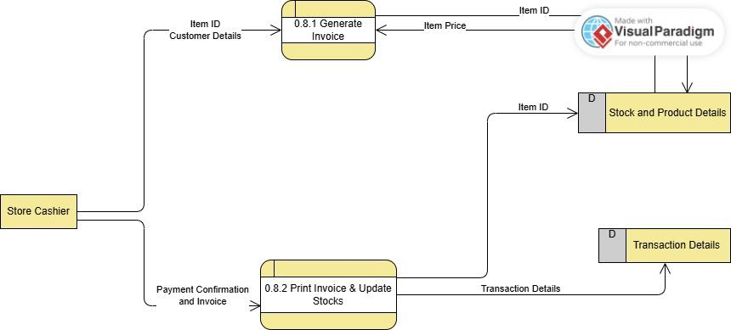
DFD - Level 2 (Process 0.8)

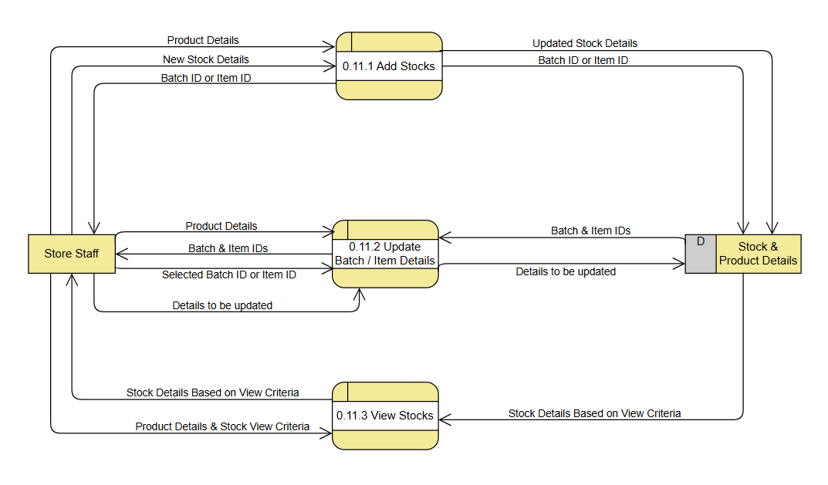
DFD - Level 2 (Process 0.11)

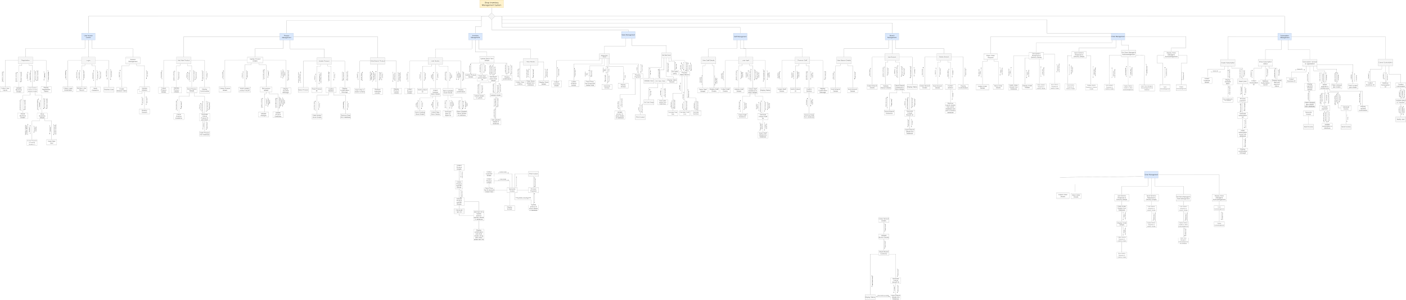
Structure Chart Link (draw.io)
Structure Chart

Data Dictionary

Class No. | Data Class | Serial No. | Data Field Name
1 | Registration Credentials | 1.1 | Business_Name
 |  | 1.2 | Business_Email
 |  | 1.3 | Primary_Phone_No
 |  | 1.4 | Password
 |  | 1.5 | Primary_Address
2 | Business ID | 2.1 | Business_ID
3 | Login Credentials | 3.1 | Business_ID
 |  | 3.2 | Branch_ID
 |  | 3.3 | User_Type
 |  | 3.4 | Personal_ID
 |  | 3.5 | Password
4 | Branch Details & Store Manager Details | 4.1 | Branch_Address
 |  | 4.2 | Branch_Name
 |  | 4.3 | Branch_Phone_No
 |  | 4.4 | Branch_Email
 |  | 4.5 | Store_Manager_Phone_No
 |  | 4.6 | Store_Manager_Email
 |  | 4.7 | Store_Manager_Name
 |  | 4.8 | Password
5 | Branch ID | 5.1 | Branch_ID
6 | Staff & Cashier Details | 6.1 | Staff_Type
 |  | 6.2 | Store_Staff_Name
 |  | 6.3 | Cashier_Name
 |  | 6.4 | Store_Staff_Email
 |  | 6.5 | Cashier_Email
 |  | 6.6 | Store_Staff_Phone_No
 |  | 6.7 | Cashier_Phone_No
 |  | 6.8 | Password
7 | Store Staff or Cashier ID | 7.1 | Store_Staff_ID
 |  | 7.2 | Cashier_ID
8 | Product Details | 8.1 | Product_Category
 |  | 8.2 | Brand_Name
 |  | 8.3 | Product_Name
 |  | 8.4 | Low_Stock_Threshold
9 | Product ID | 9.1 | Product_ID
10 | Active Stock Details | 10.1 | Product_Category
 |  | 10.2 | Brand_Name
 |  | 10.3 | Product_Name
 |  | 10.4 | Product_ID
 |  | 10.5 | Product_Quantity
11 | Requested Order Details | 11.1 | Request_ID
 |  | 11.2 | Requirement_Date
 |  | 11.3 | Date
 |  | 11.4 | Branch_ID
 |  | 11.5 | Product_ID
 |  | 11.6 | Product_Quantity
12 | Placed Order Details | 12.1 | Order_ID
 |  | 12.2 | Expected_Delivery_Date
 |  | 12.3 | Date
 |  | 12.4 | Product_ID
 |  | 12.5 | Product_Quantity
 |  | 12.6 | Supplier_Name
 |  | 12.7 | Supplier_Phone_No
 |  | 12.8 | Supplier_Email
13 | Acknowledgement | 13.1 | Order_ID
 |  | 13.2 | Delivery_Date
 |  | 13.3 | Delivered_With_Error
 |  | 13.4 | Description_Of_Errors_In_Delivery
14 | Low Stock Notification | 14.1 | Branch_ID
 |  | 14.2 | Product_ID
 |  | 14.3 | Product_Quantity
 |  | 14.4 | Alert_Date
15 | Item ID & Customer Details | 15.1 | Customer_Name
 |  | 15.2 | Customer_Contact
 |  | 15.3 | Item_ID
 |  | 15.4 | Date
16 | Invoice | 16.1 | Customer_Name
 |  | 16.2 | Customer_Contact
 |  | 16.3 | Item_ID
 |  | 16.4 | Item_Price
 |  | 16.5 | Product_ID
 |  | 16.6 | Product_Quantity
 |  | 16.7 | Taxes
 |  | 16.8 | Discount
 |  | 16.9 | Amount_Payable
 |  | 16.10. | Date
 |  | 16.11. | Branch_ID
 |  | 16.12. | Branch_Address
17 | Sales View Criteria | 17.1 | Branch_ID
 |  | 17.2 | Product_Category
 |  | 17.3 | Brand_Name
 |  | 17.4 | Product_Name
 |  | 17.5 | Product_ID
 |  | 17.6 | Price_Lower_Limit
 |  | 17.7 | Price_Upper_Limit
 |  | 17.8 | Timespan_Range_Type
 |  | 17.9 | Timespan_Lower_Limit
 |  | 17.10. | Timespan_Upper_Limit
18 | Filtered Sales Details | 18.1 | Branch_ID
 |  | 18.2 | Product_Category
 |  | 18.3 | Brand_Name
 |  | 18.4 | Product_Name
 |  | 18.5 | Product_ID
 |  | 18.6 | Price_Lower_Limit
 |  | 18.7 | Price_Upper_Limit
 |  | 18.8 | Timespan_Range_Type
 |  | 18.9 | Timespan_Lower_Limit
 |  | 18.10. | Timespan_Upper_Limit
 |  | 18.11. | Total_Sales
 |  | 18.12. | Most_To_Least_Selling_Product_Category
 |  | 18.12. | Most_To_Least_Selling_Brand_Name
 |  | 18.13. | Most_To_Least_Selling_Product_Name
 |  | 18.14. | Most_To_Least_Selling_Timespan
19 | ItemSpecific Details | 19.1 | Item_ID
 |  | 19.2 | Item_Manufacture_Date
 |  | 19.3 | Item_Expiry_Date
20 | Product Specific Details | 20.1 | Product_ID
 |  | 20.2 | Product_Price
 |  | 20.3 | Product_Material
 |  | 20.4 | Taxes
 |  | 20.5 | Discount
21 | Subscription Plan | 21.1 | Plan_Type
22 | Subscription Invoice | 22.1 | Subscription_Invoice_ID
 |  | 22.2 | Business_ID
 |  | 22.3 | Business_Name
 |  | 22.4 | Business_Email
 |  | 22.5 | Primary_Phone_No
 |  | 22.6 | Plan_Type
 |  | 22.7 | Subscription_Start_Date
 |  | 22.8 | Subscription_End_Date
 |  | 22.9 | Subscription_Duration
 |  | 22.10 | Payable_Subscription_Amout

Data Field Name | Data Type | Description | Modules used in | Example
Business_Name | String | Unique Business name for each registered business | Business Registration Module | “FreshMart Superstore”
Business_Email | String | Business email for authentication | Business Registration Module | “contact@freshmart.com”
Primary_Phone_No | String | Primary Phone no. for authentication | Business Registration Module | “+91-9123456789”
Password | String | User security key | Business Registration Module, Login Module | “hashed_password_123”
Primary_Address | String | Main office location | Business Registration Module | “123 Park Street, Kolkata, West Bengal, 700016”
Business_ID | String | Unique business identifier | Business Registration Module, Login Module | “BUS12345”
Branch_ID | String | Specific branch identifier | View & Manage Branch Details Module | “BR001”
User_Type | ENUM | Dropdown of users, i.e. Admin, Store Manager, Staff and Cashier | Business Registration Module, Login Module | “Admin” / “Store_Manager” / “Cashier” / “Staff”
Branch_Address | String | Branch physical location | View & Manage Branch Details Module | “Ground Floor, City Center Mall, Salt Lake, Kolkata”
Branch_Name | String | Store branch name | View & Manage Branch Details Module | “FreshMart Salt Lake Branch”
Branch_Phone_No | String | Branch contact number | View & Manage Branch Details Module | “+91-9134567890”
Branch_Email | String | Branch email address | View & Manage Branch Details Module | “saltlake@freshmart.com”
Store_Manager_Phone_No | String | Manager contact number | View & Manage Branch Details Module | “+91-9876543210”
Store_Manager_Email | String | Manager email address | View & Manage Branch Details Module | “manager.saltlake@freshmart.com”
Store_Manager_Name | String | Store manager name | View & Manage Branch Details Module | “Rahul Sharma”
Staff_Type | ENUM | Staff role category, i.e. Staff and Cashier | View & Manage Staff Details Module | “Staff” / “Cashier”
Store_Staff_Name | String | General Staff’s full name | View & Manage Staff Details Module | “Ankit Roy”
Cashier_Name | String | Cashier’s full name | View & Manage Staff Details Module | “Priya Das”
Store_Staff_Email | String | General Staff’s email address | View & Manage Staff Details Module | “ankit.roy@freshmart.com”
Cashier_Email | String | Cashier email address | View & Manage Staff Details Module | “priya.das@freshmart.com”
Store_Staff_Phone_No | String | General Staff’s contact number | View & Manage Staff Details Module | “+91-9998877766”
Cashier_Phone_No | String | Cashier contact number | View & Manage Staff Details Module | “+91-9876501234”
Store_Staff_ID | String | General Staff’s unique ID | View & Manage Staff Details Module | “GENSTF2025”
Cashier_ID | String | Cashier’s unique ID | View & Manage Staff Details Module | “CASH789”
Product_Category | String | Type of product | View & Manage Product Details Module | “Dairy Products”
Brand_Name | String | Product brand name | View & Manage Staff Details Module | “Amul”
Product_Name | String | Product name | View & Manage Staff Details Module | “Butter”
Low_Stock_Threshold | Number | Minimum stock level | View & Manage Staff Details Module | 50
Product_ID | String | Unique product ID | View & Manage Staff Details Module | “DAIRY_AMUL_BUTTER_123”
Product_Quantity | Number | Needed product count | View & Manage Staff Details Module | 120
Request_ID | String | Request record ID | Communication Window between Admin & Store Manager Module | “REQ1001”
Requirement_Date | Date | Date of request | Communication Window between Admin & Store Manager Module | “2025-10-20”
Date | Date | Present date | Communication Window between Admin & Store Manager Module | “2025-10-26”
Order_ID | String | Unique order id | Communication Window between Admin & Store Manager Module | “ORD9988”
Expected_Delivery_Date | Date | Planned delivery date | Communication Window between Admin & Store Manager Module | “2025-10-30”
Supplier_Name | String | Supplier's full name | Place Order to the Suppliers Module | “ABC Distributors Pvt. Ltd.”
Supplier_Phone_No | String | Supplier's phone number | Place Order to the Suppliers Module | “+91-9800011223”
Supplier_Email | String | Supplier's email address | Place Order to the Suppliers Module | “sales@abcdist.com”
Delivery_Date | Date | Delivery date of the placed order | Communication Window Module | “2025-10-29”
Delivered_With_Error | Boolean | True if delivered items have any kind of error | Communication Window between Admin & Store Manager Module | true
Description_Of_Errors_In_Delivery | Text | Description of the error present in the delivered items | Communication Window between Admin & Store Manager Module | “5 packs damaged during transport”
Alert_Date | Date | The date stock alert is generated | Low Stock Alert Module | “2025-10-25”
Customer_Name | String | Customer's name | Manage Sales Record Module | “Aman Ghosh”
Customer_Contact | String | Customer's phone no. | Manage Sales Record Module | “+91-9876512345”
Item_ID | String | Unique ID of a specific item | Manage Sales Record Module | “SaltLake_DAIRY_AMUL_BUTTER_123_Jan01_002”
Item_Price | Number | Price of an item | Manage Sales Record Module | 45.50
Taxes | Number | Taxes applicable on the product | Manage Sales Record Module | 8.18
Discount | Number | Currently available discounts on the product | Manage Sales Record Module | 5.00
Amount_Payable | Number | Net payable amount | Manage Sales Record Module | 48.68
Price_Lower_Limit | Number | Lower limit of price to filter sales details for generating sales report | View Sales Record Module | 50
Price_Upper_Limit | Date | Upper limit of price to filter sales details for generating sales report | View Sales Record Module | 2000
Timespan_Range_Type | ENUM | Timespan range (Year/ Month/ Week/Day) | View Sales Record Module | “Yearly” / “Monthly” / “Weekly” / “Daily”
Timespan_Lower_Limit | Date | Lower limit of timespan (starting year/ month/day) | View Sales Record Module | “2025-10-01”
Product_Price | Number | Price of the product | View & Manage Product Details Module | 500
Item_Manufacture_Date | Date | Manufacture date of the item | View & Manage Product Details Module  Update Product Details Module | “2025-10-01”
Item_Expiry_Date | Date | Expiry date of the item | View & Manage Product Details Module  Update Product Details Module | “2025-12-30”
Product_Material | String | Material the product is mostly made of | View & Manage Product Details Module | “Plastic”
Timespan_Upper_Limit | Date | Upper limit of timespan (starting year/ month/day) | View Sales Record Module | “2025-10-01”
Total_Sales | Number | Total sales amount filtered according to the criteria selected | View Sales Record Module | 35000
Plan_Type | ENUM | To use this SIMS the user must purchase a plan for a specific time period. | Subscription Module | “Yearly”/”Quaterly”/ “Biannually”
Subscription_Invoice_ID | String | Unique invoice ID for subscription | Subscription Module | “SUB-INV-2025-123”
Subscription_Start_Date | Date | Starting date of the subscription plan | Subscription Module | “2025-10-26”
Subscription_End_Date | Date | Ending date of the subscription plan | Subscription Module | “2025-10-26”
Subscription_Duration | Number | Duration of the subscription plan (in days) | Subscription Module | 365
Payable_Subscription_Amout | Number | Payable amount for the selected subscription type | Subscription Module | 4999

