MULTICOLLINEARITY
The use and interpretation of a multiple regression model often depend explicitly or implicitly on the estimates of the individual regression coefficients. The inferences that are frequently made include:
- Identifying relative effects of regressor variables
- Prediction and/or estimation
- Selection of an appropriate set of variables in the model
If there is no linear relationship between the regressors, they are said to be orthogonal. When there are near-linear dependencies among the regressors, the problem of multicollinearity is said to exist. In such cases, the inferences based on regression model can be misleading or erroneous.

EFFECTS OF MULTICOLLINEARITY
Suppose that there are only two regressor variables X₁ and X₂. The model, assuming that X₁, X₂, and Y are scaled to unit length, is
And the least-squares normal equations are
where r₁₂ is the simple correlation between X₁ and X₂, and r_{1y} and r_{2y} are simple correlations between X₁ and Y and X₂ and Y respectively. The inverse of is
and the estimates of the regression coefficients are
If there is strong multicollinearity between X₁ and X₂, then the correlation r₁₂ will be large. This results in high amount of variances and covariance of the regression coefficients.

When there are more than two regressor variables, multicollinearity produces similar effects. It can be shown that the diagonal elements of the matrix are
where is the coefficient of multiple determination from the regression of X_{j} on the remaining p-1 regressor variables. If there is strong multicollinearity between X_{j} and any subset of other p-1 regressor variables, then the value of will be close to unity. Since the variance of is , strong multicollinearity implies that the variance of the least-squares estimate of the regression coefficient is very large. Generally, the covariance of and will also be large if the regressors X_{i} and X_{j} are involved in a multicollinear relationship.

EXAMPLE: THE ACETYLENE DATA
The following table presents data concerning the percentage of conversion on n-heptane to acetylene and three explanatory variables. A full quadratic response surface in all three regressors is often considered to be an appropriate tentative model.
Observation | Conversion % (Y) | Reactor Temperature (X₁) | Ratio of H₂ to n-heptane (X₂) | Contact Time (X₃)
1  2  3  4  5  6  7  8  9  10  11  12  13  14  15  16 | 49.0  50.2  50.5  48.5  47.5  44.5  28.0  31.5  34.5  35.0  38.0  38.5  15.0  17.0  20.5  29.5 | 1300  1300  1300  1300  1300  1300  1200  1200  1200  1200  1200  1200  1100  1100  1100  1100 | 7.5  9.0  11.0  13.5  17.0  23.0  5.3  7.5  11.0  13.5  17.0  23.0  5.3  7.5  11.0  17.0 | 0.0120  0.0120  0.0115  0.0130  0.0135  0.0120  0.0400  0.0380  0.0320  0.0260  0.0340  0.0410  0.0840  0.0980  0.0920  0.0860

The least-squares regression model is
MULTICOLLINEARITY DIAGNOSTICS
- Examination of the Correlation Matrix

A very simple measure of multicollinearity is inspection of the off-diagonal elements rij in matrix. If regressors X_{i} and X_{j} are nearly linearly dependent, then |r_{ij}| will be near unity. Inspection of the correlation matrix indicates whether there are near-linear dependencies in the sample data.

Examining the simple correlations r_{ij} between the regressors is helpful in detecting near-linear dependence between pairs of regressors only. When more than two regressors are involved in a near-linear dependence, there is no assurance that any of the pairwise correlations will be large. Consequently, we may not get any indication of the near-linear dependence among the regressors.

- Variance Inflation Factors (VIF)
The diagonal elements of the matrix are very useful in detecting multicollinearity. The j^{th} diagonal element C_{jj} of matrix C can be written as
where is the coefficient of multiple determination obtained from the regression of X_{j} on the remaining p-1 regressor variables. If X_{j} is nearly orthogonal to the remaining regressors,
is small and C_{jj} will be close to unity. However, if there is strong multicollinearity between X_{j} and any subset of other p-1 regressor variables, then the value of will be close to unity and Cjj will be large. Since the variance of is , we can view Cjj as the factor by which the variance of is increased due to near-linear dependencies among the regressors. We call

the variance inflation factor. The VIF of each term measures the combined effect of the dependencies among the regressors on the variance of that term. One or more large VIFs (more than 5 or 10) indicate multicollinearity.

- Eigensystem Analysis of X/X

The characteristic roots or eigen values of matrix, say , can be used to measure the extent of multicollinearity in the data. If there are one or more near-linear dependencies in the data, then one or more of the characteristic roots will be small. One or more small eigen values imply that there are near-linear dependencies among the columns of . Some analysts prefer to examine the condition number of , defined as

Generally, if the condition number is less than 100, there is no serious problem with multicollinearity. Condition numbers between 100 and 1000 imply moderate to strong multicollinearity, and if exceeds 1000, severe multicollinearity is indicated.

Eigen system analysis can also be used to identify the nature of near-linear dependences in data. The matrix may be decomposed as

where is a p × p diagonal matrix whose main diagonal elements are the eigen values of and is a p × p orthogonal matrix whose columns are the eigen vectors of . Let the columns of are denoted by . If the eigenvalue λ_{j} is close to zero, indicating a near-linear dependence in the data, the elements of the associated eigen vectordescribe the nature of this linear dependence.

- Other Diagnostics
The determinant of can be used as an index of multicollinearity. Since the matrix is in correlation form, the possible range of values of the determinant is . If , the regressors are orthogonal, while if , there is an exact linear dependence among the regressors. The degree of multicollinearity becomes more severe as approaches zero. While this measure of multicollinearity is easy to apply, it does not provide any information on the source of the multicollinearity.
The F statistic for significance of regression and the individual t statistics can sometimes indicate the presence of multicollinearity. Specifically, if the overall f statistic is significant but the individual t statistics are all non-significant, multicollinearity is present. Unfortunately, many data sets that have significant multicollinearity will not exhibit this behaviour, and so the usefulness of this measure of multicollinearity is questionable.

The signs and magnitudes of the regression coefficients will sometimes provide an indication that multicollinearity is present. In particular, if adding or removing a regressor produces large changes in the estimates of the regression coefficients, multicollinearity is indicated. If the deletion of one or more data points results in large changes in the regression coefficients, there may be multicollinearity present. Finally, if the signs and magnitudes of the regression coefficients are contrary to prior expectation, one should be alert to possible multicollinearity.
The VIFs and the procedures based on the eigen values of are the best currently available multicollinearity diagnostics. They are easy to compute, straightforward to interpret, and useful in investigating the specific nature of the multicollinearity.

METHODS FOR DEALING WITH MULTICOLLINEARITY
The general approaches for dealing with the problems caused by multicollinearity include model re-specification, and the use of estimation methods other than least-squares, namely Ridge regression. Sometimes, collection of additional data helps in combating with multicollinearity.
A widely used and highly effective approach for model re-specification is variable elimination. If two regressors are highly correlated, dropping one of them may be helpful in combating multicollinearity. However, it may not provide a satisfactory solution if the regressor dropped from the model have significant explanatory power relative to the response. That is, eliminating regressors to reduce multicollinearity may damage the predictive power of the model.
Example: Drop X₃ (or X₁) from the Acetylene data and interpret.

RIDGE REGRESSION
The Gauss-Markov property for least-squares estimation states that the estimator is an unbiased estimator of and has minimum variance in the class of unbiased linear estimators. But there is no guarantee that this variation will be small. The situation is illustrated in the following figure (a), where the sampling distribution of is shown. The variance of is large, implying that confidence intervals on would be wide and the point estimate is very unstable.
One way to tackle this problem is to drop the requirement that the estimator of be biased. Suppose that we can find a biased estimator of , say , that has a smaller variance than the unbiased estimator . The mean square error (MSE) of the estimator is defined as
By allowing a small amount of bias in , the variance of can be made small such that the MSE of is less than the variance of the unbiased estimator . Figure (b) illustrates a situation where the variance of the biased estimator is considerably smaller than the variance of the unbiased estimator. The small variance for the biased estimator also implies that is a more stable estimator of than the unbiased estimator .
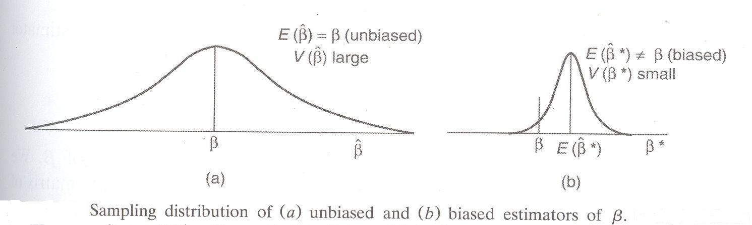

Ridge regression is a procedure for obtaining biased estimators of regression coefficients. The ridge estimator is found by solving a slightly modified version of the normal equations. The ridge estimator is obtained as the solution of
where k ≥ 0 is a constant selected by the analyst. When k = 0, the ridge estimator is the least-squares estimator.
The ridge estimator is a linear transformation of the least-squares estimator.
Therefore, is a biased estimator of . The constant k is referred to as the biasing parameter. The covariance matrix of is
The mean square error of the ridge estimator is
where λ₁, λ₂, …, λ_{p} are the eigen values of . If k > 0, the bias inincreases, but the variance decreases. Therefore, a value of k is to be chosen such that the reduction in the variance term is greater than the increase in the squared bias. In that case, the mean square error of the ridge estimator will be less than the variance of the least-squares estimator . Hoerl and Kennard proved that there exists a nonzero value of k for which the MSE of is less that the variance of the least squares estimator , provided is bounded.
The residual sum of squares is
The first term is the residual sum of squares for the least-squares estimates . Therefore, as k increases, the residual sum of squares increases. Since, the total sum of squares is fixed, the regression sum of squares and hence, R² decreases as k increases. Therefore, the ridge estimate will not necessarily provide the best fit to the data.
Hoerl and Kennard suggested that an appropriate value of k may be determined by inspection of the ridge trace. The ridge trace is a plot of the elements of versus k for values of k in the interval (0, 1). If multicollinearity is severe, the instability in the regression coefficients will be obvious from the ridge trace. As k is increased, some of the ridge estimates will vary dramatically. At some value of k, the ridge estimateswill stabilize. The objective is to select a reasonably small value of k at which the ridge estimates are stable. Hopefully this will produce a set of estimates with smaller MSE than the least-squares estimates.

EXAMPLE: THE ACETYLENE DATA
To obtain the ridge solution for the acetylene data, we have to solve the equation for several values of 0 ≤ k ≤ 1, with and in correlation form. The ridge trace is shown in the following figure and the ridge coefficients for several values of k are listed in the following table. For each ridge model, R2 and residual sum of squares is also listed. From the table, k can be chosen as 0.032.
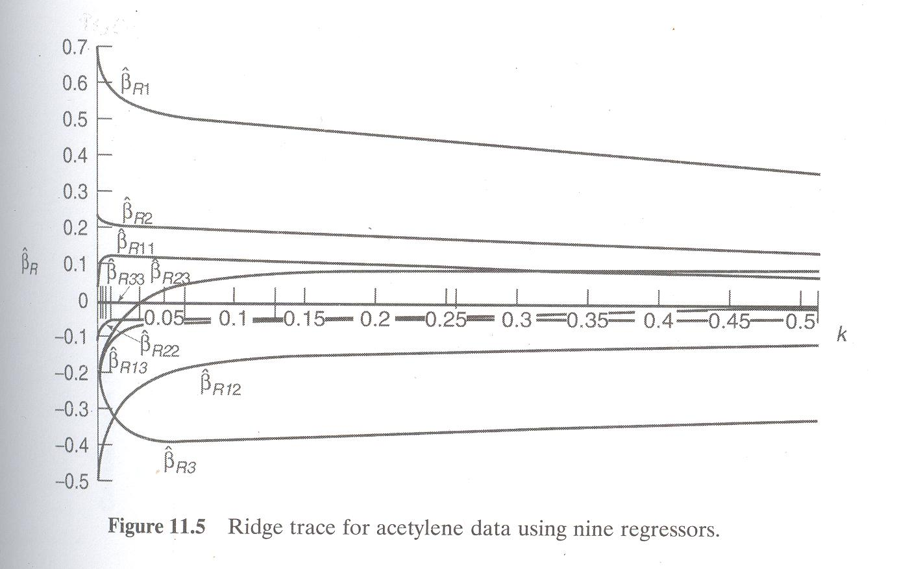

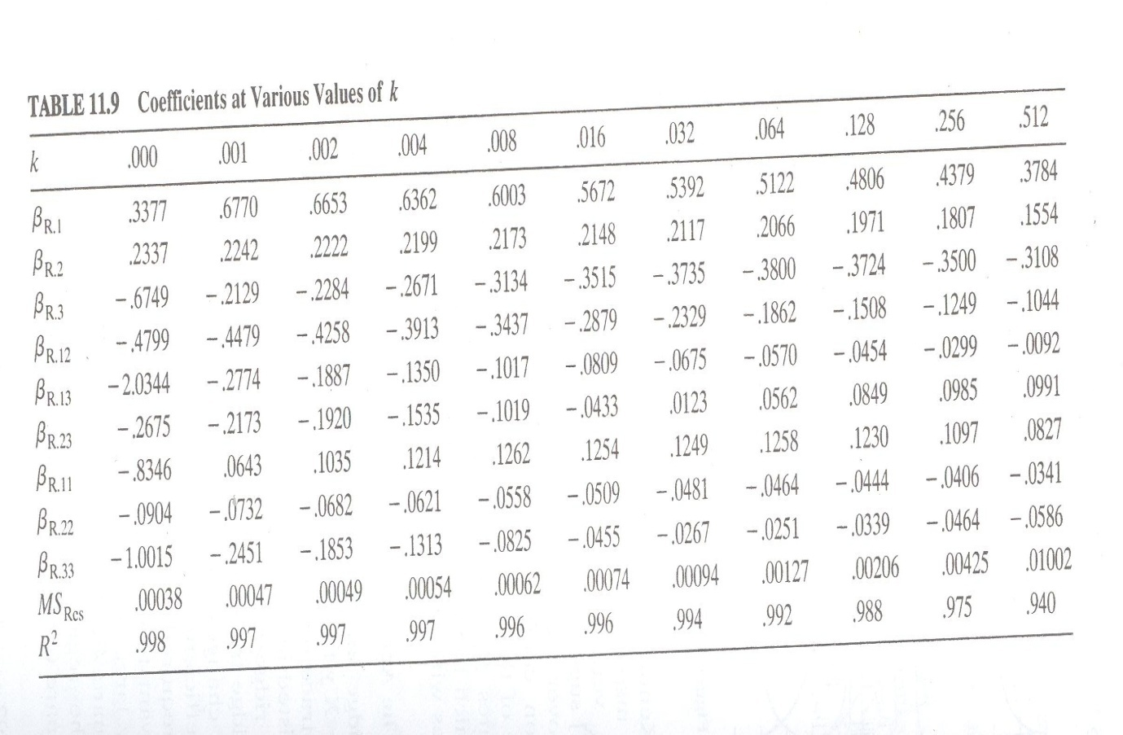

For k = 0.032, the ridge regression model becomes
The ridge regression estimates may be computed by using Excel and augmenting the standardized data as follows:
where is a p × p diagonal matrix with diagonal elements equal to the square root of the biasing parameter and is a p × 1 vector of zeros. The ridge estimates are then computed from
Methods for choosing k
Choosing k by inspection of the ridge trace is a subjective procedure. Some authors have proposed procedures for choosing k that are more analytical. Hoerl, Kennard and Baldwin suggested that an appropriate choice for k is where and are found from the least-squares solution. They showed via simulation that the resulting ridge estimator had significant improvement in MSE over least squares. They later proposed an iterative estimation procedure using the same equation.

McDonald and Galarneau suggest choosing k so that
A drawback to this procedure is that k may be negative. There are many other possibilities for choosing k such as using mallow’s Cp statistic, minimizing PRESS statistic, and minimizing maximum VIF etc.
RELATIONSHIP TO OTHER ESTIMATORS
Ridge regression is closely related to Bayesian estimation. Generally, if prior information about can be described by a p-variate normal distribution with mean vector and covariance matrix , then the Bayes estimator of is
If we choose the prior mean = 0 and , then we obtain the usual ridge estimator
PRINCIPAL COMPONENT REGRESSION
Biased estimators of regression coefficients can also be obtained using principal component regression. Let us consider the canonical form of the model
We recall that is a p × p diagonal matrix of the eigen values of and is a p × p orthogonal matrix whose columns are the eigen vectors associated with . The columns of Z, which define a new set of orthogonal regressors, such as
are referred to as principal components.
The least-squares estimator of α is
and the covariance matrix of is
Thus, a small eigen value of means that the variance of the corresponding orthogonal regression coefficient will be large. Since , the eigen value λ_{j} is referred to as the variance of the j^{th} principal component. If all the λ_{j} are equal to unity, the original regressors are orthogonal, while if a λ_{j} is exactly equal to zero, this implies a perfect linear relationship between the original regressors. One or more of the λ_{j} near zero implies that multicollinearity is present.
The covariance matrix of the standardized regression coefficients is
This implies that the variance of is . Therefore, the variance of is a linear combination of the reciprocals of the eigen values. Therefore, one or more small eigen values can destroy the precision of the least-squares estimate .
The principal component regression approach combats multicollinearity by using less than the full set of principal components in the model. To obtain principal component estimator, we first arrange the regressors in order of decreasing eigen values, Suppose that the last s of these eigen values are approximately equal to zero. In principal component regression, the principal components corresponding to near-zero eigen values are removed from the analysis and least-squares applied to the remaining components. The principal –component estimator is
In terms of the standardized regressors

PRINCIPAL COMPONENT REGRSSION FOR ACETYLENE DATA
The linear transformation that transforms the original standardised regressors into an orthogonal set of variables The eigen values λ_{j} and the T matrix are shown here. This matrix indicates that the relationship between Z₁ and the standardized regressors is
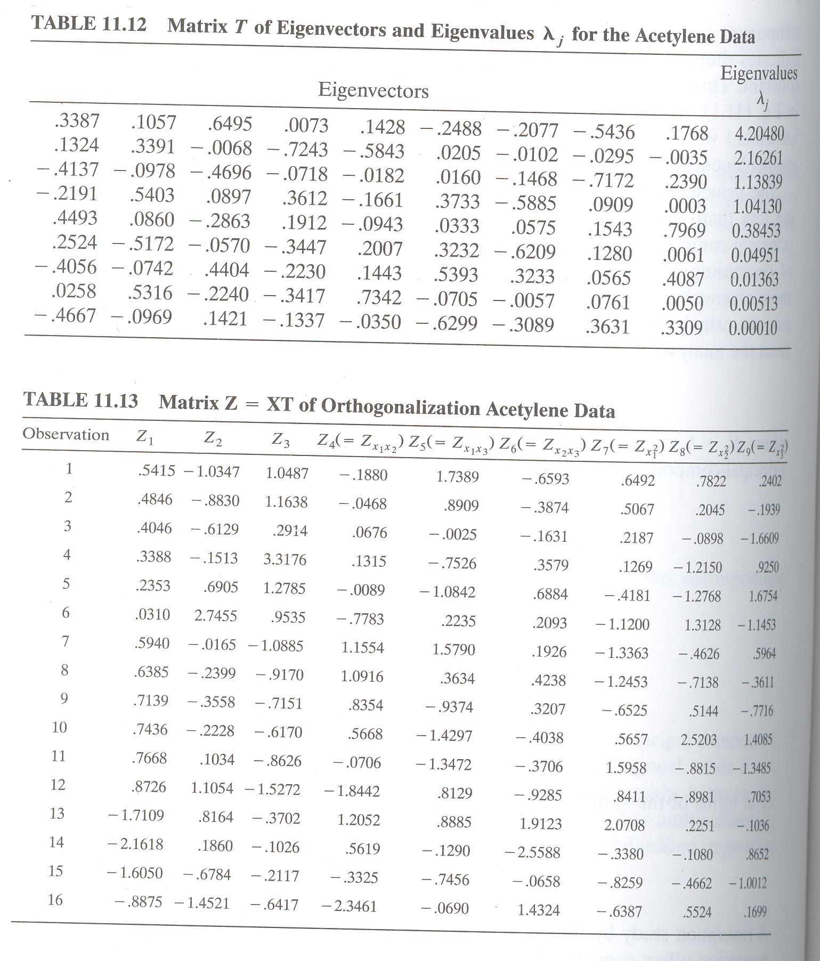

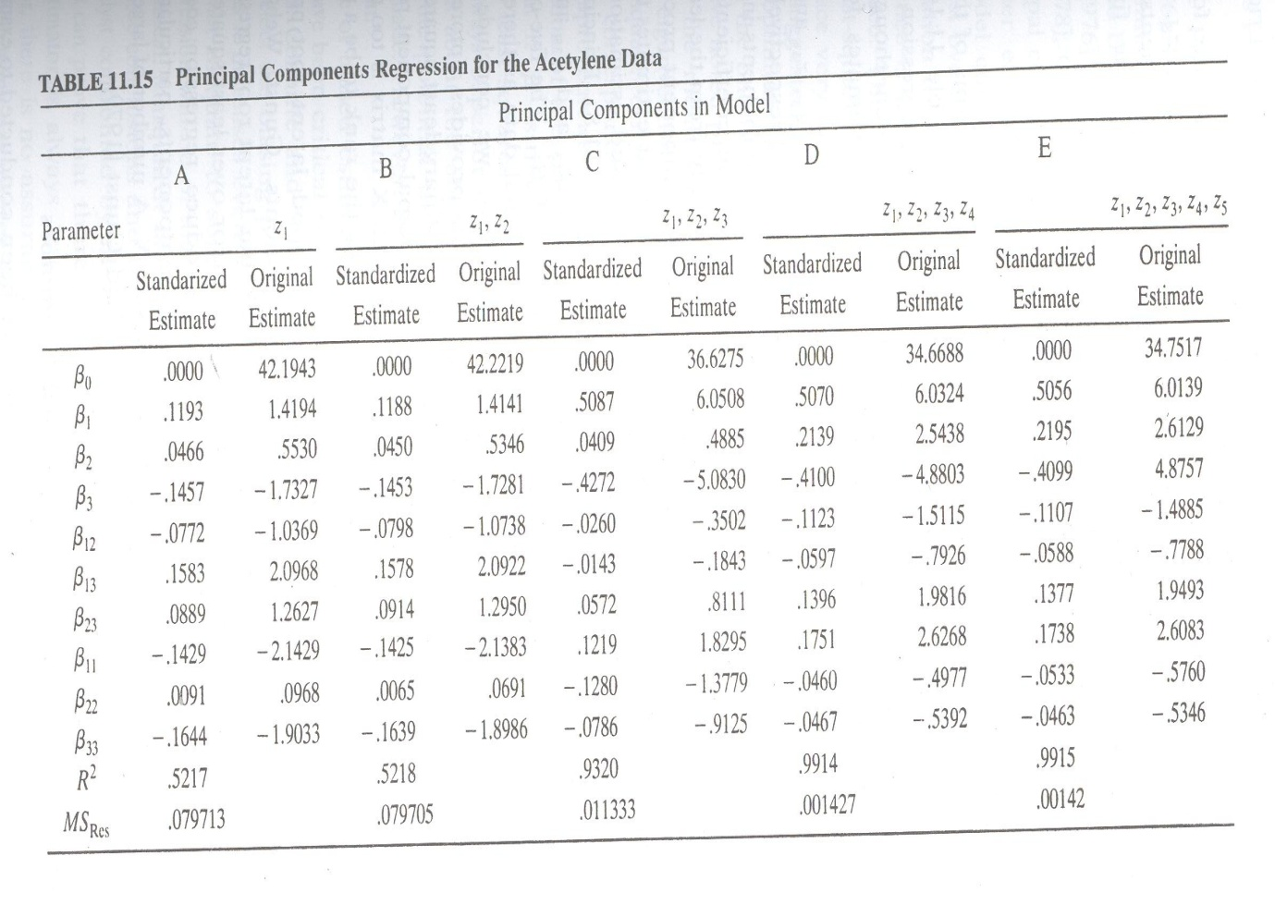

Suppose we consider a regression model involving only the first principal component, as in
The fitted model is
The coefficients in terms of the standardized regressors are found from . The values of standardized regression coefficients as well as the regression coefficients in terms of the original centered regressors are shown in above table.
Note that even though only one principal component is included, the model produces estimates for all nine standardized regression coefficients. The results of working with five principal components are also shown in the above table.

