**STL – MAP:**

#include<map>

***//map will be automatically sorted on bases of key***

***//variable declaration of map***

map < string , int> arr ;

map < string , int> :: iterator it ;

arr["c"] = 56;

arr["b"] = 57;

arr["a"] = 54;

map<char,int> map3 (m);

/* creates map map3 which is a copy of map m */

***// arr[key] = value;***

***//it will print the value***

cout<<arr["c"]<<endl; ans : 56

***// how to print column***

it=arr.begin();

cout<<it->first<< " "<< it->second<<endl; ans : a 54 because auto sort

**Tricks :**

1.***Erase***

arr.erase("a"); // it will remove the key a

remove all element upto key 3

g.erase(g.begin(), g.find(3))

2***.Insert***

arr.insert(make_pair("a",0)); // it will create arr[“a”] = 0 ;

map<int, int> g;

g.insert(pair<int, int>(1, 40));

m.insert( pair<int,int> (4,5));

/* inserts a new entry of key = 4 and value = 5 in map m */

m.insert( make_pair(5, 6));

/* inserts a new entry of key = 5 and value = 6 */

3.***Multiple input taking in map***

for(int i = 0 ; i<n ; i++)

{

cin>>s;

cin>>m;

arr[s] = m;

//arr[key] = value;

}

4.***Find***

while(cin>>s)

{

if(**arr.find(s)!= arr.end())**

//arr.end() actually is a null value..if it doesnot find any thin it will match null value

cout<<s<<" "<<**arr.find(s)->second**<<endl;

else cout<<"Not found"<<endl;

}

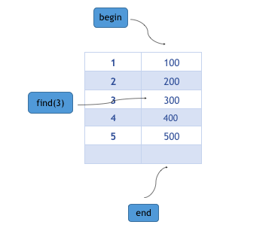

5***. Find – erase – insert – pair***

cin>>s;

if(x.find(s)!= x.end())

{

int p;

p= x.find(s)->second ;

x.erase(s);

x.insert(make_pair(s,p));

}