**暨南大学本科实验报告专用纸**

课程名称 数值分析 成绩评定

实验项目名称 ComputingProblems 指导教师 LiangdaFang 实验项目编号 01 实验项目类型 验证 实验地点 N515

学生姓名 陈圣尹 学号 2016051519

学院 信息科学技术学院 系 计算机系 专业 计算机科学与技术

实验时间 年 月 日 午～ 月 日 午 温度 ℃湿度

**Ⅰ、Problem**

Let A be the 1000 × 1000 matrix with entries A(i,i) = i,A(i,i + 1) = A(i + 1,i) = 1 2,A(i,i + 2) = A(i + 2,i) = 1 2 for all i that ﬁt within the matrix.

• Solve the system with Ax = [1,1,··· ,1]> by the following methods in 15 steps: 1. The Jacobi Method; 2. The Gauss-Seidel Method; 3. SOR with ω = 1.1; 4. The Conjugate Gradient Method; 5. The Conjugate Gradient Method with Jacobi preconditioner.

• Report the errors of every step for each method.

**Ⅱ、Algorithm Summary**

Jacobi Method

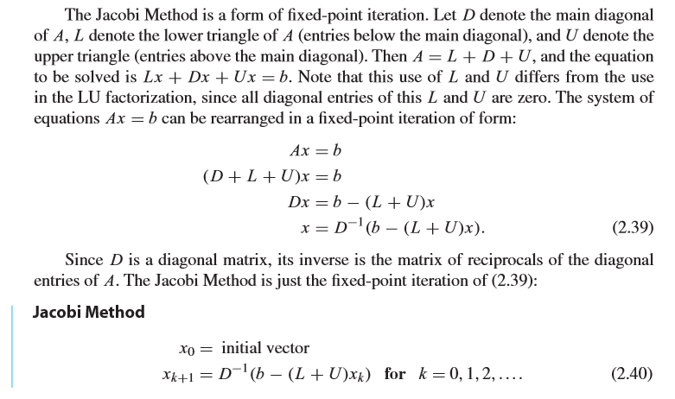

Gauss–Seidel Method

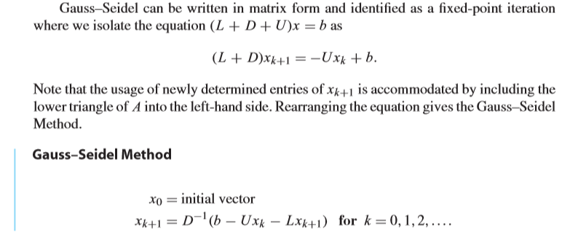

Successive Over-Relaxation(SOR)

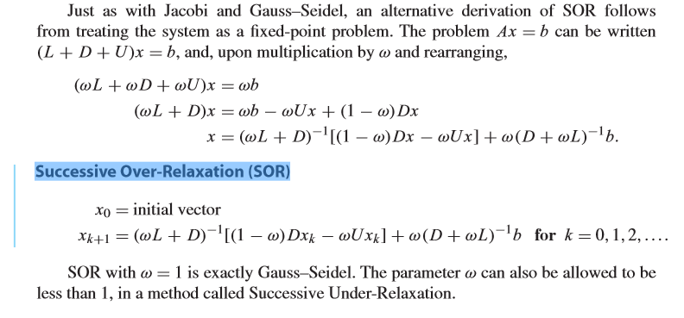

Conjugate Gradient Method

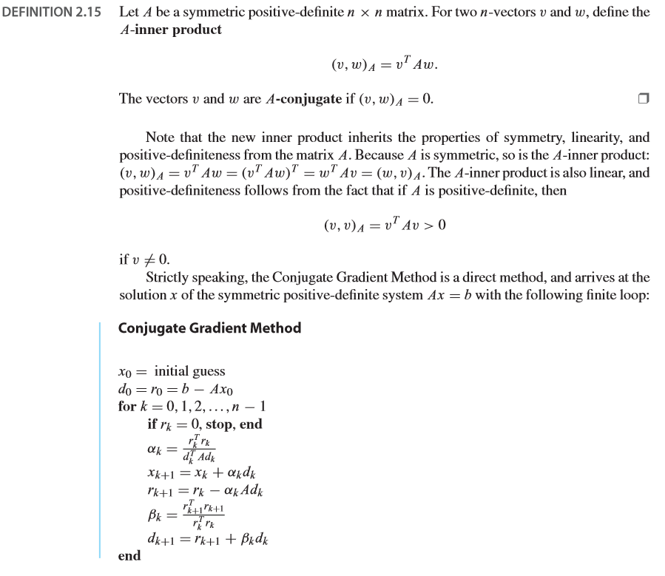

The Conjugate Gradient Method with Jacobi preconditioner 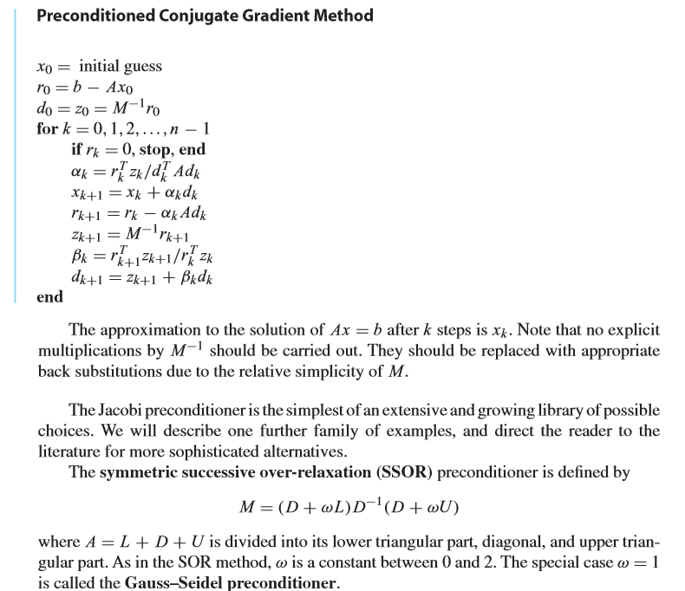

**Ⅲ、Experimental procedures**

Step1:Define A as a 1000*1000 matrix. Then get the Diagonal matrix, Lower triangular matrix and Upper triangular matrix of A

Step2: Solve the system with Ax = [1,1,··· ,1]> by the following methods in 15 steps:

1. The Jacobi Method;

2. The Gauss-Seidel Method;

3. SOR with ω = 1.1;

4. The Conjugate Gradient Method;

5. The Conjugate Gradient Method with Jacobi preconditioner.

**Ⅳ、Result Analysis**

Initialization

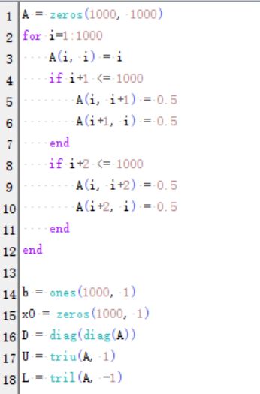

The Solution using Jacobi Method

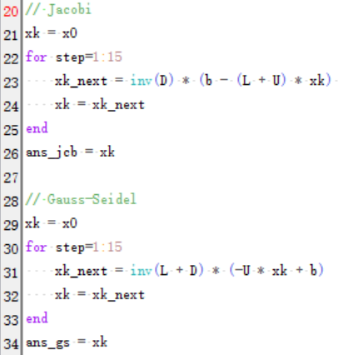

The Solution using Gauss-Seidel Method

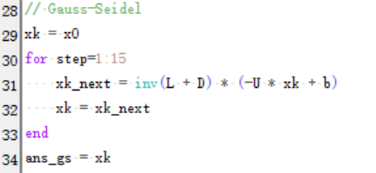

The Solution using SOR with w=1.1

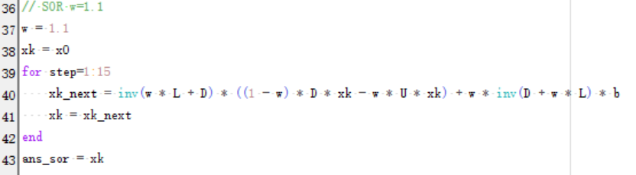

The Solution using Conjugate Gradient Method

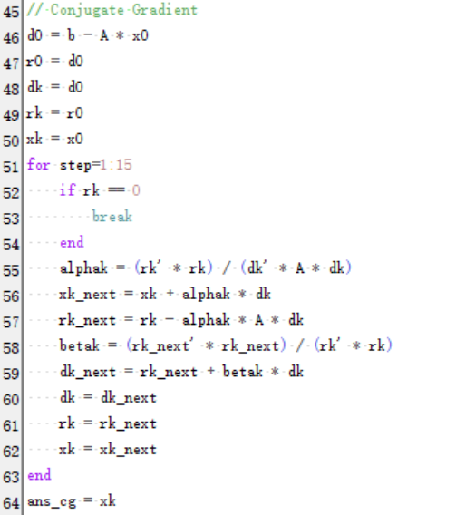

The Solution using Conjugate Gradient Method with Jacobi preconditioner

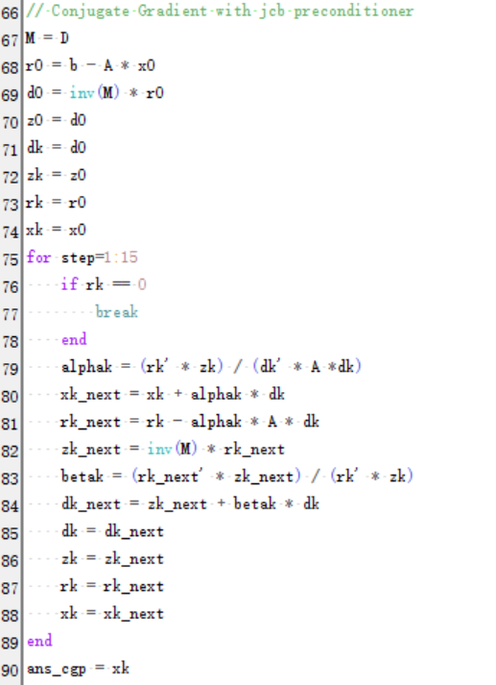

And giving the result as follows

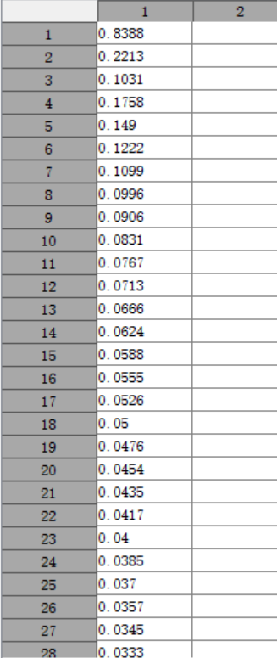

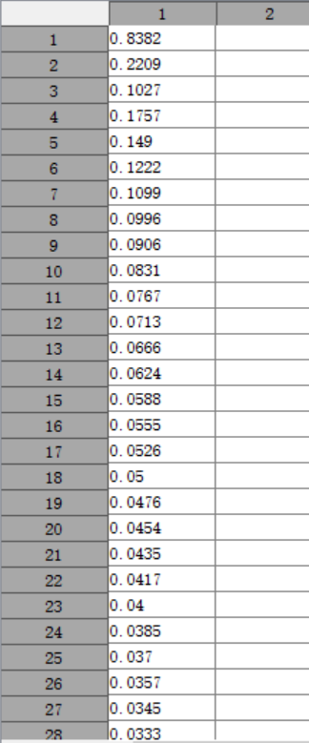

**Ⅴ、Experimental Summary**

In this experiment, we can see all of the method can get the right solution. But the efficiency of the method are different. We can select appropriate method to solve different problems.

**暨南大学本科实验报告专用纸(附页)**