**暨南大学本科实验报告专用纸**

课程名称 数值分析 成绩评定

实验项目名称 ComputingProblems 指导教师 LiangdaFang 实验项目编号 02 实验项目类型 验证 实验地点 N117

学生姓名 陈圣尹 学号 2016051519

学院 信息科学技术学院 系 计算机系 专业 计算机科学与技术

实验时间 年 月 日 午～ 月 日 午 温度 ℃湿度

**Ⅰ、Problem**

Let f(x) = and the interval to be [-1, 1].

1. Write a program generating the Newton’s divided difference formula;

2. Use the program to generate a degree n polynomial with evenly spaced points and Chebyshev points for n = 10, 20 and 40;

3. Plot the polynomials for the above types (see Figure 3.8);

4. By sampling at a 0:05 step, create the empirical interpolation errors for each type, and plot a comparison (see Figure 3.11).

**Ⅱ、Algorithm Summary**

Lagrange interpolation

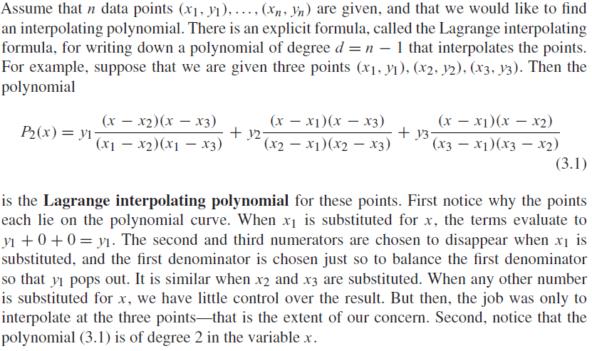

Newton’s divided differences

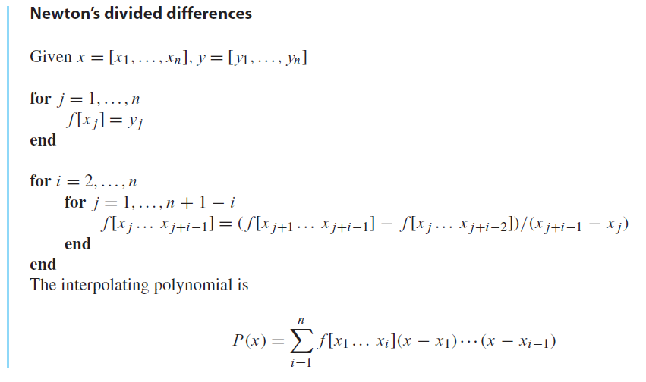

Chebyshev Interpolation

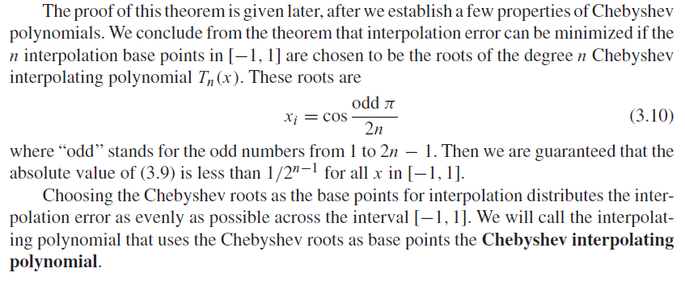

Interpolation error formula

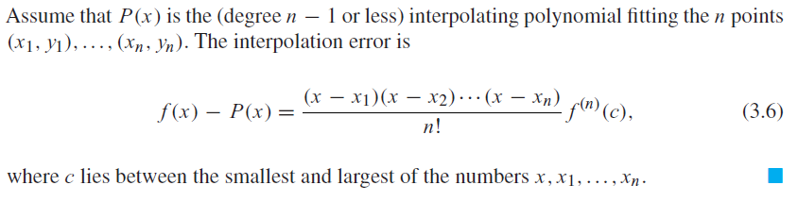

**Ⅲ、Experimental procedures**

Step1. Write a function generating the Newton’s divided difference formula

Step2. Get the evenly spaced points X_es and Chebyshev points X_cbs

Step3. Generate the Y by X_es and X_cbs according to f(x) =

Step4. Use (X_es, Y) and (X_cbs, Y) to get a degree n polynomial

Step5. Plot them and get their errors

**Ⅳ、Result Analysis**

the function that calculating the matrix F of Newton’s divided difference formula

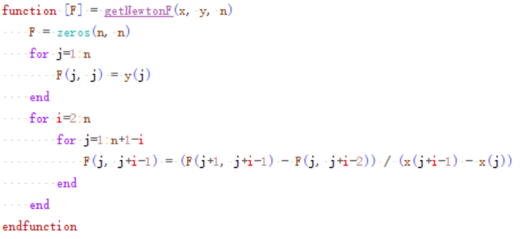

the function that calculating the result Y

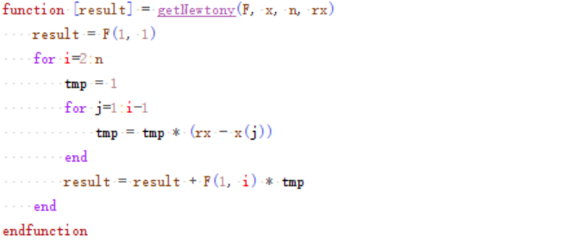

the function that get evenly spaced point

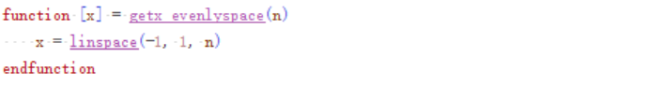

the function that get Chebyshev points

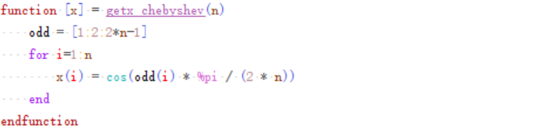

the function that get the Y of f(x) =

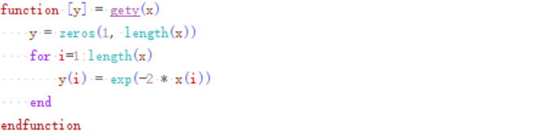

Plot the polynomials for the case n=10

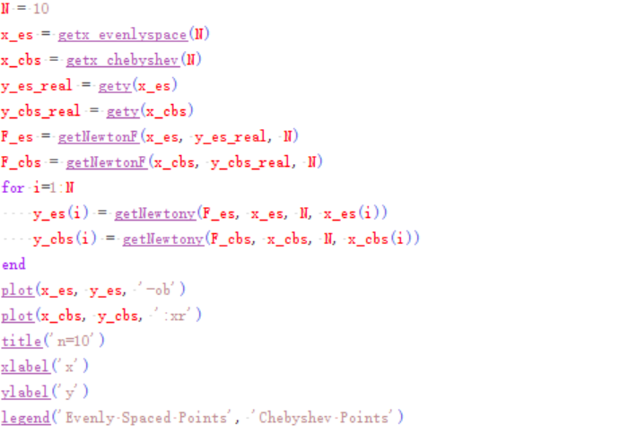

And its result is

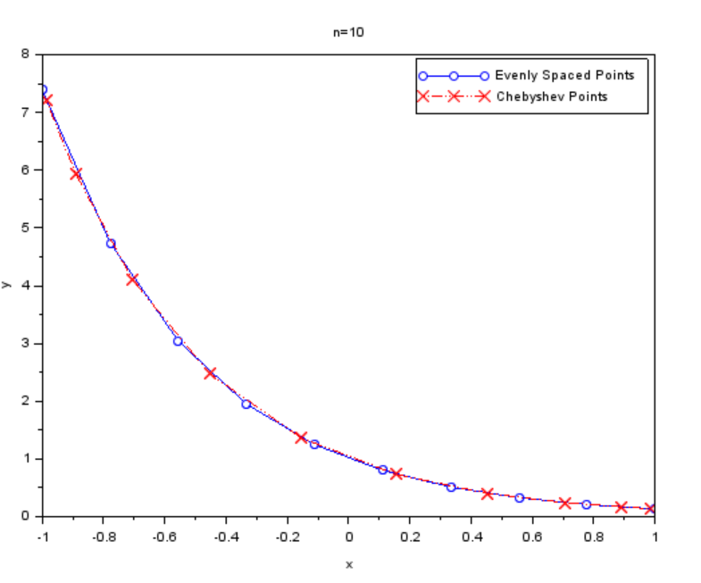

Plot the polynomials for the case n=20

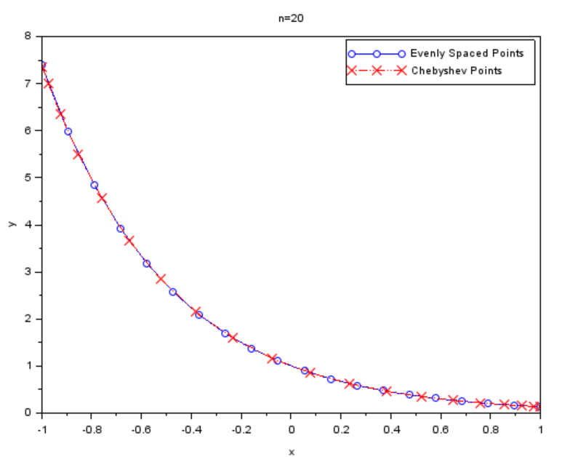

Plot the polynomials for the case n=20

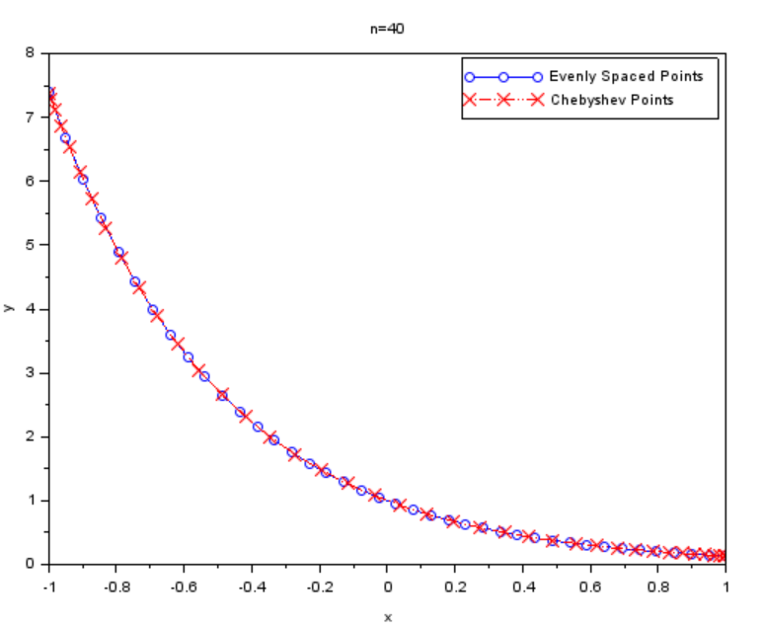

the empirical interpolation errors(n=10 | evenly spaced points)

(col1 = x, col2 = f(x), col3 = P(x), col4 = error)

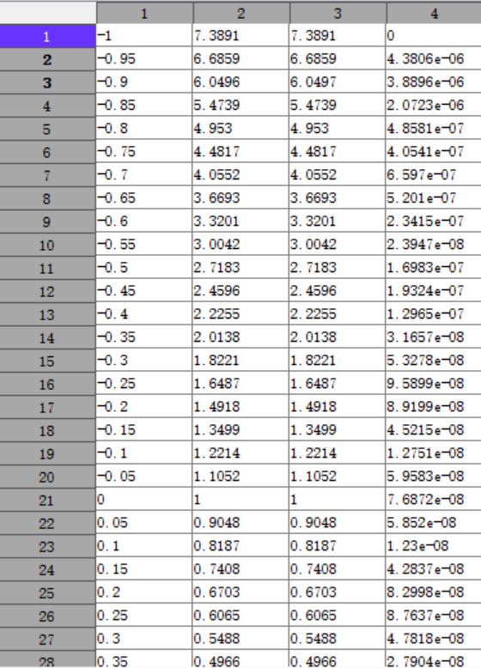

the empirical interpolation errors(n=10 | Chebyshev points)

(col1 = x, col2 = f(x), col3 = P(x), col4 = error)

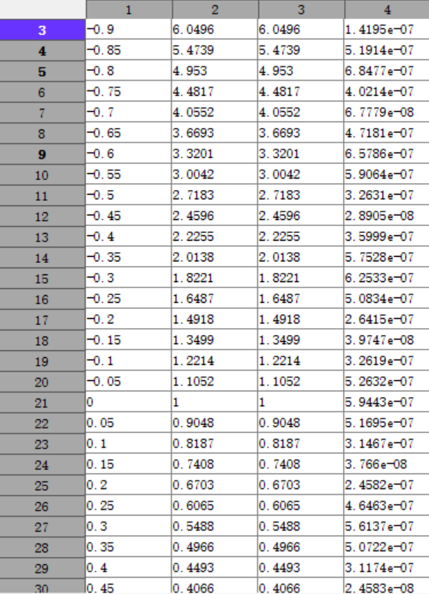

the empirical interpolation errors(n=20 | evenly spaced points)

(col1 = x, col2 = f(x), col3 = P(x), col4 = error)

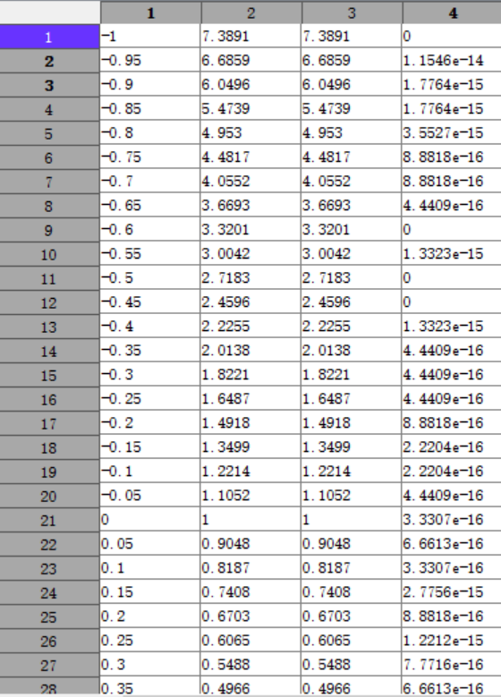

the empirical interpolation errors(n=20 | Chebyshev points)

(col1 = x, col2 = f(x), col3 = P(x), col4 = error)

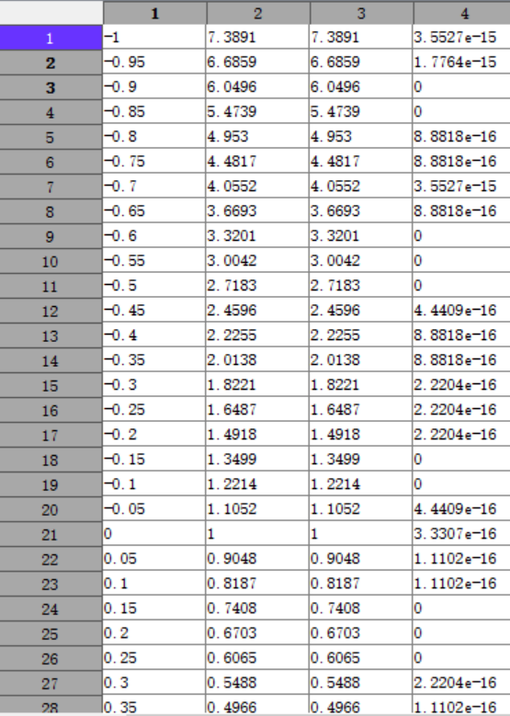

the empirical interpolation errors(n=40 | evenly spaced points)

(col1 = x, col2 = f(x), col3 = P(x), col4 = error)

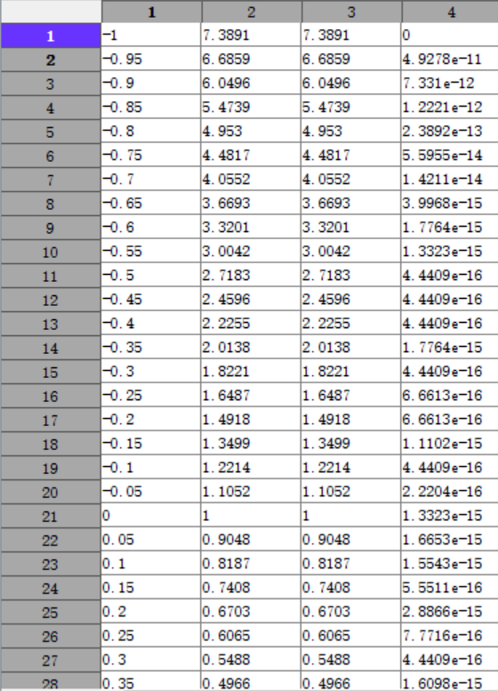

the empirical interpolation errors(n=20 | Chebyshev points)

(col1 = x, col2 = f(x), col3 = P(x), col4 = error)

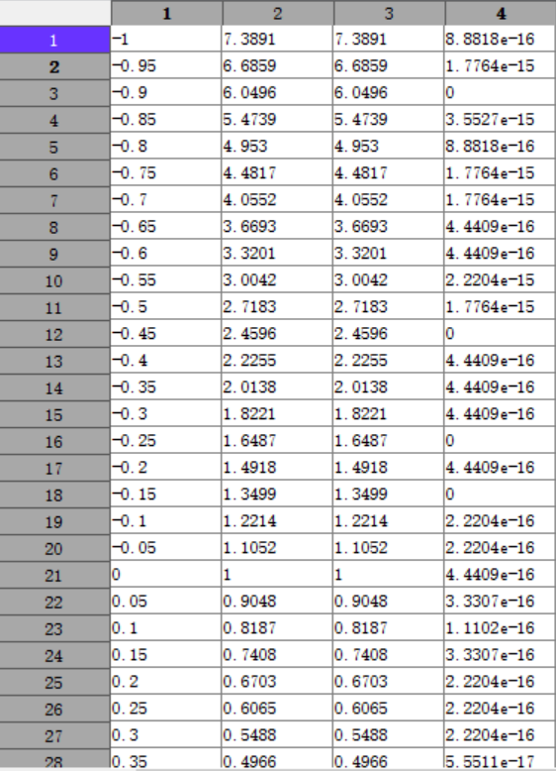

**Ⅴ、Experimental Summary**

In this experiment, we can get the fitting curve of the points given with good effect through Lagrange interpolating polynomial. As for choosing the base points x, we can use evenly spaced points or Chebyshev points. As we can see, two methods both get rather small error, but Chebyshev points get little error relatively.