**暨南大学本科实验报告专用纸**

课程名称 数值分析 成绩评定

实验项目名称 ComputingProblems 指导教师 LiangdaFang 实验项目编号 03 实验项目类型 验证 实验地点 N117

学生姓名 陈圣尹 学号 2016051519

学院 信息科学技术学院 系 计算机系 专业 计算机科学与技术

实验时间 年 月 日 午～ 月 日 午 温度 ℃湿度

**Ⅰ、Problem**

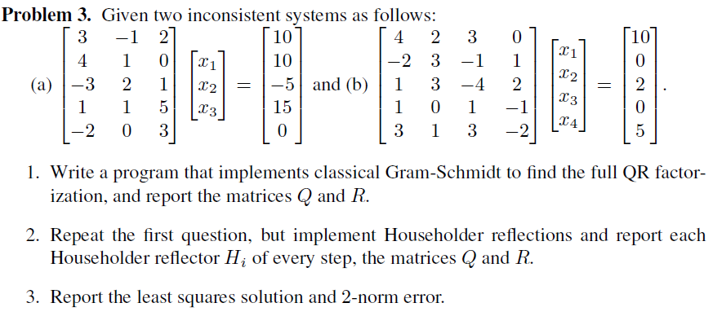

**Ⅱ、Algorithm Summary**

Gram–Schmidt orthogonalization and least squares

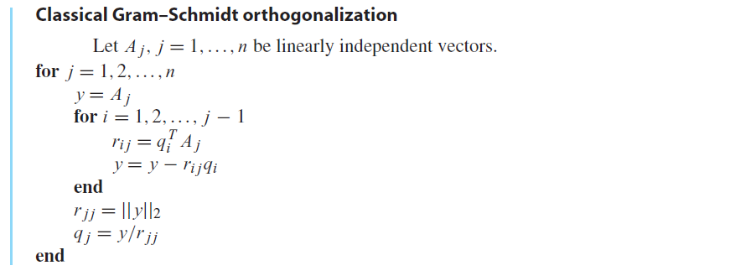

Householder reflectors



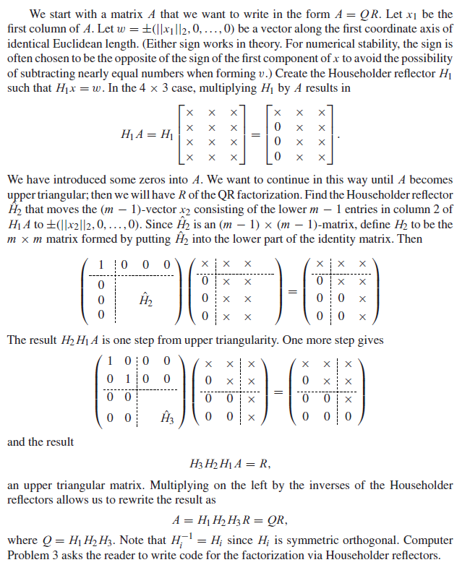

**Ⅲ、Experimental procedures**

Step1. Write a function that uses classifcal Gram-Schmidt method to find the full QR factorization and acquire matrices Q and R

Step2. Write a function that acquire Householder reflection of vector x

Step3. Write a function that uses Householder reflection method to find the QR factorization and then report the Householder reflection $H_{i}$ of each step and the matices Q and R

Step4. Solve those two system given by the problem and acquire those errors

**Ⅳ、Result Analysis**

The function that uses classifcal Gram-Schmidt method to find the full QR factorization

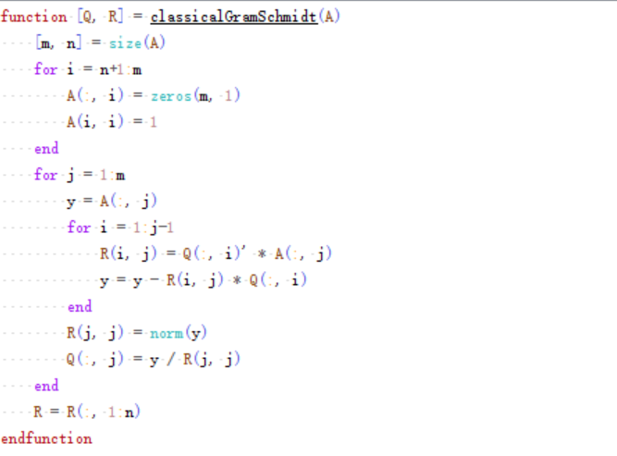

The function that uses Householder reflection method to find the full QR factorization

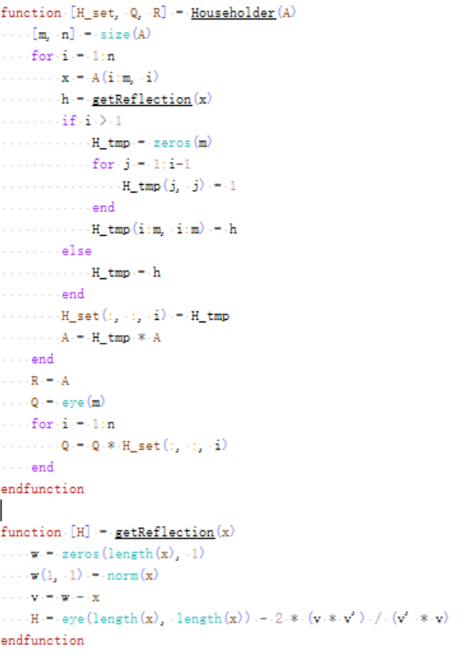

The function that solve inconsistent system

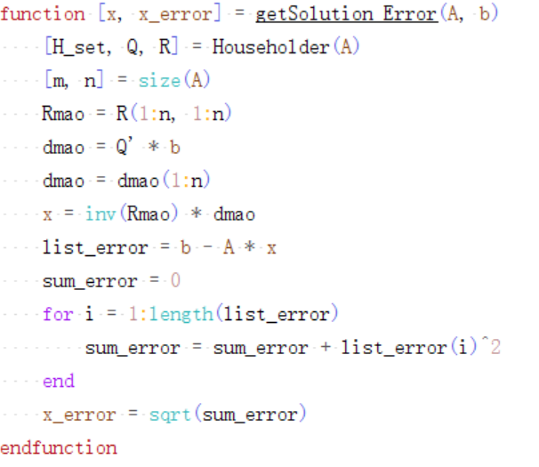

## Solve the problem 1:

Q & R (classical Gram-Schmidt)

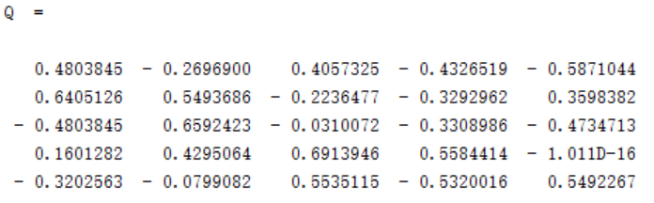

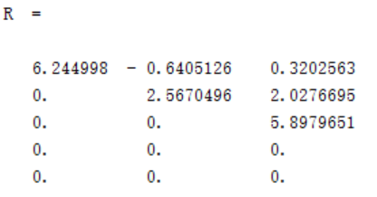

Q & R (Householder reflection)

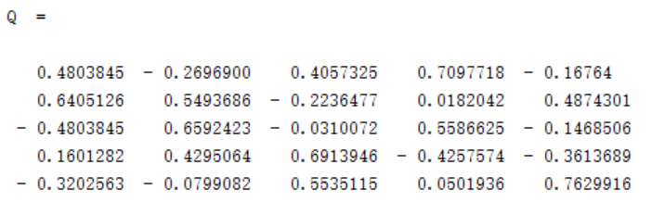

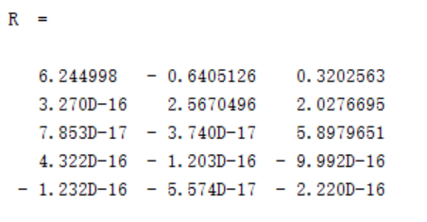

And the H of each step:

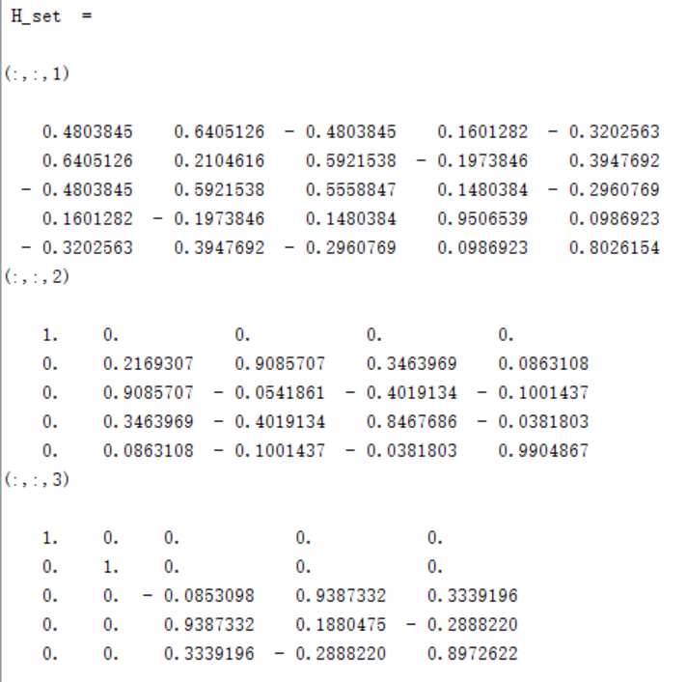

The solution of Problem 1 and 2-norm error

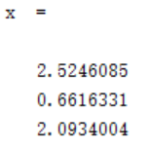

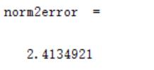

## Solve the problem 2:

Q & R (classical Gram-Schmidt)

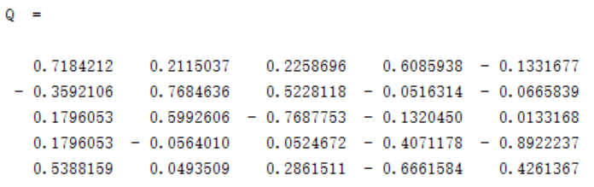

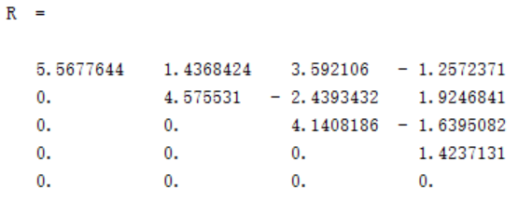

Q & R (Householder reflection)

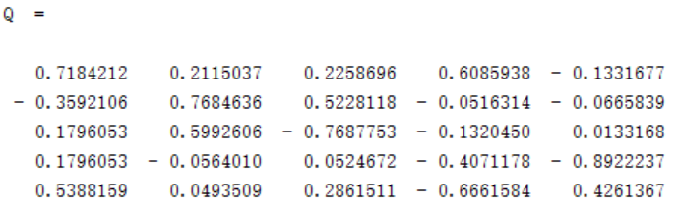

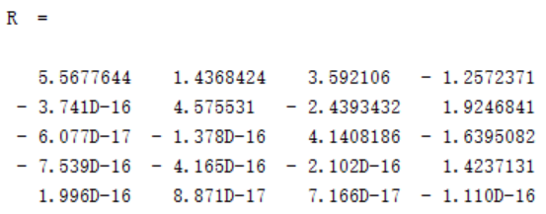

And the H of each step:

H_set =

(:,:,1)

0.7184212 - 0.3592106 0.1796053 0.1796053 0.5388159

- 0.3592106 0.5417543 0.2291228 0.2291228 0.6873685

0.1796053 0.2291228 0.8854386 - 0.1145614 - 0.3436842

0.1796053 0.2291228 - 0.1145614 0.8854386 - 0.3436842

0.5388159 0.6873685 - 0.3436842 - 0.3436842 - 0.0310527

(:,:,2)

1. 0. 0. 0. 0.

0. 0.4986479 0.7341685 0.0785069 0.4540745

0. 0.7341685 - 0.0750994 - 0.1149636 - 0.6649362

0. 0.0785069 - 0.1149636 0.9877066 - 0.0711036

0. 0.4540745 - 0.6649362 - 0.0711036 0.5887449

(:,:,3)

1. 0. 0. 0. 0.

0. 1. 0. 0. 0.

0. 0. - 0.2810595 0.2332854 0.9309047

0. 0. 0.2332854 0.9575179 - 0.1695210

0. 0. 0.9309047 - 0.1695210 0.3235415

(:,:,4)

1. 0. 0. 0. 0.

0. 1. 0. 0. 0.

0. 0. 1. 0. 0.

0. 0. 0. - 0.3227450 - 0.9464860

0. 0. 0. - 0.9464860 0.3227450

The solution of Problem 2 and 2-norm error

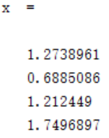

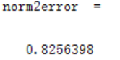

**Ⅴ、Experimental Summary**

In this experiment, we can find full QR factorization through classical Gram-Schmidt method or Householder reflections method. As we can see, Householder reflections method is quicker and more efficient than classical Gram-Schmidt method. As for the 2-norm error, we can see the error of problem 1 is 2.41, which is quite big so that the solution is not accurate enough.