Sumukh Guruprasad
student id: 2443400 Group: 10
CN7050- INTELLIGENT SYSTEMS

Week-05 Tutorial

Part A — Multimodal Agent (Text + Image)
A simple agent that routes between Gemini (text) and Hugging Face (image).
In this part I put together a small agent that can respond to two kinds of requests: text (via Gemini) and images (via a Hugging Face diffusion model). I first set up the environment and safely loaded my API keys, then wrote a tiny intent classifier that just checks for simple keywords to decide which path to take. The orchestrator uses that decision to either call Gemini for a text reply or hit the HF endpoint to generate an image. I added helpers to display images (handling different formats) and to wrap long text so it’s readable in the Colab output. Finally, I tested it with a short interactive loop, typing prompts like “write a summary” triggered the text route, while prompts containing “image/photo” produced an image.

Creating Gemini Key and Hugging Face API Key
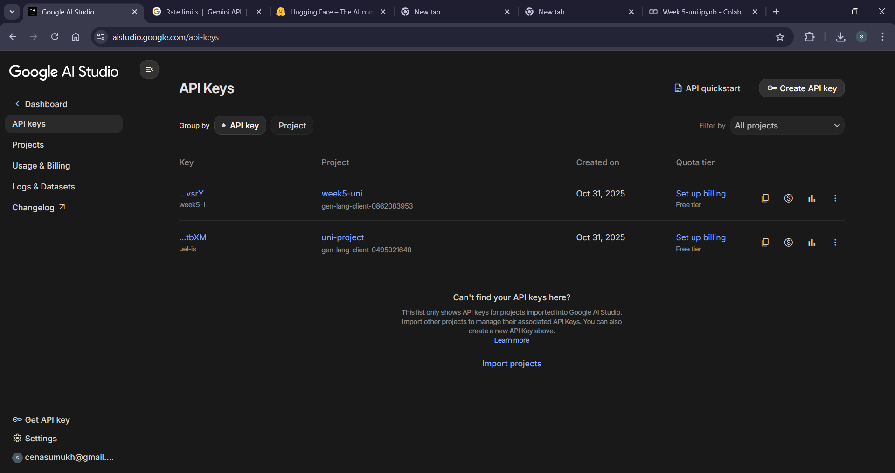
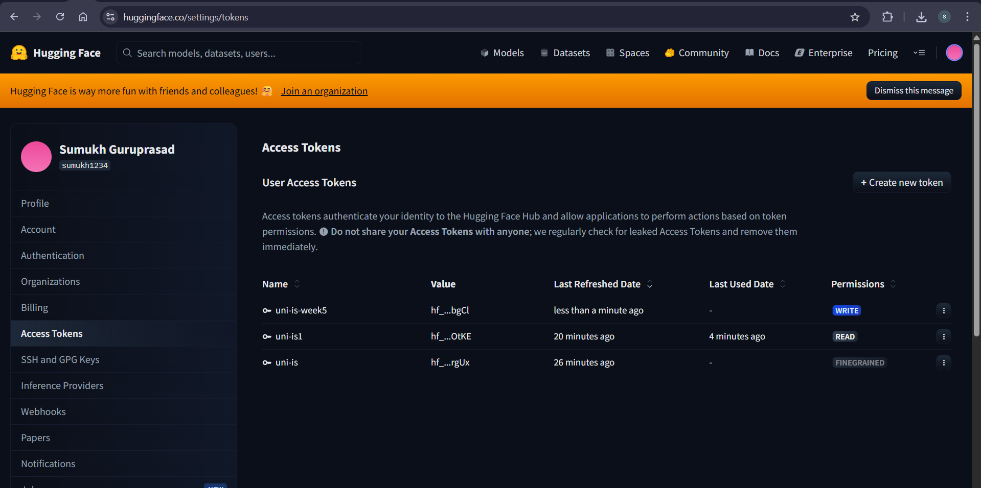

Install Dependencies
Installs the Google Gen AI SDK plus utilities like Gradio, requests, and Pillow, which are needed to call the APIs and handle images. This ensures our Google Colab runtime has everything before you run any code.
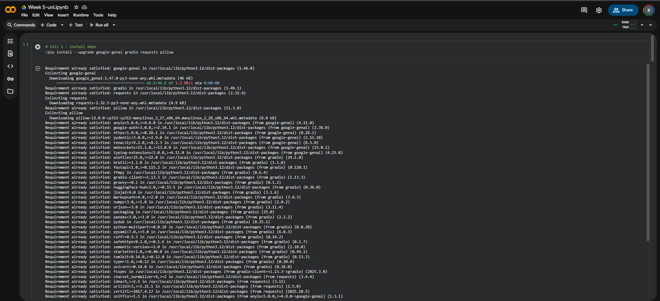

Securely enter API keys
Hide keys in the notebook output and store in environment variables for reuse.
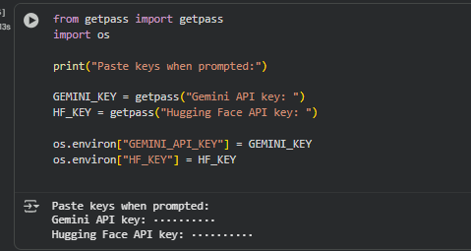

Hugging Face Image Generation Helper
HTTP call to a diffusion model endpoint; returns a PIL image.
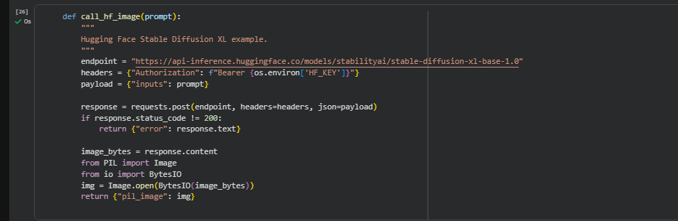

Imports + Gemini Client Initialization
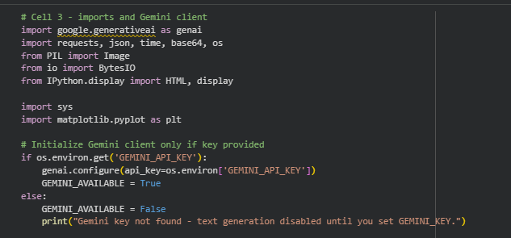

Gemini Text Generation Function
Helper that returns structured dicts for the orchestrator.
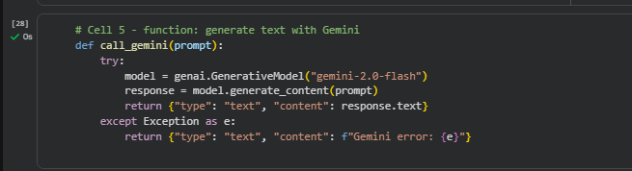

Intent Classifier (Keyword Routing)
Quick rules to decide whether to generate text or an image.
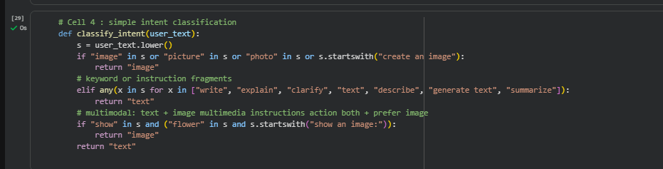

Orchestrator
Routes to the appropriate backend.
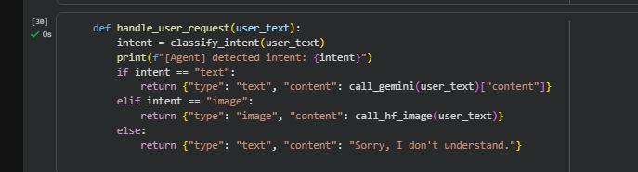

Display Helpers
Functions to show images and wrap text.
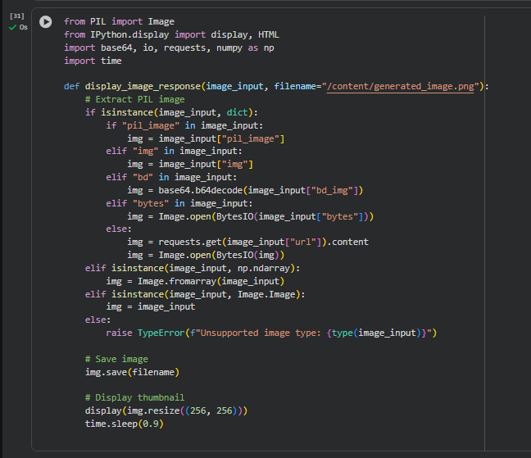

Interactive Agent Loop
Simple REPL for manual tests.
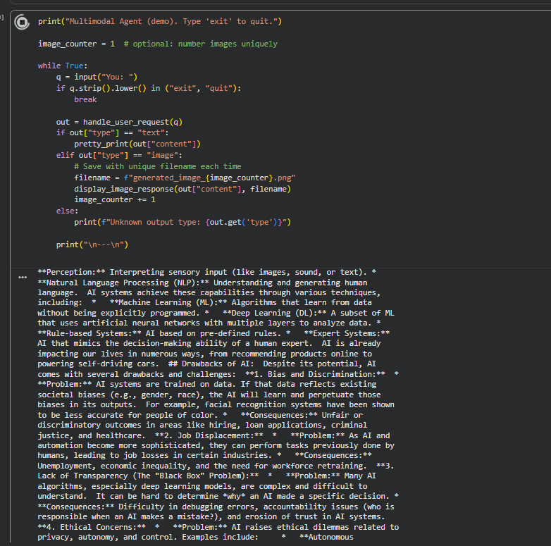
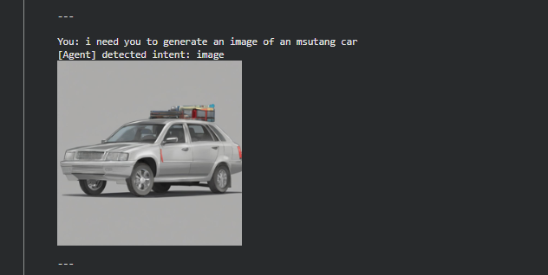


Part B — Research Learning Assistant
Search arXiv & web, chunk long text, and summarise with Gemini.
Here, I focused on building a lightweight pipeline to search for papers and summarise them clearly. I used the arxiv library to pull titles, authors, abstracts, and PDF links, and added a basic web scraper (requests + BeautifulSoup) for non-paper pages. Since some texts can be long, I split them into chunks, summarised each chunk with Gemini using a consistent instruction, and then combined the notes into one concise summary. The end-to-end cell runs a query, prints short summaries for the top results, and I included an optional step to mount Google Drive and save everything to a .txt file so I can keep my notes organised for later.
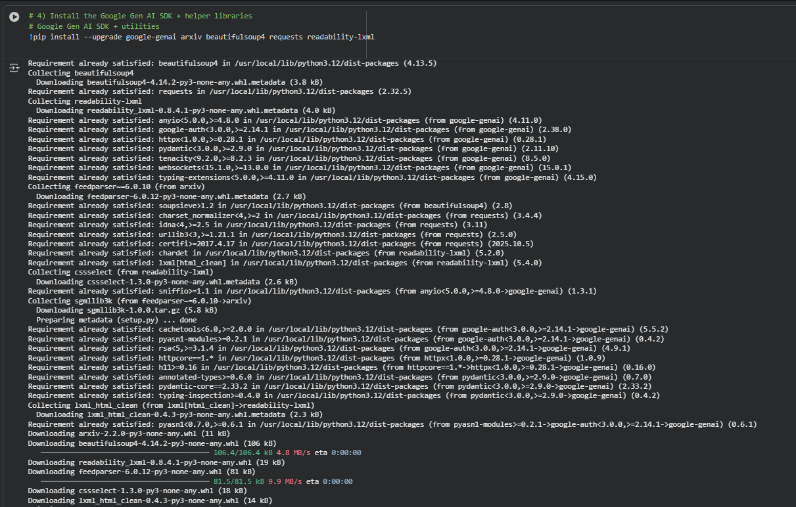
Ensures the key exists in this fresh session.
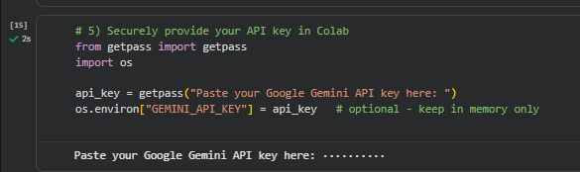
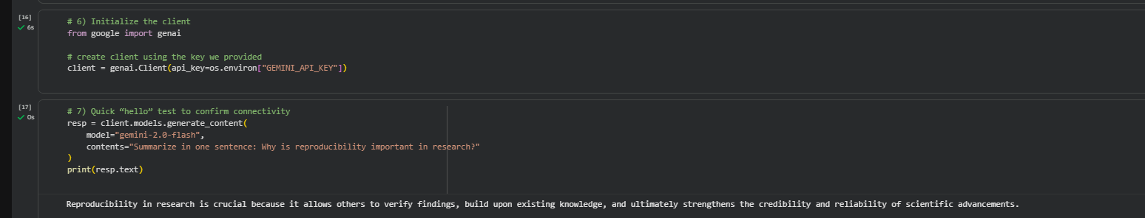

Searches for papers on Multimodal transformers
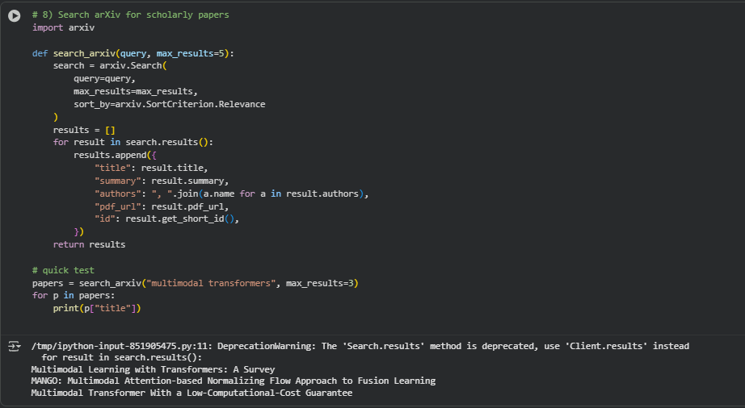

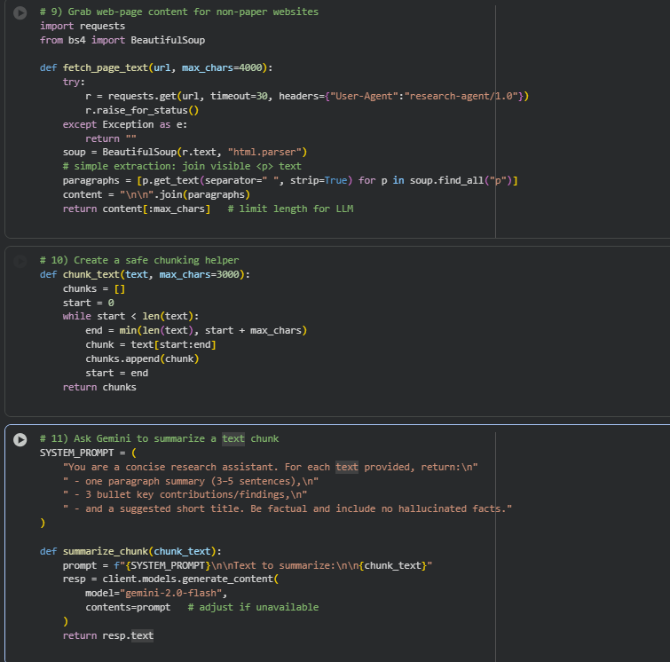

Search and summarise top N arXiv abstracts
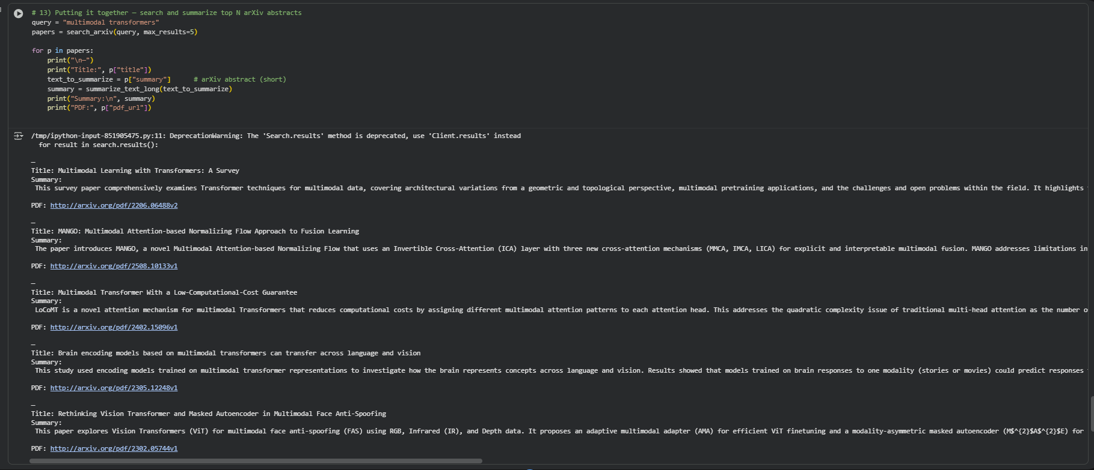

This cell runs the full pipeline: it searches arXiv for “multimodal transformers,” then loops over the top 5 results. For each paper it prints the title, a Gemini-generated summary of the abstract, and the PDF link—basically a quick research digest. (The deprecation warning is from the arxiv library and doesn’t affect the output.)
