BookNook — AWS Deployment Guide
From-scratch runbook (7 services) — with login & admin

This guide deploys BookNook (with login, roles, and an admin panel) on AWS from an empty account, in order. It uses seven services — VPC, EC2 (with Auto Scaling), RDS MySQL, S3, CloudFront, Application Load Balancer, and Route 53. It does not use IAM roles, Secrets Manager, CloudWatch, ACM, or Terraform; the database credentials and the JWT secret are written into a .env file by the instance’s user-data. Console clicks are in arrow notation (menu → option). Example region: ap-south-1.
Demo accounts seeded on first run: admin / admin123 (admin), alice / alice123 and bob / bob123 (users).
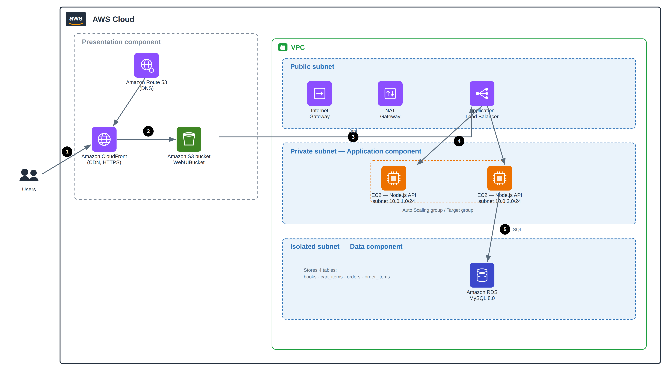
Target architecture

Phase 0 — Prerequisites
- An AWS account.
- The BookNook code in a public Git repository (the EC2 user-data clones it).
- An EC2 key pair in your region (for optional SSH access).
- A long random string to use as the JWT secret (e.g. from a password generator).
✓ Checkpoint Your code is on GitHub, you have a key pair, and you have a JWT secret string ready. Note the repo URL.

Phase 1 — Network (VPC, Subnets, Gateways, Routes)
VPC → Create VPC → VPC only → Name = booknook-vpc → IPv4 CIDR = 10.0.0.0/16 → Create VPC

Subnets (two AZs)
Subnet | AZ | CIDR | Tier
booknook-public-a | az-a | 10.0.0.0/24 | Public (ALB, NAT)
booknook-public-b | az-b | 10.0.5.0/24 | Public (ALB)
booknook-app-a | az-a | 10.0.1.0/24 | Private (EC2)
booknook-app-b | az-b | 10.0.2.0/24 | Private (EC2)
booknook-db-a | az-a | 10.0.3.0/24 | Isolated (RDS)
booknook-db-b | az-b | 10.0.4.0/24 | Isolated (RDS)
Internet Gateways → Create → Attach to booknook-vpc
NAT Gateways → Create → Subnet = booknook-public-a → Allocate Elastic IP → Create
Route table | Route | Subnets
booknook-public-rt | 0.0.0.0/0 → Internet Gateway | public-a, public-b
booknook-private-rt | 0.0.0.0/0 → NAT Gateway | app-a, app-b
booknook-db-rt | (local only) | db-a, db-b
✓ Checkpoint Public RT → IGW, private RT → NAT, db RT has no internet route.

Phase 2 — Security Groups
Security group | Inbound rule | Source
sg-alb | HTTP : 80 | Anywhere 0.0.0.0/0
sg-backend | Custom TCP : 3000 | sg-alb
sg-rds | MySQL/Aurora : 3306 | sg-backend
✓ Checkpoint Three groups exist; each source points to the group in front of it.

Phase 3 — Database (RDS MySQL 8.0)
RDS → Create database → MySQL 8.0 → db.t3.micro → VPC = booknook-vpc → Subnet group = db subnets → Public access = No → sg-rds → Initial DB name = booknook → Create
✓ Checkpoint Status Available. Copy the Endpoint and remember the password. The API creates and seeds the 5 tables, sample books, and demo users on first boot.

Phase 4 — EC2 Backend (with user-data)
EC2 → Launch instance → Ubuntu 22.04 → t3.small → Network = booknook-vpc → Subnet = booknook-app-a → Public IP = Disable → Security group = sg-backend
Advanced details → User data → paste the script below. Fill in the RDS endpoint and password, and a JWT secret.
#!/bin/bash
apt update -y
curl -fsSL https://deb.nodesource.com/setup_20.x | bash -
apt install -y nodejs git
git clone https://github.com/your-username/booknook.git /opt/booknook
cd /opt/booknook/backend
cat > .env <<EOF
PORT=3000
CORS_ORIGIN=*
JWT_SECRET=<same-long-random-string-on-every-instance>
DB_HOST=<your-rds-endpoint>
DB_PORT=3306
DB_USER=admin
DB_PASSWORD=<your-rds-password>
DB_NAME=booknook
EOF
npm install
npm start
Note: JWT_SECRET must be identical on every instance (and in the launch template used by Auto Scaling), or a login token issued by one instance is rejected by another behind the load balancer.
✓ Checkpoint The instance boots, clones the repo, and the API starts. On first run it creates the 5 tables and seeds books and the demo users (admin / alice / bob).

Phase 5 — Target Group + Application Load Balancer
EC2 → Target Groups → Create → Instances → HTTP : 3000 → Health check = /health → register booknook-api-1
EC2 → Load Balancers → Create → Application Load Balancer → Internet-facing → two public subnets → sg-alb → Listener 80 → target group → Create
curl http://<alb-dns-name>/health # {"status":"healthy"}
curl -X POST http://<alb-dns-name>/api/login \
-H "Content-Type: application/json" \
-d '{"username":"admin","password":"admin123"}' # returns a token
✓ Checkpoint Health is healthy and the login call returns a token.

Phase 6 — Auto Scaling
EC2 → Instances → booknook-api-1 → Actions → Image and templates → Create template from instance → Name = booknook-lt
Auto Scaling Groups → Create → Launch template = booknook-lt → Subnets = app-a + app-b → Attach to booknook-tg → Health check = ELB → Desired 2 / Min 2 / Max 4 → CPU 70% → Create
Note: Because the launch template carries the same .env (same JWT_SECRET), every scaled instance validates the same tokens.
✓ Checkpoint The ASG launches 2 instances and both become healthy.

Phase 7 — Frontend Storage (S3)
S3 → Create bucket → Block all public access = ON → Create
Set the API constant near the top of the script in frontend/index.html, then upload index.html:
const API = ""; // same-origin; CloudFront proxies /api to the ALB
Open the bucket → Upload → Add files = index.html → Upload
✓ Checkpoint index.html is in the private bucket.

Phase 8 — CDN (CloudFront)
CloudFront → Create distribution → Origin = the S3 bucket → Origin access = OAC → copy the bucket policy into S3 → Redirect HTTP to HTTPS → Default root = index.html → Create
Add custom error responses (403 and 404 → /index.html → 200). Then route the API through CloudFront:
Origins → Create origin → Origin domain = the ALB DNS → Protocol = HTTP only
Behaviors → Create behavior → Path pattern = /api/* → Origin = the ALB → Cache policy = CachingDisabled → Origin request policy = AllViewer → Save (repeat for /health)
✓ Checkpoint The CloudFront URL shows the login page; signing in as admin / alice / bob works over HTTPS.

Phase 9 — DNS (Route 53) — optional
Route 53 → Hosted zones → your domain → Create record → Type A → Alias = Yes → Alias to CloudFront distribution → Create
✓ Checkpoint Your domain resolves to the CloudFront distribution.

Final Verification Checklist
- CloudFront URL shows the login page.
- Sign in as admin → Manage Books and All Orders are visible.
- Admin can add a book and remove a book.
- Sign in as alice → Browse, Cart, Orders are visible.
- Alice can add to cart and check out; the order appears under Orders and in the admin’s All Orders.
- A normal user cannot reach admin actions (the API returns 403).

Troubleshooting
Symptom | Likely cause & fix
Login works on one page load but later requests 401 | JWT_SECRET differs between instances. Make every instance (and the launch template) use the same value.
ALB 502 / target unhealthy | API not on 3000 or /health failing. Confirm sg-backend allows 3000 from sg-alb.
API cannot reach the database | sg-rds must allow 3306 from sg-backend; DB_HOST must be the RDS endpoint.
Site loads but API calls fail (mixed content) | HTTPS page calling HTTP ALB. Route /api/* through CloudFront and set const API = "".
CloudFront AccessDenied for S3 | OAC bucket policy not applied — re-copy it into the bucket policy.

Teardown
Delete in order: CloudFront → S3 bucket → Auto Scaling group → Launch Template → ALB + Target group → EC2 instances → RDS → NAT Gateway (release its EIP) → VPC. The NAT Gateway and RDS are the main hourly costs.

