BookNook — Online Bookstore
A Three-Tier Web Application on AWS with Login and an Admin Panel

1. Introduction
BookNook is a full-stack online bookstore. Users sign in, browse a catalogue of books, search by title or author, filter by category, add items to a shopping cart, and place an order through a simulated checkout, with their order history available for review. The application also has an administrator role: an admin can add and remove books and view every order placed on the platform.
It is built as a three-tier architecture and deployed on Amazon Web Services using seven services. The frontend is served as static files from Amazon S3 through CloudFront; the REST API runs on Amazon EC2 instances behind an Application Load Balancer with Auto Scaling; and the data tier is an Amazon RDS for MySQL database. Authentication uses JSON Web Tokens (JWT), and passwords are stored as bcrypt hashes.
Note: this build keeps database credentials and the token secret in a .env file (no Secrets Manager), launches instances without an IAM role, and does not use CloudWatch or ACM.

2. Technology Stack
Tier / Concern | Technology
Frontend (Presentation) | HTML5, Bootstrap 5, Vanilla JavaScript (single-page app)
Backend (Application) | Node.js 20, Express.js (REST API)
Authentication | JSON Web Tokens (jsonwebtoken) + bcrypt password hashing
Database (Data) | MySQL 8.0
AWS services (7) | VPC, EC2 (+ Auto Scaling), RDS, S3, CloudFront, ALB, Route 53

3. Authentication and Roles
Every user has a role of either user or admin. When a user signs in, the server verifies the password against its bcrypt hash and returns a signed JWT containing the user id, username, and role. The browser stores this token and sends it on every request in an Authorization: Bearer header. The server validates the token on all protected routes, and admin-only routes additionally check that the role is admin.
The application seeds three demo accounts on first run:
Username | Password | Role | Can do
admin | admin123 | admin | Add / remove books, view all orders
alice | alice123 | user | Browse, cart, checkout, own orders
bob | bob123 | user | Browse, cart, checkout, own orders
The passwords here are demo values stored as bcrypt hashes; in a real system users would register their own credentials.

4. System Architecture
Each tier sits in its own network zone inside a single VPC, and traffic flows inward through a chain of security groups, so the database is never reachable directly from the internet.
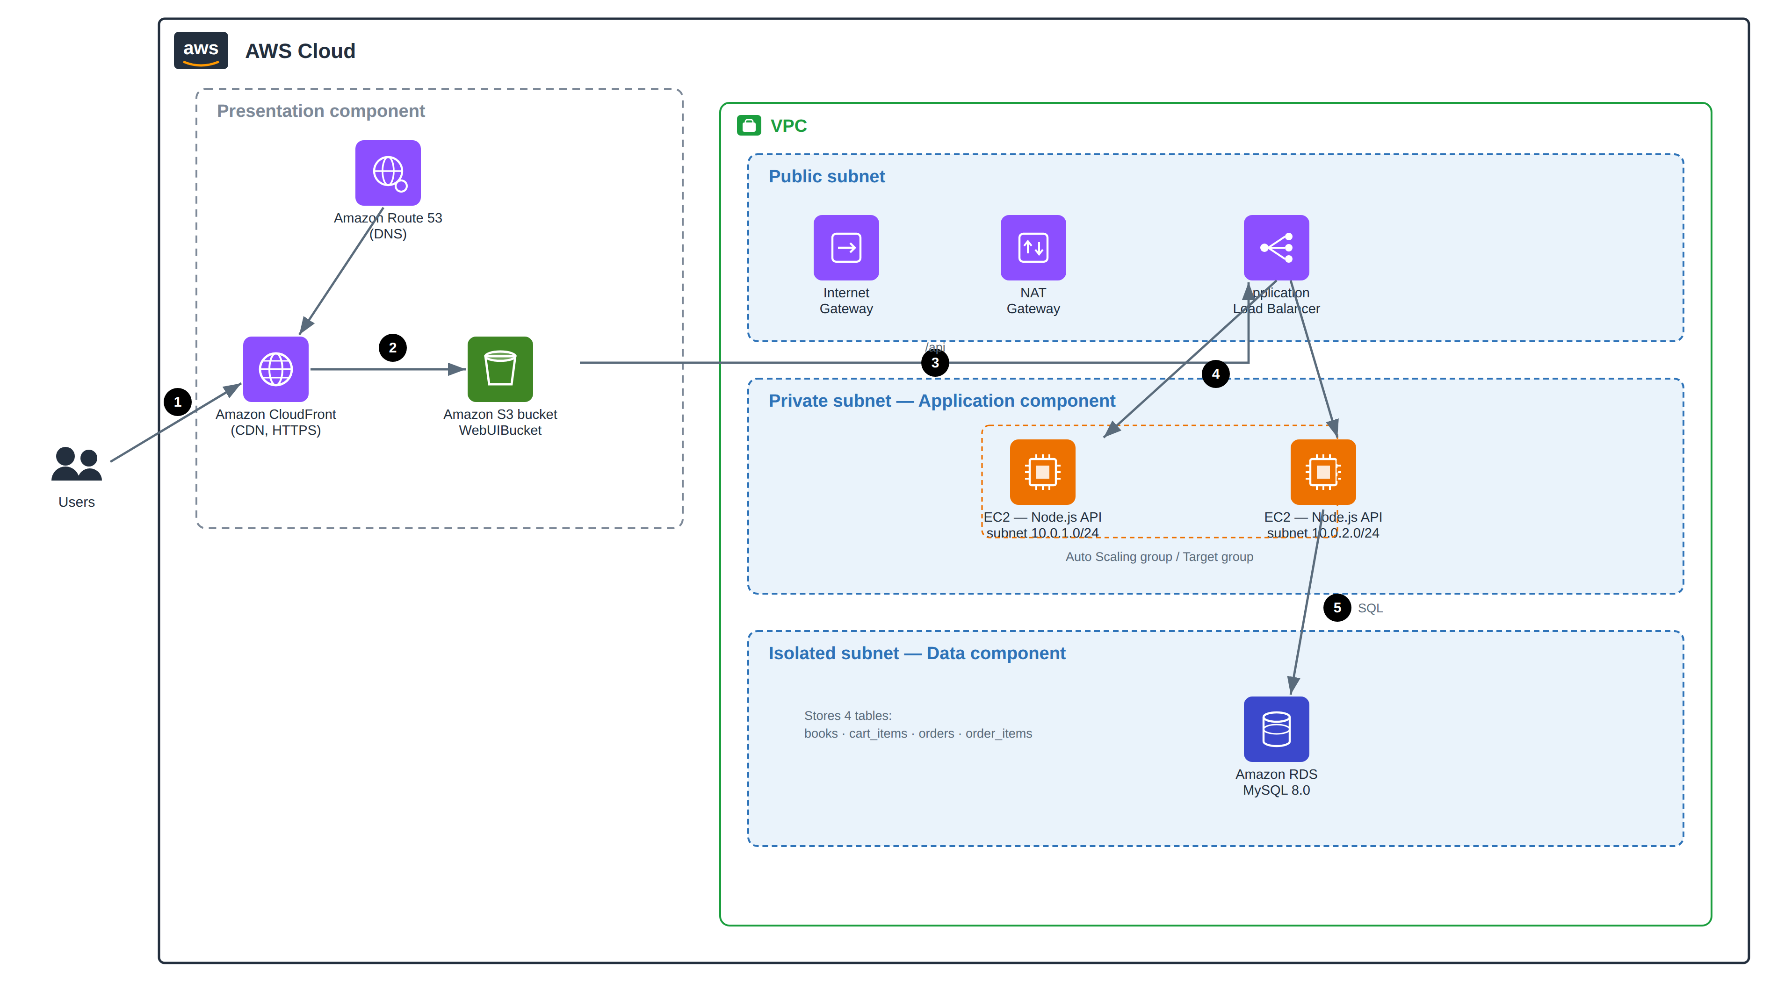
Fig 1: BookNook Three-Tier AWS Architecture
Security-group chain: the ALB accepts traffic from the internet on port 80; the EC2 instances accept traffic only from the ALB on port 3000; and the RDS database accepts traffic only from the EC2 instances on port 3306.

5. Implementation — Key Steps
The infrastructure is built in the AWS Console in arrow notation (menu → option). The full runbook is in the deployment guide; the main steps are summarised here.
1. Network
VPC 10.0.0.0/16 → public + private (app) + isolated (db) subnets across two AZs → Internet Gateway → NAT Gateway → route tables
2. Security groups
sg-alb: 80 from anywhere → sg-backend: 3000 from sg-alb → sg-rds: 3306 from sg-backend
3. Database (RDS MySQL 8.0)
RDS → Create database → MySQL 8.0 → db.t3.micro → isolated subnets → Public access = No → sg-rds → DB name = booknook
4. EC2 backend (user-data)
The user-data installs Node, clones the repo, writes the .env (including JWT_SECRET), and runs the API as a service. On first boot the API creates five tables and seeds the books and demo users.
#!/bin/bash
apt update -y
curl -fsSL https://deb.nodesource.com/setup_20.x | bash -
apt install -y nodejs git
git clone https://github.com/your-username/booknook.git /opt/booknook
cd /opt/booknook/backend
cat > .env <<EOF
PORT=3000
CORS_ORIGIN=*
JWT_SECRET=<same-long-random-string-on-every-instance>
DB_HOST=<your-rds-endpoint>
DB_PORT=3306
DB_USER=admin
DB_PASSWORD=<your-rds-password>
DB_NAME=booknook
EOF
npm install
npm start
JWT_SECRET must be identical on every instance, or a token issued by one is rejected by another behind the load balancer.
5. Load balancer, Auto Scaling, S3, CloudFront, Route 53
Target group HTTP:3000, health /health → ALB listener 80 → target group
Launch template + Auto Scaling group → Min 2 / Max 4 → CPU 70%
S3 private bucket → upload index.html (set const API = "")
CloudFront → S3 origin (OAC) + ALB origin → proxy /api/* and /health to the ALB → HTTPS
Route 53 → A/Alias record → CloudFront

6. Application Overview

6.1 Database Schema (5 tables)
Table | Description
users | id, username (unique), password_hash (bcrypt), role, created_at
books | Catalogue: title, author, category, price, description
cart_items | user_id, book_id, quantity (one row per book per user)
orders | user_id, customer name, email, address, total, status
order_items | Line items per order (title and price snapshotted at purchase)

6.2 REST API
Endpoint | Access | Purpose
POST /api/login | public | Verify credentials, return a JWT
GET /api/me | token | Current user
GET /api/books | token | List / search / filter
POST /api/books | admin | Add a book
DELETE /api/books/:id | admin | Remove a book
GET /api/cart, POST, PUT/:id, DELETE/:id | token | Cart (scoped to the user)
POST /api/orders | token | Checkout
GET /api/orders | token | The user’s own orders
GET /api/admin/orders | admin | Every order, with the username

6.3 Frontend
The frontend is a single static HTML page using Bootstrap 5 and vanilla JavaScript. When no token is stored it shows a login screen. After signing in, a normal user sees Browse, Cart, and Orders; an admin sees a Manage Books panel (an add-book form and a table of books with Remove buttons) and an All Orders view. The token is attached to every API call, and an expired or missing token returns the user to the login screen.

7. Conclusion
BookNook shows a complete web application — now with authentication and an administrator role — mapped onto a secure three-tier AWS architecture. The static frontend is delivered through CloudFront and S3; the stateless, token-authenticated API runs on EC2 behind a load balancer with Auto Scaling; and data is stored in a managed RDS MySQL database isolated from the internet. Role-based access control restricts book management and the global order view to administrators, while the layered security groups keep each tier reachable only from the tier in front of it.

