Store Sales Prediction
Wireframe Documentation

Store Sales Prediction
User Interface:
1. The user can view the following web page once entering the web application.
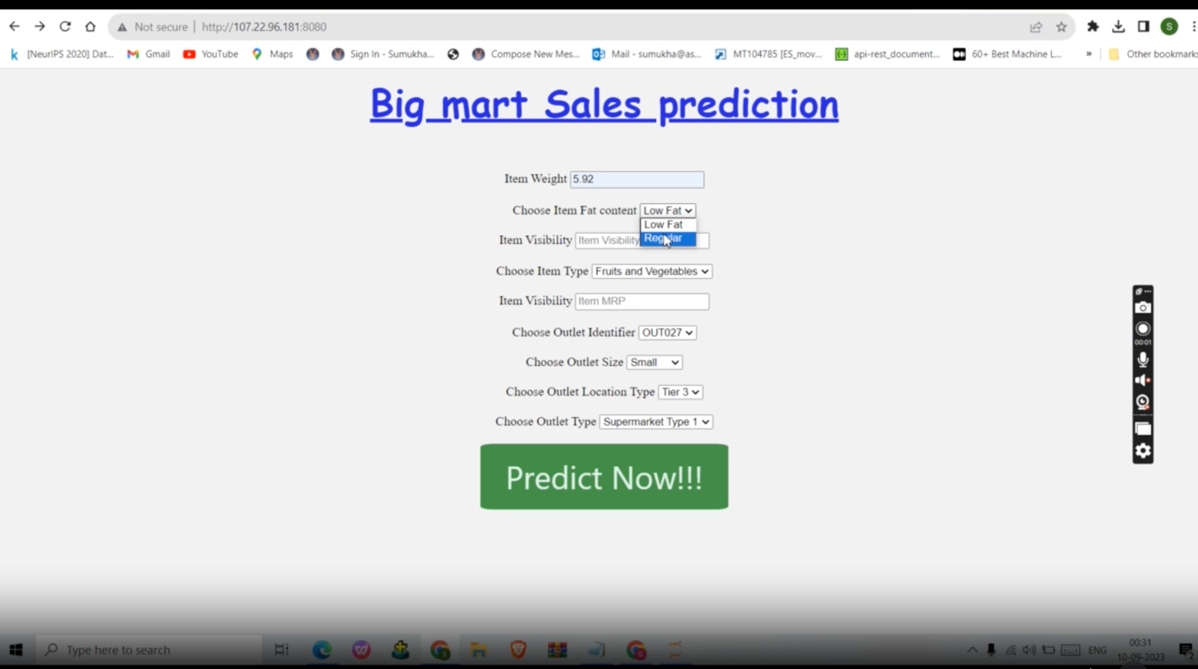

2. Change the values in the fields as needed:
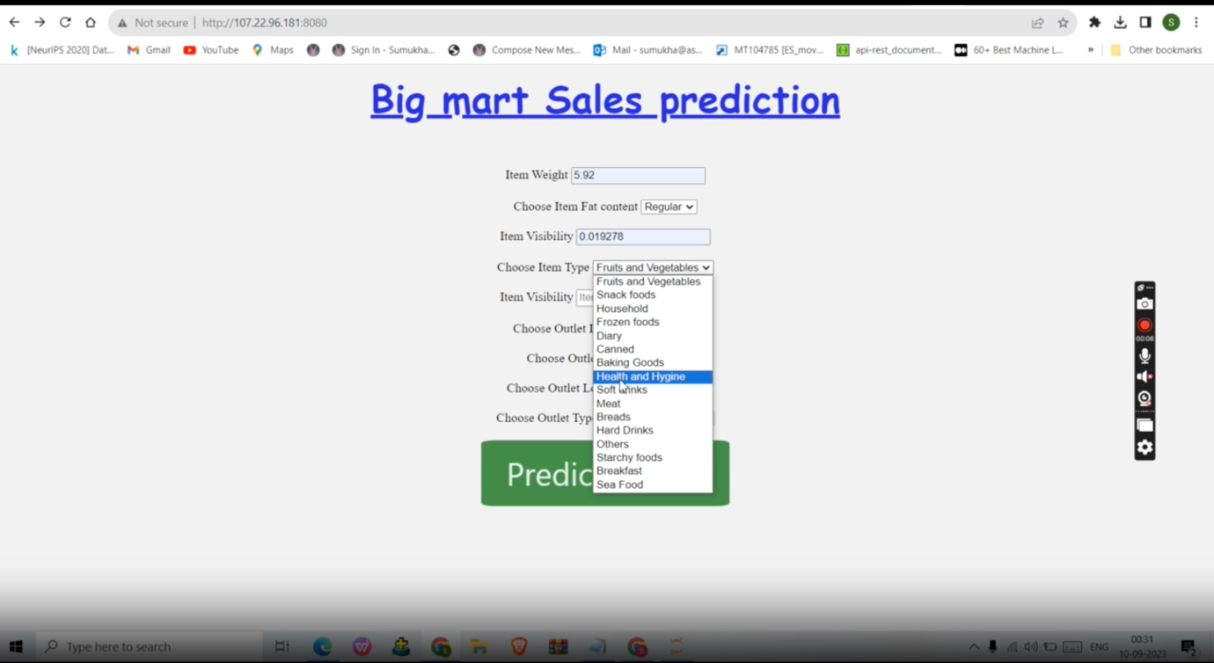
3.After clicking the “Submit ” button, User can see the prediction result on the next page with auto navigation.
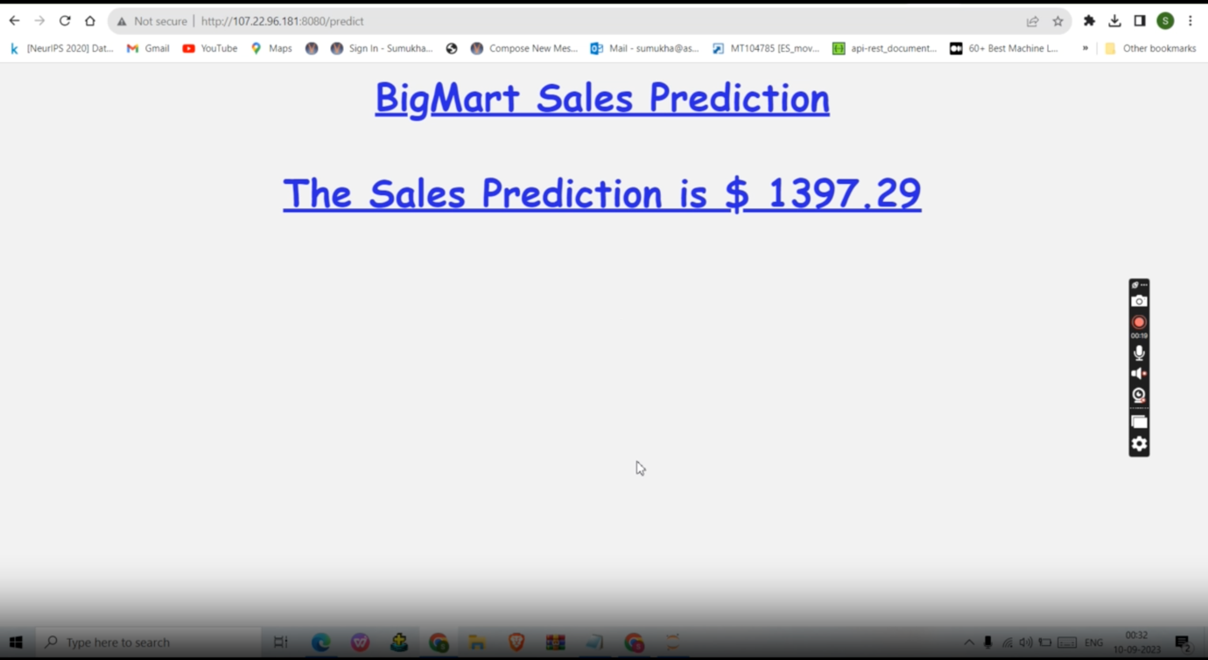
Based on User Inputs, Store Sales Prediction will predict the Item Outlet Sales and user will get predicted

