
SHIVAM GUPTA (BTCD24O1060) Cornerstone Project
Milestone 1
Architecture and Pipeline Implementation
Field | Detail
Project Title | Design and Development of a Confidence-Aware RAG Pipeline with Hallucination Detection
Milestone | Milestone 1: Architecture and Pipeline Implementation, due 27 August 2026
Prepared By | Shivam Gupta (BTCD24O1060)
Status | Complete. Pipeline, confidence layer, interface and tests all built and verified.

1. Objective
This milestone was about settling the design of the system and building it end to end. Benchmark numbers were not expected this week and none are claimed here. The question I had to answer first was how a RAG pipeline can judge the reliability of its own retrieval before it generates an answer, because the standard measure of groundedness cannot be computed at that point. Nearly everything else follows from how that is resolved: where the abstention decision sits, which models are needed, what gets logged, and what the tests have to pin down.

2. The Problem This Project Addresses
Retrieval-Augmented Generation reduces hallucination but does not remove it. An ordinary RAG application answers in the same confident tone whether the retrieved passages support the answer or not, because nothing in the pipeline ever asks whether they do. Three failure modes survive retrieval: the corpus may not contain the answer at all and the generator will usually answer anyway; the passages may be correct while the model adds a number or a causal link that appears nowhere in them; or the model may state something the passages refute, because it fell back on what it memorised during training instead of reading the context it was given.
So the system is least trustworthy at exactly the moment it has no way of saying so, and a wrong answer given confidently costs the reader more than a refusal would, because the reader cannot tell the two apart. What this project tests is the claim that a RAG system should estimate how reliable its own answer is and decline to answer when that estimate is low. The target is not higher accuracy on every question. It is a better trade: most of the wrong answers suppressed, at the cost of withholding a few correct ones.

3. Approach

3.1 Why confidence is checked twice
The project description requires the system to evaluate retrieval reliability before generating a response. Taking that literally runs into a problem. Faithfulness, the usual measure of groundedness in RAG, is the proportion of claims in an answer that the retrieved context supports. Before generation there is no answer and therefore no claims, so faithfulness is undefined at that point. After generation it can be computed, but by then the tokens have been paid for and the fluent wrong answer already exists inside the system, one display call away from the user.
Rather than pick one of the two, the pipeline asks two different questions at two different points, using a model suited to each.
 | Gate A, before generation | Gate B, after generation
Question asked | Could these passages support any answer to this question? | Is the answer that was produced entailed by these passages?
Model | Relevance reranker  cross-encoder/ms-marco-MiniLM-L-6-v2 | NLI cross-encoder  cross-encoder/nli-deberta-v3-base
Catches | Retrieval failure: the question is outside the corpus | Invented detail, and outright contradiction
On failure | Abstain without calling the generator at all | Suppress the answer and report which claims failed

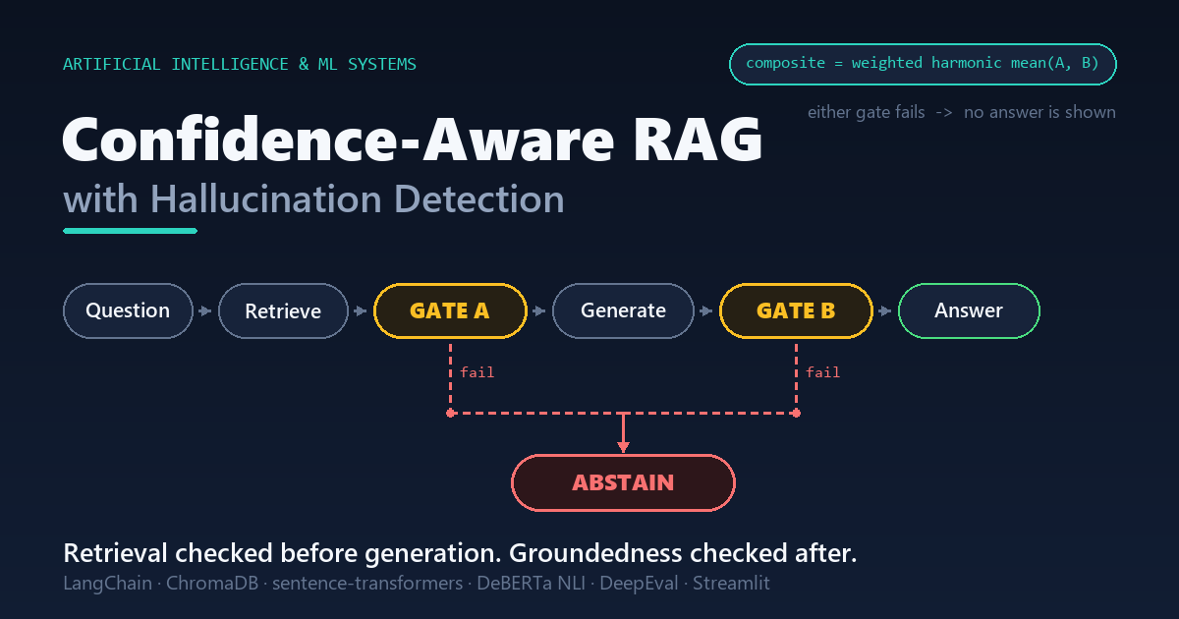
Figure 1. The two gates in the pipeline. Retrieval sufficiency is checked before generation, answer groundedness after it, and either gate failing suppresses the answer.
The gates use different model families because they are different tasks. NLI asks whether a premise entails a hypothesis, and before generation there is no hypothesis, only a question. Deciding whether a passage answers a question is a ranking problem, so Gate A uses a reranker trained on relevance judgements and Gate B uses an NLI model. One model doing both jobs would be misapplied at one end or the other.
Cosine similarity from the retriever was the obvious cheap signal for Gate A, and I decided against making it the deciding input. MiniLM cosine values are not calibrated probabilities: in the test corpus a passage that genuinely answered the question scored 0.531, so any fixed cut-off on that scale is an arbitrary constant. The reranker's output, once passed through a sigmoid, behaves much more like a probability, so that is what drives the gate. Similarity statistics are still recorded on every query, because they are inputs to threshold calibration later rather than usable thresholds now.

3.2 Scoring one claim at a time
Gate B does not score the answer as a single block. The answer is split into sentence-level claims, and each claim is checked against every retrieved passage, keeping the best entailment score and the worst contradiction score across them. Each claim then gets a label taken from the RAGTruth hallucination taxonomy: evident conflict when contradiction probability reaches 0.50, baseless information when entailment falls below 0.50 without any contradiction, and supported otherwise. Contradiction is tested first, because a claim that conflicts with the source is a worse failure than one the source is merely silent about.
Working claim by claim is what makes the output diagnostic: the interface can point at the sentence that is unsupported and at the passage that came closest to supporting it, instead of showing one number and leaving the user to guess. The gate itself does need a single number, and it uses the mean entailment probability across the claims. One contradicted claim overrides that mean and fails the gate outright, since nine correct sentences should not be able to average away one that the source refutes.

3.3 Combining the two scores
The two gate scores are combined into one composite with a weighted harmonic mean, 0.4 on retrieval relevancy and 0.6 on groundedness. The choice of mean matters more than it looks. Take an answer where retrieval was excellent but the text is almost entirely unsupported, say 0.95 and 0.05: the arithmetic mean is 0.50, which reads as borderline and would clear a mid-range threshold, while the weighted harmonic mean of the same pair is about 0.08. This is the reasoning behind using F1 instead of averaging precision and recall. Both conditions have to hold, so a near-zero in either has to dominate, and good retrieval must not be able to buy credibility for an answer that is not grounded. Groundedness carries the heavier weight because a fluent unsupported answer is the failure this project exists to catch.

3.4 What the user sees
Condition | Verdict | Shown to the user
Gate A below threshold | abstain_no_context | Abstention message. Generation never ran.
Gate A passes, Gate B below threshold | abstain_ungrounded | Abstention message with the failing claims listed. The suppressed answer stays available behind a disclosure control for inspection.
Both gates pass, composite below threshold | flag_low_confidence | The answer, with an explicit low-confidence warning.
Both gates pass, composite above threshold | answer | The answer, with its scores and the passages it came from.

Every verdict carries a one-line explanation containing the actual scores and thresholds involved, so a reviewer can always see why a query was refused. One case the table does not separate: Gate A can pass and the generator itself can then emit the insufficient-context marker it was instructed to use. That self-refusal is honoured directly and the text is discarded unscored, since measuring entailment on a refusal string would be meaningless. It currently records the same verdict as a Gate A abstention, which overstates what the confidence layer contributed, so splitting the two in the telemetry is the first item of the next milestone.

4. What Was Built
The deliverable for this milestone is working code rather than a prototype notebook: 2,989 lines of Python across 17 modules, all of it running.
Component | What it does
Ingestion and retrieval  src/ingest.py, embeddings.py, retriever.py | PDF, DOCX, Markdown and text loading, boundary-aware chunking, content-addressed chunk IDs so re-ingesting a file cannot duplicate it, one embedding entry point with a CUDA to CPU fallback, and ChromaDB search with an explicit distance-to-similarity conversion per metric.
Scoring backends  src/scorers.py | The reranker, the NLI cross-encoder and a DeepEval judge adapter. NLI label order is read from the checkpoint rather than assumed, since guessing wrong inverts every score.
Confidence layer  src/confidence.py | The two gates, the composite, the contradiction rule and the decision table. Kept behind its own interface so it can be tested with no language model present.
Generation  src/generator.py, llm.py | Grounded generation over numbered passages with a self-abstention marker, an unguarded control arm, and one factory for Ollama, Groq or Gemini with generator and judge as separate handles.
Pipeline and telemetry  src/pipeline.py, store.py | Retrieve, Gate A, abstain early, generate, Gate B, decide, log. SQLite telemetry, 30 fields per query plus a primary key, written synchronously.
Interface  app.py, pages/ | Streamlit. Gate scores against thresholds, per-claim entailment, retrieved passages, latency, and thresholds as live sliders so one query can be watched changing verdict. A second page plots the telemetry over time.
Tests and scripts  tests/, scripts/ | 31 unit tests, an index builder, a staged smoke test, a latency benchmark, and this report generator.

5. Verification
The confidence layer is the contribution, so I did not want its correctness to rest on a screenshot. The 31 unit tests cover the scoring mathematics and the decision table with no model loaded, so the suite finishes in about a tenth of a second and cannot be broken by a failed download or a busy GPU. They pin down the harmonic mean's penalty behaviour and its bounds, the distance-to-similarity conversion for each metric, sentence-splitting edge cases, the three taxonomy boundaries, all four verdicts, and the rule that one contradicted claim always fails Gate B.
A staged smoke test then runs the real components end to end and asserts behavioural separation rather than merely that nothing crashed: 24 checks passed, 0 failed. A query the corpus covers retrieved at top similarity 0.531 against 0.009 for one it does not cover. Gate A scored 0.999 on the covered query and 0.000 on the out-of-corpus one, which it refused before the generator was ever called. Gate B scored a grounded answer 0.997 and a fabricated one 0.000, labelling the fabrication an evident conflict. The composite and the verdicts followed, and a telemetry row was written and read back correctly. Two further stages need a running language model and are held behind a flag for the next milestone.
Latency was measured rather than assumed, since the confidence layer is a cost added to every single query. Warm timings on the RTX 4060, ten iterations, models loaded once and the first pass discarded:
Stage | Median | Mean | Min | Max
Retrieval (k = 5) | 17.6 ms | 25.9 ms | 14.2 ms | 106.0 ms
Gate A, reranker | 16.1 ms | 15.8 ms | 11.6 ms | 22.5 ms
Gate B, NLI over claims | 118.0 ms | 181.1 ms | 89.4 ms | 636.2 ms
Confidence layer total | 134.1 ms | 196.9 ms | 104.5 ms | 658.8 ms

The whole two-gate layer costs roughly 134 ms at the median, less than a single round trip to any hosted language model. That figure is why local cross-encoders are the primary scoring path and the LLM judge is kept as an independent cross-check: a judge costs several API calls per answer, and a sweep of thousands of benchmark questions on a free tier would hit a rate-limit wall. ruff reports no findings across the codebase; five it raised during the week were fixed, two of them real defects, namely an unguarded zip over sequences of unequal length and a timing path that dropped retrieval latency whenever generation was skipped. The tests, the smoke test, the latency benchmark and the interface each run from a single command, listed in the README.

6. Status and Limitations
The milestone is complete: the architecture is settled, the pipeline runs end to end, and the verification described above passes. What it does not have yet is stated plainly here, because a project about overconfident systems should not be overconfident about itself.
- The thresholds are placeholders. 0.45 for Gate A, 0.60 for Gate B and 0.55 for the composite were chosen to make the mechanism demonstrable, not because data supports them. They are labelled as placeholders in the code, the interface and the README, and fitting them against labelled data is the main work ahead.
- There are no benchmark results yet, and verification so far used a six-chunk sample corpus rather than the full course materials. This report claims implementation and verification, not performance.
- Gate A has a known weak spot that is not yet quantified: a reranker scores passages one at a time, so a question whose answer needs two passages combined can score low on each.
- Claim splitting is a regular expression over sentence boundaries. A sentence is a coarse stand-in for a claim, which is a simplification I am accepting on purpose.
The next step is to bring the local generator online through both gates on my own course materials, including the two smoke stages that need a language model, and to start the benchmark harness the calibration work depends on.

