

Design and Development of a Confidence-Aware RAG Pipeline with Hallucination Detection

Milestone 3: Calibration and Performance Validation

1. Objective
This milestone was about replacing the placeholder thresholds with fitted ones and measuring what that change is worth. Milestone 2 showed that uncalibrated thresholds refuse to answer 84% of answerable questions, which makes the system unusable even though it does suppress hallucinations. The question Milestone 3 had to answer was whether data-driven thresholds can reduce that over-abstention rate without letting hallucinations back through, and whether the local NLI scorer agrees with a slower LLM judge closely enough to be trusted.

2. Threshold Calibration
Thresholds were fitted against the 150-item SQuAD 2.0 sample using the answerable/unanswerable labels as ground truth. Gate A was calibrated by Youden's J (the threshold that maximizes true positive rate minus false positive rate) over the reranker score. Gate B was calibrated by F1 over mean NLI faithfulness, constrained to stay above the 0.15 contradiction cap so calibration cannot weaken the hard-fail rule.
Two properties of this calibration have to be stated before the numbers, because both limit what the numbers can be read as saying. First, the thresholds are fitted and evaluated on the same 150 items; there is no held-out split. Every figure in section 3 is therefore an in-sample figure and is optimistic by an amount this sample cannot measure. Second, Gate B's calibration uses a proxy label rather than a groundedness annotation: grounded is defined as a baseline-arm answer to an answerable question, and fabricated as a baseline-arm answer to an unanswerable one. That is the same answerable/unanswerable label Gate A is fitted on, so Gate B's AUC partly re-measures answerability rather than groundedness, and a genuinely ungrounded answer to an answerable question is counted as grounded by construction. Fixing this needs claim-level groundedness annotations, which this sample does not have.
Gate | Old (M2) | Fitted (M3) | ROC AUC | Chosen metric
Gate A | 0.45 | 0.45 | 0.652 | Youden J = 0.24
Gate B | 0.60 | 0.25 | 0.594 | F1 = 0.481
Composite | 0.55 | 0.33 | — | Harmonic mean at corner

The Gate A threshold stayed at 0.45 because that was already the Youden-optimal point. Gate B dropped from 0.60 to 0.25, and the composite dropped from 0.55 to 0.33. The ROC AUC of 0.652 for Gate A is only marginally above random (0.50), which means the reranker score alone does not separate answerable from unanswerable strongly. Gate B's AUC of 0.594 is weaker still, and given the proxy label above it should be treated as an upper bound on a quantity that has not really been measured yet rather than as a groundedness score.
A logistic model was also fitted over all four retrieval features (rerank score, top similarity, mean similarity, similarity margin) for Gate A, achieving a cross-validated AUC of 0.673. That is only 2 percentage points above the single-feature threshold, so the additional features do not add much discriminative power on this sample. The single-threshold gate is simpler and was kept.

3. Post-Calibration Results
The same 150 questions re-run with the calibrated thresholds. The guarded arm now answered 29 and abstained 121 times, compared to 15 answered and 135 abstained before calibration (Milestone 2). The baseline column is the same control run reported in Milestone 2, not a fresh sweep: the baseline enforces no gates, so changing a threshold cannot change its output, and reusing it keeps the comparison free of the generator's run-to-run sampling noise.
Metric | M2 (uncalibrated) | M3 (calibrated) | Baseline | Δ vs baseline
EM | 0.480 | 0.447 | 0.127 | +0.320
F1 | 0.509 | 0.499 | 0.249 | +0.250
Abstention rate | 90.0% | 80.7% | 0.0% | —
Hallucination rate | 4.0% | 10.7% | 100.0% | -89.3%
Over-abstention rate | 84.0% | 72.0% | 0.0% | —

Calibration moved the needle in the intended direction: over-abstention dropped from 84% to 72.0%, meaning the system now answers 21 of the 75 answerable questions instead of 12. The cost is that hallucination rate rose from 4% to 10.7%: the system now produces 8 fabricated answers instead of 3. That is the trade this project was built to measure.
Condition | M2 answered | M3 answered | M3 abstained
Answerable (75) | 12 | 21 | 54
Unanswerable (75) | 3 | 8 | 67

4. Risk-Coverage Analysis
The risk-coverage curve plots error rate (risk) against the fraction of questions answered (coverage) as the confidence threshold is varied. A system that answers everything has 100% coverage at the baseline's error rate; a system that answers one question has near-zero coverage. The area under the curve (AURC) summarizes the trade: lower is better.
Metric | Guarded | Baseline | Improvement
AURC | 0.634 | 0.866 | 0.232
Risk at 50% coverage | 48.0% | 84.0% | 36.0% lower
Risk at 80% coverage | 55.0% | 87.3% | 32.3% lower

The guarded arm's AURC of 0.634 is 0.232 below the baseline's 0.866, meaning the confidence layer as a selector produces less risk at every coverage level. At 50% coverage the guarded arm's risk is 48.0% versus the baseline's 84.0%, which is 36% lower in absolute terms. The operating point a deployment would choose is "answer as many questions as you can without exceeding X% error"; this curve shows that trade quantitatively. One caveat on how to read it: both arms are ranked by the same composite score, so the curve measures the score's value as a ranking signal, not the gates' value as a hard cut-off. The baseline curve is worse mainly because its answers are wrong more often, not because its scores rank differently.
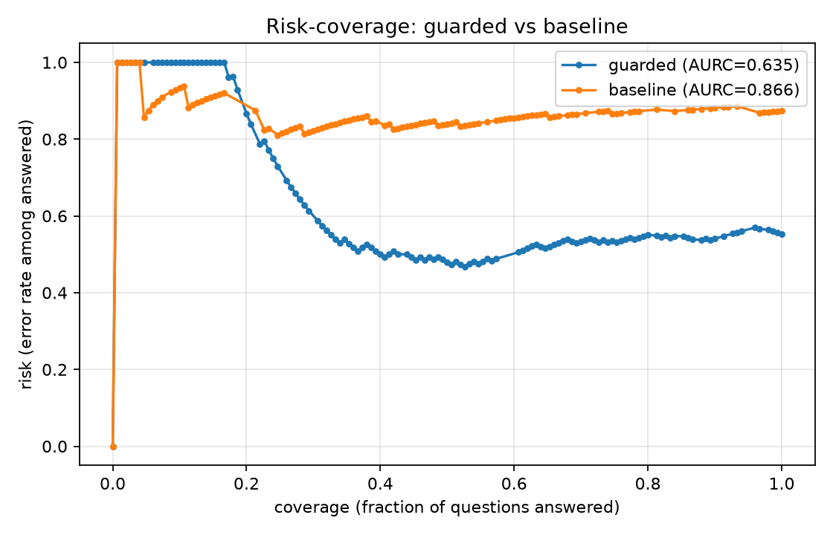
Figure 1. Risk-coverage curves for guarded and baseline arms. Lower and to the right is better.

5. Judge Agreement Study
A subset of 34 items was run with both the local NLI scorer and a DeepEval LLM judge to measure whether the cheap local path agrees with the reference standard closely enough to be trusted. The judge is gemma2 via Ollama, deliberately a different model from the llama3.1:8b generator, because a model grading its own output is a known source of self-preference bias. An earlier judge choice, qwen2.5:7b-instruct, had to be replaced: it answered "no" to every faithfulness verdict regardless of the claim, deterministically at temperature 0, which makes its scores meaningless rather than merely noisy.
Agreement has to be reported two ways, because the first way is misleading on its own. Applying the calibrated NLI threshold to both scorers assumes the two scores share a scale, and they do not: the judge's relevancy score never exceeds 0.448 anywhere in this subset, while the reranker averages 0.423. Under a common 0.45 cut-off the judge therefore fails every single item, and the resulting kappa of zero says nothing about whether the two scorers pick out the same passages. The second measurement removes the scale by giving the judge whichever cut-off lets through the same number of items the NLI scorer passed, so kappa then measures agreement on the ranking, which is the claim actually being tested. Spearman's rho is reported alongside for the same reason: it depends only on order.
Gate | n | ρ | κ (shared cut-off) | κ (rate-matched) | Observed (rate-matched)
Gate A (relevancy) | 33 | 0.132 | 0.000 | 0.040 | 60.6%
Gate B (faithfulness) | 17 | -0.298 | -0.037 | -0.037 | 41.2%

On Gate A, rate-matching accounts for a large part of the apparent disagreement but not for all of it. The shared cut-off produces κ = 0.000 with the judge passing nothing; once both scorers are made to pass 23 items each, raw agreement rises from 30.3% to 60.6% and they concur on 17 passes and 3 failures. But κ only moves to 0.040, which is negligible: at that pass rate two scorers would overlap on roughly this many items by chance alone. So the headline κ of zero was substantially a threshold artifact, and correcting it does not rescue the underlying claim. The two scorers do not rank passages the same way, and ρ = 0.132 says the same thing independently of any cut-off.
On Gate B, rate-matching changes nothing, for a reason worth stating: the judge's faithfulness score takes only 2 distinct values across the subset, 0.0 and 1.0. DeepEval's faithfulness metric is returning a verdict, not a calibrated score, so there is no continuous ranking to rate-match against and both measurements collapse to the same table. κ = -0.037 is slightly below zero, meaning the two agreed marginally less often than chance would predict. The disagreement is one-sided: the judge passed 9 items the NLI scorer failed, against 1 in the other direction. A binary reference also means ρ = -0.298 should not be read as a correlation between two graded opinions.
What this study can and cannot support. It cannot support the claim that the local scorer is interchangeable with the judge: on both gates, agreement beyond chance is indistinguishable from zero even after the scale problem is removed. It equally cannot support the opposite conclusion with any confidence, because the samples are too small. Gate A rests on 33 items and Gate B on 17, the latter because the judge only scores faithfulness on items that reached generation. At n = 17, a single reclassified item moves kappa by roughly 0.1, so the difference between -0.037 and a modest positive value is one or two answers. The honest reading is that the local scorer has not been shown to reproduce the judge's decisions, and that establishing either result properly needs a larger subset than this milestone ran.
Latency cost: the judge's median Gate B latency was 224.4 seconds versus 262 ms for the NLI scorer, a 857× slowdown. The disagreement combined with that latency cost means the local scorer cannot be blindly trusted as a drop-in replacement for the judge, but it is fast enough to be the primary path with the judge reserved for spot checks.

6. Status and Limitations
Milestone 3 is complete: thresholds are fitted, the post-calibration run is scored, the risk-coverage curves are plotted, and the judge-agreement study quantifies where the local scorer can and cannot be trusted. The claim that calibration reduces over-abstention is now supported by measurement rather than assertion.
- The 150-item sample is small enough that the confidence intervals are wide. The hallucination rate moved from 4% (3/75) to 10.7% (8/75): that is a 3-to-8 shift, which could be noise. A larger sample would tighten the intervals.
- Gate A's weak AUC (0.652) means the answerable/unanswerable split is only marginally predictable from retrieval features alone on this sample. Multi-hop questions (HotpotQA) are expected to degrade this further, since a reranker scores passages individually.
- The judge disagreement is real and was not debugged away, but it is not solely a failure of the local scorer. DeepEval's faithfulness metric returned only two distinct values across the subset, 0.0 and 1.0: it emits a verdict, not a calibrated probability. The local NLI scorer emits graded entailment probabilities, so the two are not measuring on comparable scales, and a binary signal cannot serve as a continuous reference standard for threshold calibration at all. The honest conclusion is that this study has not established the local scorer as a substitute for the judge, and that the judge as configured is unsuitable as the yardstick for that comparison.
The system is now end-to-end measurable, and the evaluation framework is in place for ablations, alternative models, and multi-hop benchmarks. The final milestone consolidates the results and demonstrates the system on the full course-materials corpus.

