Company Database

**T**his is a database which contains basic information about famous companies around the world. Customers can see & check out in which company should they invest and buy the stocks from. Also, details some of most famous founders are given.

The information which are going to be available in the database are given below:

**Table:** Companies

**Attributes:** company_name,category,founder,co_founder,founded, country,city,networth,stock

**Relations:** 1. Companies – locating – CountryLog

2. Companies – creators – FoundedBy

3. Companies – type - CatagoryType

4. Companies – offering – Services

**Table:** CountryLog

**Attributes:** country_name, city

**Relations:** 1. CountryLog – locating – Companies

2. CountryLog – Country – FoundedBy

**Table:** CatagoryType

**Attributes:** category

**Relations:** 1.CatagoryType- type – Companies

**Table:** FoundedBy

**Attributes:** founder, country, city, networth

**Relations:** 1. FoundedBy – country – CountryLog

2. FoundedBy – creator – Companies

**Table:** Services

**Attributes:** services_type, company_name, service_type_2

**Relations:** 1. Services – offering – Companies

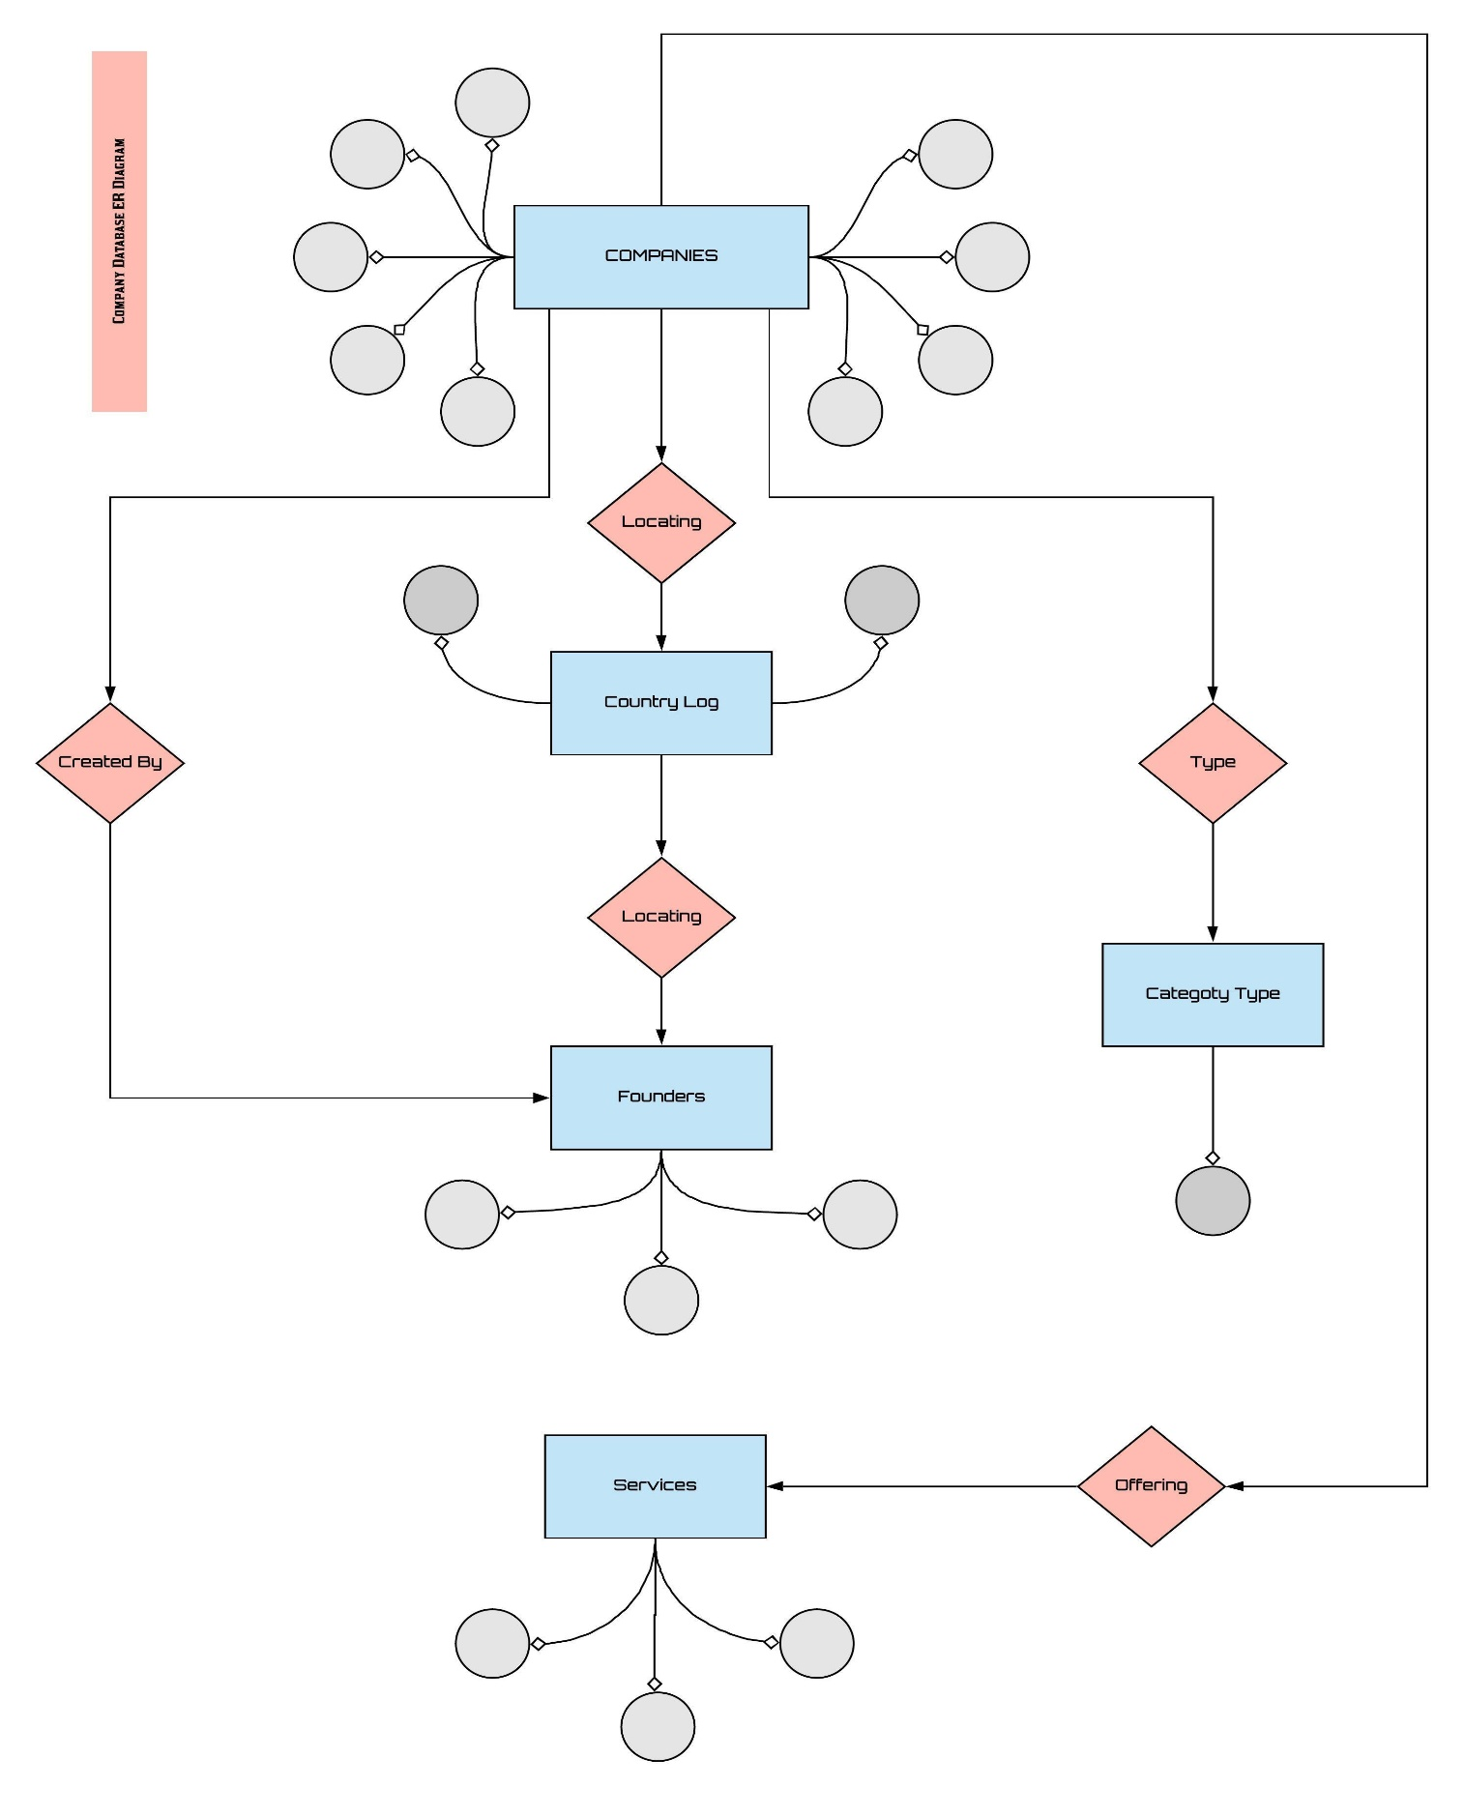ER Diagram Company Database Management

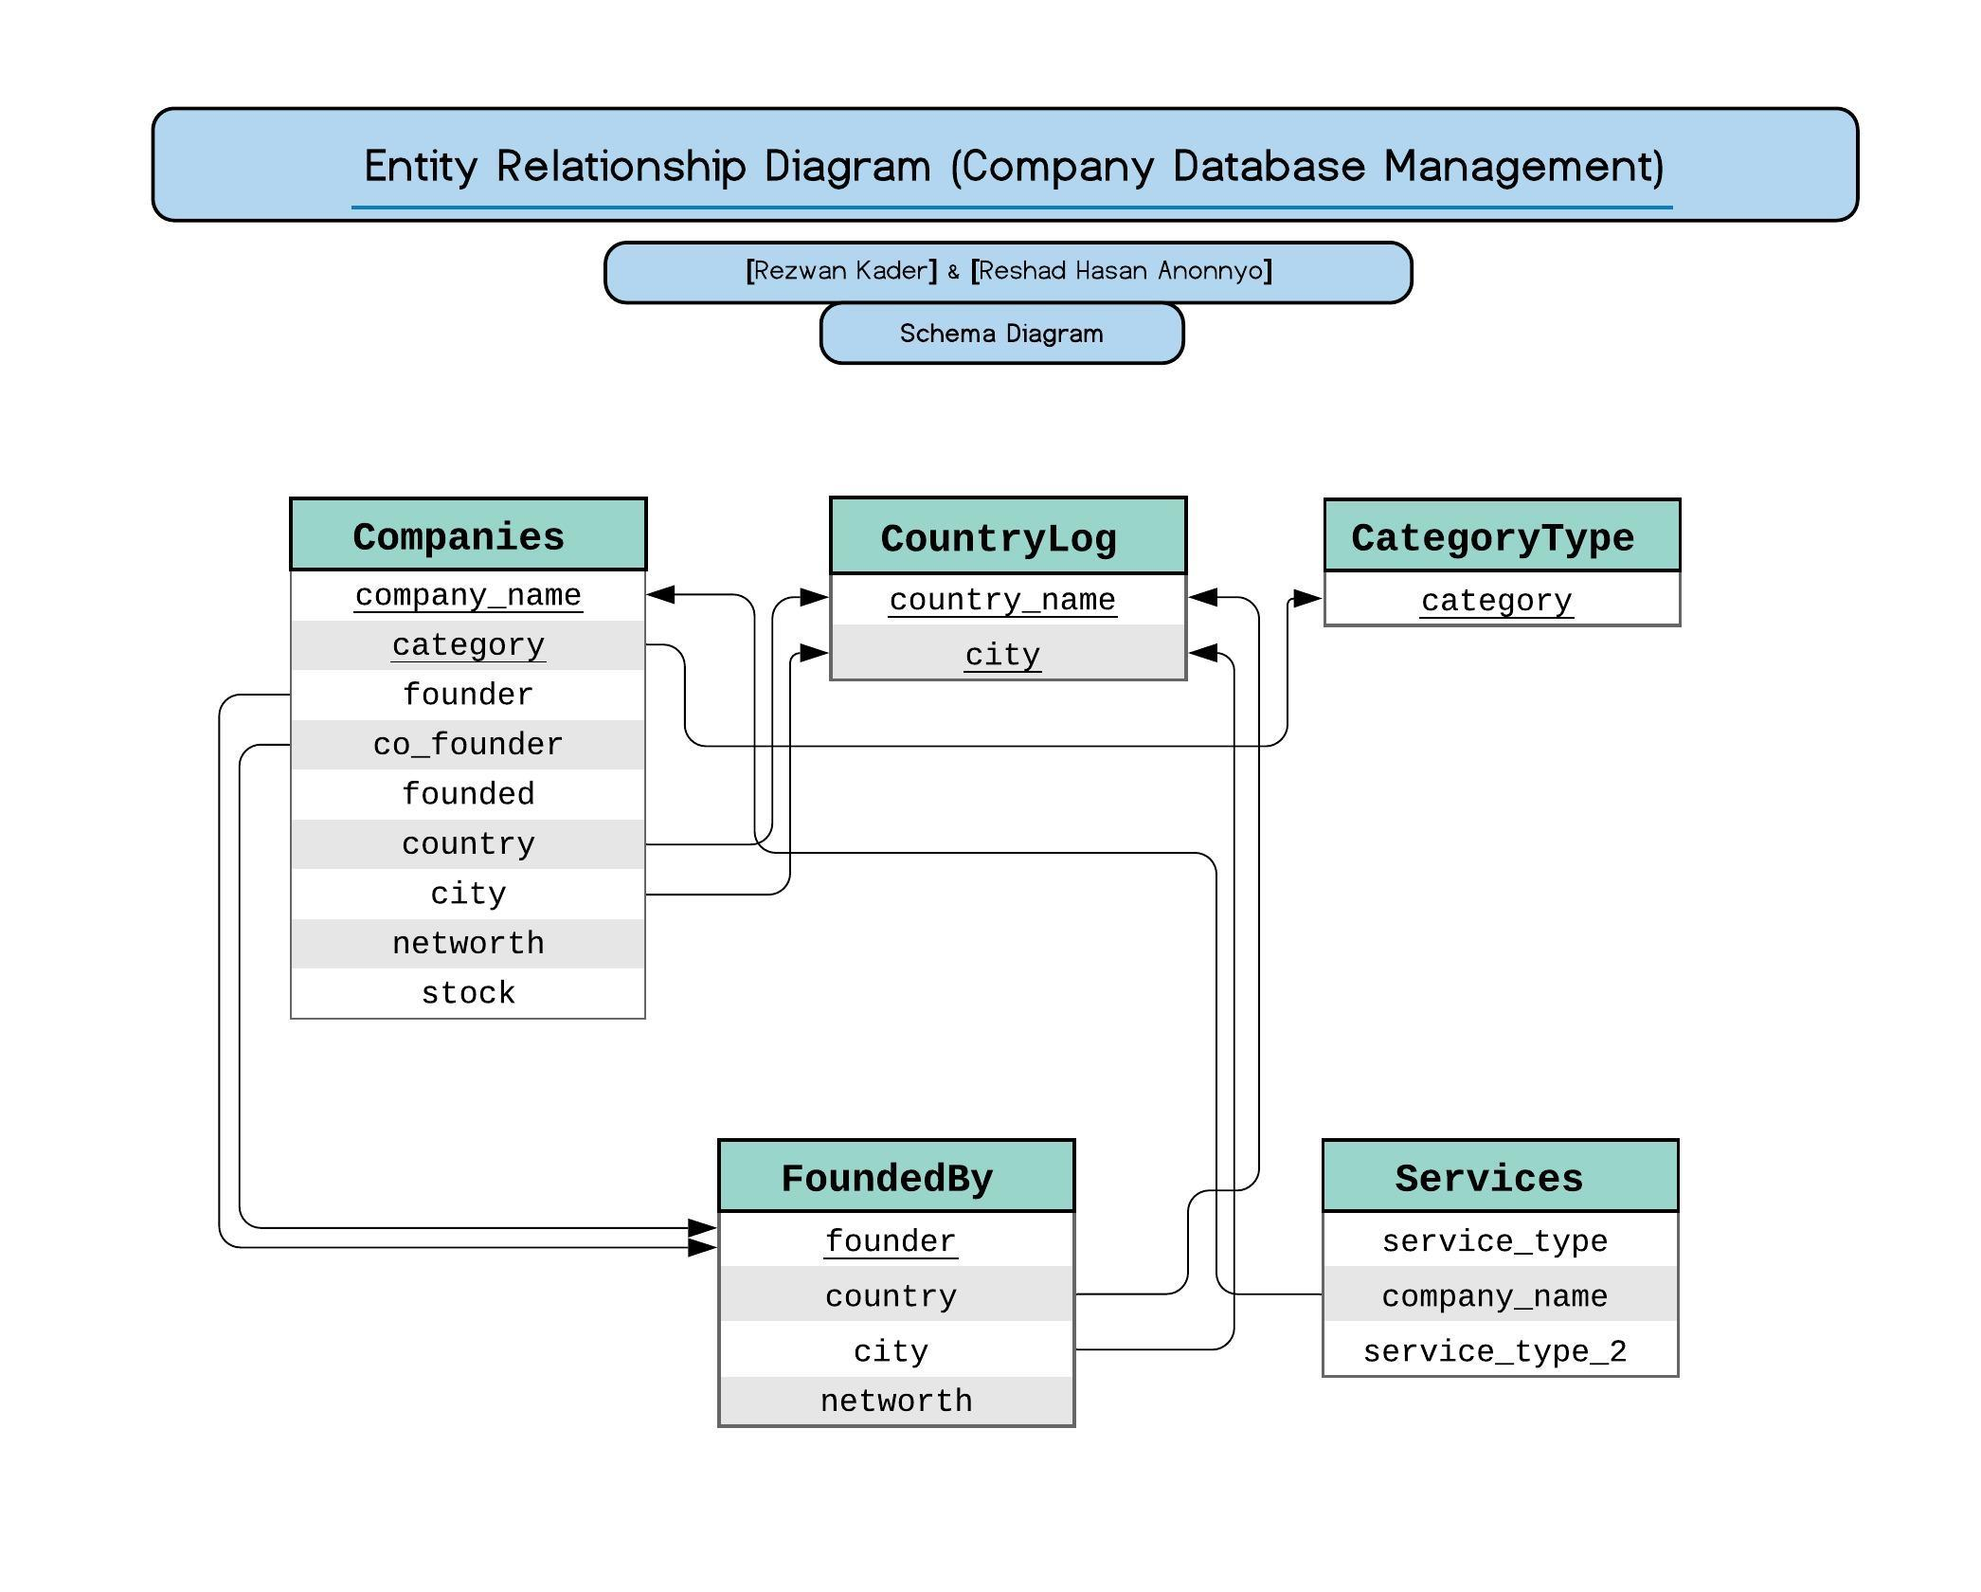

Data Entries:

Data Entry of Company List:

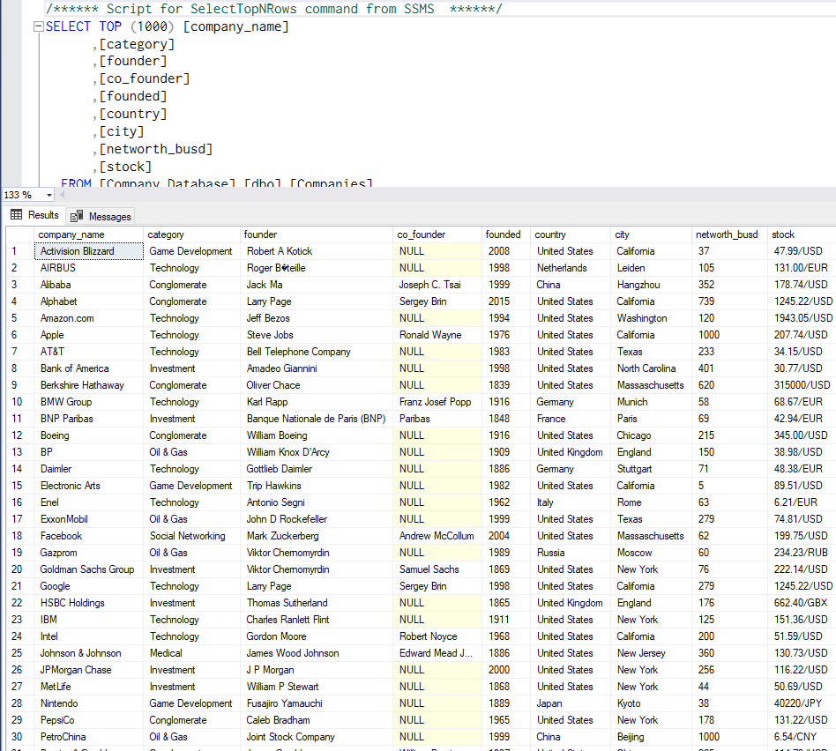

Data Entry of Country Logs:

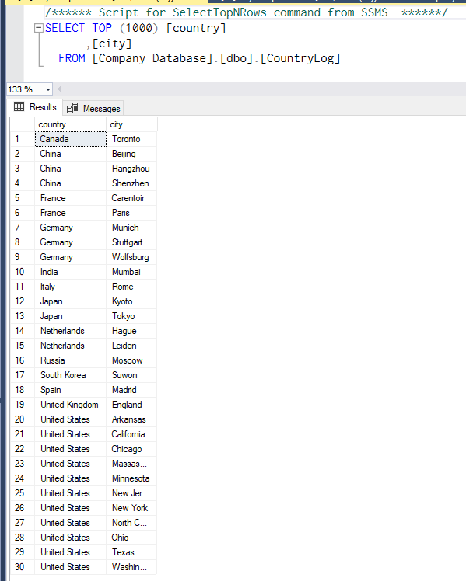

Data Entry of Category Types:

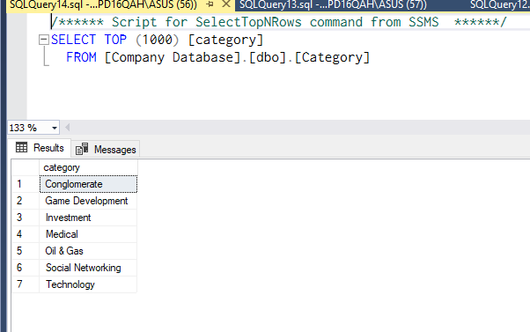

Data Entry of Founder’s List:

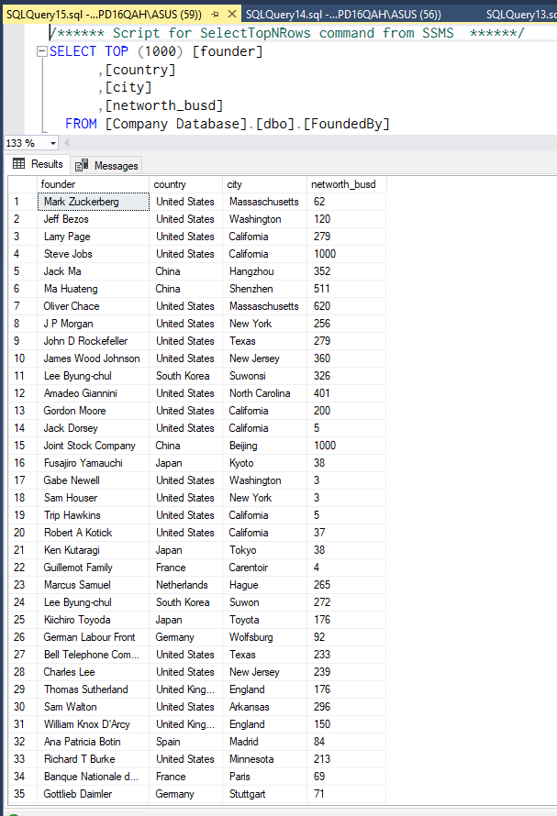

Data Entry of Services:

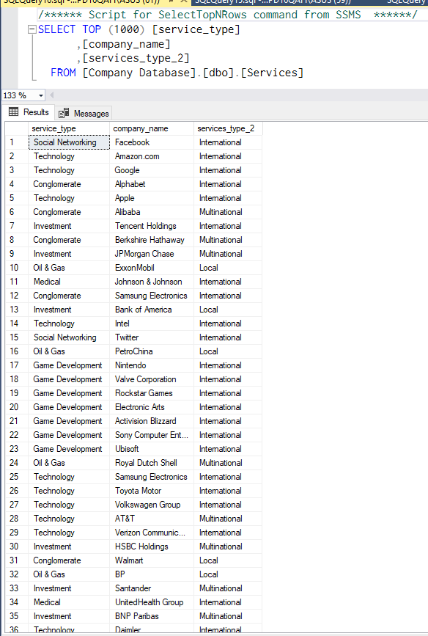

Direct Link to Database Script File:

https://drive.google.com/open?id=1DycG8J9Hq5u6J0K4bbJYj2qtbVtG0ig-

Thank You….

Project Submitted By: Team [Trojan Paradox]

Name: Rezwan Kader

ID: 17201080

Sec: B-1

Name: Reshad Hasan Anonnyo

ID: 17201069

Sec: B-1